Supplier Account Maintenance – Users and Profile

Purpose | This reference guide provides step-by instructions on how to manage your company’s or entity’s vendor profile and applies only to those vendors who have completed OregonBuys registration.  This guide addresses the following Seller Administrator functions:  Maintaining general organization information about your company, such as preferred means of contacting you, addresses, commodity codes  Managing access to OregonBuys by other employees of your company, to include adding new users, managing user account information, assigning user roles and privileges, and removing access from employees who are no longer authorized.
Audience: | Registered OregonBuys Vendors in the Seller Administrator Role

Disclaimer: This guidance offered by DAS State Procurement Services (DAS SPS) provides a general overview of this process. Vendors and Organizations may have additional internal policies or procedures. Consult the entity’s procurement office for details.

Vendor Help Desk
support.oregonbuys@das.oregon.gov or 1-855-800-5046

Table of Contents
Overview 3
Adding New Users 3
Maintaining Existing Users 4
Maintaining Addresses 5
Maintaining Commodity Codes and Services 7

Overview
Every Supplier account has at least one user with the Seller Administrator role. The Seller Administrator is responsible for maintaining the users on their OregonBuys account, maintaining organization/agency addresses, and the commodity codes (NIGP codes) that describe the goods or services an organization offers.

Adding New Users
- Navigate to the OregonBuys webpage & click Sign In.
- Enter the Login ID and Password, then click Sign In.
- Select the Seller Administrator role. Only users with the Seller Administrator role may add a new user.
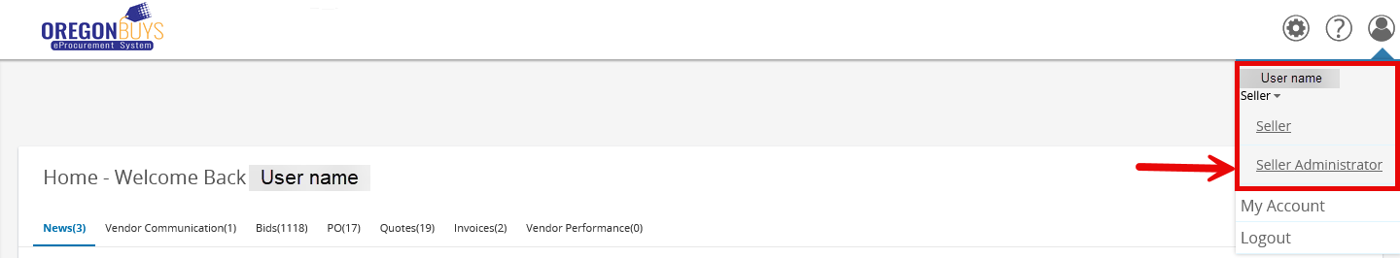
- The Seller Administrator homepage has multiple options. Click on “Add Users on this Account” to start adding a new user.
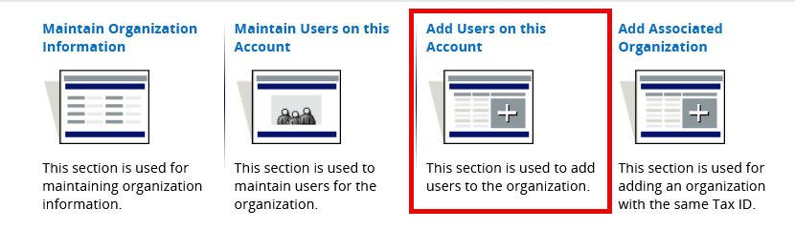
- Enter the new user’s information, including contact information, login ID and Login Question and Answer. Required information is indicated by an asterisk (*) next to the field name. Note: Once created, the login ID may not be changed or updated.
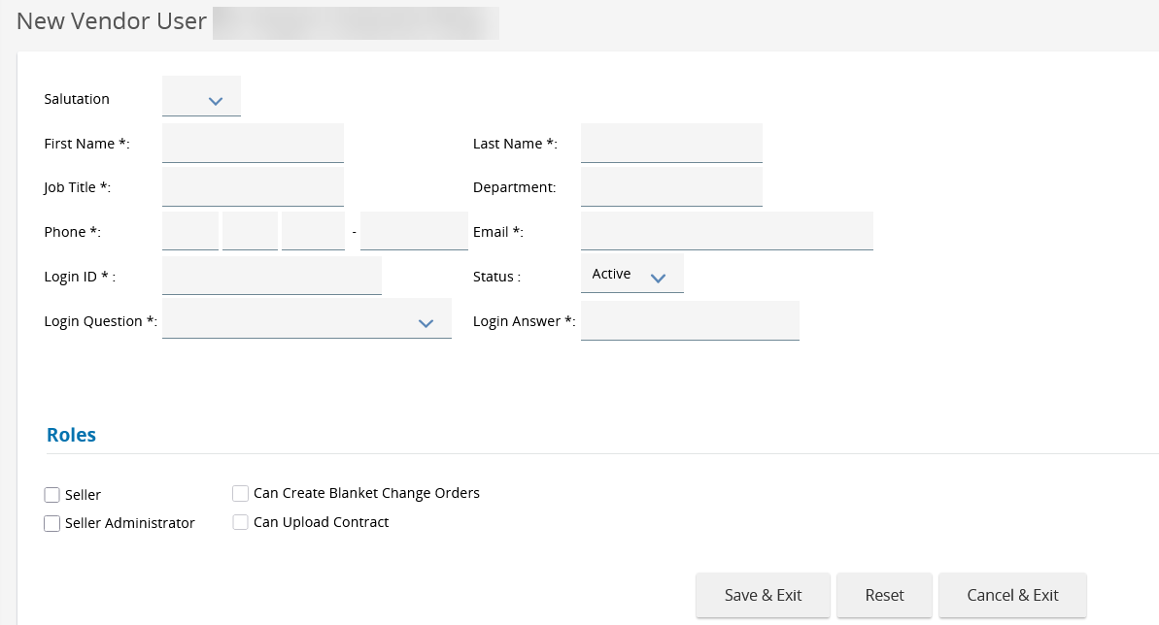
- Assign a role to the new user:
    - Seller – Allows the user to access Bids, Purchase Orders, and submit electronic Quotes
    - Seller Administrator – Allows the user to maintain the organization/agency’s OregonBuys Supplier account
    - Can Create Blanket Change Orders – Allows the user to create change orders for their Contract (Configured by the Organization managing the Contract)
    - Can Upload Contract – Allows the user to upload Contracts in the eProcurement system (Configured by the Organization managing the Contract)
- Click Save & Exit. The newly created user will receive a system-generated email providing their temporary password. OregonBuys will not send the new user their Login ID or their Login Question and Answer. The Seller Administrator must provide that information to the new user.

Maintaining Existing Users
The Seller Administrator may inactivate users, reset a user’s password, and change a user’s role.
- On the Seller Administrator homepage, click on “Maintain Users on this Account”.
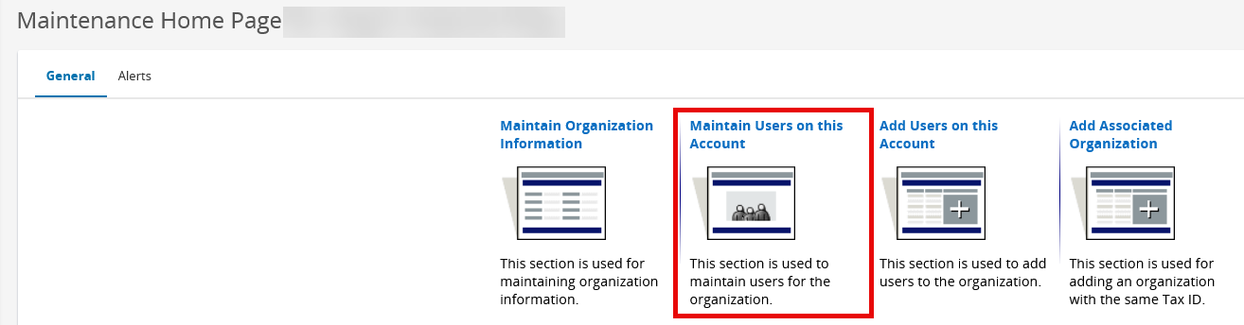
- Click on the user’s Login ID to access their account.
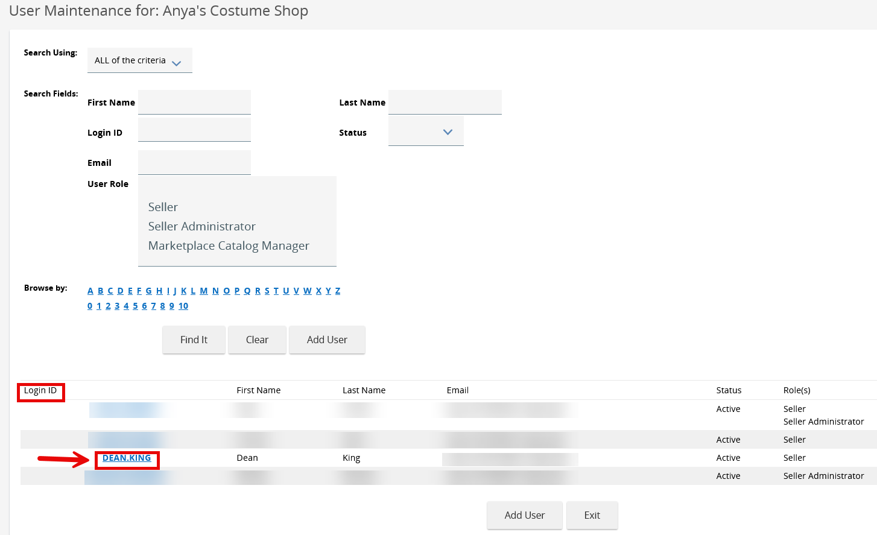
- To inactivate a user, click the drop-down arrow next to the Status field & select Inactivate or Deleted, then click Save & Exit.
- To change a user’s role, click or unclick the boxes next to the desired role.
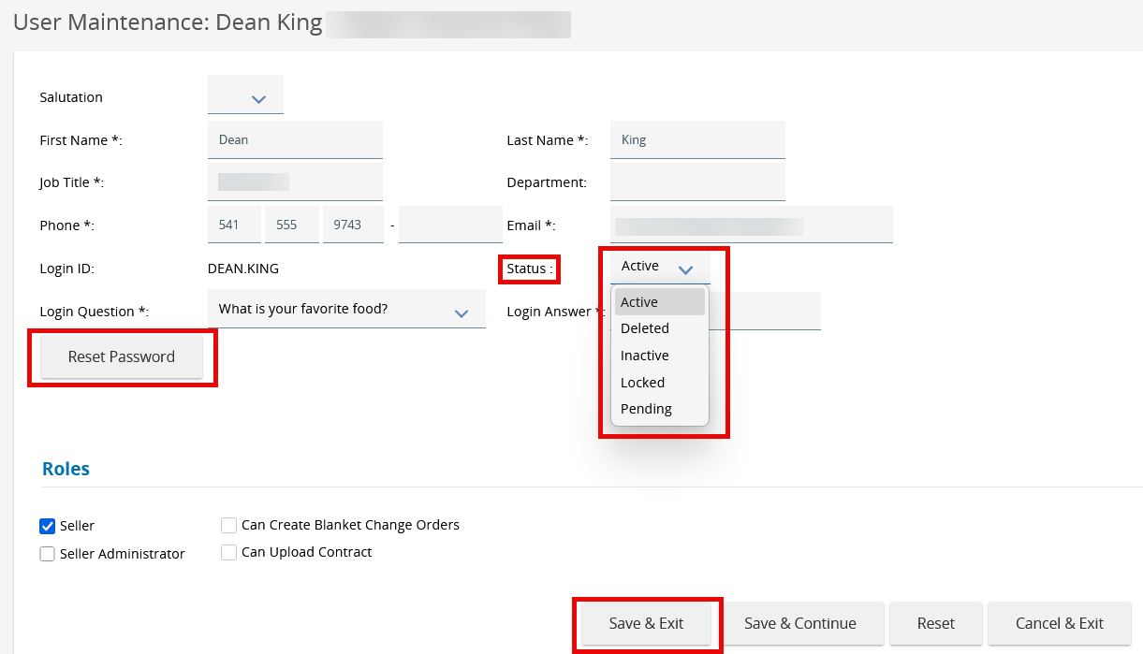
- To reset a user’s password, click the “Reset Password” button. A popup window will appear asking for confirmation; to reset the password, click “Reset Password”. OregonBuys will send a system-generated email to the user with a temporary password. To cancel the password reset, click “Cancel”. The password will not be reset.
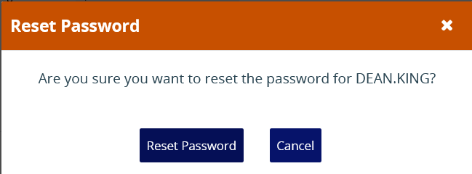

Maintaining Addresses
- On the Seller Administrator homepage, click on Maintain Organization Information.
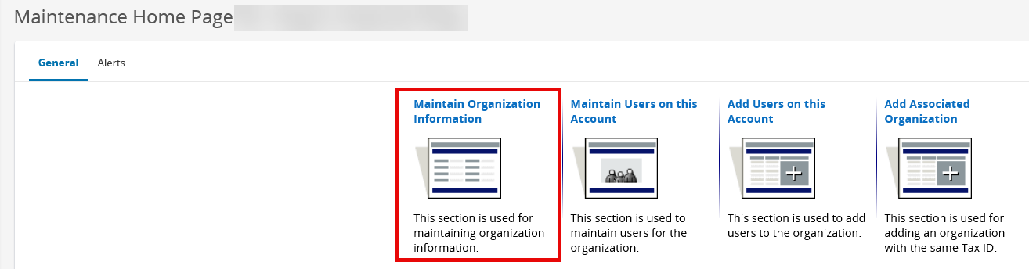
- Click Maintain Addresses
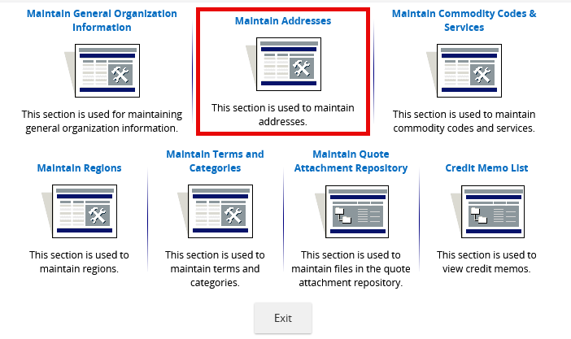
- To edit an existing address, click on the address Name and modify any fields, then click Save & Exit. Note: the address type may not be changed.
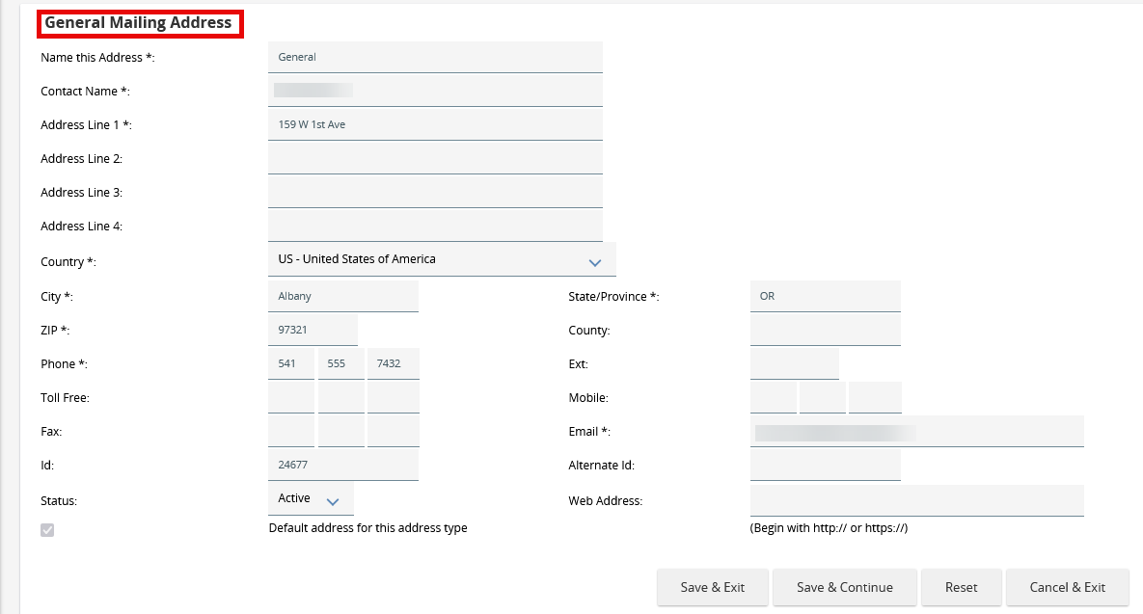
- To add a new address, go to the Maintain Addresses page and click Add Another Address.
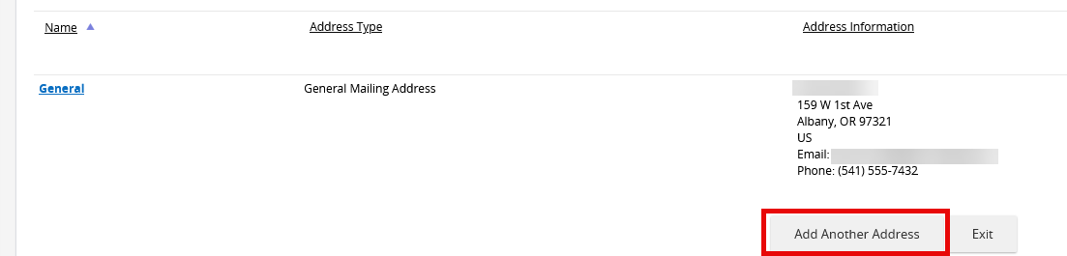
- Select the address type. Note: when adding a Bid Mailing Address, up to five (5) email addresses may be added. All Bid Mailing Address email addresses will receive email notifications when the Supplier is added to a solicitation.
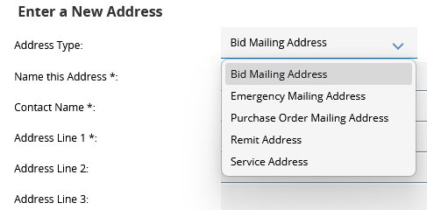
- Enter the required address information, including all required fields marked with an asterisk (*), then click Save & Exit. OregonBuys will make the new address the default address for this address type. If the new address is not the default address for this address type, uncheck the box.
The ID and alternate ID fields will be completed by the system. Data may not be entered into these fields.
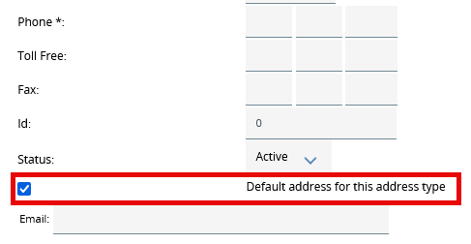

Maintaining Commodity Codes and Services
Commodity Codes (also called NIGP Codes) are informational codes that describe goods and services Suppliers provide. Solicitations posted in OregonBuys use NIGP codes to match the goods and services agencies/organizations are seeking with Suppliers who can provide them. NIGP codes may be changed or updated at any time.
- On the Seller Administrator homepage, click Maintain Organization Information
- Click Maintain Commodity Codes & Services
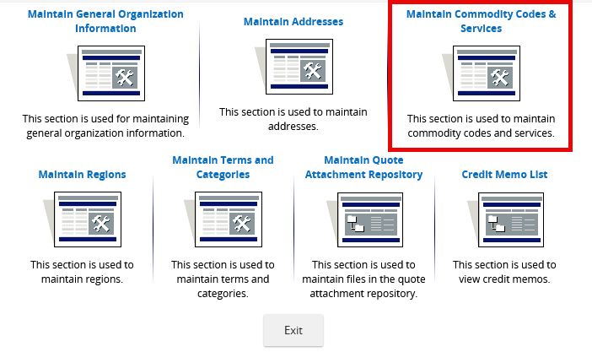
- Click Maintain Commodity Codes
- Click Add Additional Codes to add additional NIGP codes to the organization’s profile
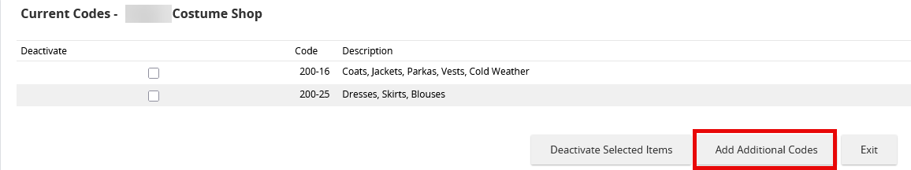
- Use the NIGP Keyword field to search for NIGP codes by keyword. To add the code to the organization profile, click the checkbox next to the code and click Save. Click Save and Add More to continue searching for codes and adding them to the organization’s profile.
