OregonBuys Amendment Guidance

Introduction
This guidance document will help approvers understand how to approve/disapprove documents in OregonBuys.

Approvals Action Button (Home Screen)
- Items can be added, cancelled, or modified
- Attachments can be added
- The location, organization, type code, fiscal year, bid type and purchase method are among the fields that CANNOT be modified

General Tab
- Some information on the general tab can be modified such as description, available date and bid opening date
- The location, organization, type code, fiscal year, bid type and purchase method are among the fields that CANNOT be modified
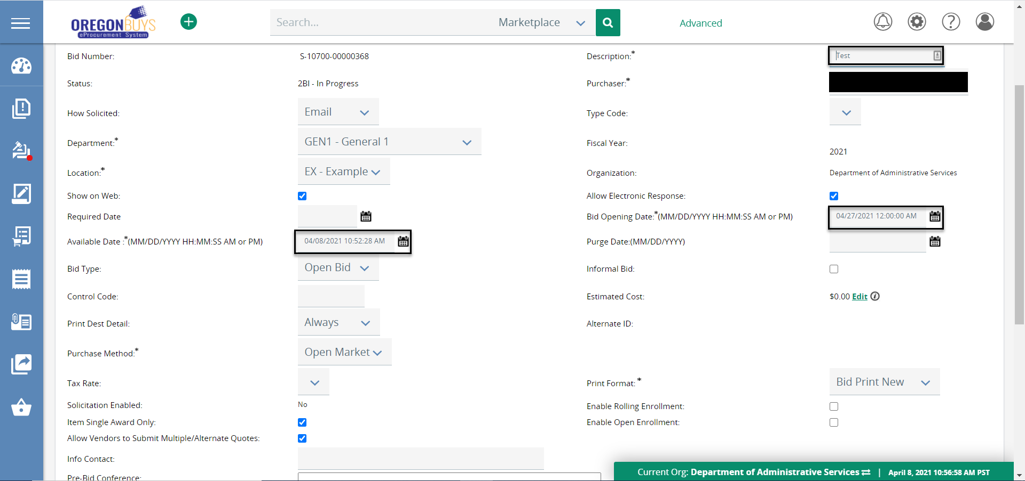

Attachments Tab
- Attachments and questions can be added or modified (e.g., responses to vendor Questions on Q&A)
