OregonBuys Credit Memo Guidance

Table of Contents

Introduction To Credit Memo 2

What is a Credit Memo? 2

Creating a Credit Memo 3

Prerequisites 3

Process 3

General Tab 4

Items Tab 9

Vendor Tab 10

Address Tab 11

Accounting Tab 13

Splitting Account Strings 14

Routing Tab 15

Attachments Tab 16

Notes Tab 17

Reminders Tab 18

Summary Tab 20

# Introduction To Credit Memo

This guidance document will help Accounts Payable (AP) users as they create Credit Memos in OregonBuys. To facilitate enhanced learning and ease of use among users, this document has been broken up into multiple sections, with each section focusing on a different action or scenario pertaining to Credit Memos. Each section reviews each tab with detailed descriptions of required fields for completion.

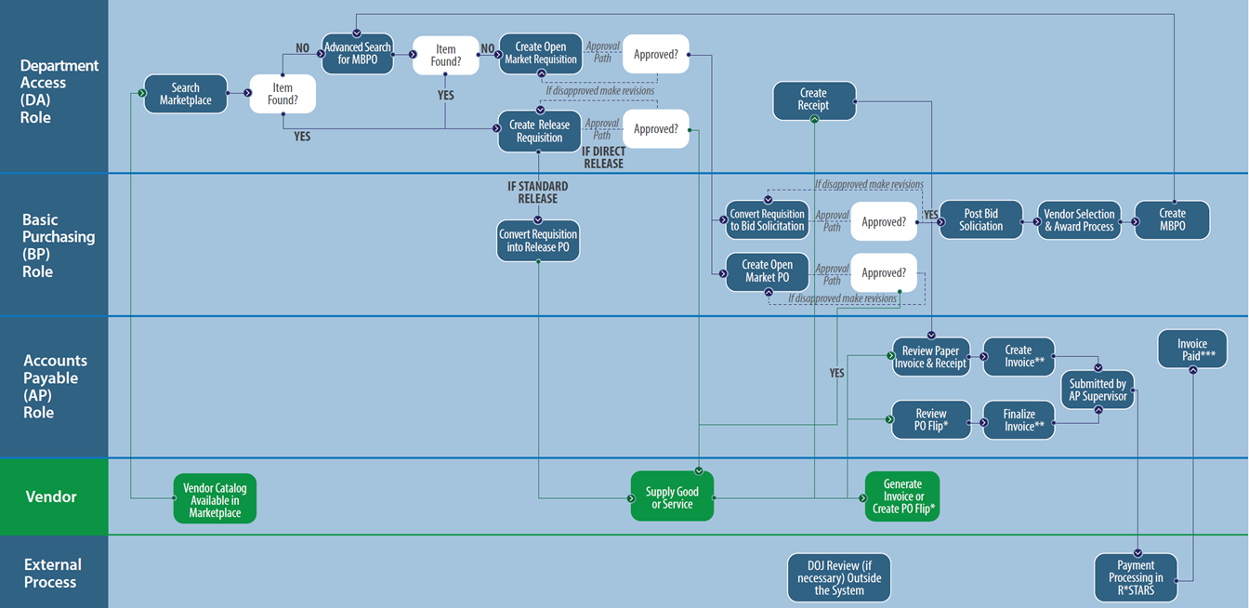Figure 1: High Level Process Flow

# What is a Credit Memo?

A Credit Memo is used when a Vendor grants an organization a credit for commodities or services. The Credit Memo document allows the Accounts Payable user to create a credit that may be applied to a future invoice from the Vendor. For example, if an organization ordered IT accessories from a Vendor and needed to return an item since the invoice was already paid, the Vendor would grant the organization a credit to apply towards a future purchase. A Credit Memo document would need to be generated in the system to be captured by a future invoice.

Once a credit memo is created, it will persist in the system until the credit memo is either canceled or fully applied.

Credit Memos that are applied to invoices for purchase orders that were released against an MBPO, (i.e., a statewide price agreement) are maintained with the agency that originated the purchase order. However, it is possible that the credit memo could be applied to any department with the agency.

If a buyer needs to apply a credit memo to an invoice on a purchase order, the buyer will need to contact an Accounts Payable user to input the credit memo details provided from the vendor into OregonBuys.

Credit memos are viewable within the Agency by Accounts Payable users, depending upon Accounts Payable Location Privileges that are set by the Organization Administrator.

# Creating a Credit Memo

## Prerequisites

Before the Accounts Payable user creates a credit memo, they will need to have the following information available:

1. The vendor’s credit memo
2. The appropriate Fiscal Year and Account Codes
3. The billing and ship to addresses
4. The Department and Location
5. A Purchase Order and Invoice from the same vendor as the Credit Memo vendor

## Process

This section includes a step-by-step process of how to create a Credit Memo in OregonBuys.

1. Beginning on the home page select the *person* icon and select ***Accounts Payable*** for the user.

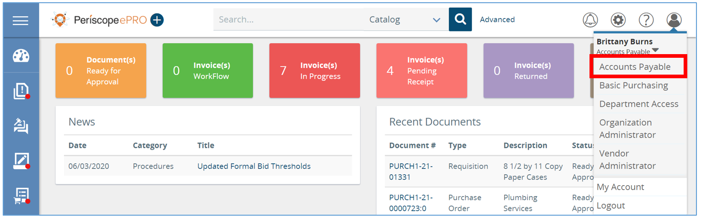

1. Next click the ***plus*** button and then select ***Credit Memo*** from the drop down.

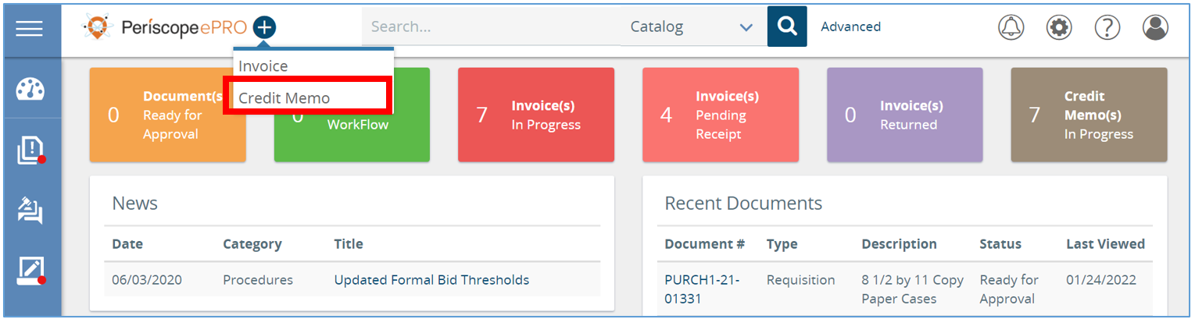

* 1. This creates a **New Credit Memo** and shows a series of tabs at the top.

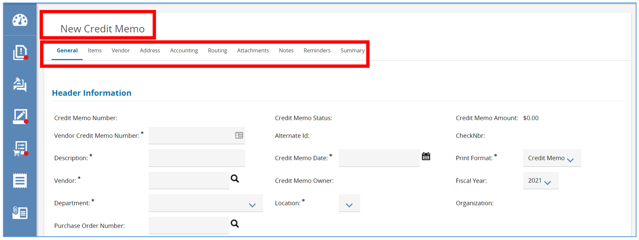

# General Tab

1. Starting on the **General** tab, start by filing out any field with an asterisk next to it. The asterisk next to a field means that field is required. This tab is used to provided general information about the Credit Memo being completed.

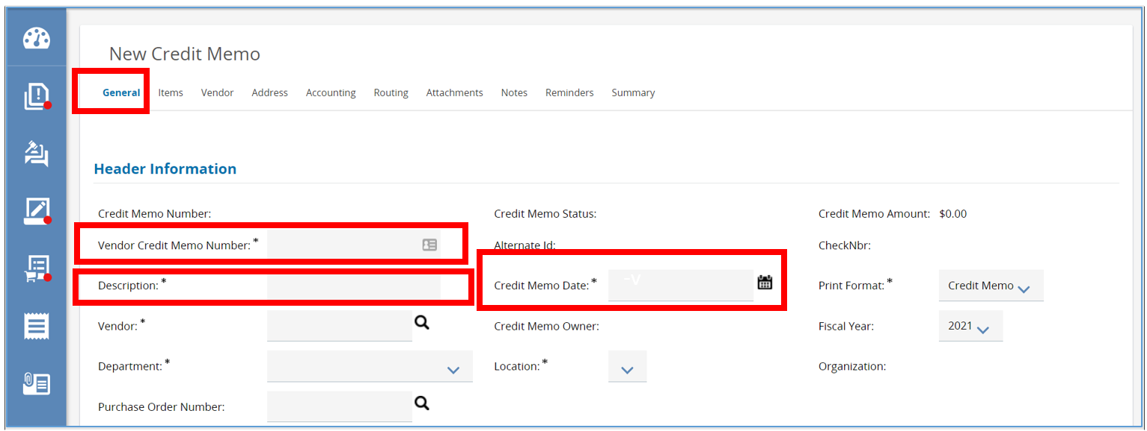

* 1. First field to enter in is the ***Vendor Credit Memo Number***.
     1. This field must be unique across all Credit Memos used for the Vendor; the system will also notify you if the number has already been used.
     2. This number is used to identify a Credit Memo.
  2. Next, complete the ***Description*** field.
     1. This field is used to specify the commodities or services that the credit is for.
     2. This field is publicly viewable, searchable, and reportable. It is recommended that this field is detailed and titled similarly to a document title.
  3. Next, complete the ***Credit Memo Date*** field.
     1. This field is the date that the Credit Memo was issued by the Vendor.
        1. Click the ***calendar*** icon, then select the **date**. Once the date is selected click ***Done*.**

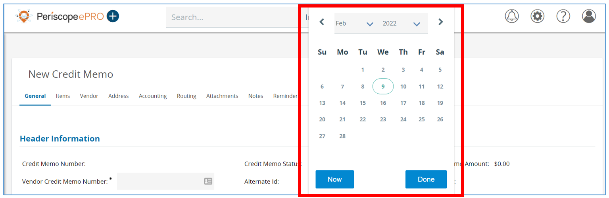

* 1. Next, input a Vendor into the ***Vendor*** field.
     1. This field is used to identify the Vendor giving out the credit.
     2. This field also contains the Vendor’s information including remit address and mailing address.
        1. To select the Vendor, click the ***magnifying glass***.

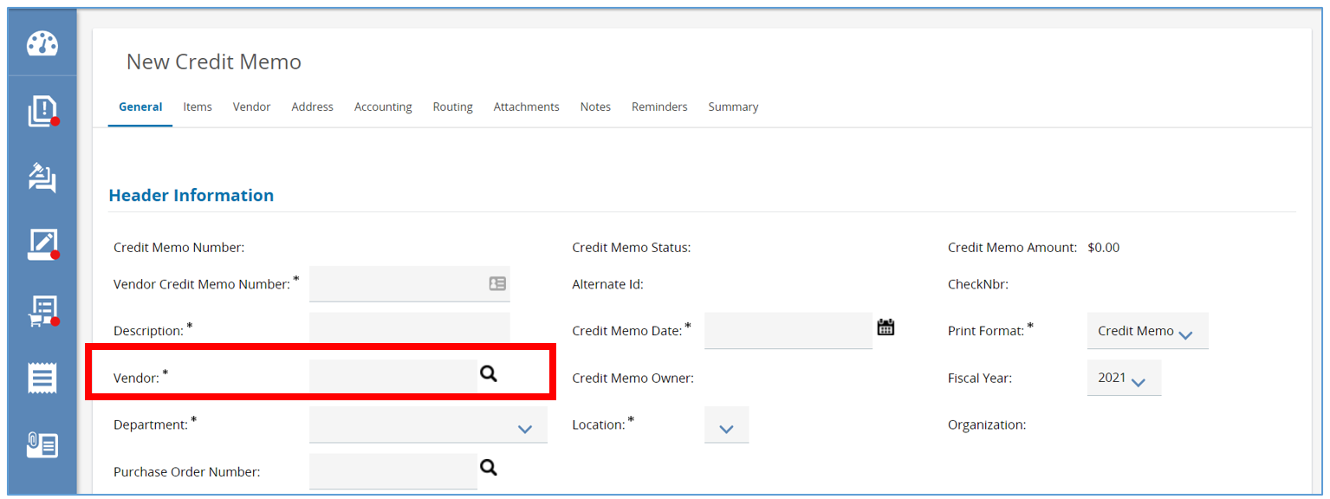

* + - 1. A pop-up window will appear where you can search for the Vendor using one of the fields provided. For example, enter in the Vendor’s name in the ***Vendor name*** field.
      2. Then click ***Find It***.

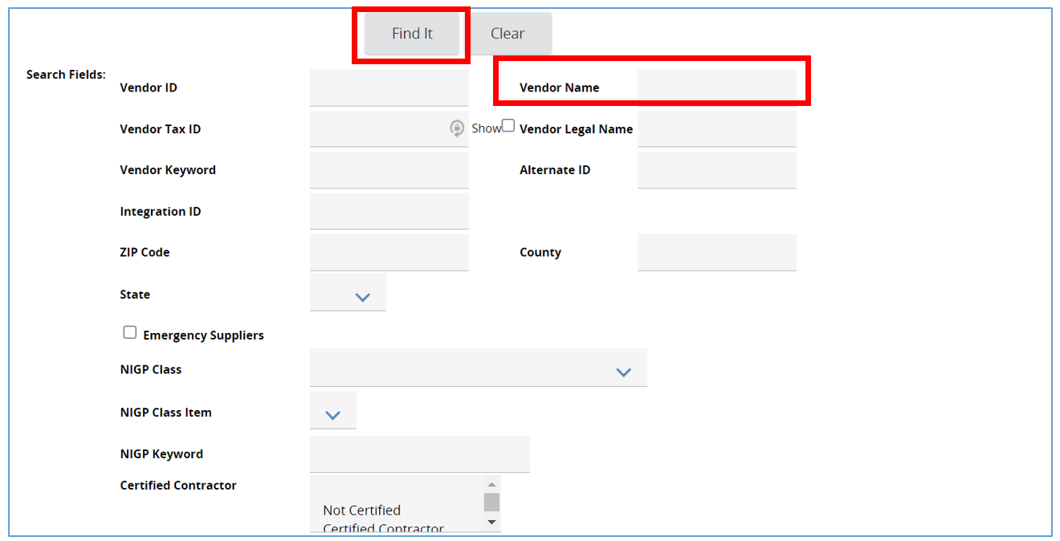

* + 1. Once the screen refreshes, the results from the search will appear.
       1. Click the radio button to select the Vendor and then click ***Add Vendor*.**
    2. The page will refresh bringing you back to the General tab, where the Vendor will now be listed.

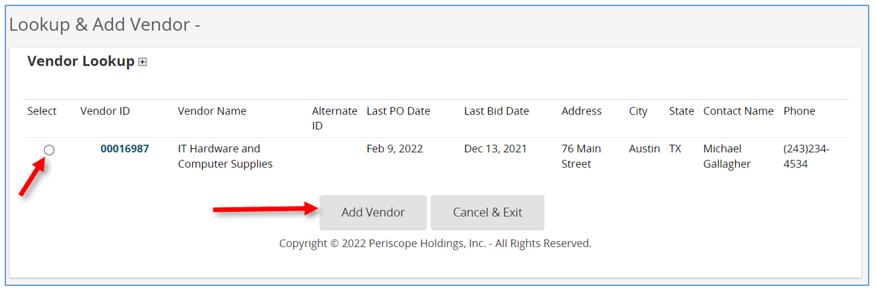

1. Next, select the ***Department*** and ***Location*** fields.
   * 1. The ***Department*** field should be populated with the department that will be using theCredit Memo*.*
     2. The ***Location*** field should be populated with the location that will be using the Credit Memo.

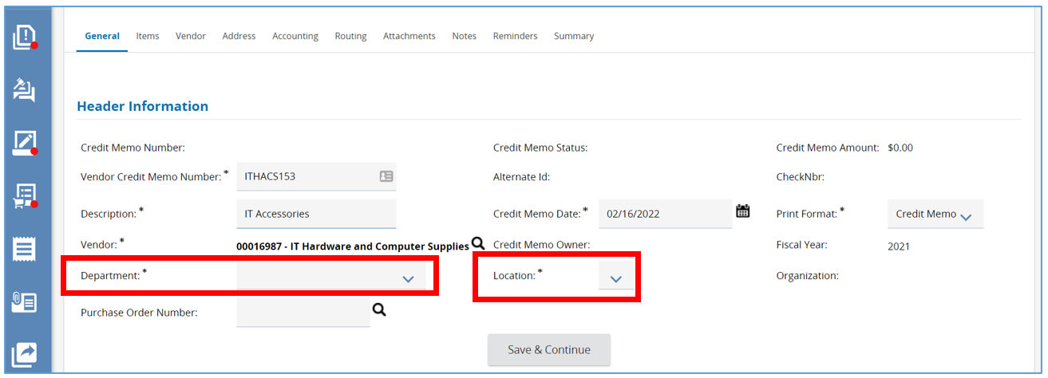

1. The ***Print Format*** can stay as is.
2. Verify the ***Fiscal Year*** Field.
3. Once the required fields are complete, click ***Save & Continue*** at the bottom of the screen.

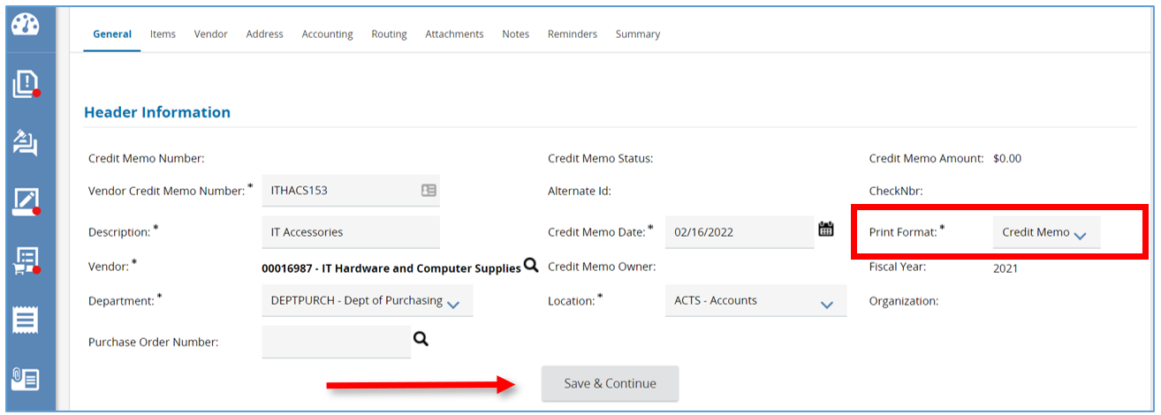

1. Once saved the system will generate a unique document number for this Credit Memo.

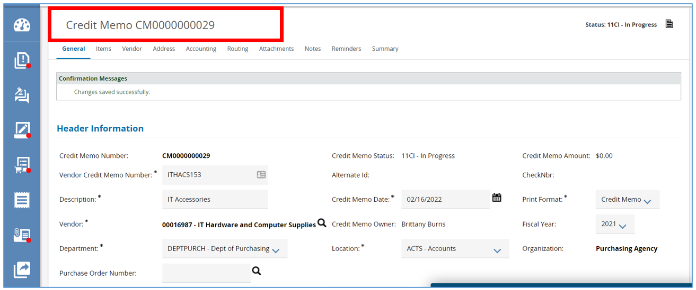

# Items Tab

1. Next, select the **Items** tab. This tab is where you can capture what commodities or services are associated with this Credit Memo.
   1. Start by clicking ***Add Item*** on the Items General subtab.

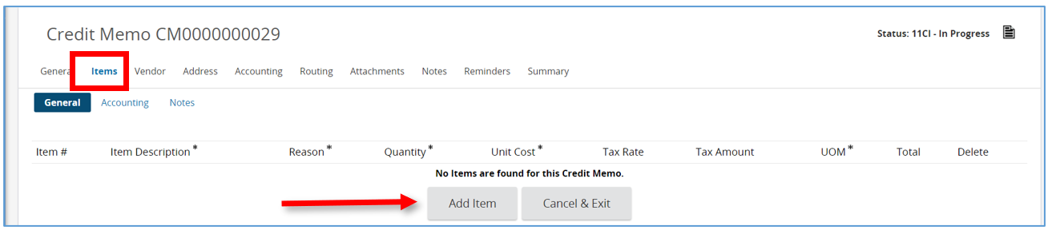

* 1. Then enter in the ***Item Description****.*
     1. It is recommended that you be as specific as possible.
  2. Next, click the drop-down arrow in the ***Reason*** field and select the reason for the Credit Memo.
  3. Next enter in the quantity amount in the ***Quantity*** field.
  4. Then fill out the ***Unit Cost*** field.
     1. The Unit Cost is the cost of the item being returned.
  5. The last required field on this screen is the ***Unit of Measure*** (UOM) field, which automatically defaults to Each (EA). To change the unit of measure, click the drop-down menu and choose the appropriate option for your Credit Memo.

1. Once you’re finished, click ***Save & Continue***.
   1. The screen will refresh back to the Items tab where a confirmation message will appear, letting you know the changes have been saved successfully.

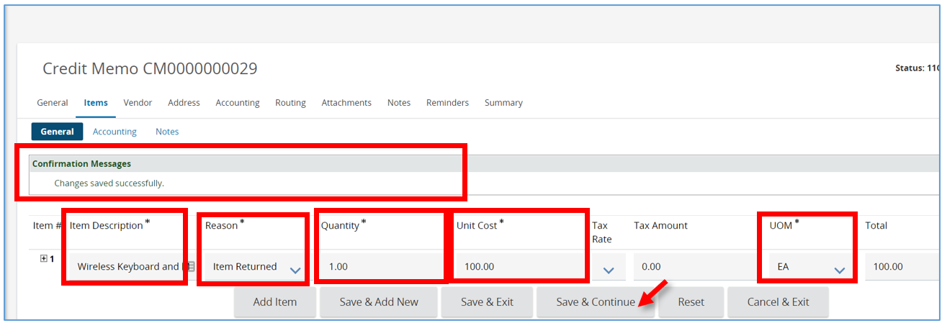

# Vendor Tab

1. Next click the ***Vendo*r** tab. This tab is where you see more detailed information related to the Vendor that was selected on the General tab.
   1. The Vendor selected will appear and here you can verify that the ***Remit-to-Address*** and ***PO Mailing Address***are correct for the Credit Memo.
   2. If necessary, you can change either field by clicking the ***drop-down arrow*** and choosing the correct address.

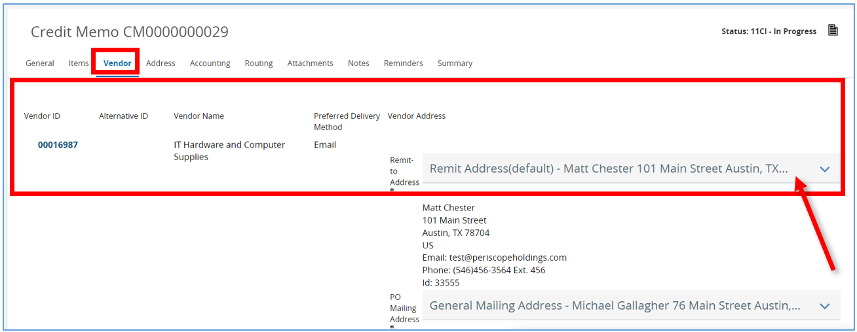

* 1. Scroll down to the bottom of the page and select the relevant ***Payment*, *Freight*, and *Shipping Terms*** as well as ***Shipping Method***. Or click ***Apply Vendor Terms to Credit Memo***.
     1. Make sure you click ***Save & Continue*** if you make any changes.

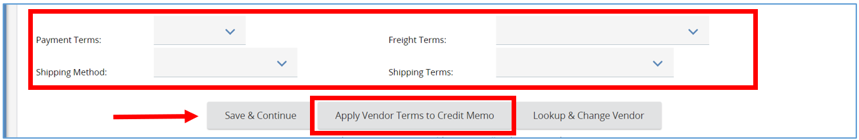

# Address Tab

1. Next, click the Address tab. This tab displays the ***Ship-to Address*** and ***Bill-to* *Address*** for your items on the Credit Memo. The options that appear here are based on your default settings.
   1. If you need to change the **Ship-to Address**, click the ***magnifying glass***.

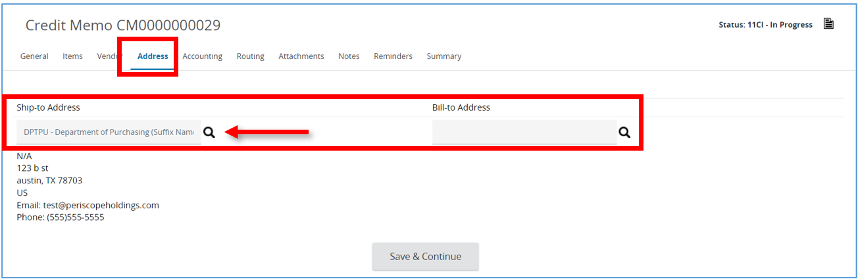

* + 1. A pop-up box will appear and here enter the search criteria into any of the provided fields.
       1. Then click ***Find it*.**

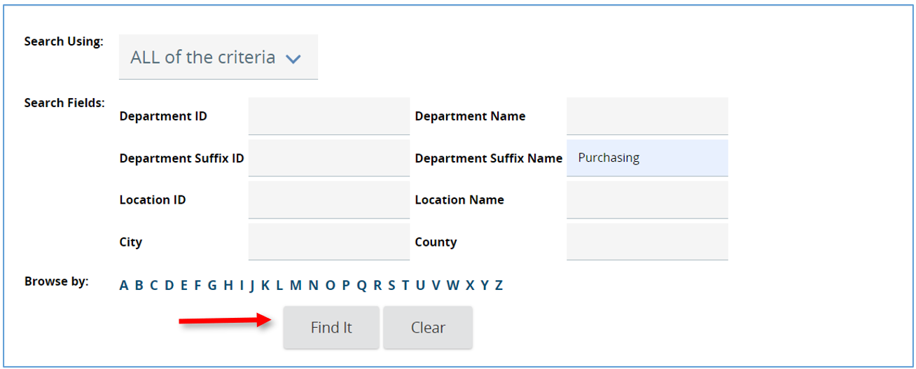

* + 1. From here select the address you want and then click ***Select*.** This will bring you back to the **Address** tab.

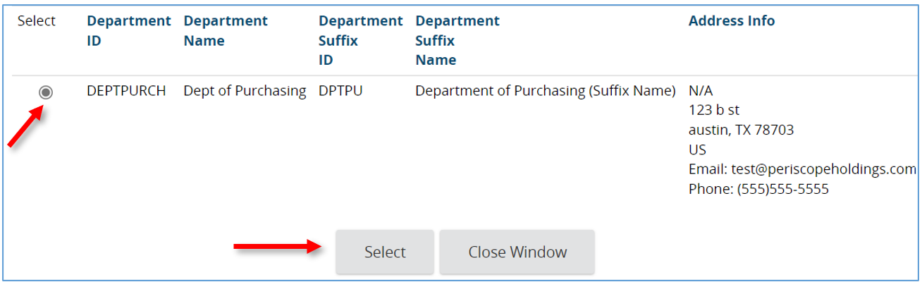

1. Click *Save & Continue* to save your address change.

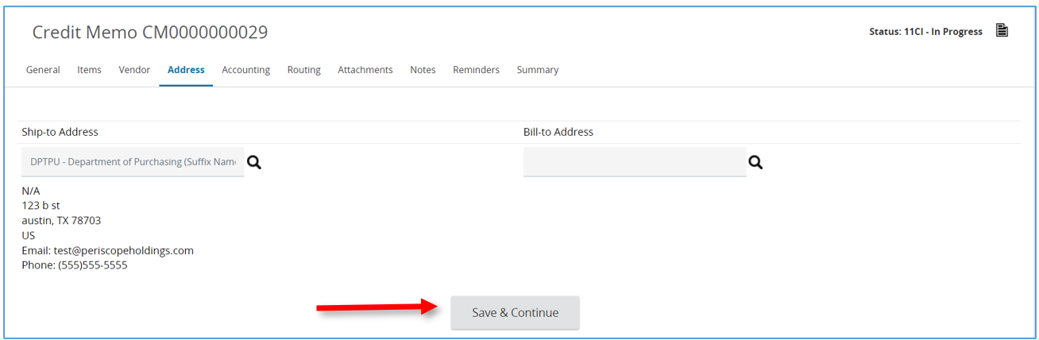

# Accounting Tab

1. Next navigate to the **Accounting** tab. This tab is used to capture the account codes applicable to all items listed on the Credit Memo and designate where the credit will be distributed for future invoices. The Accounting header can be described as a scratch pad where you define all the account strings and the dollar or percent split, so you can then apply them to every item.
   1. First enter in the account string in the ***Account Code*** field, or use the magnifying glass to lookup the account code.
      1. You can search for an entire string or search by account segment.
      2. You can also manually enter each segment or select segments.
         1. The first row entered will default to 100%, meaning that account string is allocated for 100% of the order.
   2. Next, click ***Save Based on Percentages***.
      1. This saves the account string, including the percent.
   3. Click ***Rebuild for All Items***.
      1. The account string with the percent is applied to all items entered on the Credit Memo.

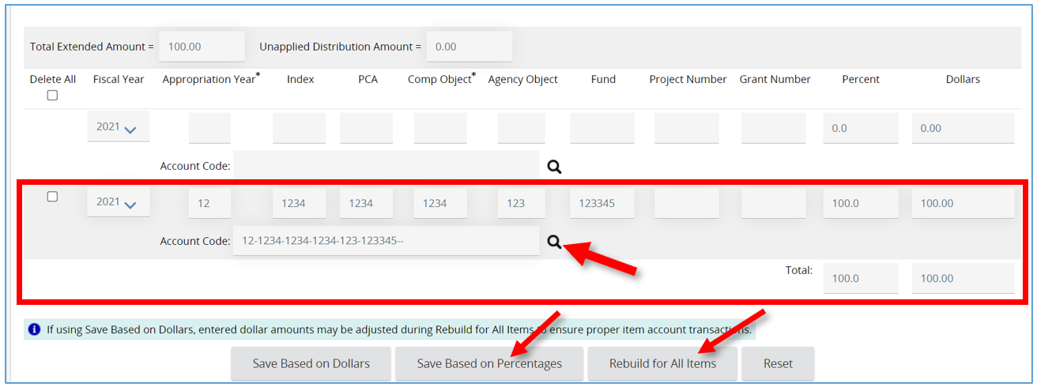

# Splitting Account Strings

1. To split account strings 50/50, enter each account string separately and then split the percentage and assign it.
   1. The ***Percent*** row defaults to 100%, so you will need to change the percentage here to 50% for each account string.
   2. Next, click ***Save Based on Percentages***, let the page refresh.
   3. Then click ***Rebuild for All Items*** to apply the account strings and percentages to every item.

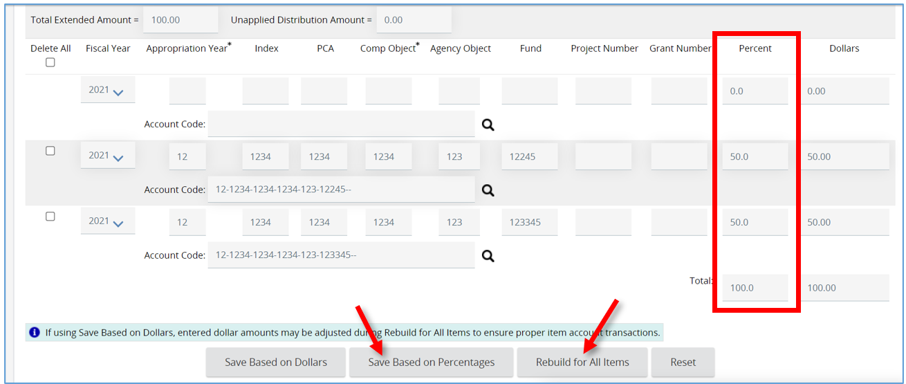

1. To split two account strings by dollars, enter the dollar amount for each account string under the ***Dollars*** column and click ***Save Based on Dollars*** instead of ***Save Based on Percentages***.
   1. Then click ***Rebuild for All Items***.

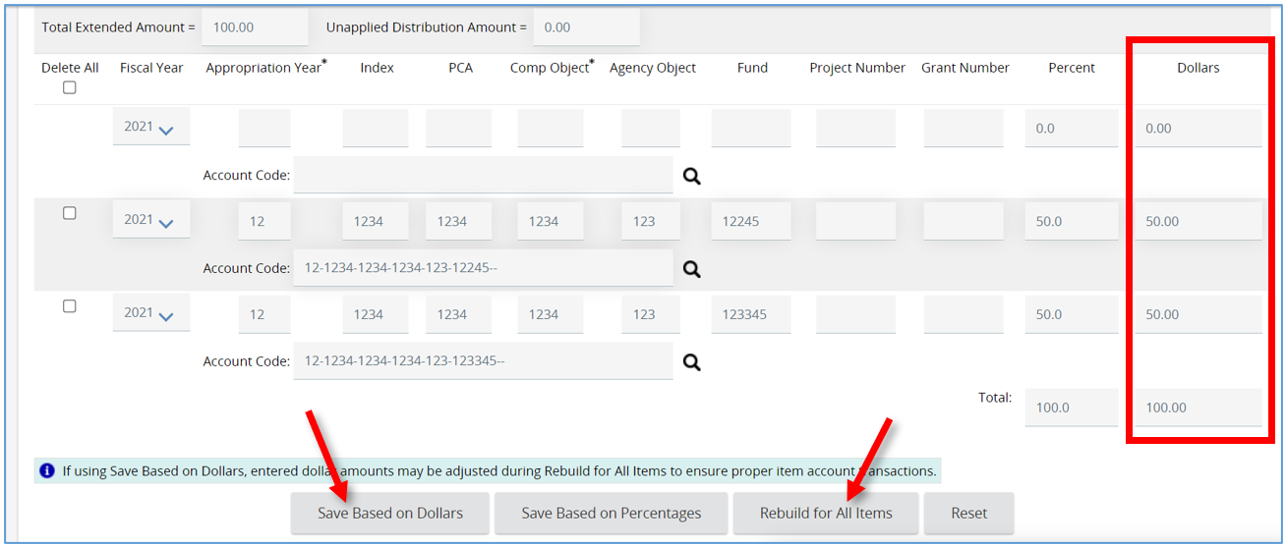

# Routing Tab

1. Next is the **Routing** tab. This tab displays the approval paths the Credit Memo triggered. This allows you to track who is in the process of reviewing and approving the document. It is also where you can refer back to who reviewed and approved the document.
   1. This tab will remain blank until an approval path is determined when the Credit Memo is submitted for approval.

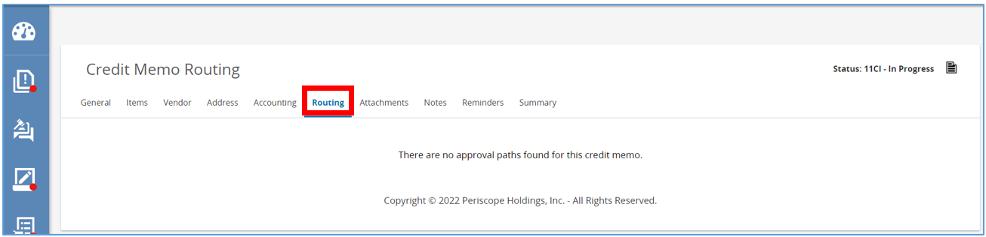

# Attachments Tab

1. Next, navigate to the **Attachments** tab. This is where you can attach any additional necessary documents that are related to the Credit Memo
   1. To add a document click ***Add File****.*
   2. Then click ***Choose File****.*
   3. Next locate and select the document from your computer and click ***Open*.**
      1. A description providing more details about the document can be added to the ***Description***field.
   4. Then click ***Save & Exit***.
      1. This will bring you back to the Attachments tab where your document shows as a hyperlink.
   5. Repeat this process to continue adding documents.
   6. When finished adding documents, click ***save and exit***.

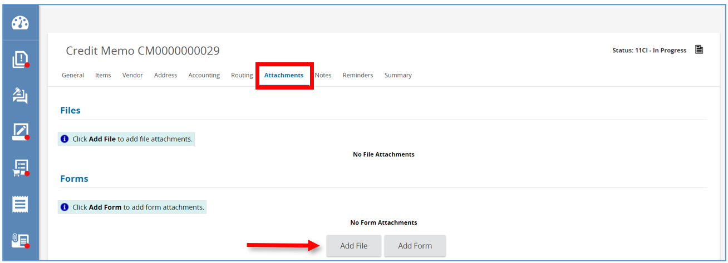

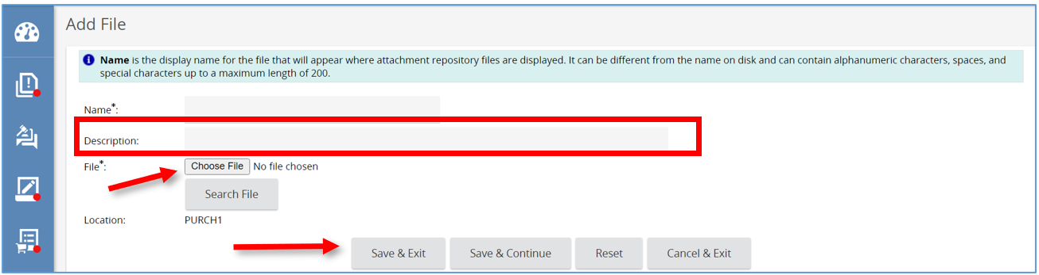

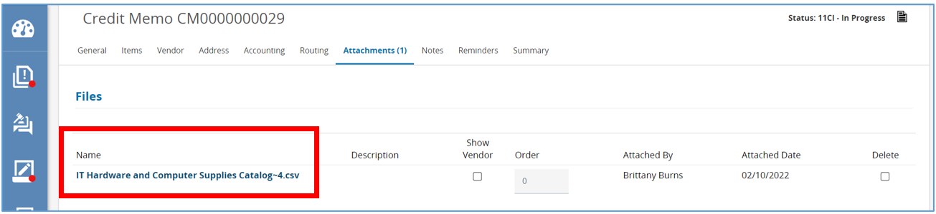

# Notes Tab

1. Next, click the **Notes** tab. This tab can be described as a digital post-it viewable by you and others in your organization.
   1. Type your note in the blank ***text*** ***field.***
   2. Then click ***Save & Continue*** when complete. Your note will be saved, and a new note field will display at the top of the notes tab.

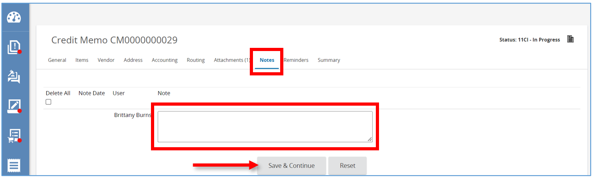

# Reminders Tab

1. Next, click on the ***Reminders*** tab. This tab is where you can send a reminder to yourself or another user within your organization about an action that needs to be taken on this Credit Memo.
   1. To create a Reminder, click the ***calendar*** icon and select a ***Due Date***.
      1. This is the date the action needs to be completed.
   2. Then click ***Done***.

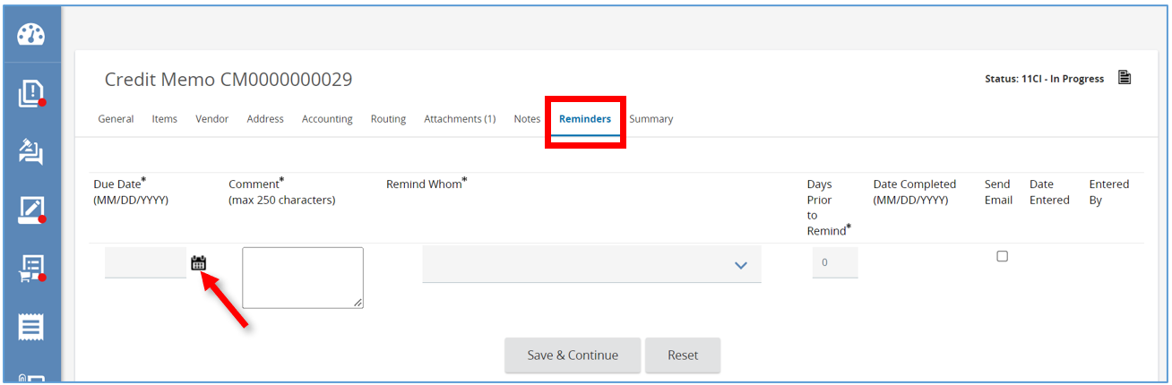

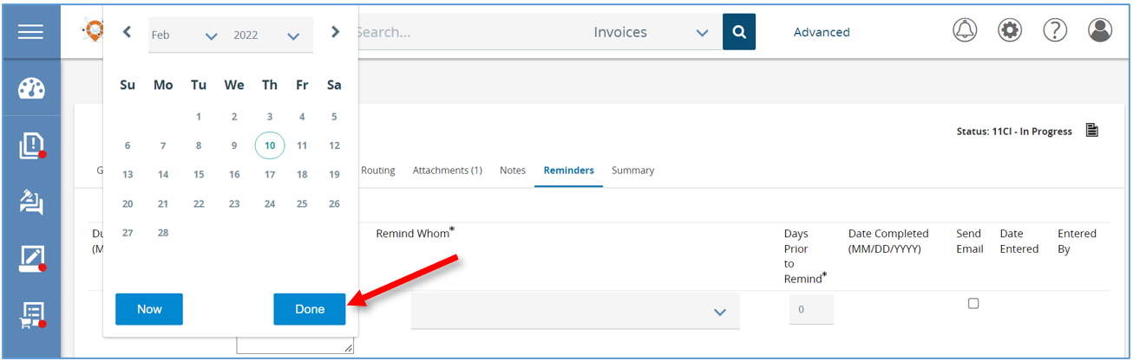

* 1. Type the Reminder in the ***Comment*** section.
  2. Select the person that needs to be reminded from the *Remind Whom* drop-down menu.

(**NOTE:** Multiple people can’t be selected for a reminder - but once Save & Continue is selected an additional reminder can be added for someone else.)

* 1. Set the ***Days Prior to Remind*** field to the day you want the person to be notified.
  2. Select the ***Send Email*** box to have the system automatically email the Reminder.
  3. Then click ***Save & Continue***.
  4. There will now be a ***Date Completed*** field that the person assigned the reminder can update when they have completed the task.

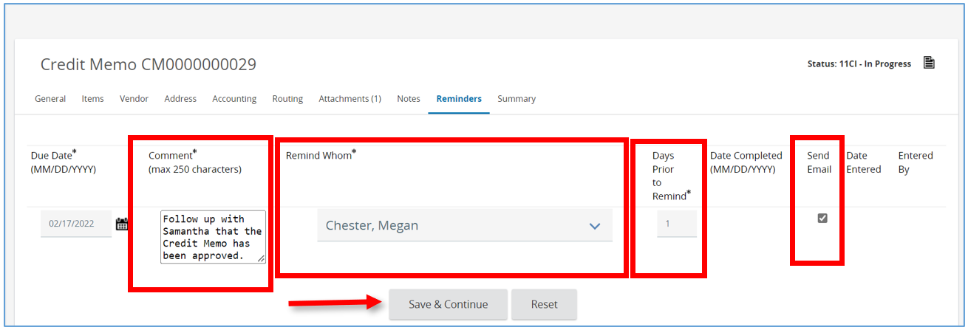

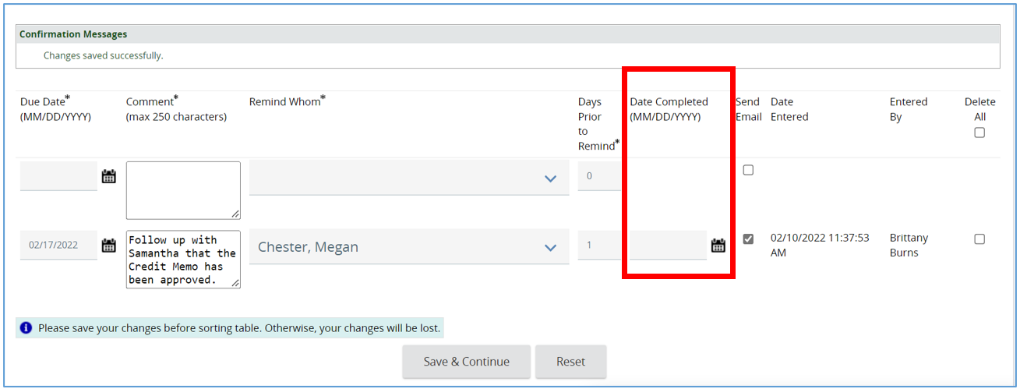

# Summary Tab

1. The last tab to complete is the Summary tab. This tab summarizes all the information from the previous tabs on one screen. This is also where you will submit the document for approval.

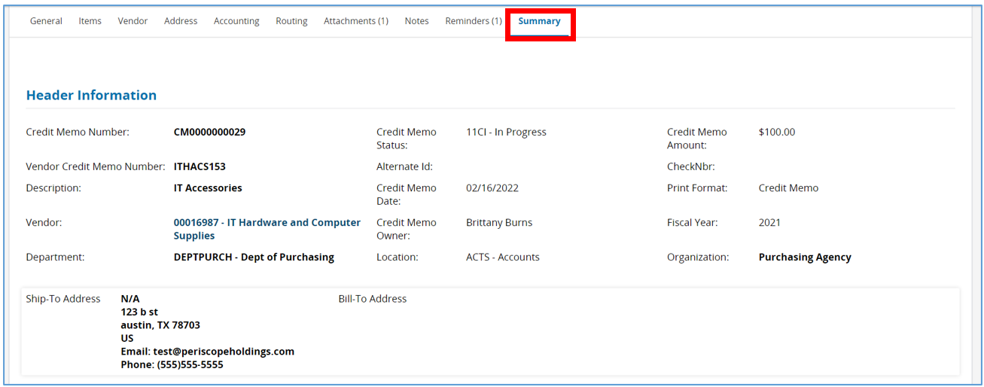

* 1. Scroll down to the bottom of the screen to see the four options you can select for the Credit Memo.
     1. The ***Submit for Approval*** button will submit the Credit Memo to the pre-determined approval paths.
     2. The ***Cancel Credit Memo*** button will cancel the Credit Memo changing the status on the Credit Memo to “Canceled”.
     3. The ***Clone Credit Memo*** button creates a second “**In Progress**” Credit Memo, copying data from this Credit Memo to the new one.
     4. The last button is to ***Print*** the Credit Memo.
  2. Once you are ready to submit the Credit Memo for approval click ***Submit for Approval***.

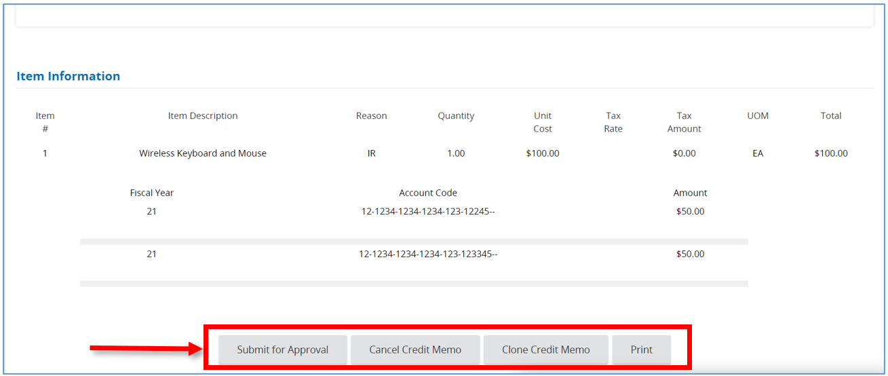

1. The next screen will now show the list of approval paths triggered. This is the last chance to review the approval paths prior to entering the approval queue.
   1. Click ***Continue*** to submit.
   2. Click ***Cancel & Exit*** to go back and make changes.

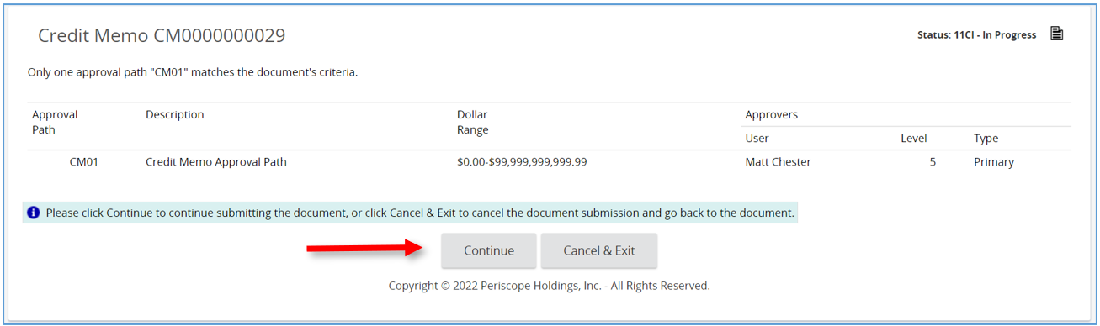

1. The Page will refresh back to the Summary tab where the status of the Credit Memo will now show “**Ready for Approval**” and you must now wait for the Credit Memo to be approved.

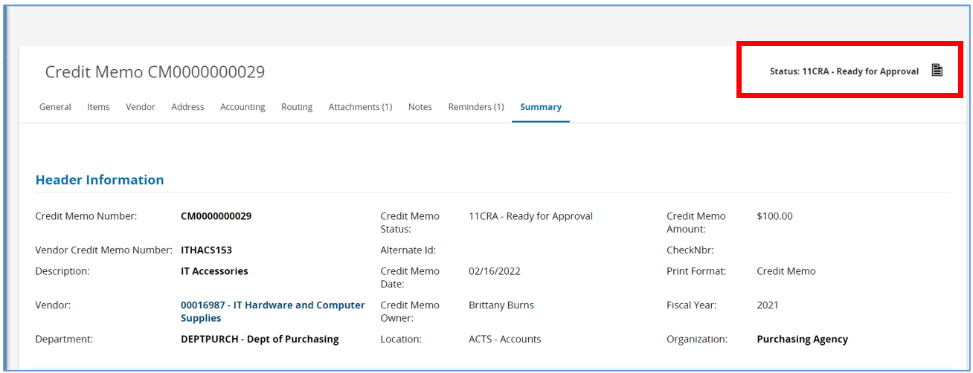

1. Once the Credit Memo is approved the status will be updated to “**Approved for Invoice**”. This means this Credit Memo is ready to be applied to an Invoice for the selected Vendor. The process is now complete.