OregonBuys Interface to R*STARS Crosswalk

R*STARS 530 Screen:
All OregonBuys batches will use Batch Type E and come into R*STARS in Edit Mode 0 with a Hold status.
Batches must be released by an R*STARS user with an appropriate user class before vendor payments will be issued.
Once the batch is released, the batch will process through the nightly R*STARS batch cycle to generate vendor payments.
- Any transactions that have errors will remain on the 530 screen the following morning with error messages. The batch will be in Edit Mode 3.
- Any transactions that have future due dates will remain on the 530 screen until the payment due date. The batch will be in Edit Mode 4.
- If the batch has both erred transactions and transactions with future due dates, the batch will be in Edit Mode 3, but only the erred transactions will display error messages.
Any error messages must be resolved in R*STARS and the batch re-released to generate payments.

R*STARS fields received from OregonBuys:
# | R*STARS Field Name | OregonBuys Source
1 | Doc Date | from OregonBuys processed date
2 | Eff Date | from OregonBuys effective date
3 | Due Date | from OregonBuys payment date
4 | Serv Date | from OregonBuys service date
5 | Cur Doc/Sfx | as assigned by OregonBuys - will begin with VU
6 | Ref Doc/Sfx | From OregonBuys PO Alt ID number (not editable by users)
7 | Trans Code | currently 222 is the only Trans Code received from OregonBuys
8 | Index | from Index selected by user in OregonBuys
9 | PCA | from PCA selected by user in OregonBuys
10 | AY | from OregonBuys fiscal year
11 | Comp/Agy Obj | from Comp and/or Agy Object selected by user in OregonBuys
12 | Amount | from OregonBuys transaction amount
13 | Rvs | typically will be blank, but will be an ‘R’ for OregonBuys credit memos
14 | Inv # | from OregonBuys invoice number
15 | DT | from OregonBuys invoice date
16 | Description | from OregonBuys invoice description
17 | Vendor/MC | from vendor remit selected by user in OregonBuys
18 | R*STARS Contract Number | from R*STARS contract number selected by user in OregonBuys
19 | Grant Number/Phase | from Grant Number & Phase selected by user in OregonBuys
20 | Subgrantee | from Subgrantee selected by user in OregonBuys
21 | Project Number/Phase | from Project Number & Phase selected by user in OregonBuys
22 | MPCD | from OregonBuys Multipurpose

OregonBuys Invoice “General” tab:
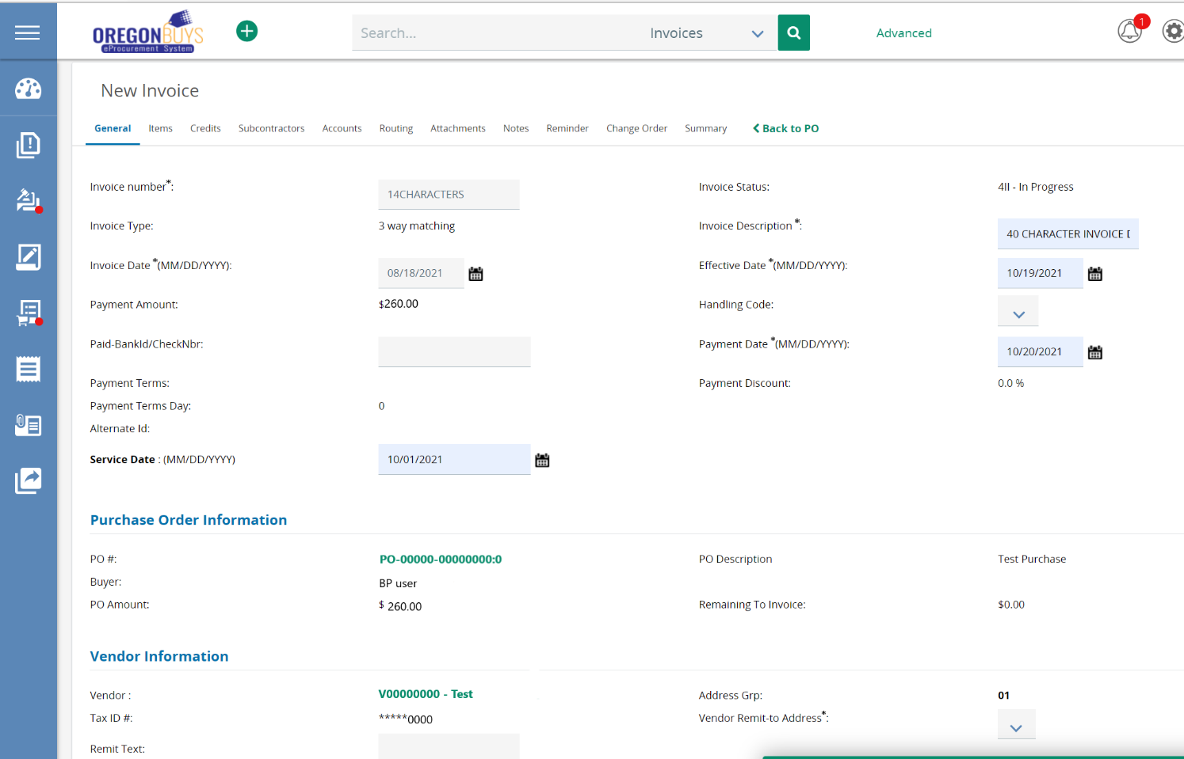
Note – the account code segments are entered on the Purchase Order document
R*STARS 505 Screen:

