OregonBuys Agency Admin II: Internal Catalog Guidance

Table of Contents
Introduction 2
Scenario 2
Prerequisites 2
Catalog Manager 2
Step 1: Creating a Catalog 3
Step 2: Create or Manage a Product/Services Lists 9
Upload and Map a Product or Service List 12
Step 3: Activating and Sharing the Supplier’s Catalog 16

Introduction
This guidance document will cover how a Department Access (DA) or Basic Purchasing (BP) user with Catalog Manager privilege would upload a Product and/or Service List on behalf of a Supplier. A Catalog is a list of Products or Services offered by a Supplier and is then shown in Marketplace.

Scenario
The Catalog Manager is working with a supplier and has been provided a catalog to load on behalf of the supplier.

Prerequisites
- Catalog Manager user role is assigned to your user
- A Product or Service list is available for use

Catalog Manager
- Starting from the Home page, click the gear icon, and select Catalog Manager from the drop-down menu.
  - The page will redirect to the Catalog Library in Catalog Manager.
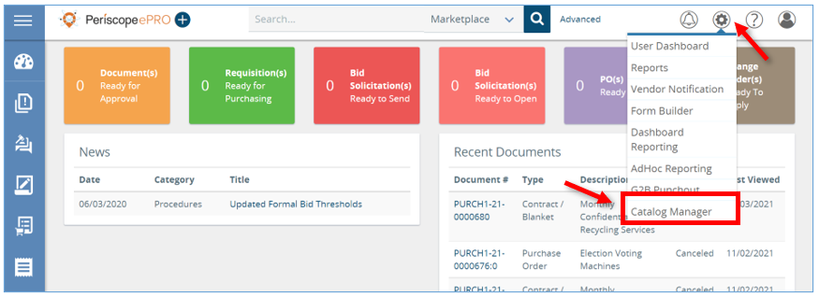
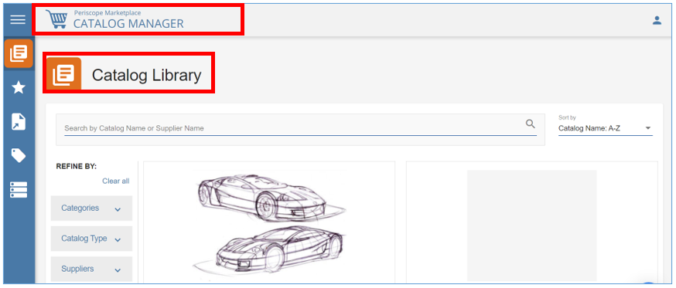

- Next, hover the mouse over the left navigation bar and click Internal Catalogs.
  - Here all the Internal Catalogs that an organization has already created will show.
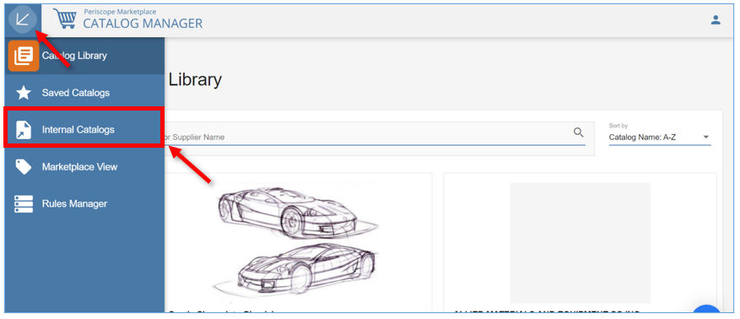

Step 1: Creating a Catalog
- To begin, click Create Catalog.
  - The Active and Purchasable toggle buttons will be discussed on page 16 of guidance document.
  - The government icon or identifies a Statewide Price Agreement.
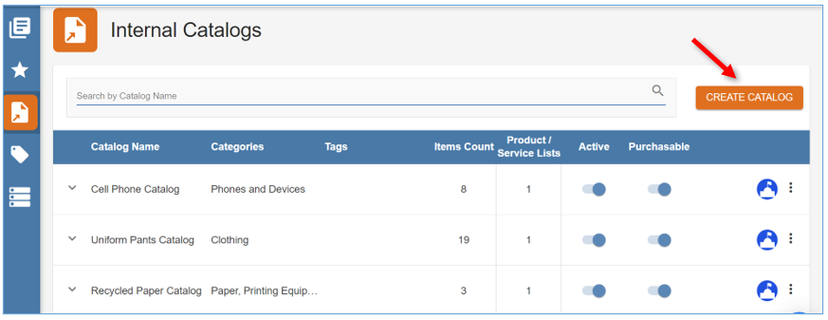

- The page will redirect and at the top there will be three steps that will help track the process of creating a Catalog.
  - Anytime you see the Instructions icon, you can hover your mouse over it to get a detailed description and to read more about best practices.
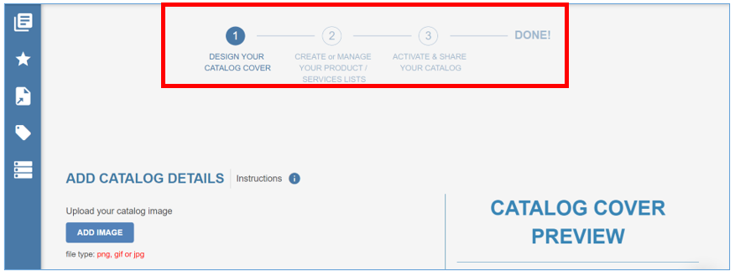
- Step 1 starts with designing the Catalog Cover. Since organizations will not actually see the title view, adding an image can be skipped.
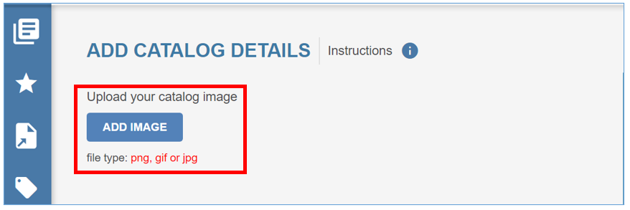
- The first required field is Supplier ID. This is the Supplier’s ID within the system.
  - It is important to make sure the correct ID is entered because this is what drives which contracts will appear in Contract Link Manager when linking products to contract items.
- The second required field is Supplier Name. Enter the Supplier’s name in this field.
- The third required field is Catalog Name. This field acts as a filter for shoppers in Marketplace, so be sure to choose a name that makes sense in that context.
- Check this box if the Catalog is a punch-out. This will allow shoppers in Marketplace to punch-out to the Supplier’s G2B website.
- A description of the Catalog can be provided in the Catalog Description box. Anything typed here will display whenever someone hovers the mouse over the tooltip icon.
NOTE: Users can perform a search by using Catalog Name or Supplier Name.
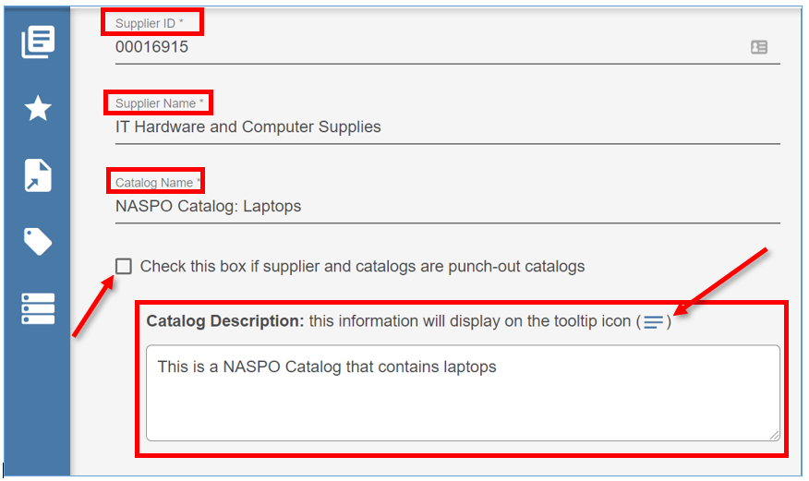

- The fourth field that is required is Categories. Categories can be searched by entering criteria into the search box. Once entered, hit the enter key on the keyboard.
  - Choose at least one option that represents the products or services on the Catalog.
  - This also affects how products are filtered for shoppers in Marketplace.
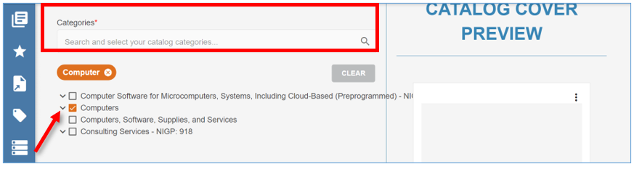
- The fifth required field is Catalog Type. Click the field and select the appropriate option from the drop-down menu.
  - The Catalog could be just Products (i.e. pencils), or just Services (i.e. janitorial services)or a combination of both.
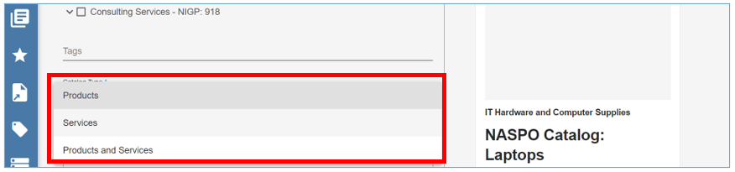
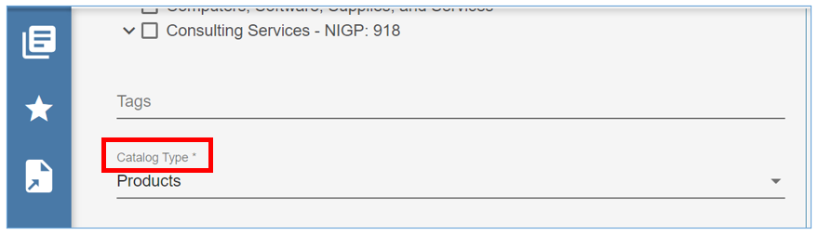

- The last required field is Start Date. The date chosen will be when the shoppers can begin searching for the products in Marketplace.
  - The Expiration Date which is optional can also be entered in this section.
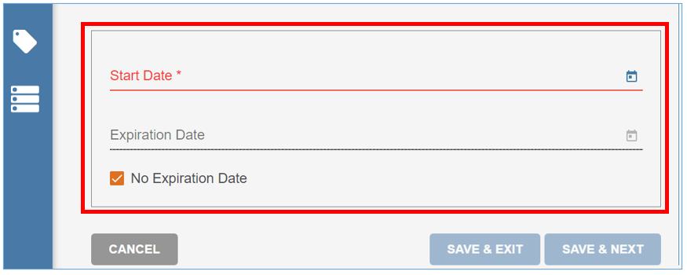
- If you plan to link the Catalog to a Master Blanket Purchase Order, you need to use the Contract Begin Date and End Date from the Master Blanket Purchase Order for the Start Date and Expiration Date on the Catalog.
  - Before navigating to the Master Blanket Purchase Order select Save & Exit or Save & Next to save information that has already been entered.
  - In the Master Blanket Purchase Order, click the Control tab. This is where the Contract Begin Date and Contract End Date will be located.
  - These are the exact dates that need to be selected for the Start Date and Expiration Date fields on the Catalog.
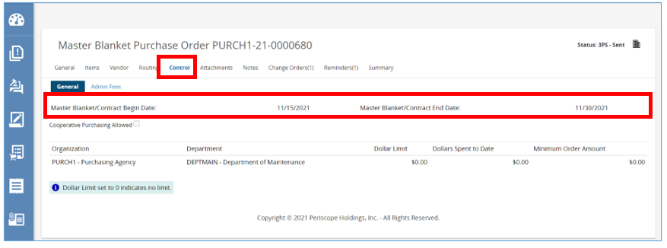

  - Go back to the Catalog and click the Calendar icon and select the correct Start Date from the Master Blanket Purchase Order.
  - Next, uncheck the No Expiration Date box and then click the Calendar icon and choose the End Date from the Master Blanket Purchase Order.
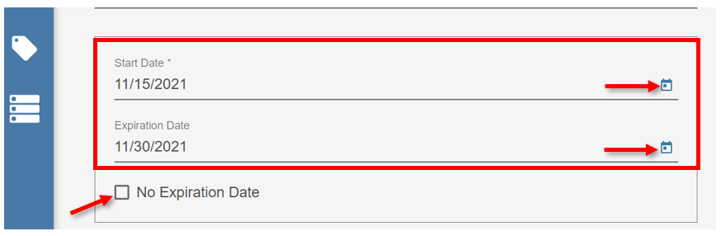
- To come back and continue working on this Catalog later click Save & Exit. This will save the Catalog Cover and redirects back to the Internal Catalogs tab.
- To move on to Step 2 click Save & Next. This saves the Catalog Cover and redirects to the next screen where the Product List can be uploaded.
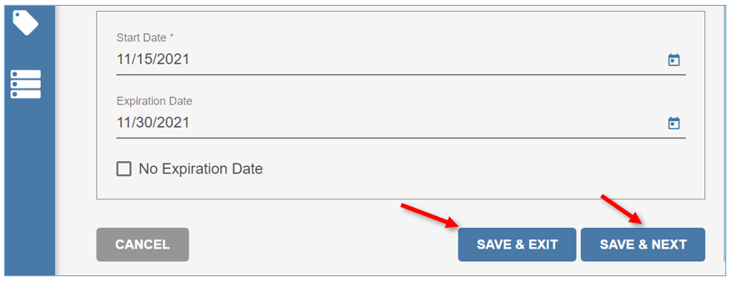

Step 2: Create or Manage a Product/Services Lists
The top of the page should now show Step 2, Create or Manage Your Product/Services.
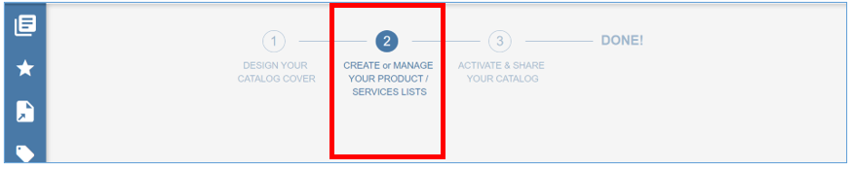
- To start, click Create List.
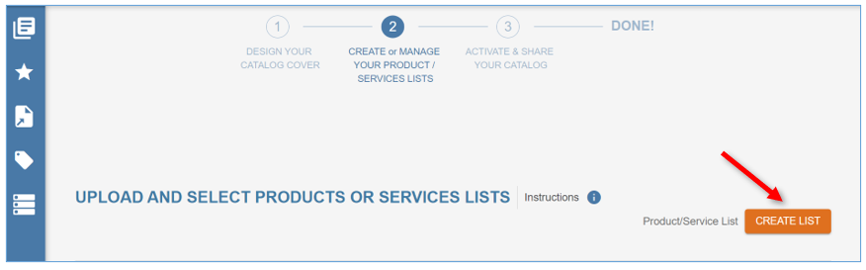
- Next, enter the Name of the list.
  - It is recommended to use the Vendor’s name, followed by a general description of the products or services.
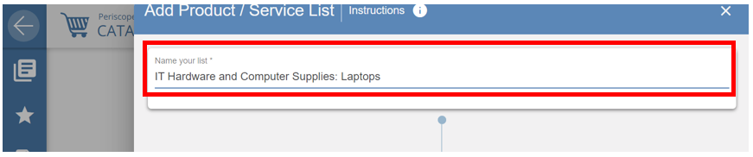
- After entering in the name of the list there will be another flowchart to help with the next section.
- Step 1: If there isn’t a Product/Service List file, download a template by clicking the CSV template link. The template shows below.
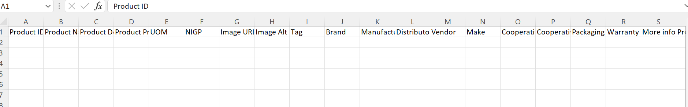

  - There are six required fields in a template:
    - Product/Service Unique Number: This field is the unique identifier of each product. This field only accepts alphanumeric characters.
    - Product/Service Name: This field is the primary name of the product or service and is the first field that displays to shoppers. This field has a 500-character limit.
    - Product/Service Description: This field is where any additional information about the product or service is entered. It is recommended to be as detailed as possible and there is a 4000-character limit.
    - Product/Service Price: This field is the cost of the product or service based on the Catalog. If a product is linked to a contract item on a Master Blanket, the on-contract price of the item overrules the price of the product in the Catalog and displays to the shopper in Marketplace. For this field use only numbers, decimals, and dollar signs or format the column to General.
    - SKU field or UPC field: These fields are used to efficiently match and link products with contract items on a Master Blanket Purchase Order.
    - UOM (Unit of Measure): This field is the measurement of the quantity in which the product or service is sold. An approved abbreviation for this column must be used.

  - Make sure to complete any additional fields that apply to the products.

- Once all the required fields and any additional fields are complete delete all the unused columns in the template and save the template to the computer using the .CSV format and appropriate file name.

- Step 2: This step is to make any necessary changes in the template or list.
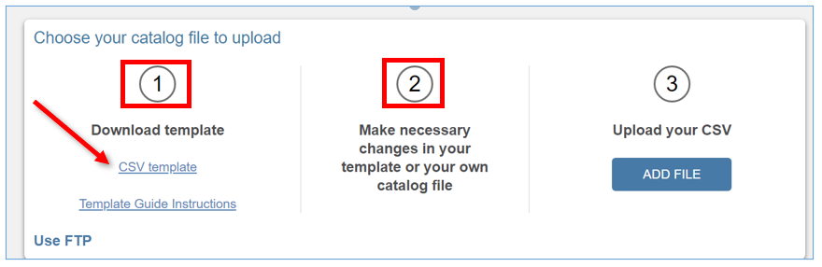

  - The Template Guide Instructions link provides instructions for how to read and use the template provided.
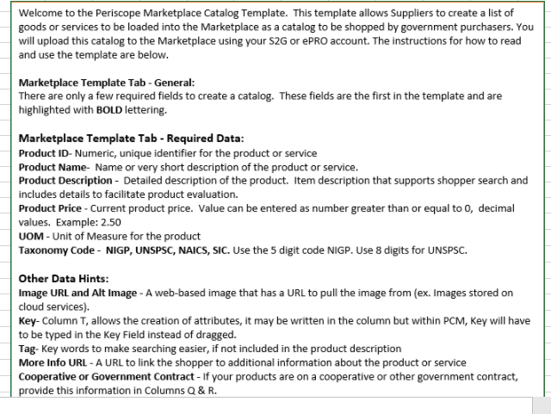

Upload and Map a Product or Service List
- Step 3: Once the Product or Service List is complete and saved to the computer, upload the list by clicking Add File.
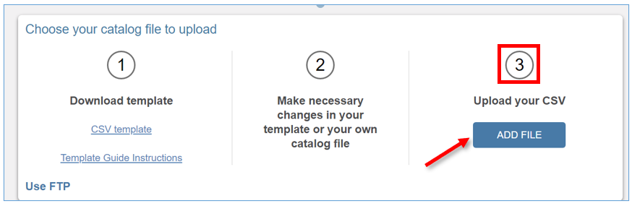
- Locate and select the file, then click Open.
- The screen will refresh and there will be a message indicating the file was uploaded successfully.
- Then click Next.
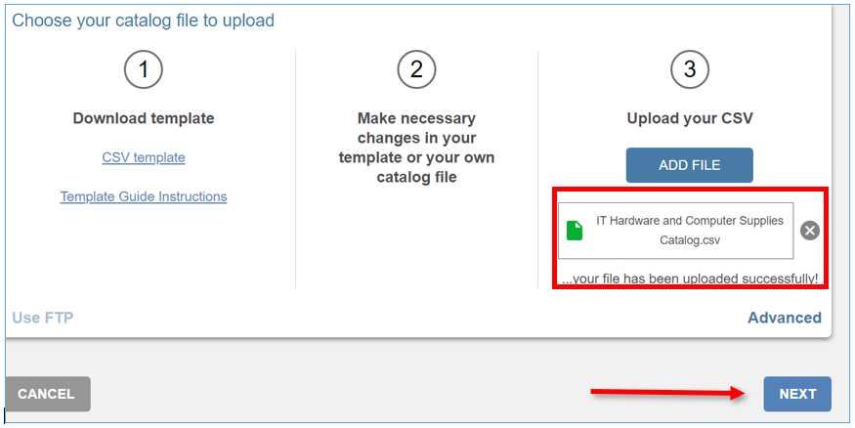

- The page will redirect to the mapping screen where each column on the Product List can be mapped to the correct field in Marketplace.
  - The page will be divided into two sections:
    - On the left there will be the fields available in Marketplace.
    - The right side of the screen will show the Product file that was uploaded.
  - There is also a key at the top of the screen:
    - Fields with a green square are used for searching by shoppers.
    - Fields with a purple square are used for filtering by shoppers.
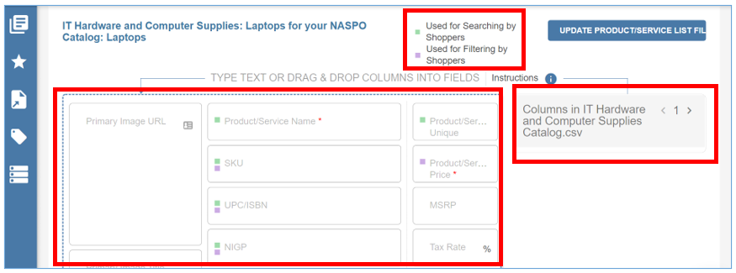
- To map the fields, drag and drop each .csv column to the corresponding Marketplace field.
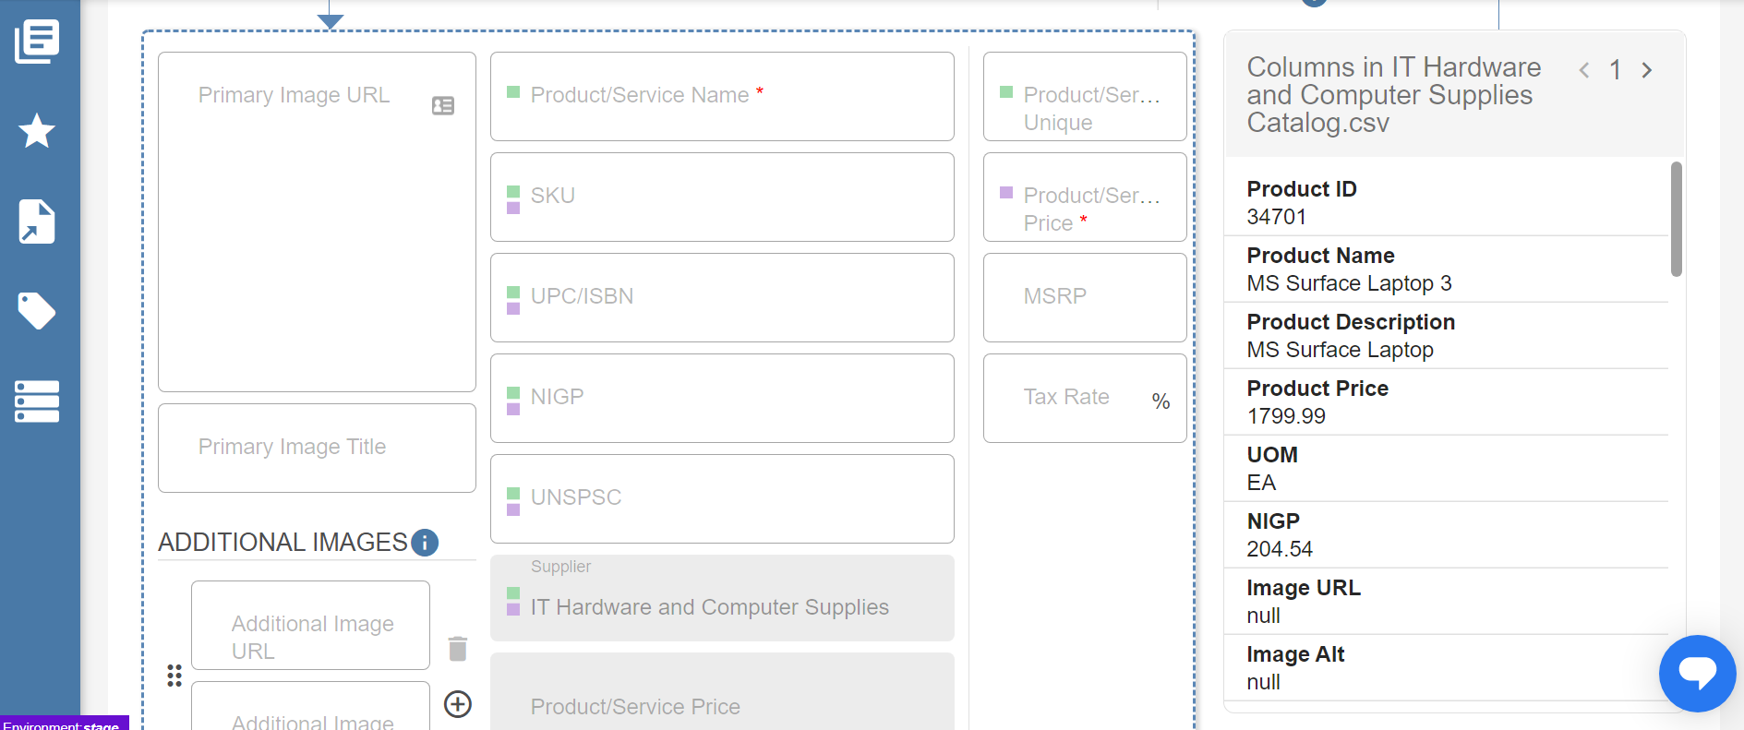

  - If there is a mistake to where the column is in the wrong field, click the X button to delete the mapping.
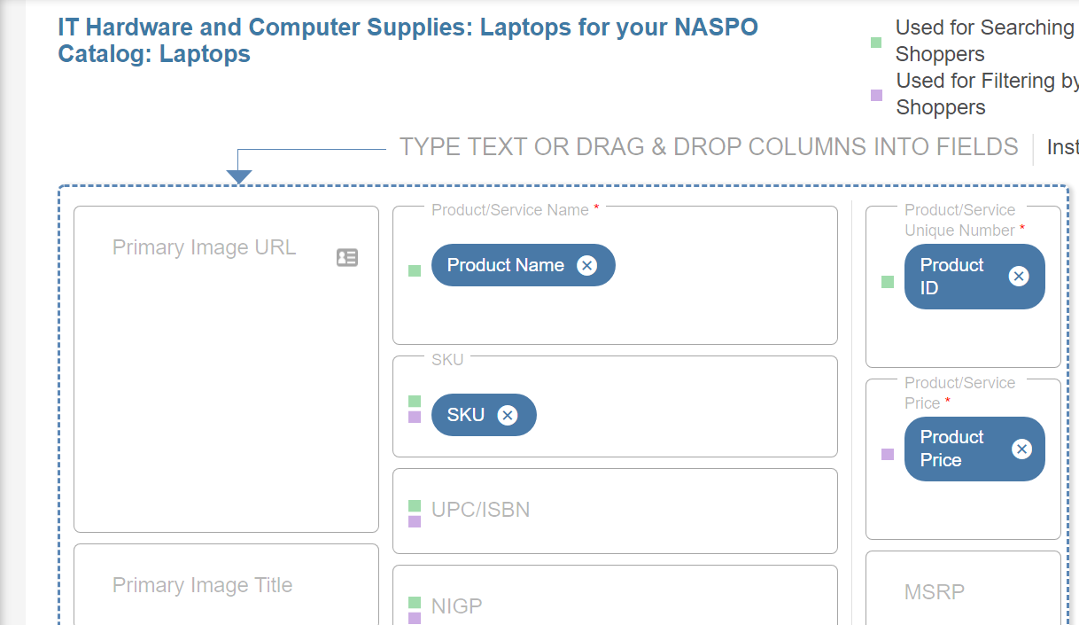
- The Product/Service Description field is the only field that allows for some HTML.
- When mapping is complete, there is an option to preview the work completed so far. Just click Preview at the bottom of the screen.
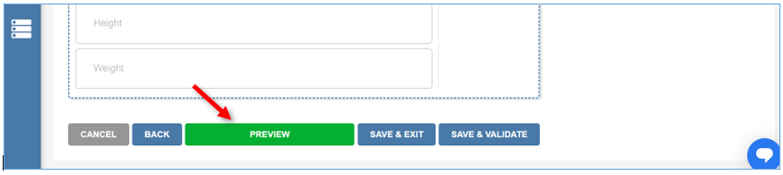
- The Buyer’s Detail Preview screen will appear.
- To preview more items, click the arrow.
- When complete, scroll to the bottom of the screen and click Close.
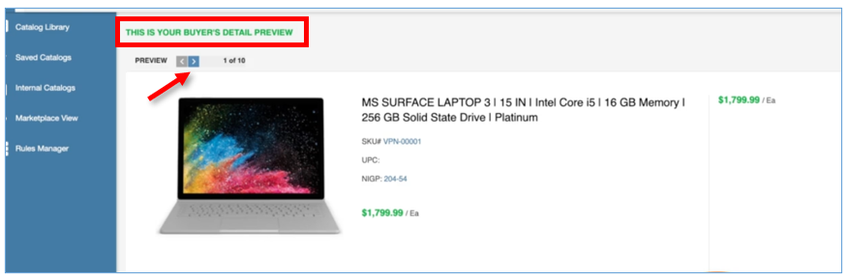
- To come back and continue working on mapping later, scroll down to the bottom of the screen and click Save & Exit. This saves the fields mapped and redirects back to the Internal Catalogs tab.
- Once you are back on the Internal Catalogs screen you can locate the Catalog you were working on from that screen and select the ellipsis button to see editing options.
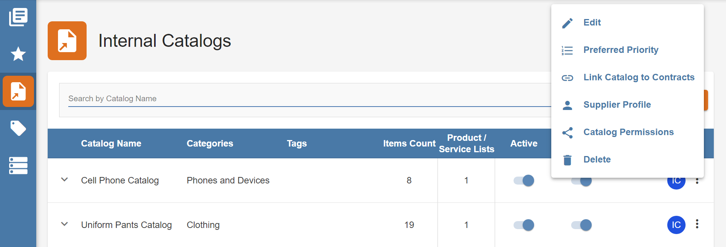
- If complete and ready to move on click Save & Validate. This saves and validates the fields mapped.
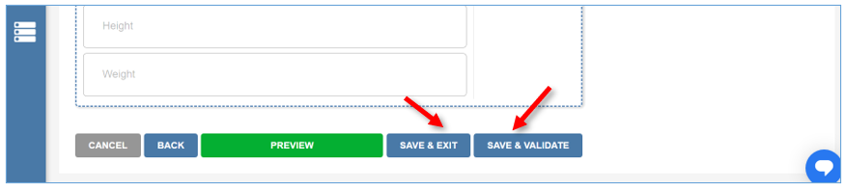
- As the Product/Service List is being validated, the progress will show here. From here click Close.
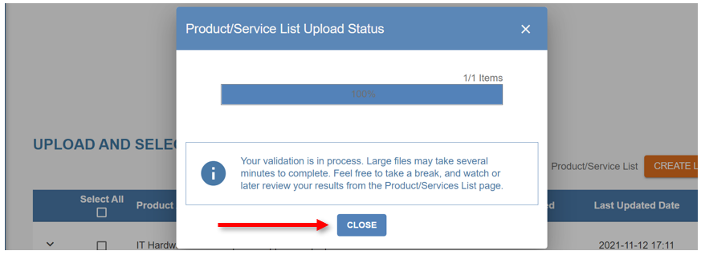
- The next screen will show the number of Products and/or Services on the list that are uploaded and validated.
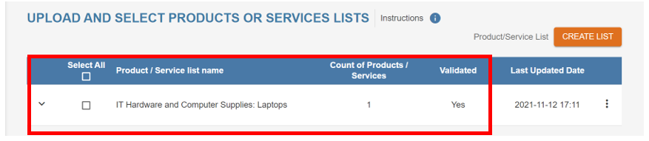

Step 3: Activating and Sharing the Supplier’s Catalog
Once the Product List has been uploaded and mapped, the next step is to activate and share it with shoppers.
If the Catalog is being linked to a Master Blanket Purchase Order, it is recommended to do the linking before the Catalog is activated and shared. This ensures anyone shopping the Catalog will be able to order the products at the negotiated price.
- To prepare the Product/Service List for linking, click the box to select the list and click Save & Exit.
  - The page will redirect back to the Internal Catalogs screen.
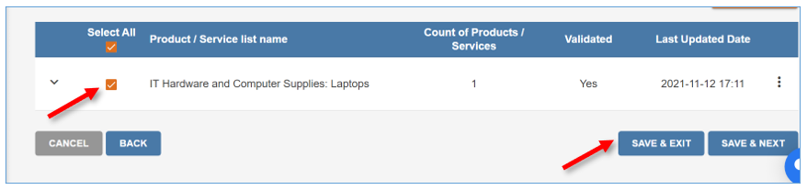
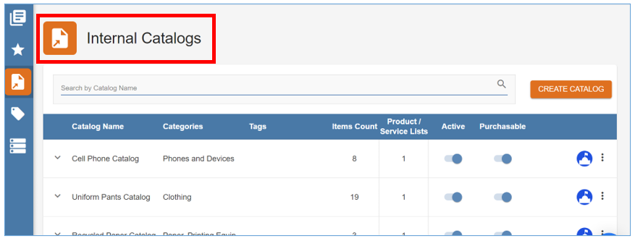
- Once Catalog is linked the next step is to activate it.
- On the Internal Catalog screen, locate the Catalog.
- To activate it, so the products are searchable in Marketplace toggle on the radio button under the Active column.
- To allow shoppers to place products into their shopping cart and on a Requisition, the radio button under the Purchasable column must be toggled on too.
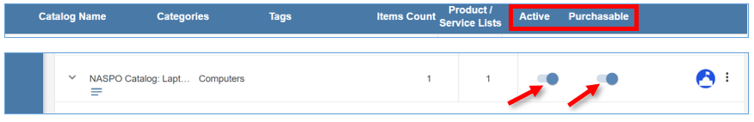
This will complete the process and shoppers within the organization can now search for products on the Catalog in Marketplace and request orders in the system.

