OregonBuys Invoices Guidance

Table of Contents

Introduction 3

High Level Process Flow 3

Prerequisites 3

Scenario 3

1. General 3

2. Items 3

3. Credits 4

4. Accounts 4

5. Routing 4

6. Attachments 4

7. Notes 4

8. Change Order 4

9. Summary 4

Creating an Invoice 5

General Tab 7

Items Tab 9

Credits Tab 10

Subcontractors, Accounts, and Routing Tabs 10

Attachments Tab 11

Notes Tab 11

Reminder Tab 13

Change Orders Tab 15

Summary Tab 15

Creating an Invoice for a Partial Receipt 18

General Tab 20

Items Tab 22

Summary Tab 23

Creating an Invoice with a Change Order 26

General Tab 28

Items Tab 30

Change Order Tab 31

Paying Invoice in Biennium Following Purchase Order 35

General Tab 37

Items Tab 39

Summary Tab 40

# Introduction

This guidance document will help Accounts Payable (AP) users as they create Invoices in OregonBuys. To facilitate enhanced learning and ease of use among users, this document has been broken up into multiple sections, with each section focusing on a different action or scenario pertaining to Invoices. Each scenario reviews each tab with detailed descriptions of required fields for completion so information will repeat across the different scenarios.

## High Level Process Flow

Figure : High Level Process Flow

Prerequisites

1. User must have the **Accounts Payable** role
2. Knowledge of the Purchase Order associated with the Invoice

# Scenario

### General

In this guidance document the Accounts Payable user in the Agency is finding a Purchase Order and creating an Invoice to submit. This Invoice has been received from the Vendor, and the AP user is creating a copy in OregonBuys to be submitted to R*STARS.

The AP user will input the required Invoice information, such as the Invoice Number and dates associated with the Invoice, as well as verifying the correct Remit-to Address is selected for the Vendor.

### Items

The line items from the Purchase Order appear on this screen. The AP user is inputting the payment amounts for each item.

### Credits

If there are any Credit Memos available for this vendor, they will appear on this tab.

There are no Credit Memos applied in this scenario.

### Accounts

The AP user is able to review the account codes that are associated with the Purchase Order coming into the Invoice on this tab.

### Routing

The Routing for approvals on this document may be set manually or selected at the point that the document is Submitted for Approval. Invoices require an AP Supervisor to give Final Approval before the Invoice is sent to R*STARS.

### Attachments

The Accounts Payable user should add attachments to document background information for this Invoice. In addition, the Agency may have set up standard documents (for example Terms and Conditions) to be attached to all Invoices for the Agency.

### Notes

It is suggested that Notes related to Deadlines, Approval Information, Contact Information, or other information that the Accounts Payable user deems important for tracking or approving this Invoice be added on the Reminders and Notes tabs.

### Change Order

The Accounts Payable user can maintain or update the account codes for this Invoice using an *Invoice Change Order*, which can be started using this tab. The Change Order will not take effect until the Invoice is approved.

### Summary

The Invoice should be submitted for any applicable approvals and the user will see the status change to “Ready for Approval”.

**NOTE:** It is recommended agencies regularly pull a reconciliation report from RSTARS to insure all payments were made. For more information about the OregonBuys Accounts Payable (AP) Daily to OregonBuys to R*STARS Reconciliation Process view the following course in Workday:

[DAS - PS - OregonBuys Accounts Payable (AP) Daily OregonBuys to R*STARS Reconciliation Process](https://wd5.myworkday.com/oregon/learning/course/7de84fe436940101587e70acb1190000?record=c482979e98f3010158b49fc28c720001&type=9882927d138b100019b928e75843018d)

# Creating an Invoice

This section includes a step-by-step process of how to create an Invoice in OregonBuys.

1. Login using your login credentials at **oregonbuys.gov.** To create an Invoice the user must have the **Accounts Payable** role

1. Navigate to the left side of the Homepage and click the green **“+”** icon
   1. Select ***Invoice*** on the drop down

1. Search. for your **Purchase Order**
2. Use the fields to search for your Purchase Order based on a number of criteria (e.g. NIGP Class and Class Item codes)
3. Select ***Find It*** to search
4. Select the correct **Purchase Order**
5. Click ***Select***

General Tab

1. Simple Invoice Needs
   1. **Invoice Number** – this field is filled out by the user. The Invoice number is an identifier for the Invoice and one vendor may not have duplicate Invoice numbers in the system.
   2. **Invoice Description** – format in this field should reflect what is being procured. This field is publicly viewable, searchable, and reportable. Please ensure that this field is detailed and titled similarly to a document title.
2. Other fields
   1. **Invoice Date** – populated with the date on the Invoice is received by agency personnel.
   2. **Effective Date** –This field maps to Effective Date in R*STARS.
   3. **Payment Date** – populated with the date the payment has been or will be made. This field maps to Due Date in RSTARS.
   4. **Payment Amount** – This is the amount to pay on the invoice
   5. **Paid-BankId/CheckNbr** – This will be populated with the paid status once the invoice is paid in R*STARS
   6. **PO Number** – this field is automatically populated. The Purchase Order Number, or PO Number, is the number of the Purchase Order that the Invoice is for. The PO number on this screen is a hyperlink that will take the user to the Purchase Order the current Invoice is for.
   7. **PO Description** – this field is automatically populated. The PO Description is a description of the Purchase Order the Invoice is for.
3. **Scroll to the bottom** of the page
4. Select ***Save & Continue***

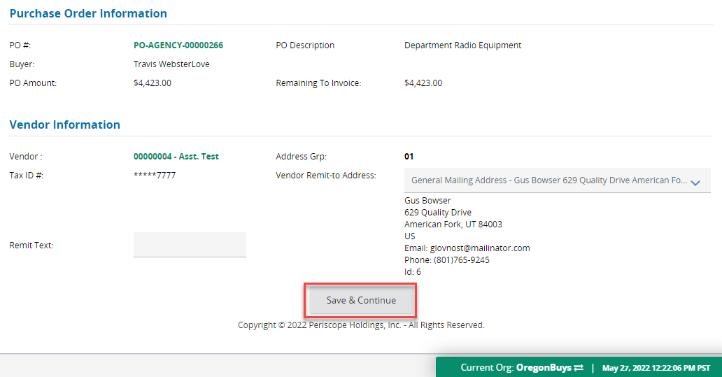

## Items Tab

1. Select ***Pay All Items*** to update the ***Invoice Amount*** field to the ***Permit to Pay*** amount. The ***Permit to Pay*** amount is the amount that has been marked as ***Received*** on the Purchase Order.
   1. The red validation error will always pop up reminding you that before you can proceed, you must input some ***Invoice Amount***on the line items.
   2. This example goes through the ***Pay All Items*** option, instead of individually entering the ***Invoice Amount***per line item.
   3. Selecting ***Final Pay*** closes out the Purchase Order and **will not** **allow** the user to create a Change Order

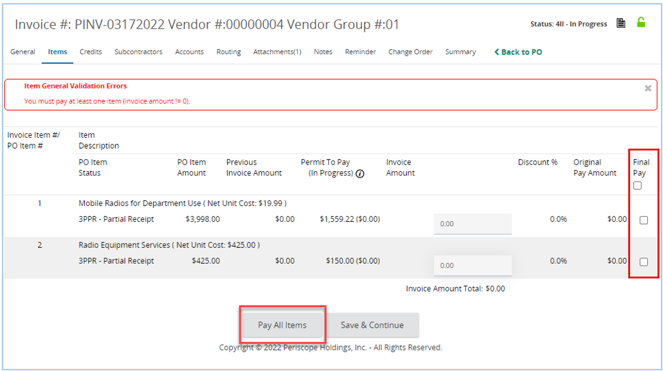

Select **only** if you are ready to close out the purchase order.

## Credits Tab

1. Select any Credits that must be removed from the invoice using the checkboxes under “***Credit Captured to Invoice***”
   1. Select ***Save & Continue*** under the “***Credit Captured to Invoice*”** section
2. Select any Credit Memos that must be included in the invoice using the checkboxes under “***Credit Memo Selection***”
3. Graphical user interface, text, application, email

   Description automatically generatedSelect ***Save & Continue*** under the “***Credit Memo Selection***” section

## Subcontractors, Accounts, and Routing Tabs

1. These tabs exist throughout OregonBuys and are available for only review on the invoice.

## Attachments Tab

1. Graphical user interface, text, application, email

   Description automatically generatedTo add a file on the **Attachments Tab**, select ***Add File***
2. Then click ***Choose File*,** then locate and select the document from computer. OregonBuys supports all document types except saved emails and .exe files. Documents should be named without special characters to ensure the file is saved properly.
3. Graphical user interface, application

   Description automatically generatedNext click ***Save & Exit***.
4. The page will refresh back to the ***Attachments* Tab** and the document will show as a hyperlink.

## Notes Tab

This tab is similar to a digital post-it viewable by the user and others in the Agency.

1. Type the note in the text field and click ***Save & Continue***

## Reminder Tab

This tab is where you can send a notification to yourself or another user in our organization about acting on this specific Requisition

1. First, to create a reminder select the calendar in ***Due Date*** field. This is the date the action needs to be completed.
   1. Once the date is selected, click ***Done*** on the calendar.

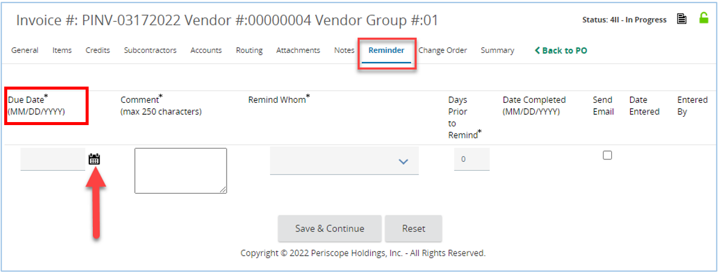

1. Next, type the reminder into the ***Comment*** section.
2. Then **select the person** that needs to be reminded or notified.
3. Next, select the ***Days Prior to Remind*** field to the day you want the person to be notified.
4. Check the ***Send Email*** box to have the system send an email reminder.
5. Lastly, click ***Save & Continue***.

1. You will now see a ***Date Completed*** field, which the person you selected to be reminded can update when they’ve completed the task.

## Change Orders Tab

This tab is where a Change Order can be created on the Invoice. The Invoice Change Order can be used to modify and update the account codes for this Invoice. For more information, refer to the “Creating an Invoice with a Change Order” section below.

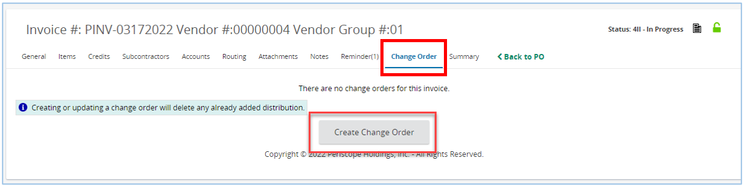

## Summary Tab

This tab gives a summary of the information input on this Invoice. At the bottom of this tab is also where users will be able to Submit their Invoice for Approval.

1. Select the ***Submit*** button

1. Click ***Continue*** to send this along the appropriate Approval Path. The AP Supervisor role in OregonBuys is required to be the final approval on all Invoices. Once *Continue* is selected the status is set to ***Ready for Approval****.* **NOTE:** Approval Path set-up is unique by organization. If needed, contact your agency core team members who were involved with the Approval Path set-up for your organization with questions, etc.

1. AP Supervisor(s) must login and approve the Invoice
   1. Graphical user interface, text, application

      Description automatically generatedApprovers can choose to ***Approve*** or ***Disapprove*** the Invoice and add comments explaining the decision, then click ***Save & Continue****.*

1. After final approval, the status is set to ***Approved for Payment***. Once an Invoice is in *Approved for Payment* status, the R*STARS interface pulls the transactions into a file that is transferred to R*STARS each night. The transactions are loaded into R*STARS in a “hold” status on the 530 screen. The R*STARS user will need to release the transactions for payment.

# Creating an Invoice for a Partial Receipt

1. **Login** using your login credentials at **oregonbuys.gov**. To create an Invoice, users must have the **Accounts Payable** role.

1. Navigate to the left side of the Homepage and click the green **“+”** icon
   1. Select *Invoice* on the drop down menu.

1. Search for your Purchase Order.
   1. Use the fields to search for your Purchase Order based on a number of criteria (e.g. NIGP Class and Class Item codes)
   2. Select ***Find It*** to search
   3. Select the correct **Purchase Order**.
   4. Click ***Select***

## General Tab

1. Fill out the **New Invoice** page.

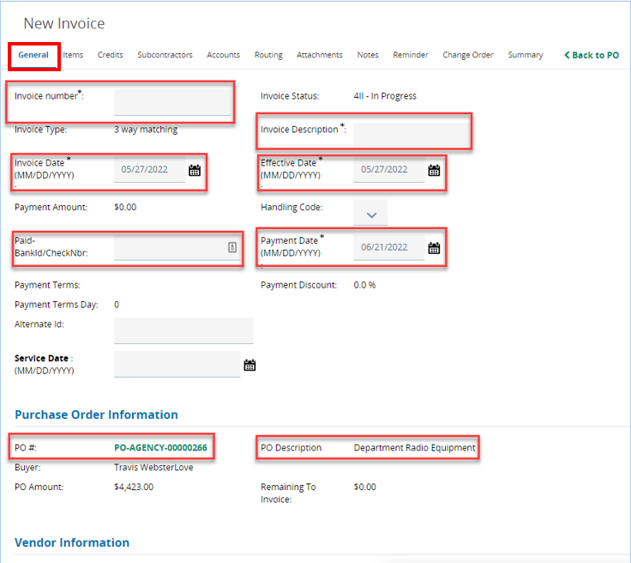

1. Simple Invoice Needs:
   1. **Invoice Number** – this field is filled out by the user. The Invoice number is an identifier for the Invoice and one vendor may not have duplicate Invoice numbers in the system.
   2. **Invoice Description** – format in this field should reflect what is being procured. This field is publicly viewable, searchable, and reportable. Please ensure that this field is detailed and titled similarly to a document title.
2. Other Fields:
   1. **Invoice Date** – populated with the date on the Invoice is received by agency personnel.
   2. **Effective Date** –This field maps to Effective Date in R*STARS.
   3. **Payment Date** – populated with the date the payment has been or will be made. This field maps to Due Date in RSTARS.
   4. **Payment Amount** – This is the amount to pay on the invoice
   5. **Paid-BankId/CheckNbr** – This will be populated with the paid status once the invoice is paid in R*STARS
   6. **PO Number** – this field is automatically populated. The Purchase Order Number, or PO Number, is the number of the Purchase Order that the Invoice is for. The PO number on this screen is a hyperlink that will take the user to the Purchase Order the current Invoice is for.
   7. **PO Description** – this field is automatically populated. The PO Description is a description of the Purchase Order the Invoice is for.
3. Scroll to the bottom of the page
4. Select ***Save & Continue***



## Items Tab

1. Select ***Pay All Items***
   1. The ***PO Item Amount*** shows what would be due if everything had been received.
   2. The ***Permit to Pay*** shows what the user is permitted to pay due to what has been received.
      1. The red validation error will always pop up reminding you that before you can proceed, you must input some *Invoice Amount* on the line items.
      2. This example goes through the ***Pay All Items*** option, instead of individually entering the ***Invoice Amount***per line item.
2. A screenshot of a computer

   Description automatically generatedThe ***Invoice Amount*** is what will be paid with the Invoice. Selecting ***Pay All Items*** updates the ***Invoice Amount*** to the ***Permit to Pay*** amount.

## Summary Tab

1. Select the ***Submit*** button on the bottom of the **Summary Tab**

1. Click ***Continue*** to send this along the appropriate Approval Path. The AP Supervisor is required to be the final approval on all Invoices. Once ***Continue*** is selected the status is set to ***Ready for Payment*** and the AP Supervisor will need to login to complete the process.

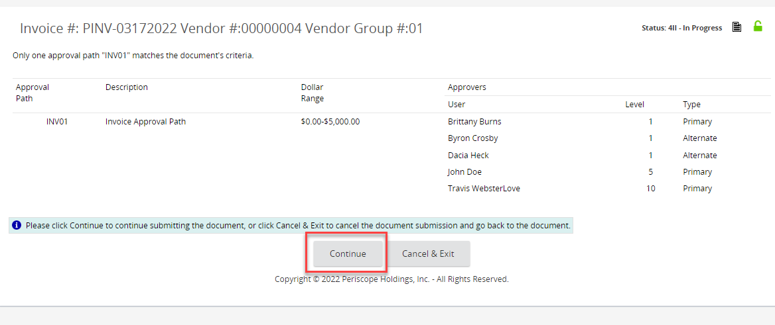

1. Once an Invoice is in ***Ready for Approval***, the AP Supervisor(s) must login and approve the Invoice
   1. An approver can add a new approver, set the approval order, and change the primary approver. This is optional.
2. Approvers can choose to ***Approve*** or ***Disapprove*** the Invoice and add comments explaining the decision.
3. After final approval the status is set to ***Approved for Payment***.

# Creating an Invoice with a Change Order

**Login** using your login credentials at **oregonbuys.gov**. To create an Invoice, users must have the **Accounts Payable** role

1. Navigate to the left side of the Homepage and click the green **“+”** icon
   1. Select ***Invoice*** on the drop down

1. Search for your **Purchase Order**
   1. Use the fields to search for your **Purchase Order** based on a number of criteria (e.g. NIGP Class and Class Item codes)
   2. Select ***Find It*** to search
   3. Select the correct **Purchase Order**
   4. Click ***Select***

## General Tab

1. Fill out the **New Invoice** page.

1. Simple Invoice Needs:
   1. **Invoice Number** – this field is filled out by the user. The Invoice number is an identifier for the Invoice and one vendor may not have duplicate Invoice numbers in the system.
   2. **Invoice Description** – format in this field should reflect what is being procured. This field is publicly viewable, searchable, and reportable. Please ensure that this field is detailed and titled similarly to a document title.
2. Other fields:
   1. **Invoice Date** – populated with the date on the Invoice is received by agency personnel.
   2. **Effective Date** –This field maps to Effective Date in R*STARS.
   3. **Payment Date** – populated with the date the payment has been or will be made. This field maps to Due Date in RSTARS.
   4. **Payment Amount** – This is the amount to pay on the invoice
   5. **Paid-BankId/CheckNbr** – This will be populated with the paid status once the invoice is paid in R*STARS
   6. **PO Number** – this field is automatically populated. The Purchase Order Number, or PO Number, is the number of the Purchase Order that the Invoice is for. The PO number on this screen is a hyperlink that will take the user to the Purchase Order the current Invoice is for.
   7. **PO Description** – this field is automatically populated. The PO Description is a description of the Purchase Order the Invoice is for.
3. Scroll to the bottom of the page
4. Select ***Save & Continue***

## Items Tab

1. Select the ***Items Tab****.*

1. Select ***Pay All Items***
   1. The red validation error will always pop up reminding you that before you can proceed, you must input some *Invoice Amount* on the line items. The error message is generated immediately because there are no payment amounts entered on the items Tab yet.
   2. This example goes through the ***Pay All Items*** option, instead of individually entering the ***Invoice Amount*** per line item.
   3. Selecting ***Final Pay*** closes out the Purchase Order and **will not allow** the user to create a Change Order.

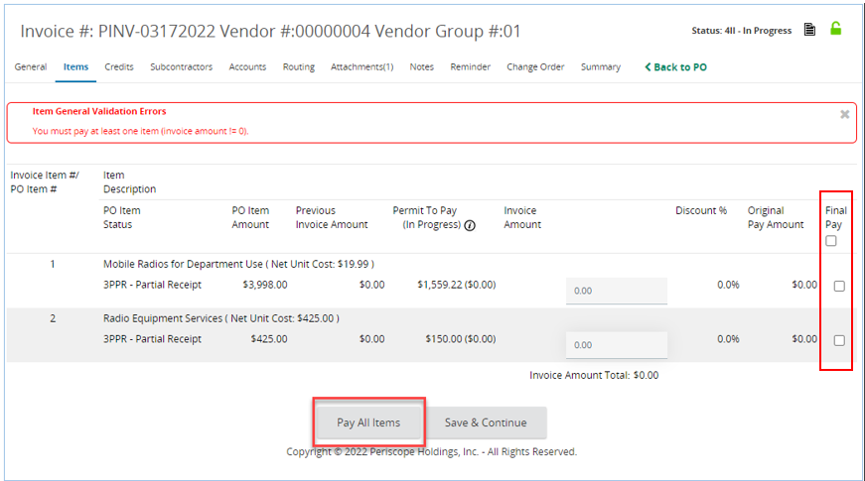 https://www.flipsnack.com/osdsocialmedia/buy-the-way-issue-24/full-view.html

Select **only** if you are ready to close out the purchase order.

## Change Order Tab

1. Select the **Change Order** Tab.
   1. Select ***Create Change Order****.*

1. Select the ***number*** by the item.

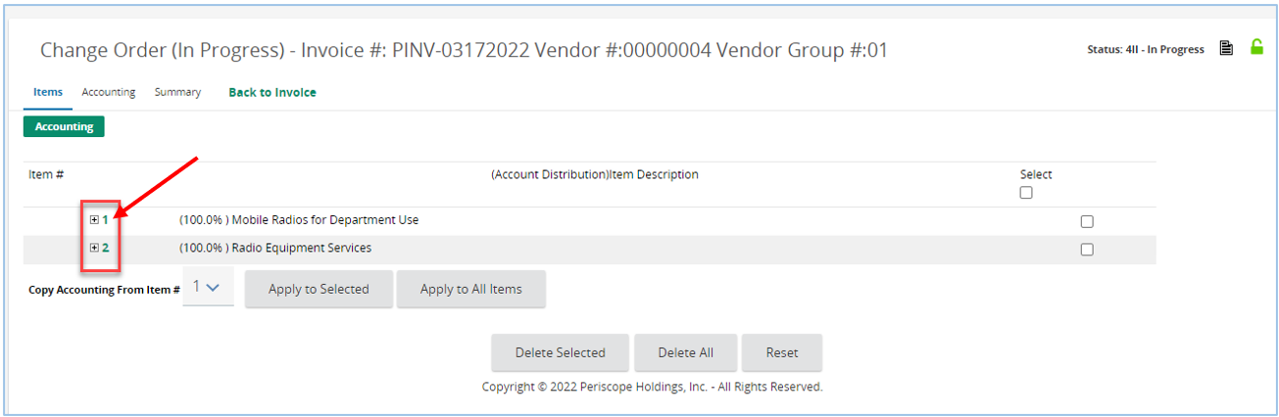

1. The user can update the **Account Code** distribution.
   1. Update the **Account Distribution.**
   2. Select either ***Save Based on Dollars*** when the accounting is split by dollar amount above,
   3. or ***Save Based on Percentages*** when the accounting is split by percentages above.
   4. Select ***Back to Invoice*** at the top.

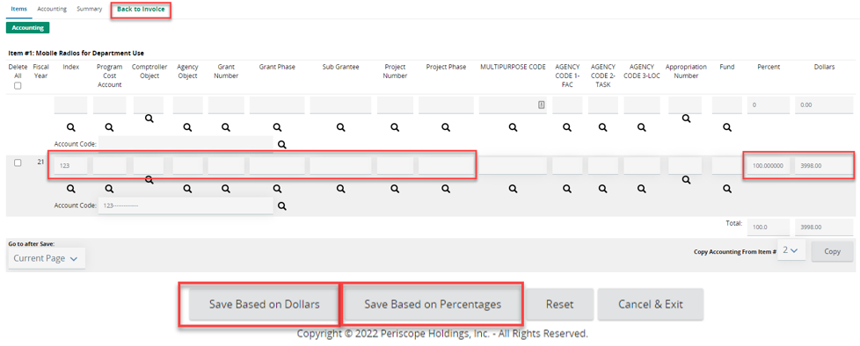

1. Graphical user interface

   Description automatically generated with medium confidenceThe system will take you back to the **Summary Tab** of the Invoice, showing a Change Order has been added to the Invoice.
2. Scroll down and select the ***Submit***button.

1. Graphical user interface, text, application, email

   Description automatically generatedClick ***Continue*** to send this along the appropriate Approval Path. The AP Supervisor is required to be the final approval on all Invoices. Once ***Continue*** is selected the status is set to ***Ready for Approval.***
2. AP Supervisor(s) must login and approve the Invoice.
3. The AP Supervisor will be able to navigate to any Invoices in ***Ready for Approval*** status from their home page.
4. Approvers can choose to ***Approve*** or ***Disapprove*** the Invoice and add comments explaining the decision.

1. After final approval the status is set to ***Approved for Payment****.*

# Paying Invoice in Biennium Following Purchase Order

Users will need to use this process when a good/service is received in the biennium after the Purchase Order is created. For instance, an order is placed in one biennium (maybe towards the end) but the product is then not received until the next biennium (likely towards the beginning).

The Receipt guidance document will cover the parts of the previous step in the process relating to Receipts.

Following the Basic Purchasing user cloning the Purchase Order from the previous biennium and creating a Receipt, the AP user should navigate to their Purchase Order in *Complete Receipt* status.

1. **Login** using your login credentials at **oregonbuys.gov**. To create an Invoice the user must have the **Accounts Payable** role.

1. Navigate to the left side of the Homepage and click the green **“+”** icon.
   1. Select ***Invoice*** on the drop down.

1. Search for your **Purchase Order**.
   1. Use the fields to search for your Purchase Order based on a number of criteria (e.g. NIGP Class and Class Item codes).
   2. Select ***Find It*** to search
   3. Select the correct **Purchase Order**
   4. Click ***Select***

General Tab

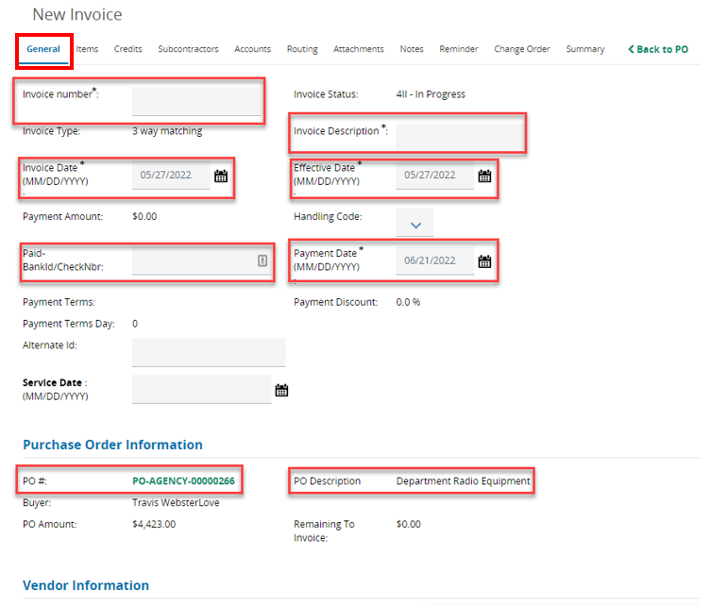

1. Simple Invoice Needs:
   1. **Invoice Number** – this field is filled out by the user. The Invoice number is an identifier for the Invoice and one vendor may not have duplicate Invoice numbers in the system.
   2. **Invoice Description** – format in this field should reflect what is being procured. This field is publicly viewable, searchable, and reportable. Please ensure that this field is detailed and titled similarly to a document title.
2. Other fields:
   1. **Invoice Date** – populated with the date on the Invoice is received by agency personnel.
   2. **Effective Date** –This field maps to Effective Date in R*STARS.
   3. **Payment Date** – populated with the date the payment has been or will be made. This field maps to Due Date in RSTARS.
   4. **Payment Amount** – This is the amount to pay on the invoice
   5. **Paid-BankId/CheckNbr** – This will be populated with the paid status once the invoice is paid in R*STARS
   6. **PO Number** – this field is automatically populated. The Purchase Order Number, or PO Number, is the number of the Purchase Order that the Invoice is for. The PO number on this screen is a hyperlink that will take the user to the Purchase Order the current Invoice is for.
   7. **PO Description** – this field is automatically populated. The PO Description is a description of the Purchase Order the Invoice is for.
3. Scroll to the bottom of the page.
4. Select ***Save & Continue****.*

## Items Tab

1. Select ***Pay all Items****.*
   1. The red validation error will always pop up reminding you that before you can proceed, you must input some ***Invoice Amount***on the line items.
   2. This example goes through the ***Pay All Items*** option, instead of individually entering the ***Invoice Amount***per line item.
   3. Selecting ***Final Pay*** closes out the Purchase Order and **will not allow** the user to create a Change Order.

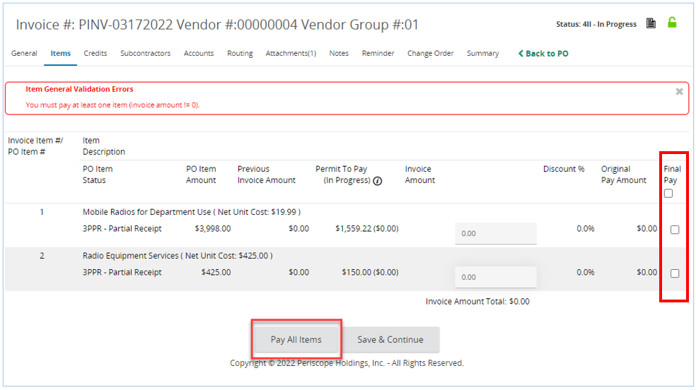

Select **only** if you are ready to close out the purchase order.

## Summary Tab

This tab gives a summary of the information input on this Invoice. At the bottom of this tab is also where users will be able to Submit their Invoice for Approval.

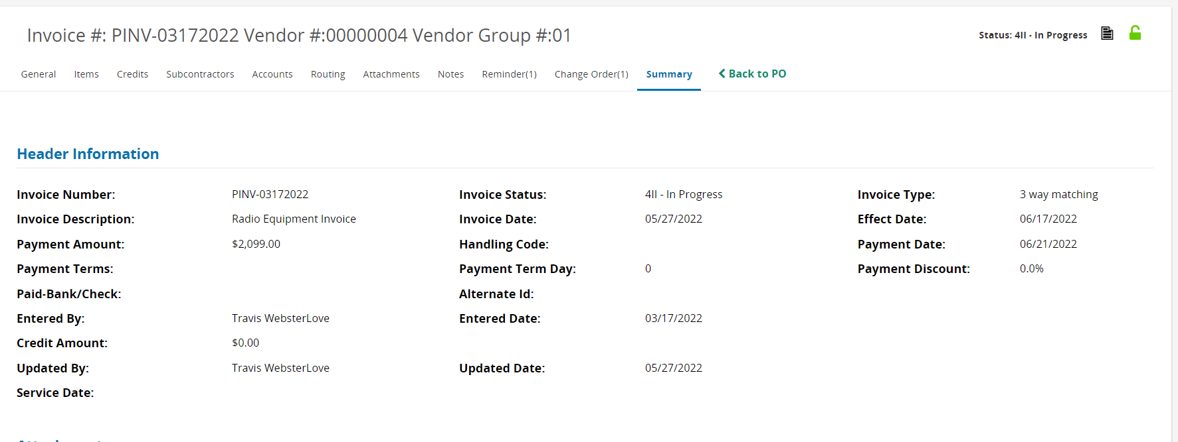

1. Graphical user interface, text, application

   Description automatically generatedScroll to the bottom and select the ***Submit*** button

1. Graphical user interface, text, application, email

   Description automatically generatedClick ***Continue*** to send this along the appropriate Approval Path. The AP Supervisor role in OregonBuys is required to be the final approval on all Invoices. Once *Continue* is selected the status is set ***Ready for Approval.***
2. AP Supervisor(s) must login and approve the Invoice
   1. Graphical user interface, text, application

      Description automatically generatedApprovers can choose to ***Approve*** or ***Disapprove*** the Invoice and add comments explaining the decision.
3. Graphical user interface, text, application, chat or text message

   Description automatically generatedAfter final approval the status is set to ***Approved for Payment****.* Once an Invoice in in ***Approved for Payment*** status the R*STARS interface pulls the transactions into a file that is transferred to R*STARS each night. The transactions are loaded into R*STARS in a “**hold**” status on the 530 screen. The R*STARS user will need to release the transactions for payment.

**NOTE:** It is recommended agencies regularly pull a reconciliation report from RSTARS to insure all payments were made. For more information about the OregonBuys Accounts Payable (AP) Daily to OregonBuys to R*STARS Reconciliation Process view the following course in Workday:

[DAS - PS - OregonBuys Accounts Payable (AP) Daily OregonBuys to R*STARS Reconciliation Process](https://wd5.myworkday.com/oregon/learning/course/7de84fe436940101587e70acb1190000?record=c482979e98f3010158b49fc28c720001&type=9882927d138b100019b928e75843018d)