OregonBuys Agency Admin IV: Linking Contract Items Guidance

Table of Contents
Introduction 2
Prerequisites 2
Scenario 2
Catalog Manager 2
External Catalogs 3
Internal Catalog 5
Contract Link Manager 7
Locate Products and Automatically Match and Link Them 7
Locate Products and Manually Match and Link Them 11
Applying Discount to Contract for All the Products in A Catalog 15

Introduction
This guidance document will cover the best way for a Department Access or Basic Purchasing user with Catalog Manager privilege how to access the Catalog Link Manager for both External and Internal Catalogs, how to match and link Contract Line Items on a Master Blanket Purchase Order to Products or Services on a Catalog using automatic and manual matching, how to use the search and filter features and how to link a single Contract Line Item to an entire Catalog.
Figure 1: High Level Process Flow
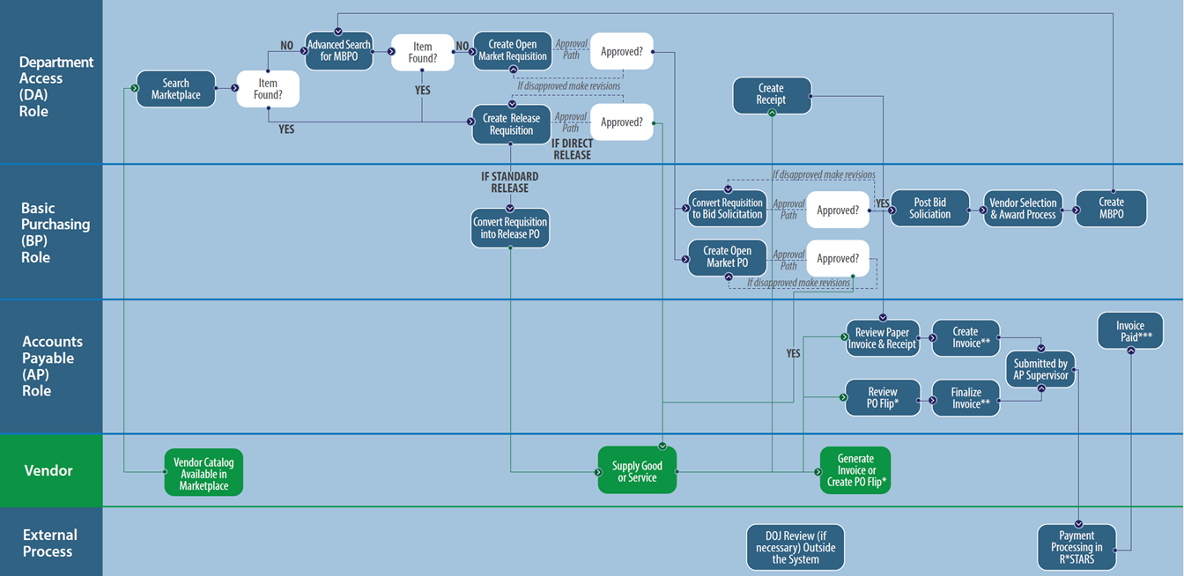

Scenario
A Master Blanket Purchase Order (MBPO) has been established in the Agency. The Product or Service list related to that MBPO has been uploaded in OregonBuys, either by the vendor or on behalf of the vendor. In order to link the uploaded catalog and the MBPO, the user must go into Catalog Manager to link the items together, so they appear correctly in Marketplace.

Prerequisites
- Catalog Manager user role is assigned to your user.
- A Product or Service list from the vendor is uploaded in OregonBuys.
- Information on the specific Master Blanket Purchase Order to be linked is available.

Catalog Manager
- To begin, navigate to an External or Internal Catalog in Catalog Manager.
- Starting from the Home page, click the gear icon, and select Catalog Manager from the drop-down menu.
- The page will redirect to the Catalog Library in Catalog Manager.
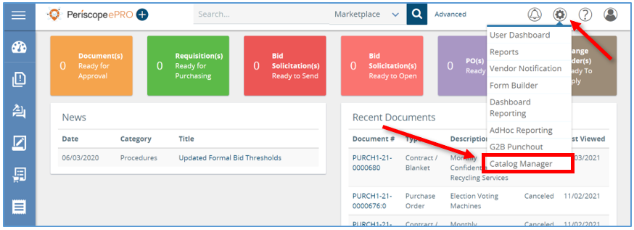
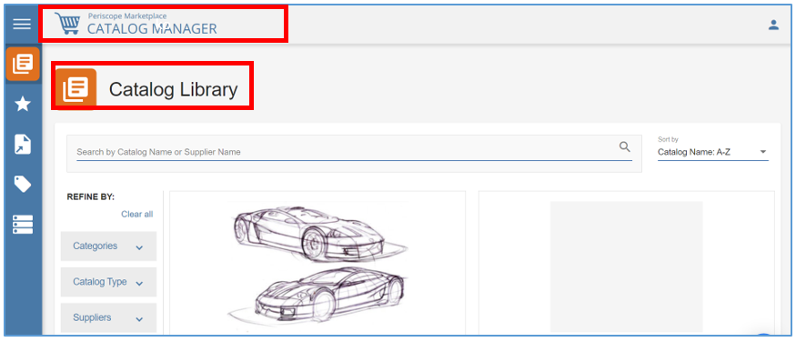

External Catalogs
- For an External Catalog hover your mouse over the left navigation bar and click Saved Catalogs.
- This will take you to an External Catalog that is already in the process of being activated for Shoppers.
  - Remember External Catalogs are loaded by the Supplier themselves.
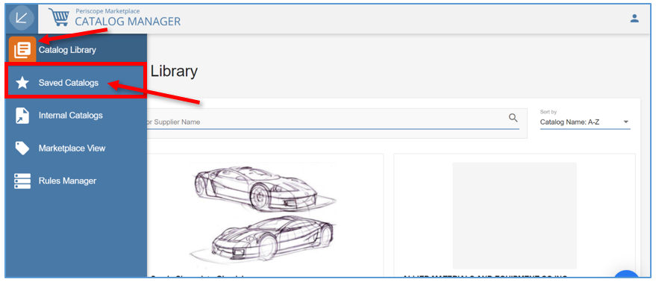
- Next locate the Catalog and click the ellipsis icon in the upper right-hand corner.
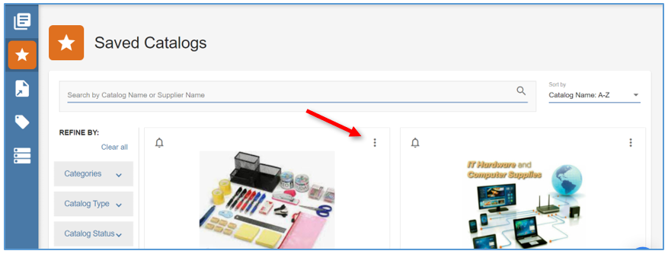

- Then select Link Catalog to Contracts.
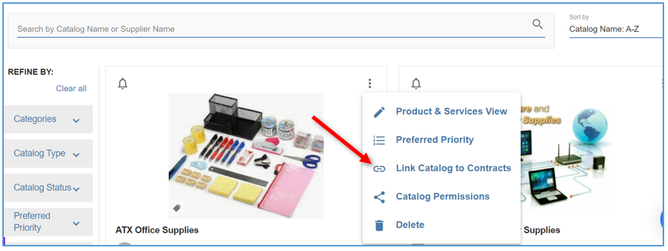

Internal Catalog
- For an Internal Catalog hover the mouse over the left navigation bar and click Internal Catalogs.
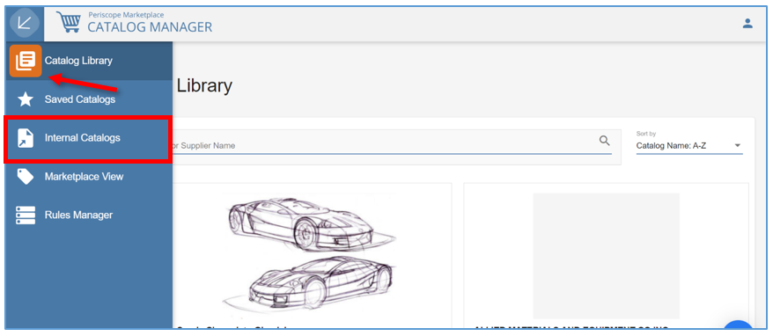

- Now locate the Catalog using the search bar to search by Catalog Name.
  - The system will automatically display the Catalog you are searching for.
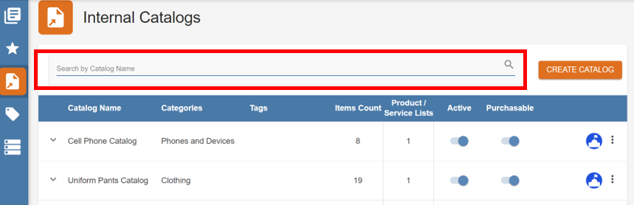
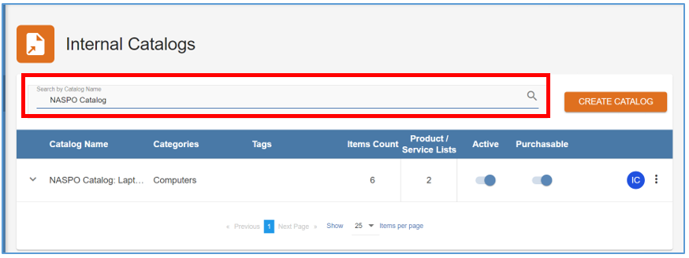
- Next, click the ellipsis icon on the right side of the screen and select Link Catalog to Contracts.
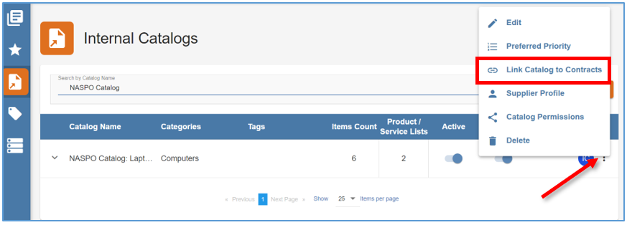

- The page will redirect to the Contract Link Manager page, this is where you can link the Contract Items with the Supplier’s Products for this Catalog.

Contract Link Manager
- Next you will match the Items and Products together and then link them.
  - Items can be matched and linked with Products manually or matched and linked by UPC or SKU automatically.
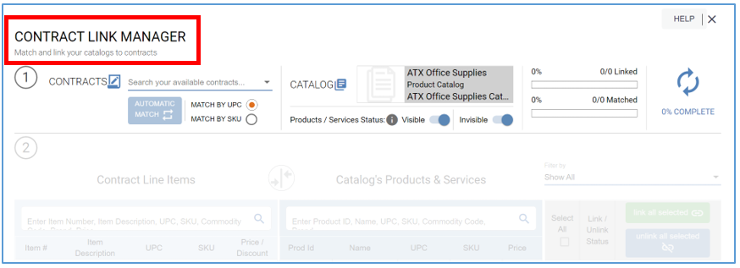

Locate Products and Automatically Match and Link Them
1. Step 1 is the Contracts section, click the drop-down menu and select the Master Blanket Purchase Order that you’re linking it to.
- Step 2 includes the Contract Line Items section on the left and the Catalog’s Products & Services section on the right. In Step 1:
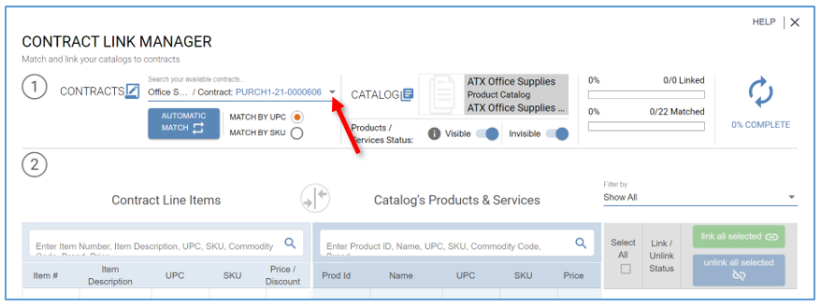
  - If you want to match the Contract Items with Products on the Catalog based on SKU, select the radio button next to Match By SKU.
  - If you want to match the Contract Items with Products on the Catalog based on UPC, select the radio button next to Match By UPC.

- Then click Automatic Match.
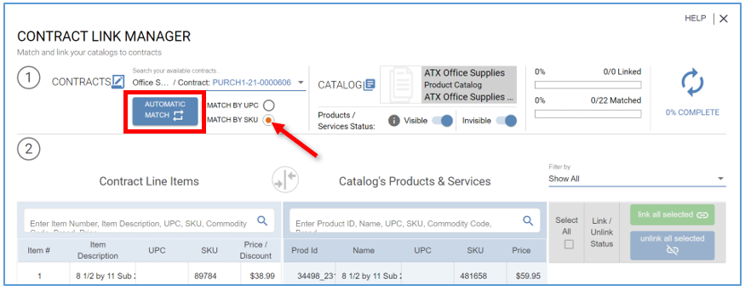
- The screen will refresh and now you will see all the Contract Items with Products that have matching SKU’s.
- In the top right corner of the screen, you will see the number of Products in the Catalog that have been matched.
  - The blue icon next to the Item # and Prod ID columns indicates that item has been matched and can now be reviewed side-by-side.
- Next confirm the matches are correct and link each one individually by clicking on the green link button.
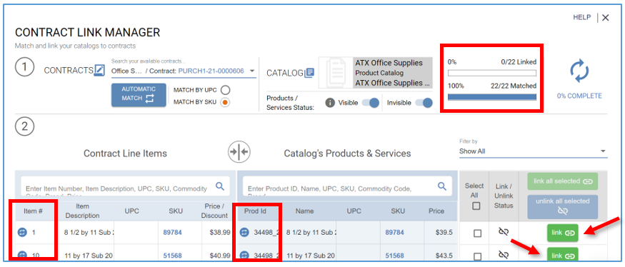

- In the top right corner of the screen, you will now see the Products in the Catalog that are linked. The green link button and blue button in the Item # and Prod Id columns will now turn orange.
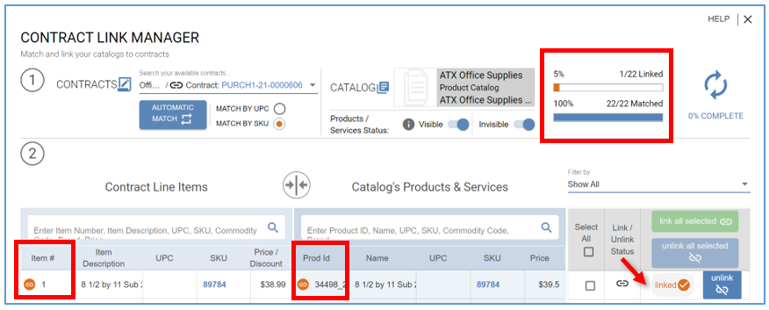
- You can unlink items by clicking on the blue unlink button.
- To link all matches at once instead of one at a time, click the Select All header box and click link all selected in green.
  - Only 10 Items will show on the page, you will need to click the link selecting all Items in the Catalog.
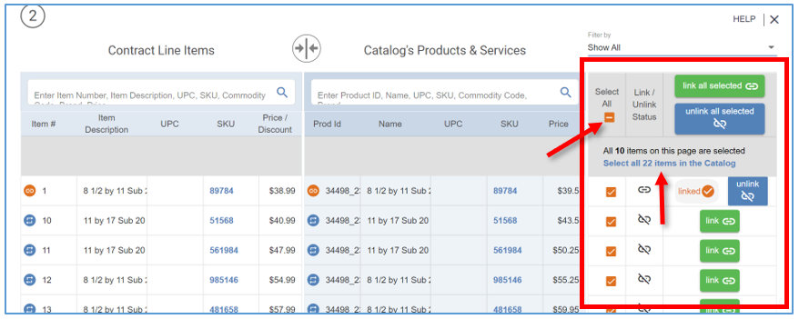

- Once the link is selected you will now see that all Items on the Catalog have been selected.
- From here click link all selected.
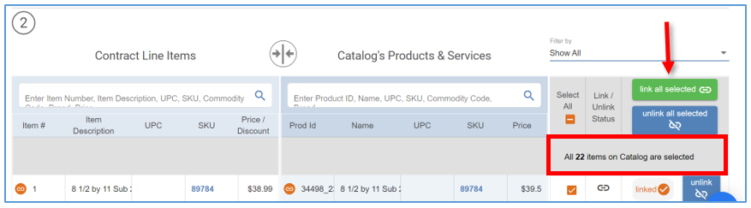
- A pop-up window will appear with the Linking Status.
- You can allow validation to be completed or click Close and the validation will continue to run in the background.
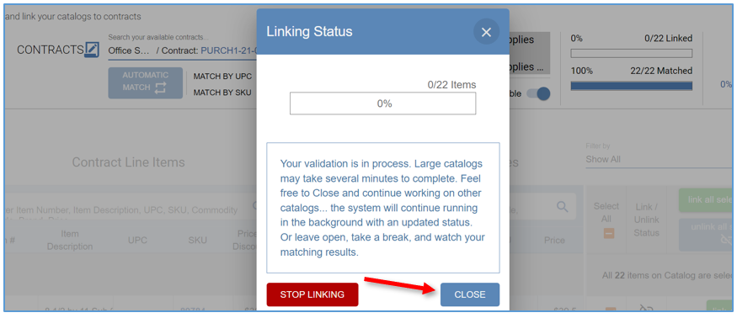
- All Contract Items and Products that have matching SKUs are linked.
- Shoppers in Marketplace will now see them with the price of the Contract Item and it will also show on Requisitions.

Locate Products and Manually Match and Link Them
Whether it’s a Contract Item on a Master Blanket Purchase Order or a Product or Service in either an internal or external Catalog there are several features set in place to help you locate Items.
- Under Contract Line Items, use the search bar to search by Line Item #, Item Description, UPC, SKU, Commodity Code, Brand, Price, Discount %, Manufacturer or Tags.
- Under Catalog’s Products & Services, use the search bar to search by Product Id, Product Name, UPC, SKU, Commodity Code, Brand, Product Description, Tags, Distributor or Manufacturers.
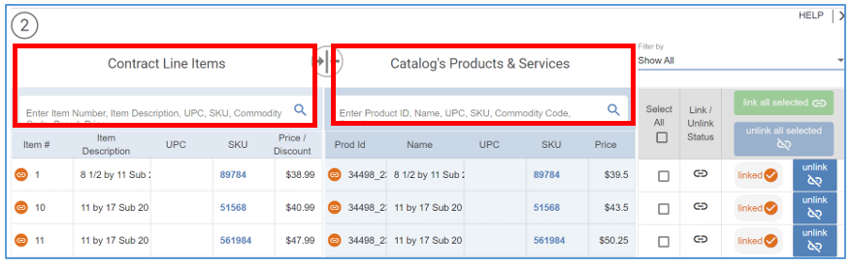
- Enter in one of those features to locate an Item. As you type, some Product suggestions will appear.
- Once you see what you are looking for select the name or to see everything that fits your search criteria finish typing your inquiry.
- Then click enter on the keyboard to start search.
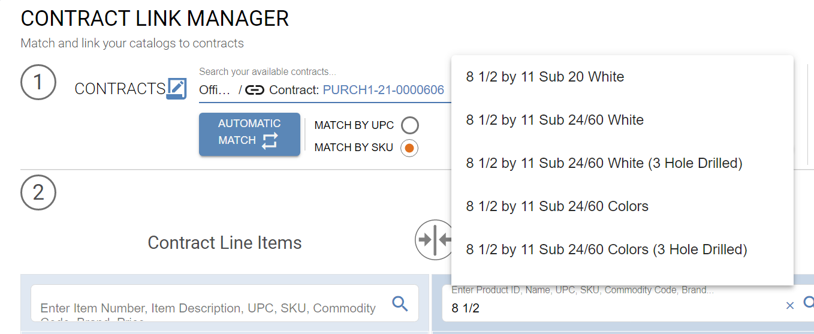

- To delete your search and reset the results, click the X button next to the magnifying glass icon.
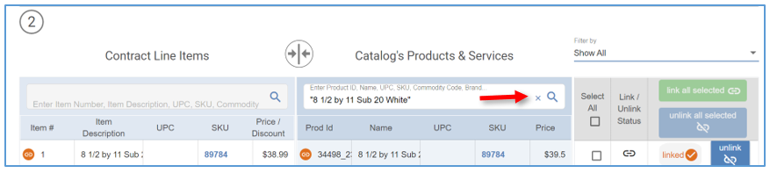
- To filter results, select the drop-down menu under Filter by. There are several filter options to choose from:
  - Show all
  - Matches with the same UPC
  - Matches with the same SKU
  - Items without matches
  - Items matched manually
  - Linked items
  - Unlinked items
  - Broken Automatic Matches
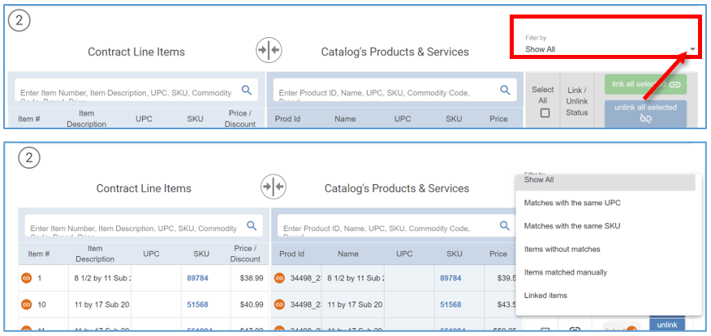

- To manually link a Contract Line Item, hover mouse over the Item Description to get the description of the Contract Item.
- Then select the Contract Item by clicking anywhere on it.
- Next match and select it to the correct Product by clicking anywhere on it.
- Before selecting, hover over the Product Name to see the full details and to make sure it is a match.
- Then click the green link button.
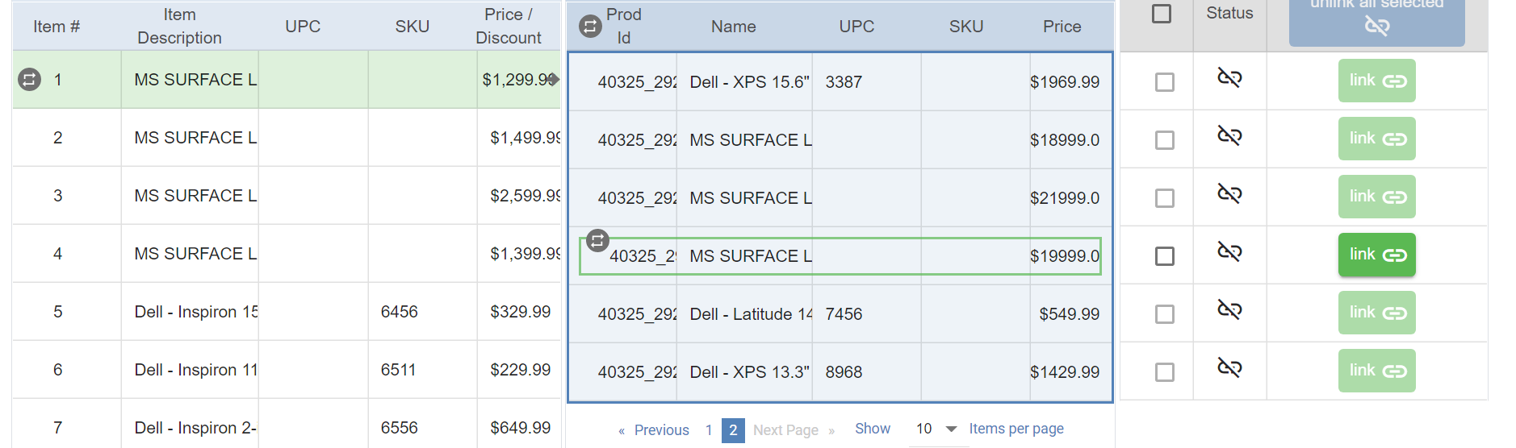
- Repeat those steps for any remaining Contract Items and Products. Once finished the Contract Items and Products in the Catalog will now be linked and you can exit out of the Contract Link Manger.
- To exit, click the X button in the top right corner of the screen.
  - This will bring you back to the Saved Catalogs tab if this is an External Catalog, or the Internal Catalog list if this is an Internal Catalog.
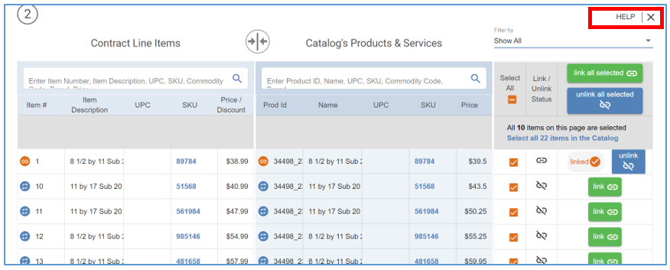
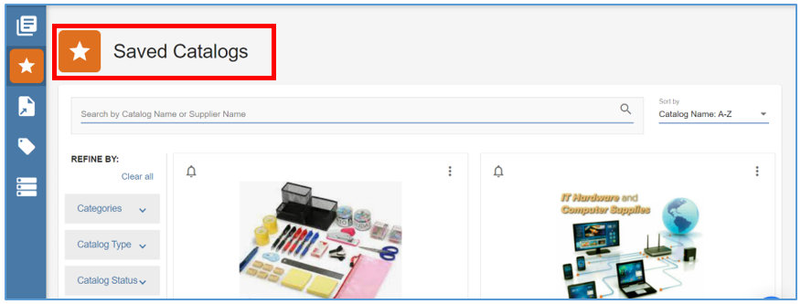
- Toggle on the Active button on the Catalog Cover to make the Catalog active to Shoppers.
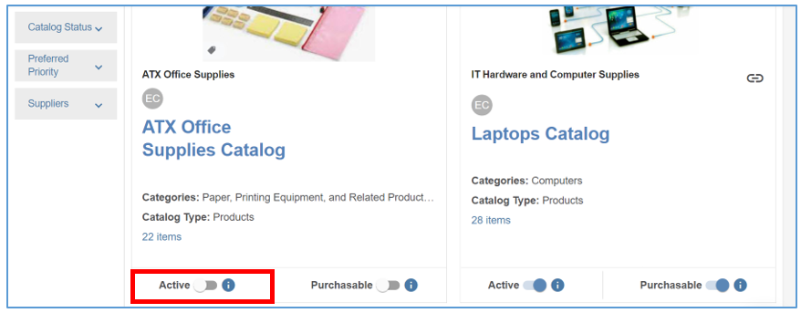

Applying Discount to Contract for All the Products in A Catalog
- To do this, click the Contracts drop-down arrow and select the Contract.
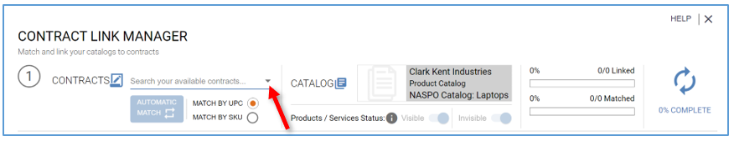
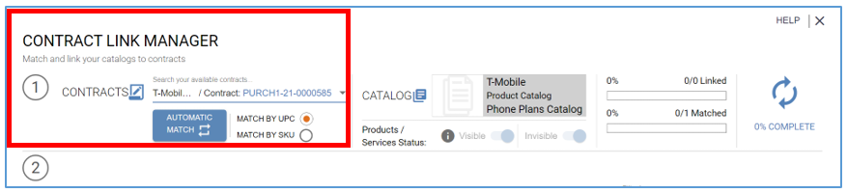
- Next click anywhere on the Contract Line Item that contains the discount and select it.
- Then on the Catalog side, next to Product ID, you will find a Match/Unmatch All icon, click it.
  - That will match all the visible Products on this page to the Contract Item.
  - To match any remaining Products on the Catalog, click the Match all items in the Catalog link.
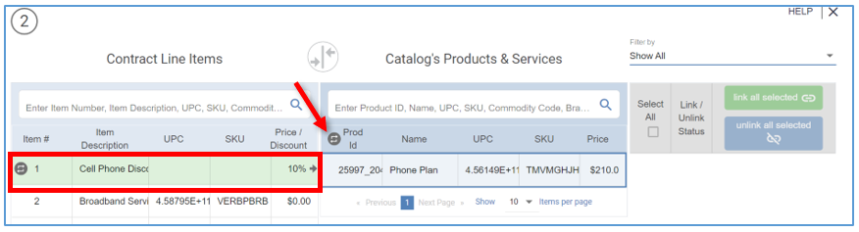
- A pop-up will appear displaying the Matching Status.
- You can allow validation to be completed or click Close and the validation will continue to run in the background.
- Click the Select All header checkbox.
  - If there are more than 10 items on the Catalog, click Select all items in the Catalog.

- Then, click Link All Selected. All Products have now been linked.
- You will also see the orange link icon next to all the Products.
- The Products in the Catalog will now appear in Marketplace at a discounted rate from their listed price.
- Once you are complete, close out of Contract Link Manager by clicking the X button, which will bring you back to your Internal Catalogs.
