OregonBuys Master Blanket Purchase Order (MBPO) Guidance

Table of Contents
Introduction 2
General Tab 2
Items Tab 4
Control Tab 6
Attachments Tab 7
Notes Tab 8
Reminders Tab 9
Change Orders 10
Summary Tab on Change Order 11

Introduction
This guidance document will help Basic Purchasers (BP) as they create Master Blanket Purchase Orders (MBPO) in OregonBuys.

General Tab
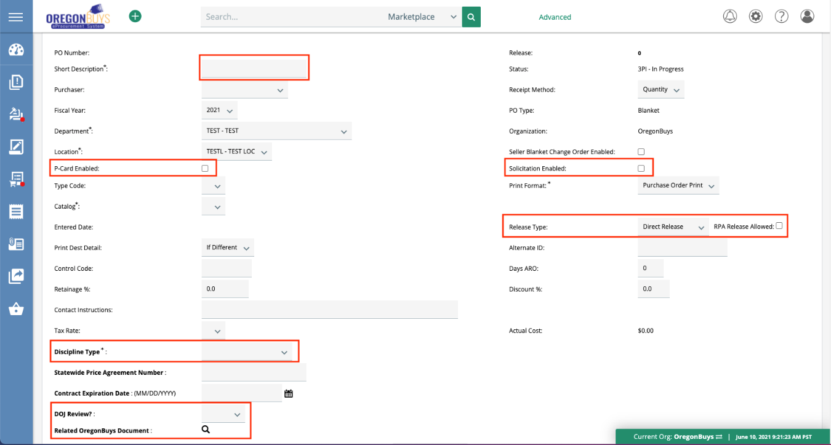
- Short Description – this field contains the space to make a unique. This is a searchable field, so make the description as unique as possible. The format in this field should reflect what is being procured. This field is publicly viewable, searchable and reportable. This will be the title of your MBPO in OregonBuys and all related reports.
- Contact Instructions: This is a pretext field that displays to the vendors. You can use this to type in the contact name, phone number and e-mail for questions regarding the bid.
- Solicitation Enabled – this checkbox allows users to release “mini” bid solicitations or quotes off of approved Release Requisitions which are a part of Phase 2. Selecting this option automatically updates the Release Type to Standard Release (Solicitation Enabled MBPO’s must be Standard Release type).
  - Leave this box unchecked for most MBPOs.
- Release Type – this field contains three different selectable release types (Direct, Standard, and RPA Only Release).
  - Direct Release enables the automatic creation of a Release PO, in sent (sent to vendor) status, once a Release Requisition is approved. You should select Direct Release for price agreements with goods/commodities
  - Standard Release requires the review and approval of the Release PO (by the Purchaser and their approvers) prior to release to vendor. RPA Only restricts the MBPO to allow only payment requests for orders processed outside the system. Standard Release should be selected for price agreements with services.

  - RPA (Request for Payment Authorization) Release Allowed checkbox – enables purchasers to enter payment requests against an MBPO for items purchased outside the system. You should check this box, to ensure that purchases outside the system can be recorded against the MBPO.
- Discipline Type - A and E; A and E Related Services; Ordinary Construction; Personal Services; Public Improvement; Supplies; Trade Services; ORS190; Subgrantee (non-procurement)
- Contract Expiration Date – Used for reporting and should be completed
- DOJ Review?. If the MBPO requires DOJ Review select “Yes” and the date/time, attorney name for reporting purposes.
  - NOTE: The actual DOJ Review is conducted and documented outside of OregonBuys.
- Related OregonBuys Document – this field is used to link an existing document within OregonBuys that is related to this Master Blanket Purchase Order. Use the magnifying glass to search within the system for a document.

Items Tab
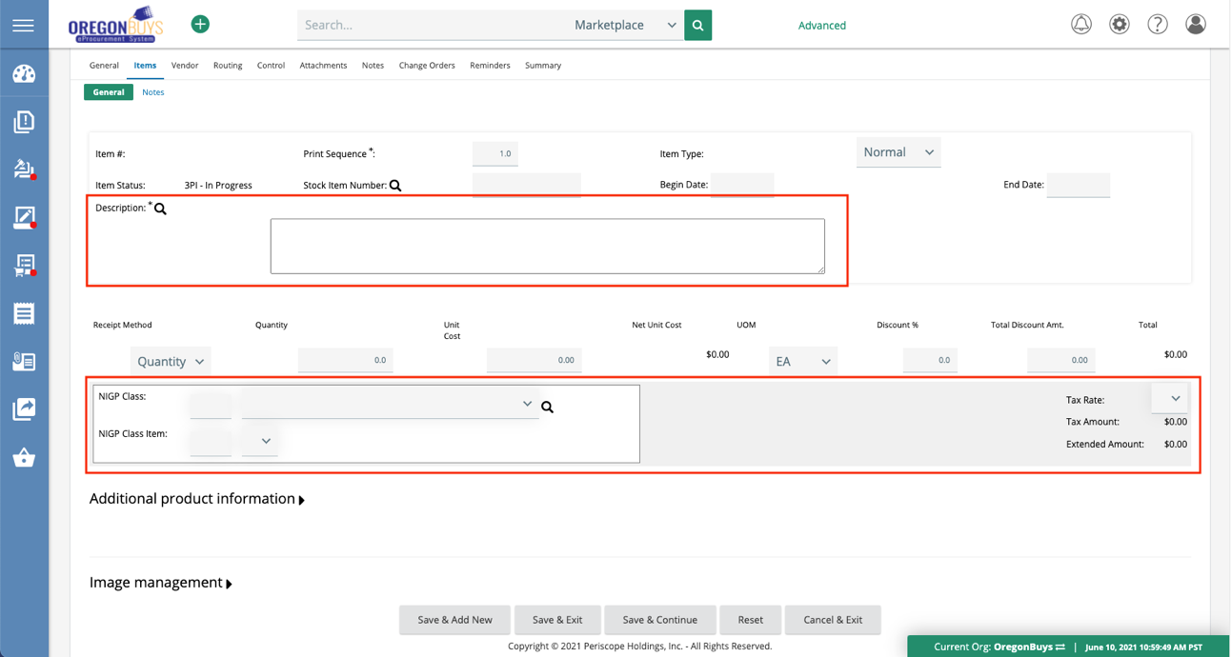
- Items should include the specific goods, services, or categories authorized for purchase under the price agreement
- To facilitate reporting, receiving and invoicing, please ensure that you add as many line items as needed directly into this tab. Attaching a PDF inhibits future use of the MBPO.
- Items may be mapped to catalog items in Marketplace and will restrict what users can buy, discounts, and pricing
- The Item Description field is searchable and is key for generating quality reports.
- NIGP codes are required for every MBPO. OregonBuys uses the 5 digit NIGP code for simplicity and accuracy with reporting and ease for ordering.

Vendor Tab

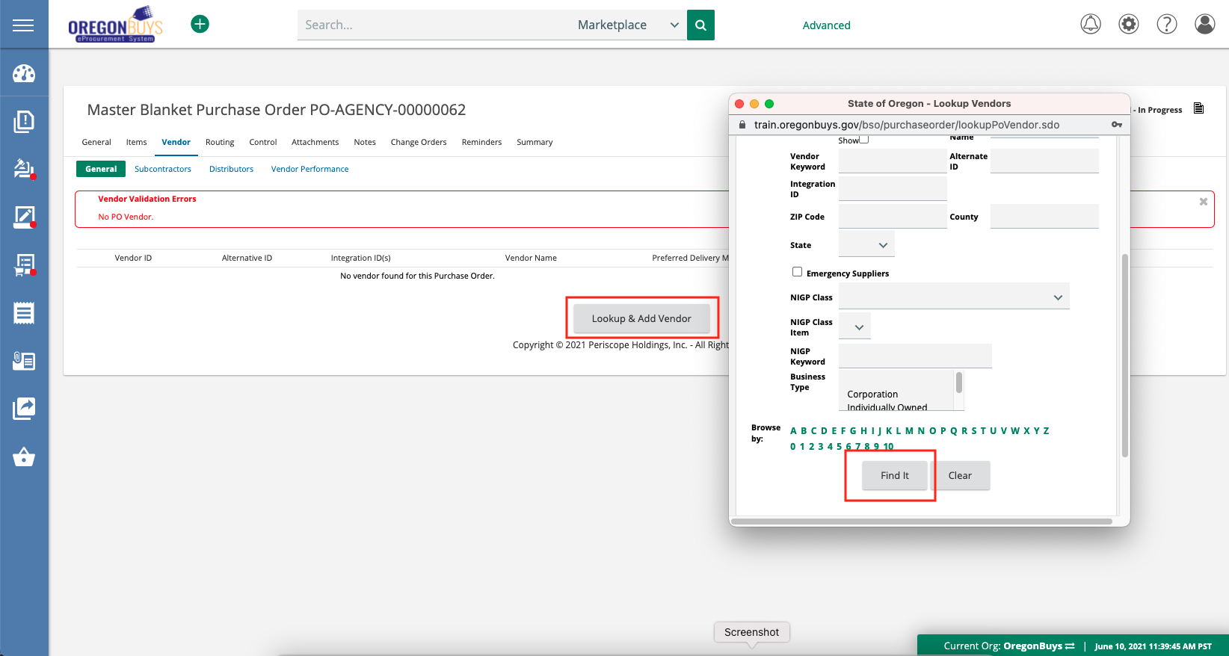
- For the MBPO to be used, a vendor must be assigned to the document. If your vendor cannot be found using search, they may not be registered. Vendors must be registered to receive MBPOs.
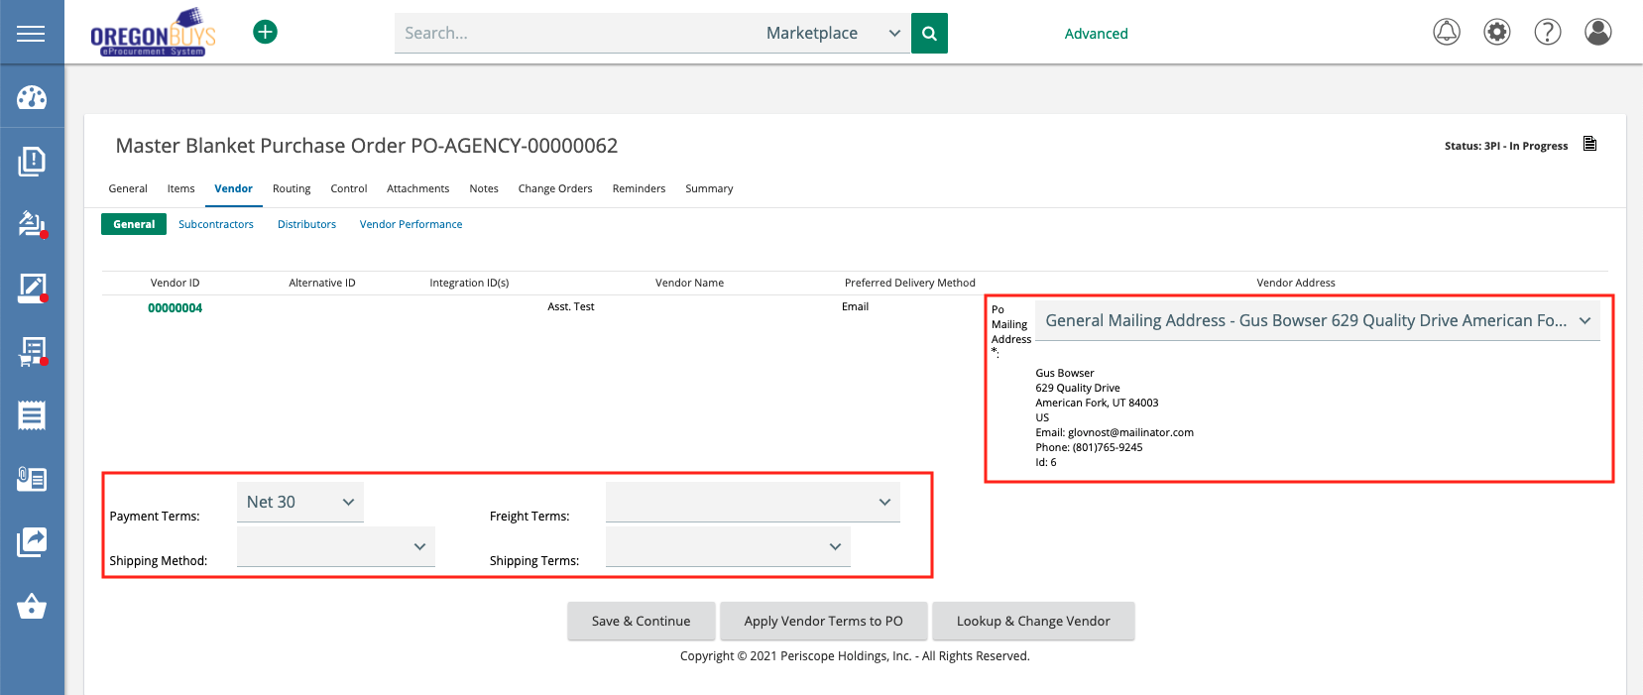
- Buyers should review the PO Mailing Address along with Payment Terms, Freight Terms, Shipping Method, and Shipping Terms

Control Tab
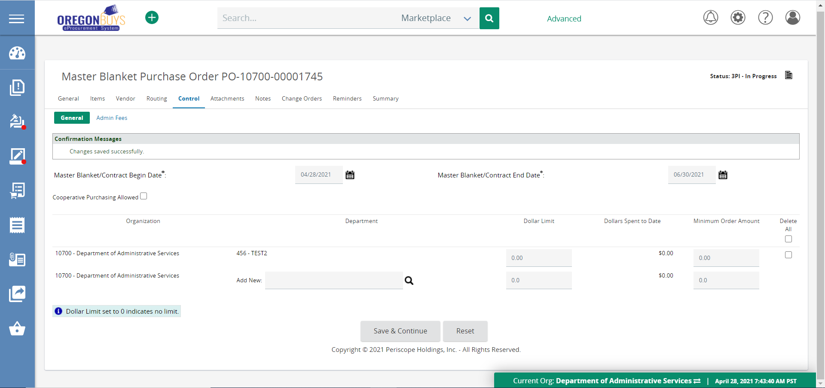
- Master Blanket/Contract Begin/End Dates – these fields represent the agreement begin/end dates. If orders will be placed against the MBPO, they can only be created/submitted between these dates.
- Cooperative Purchasing Allowed – Check this box if any other agency, other than your own, will be permitted to buy off of this contract/Price Agreement in the future. This enables multiple agencies to release/order against the MBPO. Used mostly for DAS and Statewide Price Agreements. Leave this box unchecked if only your agency will be buying off of this contract.
- Add New Organizations – this field allows the Buyer to search and add Agencies and/or OrCPP members that can release/order against the MBPO.
- Dollar Limit – this field is the total dollar amount that can be released against the MBPO.
- Minimum Order Amount – this field is the minimum amount that can be released at one time against the MBPO.

Attachments Tab
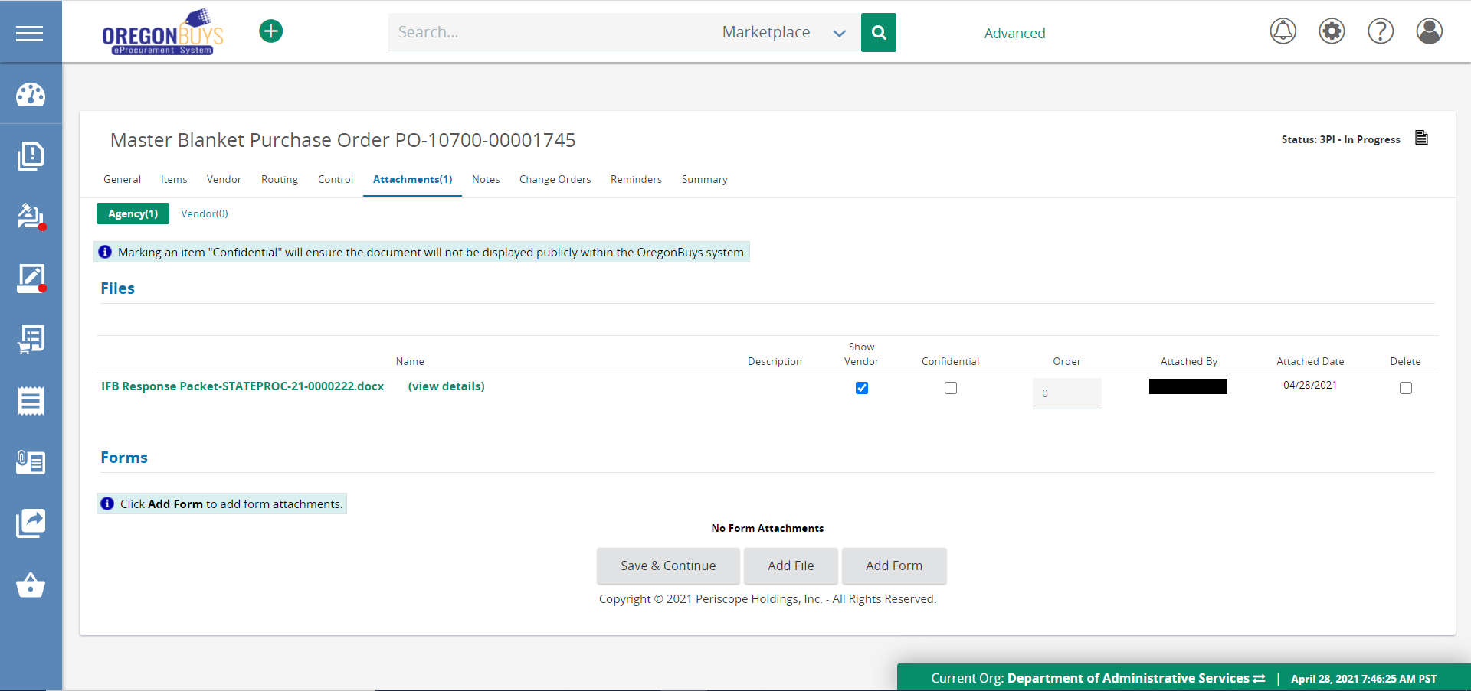
- Show to Vendor – the checkbox enables attachment to be viewed publicly.
- Confidential – this checkbox disables external users from viewing the attachment.
- Show to Vendor and Confidential (checked together) – Enables only the vendor(s) listed on the MBPO to view the attachment.
- Vendors can add an Attachment to the MBPO; Purchaser on MBPO will receive an email when attachments are added.

Notes Tab
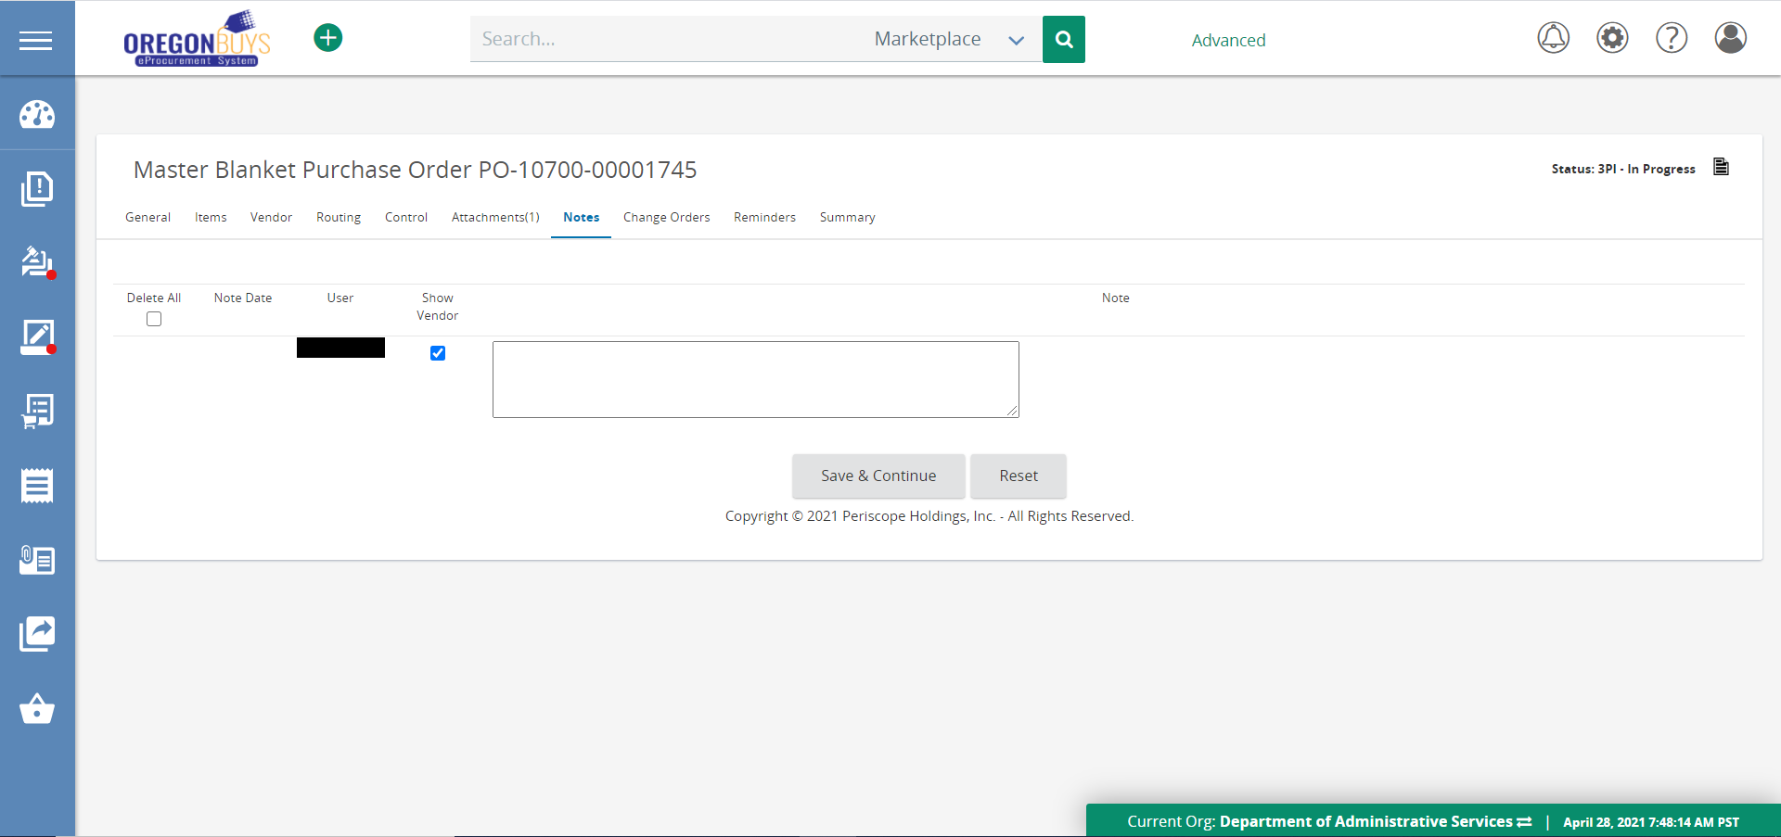
- The Notes Tab is used for internal notes.
- Can be shared with the vendor by selecting the Show to Vendor checkbox.
- Adding document history or other important information necessary to the MBPO is encouraged. Notes should be used as a keeper of important information and should not be substituted with an attachment to encourage shareability and enhance search results.
- Notes are subject to public record requests.

Reminders Tab
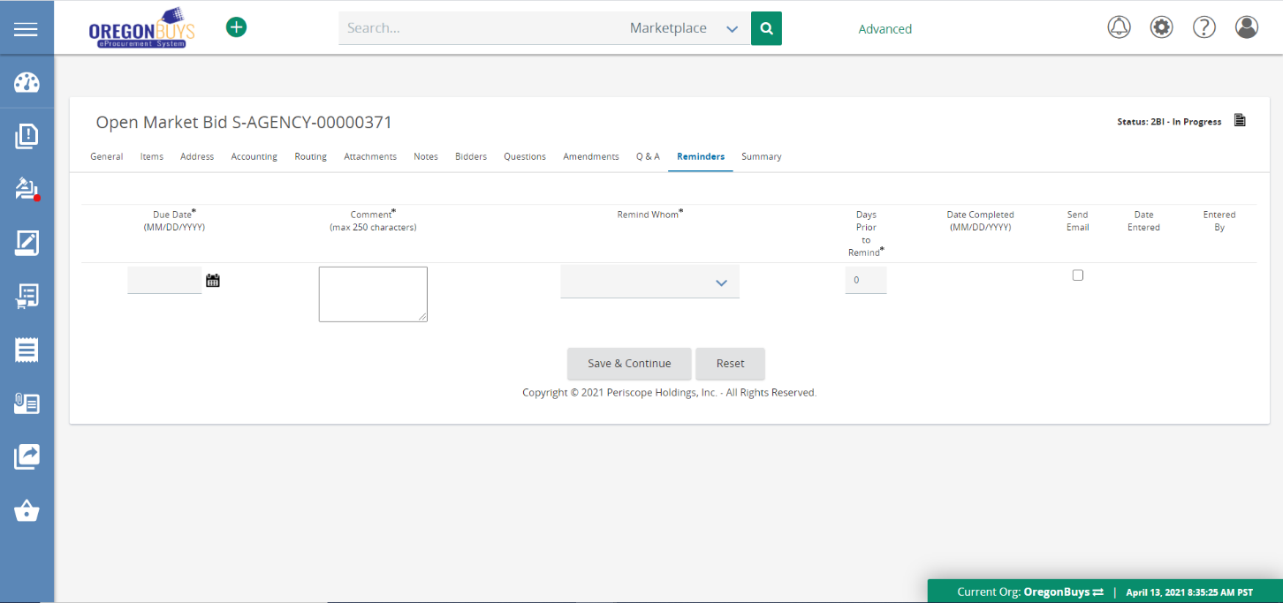
- Create reminders for users within OregonBuys that trigger at specific times.
- Set future reminder to self or division user reminding of upcoming contract expiration.
- Set reminder for team member to conduct a peer review.
- Set a reminder for a manager to review.

Change Orders
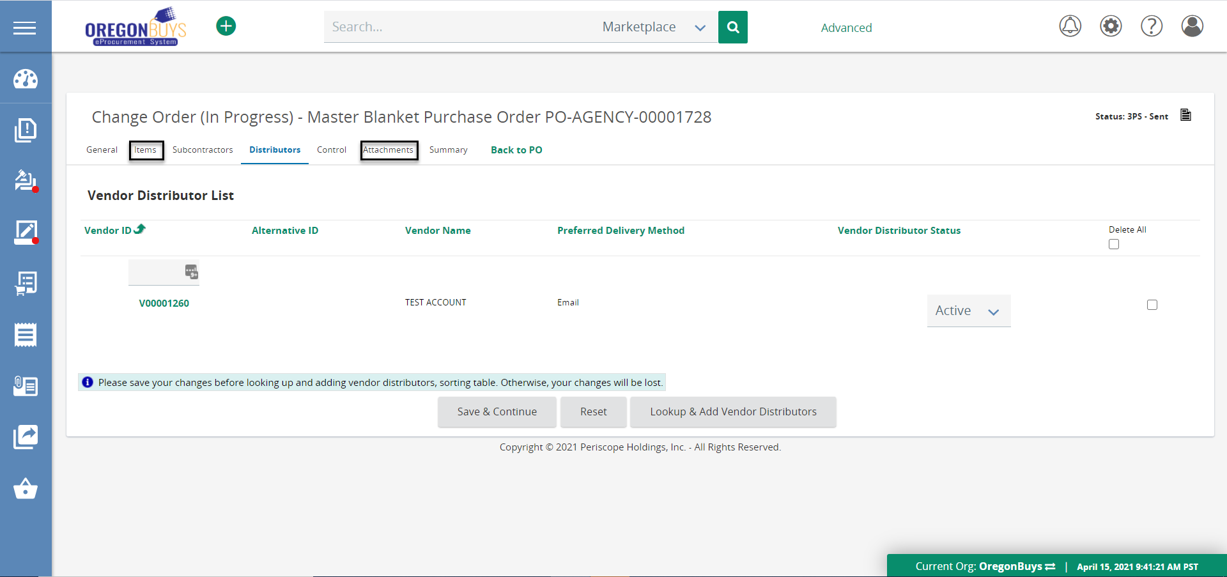
- Use when adding Attachments to the MBPO.
- Use to add Distributors on the MBPO .
  - Distributors are vendors who have the rights to sell items on manufacturers’ behalf. For example – Company X does not sell tires directly to the State but sells through local automotive shops.
- Use to add items or pricing of Items on the MBPO.
- Change Orders are used for administrative changes or for formal contract amendments.
What cannot be changed on a Change Order?
- Document Fiscal Year cannot be changed.
- Vendors cannot be changed.

Summary Tab on Change Order
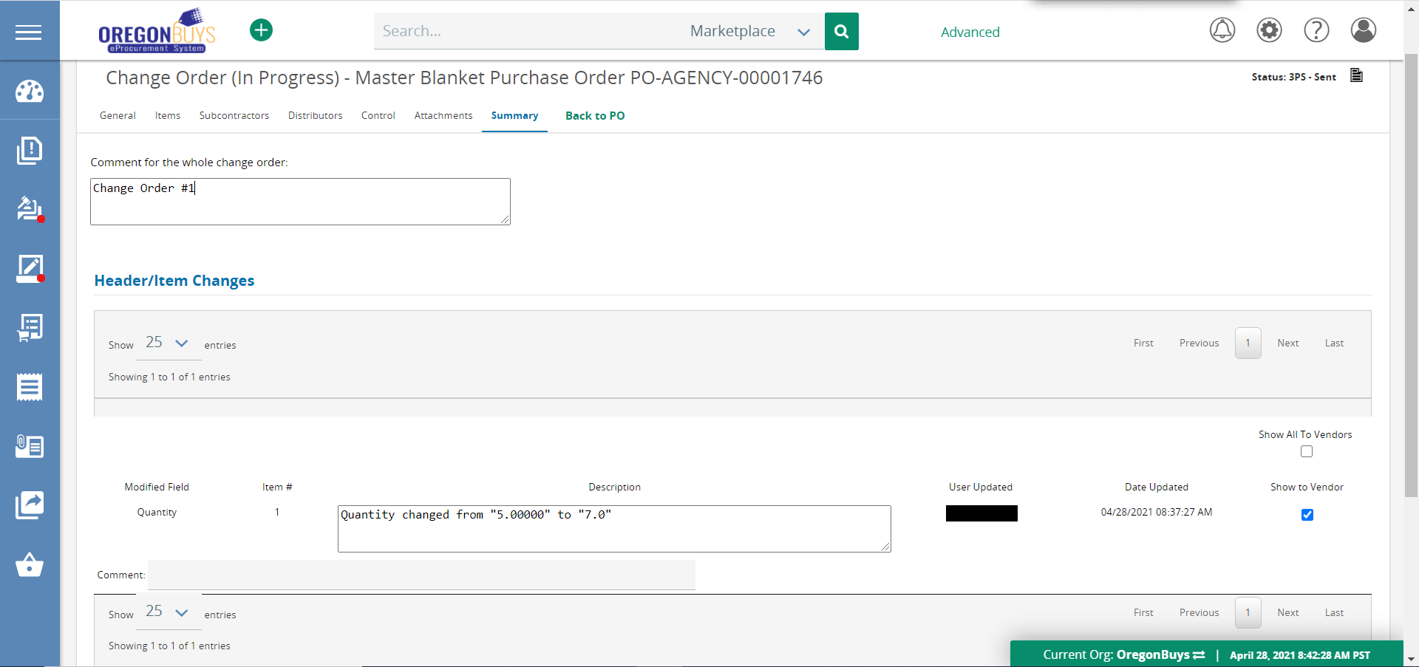
- Use the comment field for comments related to the Change Order
- Adding any text in the “Comment for the whole change order” will result in the vendor receiving notification of the Change Order with that text.
- Select Show to Vendor to show vendor modifications to the MBPO

