OregonBuys Agency Admin III: How to Modify a Product or Service List Uploaded on Behalf of a Supplier Guidance

Table of Contents
Introduction 2
Scenario 2
Prerequisites 2
Catalog Manager 2
Internal Catalogs 4
Update Product/Service List File 7
Summary of Changes 11

Introduction
This guidance document will cover the best way for a Department Access (DA) or Basic Purchasing (BP) user with Catalog Manager privilege to locate a Product or Service list uploaded on behalf of a Supplier and how to modify that Product or Service list and replace it with an updated version.
Figure 1: High Level Process Flow
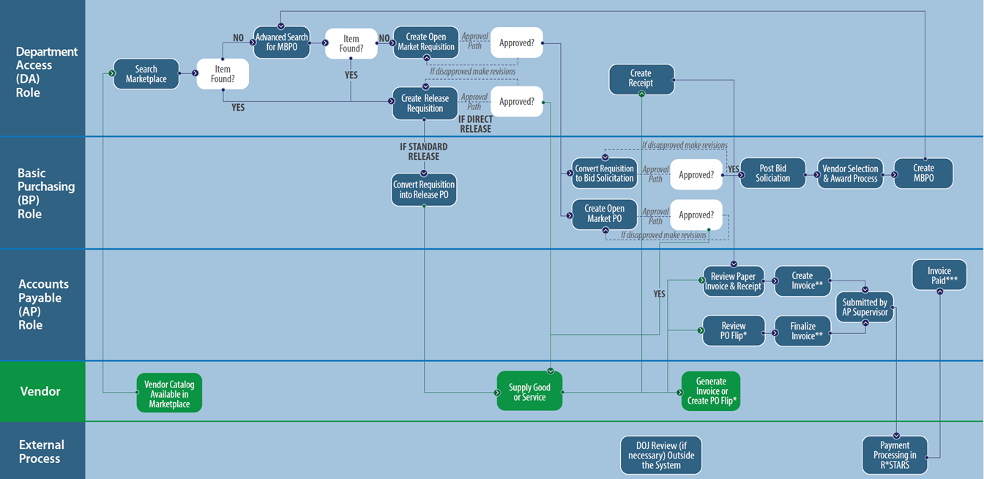

Scenario
A Master Blanket Purchase Order (MBPO) has been established in the Agency. The Product or Service list related to that MBPO has been uploaded in OregonBuys, either by the vendor or on behalf of the vendor. In order to link the uploaded catalog and the MBPO, the user must go into Catalog Manager to link the items together, so they appear correctly in Marketplace.

Prerequisites
- Catalog Manager user role is assigned to your user.
- A Product or Service list from the vendor is uploaded in OregonBuys and updates have been provided by the vendor.
- Information on the specific Master Blanket Purchase Order to be linked is available.

Catalog Manager
- To begin, navigate to the Internal Catalogs tab in Catalog Manager.
- Starting from the Home page, click the gear icon, and select Catalog Manager from the drop-down menu.
  - The page will redirect to the Catalog Library in Catalog Manager.
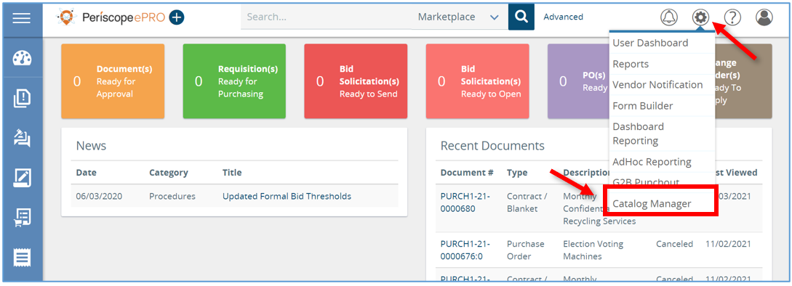
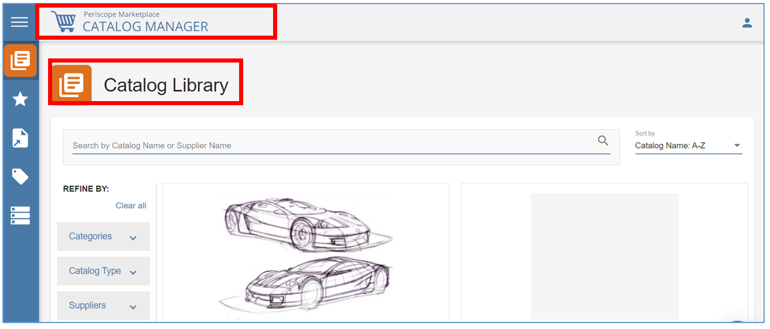

Internal Catalogs
- Next, hover the mouse over the left navigation bar and click Internal Catalogs.
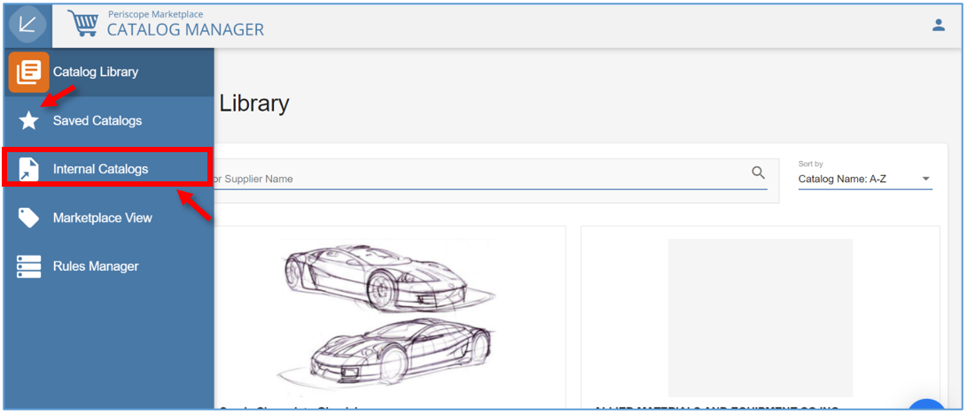
  - Here all the Internal Catalogs that an organization has already created will show.
- From here locate the Catalog that needs to be modified using the search bar or browsing by Catalog Name and Categories.
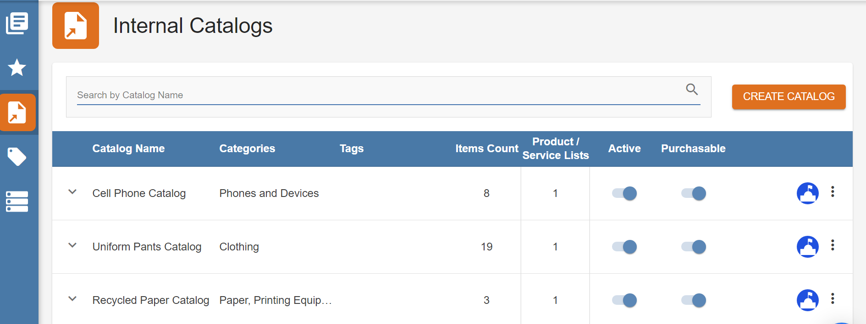

- Once the Catalog is selected, access the Product or Service List by clicking the drop-down arrow on the left of the selection.
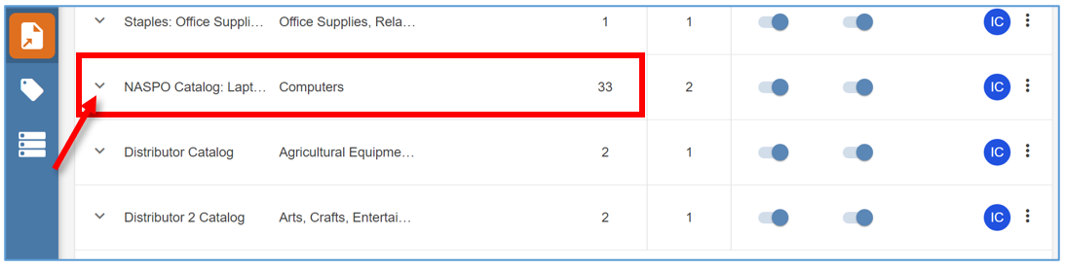
  - The status bar for the Product List on the Catalog selected will now show.
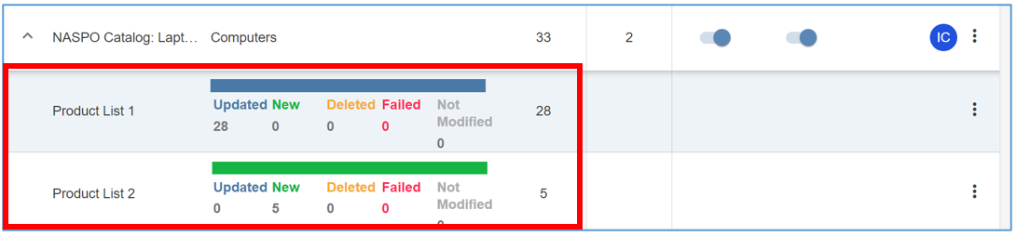
- Next, click the ellipsis on the right side of the status bar.
  - Then click Edit.
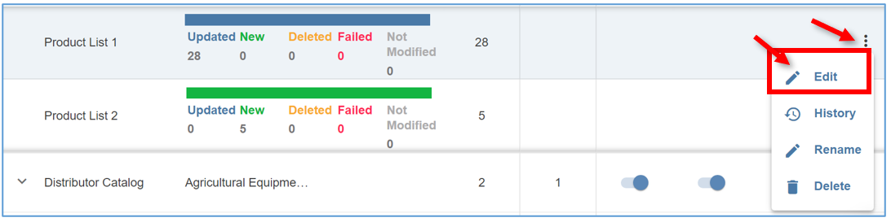

  - The page will redirect to Step 2: Create or Manage Your Product/Services Lists on the mapping screen.
  - This is where the replacement of the previously uploaded list takes place.
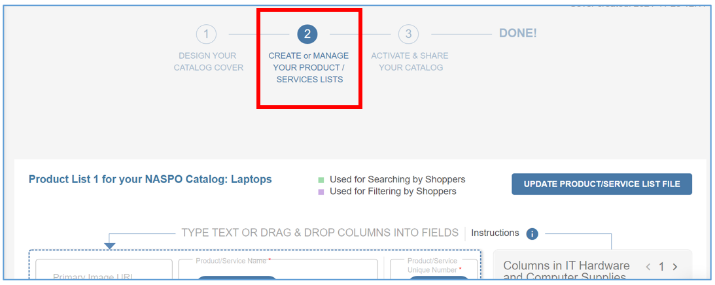
  - Below the button to Update Product/Service List Fill you can see the name of the current Product list which is the CSV file that was uploaded on behalf of the Supplier.
    - This name is seen in the below image with “Columns in File Name”.
  - IMPORTANT NOTE: When making changes to the Product List be sure to save the file using the exact same name as the current one. Keeping the exact file name will keep all the mapping already completed in place.
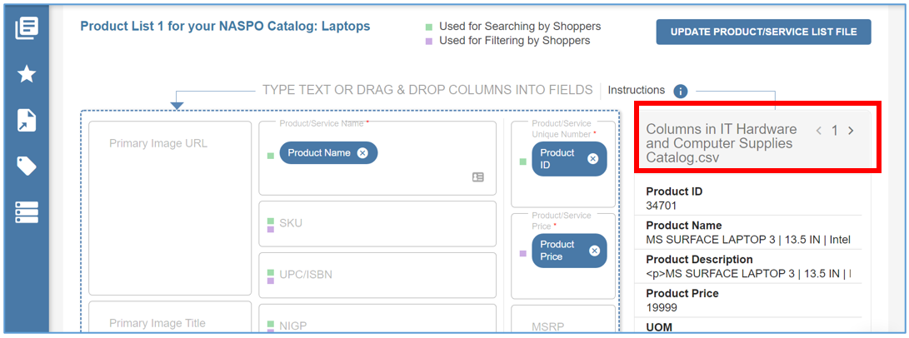
  - If the Product List is uploaded with a different name, you will need to start over on this page and re-map everything. It is important that you double check the Product List name before uploading.

Update Product/Service List File
- To replace the existing list with the new one, click Update Product/Service List File.
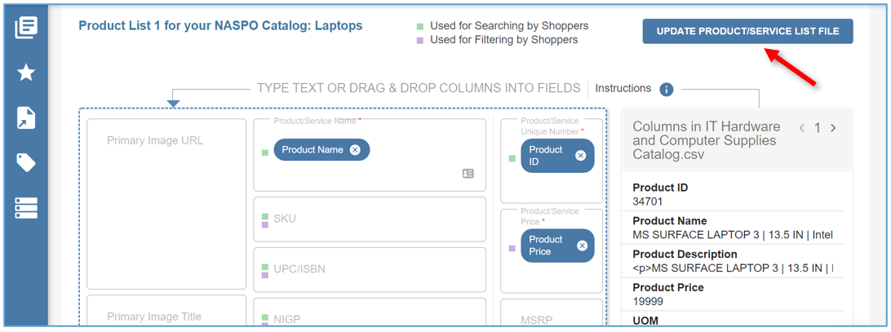
  - The page will now display a pop-up window in the middle of the screen.

- Click Add File in the window.
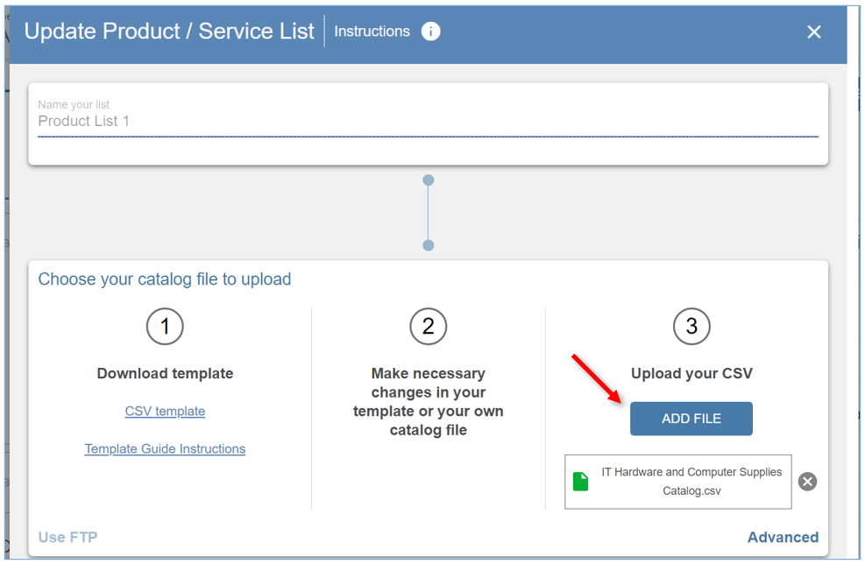

- Then locate and select the updated List from the saved location.
  - Click Open.
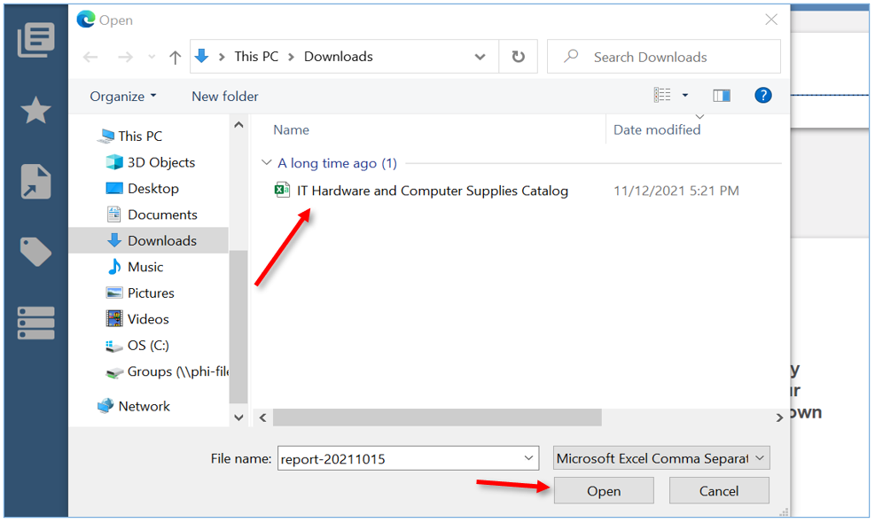
  - Here is the final chance to verify the CSV file name is the same as the previously uploaded name. If the name is not correct select Cancel on the left side of the pop-up window.
    - This will allow you to select the create file name of the updated list without having to re-map everything.
    - If the Product List is uploaded with a different name, you will need to start over on this page and re-map everything. It is important that you double check the Product List name before uploading.
  - Then click Update.
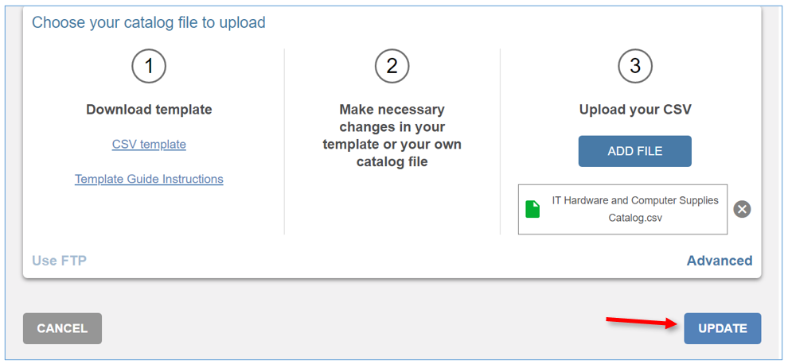
  - The page will refresh bringing you back to the mapping screen where all the mapping will show still in place.
  - If you need to update anything on this page, make those necessary changes first and then scroll down to the bottom of the page.
  - Select Preview to see the first 10-line items and to verify that everything looks correct.
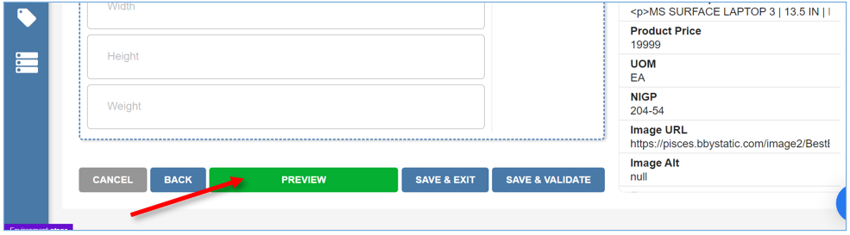
- Once you’re satisfied with the changes, click Save & Validate.
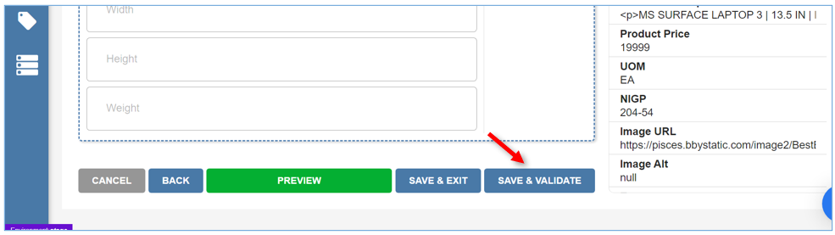
- As the Product/Service List is being validated, the progress will show here.
  - From here click Close or you can wait until the status bar shows complete at 100%.
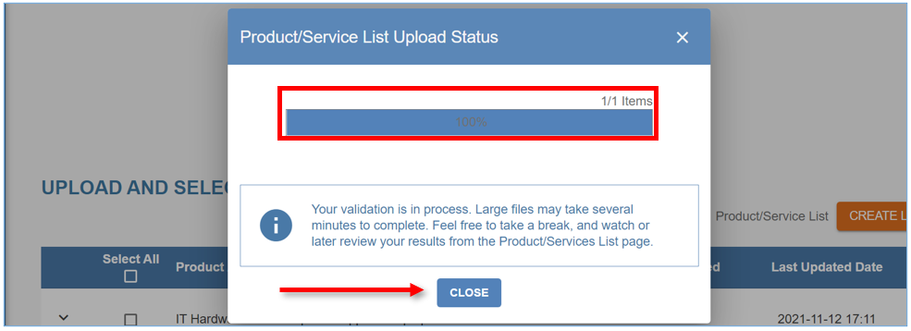
  - The next screen will show the number of Products and/or Services on the list that are uploaded and validated.
  - Once the Validated column displays Yes, the validation process is complete.
- Next click Save & Exit.
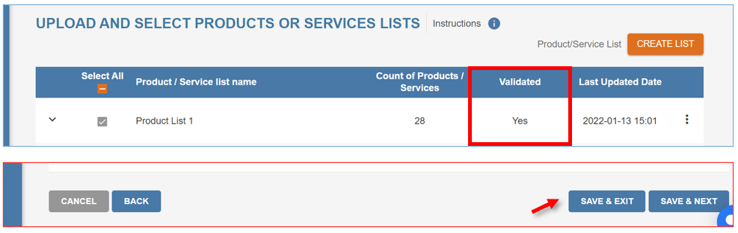

- The page will refresh back to the Internal Catalogs tab, completing the process.
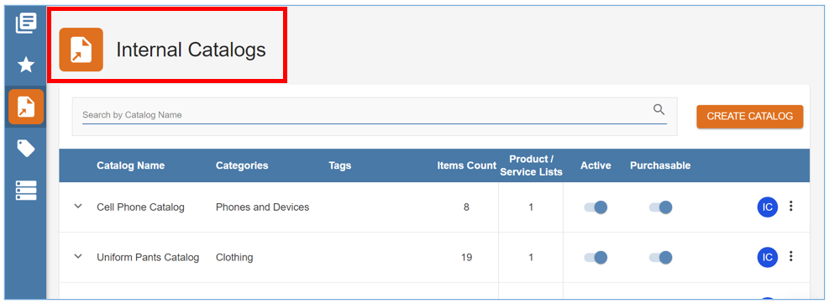

Summary of Changes
- To view a summary of the changes that were completed, navigate to the Catalog, and click the arrow on the Catalog again.
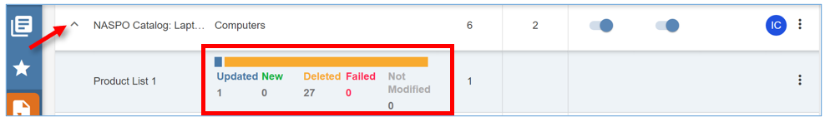
  - The Updated column will now display the number of existing products on the Product List that have changed.
  - If an item failed, you will see a red error message stating the Product List needs your attention.
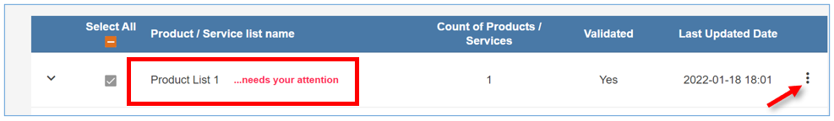
    - Click on the ellipsis on the right of the Product List and select Failed.
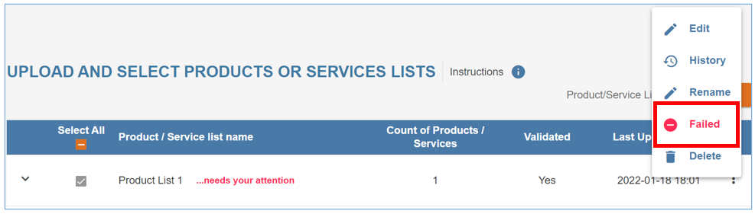
      - There will be a pop-up window letting you know that your Catalog has some Products/Services that did not load to Marketplace.
  - To review the Products/Services that failed, click on Download Report. The downloaded report defaults to a CSV format and there are some save options such as choosing save location.
  - IMPORTANT NOTE: When saving the Download Report CSV file - be sure to save the file using the exact same name as the current one.
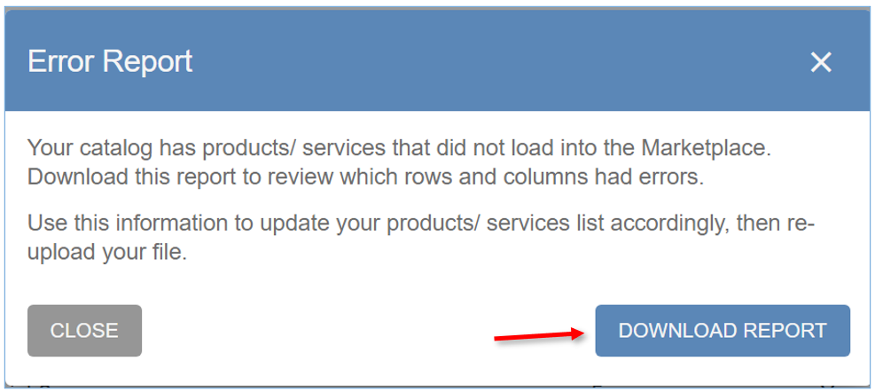
    - Then open the csv file that was downloaded and review errors on report.
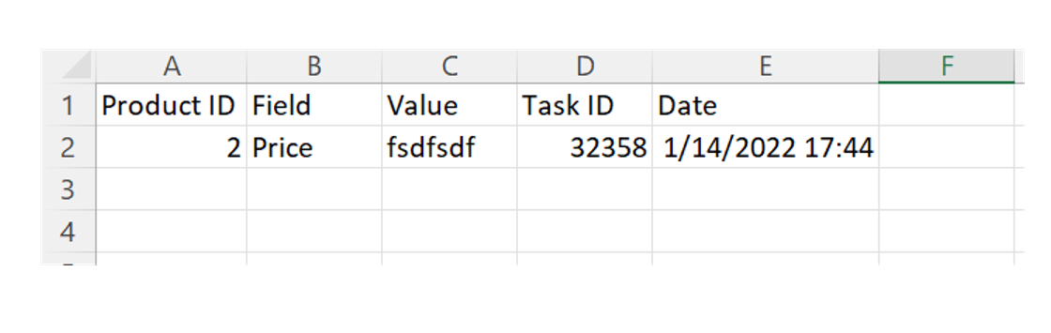
  - You will now need to update the list and re-upload the file.
    - Click the ellipsis on the right of the Product List.
    - Click Edit and update any errors on the saved product list csv file.
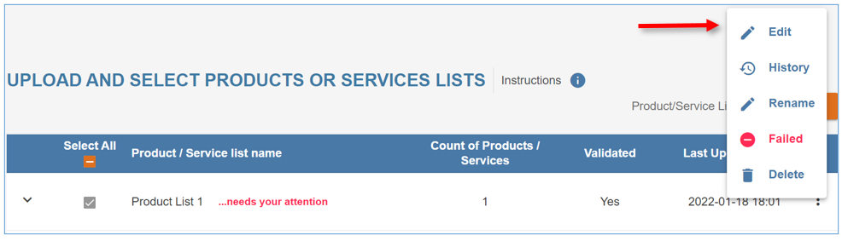
    - Once you’re satisfied with the corrections made, click Save & Validate
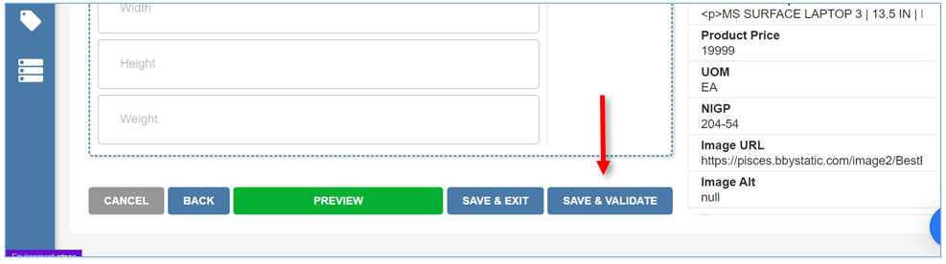

    - As the Product/Service List is being validated, the progress will show here.
    - From here click Close or you can wait until the status bar shows complete at 100%.
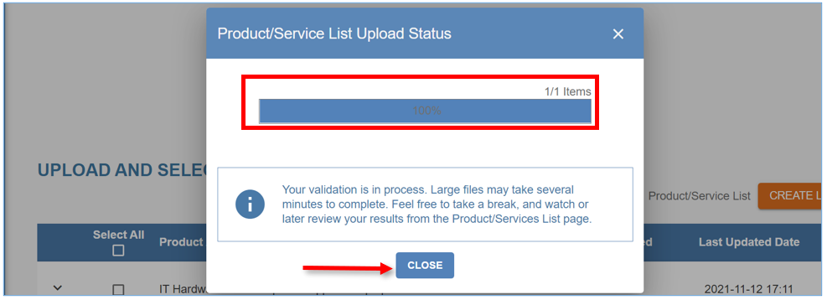
    - The next screen will show the number of Products and/or Services on the list that are uploaded and validated.
    - Once the Validated column displays Yes, the validation process is complete.
    - Next click Save & Exit.
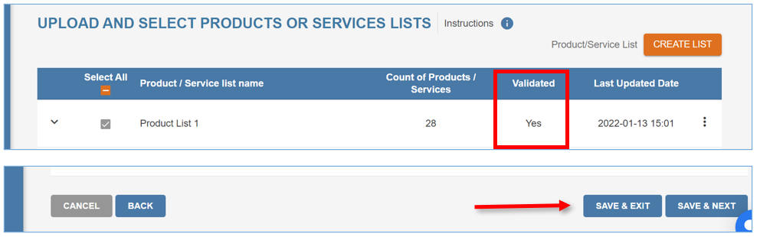

  - The changes that were made are immediately visible in Marketplace.

