Creating and Maintaining News Items

# Introduction

This guide explains how Organization Administrators create and maintain News Items for their organization. News Items appear on the homepage after login and can be used to post announcements to agency staff or link to documents and resources outside of the system.

Instructions

1. Log in to OregonBuys as an Organization Administrator, and go to the “System Configuration” tab.  
   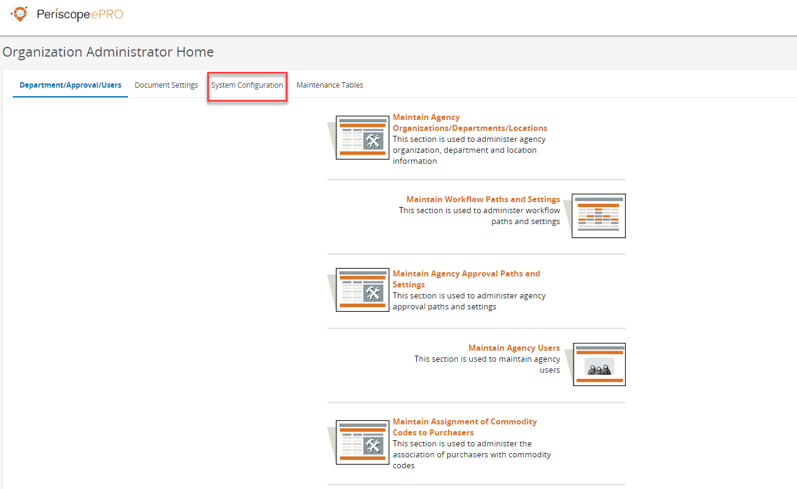
2. Select the third item, “Maintain News”.  
   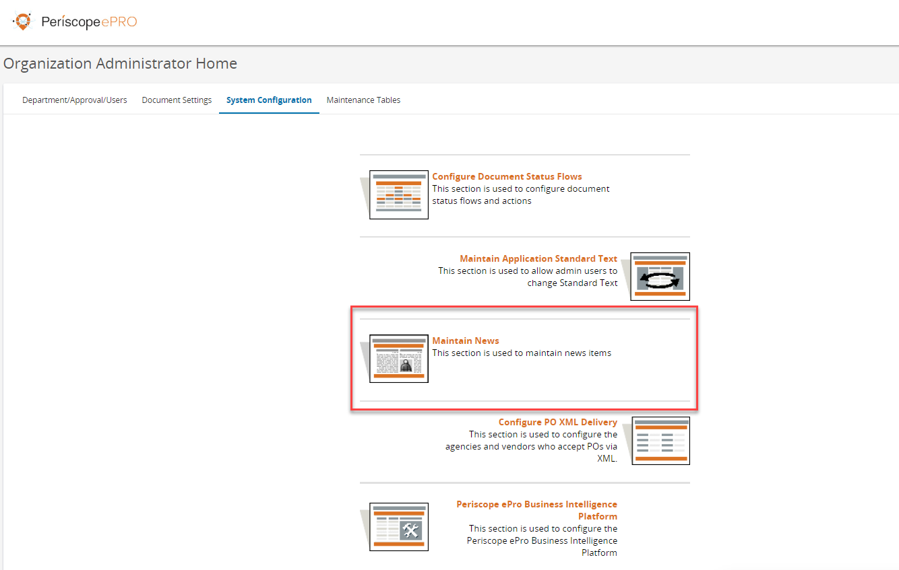
3. On the Maintain News page, choose either “Maintain News Items” to edit existing items, or choose “Add News Items” to create a new news item.

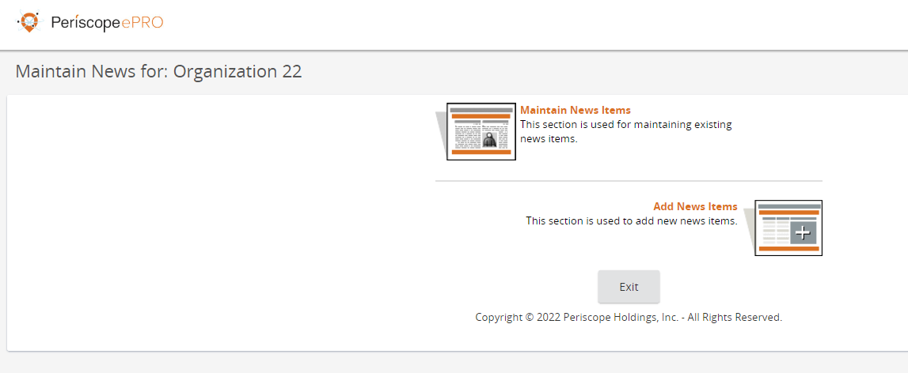

* 1. If you choose “Maintain News Items”, a list will open with existing news items for your agency (news items set by an IA for all Organizations do not appear here). Click on the applicable News ID number to open the Edit News Item window.   
     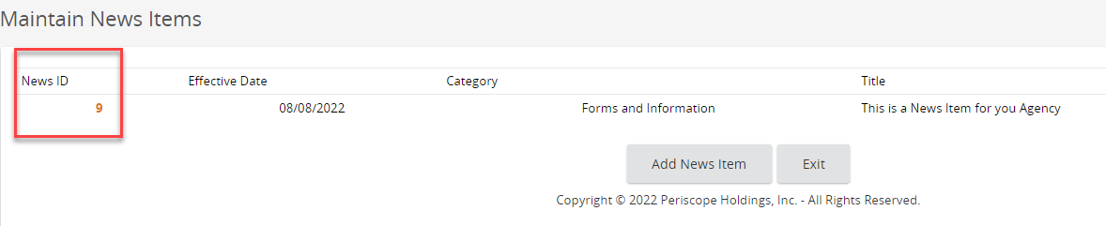
     1. In the Edit News Item window, make the necessary changes to the fields.  
        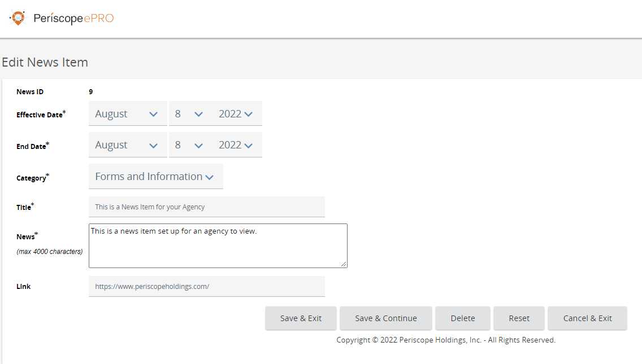
  2. If you choose “Add News Items”, a blank News Item screen opens where you can fill in the dates for the item, select the Category, add a Title and body, and input a link as needed.  
     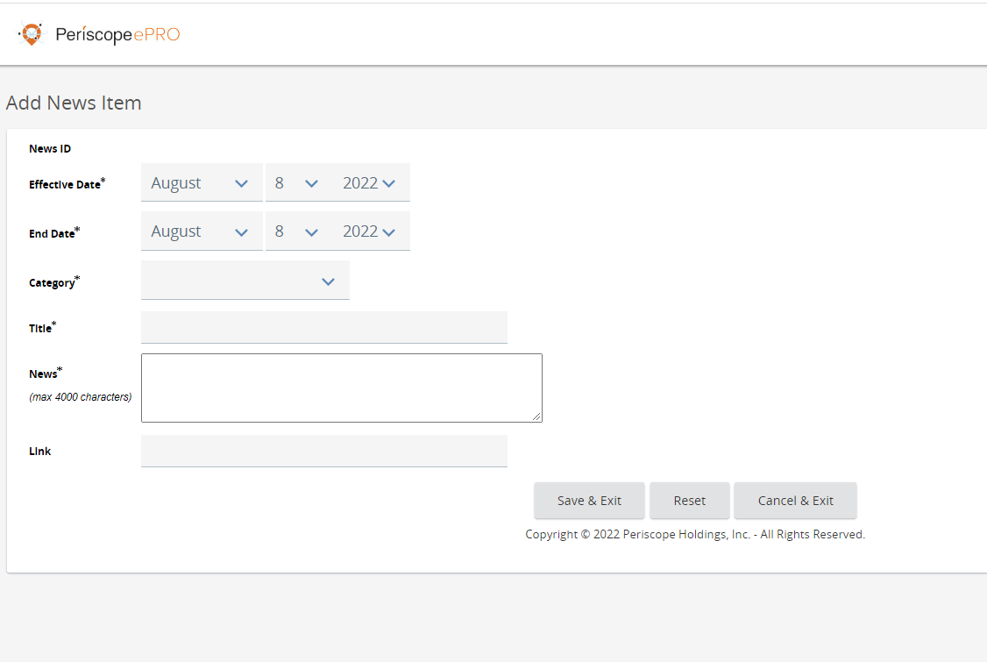

1. Select “Save & Exit” to save the changes made and return to the maintenance screen or select “Save & Continue” to save any changes and continue editing. Select “Delete” to delete the news item, or “Reset” to undo any unsaved changes. Select “Cancel & Exit” to not save any changes and return to the maintenance screen.