OregonBuys

Notice Guidance

Vendor Help Desk support.oregonbuys@oregon.gov or 1-855-800-5046
State Agency / OrCPP User Help Desk epro-support@periscopeholdings.com or 1-888-472-9102

Table of Contents
Overview 3
Organizational Structure 3
DASOBO – DAS on-Behalf Of: 3
Agency Specific Organization: 3
How to Post a Notice 4
Step 1 – Log into OregonBuys 4
Step 2 – Check to make sure you are in the correct OregonBuys Organization 5
Step 3 – Create the Notice 5
Step 4 – General Tab 7
Step 5 – Items Tab 9
Step 6 – Attachments Tab 10
Step 7 – Notes Tab (optional) 13
Step 8 – Bidders Tab (Do Not Use) 13
Step 9 – Reminders Tab (optional) 13
Step 10 – Summary Tab, Review and Submit for Approval 13
Step 11 – Post the Notice 14
SPECIAL PROCUREMENT PROCESS: 15
Step 12 – Notify DAS PS When the Notice Is Posted 15
Step 13 – Wait for the Protest Period to End 15
Step 14 – Proceed with the Special Procurement 15

Overview
This Notice Guidance document demonstrates the general Notice process inside of the OregonBuys system. In some instances, such as a Special Procurement or other type of solicitation, there are unique system requirements that will be needed. These are also referenced in this document.

NOTE: The Intent to Award process WILL NOT utilize this general Notice process. Instead, the Intent To Award is attached to the Bid as a Bid Amendment.

Organizational Structure
Each Agency’s Core Team set up their Agency’s structure in OregonBuys as an Organization with Department(s) and Location(s). This can be a little confusing because the system uses terminology that does not directly correlate to Oregon’s business, so a Department or Location may actually represent the Agency’s divisions, business units, or something else, as determined by the Agency’s Core Team.

DASOBO – DAS on-Behalf Of:
Requests for DAS PS to do work on behalf of a non-DAS agency will be submitted to the DASOBO Organization and any resulting solicitations and contracts will be developed and published there as well.
The DASOBO Organization has a single Department of AGENCY – State Agency with a Location set up for each agency with an active contract that DAS PS maintains as [Agency Org ID] – [Agency Name]. If a Location has not been set up to represent the agency in DASOBO, the Agency DPO will need to follow the instructions in the DASOBO Guidance for Non-DAS Agencies to get set up.

Agency Specific Organization:
If the agency is performing their own procurement internally, the agency should be sure to identify the specific organization in which the work is needing to be completed. This is noted as some Agency’s have more than one Organization in which they can complete work.

How to Post a Notice

Step 1 – Log into OregonBuys
- Navigate to https://oregonbuys.gov/bso
- Select the orange “Sign In” button to bring up the pop-up box to input login credentials 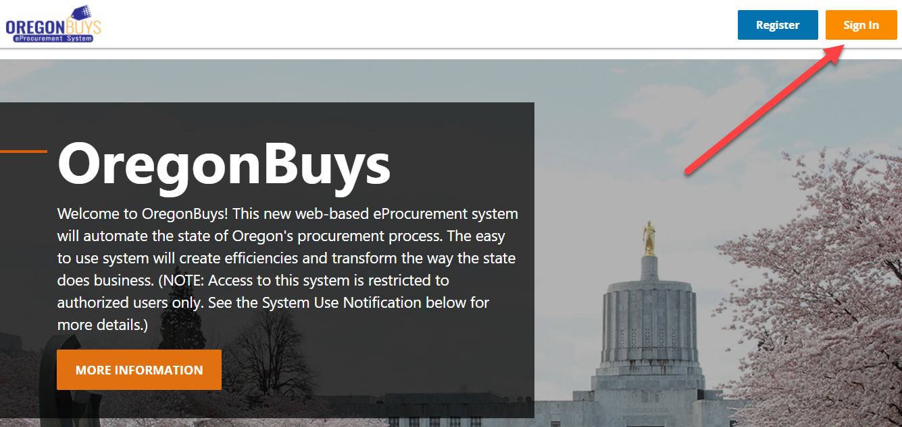
- Enter your OR Number as the Login ID, enter your password, and click Sign In
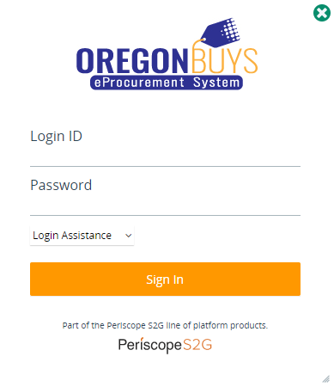

Step 2 – Check to make sure you are in the correct OregonBuys Organization
NOTE: Most users will only have access to one OregonBuys Organization inside of OregonBuys. However, some users may have access to more than one OregonBuys Organization depending on the type of work they perform or help support

- Check your Current Organization in the green banner on the bottom right corner of the screen
- If you are not in the Organization that represents the posting Agency, click the double arrows to switch:
For example, a DAS PS user might click the double arrows to switch to the DAS On-Behalf Of organization option and click Select:
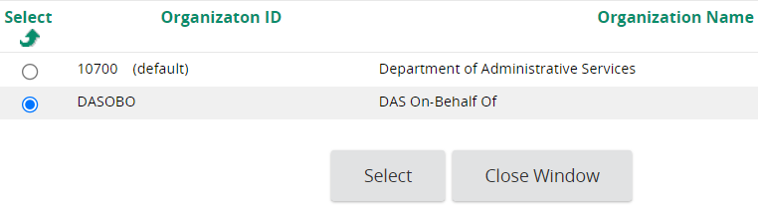

- If the correct Organization is not appearing contact the agency Help-Desk at
epro-support@periscopeholdings.com or 1-888-472-9102

Step 3 – Create the Notice

- Click the green ‘+’ symbol at the top of the screen and select Bid Solicitation (this is the best document type in OregonBuys to represent a Notice)
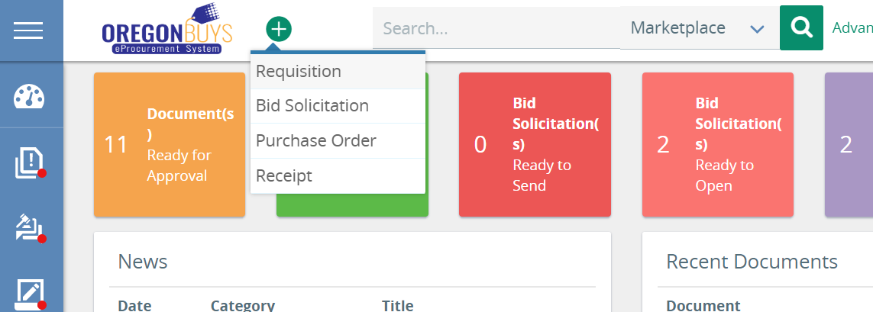
- Select Create a bid from scratch and click Continue to create the Notice document
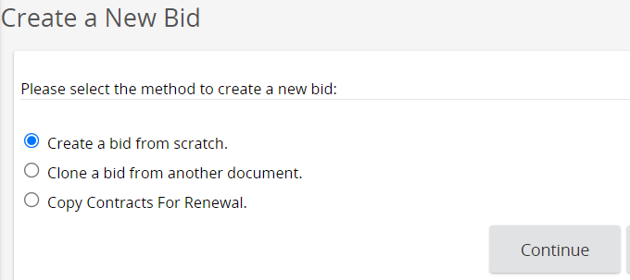
- The screen will reload on the General tab of a New Bid and the document number will not be generated until all of the Required Fields * are complete and the Save & Continue button is clicked.
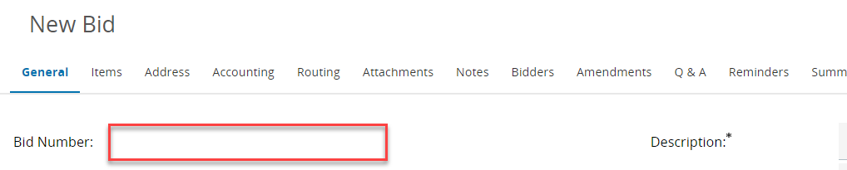
Proceed to the next step for more details about the General Tab fields.

Step 4 – General Tab
The General Tab is where the posting Agency can describe the overall details of the Notice in a searchable and reportable way. Agency must complete all Required (*) fields before saving, but the Agency may require the use of optional fields to help facilitate searching and reporting.
Below are the minimum requirements for completing the Notice.
- Complete the fields at the top of the New Bid to reflect the Notice
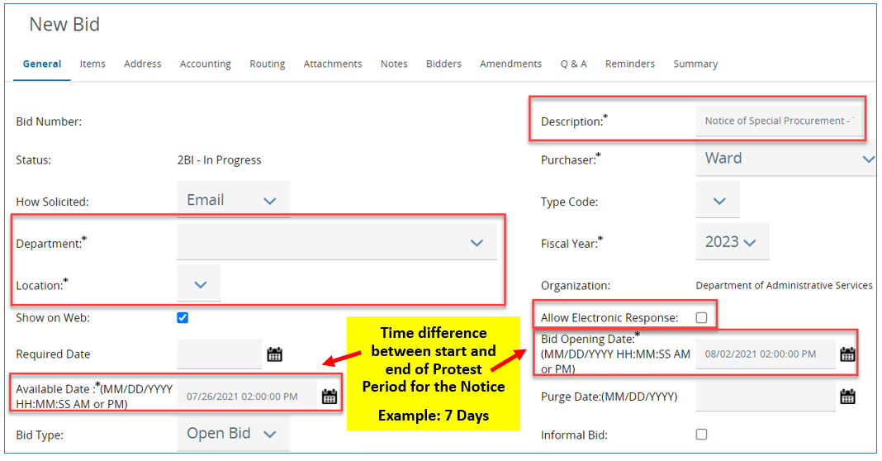
- Description – Enter “Notice of (fill in the blank): [unique title of the Notice]”
- Department – Select the Agency’s Department that is performing the procurement
- Location – Select the Agency’s Location that is performing the procurement
- Allow Electronic Response – Uncheck this box to prevent Vendors from submitting Quotes
- Available Date – Date/Time to make the Notice visible to the public
IMPORTANT TO UNDERSTAND: The Available Date is a required field to proceed with remaining Notice work. This date can be adjusted later once you have completed the remaining Notice work and are confident of the exact date that will be needed.
Please note some organizations have additional Approval requirements which can take extra time to obtain and should be factored in when determining the correct Available date.
Also, the Notice becomes publicly visible on either the Available Date or Sent Date – whichever comes last. The Notice also needs to be “sent” in the system by you or someone working with you on your behalf. (See Step 11 – Post the Notice below)
- Bid Opening Date – Minimum required full calendar days after Available Date, marking the end of the protest period for the Notice (NOTE: This depends on the type of solicitation)
- All other fields in this screenshot are either optional or should default to the correct setting
- All other fields above the red box may be ignored when posting a Notice
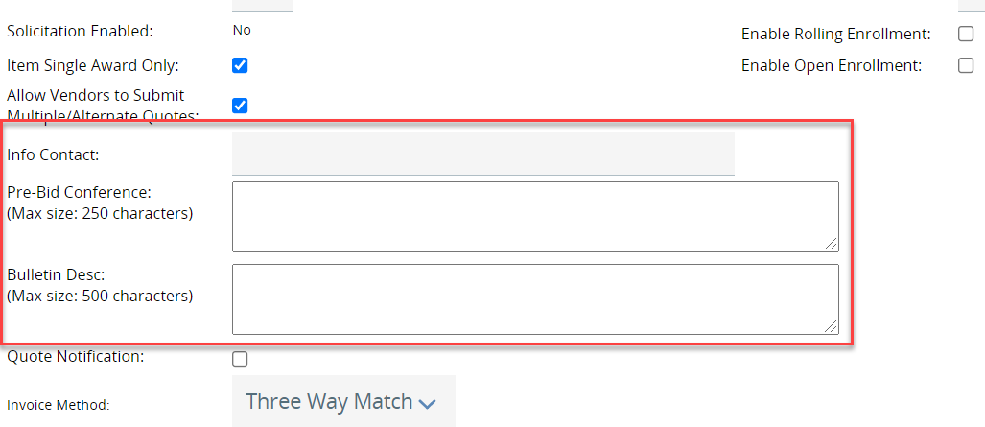
- Info Contact – Enter “See Attached (fill in the blank) Notice”
- Pre-Bid Conference – This field may be left blank unless otherwise needed
- Bulletin Desc – Enter “THIS IS A NOTICE, NOT A BID. SEE ATTACHMENTS FOR INFORMATION”
- Complete the Custom Columns (these are the Bold fields at the bottom and may differ slightly if your Agency added Agency Specific Custom Columns)
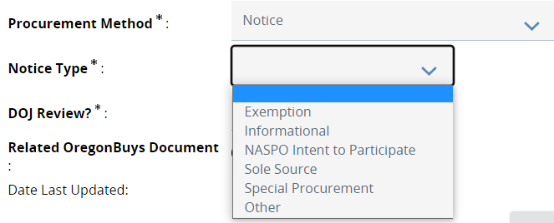
If the Exemption, Sole Source or Special Procurement Notice Type option is selected, an additional required field will appear where the Approved Special Request Number will be input into the system. (NOTE: This will be the Open Market Requisition number that was submitted to and approved by DAS PS).

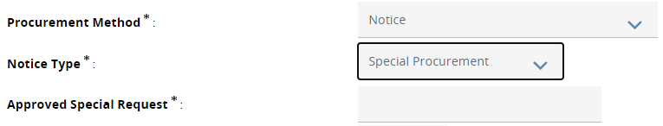
Select “Other” if a Notice is being posted that is not provided. An additional required field will appear to further input detailed information where you can explain what is occurring.
- Discipline Type – Select the best Discipline Type of the procurement
- Procurement Method – Select Notice
- DOJ Review? – Select No
- Related OregonBuys Document – Optionally link to a related document within the same Organization as the Notice (i.e. an existing Award or Solicitation)
- Click Save & Continue to save your progress!

Step 5 – Items Tab
The Items Tab requires adding at least one Normal item with some pieces of required Item Information which includes the Description, NIGP Code and Quantity fields.
The Description field is used to provide details about this Notice.
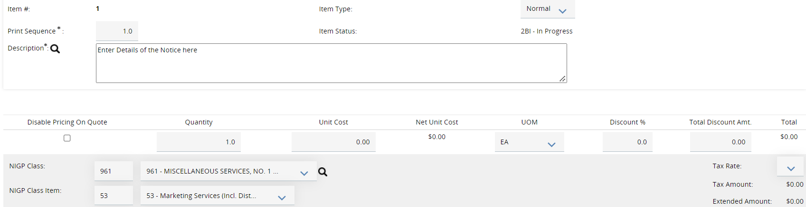
- Click the Items tab to add any items relevant to the Notice
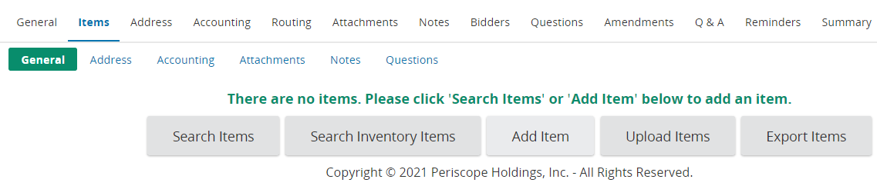
- Click Add Item to add a new line item
- Provide enough relevant info to explain the need (NIGP code, Description, UOM, etc.):
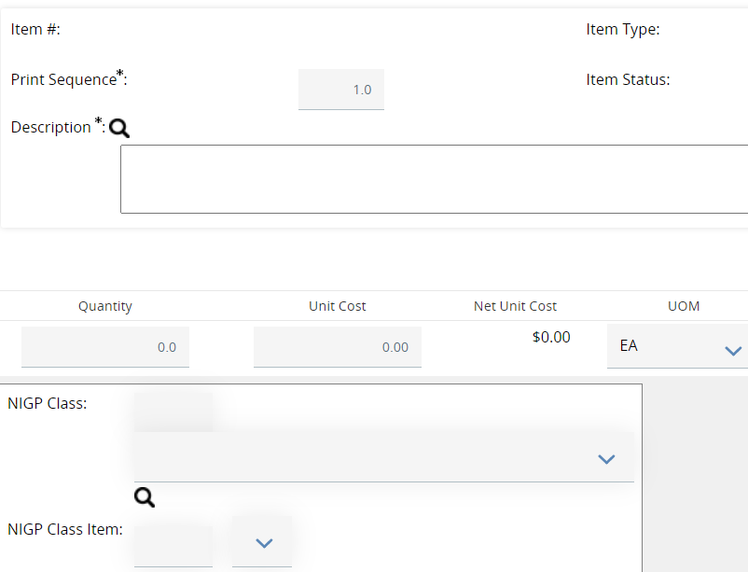
- Include any relevant Additional product information (i.e. Brand Name Determination)
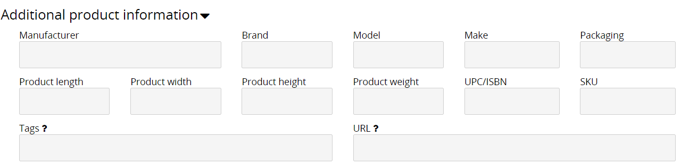
- Click Save & Add New to save your progress and to generate a new line item
- Click Save & Exit to save your progress on the Items tab and view all completed items

Step 6 – Attachments Tab
Attach the Notice and any other documents relevant to the public notice.
(NOTE: If a Protest Period is required, refer to and use your agency’s standard Protest Period documents and language. OregonBuys fills the public posting requirements. The submission and processing of Protests occur outside of the OregonBuys system. Attach all necessary instructions for vendors/suppliers to submit a Protest on the “Attachments Tab” of the Bid page.)
Steps to Attach documents:
- Download, complete, and/or compile all materials that are relevant to this public notice. Please name your documents with something meaningful and descriptive of what it contains. For example:
  - Notice of Special Procurement.pdf
  - Approved Special Procurement.pdf
  - (optional) Supporting documentation
- Click the Attachments tab, then click Add File
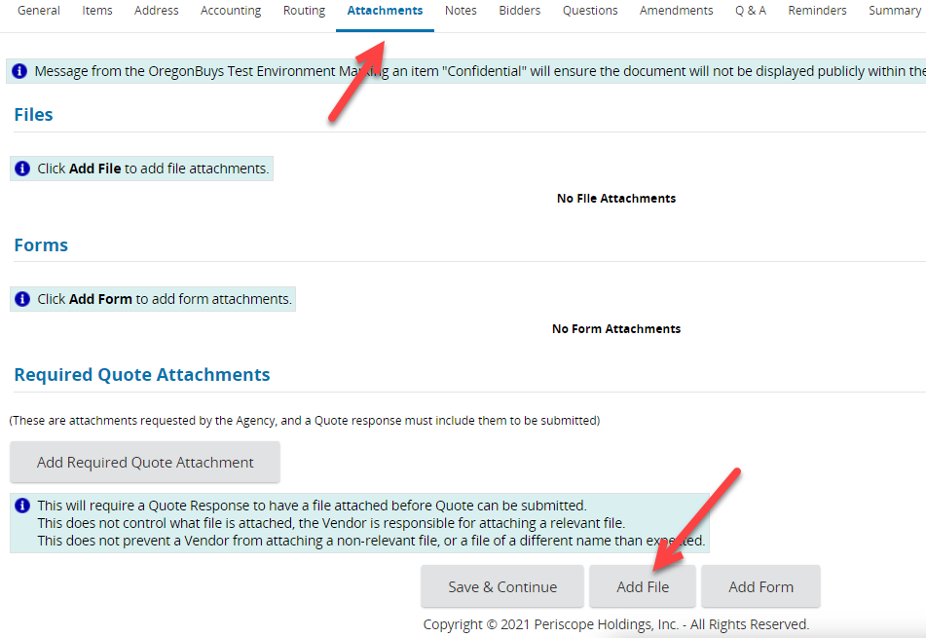

- Choose the document to upload either by:
  - Clicking Choose File, navigating to the document, and double clicking the desired document in the new window (or selecting it and clicking Open)
  - OR simply drag and drop your attachment onto the Choose File button
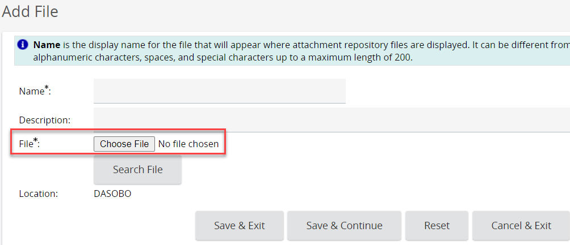
- Name the document. The Name field automatically populates with the document name and extension, so you can save yourself a little time by naming it something meaningful before attaching it!
- The Description field is an optional field that allows more detail regarding the attached document. Suggested best practice is to include a Name (Approved Special Procurement) and Description (Approved Special Procurement to procure something special)
- Emails cannot be attached as files; Agencies will need to save emails in a different file format to be able to attach them
- Click Save & Exit. Once all the attachments are added move to the next step.
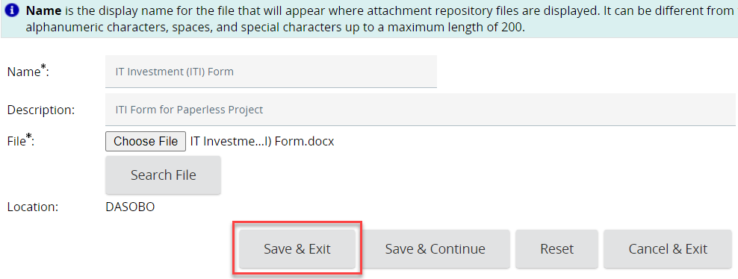

Step 7 – Notes Tab (optional)
- Optionally, add a note to the Notice for future reference. These are internal notes only.
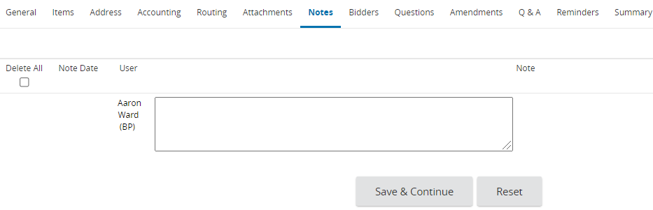

Step 8 – Bidders Tab (Do Not Use)
- DO NOT USE – This tab is used to notify vendors of a Bid Solicitation. Agencies are posting a Notice and do not need to notify the vendors directly

Step 9 – Reminders Tab (optional)
- Optionally, set a Reminder to remind the procurement professional of upcoming tasks
  - For example, the procurement professional may set a reminder for one business day after the Open Date to confirm with DAS PS that no protests were received

Step 10 – Summary Tab, Review and Submit for Approval
* IMPORTANT REMINDER *
Double Check the Available Date and Bid Opening Date before Submitting!
Example: Special Procurement Notices must be visible for a minimum of Seven (7) Calendar days

- Click on the Summary tab and confirm that all of the entered information is complete and accurate
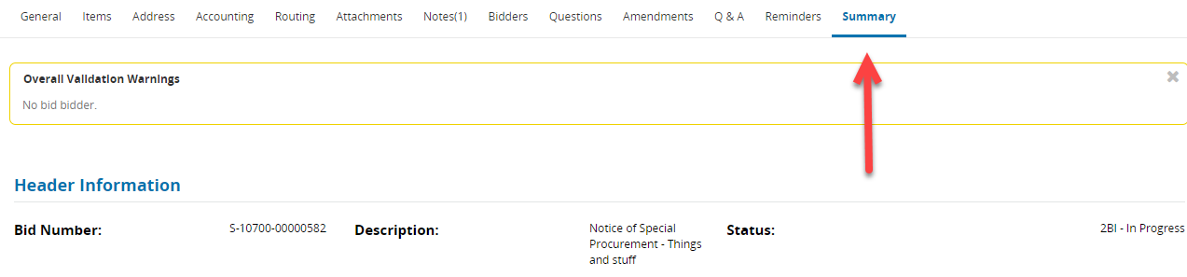
  - The No bid bidder warning indicates that Vendors will not be notified directly. This warning may safely be ignored when posting a Notice
- After validating all of the information is correct, click Submit for Approval followed by Continue to bypass the No bid bidder warning one last time
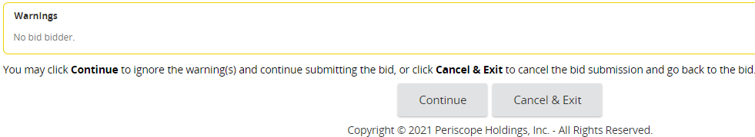
  - Agency Specific Approval Paths may need to be navigated at this point, if the Agency’s Core Team decided to set them up
  - If not, use the Automatic approval option to automatically approve the Bid (Notice)
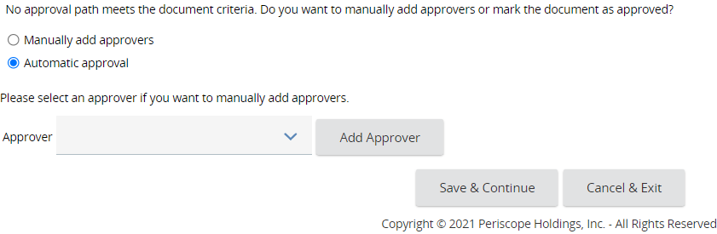

Step 11 – Post the Notice
Documents must be in “Sent” status in OregonBuys to be visible to the public. While “In Progress”, the document is still in draft and will only be visible to Agency users with access to the same organization.
- Select Change bid status to “Sent” only
  - Selecting this option will not send an email to the Vendors about this Notice, but it will be publicly available for Vendors to find in OregonBuys
- Click the Send Bid button to make the Notice visible to the general public
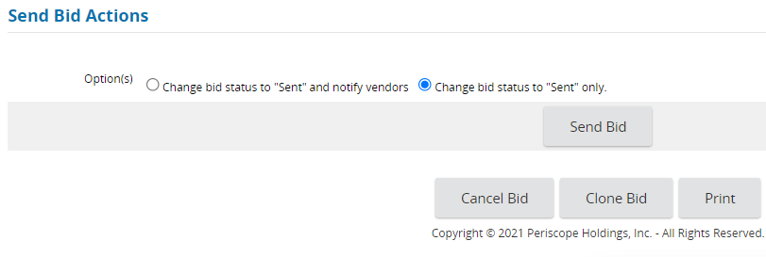

SPECIAL PROCUREMENT PROCESS:
For OregonBuys users who are working on a Special Procurement proceed with the following steps:

Step 12 – Notify DAS PS When the Notice Is Posted
- Click the Print button and download a copy of the resulting PDF
  - Rename this document “Posted Special Procurement Notice.pdf”
- Email the downloaded PDF to EGS.PSCustomerCare@oregon.gov and CC the DAS PS Policy Analyst who provided the final approval on the Requisition

Step 13 – Wait for the Protest Period to End
- DAS PS will notify the Agency via EGS.PSCustomerCare@oregon.gov after the Bid Opening Date/Time if any protests were received
  - If a protest was received, wait until DAS PS makes a final determination

Step 14 – Proceed with the Special Procurement
After confirmation from DAS PS that no valid protests were received, the Agency may proceed with the Special Procurement as described in the Approved Special Procurement.
The documents created for the next steps (i.e. Solicitation or Award) should be developed and posted in the Agency organization.

That’s it! Please report any errors or issues that you run into!

