Organization Administrator Guide to Creating a Department, Location, and Address in the OregonBuys

Introduction
This guide will help individual Agency Organization Administrators (OAs) in creating their required Department(s), Location(s) and associated addresses. Agency OAs will perform this activity before go-live to ensure that their agency users are assigned to the correct Department and Location.

Important Highlights
- When entering system IDs, Departments, Locations, and Addresses in the PROD environment, we recommend being as specific as possible.
- Department and Locations will be uploaded based on the Agency Configuration Templates provided by your agency
- The first Department ID should use the first 3-digits of your Agency Code, followed by T1. For example, the first Department ID would be 123T1.
- The first Department Name should be Business Unit 1.
- The second Department ID will follow the same format, except increase by 1. For example, the second Department ID would be 123T2.
- The second Department Name should be Business Unit 2.
- The first Department Suffix ID would mirror the Department ID, and the Department Suffix Name would be the Division associated with the address.
- The first Location ID would be an abbreviation of the Location Name. The Location Name would represent the Division within the Department or an actual location of your Department.
- The instructions above for entering the Department Suffix ID, Department Suffix Name, Location ID, and Location Name would apply to the second created Department.

Creating a Department with a Location and Address
This section includes a step-by-step process of how to create a Department, Location, and Address in the OregonBuys Training Environment.
- Login using your login credentials at train.oregonbuys.gov.
- Navigate to the right of the Homepage and click on the ‘Account’ icon.

- Click the ‘Down Arrow’ next to the current role you are logged in.
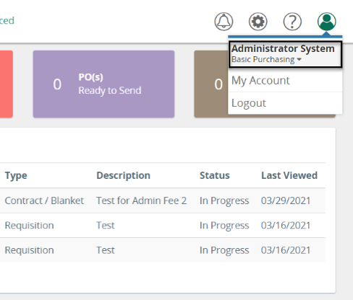
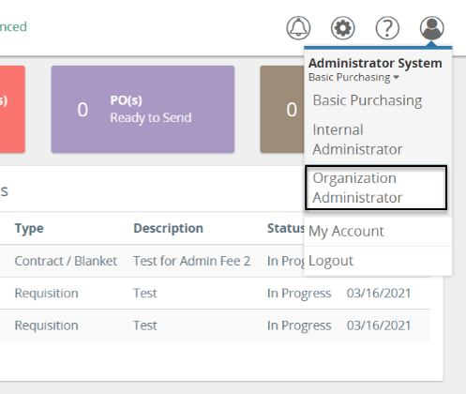
- Select the user role ‘Organization Administrator’ from the dropdown list.
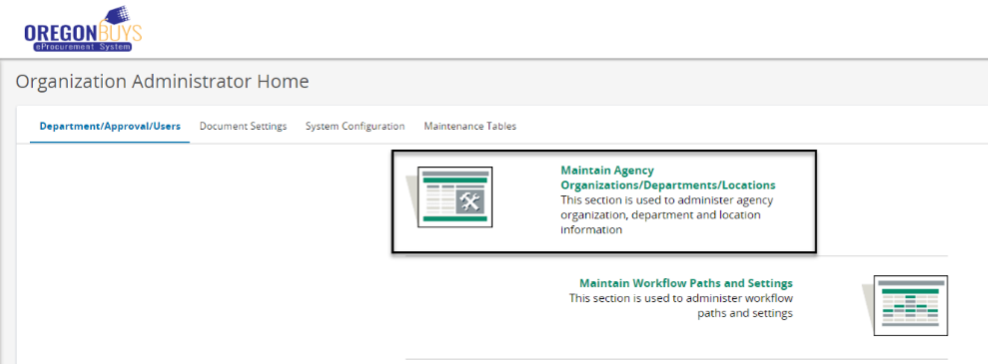
- Once you have arrived at the Organization Administrator Homepage, click ‘Maintain Agency Organizations/Departments/Locations’.

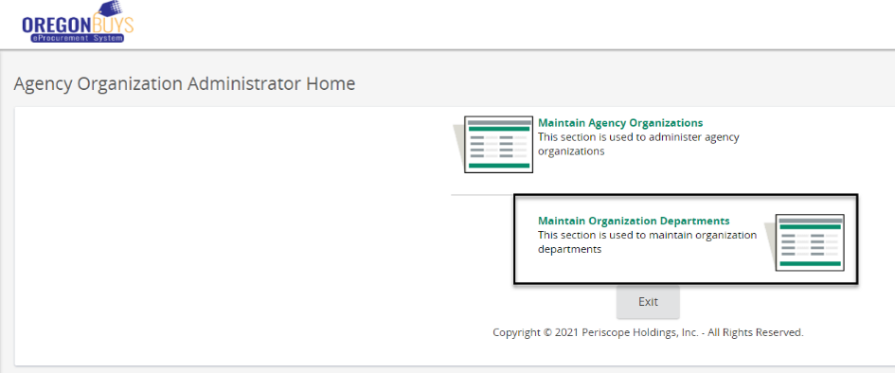
- Select ‘Maintain Organization Departments’.

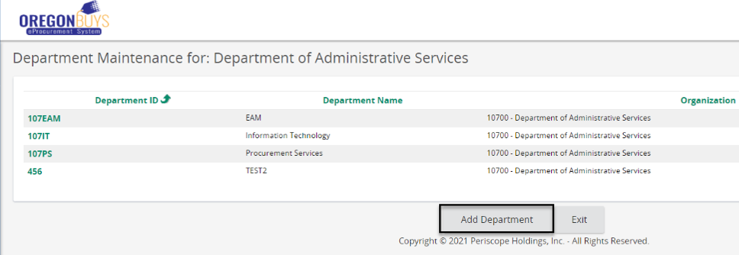
- Click ‘Add Department’

- Type your Department ID and Department Name, then click ‘Save & Exit’.
  - For ‘Department ID’, use your 3-Digit Agency Code, followed by T1.
    - For example – the Secretary of State’s first Department ID would be 165T1. Following this concept, each additional Department ID will increase by increments of 1. The second Department ID would be 165T2, etc..
  - For the Department Name, enter each business unit within your Organization.
    - For example - enter Business Unit 1 for your first Department. The next Department would be Business Unit 2.
  - Disregard other fields.

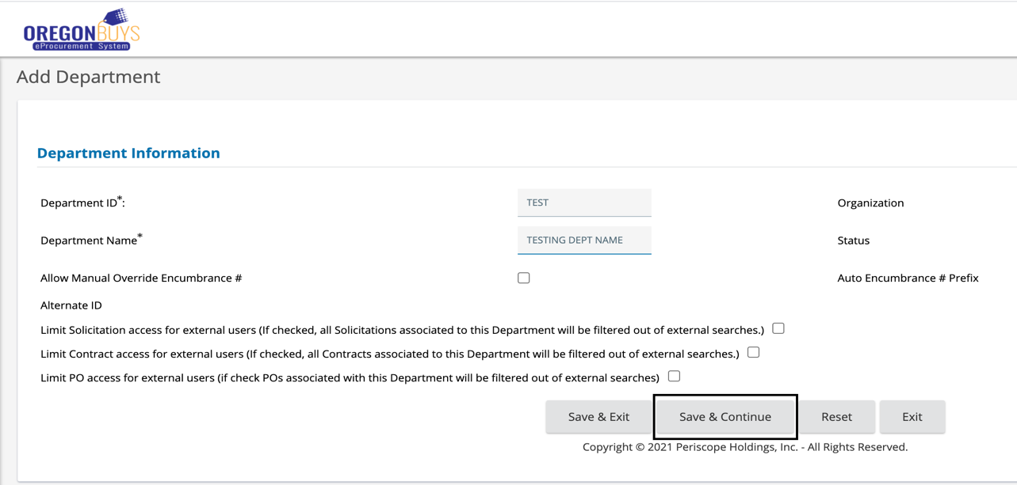
- Click ‘Save & Continue’.
- Once you have clicked ‘Save & Continue’, a confirmation message displays confirming your Department is saved.
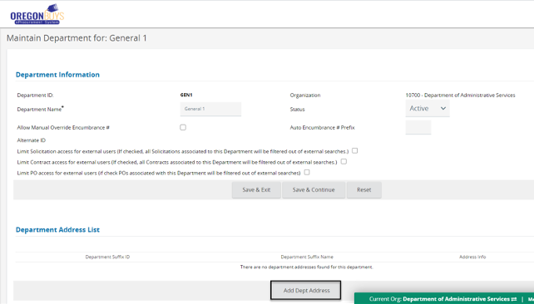
- Scroll down to the Department Address List and click ‘Add Dept Address’.

- Complete all the required (*) fields and click ‘Save & Exit’.
  - CAUTION: Please do not use a valid mailing address in TRAIN.
  - When adding a Department Suffix ID, use the following format - 3-Digit Agency Code followed by T1.
    - For example – 165T1.
  - When adding a Department Suffix Name, enter the name of the Business Unit’s Division that address is associate with.
    - Example: Division 1.
  - If you add an additional address under the first Department, the next Department Suffix ID format would be 165T2, etc..

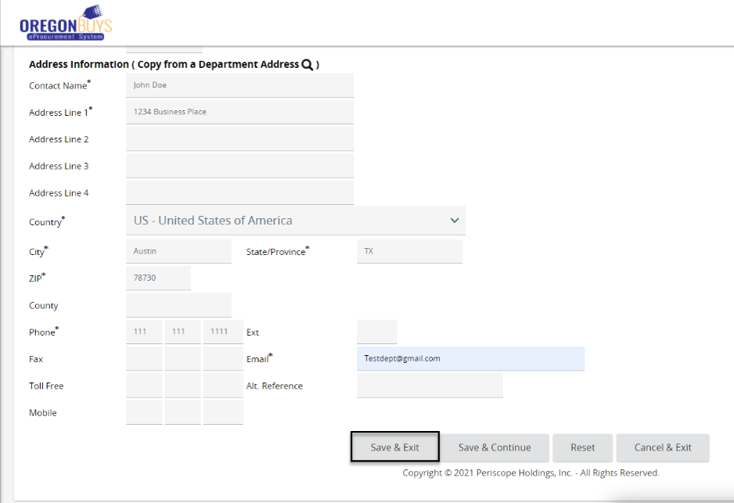
- Once you have clicked ‘Save & Exit’ OregonBuys will automatically load the Department Maintenance page for your newly created Department. Scroll down and click on ‘Add Location’.
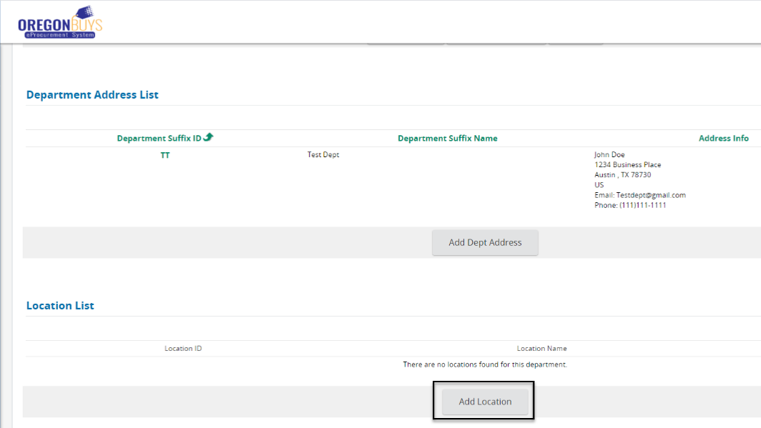
- Complete all required (*) fields.
  - For ‘Location ID’, use the abbreviation for the Division within the Business Unit.
    - For example – Division 1 becomes DIVT1.
  - For the Location Name, use Division 1.
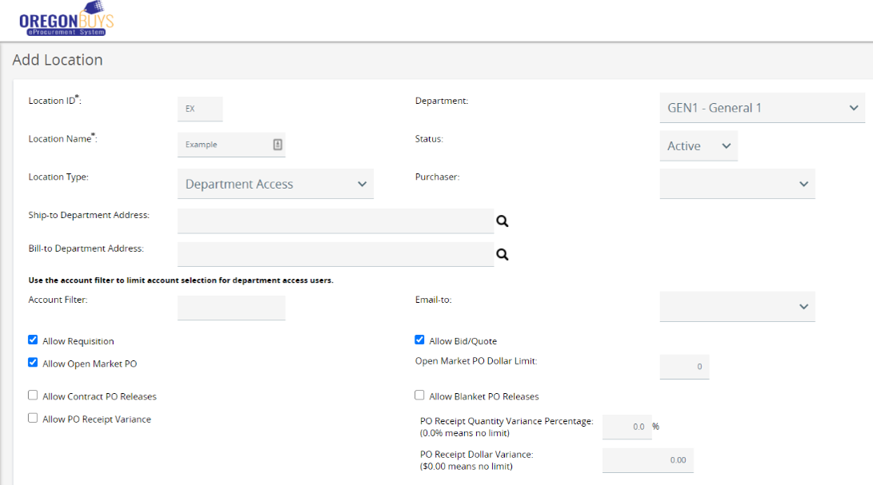
    - For example – Division 1.
- Click ‘Save & Exit’.
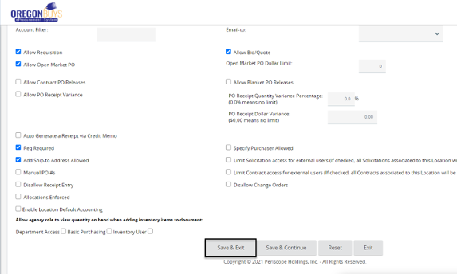

- You will now see your newly formed Location on the Department Maintenance page for your department. Click ‘Exit’ to navigate back to the main Department Maintenance page for the organization.
