Organization Administrator Guide to Creating an Agency User in the OregonBuys

Introduction
This guide will help individual Agency Organization Administrators (OAs) in creating their required Agency Users. Agency OAs will perform this activity before go-live to ensure that their Agency Users are able to access the PROD Environment.

Important Highlights
- For Non-Organization Administrators, the standard user login ID in the PROD environment will be user’s OR Number (OR included).
- When creating each user, make sure to use their work email, which allows them to receive an email from the system providing their temporary password to log into the PROD environment.
- Users can be assigned any of the Departments, Locations, and Addresses that were built under your Organization. This allows them to create documents in the system.
- Make sure to assign each user the correct role
- Once a user is created, make sure to email them their login id. OregonBuys is PCI compliant, and restricts the system from emailing a user their login id and password in the same email. The system will auto-generate an email with a temporary password to the new user.

Creating a New Agency User
This section includes a step-by-step process of how to create an Agency User from logging in to the OregonBuys PROD Environment.
- Login using your login credentials at oregonbuys.gov
- Navigate to the right of the Homepage and click on the ‘Account’ icon.

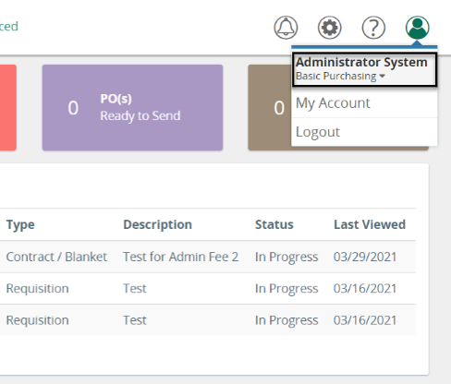
- Click the ‘Down Arrow’ next to the current role you are logged in.

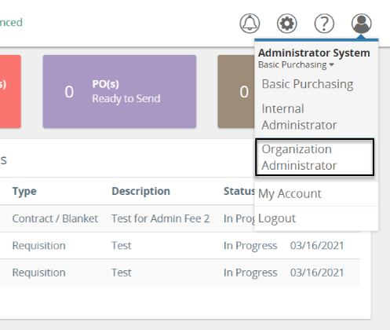
- Select the user role ‘Organization Administrator’ from the dropdown list.
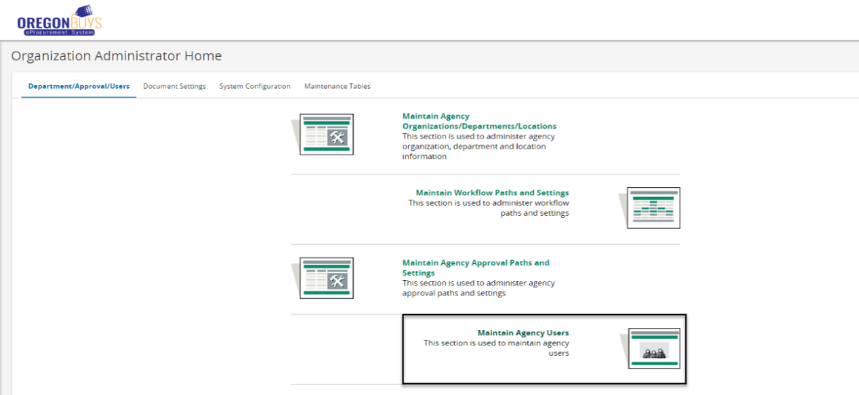
- Once you have arrived at the Organization Administrator Homepage, click ‘Maintain Agency Users’.

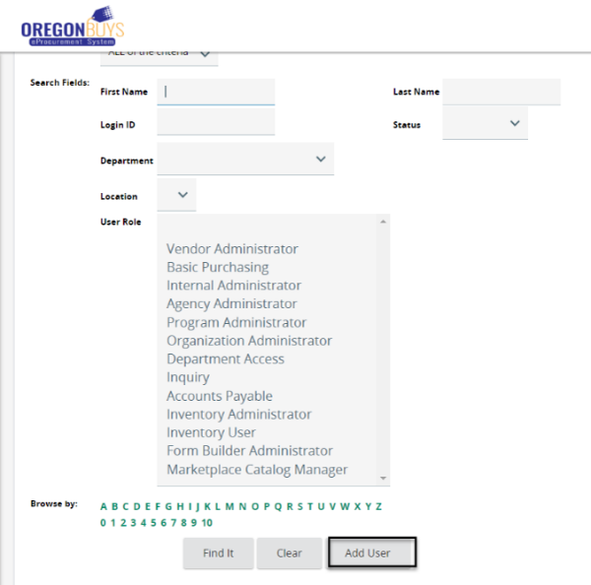
- Navigate to the middle of the page and click ‘Add User’.

- Complete all the required (*) fields in the User Information section and ensure that all appropriate roles are selected in the Roles section.
  - The First, Last Name, and Email address should be the user’s real information.
  - The login id format for Non-Organization Administrators will be the following:
    - ORNUMBER should be the user’s actual OR Number)
  - Select a Department, Location, Bill-to, and Ship-to Address.
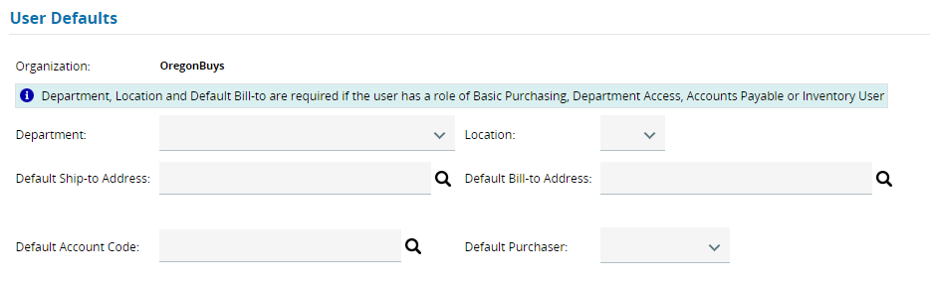
    - Choose the Department, Location, and Addresses based on where that user works.

    - Select the Role(s) that match the user functions in the system.

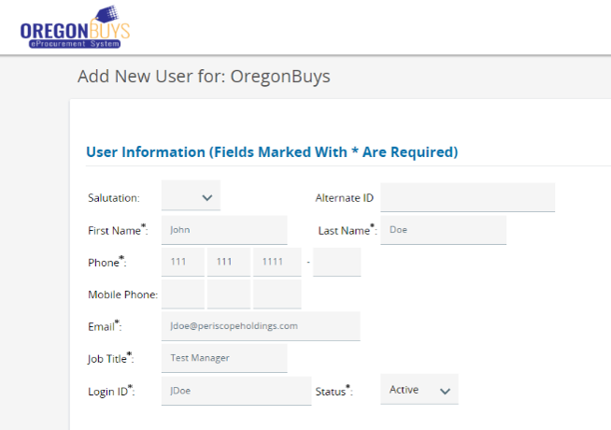
    - User role information can be found in the User Role document.
- Click ‘Save & Exit’ once completing all the necessary information.
  - After clicking ‘Save & Exit’, the system will automatically email that user their temporary password.

- Email the user their login id.
  - Once a user is created, make sure to email them their login id. OregonBuys is PCI compliant, restricting the system from emailing a user their login id and password in the same email. The system will auto-generate an email to the user with a temporary password that must be changed upon login.
