OregonBuys Open Market Purchase Order Guidance

Table of Contents
Table of Figures 2
Introduction 4
High Level Process Flow 4
Scenario 4
Prerequisites 5
Process for Creating an Open Market Purchase Order 6
Home Page 6
1. Creating a New Purchase Order from Scratch. 6
General Tab 7
Items Tab 15
2. Add Items from Scratch 15
3. NIGP Code Search 18
4. Adding item from a Previously Approved Master Blanket Purchase Order or Open Market Purchase Order 24
5. How to Upload Items 26
Vendor Tab 27
Address Tab 30
Accounting Tab 33
6. Split Two Account Strings 34
7. Account Strings Applied by Dollars 35
Routing Tab 35
Attachments Tab 35
Notes Tab 37
Change Orders Tab 37
Reminders Tab 38
Summary Tab 40
Submit the Open Market Purchase Order for Approval. 42

Table of Figures
Figure 1: High Level Process Flow 6
Figure 2: Verify BP Role 7
Figure 3: Create Purchase Order Using Plus Button 7
Figure 4: Create from Scratch 8
Figure 5: Set PO Type to "Open Market" 8
Figure 6: Update Short Description 9
Figure 7: Set Department and Location 10
Figure 8: Leave Print Format As-Is 10
Figure 9: Enter Discipline Type 11
Figure 10: Enter Receipt Method 12
Figure 11: Enter Type Code 14
Figure 12: Set the Entered Date 14
Figure 13: Enter Alternate ID 15
Figure 14: Insert Required Date 15
Figure 15: Enter Promised Date 16
Figure 16: Save and Continue 16
Figure 17: New Document Number -- In Progress Status 17
Figure 18 Add Item from Scratch 17
Figure 19: Item Detail Screen 18
Figure 20: Add Item Description 18
Figure 21: Enter Quantity 18
Figure 22: Enter Cost 19
Figure 23: Enter Unit of Measure (UOM) 19
Figure 24: Search NIGP with Magnifying Glass 19
Figure 25: NIGP Code Search 20
Figure 26: Select NIGP Code from Search 20
Figure 27: Updated Commodity Code 20
Figure 28: Additional Product Information 21
Figure 29: Save and Add New Item 21
Figure 30: Save and Exit to Save the Item 22
Figure 31: See item on the General Tab 22
Figure 32: Save & Continue Working on Items 23
Figure 33: Reset to Clear Items 24
Figure 34: Cancel & Exit 25
Figure 35: Adding Items from Approved MBPO 26
Figure 36: Find Items from Approved MBPO 27
Figure 37: Click Checkbox to Select Item 28
Figure 38: Upload Items from CSV File 28
Figure 39: Choose CSV File to Upload Items 29
Figure 40: Lookup & Add Vendor 29
Figure 41: Enter Vendor Search and Find It 30
Figure 42: Select the Vendor and Click Add Vendor 31
Figure 43: NEEDS A CAPTION 31
Figure 44: Change Ship To Address 32
Figure 45: Enter Address Search Criteria and Find It 32
Figure 46: Select Address 32
Figure 47: Click Save & Continue to Apply Address Change 33
Figure 48: Apply New Address to All Items 33
Figure 49: Apply Account Codes to Purchase Order 35
Figure 50: Split Purchase Order Among Multiple Account Codes 35
Figure 51: Account Strings Applied by Dollars 36
Figure 52: Set Approval Path in Routing Tab 36
Figure 53: Add Attachments 37
Figure 54: Choose File for Attachment 37
Figure 55: Enter Notes 38
Figure 56: Change Orders Tab 38
Figure 57: Set the Reminder Date 39
Figure 58: Add Reminder Details 40
Figure 59: Enter Date Completed 40
Figure 60: Summary Tab 41
Figure 61: Submit for Approval 42
Figure 62: Approvers 43
Figure 63: Select how the Purchase Order will be Approved 43
Figure 64: Ready to Send 44
Figure 65: Set Options to Send Email and Notify Vendor 44
Figure 66: Open Market Purchase Order Sent Status 44

Introduction

High Level Process Flow
The following is a high-level process overview for OregonBuys. This guidance document is focused on the Open Market Purchase Order process used by the Basic Purchasing user.
Figure 1: High Level Process Flow
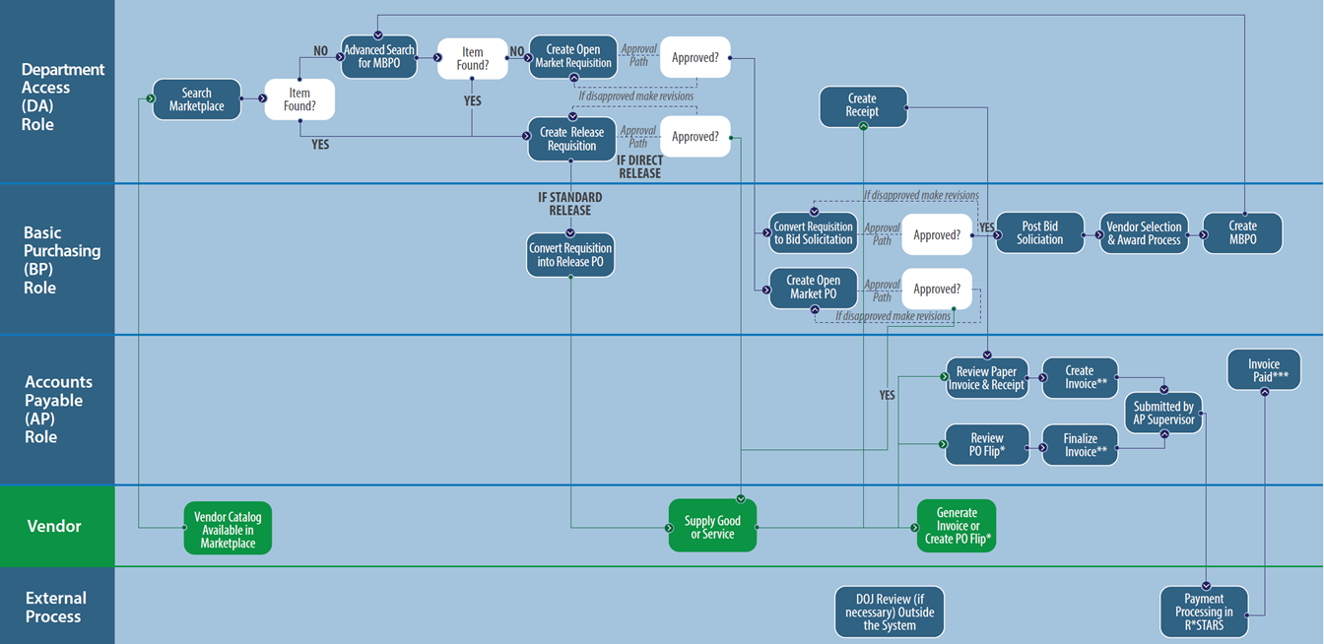
An Open Market Purchase Order allows the Basic Purchasing (BP) users to purchase goods or services not currently on a contract. There are three methods for creating an Open Market Purchase Order: Create from Scratch, Create from a Requisition, or Cloning an Existing Purchase Order. Since describing each method creates some redundancy, go to the method that best meets your needs and ignore the rest.
We will walk through each tab of the document using a new Open Market Purchase Order that will be created by scratch.

Scenario
General:
In this guidance document the Basic Purchaser in the agency is creating and sending an Open Market Purchase Order to purchase Election machines.
Item:
The line item associated with this Purchase Order is an Optical Ballot Scanner with NIGP Class code 578 and NIGP Class Item code 34.
Accounting:
The account code segments are input on this tab.

Vendor:
There are no Subcontractors, Distributors, or Vendor Performance associated with this vendor.
Routing:
The Routing for approvals for this document may be set manually or selected at the point that the document is Submitted for Approval.
Attachments:
The Basic Purchaser should add attachments to document background information for this Release. In addition, the Agency may have set up standard documents (for example Terms and Conditions) to be attached to all Purchase Orders for the Agency.
Notes:
It is suggested that notes related to deadlines, approval information, contact information, or other information that the Basic Purchaser deems important for tracking or approving this Purchase Order be added on the Reminders and Notes tabs. It would be good practice for the Agency Procurement Team to establish standard procedures for these tabs.
Summary:
The Open Market Purchase Order should be submitted for any applicable approvals and the user will see the status change to “Ready for Approval”.

Prerequisites
- User must have the Basic Purchaser (BP) user role
- Information specific to the Services or Supplies being purchased is known (e.g. quantity, shipping and billing addresses, etc.)

Process for Creating an Open Market Purchase Order

Home Page
- Beginning on the Home Page, click the person icon in the top right corner, and select Basic Purchasing from the drop-down menu.
Figure 2: Verify BP Role
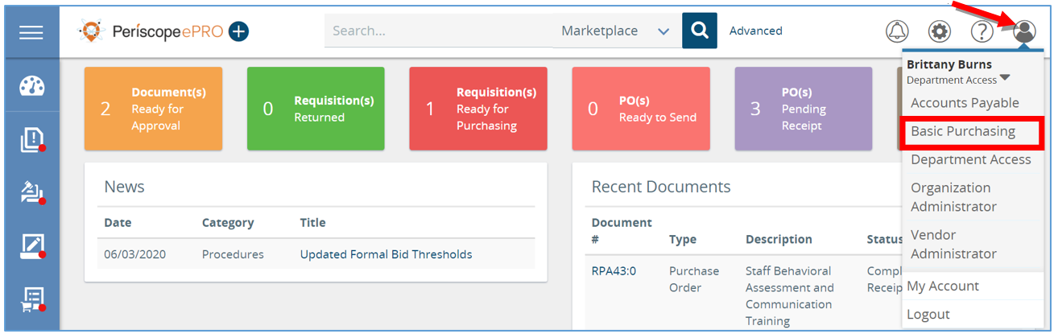
2. Next, click the plus button and select Purchase Order from the menu. The page will redirect to the first screen in creating a new Purchase Order.
Figure 3: Create Purchase Order Using Plus Button
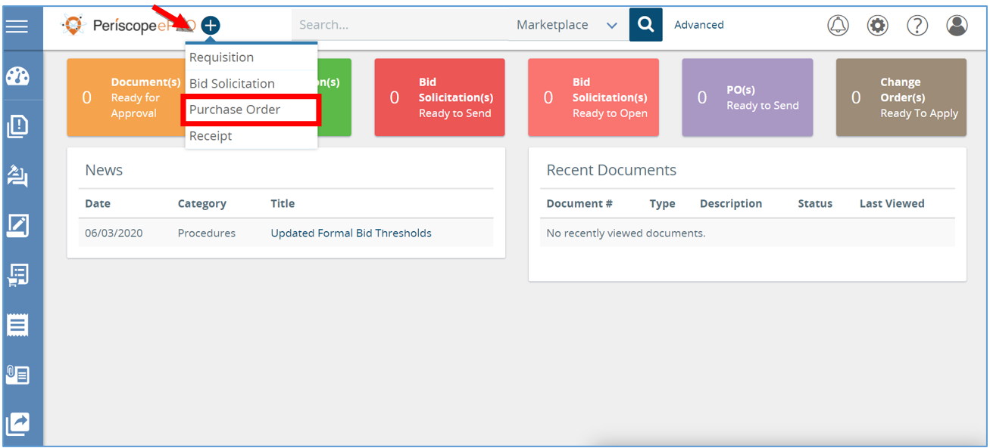

Creating a New Purchase Order from Scratch.
- First, select the method you want to use to create a new Purchase Order. Since this document covers creating a new Purchase Order from scratch leave the first radio button selected. You would create the Purchase Order from scratch if you weren’t cloning an existing Purchase Order and you weren’t converting from a Requisition document. (NOTE: While not part of this section – another common way to create Purchase Orders is from a Requisition.)
  - Select Clone a purchase order from another purchase order if you want to duplicate a new purchase order from a purchase order that is already completed.
  - Select Create a purchase order from a requisition if you are creating a new purchase order from a requisition already completed.
Figure 4: Create from Scratch
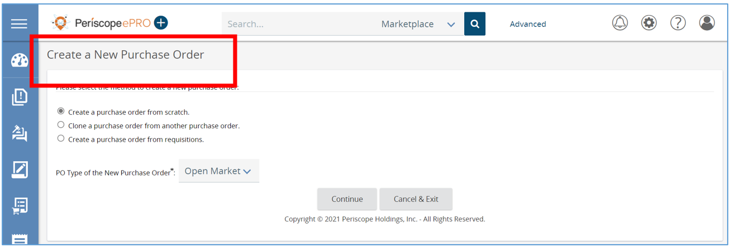
- Once the method is selected, the next required field to complete is PO Type of the New Purchase Order. Leave that field as Open Market and click Continue. This will create a new Purchase Order (PO for short).
A required field will be indicated with an asterisk.
Figure 5: Set PO Type to "Open Market"
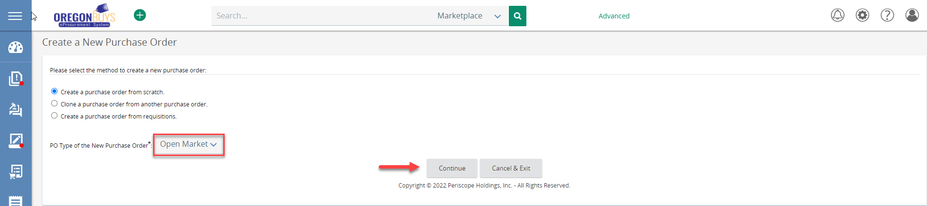

General Tab
The General tab holds detailed general information about your Open Market Purchase Order document. The required fields will be indicated with an asterisk and must be completed before moving on to the next tab.
- First, on the New PO page you will fill out any field with an asterisk, starting with the Short Description field.
  - Enter the short description.
    - The Short Description is searchable.
    - It is recommended that this be as descriptive as possible to reduce the confusion among other Purchase Orders.

Figure 6: Update Short Description
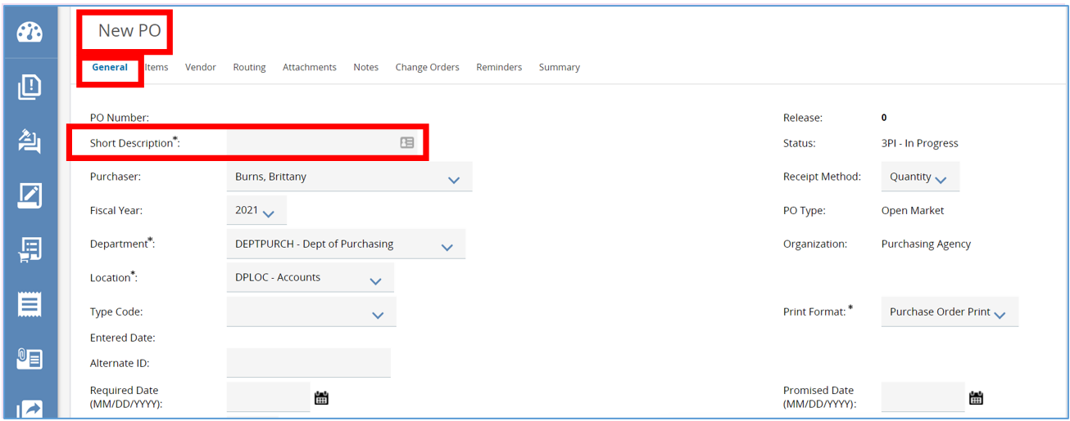The Department and Location fields will prepopulate if starting from a new Purchase Order based on your default settings. The default Organization, Department, and Location settings are set by the Organization Administrator for each user.
  - If the user needs to change these two fields, they can click on the drop-down menu and select a different Department and Location.
    - Locations are a subset of Departments similar to an agency’s divisions, bureaus, or programs.
Figure 7: Set Department and Location
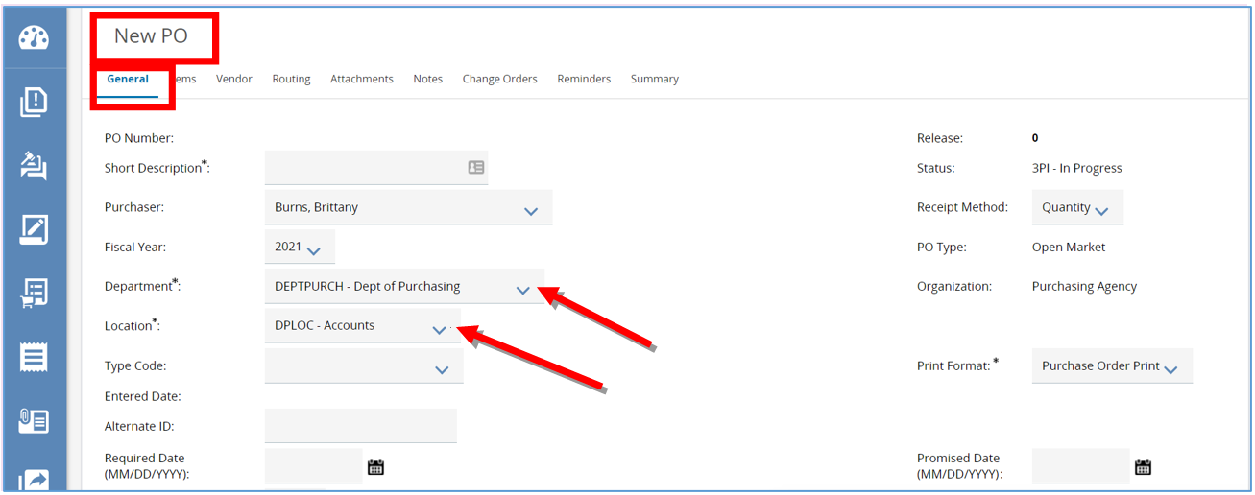
  - The user can leave the Print Format as is.
Figure 8: Leave Print Format As-Is
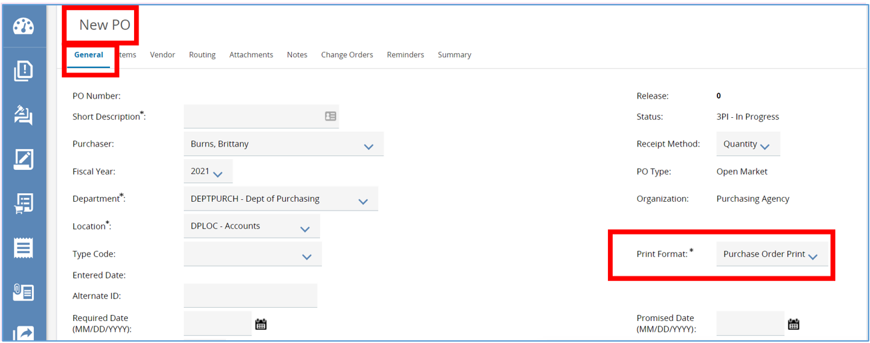Enter the Discipline Type. All enterprise purchase orders are required to be identified by the “procurement discipline”. For example, personal services, supplies, architecture and engineering, ordinary construction, trade service, etc. Scroll the General Tab page down in order to see Discipline Type.
Figure 9: Enter Discipline Type
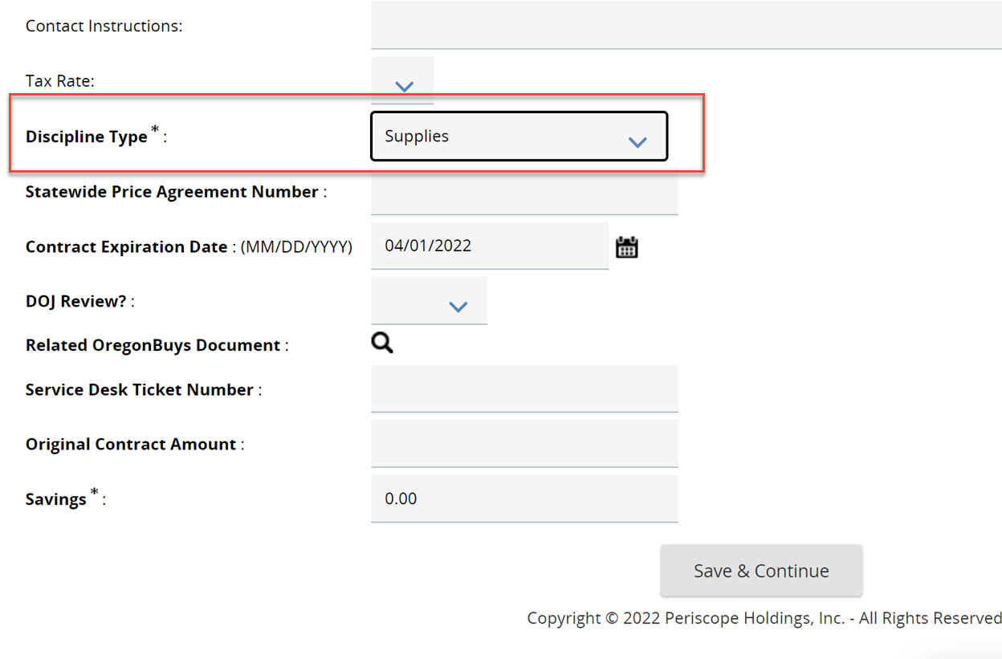

- Next, look at the Receipt Method. This field is not required but drives additional functionality. It determines how receiving is entered into the system. Receiving can be entered in the system as either Quantity or Dollars.
NOTE: If Receipt Method is set to Quantity, then the Receipt will allow the user to mark items as Received on a unit basis (e.g. receiving per package). If Receipt Method is set to Dollars, then the Receipt will allow the user to mark items as Received based on a dollar amount (e.g. receiving $1,000 of services).
Figure 10: Enter Receipt Method
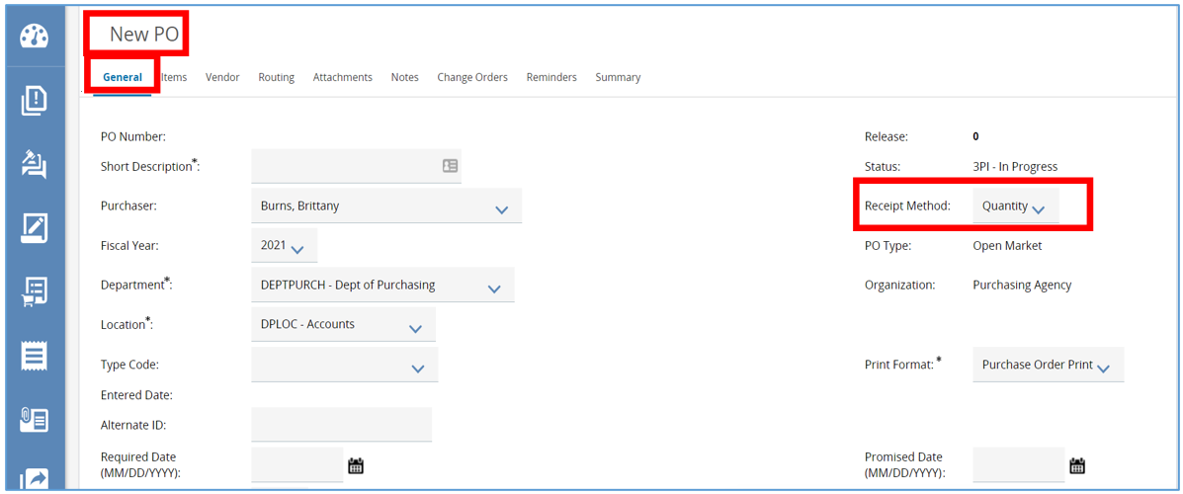
- On the General tab there are additional fields that can be updated but are not required. The following list describes the fields on the General Tab and additional detail on select fields follows.
FIELD | DESCRIPTION
PO Number | The PO Number auto-populates when the PO is first saved.
Release | If PO was a Release or RPA Release against a Master Blanket Purchase Order, ePro would auto-populate this.
Short Description* | Short Description helps the user identify the document.
Status | Status indicates the document status according to the ePro status flow.
Purchaser | Purchaser lists the buyer/purchaser for the PO.
Receipt Method | Determines how the PO is to be received, (by Quantity or Dollars).
Fiscal Year | If more than one choice of fiscal year is available, the fiscal year can be selected by using the drop-down.
PO Type | Blanket Purchase Order, Contract Purchase Order, G2B Blanket Purchase Order, Open Market Purchase Order.
Department* | The department that is purchasing the items or services. Your agency may have already set a user default for this field.
Organization | The organization of this purchase order. This field is protected and not subject to change.
Location* | The location within the department requiring the goods or services.
P-Card Enabled | Check if using P-Cards (ePro must be configured for P-Cards)
Type Code | If applicable, these are defined by your agency.
Print Format* | The Agency defined print document format.
Entered Date | This will populate when the document is saved.
Print Dest Detail | Choose if addresses for items going to different destinations print out on the PO: if different, never, always.
Alternate ID | Agency defined alternate ID field. The length of this field is determined by system settings. The field length can be from 0 to 50 characters.  CAUTION: the alternate id field may be used by interface processing. Beware deleting or changing data within the alternate id field as it may cause invalid data or errors during the interface processes.  NOTE: Field is maintainable when document status is “In Progress” or “Ready for Approval”.
Required Date | The date and time by which the originator requested that delivery of the items on this purchase order be delivered.
Promised Date | The date by which the vendor must deliver the goods.
Control Code | Agency defined control code.
Days ARO | The number of days after receiving this order by which the vendor should deliver the goods.
Retainage % | Percent of payment to be withheld pending completion of services or delivery of goods negotiated in advance with vendor.
Discount % | Percentage of discount to be applied to PO.
Contact Instructions | Defines contact for the document.
Tax Rate | Tax rate applied to this purchase order.
Actual Cost | The total cost of all the items on this purchase order, including any applicable tax, freight, or discounts.
Invoice Method | The Invoice Method for this purchase order. Default is “Three Way Match”.  Allowed Options:  Three Way Match – Invoicing requires PO, Receipt and Invoice.  Two Way Match – Invoicing requires PO and Invoice.
Custom Column(s) | Agency defined custom column(s) for the purchase order. Required entry based on custom column definition.

  - Type Code: If applicable, this is defined by your agency. The Type Code provides additional information on the document without driving further functionality. Some agencies use this to specify a Sole Source Procurement, for example.
Figure 11: Enter Type Code
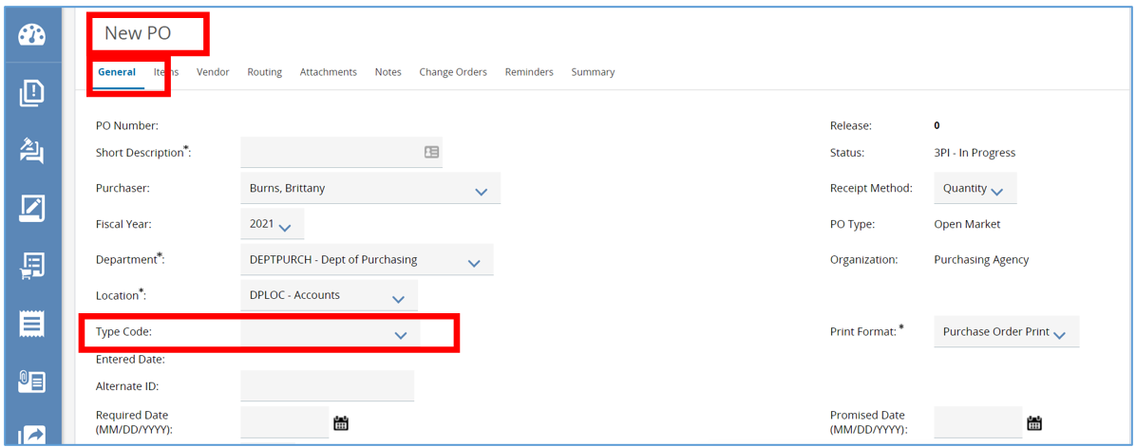
  - Entered Date: This will automatically populate with today’s date when the document is saved.
Figure 12: Set the Entered Date
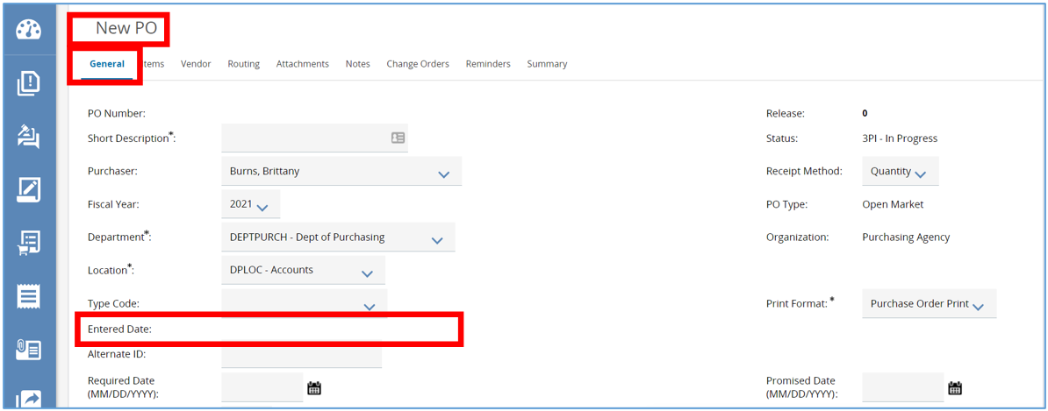

  - Alternate ID: This field is used by interface processing. Currently not used on the Purchase Order document.
Figure 13: Enter Alternate ID
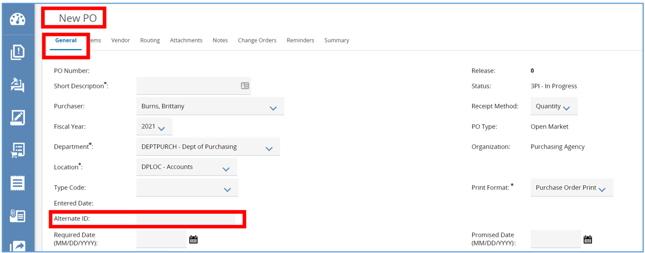

  - Required Date: The date and time by which the originator requested that delivery of the items on this purchase order be delivered.
Figure 14: Insert Required Date
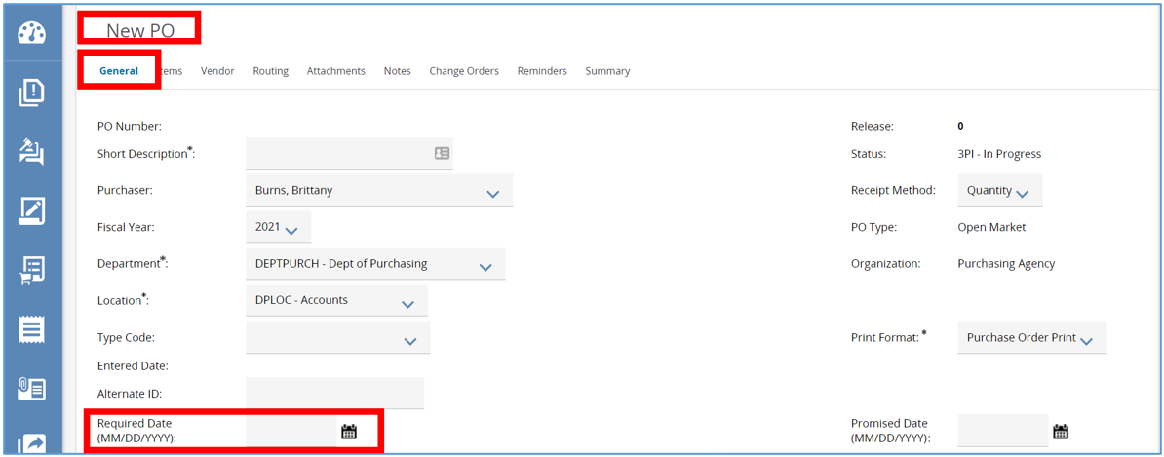

  - Promised Date: The date by which the vendor must deliver the goods.
Figure 15: Enter Promised Date
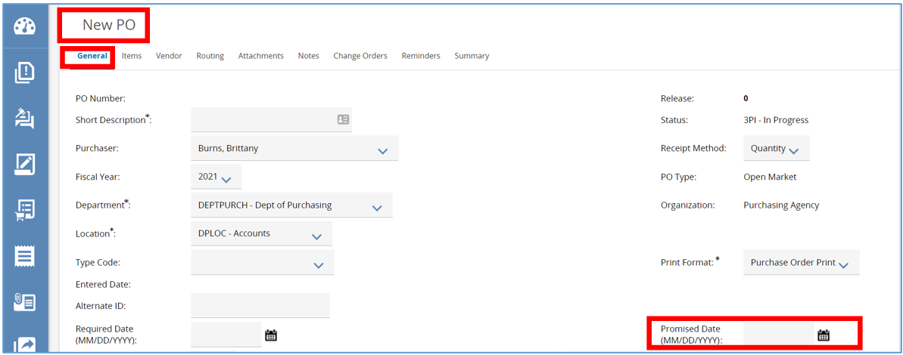
- Once all the required fields and selected optional fields are completed, scroll down and click Save & Continue.
Figure 16: Save and Continue
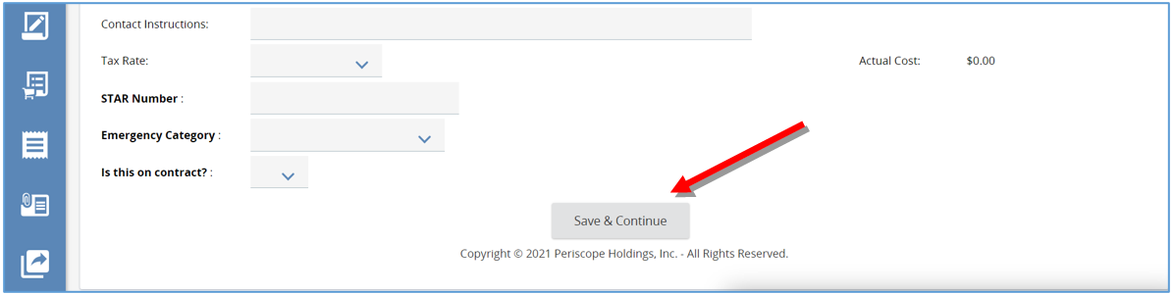
  - Once saved, the system will generate a unique document number for the Open Market Purchase Order just created. The document number is shown at the top left of the page.
  - The Open Market Purchase Order will now have a status of “3PI - In Progress”. This means the document is now saved and editable
Figure 17: New Document Number -- In Progress Status
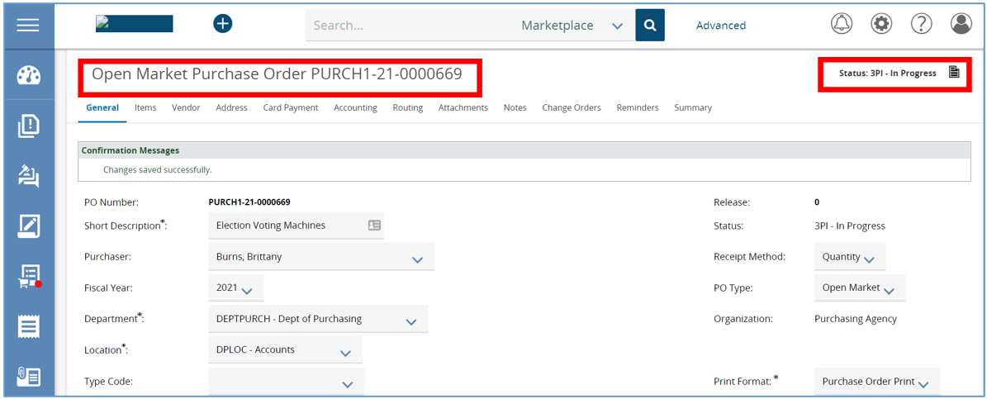

Items Tab
This tab is where you will input and view the line items detailing the commodities or services you are ordering. There are three ways to add items. Items can be added ‘from scratch’, added by reference to items on a Master Blanket Purchase Order or added by uploading from a file.

Add Items from Scratch
- To create an item from scratch, click Add Item. This will take you to the Item Detail screen.
Figure 18 Add Item from Scratch
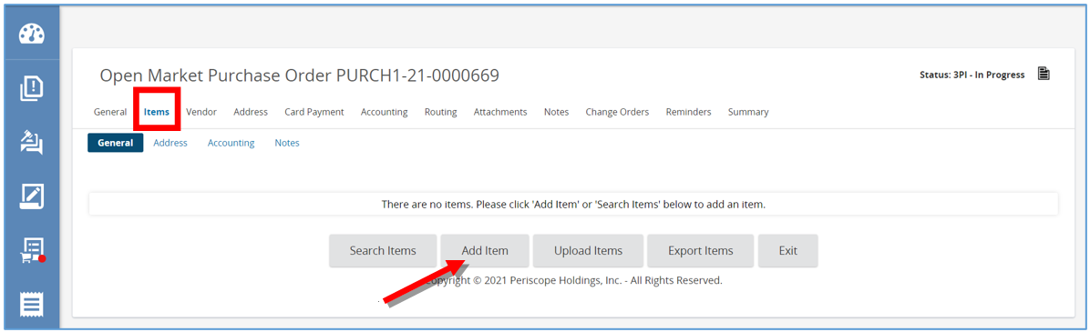
Figure 19: Item Detail Screen
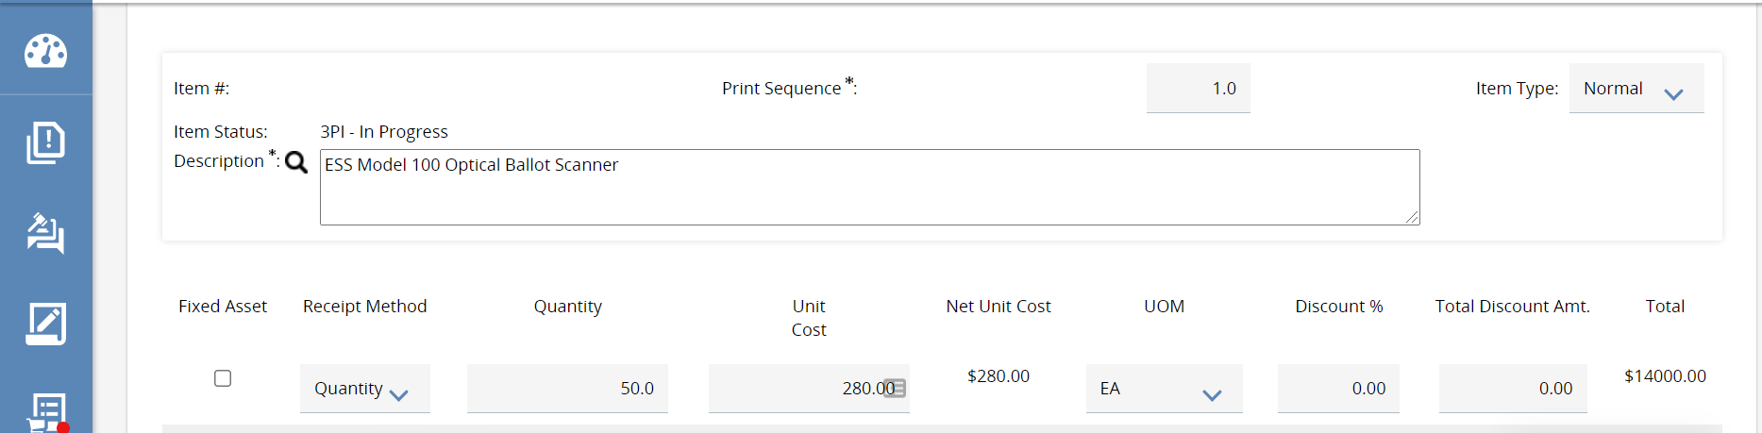
- Then add the Item Description. It is best practice to be as specific as possible since this is a searchable field.
Figure 20: Add Item Description
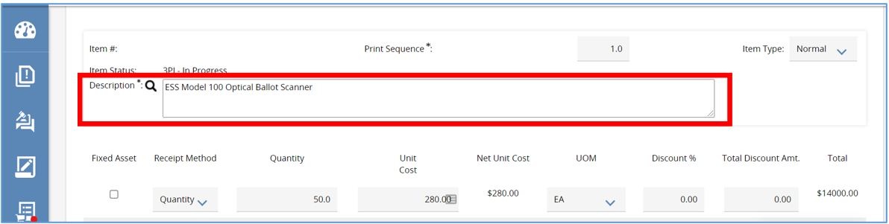
- With Receipt Method set to Quantity fill in the Quantity field with the number of items to order. Note that the Receipt Method can be set to either Quantity or Dollars. If Receipt Method is set to Quantity, then the Receipt will allow the user to mark items as Received on a unit basis (e.g. receiving per package). If Receipt Method is set to Dollars, then the Receipt will allow the user to mark items as Received based on a dollar amount (e.g. receiving $1,000 of services).
Figure 21: Enter Quantity
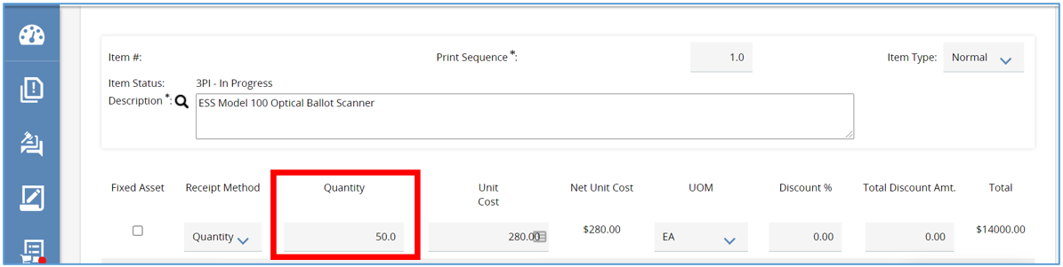
- There is also a Unit Cost field, this will default to zero dollars. If the cost is known enter it in this field.
Figure 22: Enter Cost
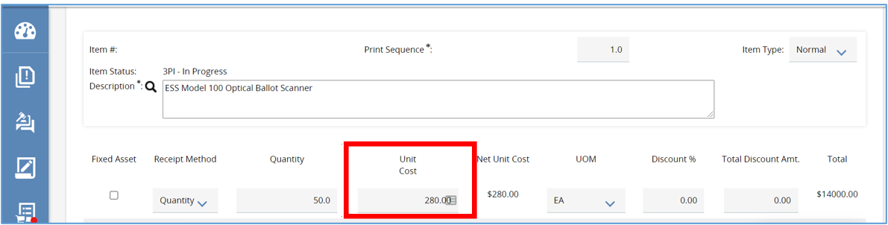
- The Unit of Measure field will default to each (EA). This field can be changed by clicking the drop-down menu, from there select the option that best fits.
Figure 23: Enter Unit of Measure (UOM)
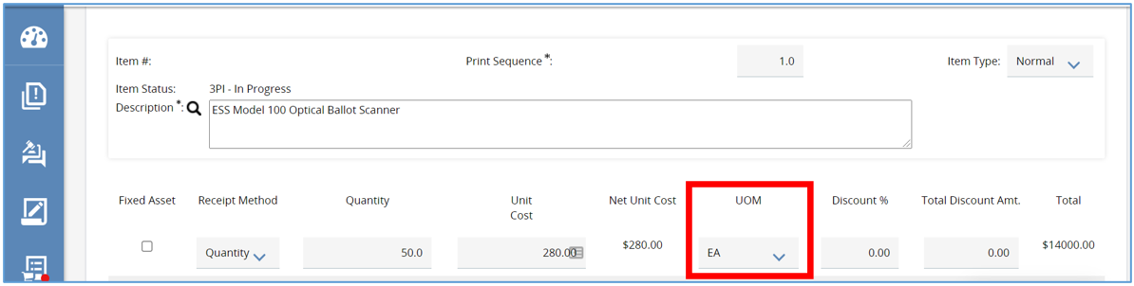
- Next are the NIGP Class and NIGP Class Item fields. When adding an item to an Open Market Purchase Order, that item needs to be assigned a Commodity Code. NIGP stands for National Institute of Governmental Purchasing which provides a universal taxonomy for identifying commodities and services in procurement systems.
  - The Commodity Code can be entered manually.
  - Or by clicking the drop-down arrow in either NIGP field.
  - The most common way is by clicking the magnifying glass to complete a search.
Figure 24: Search NIGP with Magnifying Glass
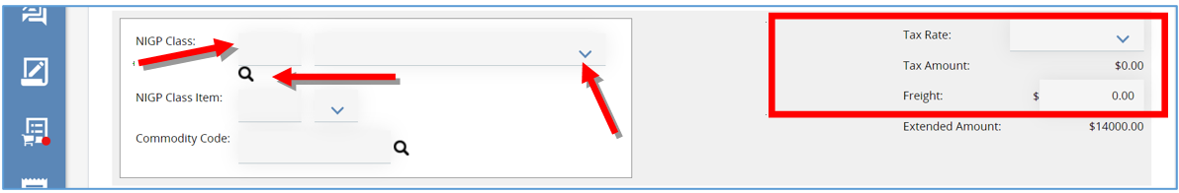

NIGP Code Search
- Once magnifying glass is selected, a pop-up window will appear. From here search for the code using the NGIP Keyword field, then click Search.
Figure 25: NIGP Code Search
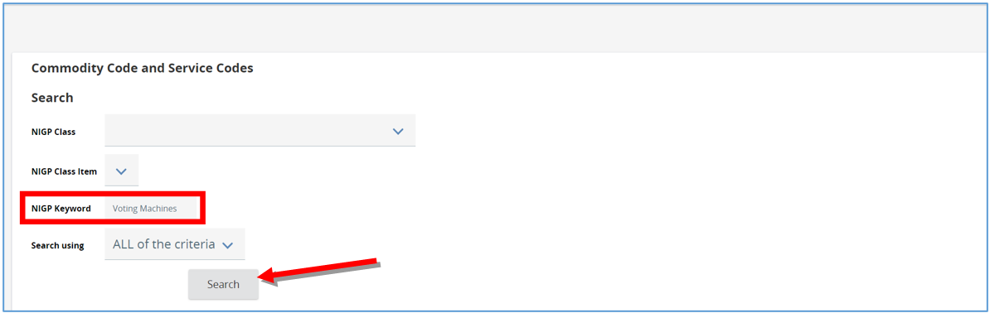
- The screen will refresh and display all the codes associated with the search completed. Click the appropriate code. then click Save and Exit to close the NIGP code finder window.
Figure 26: Select NIGP Code from Search
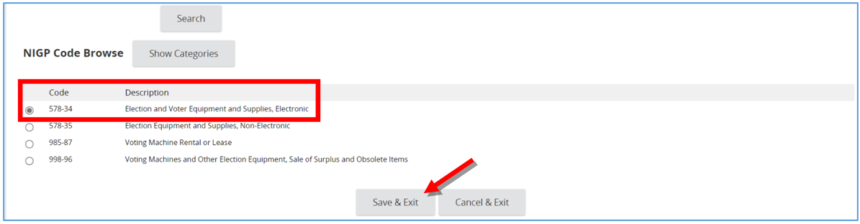
- The page will refresh back to the Item Detail screen. The Commodity Code will now be populated.

Figure 27: Updated Commodity Code
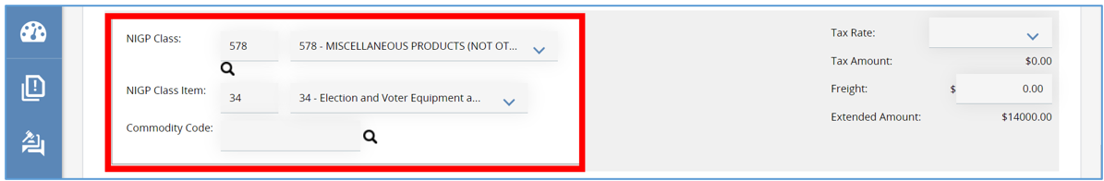

- Additional information about the item can be added by expanding the Additional product Information section.
Figure 28: Additional Product Information
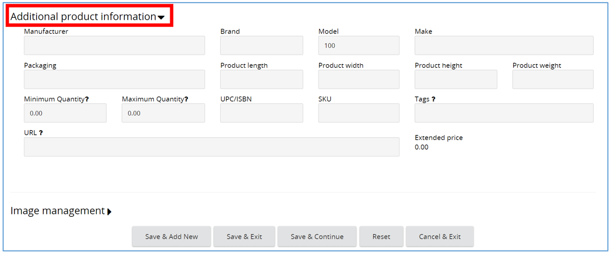
- When finished click one of these options that are explained below:
  - Save & Add New to add a new item
  - Save & Exit to return to the items tab
  - Save & Continue to save you work and continue working on the item
  - Reset to clear what was entered on the item detail screen and start over
  - Cancel & Exit to clear the item information and go back
  - For Example:
    - Click Save & Add New to save this Item Detail and to start a new item by repeating the steps just completed.
Figure 29: Save and Add New Item
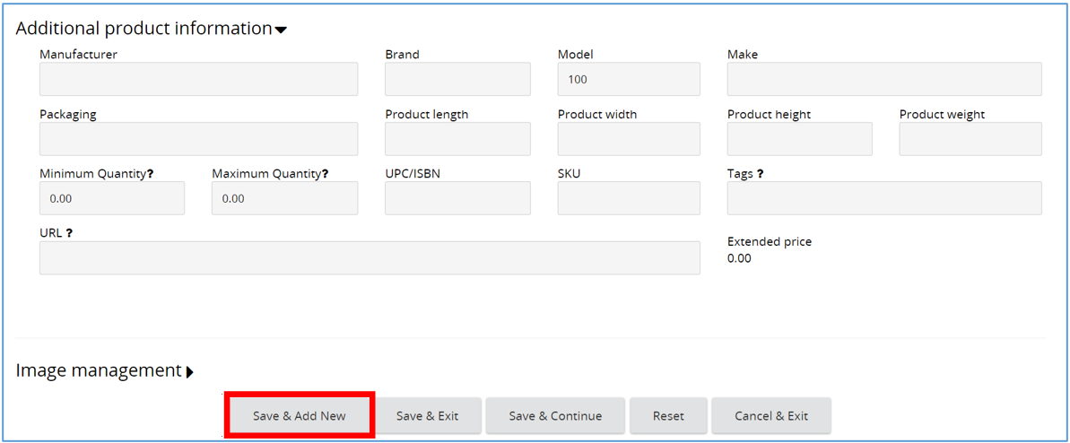

- Click Save & Exit to save this Item Detail and return to the Items tab.
Figure 30: Save and Exit to Save the Item
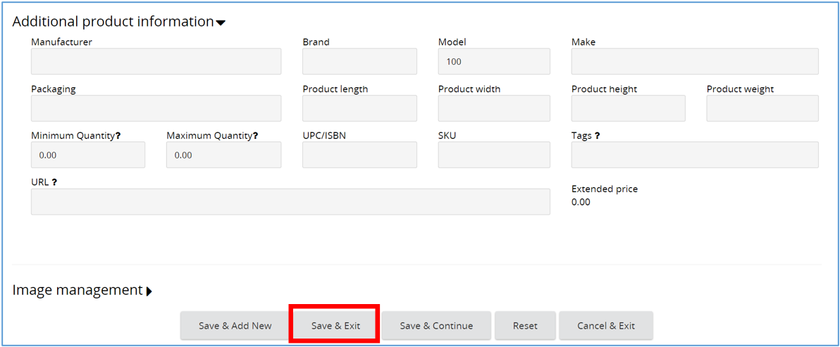

- Here the General subtab will show the item entered.

Figure 31: See item on the General Tab
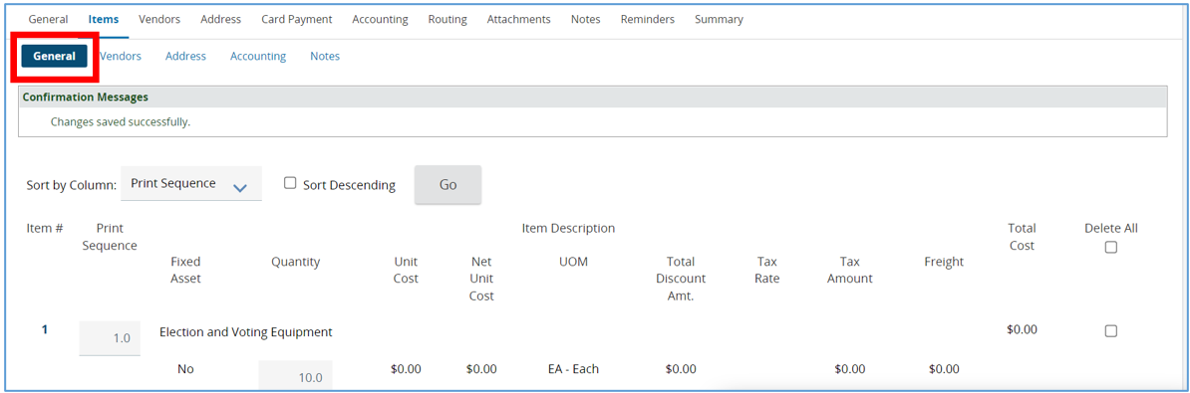
- Click Save & Continue to save data entered and continue working on the same Item Detail.
Figure 32: Save & Continue Working on Items
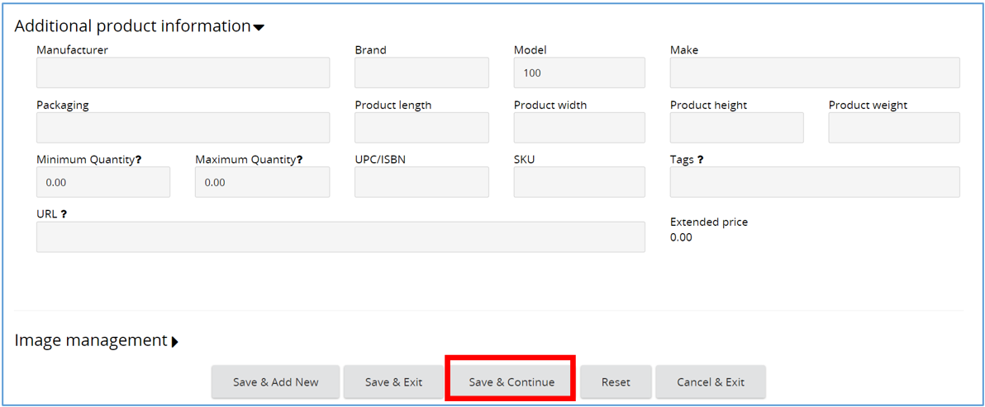

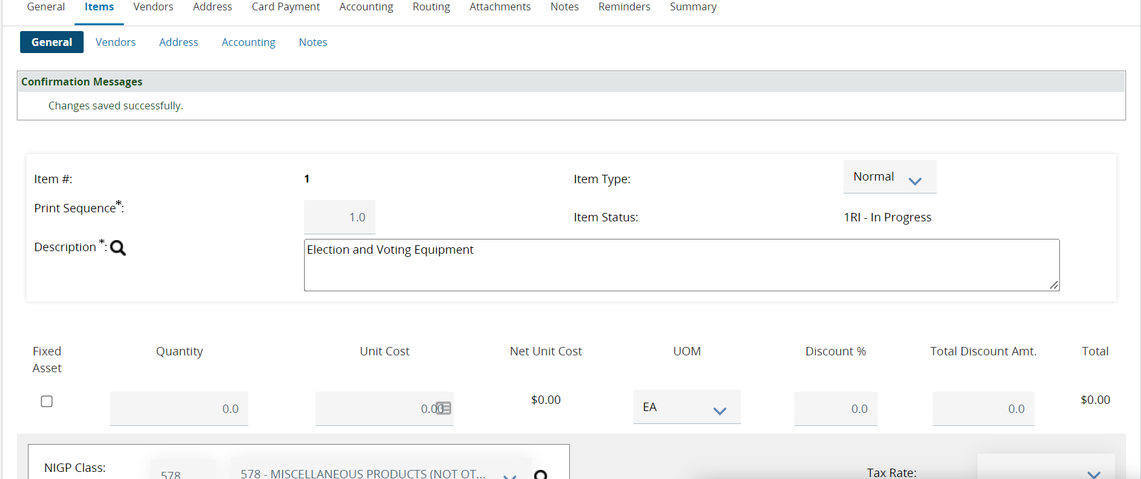
- Click Reset to clear what was entered on the item detail screen and start over.
Figure 33: Reset to Clear Items
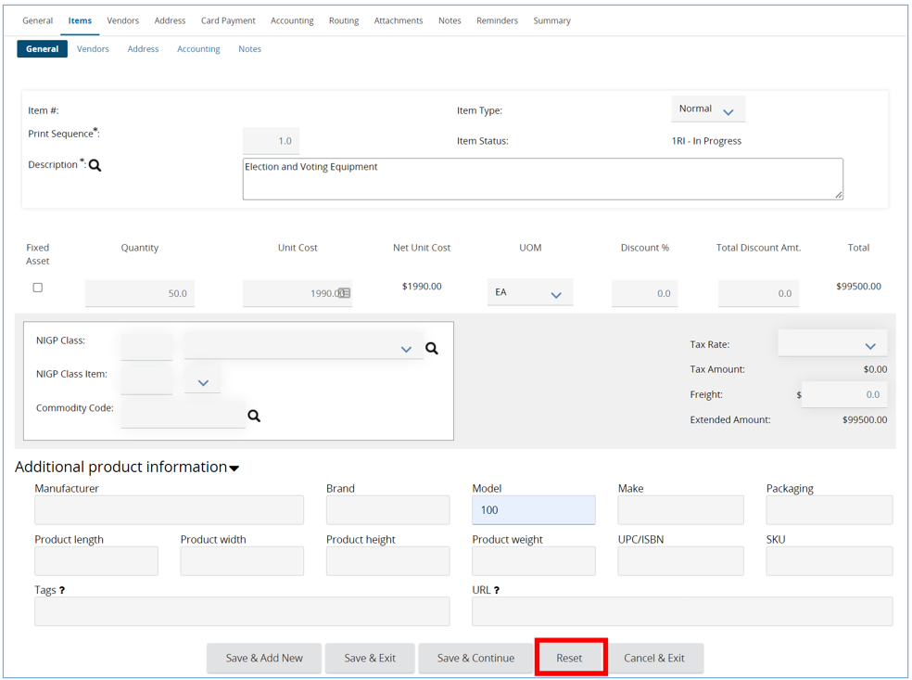

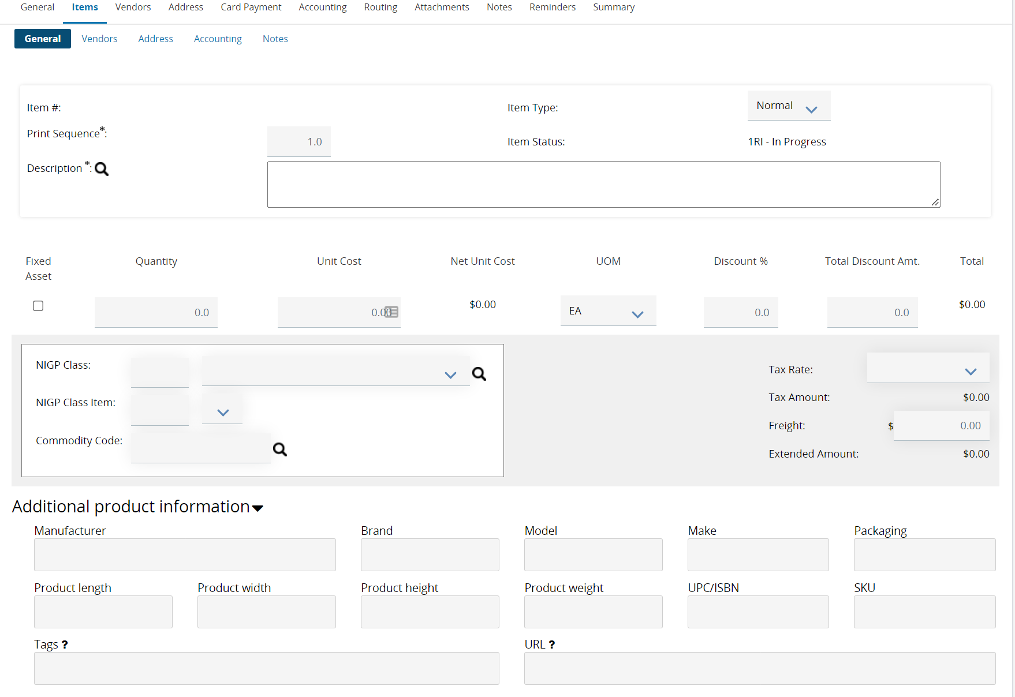
- Click Cancel & Exit to leave the item detail screen and go back to the Item tab.
Figure 34: Cancel & Exit
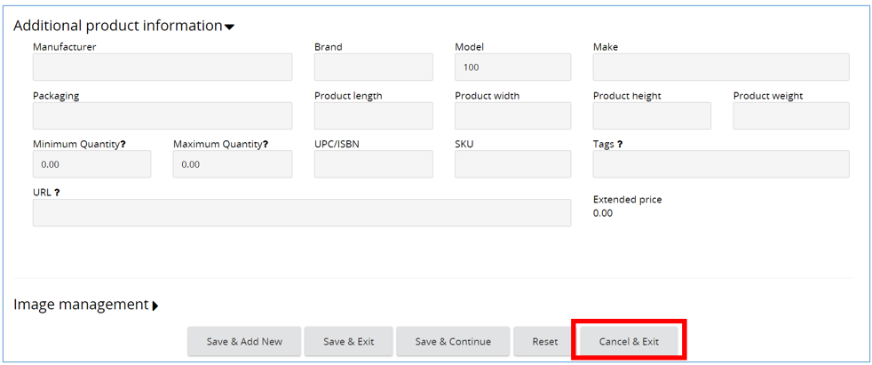

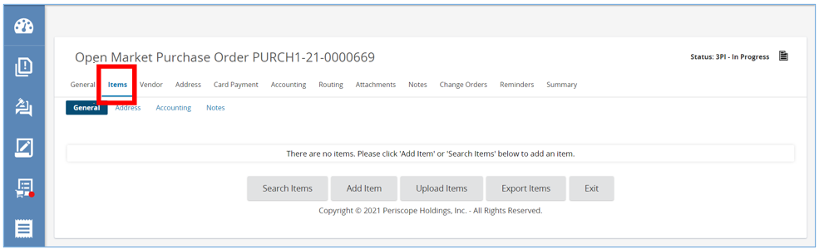

Adding item from a Previously Approved Master Blanket Purchase Order or Open Market Purchase Order
NOTE: A Master Blanket Purchase Order or Open Market Purchase Order must be accessible to your user to show items that can be added.
- An item can also be added from a previously approved Master Blanket Purchase Order or Open Market Purchase Order by clicking Search Items.
Figure 35: Adding Items from Approved MBPO
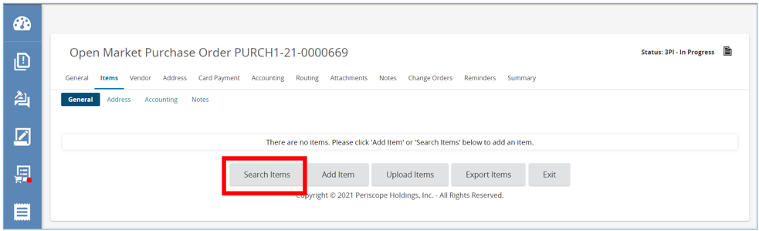

- The page will refresh allowing you to enter in the search criteria from the previously approved Master Blanket Purchase Order or Open Market Purchase Order, if available.
- Then click Find it.
Figure 36: Find Items from Approved MBPO
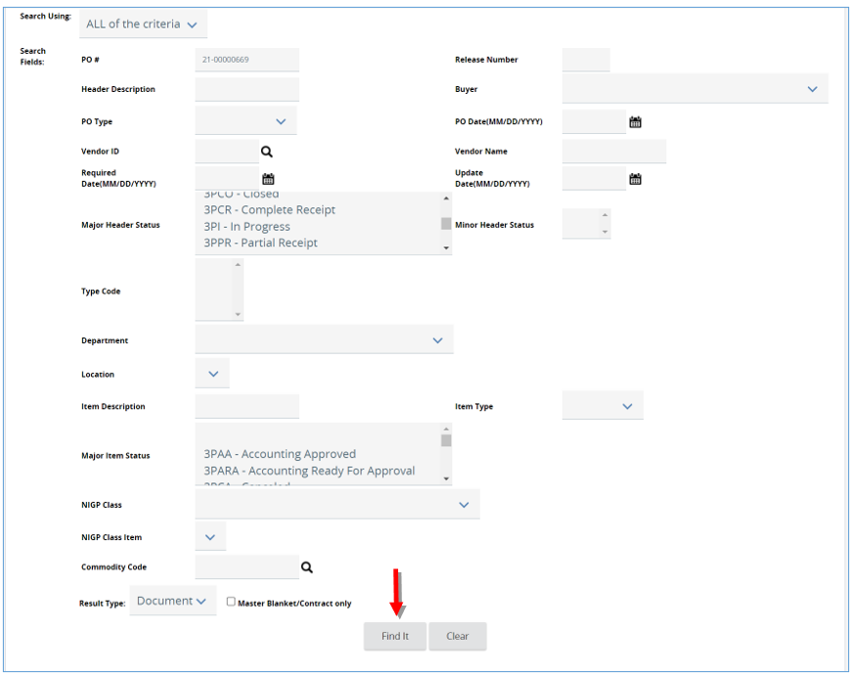

- The screen will refresh and display all the items associated with the search completed. Click the checkbox to select the needed items, and enter the quantity required for each item selected. Then click Save and Continue.
Figure 37: Click Checkbox to Select Item
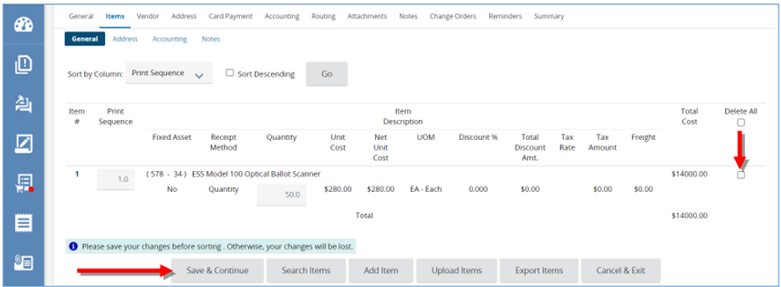

How to Upload Items
NOTE: In order to Upload Item, the Basic Purchasing user must have the “Enable PO Item Upload” privilege for this role enabled by the Organization Administrator (OA).
Also note that the upload format is in CSV format. To create a template of this upload format, create a “dummy” item, or add an item, then click the “Export Items” button to create a template that can be populated with items to upload.
Alternatively, use this embedded object as the template and update it with items to upload:
- To upload an item from a CSV file, click Upload Items.
Figure 38: Upload Items from CSV File
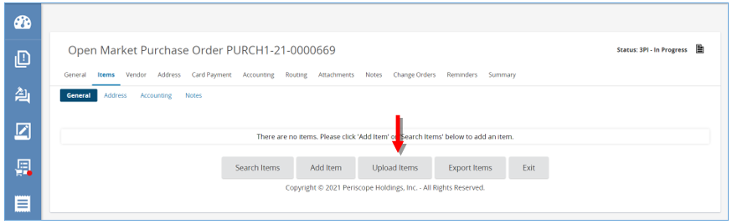
- The page will refresh where you can upload the file by clicking Choose File.
- Once file has been added click Save & Exit.
Figure 39: Choose CSV File to Upload Items
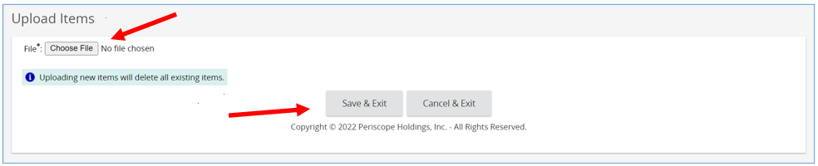

Vendor Tab
The Vendor Tab is where the vendor who will fulfill the Purchase Order is added. Vendors will need to be registered in the system to fulfill Purchase Orders. If a vendor/supplier can’t be found, they are more than likely not yet registered in the system.
- To select a vendor, click Look Up & Add Vendor.
Figure 40: Lookup & Add Vendor
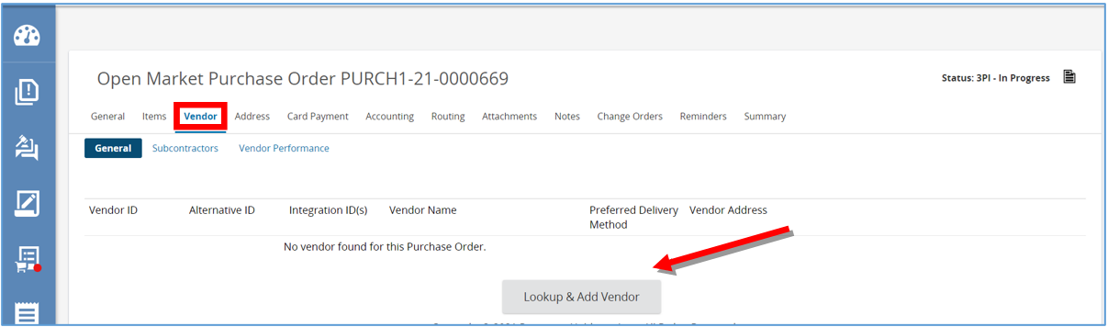A pop-up window will appear allowing for a vendor search. Type the vendors name in the Vendor Name field.
NOTE: You can enter other search criteria on the pop-up window such as “NIGP Class” rather than Vendor Name if that is convenient. Also, it may help to relax the search criteria by selecting, “Any of the Above” from the “Search Using” pulldown menu at the top left of the pop-up window.
- Scroll down and click Find It. (REMINDER: Vendors must be registered in the system in order to be able found and selected.)
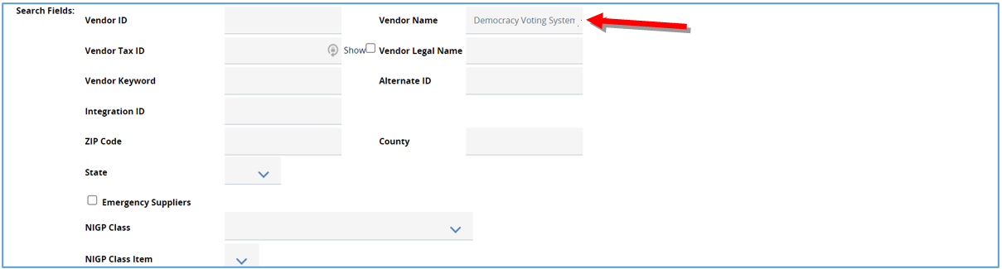
Figure 41: Enter Vendor Search and Find It
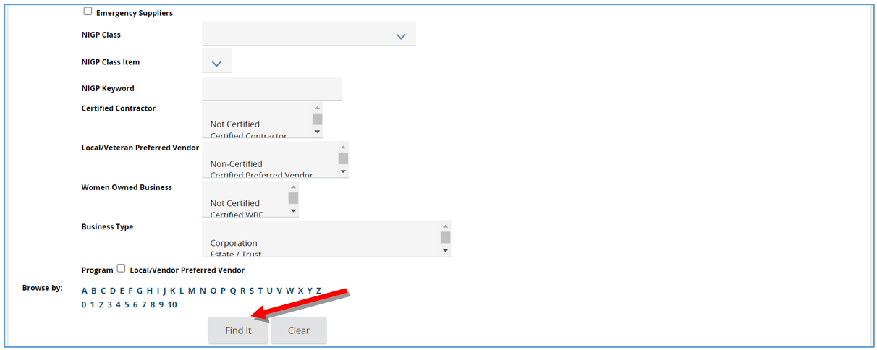
- Select the vendor, then click Add Vendor.
NOTE: The Remit Address for the vendor is pulled in from R*STARS. If the address doesn’t exist in OregonBuys the vendor may not be in RSTARS. If this is the case, then additional set-up and configuration for the vendor/supplier inside of R*STARS may be needed.

Figure 42: Select the Vendor and Click Add Vendor
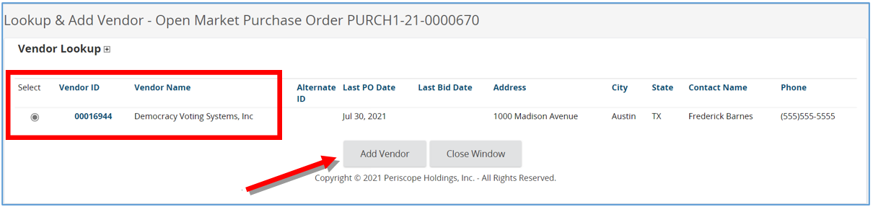
- The page will refresh back to the Vendor Tab, General subtab where the vendor is added. Once the vendor has been added select Save and Continue.
  - The Subcontractors Tab allows a vendor to be selected who will subcontract with the primary vendor to fulfill the Purchase Order.
  - The Vendor Performance Tab allows the user to document the performance of the seller, subcontractor or distributor against a particular purchase order.
  - If a vendor can’t be found, make sure the vendor completed the registration process.

Figure 43: Adding a Subcontractor
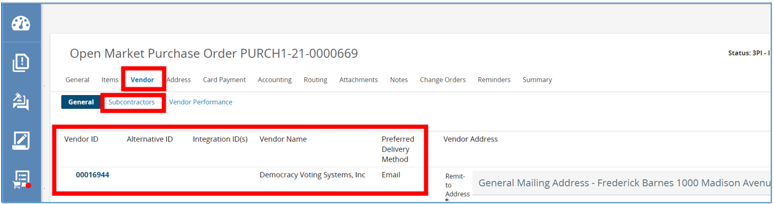
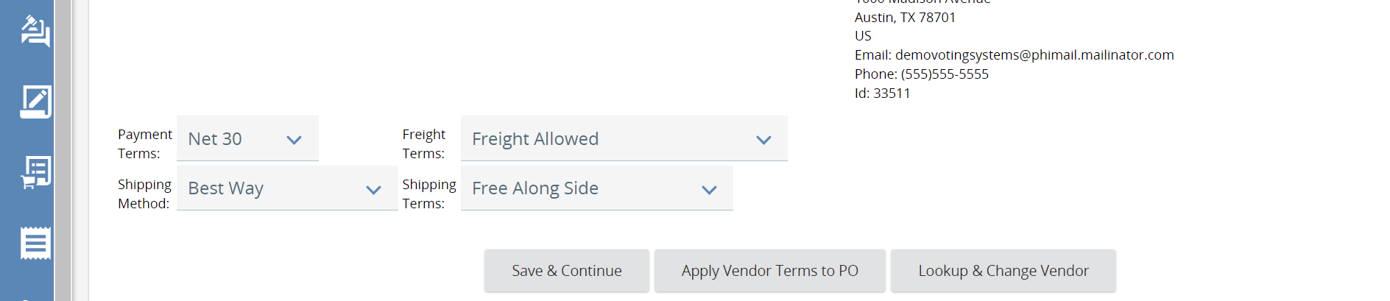

Address Tab
This tab displays the Ship-to and Bill-to Address fields for items on the PO.
- The options that appear on this screen are based on the default settings.
  - To change the Ship-to Address click on the magnifying glass.
  - In the pop-up that follows, enter search criteria in of the fields.
Figure 44: Change Ship To Address
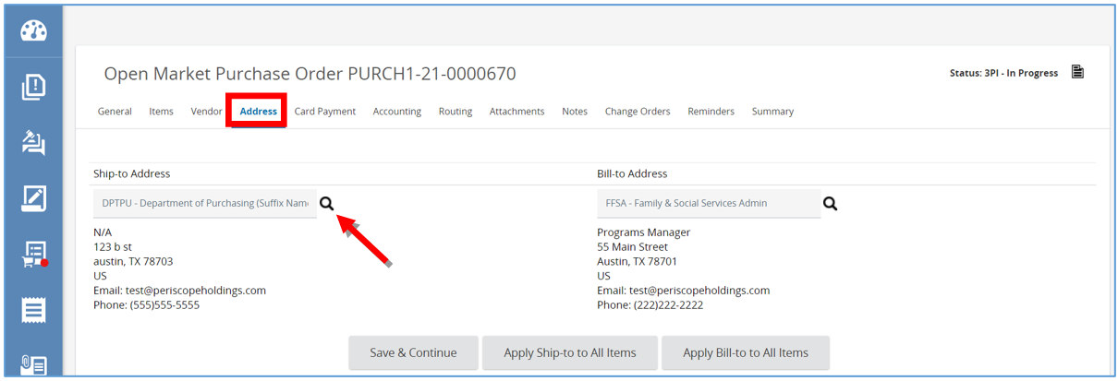
- Once search criteria is entered click on Find It.
Figure 45: Enter Address Search Criteria and Find It
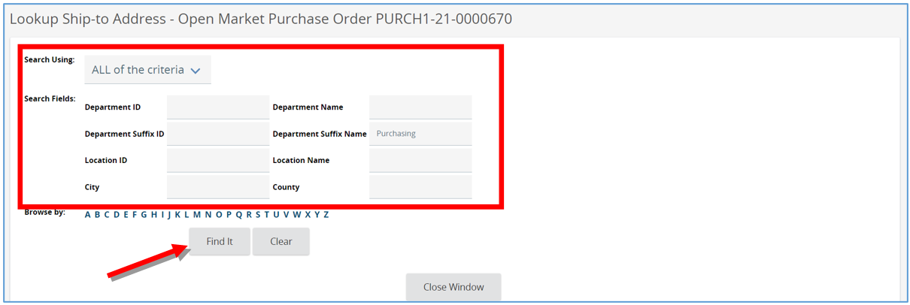
- Then select the address of choice and click Select.
Figure 46: Select Address
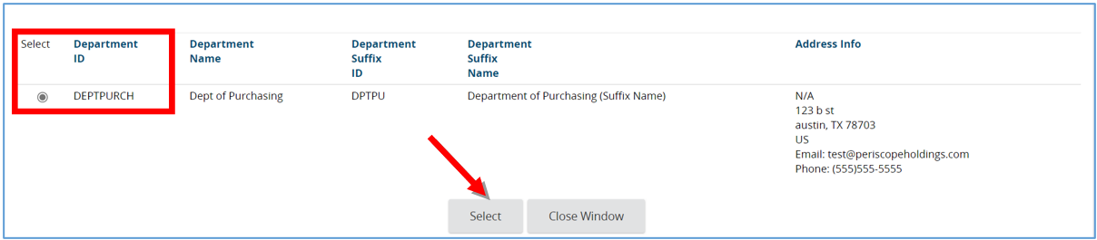
- The screen will refresh, then click Save & Continue.

Figure 47: Click Save & Continue to Apply Address Change
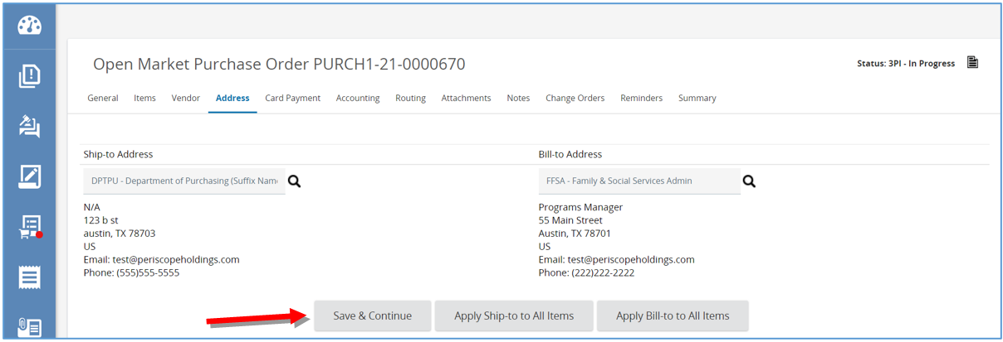

- Then click Apply Ship-to to All Items to have the new address applied to all the items.
Figure 48: Apply New Address to All Items
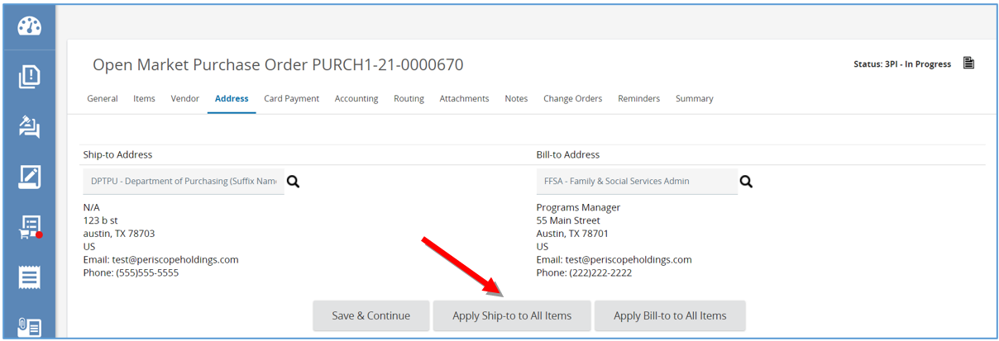
- If the Ship-to or Bill-to Address is different per items, addresses can be added on the “Address Sub-Tab” of the Items Tab.
  - Select the Items Tab and then select the Address Sub-Tab.
  - Select the Item that requires a different Ship-to or Bill-to Address.
  - Click the magnifying glass.
  - In the pop-up that follows, enter search criteria in of the fields
  - Once search criteria is entered click on Find It.
  - Then select the address of choice and click Select.
  - Then select Apply to Selected.
  - And then Save and Continue to apply those changes.

Figure 49: Apply different Ship-to and Bill-to Addresses to specific items
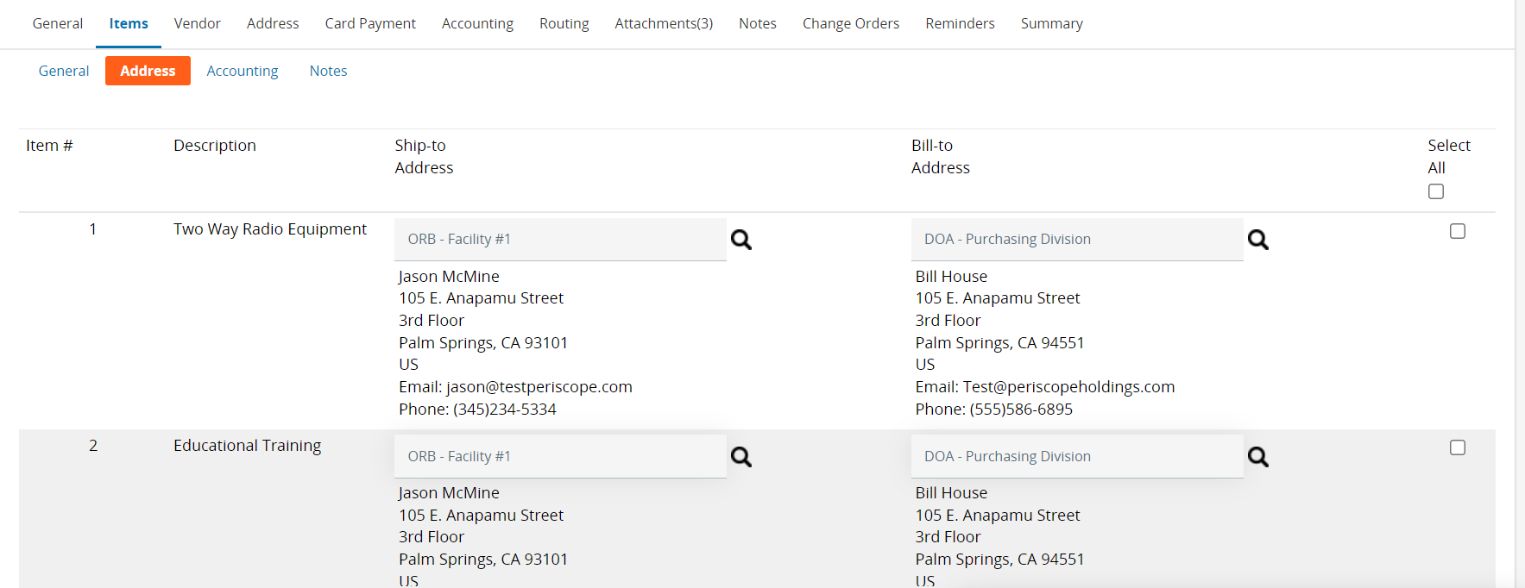
Figure 50: Use the Ship-to or Bill-to Address look up via the magnifying glass to find addresses
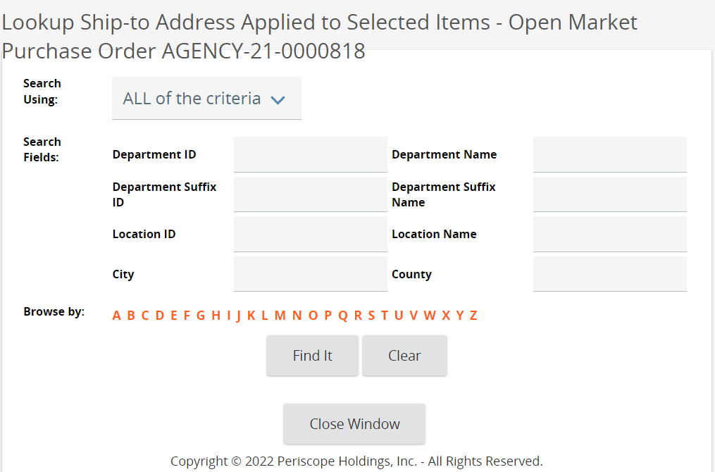

Figure 51: Select the appropriate address from the results
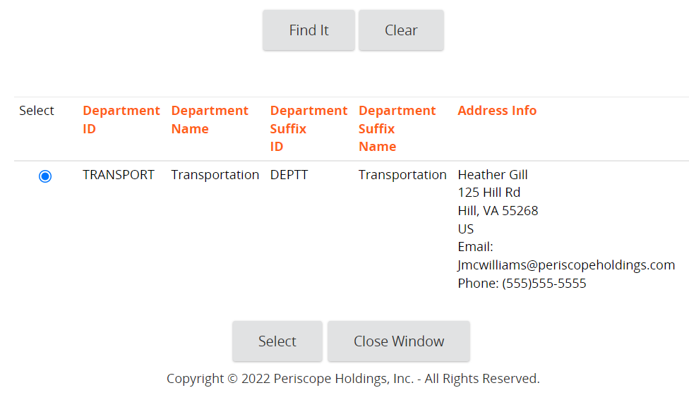
Figure 52: Address is applied to the item
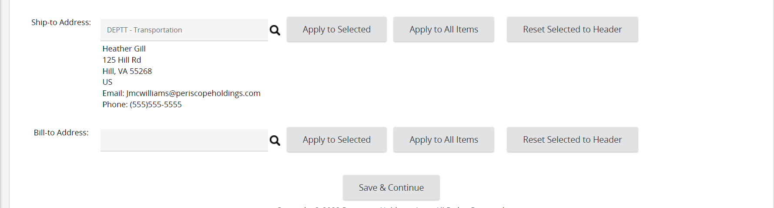

Accounting Tab
Prerequisites
Before setting up the information needed on the Accounting Tab gather the following information:
1. What account codes or account string will you charge to items on the PO?
2. Will the PO be charged to a single account code?
3. Will the PO be pro-rated to various account codes (split account codes)?
4. Do line items on the PO need to be assigned to specific account codes?
5. Will the PO be applied by Dollars or Percentage?
This tab is where all the Account Strings in the dollar or percentage split are defined and can be applied to all items. If the Purchase Order being worked on originates from a Requisition or Bid Solicitation that already has this information, this tab can be skipped. To modify this information, follow this three-step process.
- First, enter the Account String using one of these options.
  - The search can be done for an entire string
  - The search can be done by segment
  - The search can be done by manually entering each segment or select segments
- Secondly, click Save Based on Percentages.
  - This will save the account string including the percentage.
- Lastly, click Rebuild for All Items.
- An additional line will appear allowing for an additional account string to be added if necessary.

Figure 53: Apply Account Codes to Purchase Order
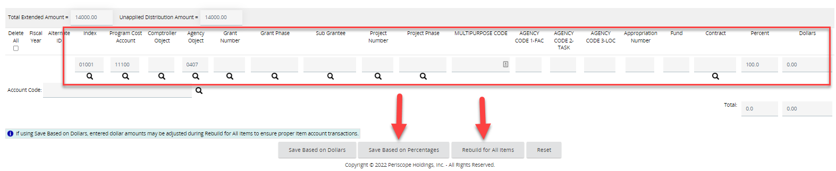

Split Two Account Strings
NOTE: A Purchase Order can be split among multiple accounts. This example will split the purchase order between multiple accounts and percentages.
- Two Account Strings can be added and split by percentage, (50/50 in the below example). To do that enter each account string separately.
- Then split the percentage and assign the percentage to each accounting string.
- Next, click Save Based on Percentage.
- Then, click Rebuild for All Items.
Figure 54: Split Purchase Order Among Multiple Account Codes
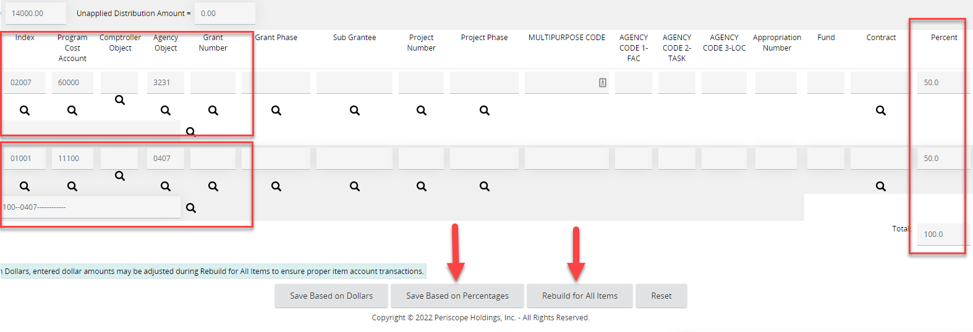

Account Strings Applied by Dollars

If there are accounts that are going to be allocated a specific dollar amount instead of a percentage, a Purchase Order can be applied by dollars instead.
- Enter in the dollar amount for each account string under the Dollars column.
- Then click Save Based on Dollars.
Figure 55: Account Strings Applied by Dollars
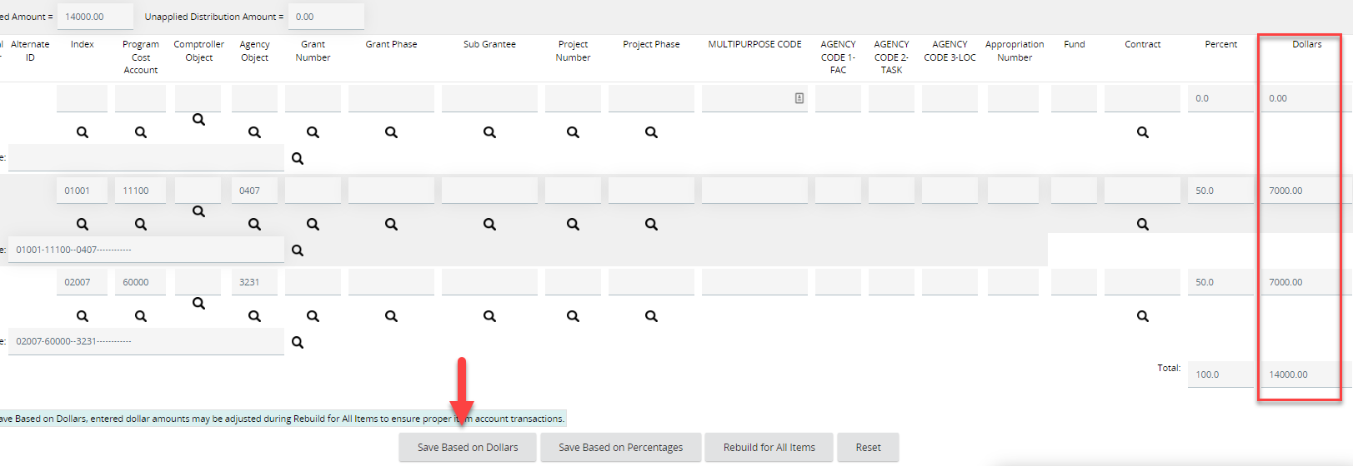

Routing Tab
This tab displays the approval paths the Open Market Purchase triggered. This allows the ability to track who is in the process of reviewing and approving the document. It also allows the ability to refer back to who reviewed and approved the document for historical purposes. This tab will remain blank until an approval path is determined when the Open Market Purchase Order is submitted for approval.
Figure 56: Set Approval Path in Routing Tab
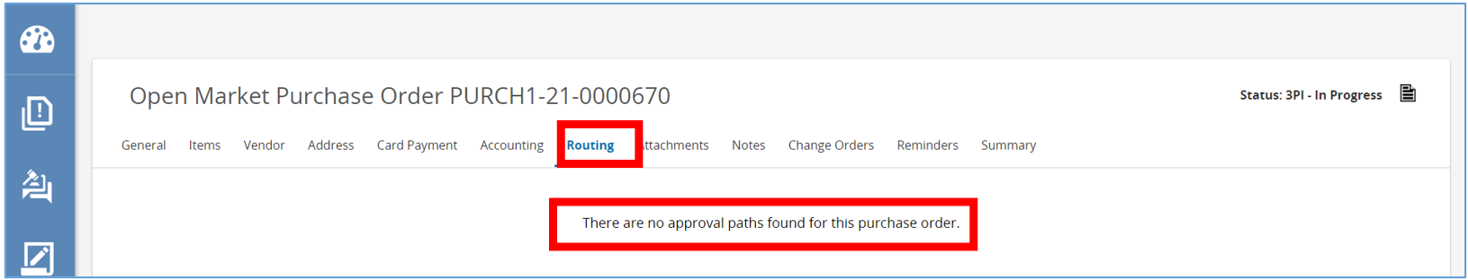

Attachments Tab
Attachments can be associated with the Purchase Order. Note, however, your organization may automatically attach documents to purchase at the time the Purchase Order document is created. This done by the Organization Administrator under the Department/Approval/Users Tab in the Maintain Document Attachment Repository section.
Prerequisites:
Identify the attachments needed for this Purchase Order:
  - Vendor Quote
  - Specifications
  - Terms & Conditions
  - Other
This tab is where additional documents related to the Open Market Purchase Order can be attached.
- To add a file, click Add File.
Figure 57: Add Attachments
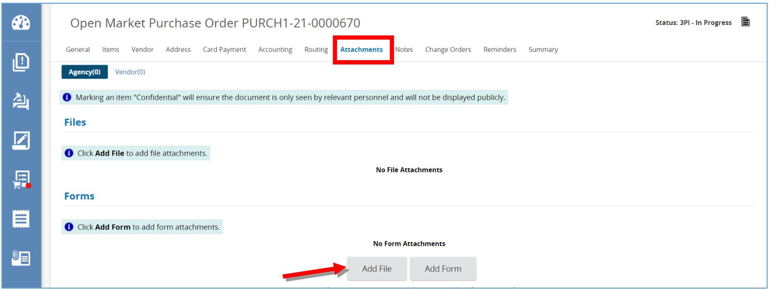
- Then click Choose File, then locate and select the document from computer. OregonBuys supports all document types except saved emails and .exe files. Documents should be named without special characters to ensure the file is saved properly.
- Next click Save & Exit.
- The page will refresh back to the Attachment Tab and the document will show as a hyperlink.
Figure 58: Choose File for Attachment
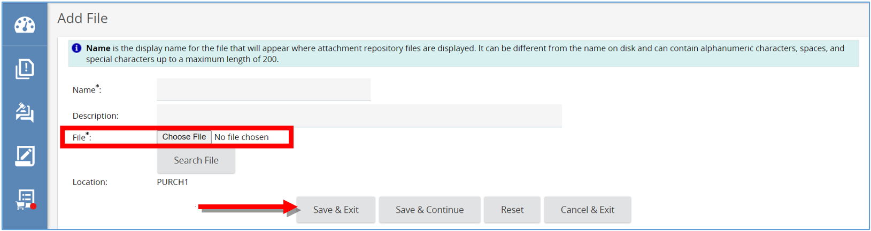

Notes Tab
This tab is similar to a digital post-it viewable by the user and others in the organization.
- Type the note in the text field and click Save & Continue.
Figure 59: Enter Notes
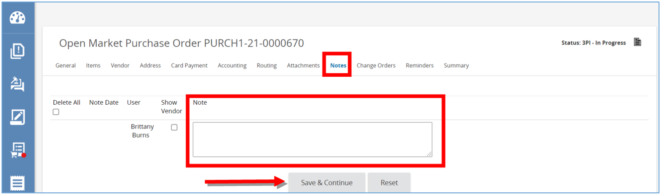

Change Orders Tab
This tab is where the Open Market Purchase Order can be modified after it’s been approved and sent. You would use this tab in the event that the Purchaser listed on the Purchase Order has changed, or the Terms and Conditions have been updated and need to be attached to the Purchase Order.
NOTE: For more specific information about change orders, see OregonBuys Purchase Order III Change Order Guidance
Figure 60: Change Orders Tab
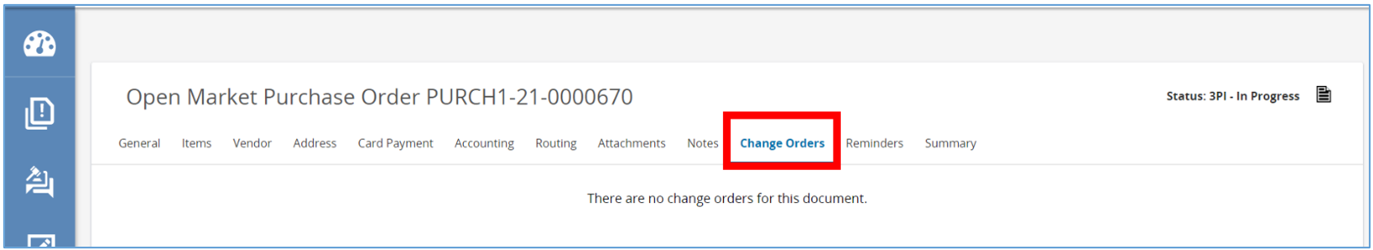

Reminders Tab
The Reminders Tab is where a reminder can be sent to yourself or another user within the organization about taking an action on this specific Open Market Purchase Order.
Prerequisites:
It is helpful to have the following information prior to setting up reminders:
- Due Dates for expiration.
- Names of people needed for approvals or other responsibilities.
- Deadlines for people to review the document by.

- To create a reminder, click the calendar icon to select the due date, which is the date the action needs to be completed. Then click Done.
  - This is the date the action needs to be completed.
Figure 61 Set the Reminder Date
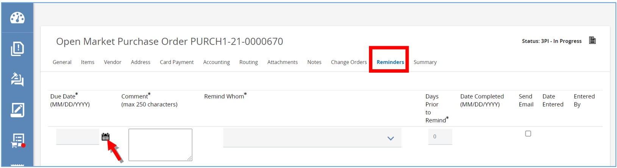
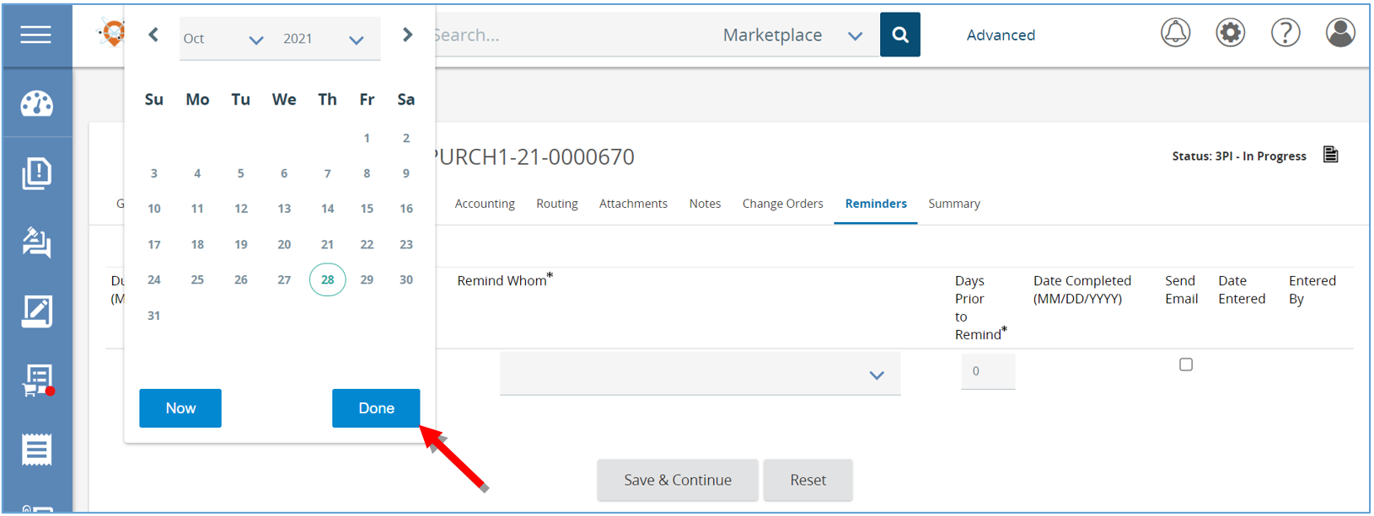
- Type the reminder in the Comment section.
- Select the person that needs to be reminded from the drop-down arrow.
- Set the Days Prior to Remind field to the day the person needs to be notified.
- Check the Send Email box to have the system email the reminder and click Save & Continue.
Figure 58: Add Reminder Details
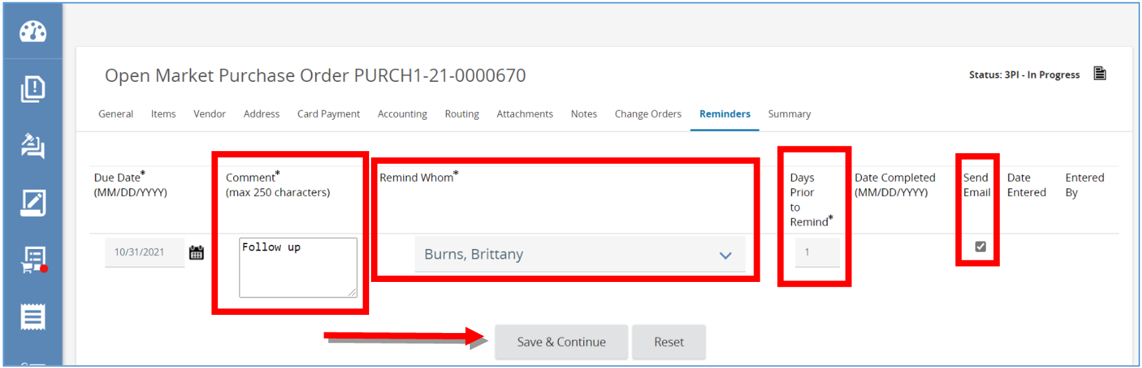

- After clicking Save & Continue there will now be a Date Completed field that the person assigned the reminder can update when they have completed the task
Figure 62: Enter Date Completed
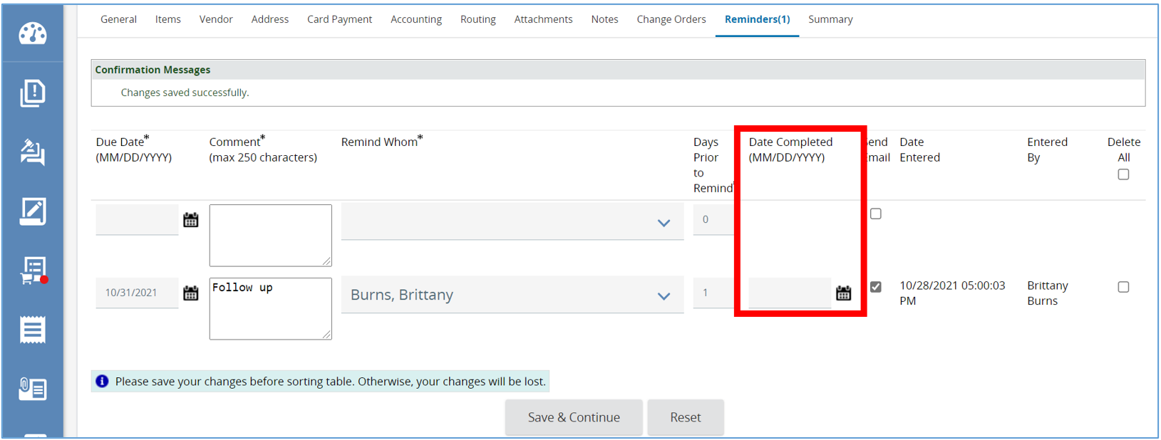

Summary Tab
Prerequisites:
Prior to completing the document, have the following information:
- Know whether or not this Purchase Order is ready for approval.
- Should it be cancelled?
- Is there something significant about this document that needs to be changed? If so, you may want to clone this document and make changes to the clone.
This tab summarizes all the information on the previous tabs into one screen. This is also where the document is submitted for approval.
Figure 63: Summary Tab
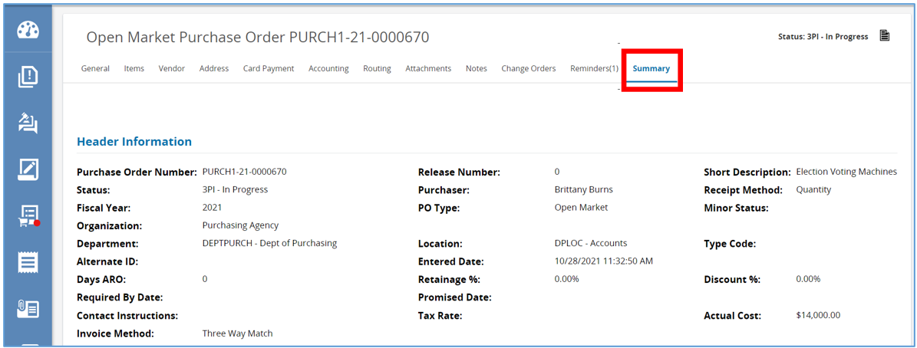
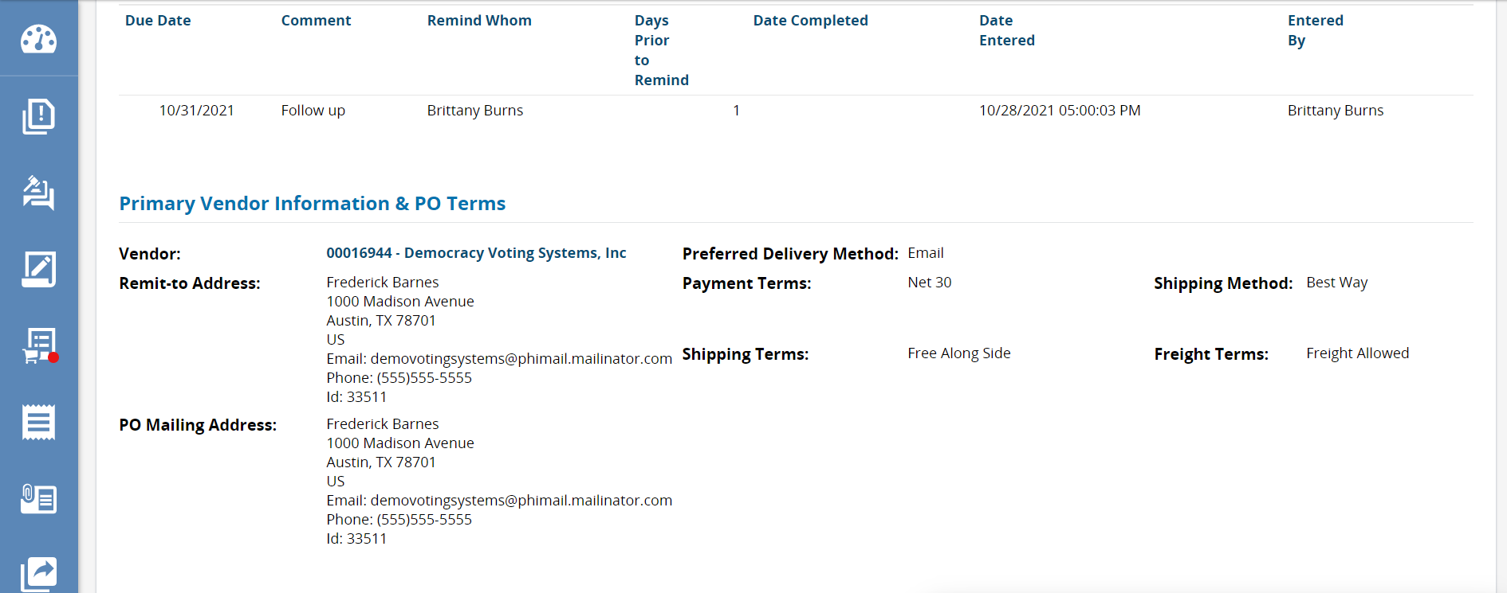
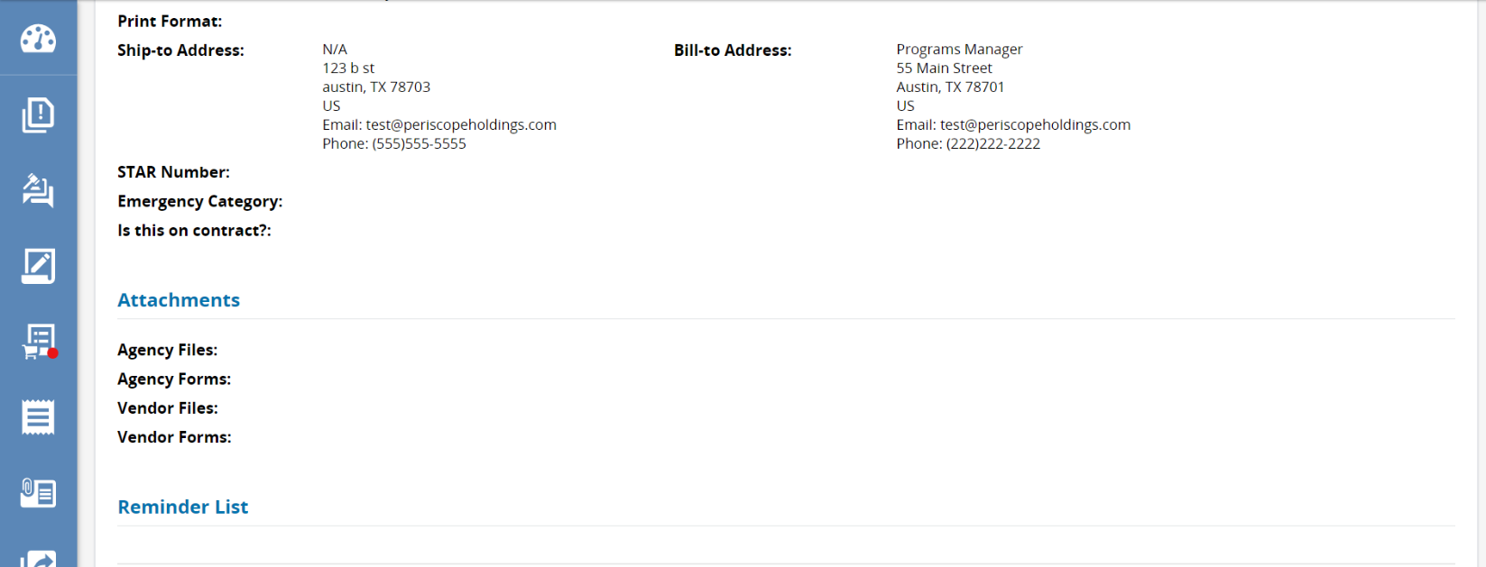
- Towards the bottom of the screen there are five buttons.
  - Click Submit for Approval to submit Open Market Purchase Order to the predetermined approval paths.
  - Click Cancel PO to cancel the Open Market Purchase Order which will change the status to canceled.
  - Click Clone PO to clone this Open Market Purchase Order which will create a second In-Progress Purchase Order, copying the date from this one to the new one.
Figure 64: Submit for Approval
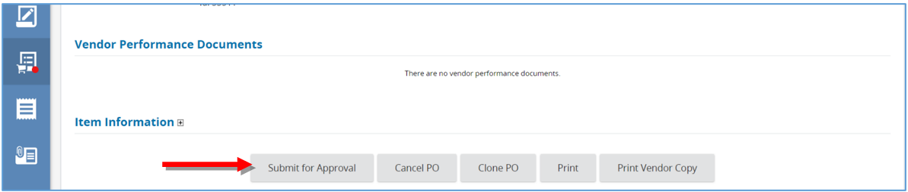

Submit the Open Market Purchase Order for Approval.
The following instructions begin on the Summary Tab of the Open Market Purchase Order. This is where the Purchase Order needs to be submitted for approval and converted to a “Sent” status.
- After clicking Submit for Approval, the page will refresh with the Approver screen.
Figure 65: Approvers
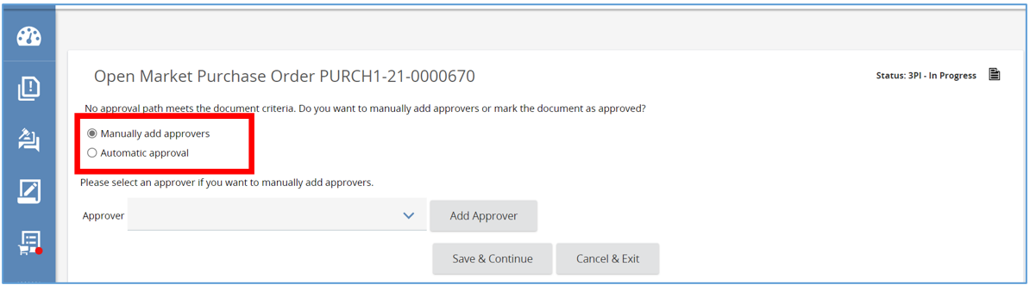

- There are two options to approve the Purchase Orders.
  - Automatic Approval: No approvers are necessary, the document is automatically approved, through the configuration set by the Organization Administrator through the Approval Path.
  - Manually Add Approvers: Using the drop down, select the approvers from a list of system users
- After making selection, click Save & Continue.
Figure 66: Select how the Purchase Order will be Approved
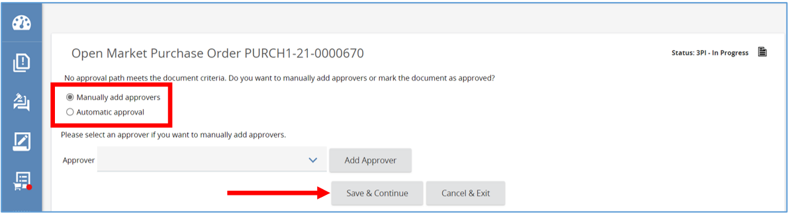
- Figures 67 through 69 will show the following processes.
- The page will refresh back to the Summary Tab and a message will appear confirming the changes have been saved. The status of the Purchase Order will now change to “Ready to Send”.
- Scroll down to the bottom of the page in the Vendor Notification Actions section.
(NOTE: Examples on provided on the following page.)
  - There are two options to select:
    - Send Email and Notify Vendor which sends the vendor a notification
    - Set to print status which saves and continues without a notification
- Select Vendor Notification Actions option and select Save & Continue
- The page refreshes, leaving you on the Summary Tab and the status of the Purchase Order will now change to “Sent”.
- Vendors will see the Purchase Order when they log into the system.
Figure 67: Ready to Send
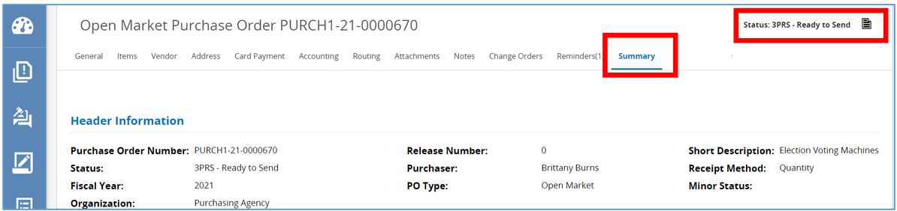
Figure 68: Set Options to Send Email and Notify Vendor
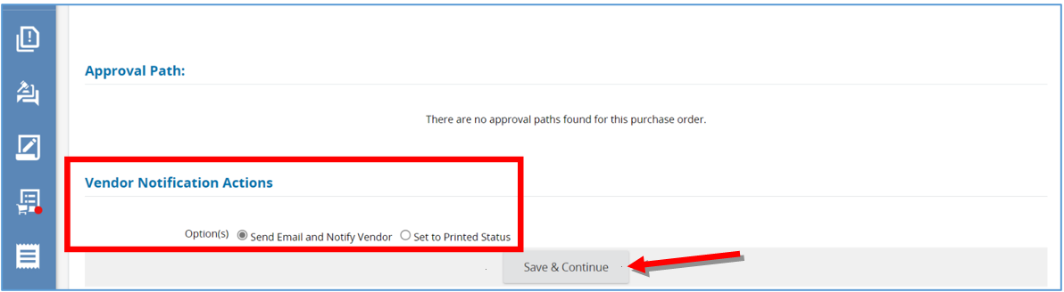
Figure 69: Open Market Purchase Order Sent Status
