OregonBuys Requisitions I: Open Market Requisition

Table of Contents
Introduction 2
Prerequisites 2
Scenario 2
General notes 2
How to Access an Open Market Requisition 3
Creating a New Requisition 4
General Tab 4
Items Tab 8
Add an Item from a Previous Order 16
Vendors Tab 19
Address Tab 20
Card Payment Tab 20
Accounting Tab 21
Splitting Account Strings 22
Apply Account Strings by Dollars 22
Routing Tab 23
Attachments Tab 23
Notes Tab 24
Reminders Tab 25
Summary Tab 27

Introduction
This guidance document will show you the basics of creating an Open Market Requisition from start to finish. An Open Market Requisition is a document used to request goods or services that are not available on an existing contract. An Open Market Requisition can be created to request and receive informal quotes from vendors for small purchases, to provide documentation and request approval of special purchasing arrangements.
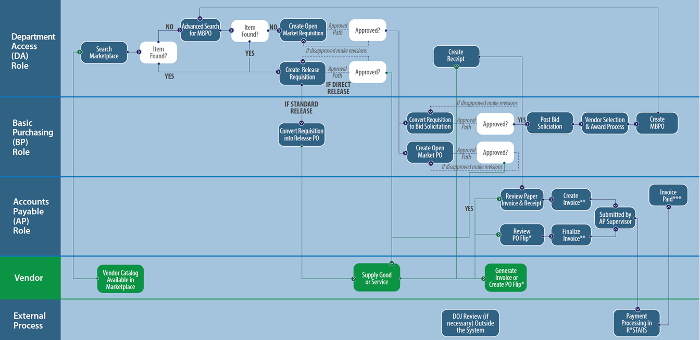
- Figure 1: High Level Process Flow

Prerequisites
- Department Access User with set Department and Location
- Have a need to purchase an item that isn’t currently on a contract
- Need a recommended vendor (optional)
- Need to know item details and NIGP code or how to look up
- Need accounting/PCA Information to load into the system
- Identify approvers
- Identify buyers to route when completed.

Scenario
In this guidance document the Department Access (DA) user is requesting training and education services that are not on an existing contract or price agreement. The DA user will submit the requisition for approval before the Basic Purchasing (BP) user will take action on the request.

General notes
Prior to creating an Open Market Requisition, it is important to search existing contracts and price agreements to ensure that the goods are services are not already available through those contracts.

How to Access an Open Market Requisition
- Starting from the Home page, click the person icon in the top right corner, and Department Access as the user from the drop-down menu. Please note that a BP user can also create an Open Market Requisition but for the purposes of this example we are using the DA user role.
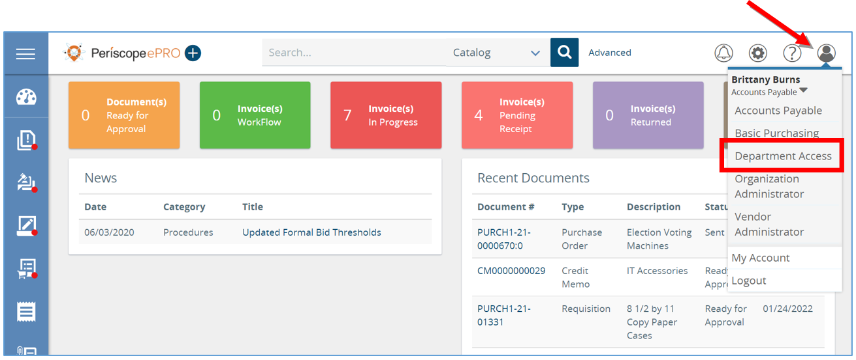
- Next, click the plus button and then select Requisition.
  - This will create a new Requisition
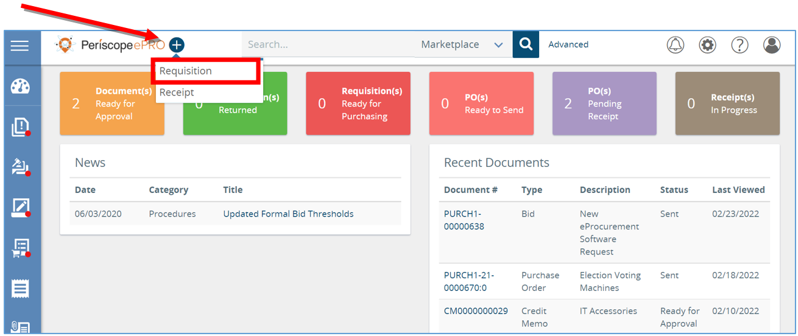

Creating a New Requisition
The new Requisition document will now show a series of tabs at the top. Starting with the General tab and ending with the Summary tab, you will work your way through the tabs from left to right to create a new Requisition. Fields that have an asterisk next to them are required fields to be completed.
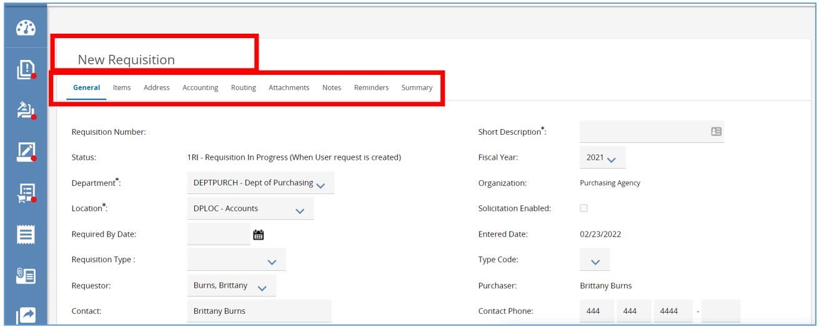

General Tab
- Starting from the General tab, enter the description of the commodities or services the organization needs.
  - This is a searchable field so be as specific as possible.
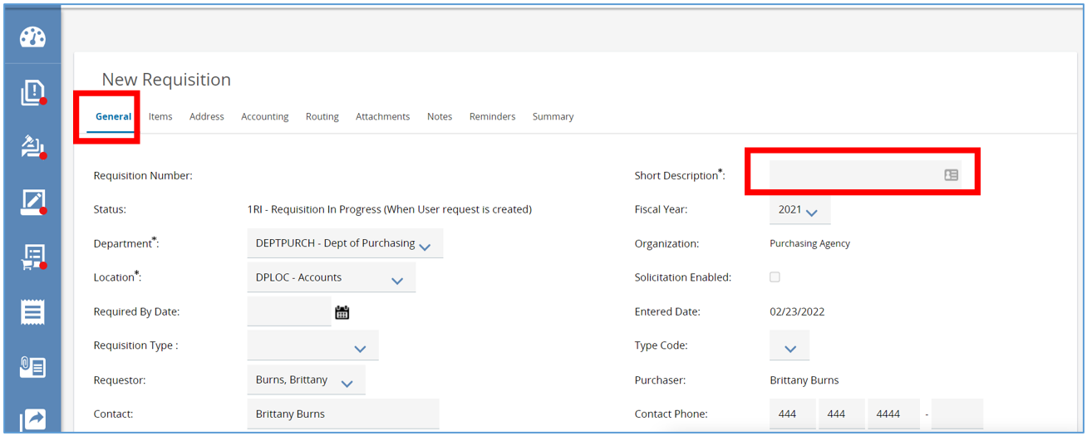
- Next, navigate to the Department and Location fields.
  - Both fields will be populated based on your default settings.
  - If you need to change the Department and Location fields, use the drop-down arrow, and select the appropriate options needed.
    - Locations are subsets of departments which are similar to an agency’s divisions, bureaus, or programs.
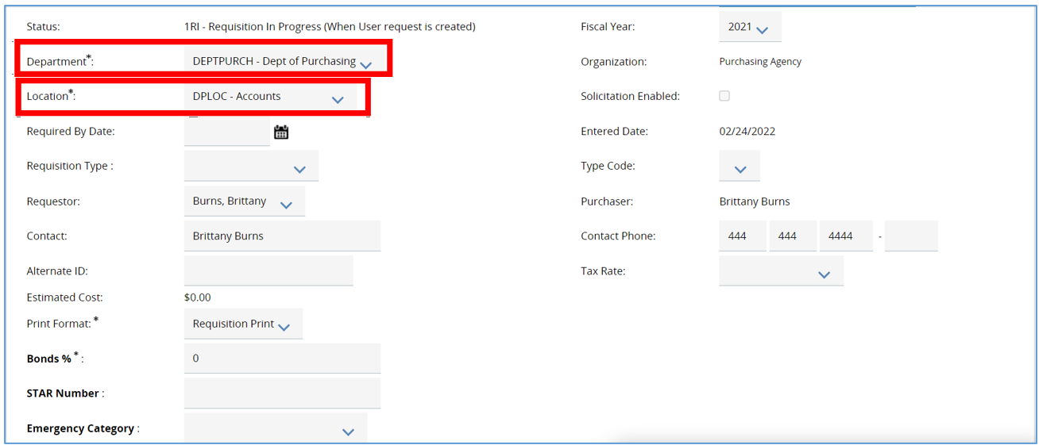
- Next, navigate to the Print Format. This field can stay as is.
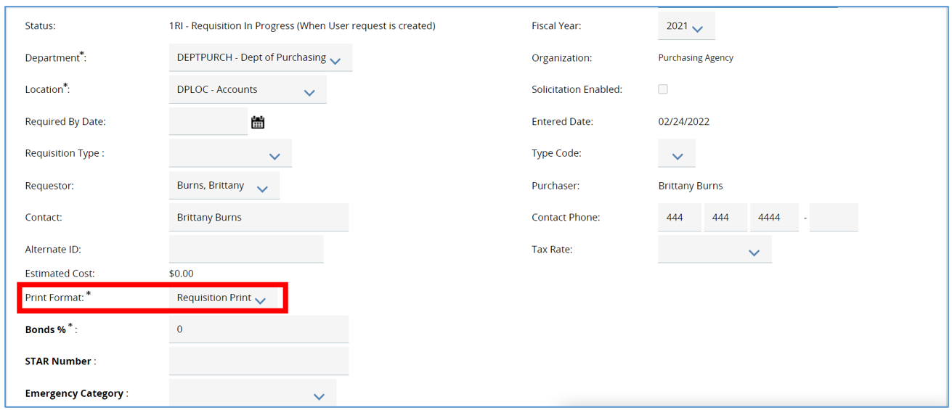
- The next required field on the General tab is the Discipline Type field.
  - The options provided are set at the Enterprise level and are based on the ORPIN System.
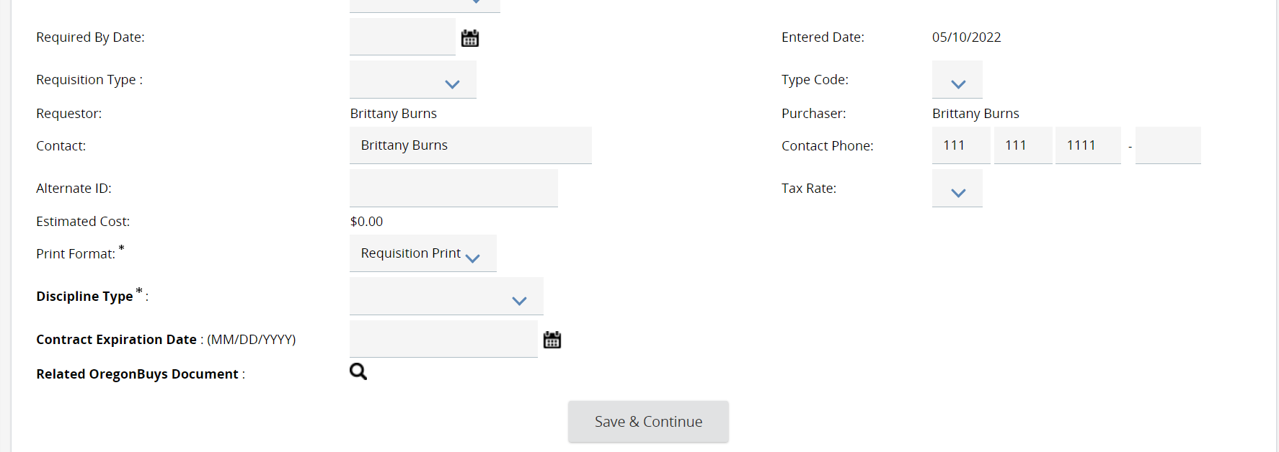

- Last field to complete on the General tab is the Requisition Type field.
  - This determines the type of Requisition you want to create and drives additional functionality on the Item tab. This guidance takes you through Open Market Requisitions. For other types, see alternative guidance.
    - To learn more about Release Requisitions refer to OregonBuys Requisition II: Release Requisition guidance document.
    - To learn more about RPA’s refer to OregonBuys Requisition IV: Request for Payment Authorization guidance document
      - An RPA Release is an RPA against Master Blankets that allow RPA Releases.
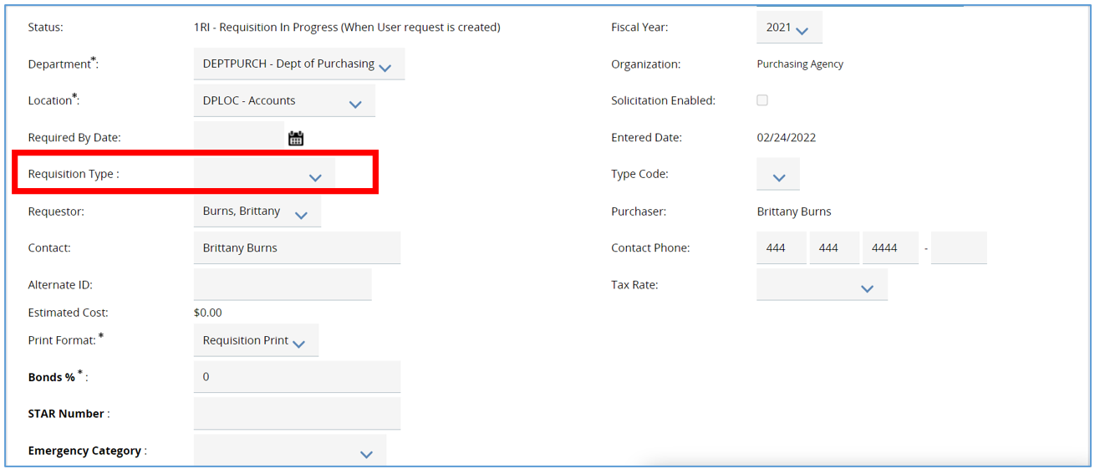
- Select Open Market.
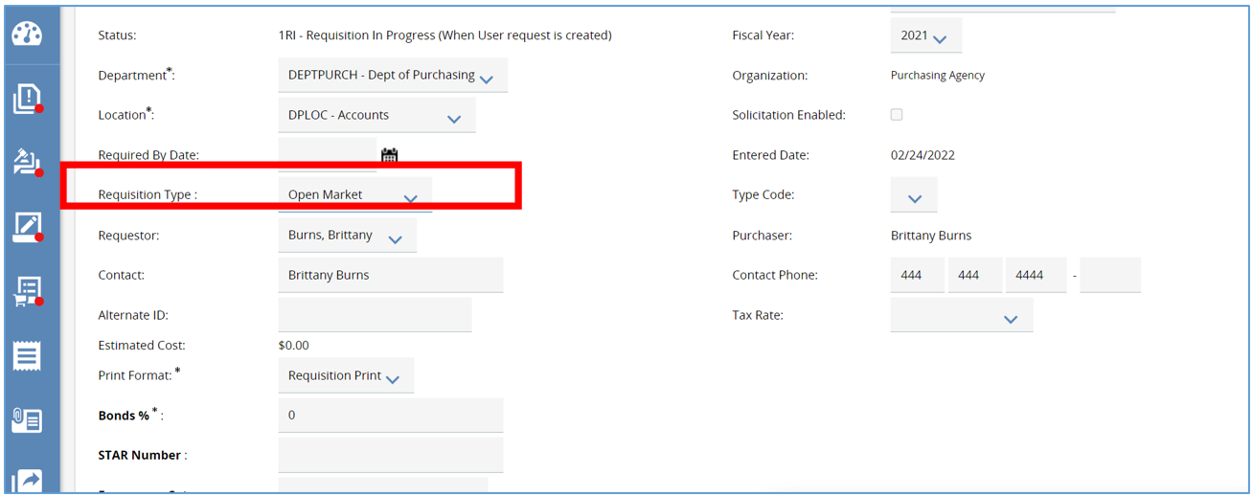

- Once the required fields are completed, click Save & Continue. This will save all the data entered if you need to finish at a later time.
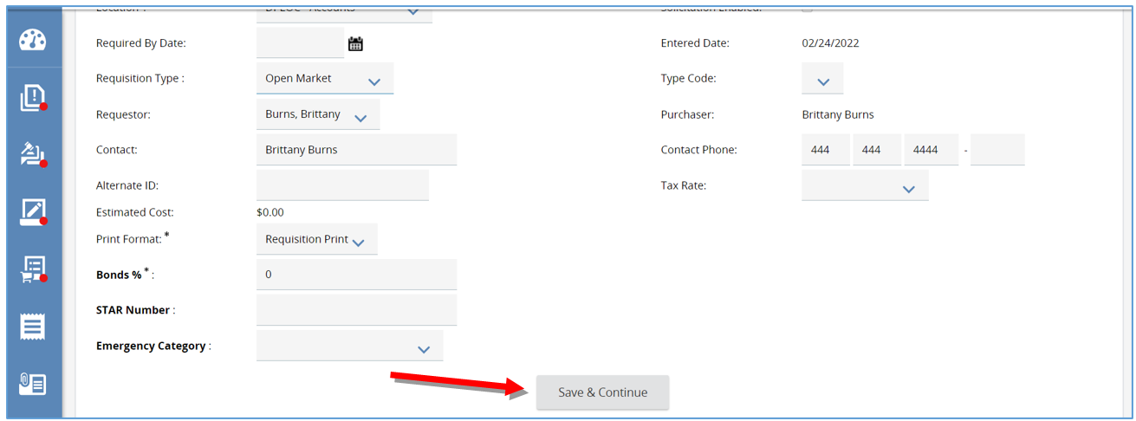
- The system will now generate a unique document number in the left-hand corner of the screen.
  - In the right hand-corner the status will now show In Progress.
    - This means the document is saved and is editable.
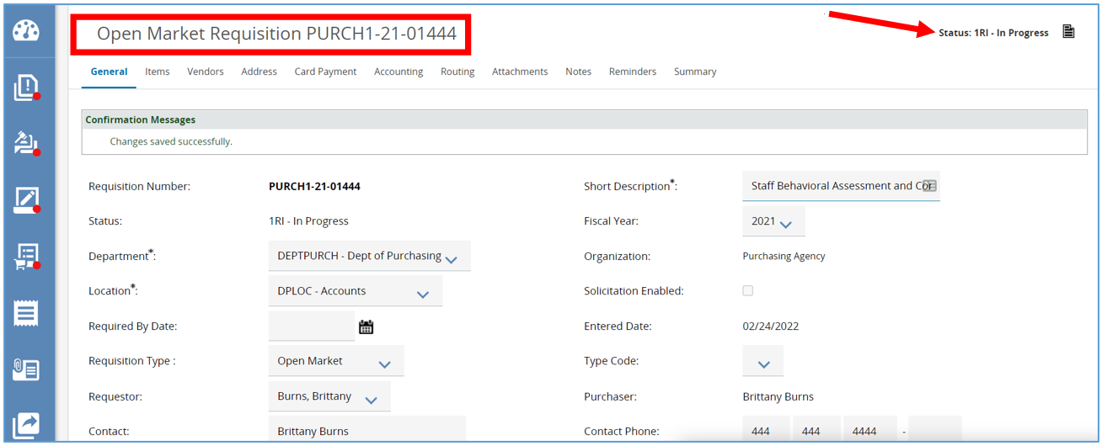

Items Tab
The Items tab is where you create line items detailing the commodities or services that the Requisition is for.
- To create a new line item, click the Add Open Market Item button.
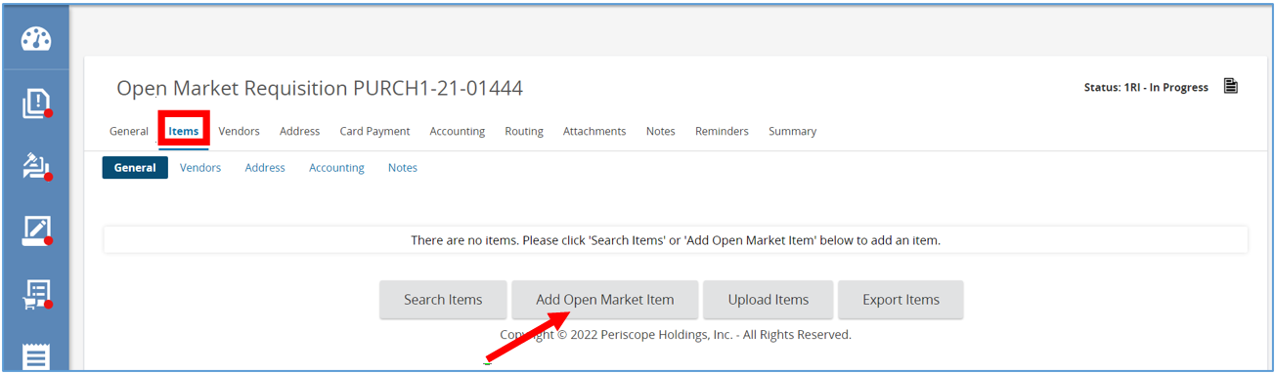
  - The page will refresh to the Items detail screen.
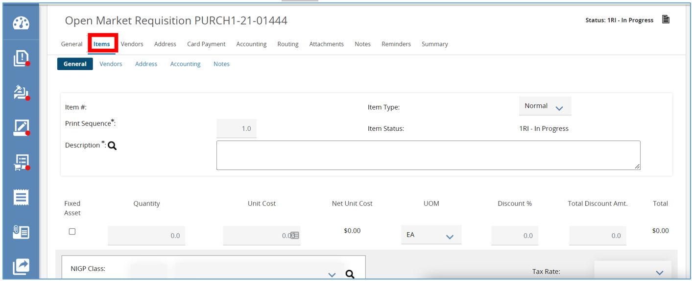
- Next, add the Item Description.
  - It is recommended to be as specific as possible.
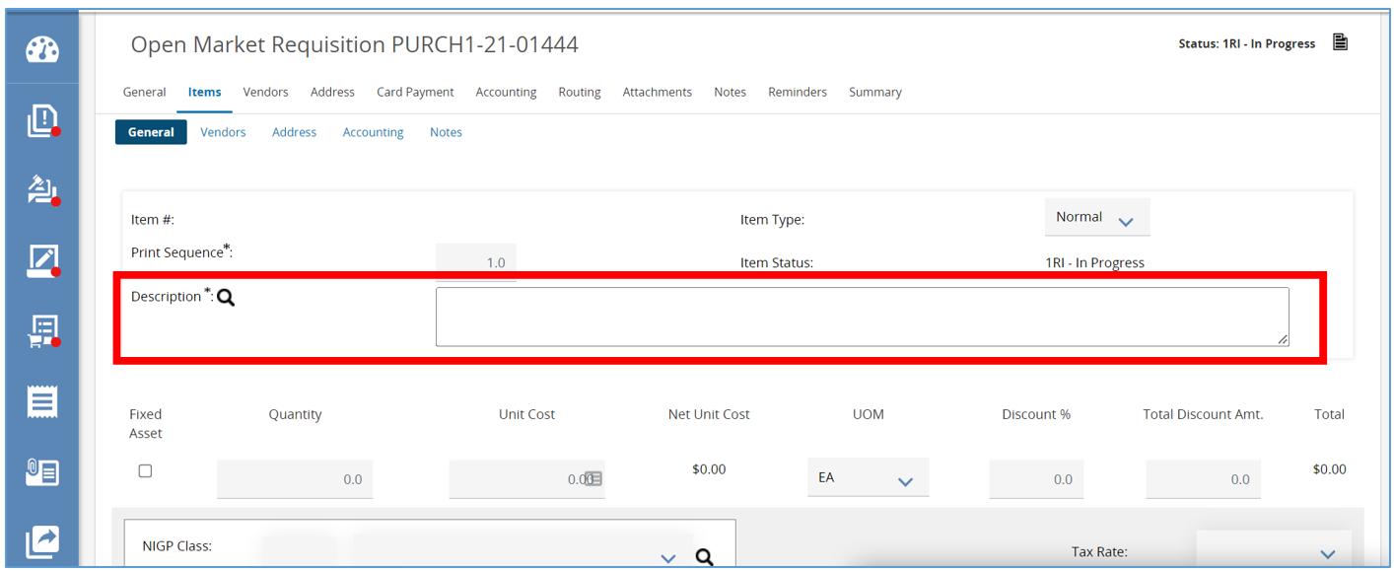
- Then, fill in the Quantity field.
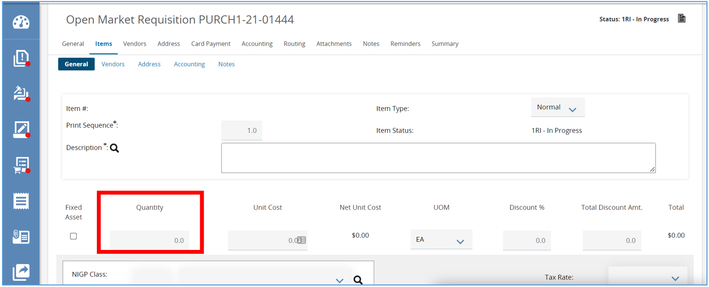

- Next, complete the Unit Cost field.
  - This field defaults to $0.
  - To trigger certain approval thresholds or based on information you’ve requested from subject matter experts, enter in the estimated Unit Cost in this field.
    - The total amount will than update.
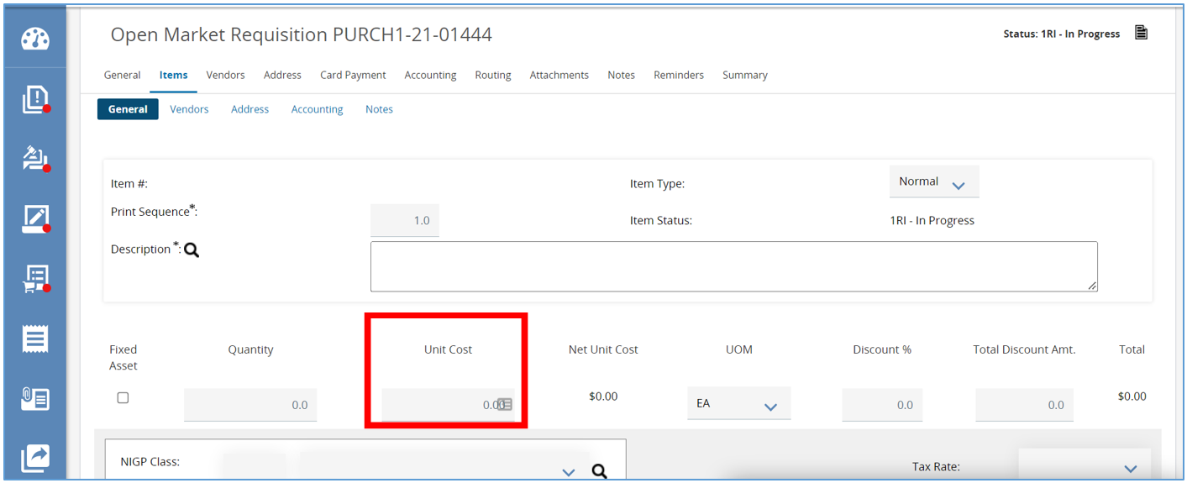
- Then, complete the Unit of Measure field.
  - This field will default to Each and can be left as is.
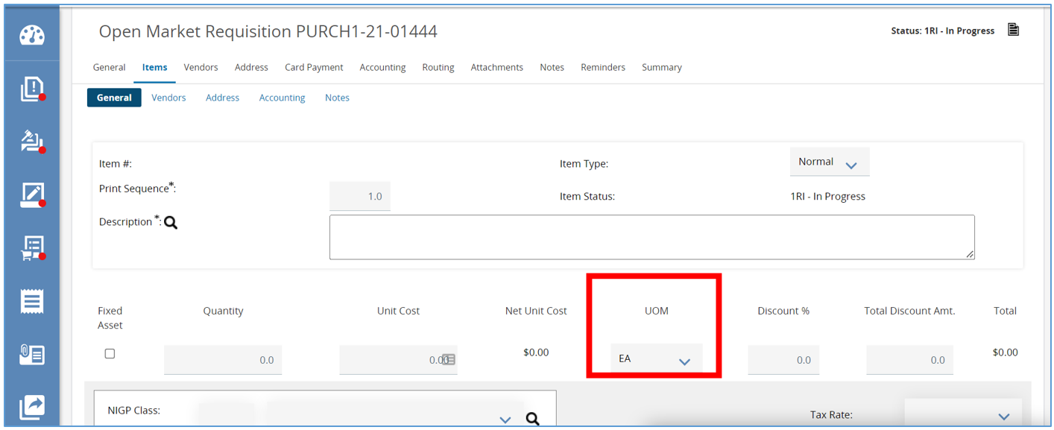
  - To change the Unit of Measure, click on the drop-down menu and select the appropriate choice.
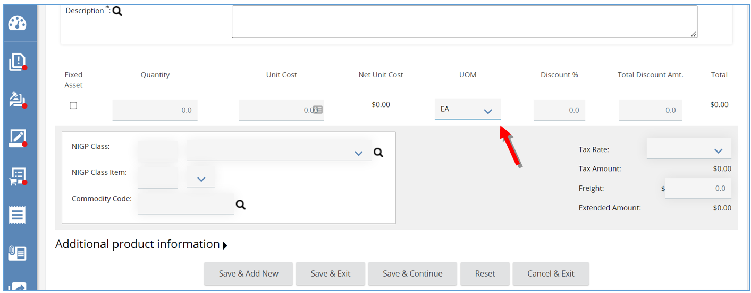
- Next, complete the NIGP Class and NIGP Class Item fields.
  - Anytime an Item is being added to a Requisition, a commodity code needs to be assigned.
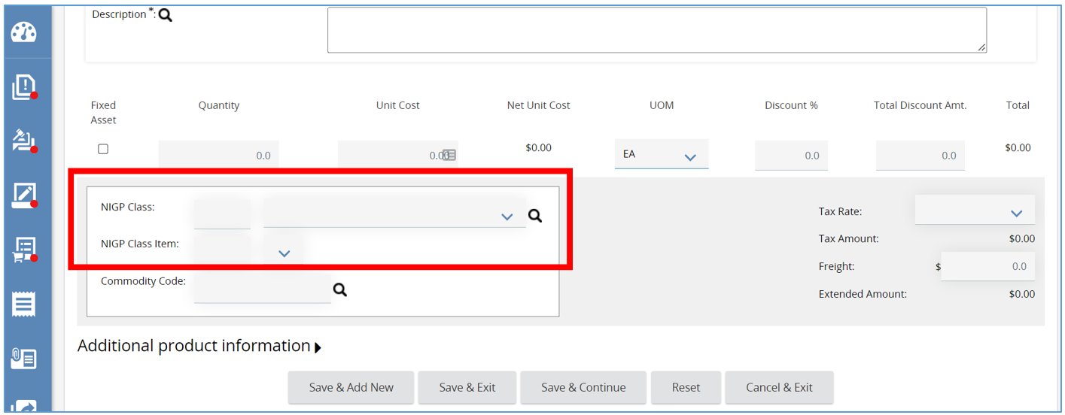
    - There are three ways to add a Commodity Code.
      - If you know the commodity code, manually enter it into the fields.
      - You can use the drop-down menu in each of the fields.
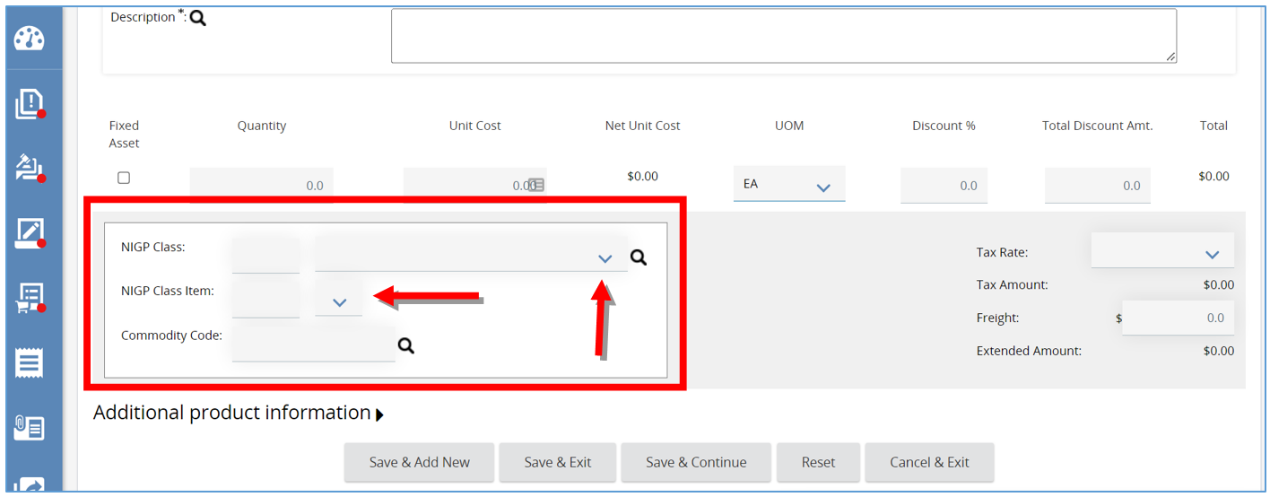

      - Lastly, click the magnifying glass, this will open a pop-up window allowing a search for the code.
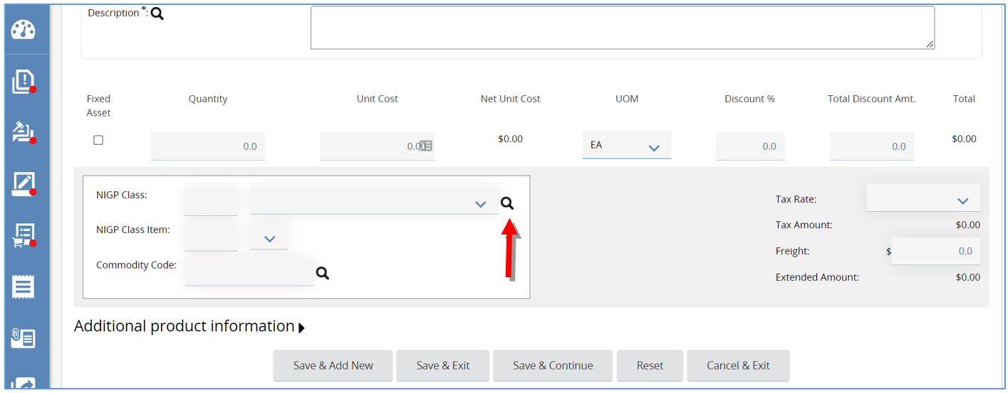
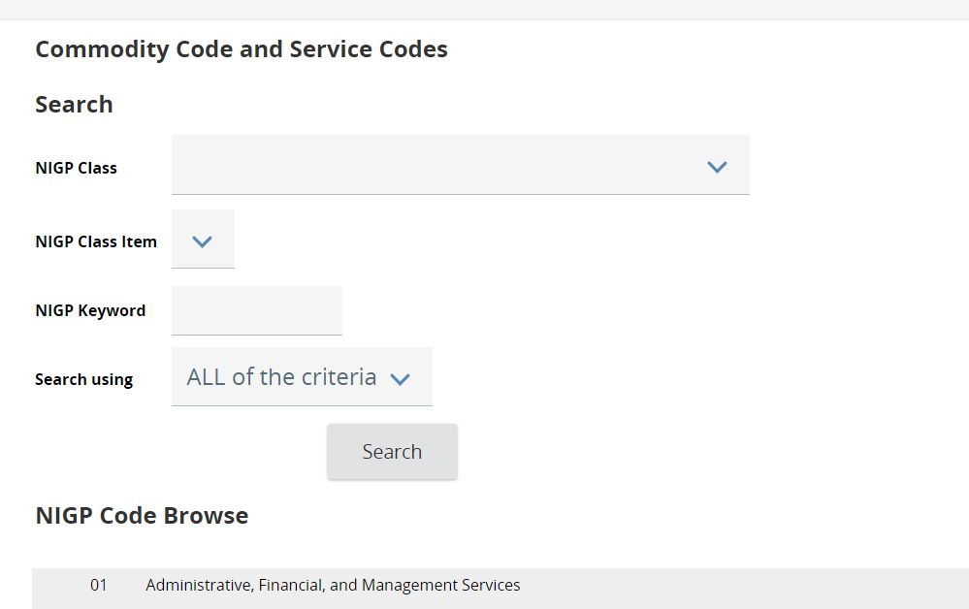
        - Type in a keyword in the NIGP Keyword field and click Search. The screen will refresh showing the codes associated with the search just completed.
        - Select the NIGP code you want, then click Save & Exit.
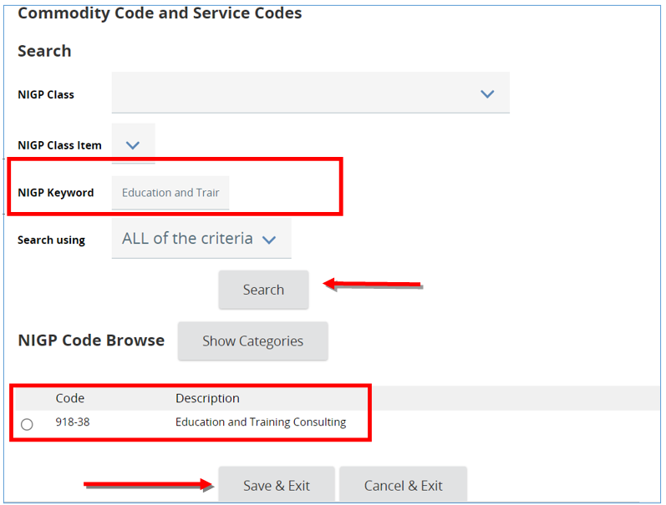
  - The page will refresh back to the Item Details screen where the commodity code renders.
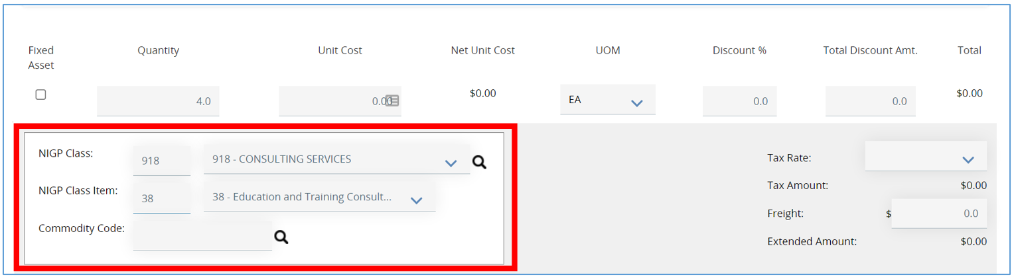

- Next, expand the Additional Product Information field if you have any additional information you would like to provide to the Vendors.
  - Enter information in any of the fields provided.
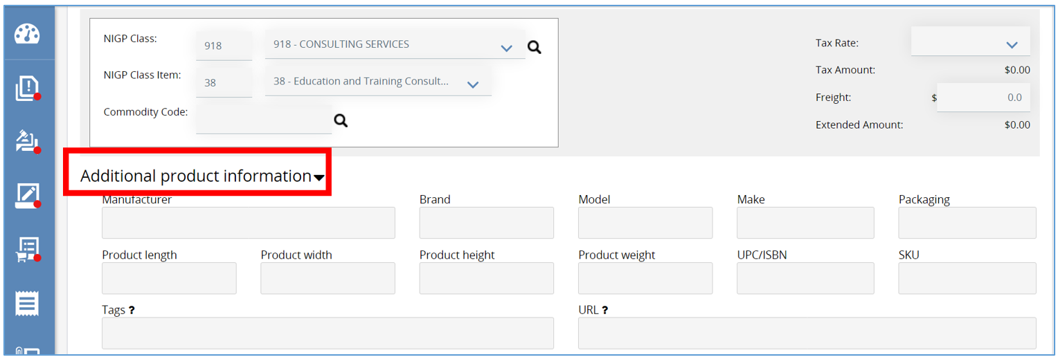
- When finished, click Save & Add New to save the Item Detail just completed and start a new Item.
  - Or click Save & Continue to save the data entered and continue working on this Item Detail
  - Or click Save & Exit to save this Item Detail and to return to the Items General subtab.
    - You will now see a confirmation message confirming the Item was saved.
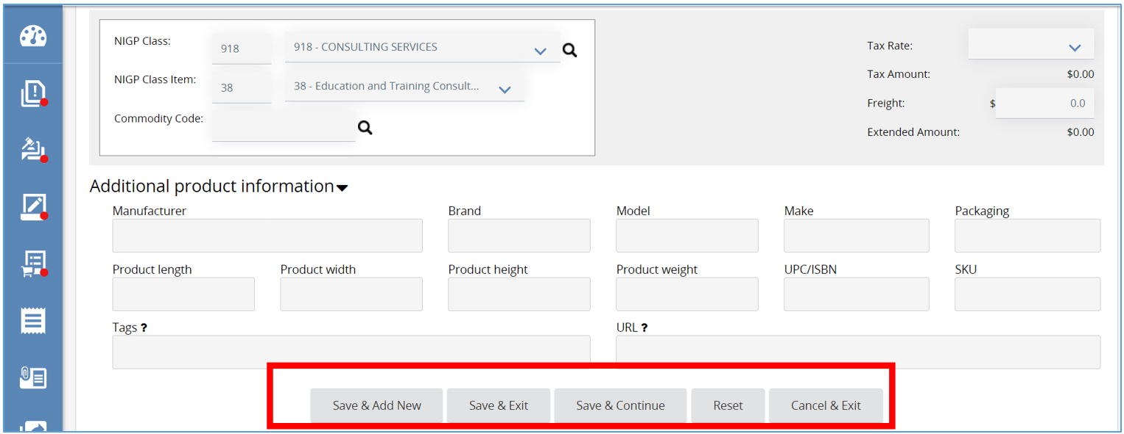
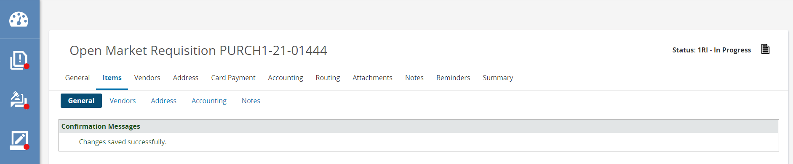

- Lastly, if you had more than one Item on a Requisition, the other subtabs allow you to assign specific information to each item if necessary.
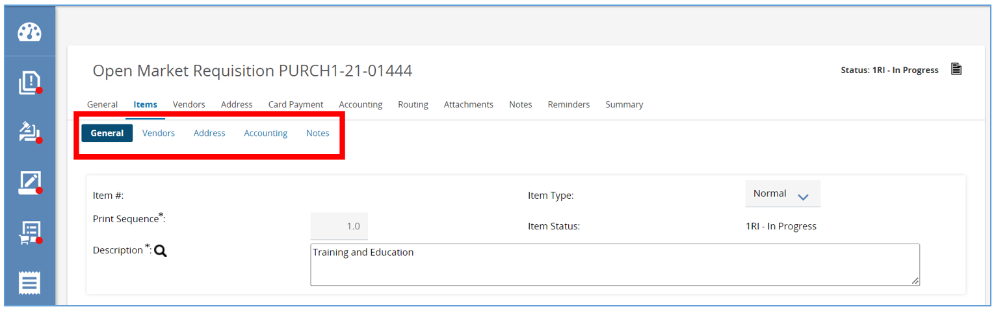

Add an Item from a Previous Order
- To add an item from a previous order click Search Items on the Item Details screen.
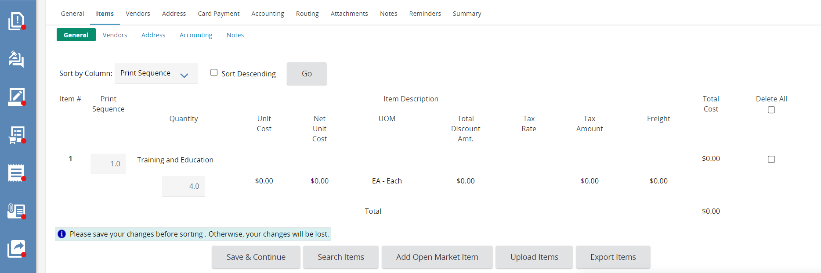
- Then expand the Advance Search option by clicking the plus button
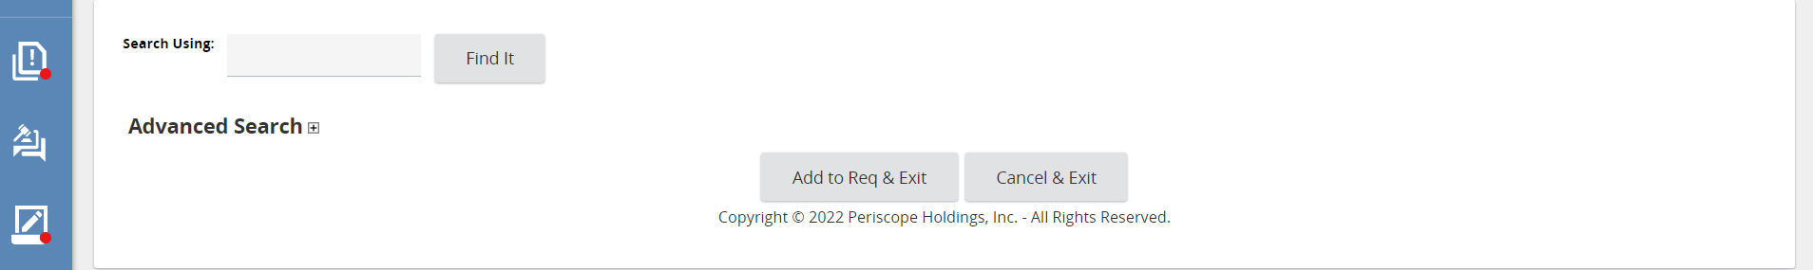

  - Here you can search by the Purchase Order number, the Header Description, Items Description, the Vendor Name, and any of the additional fields listed.

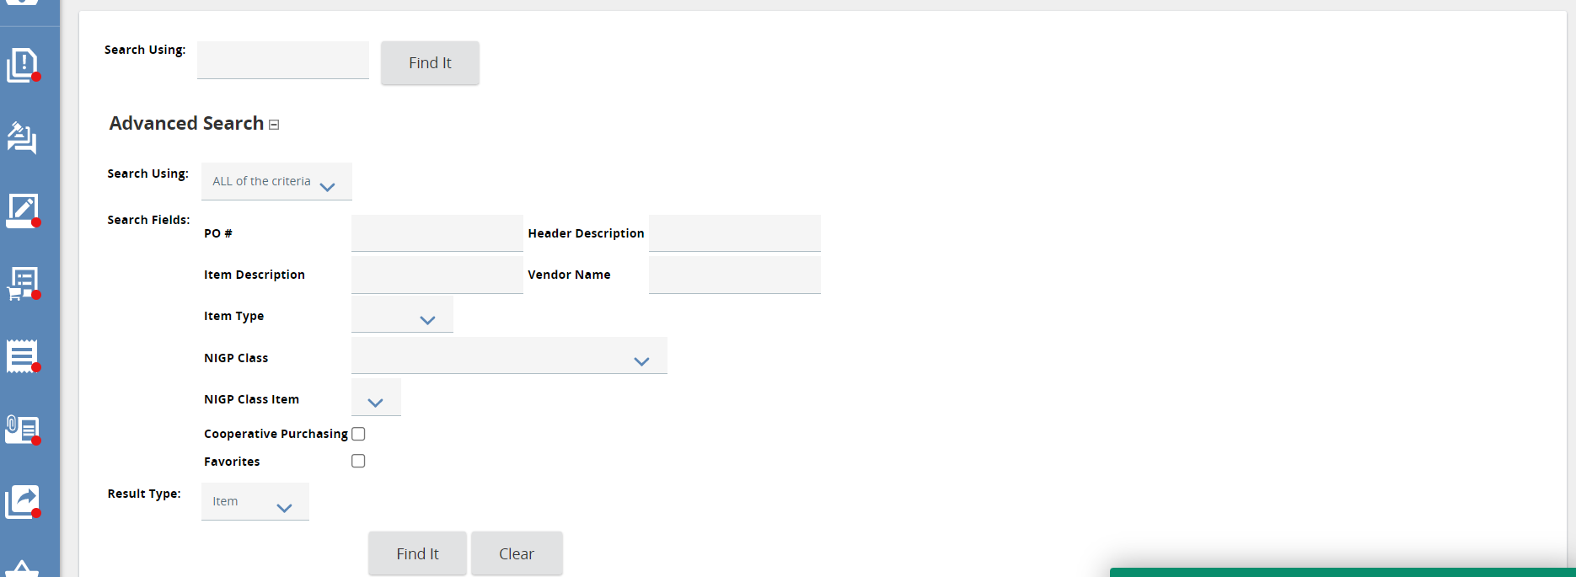
3. Then click Find it.
- The page will refresh and display the search results.
  - Some of the fields are:
    - Quantity
    - Item Description
    - Unit Price
    - UOM (Unit of Measure)
    - Vendor Name
    - Class Item
    - PO #/Line #
  - You also have the option to star an item as a favorite by clicking the star icon.
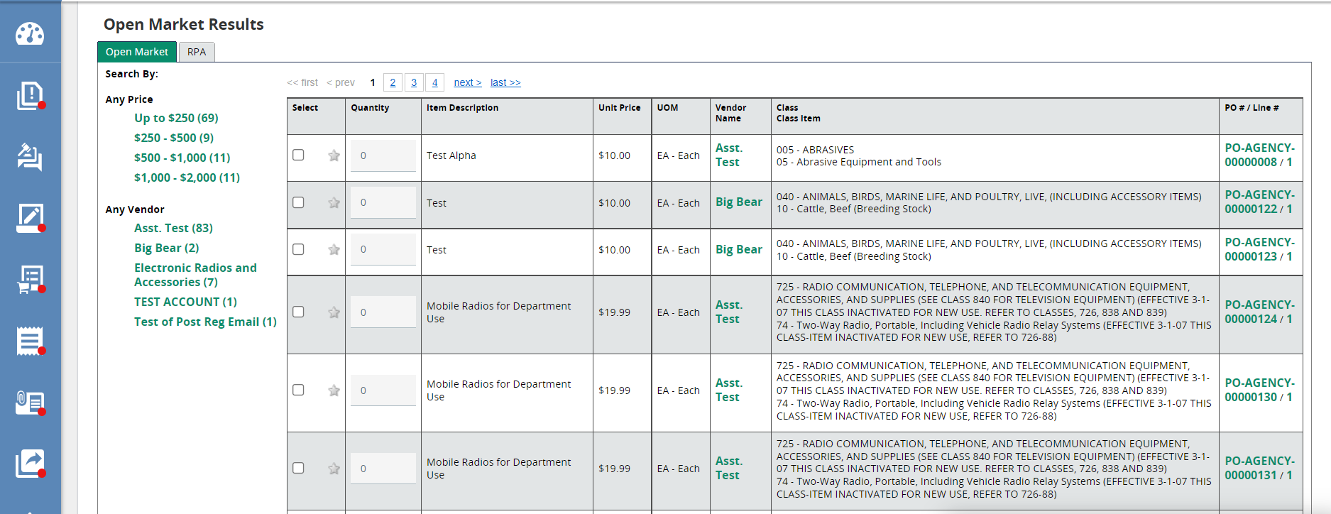
5. To select the Item, check the box in the Select column of the Item of your choice.
- Then enter in the quantity in the Quantity field.
- Scroll down and click Add to Req & Exit.
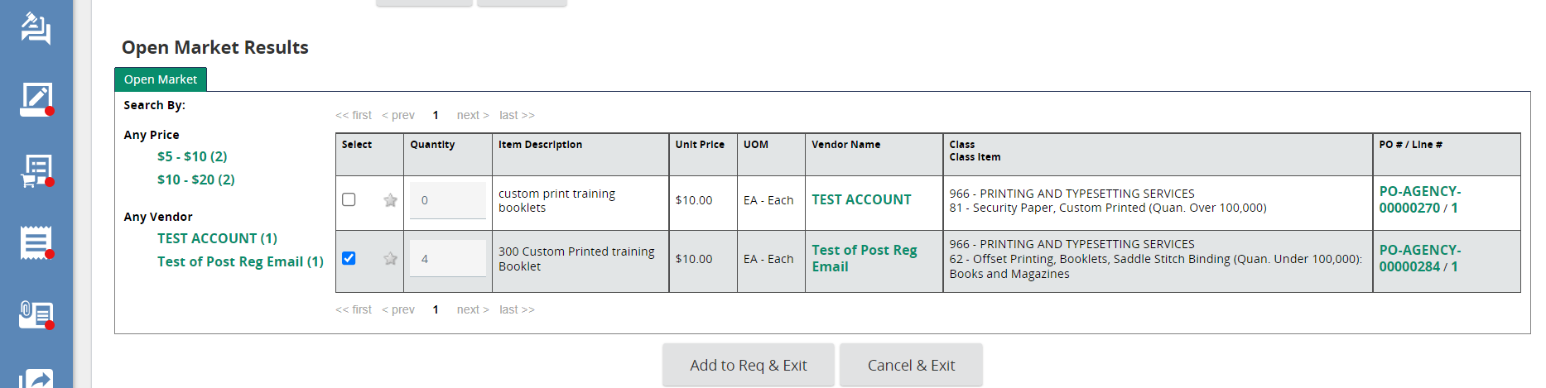

- You can also add an item from a previous order from a spreadsheet by clicking Upload Items.
  - This button will only appear if the user has the “Allow Requisition Item Import” privilege assigned to their user.
  - The template for the spreadsheet can be found by selecting Export Items next to Upload Items.
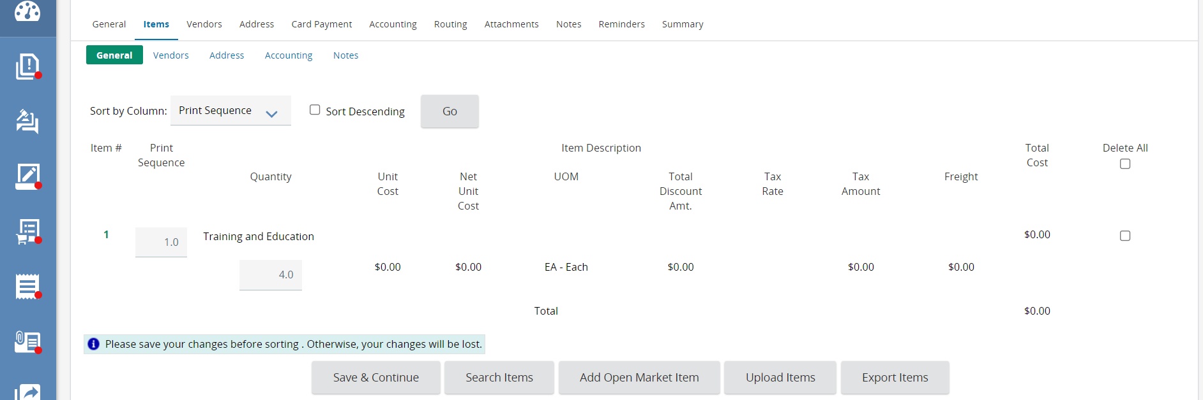

Vendors Tab
This tab is used to gather informal quotes and recommendations for small purchases. Since there is no recommended vendor at header level, we can skip this tab. This tab is covered in the OregonBuys Requisition III: Informal Quotes guidance document.
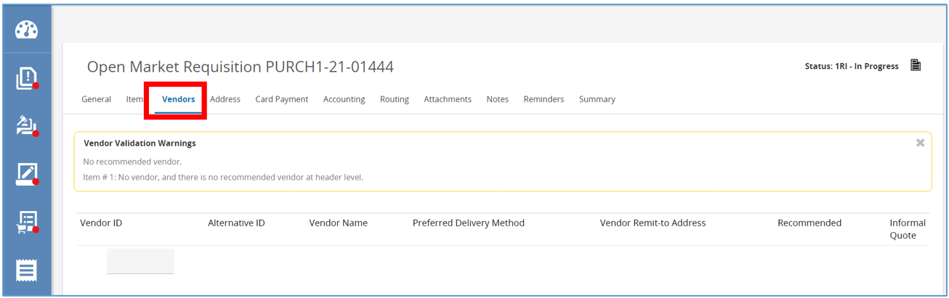

Address Tab
This tab displays the Ship-to and Bill-to Address for your Items on the Requisition. The options that appear on this tab are based on your default settings.
- To change the Ship-to Address, click the drop-down and select the appropriate Department.
- Then click Save & Continue.
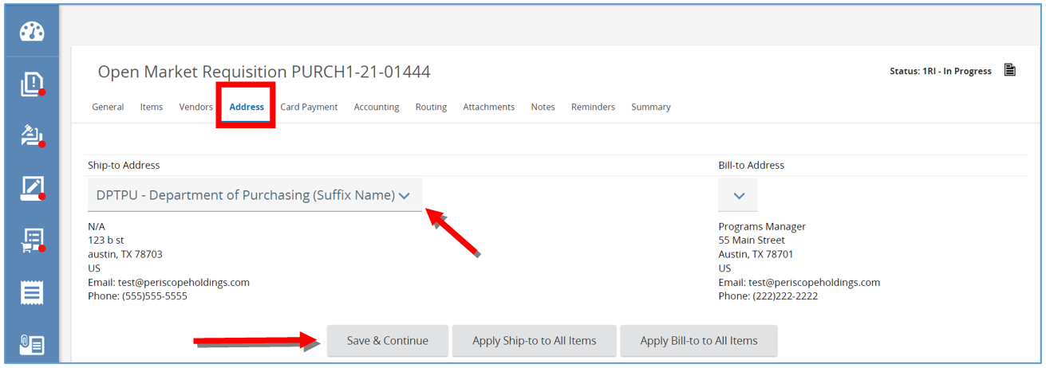

- Next, the page will refresh and then click Apply Ship-to To all Items.
  - This will apply the new address to all the Items.
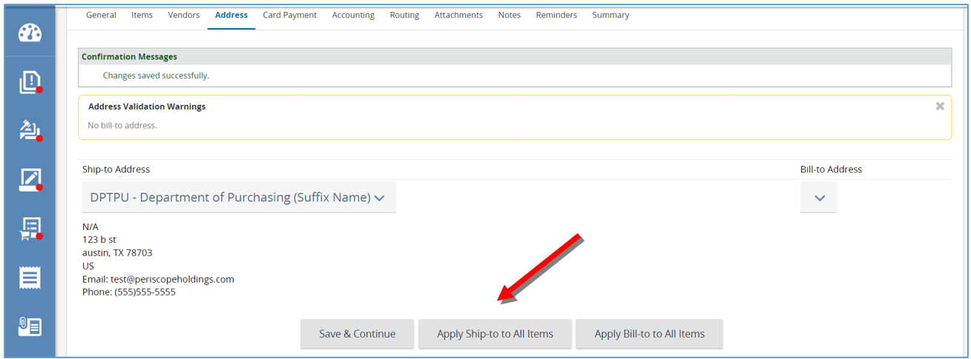

Card Payment Tab
This tab is only available if you’ve enabled the Card Payment functionality for your system.
- If applicable, select a P-Card assigned to your account by clicking on the drop-down arrow.
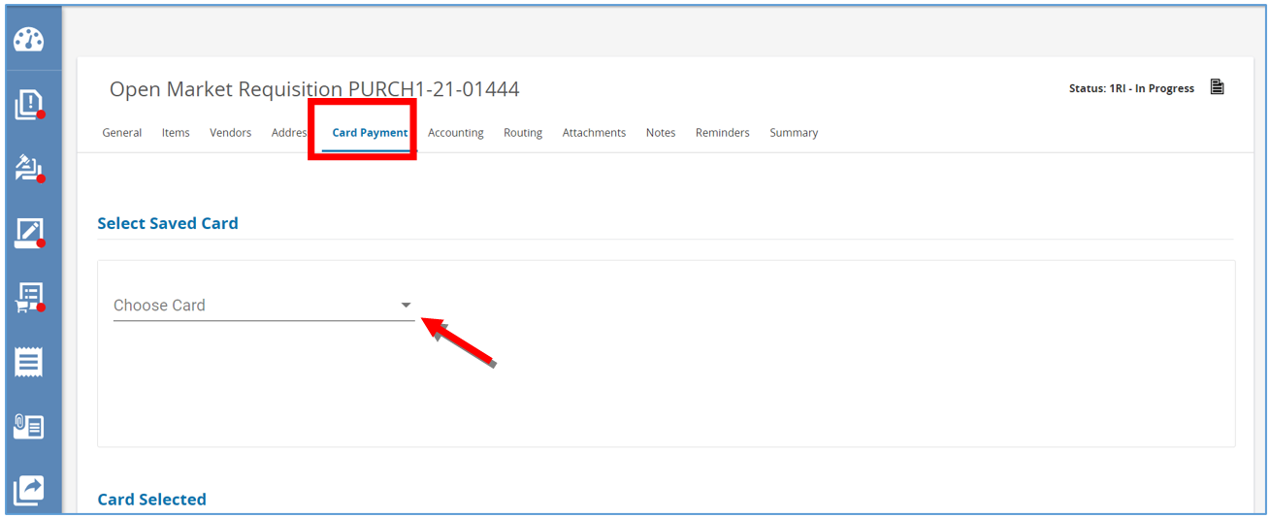

Accounting Tab
This tab is where you define all account strings and the dollar or percentage split, so it can be applied to all Items. If you have one account string to pay 100% of you Items, use these three steps:
- First enter in the account string.
  - You can search for an entire string
  - You can also search by segment
  - Lastly you can search manually by entering each segment or select segments
    - The first row will default to 100% which means this account string is meant to pay 100% of the
order.
- Click Save Based on Percentages.
- This will save the account string including the percent. Click Rebuild for All Items.
  - This will apply the account string with the percent to all Items entered in the Requisition.
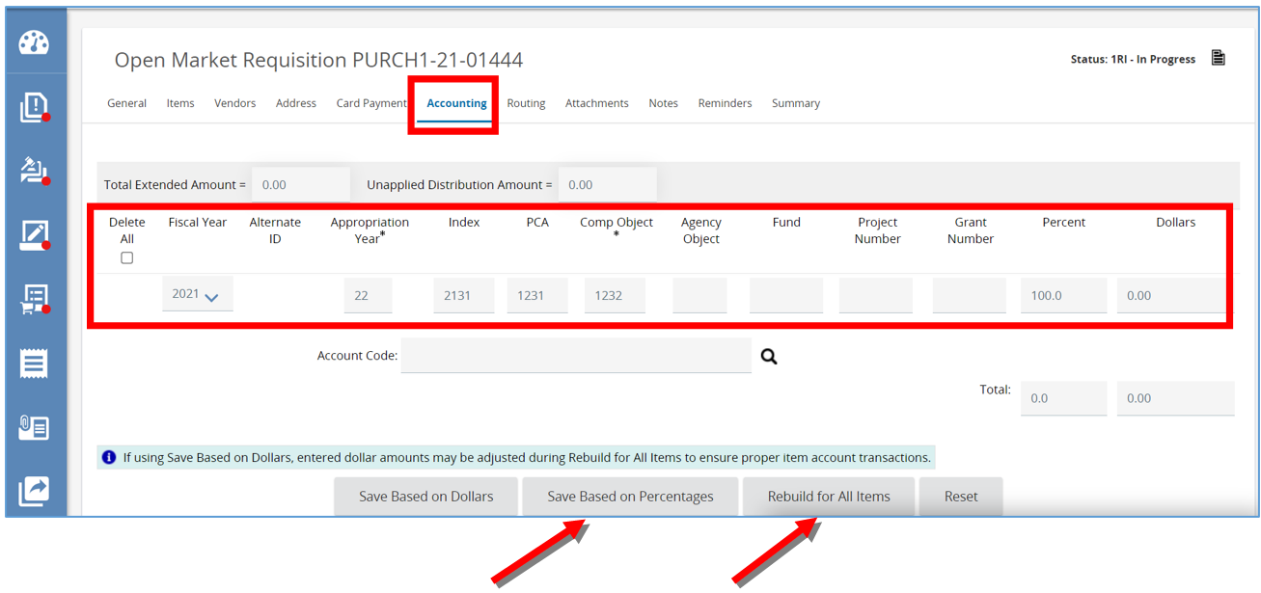

Splitting Account Strings
You wanted to split two account strings 60/40. You will need to enter each account string separately and assign the percentage split.
- Change the first account string to 60%.
- Then enter in the second account string and then enter 40 in the percentage field.
- Click Save Based on Percentages, the page will refresh.
- Then click Rebuild for All Items to apply the account strings and percentages to all the Items.
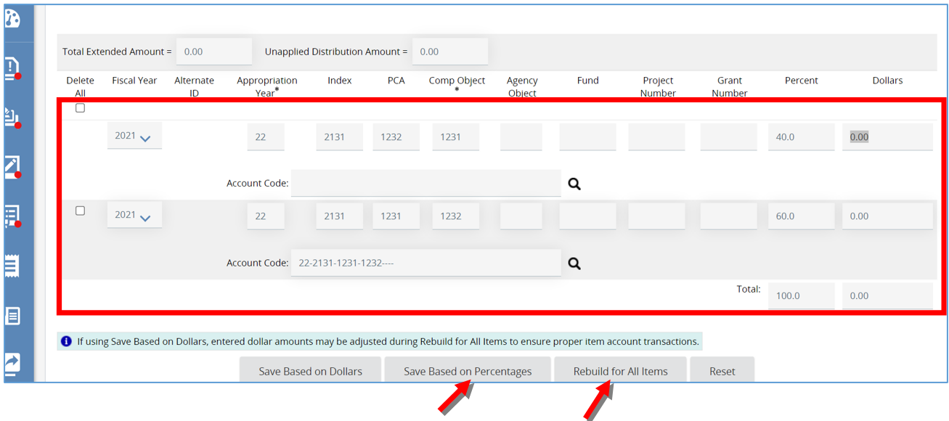

Apply Account Strings by Dollars
You can also apply account strings by dollars.
- To do this enter in the dollar amount for each account string under the Dollars field.
- Then click Save based on Dollars.
- Then click Rebuild for All Items.
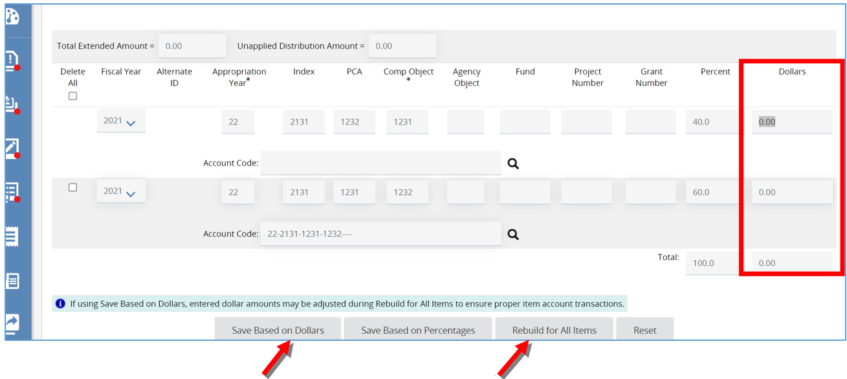

Routing Tab
This tab displays the approval paths the Requisition triggered which allows you to track who is in the process of reviewing and approving the document. This tab also allows you to refer back to who reviewed and approved the document for historical purposes.
This tab will remain blank until an approval path is determined when the Requisition is submitted for approval.
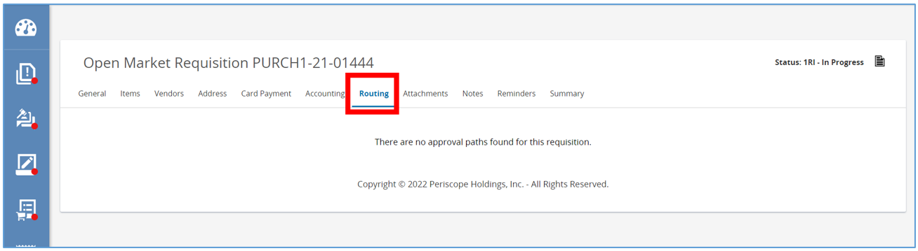

Attachments Tab
This tab is where you can attach additional documents related to your request.
- To add a file, click Add File.
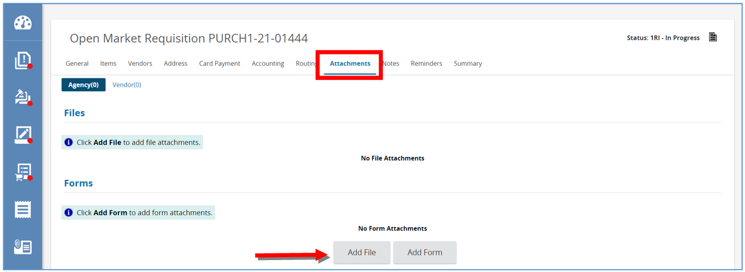
- Then click Choose File and locate and select the document from computer.
- Next click Save & Exit.
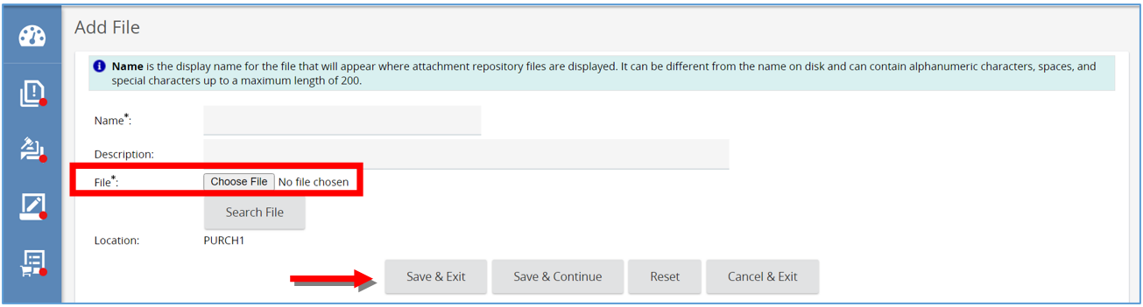
- Page will refresh back to the Attachment tab and document will show as a hyperlink.

Notes Tab
This tab is like a digital post-it only viewable by you and others in your organization.
- If you want an approver to review the information on the account tab, type your note in the text field.
- Then click Save & Continue.
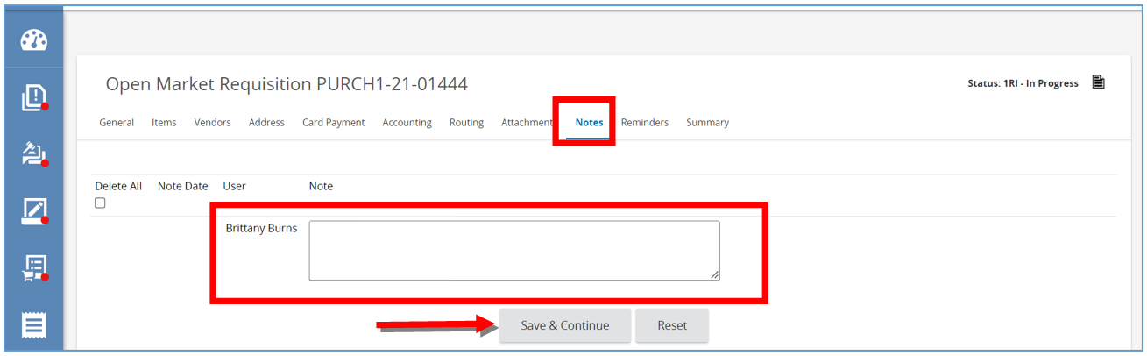

Reminders Tab
This tab is where you can send a notification to ourselves or another user in our organization about acting on this specific Requisition
- First, to create a reminder select the calendar in Due Date field. This is the date the action needs to be completed.
  - Once the date is select, click Done on the calendar.
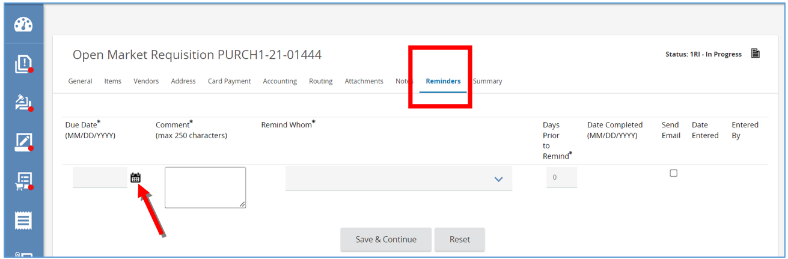
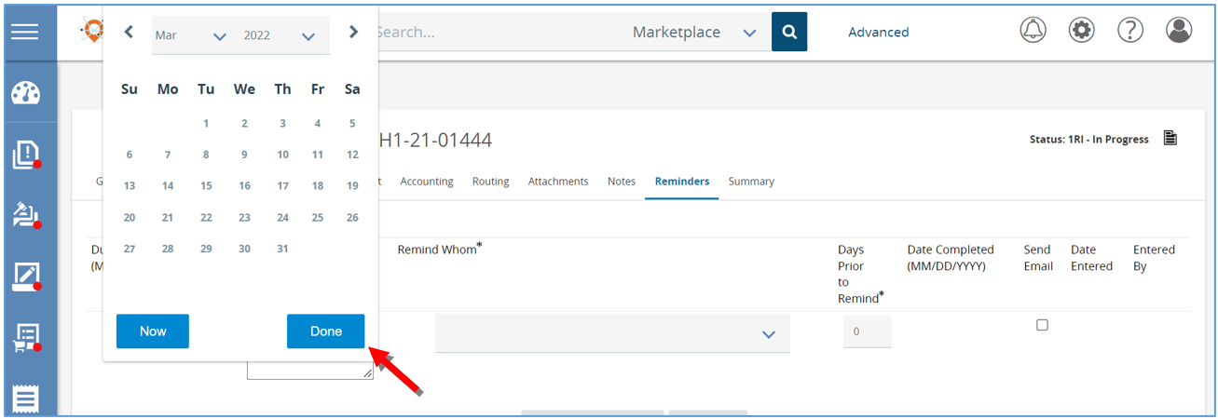
- Next, type the reminder into the Comment section.
- Then select the person that need to be reminded.
- Next, set the Days Prior to Remind field to the day you want the person to be notified.
- Check the Send Email box to have the system send an email reminder
- Lastly, click Save & Continue.
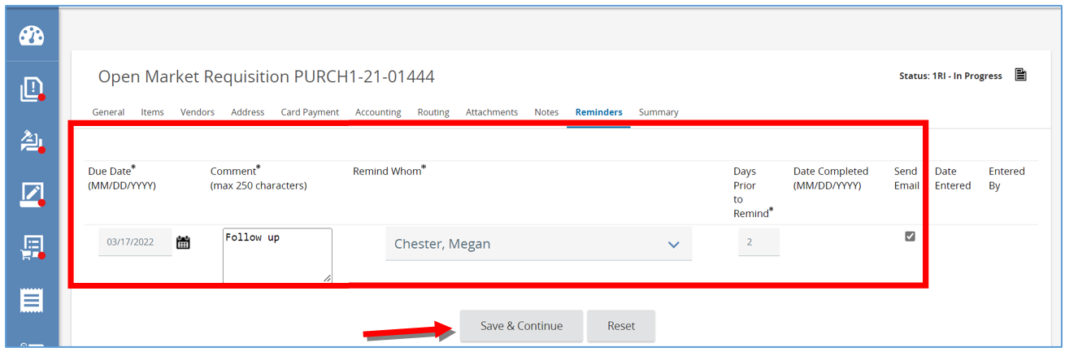
- You will now see a Date Completed field, which the person you selected to be reminded can update when they’ve completed the task.
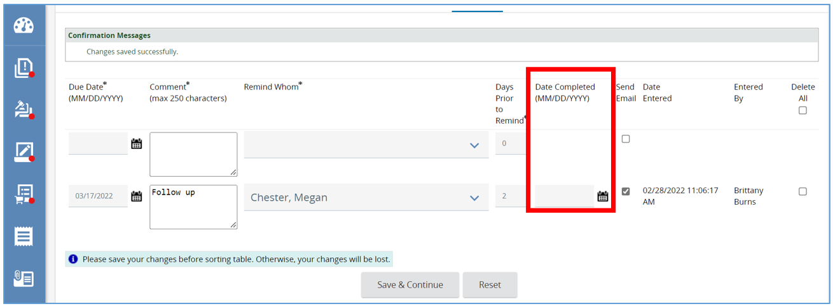

Summary Tab
This tab summarizes all the information from the previous tabs on one page. At the bottom of the page, you have four options for this Requisition. The Vendor Validation warning will appear but because it’s outlined in yellow, that means it is a soft warning which doesn’t stop you from submitting for approval.
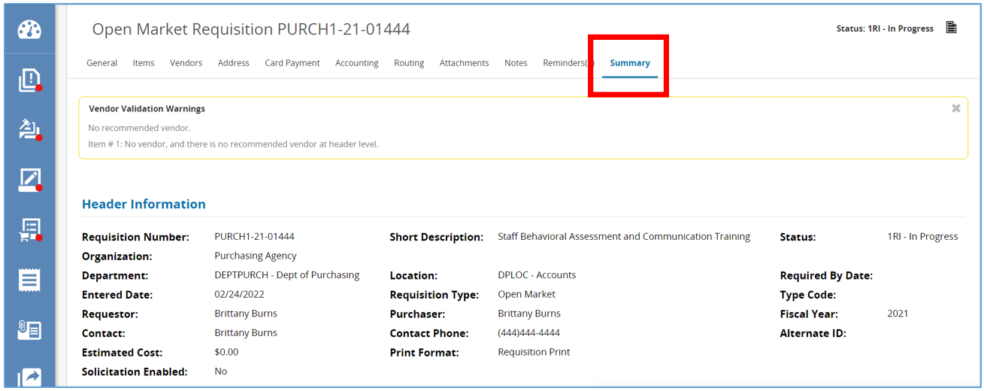
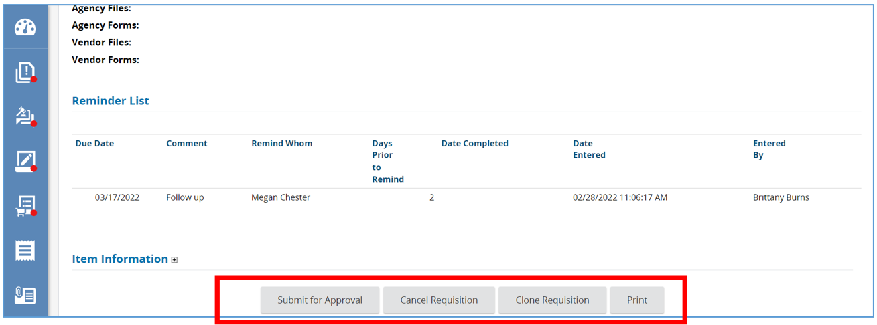
- Click Submit for Approval to submit the Requisition to the approval paths.
- The page will refresh and on the next page, you will see the list of approval paths triggered. This is the last chance to review those paths prior to entering the approval queue.
- To submit, click Continue or to go back to make changes by clicking Cancel & Exit.
- After submitting for approval, the page will refresh back to the Summary tab, the status will change and read Ready for Approval.
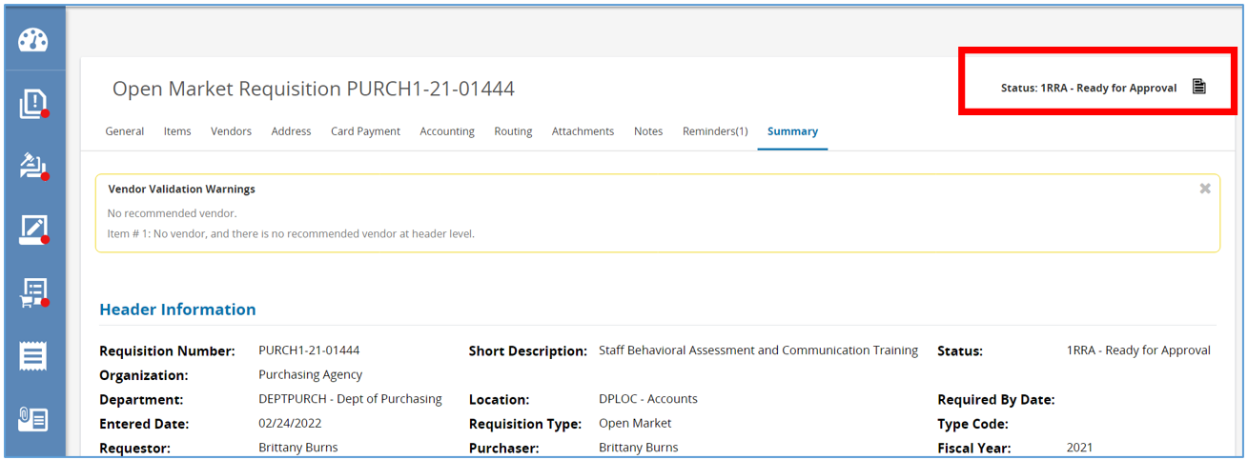
- You will now wait for the Requisition to be approved.
- Once approved, the status will change to Ready for Purchasing. This means a Buyer within the organization will decide what’s next. It will then show up as an updated number in the "Requisitions Ready for Purchasing" action button on the home screen for the BP user.
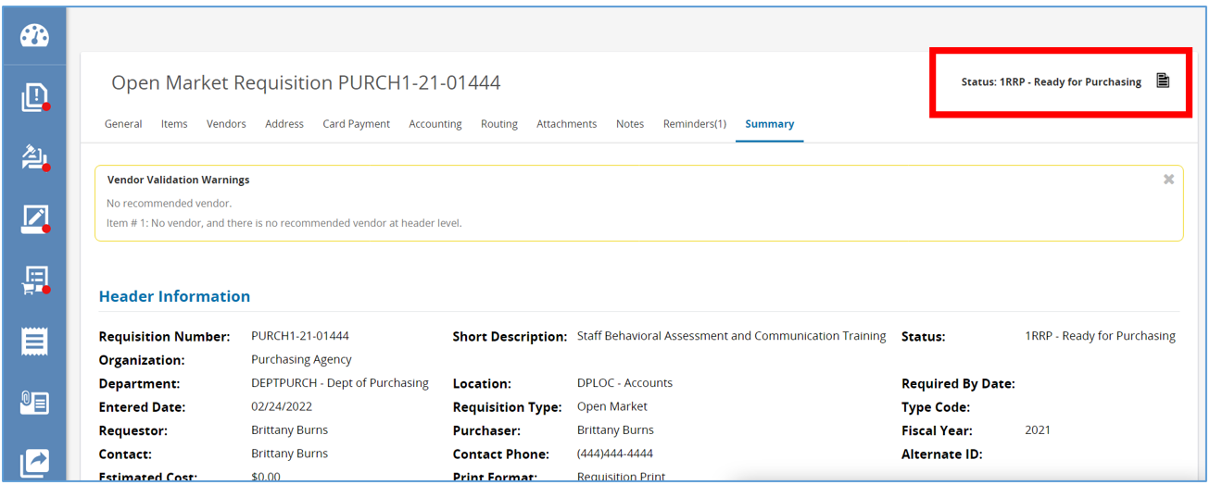
  - Click Cancel Requisition to cancel the Requisition, changing the status to Canceled.
  - Click Clone Requisition to clone the Requisition, which creates another “In Progress” Requisition duplicating the data from this Requisition to the new Requisition.
  - You can click Print to print the Requisition.
