OregonBuys Change Order Guidance

Table of Contents
Introduction 2
OregonBuys Process Flow 2
Scenario 2
Creating a Change Order 3
Prerequisite 3
General Notes 3
Summary Tab of Master Blanket Purchase Order to Change 3
General Tab 6
Control Tab 8
Attachments Tab 9
Summary Tab 10
Set up Approval for the Change Order 11
Apply Change Order 12
Prerequisites 12
Next Steps 13

Introduction
This guidance document will help Basic Purchasers (BP) as they initiate and apply a Change Order. A Change Order is a formal update to the original scope of work on a contract, either a one-time purchase, an individual order on a contract, or the Master agreement itself after it’s been approved or sent to the vendor.
Changes can be made to:
- General Information
- Item Information
- Departments and locations
- Cost Information
- Attachments
Changes cannot be made to:
- 2-way / 3-way match
- Appropriation / Biennium Year

OregonBuys Process Flow
In the overall process flow in OregonBuys, a Change Order can be applied to other document types:
- Open Market Purchase Orders
- Master Blanket Purchase Orders
- Figure 1: High Level Process Flow
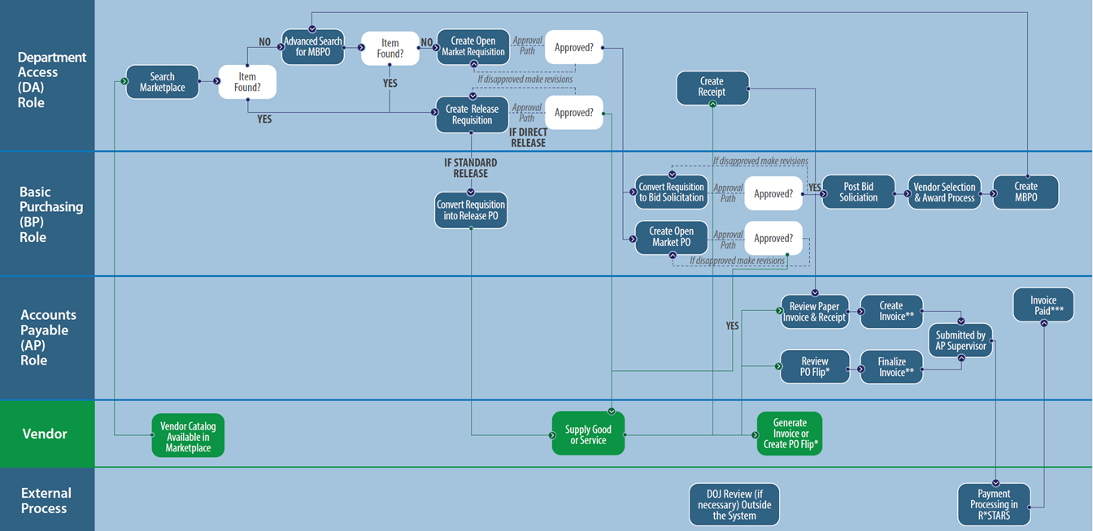

Scenario
In this Guidance Document we are assuming the vendor has updated their pricing for a good on contract for a lower amount. The Basic Purchasing user that oversees the contract is creating a Change Order on the Master Blanket Purchase Order to apply this update.

Creating a Change Order
This section includes a step-by-step overview of how to create a Change Order for the purpose of this example, we are updating the pricing on an item.
NOTE: This scenario is based on a Master Blanket Purchase Order. There are some differences between a Change Order on a Master Blanket compared to other Purchase Order types, specifically in editing the beginning and end dates as well as the access other Departments and Locations have.

Prerequisite
Prior to initiating a Change Order the Basic Purchaser needs to have the following information available:
- The approved Master Blanket Purchase Order in Sent status that is the subject of the change. Change Orders are only available on certain Purchase Order documents – the Open Market Purchase Order and Master Blanket Purchase Order

- Know whether you want the vendor to approve the change order (Bilateral Approval)

General Notes
- Remember that changes to item costs, for example, may require a higher-level approval. This means that if the cost of all the items in the MBPO exceeds the dollar amount of the approval authority for an approver, a different approval path routing or approver may be required.

Summary Tab of Master Blanket Purchase Order to Change
- Begin on the Summary tab of an approved Master Blanket Purchase Order.
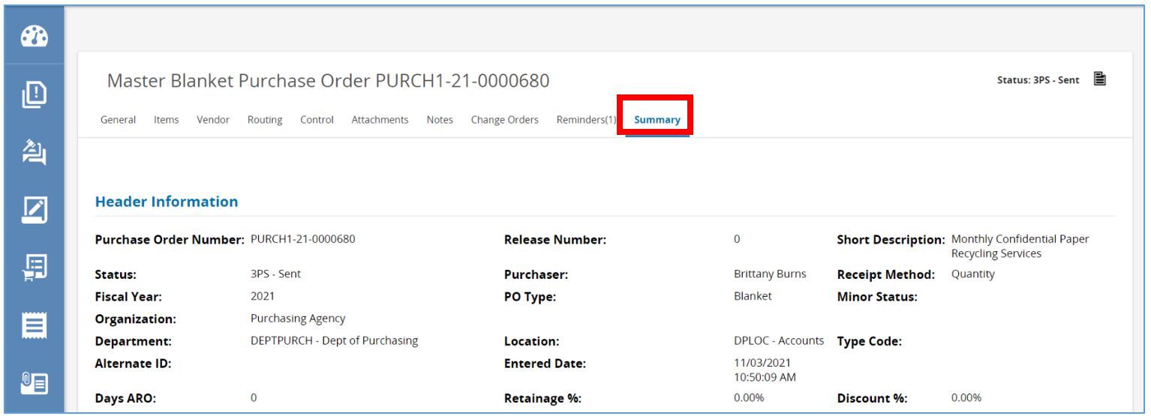
- Next, select the Change Orders tab at the top of the page and click Create Change Order.
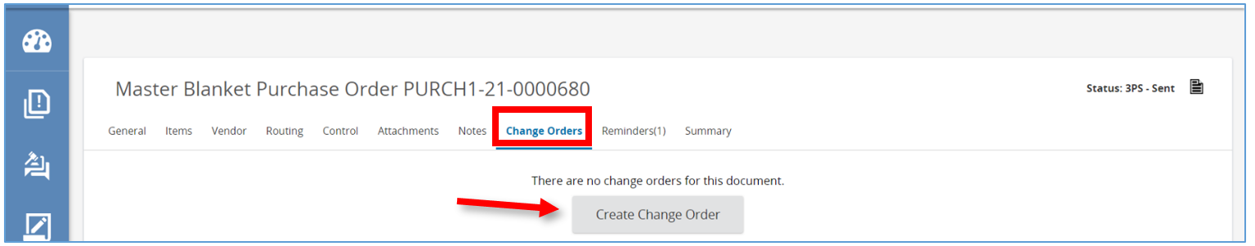

- The page will redirect to the Items tab of the Change Order. Here there will be a list of all the items on the Master Blanket Purchase Order. Items can be modified, added, or canceled on this page. In this guidance document, we will modify an item on the MBPO. For instructions on adding an item, please refer to Purchase Order Guidance II – Items Tab (#5). To remove an item, click the cancel check box to the right-hand side of the line item. Be aware that once an item is canceled, the Change Order would need to be canceled before being applied to un-cancel the item.
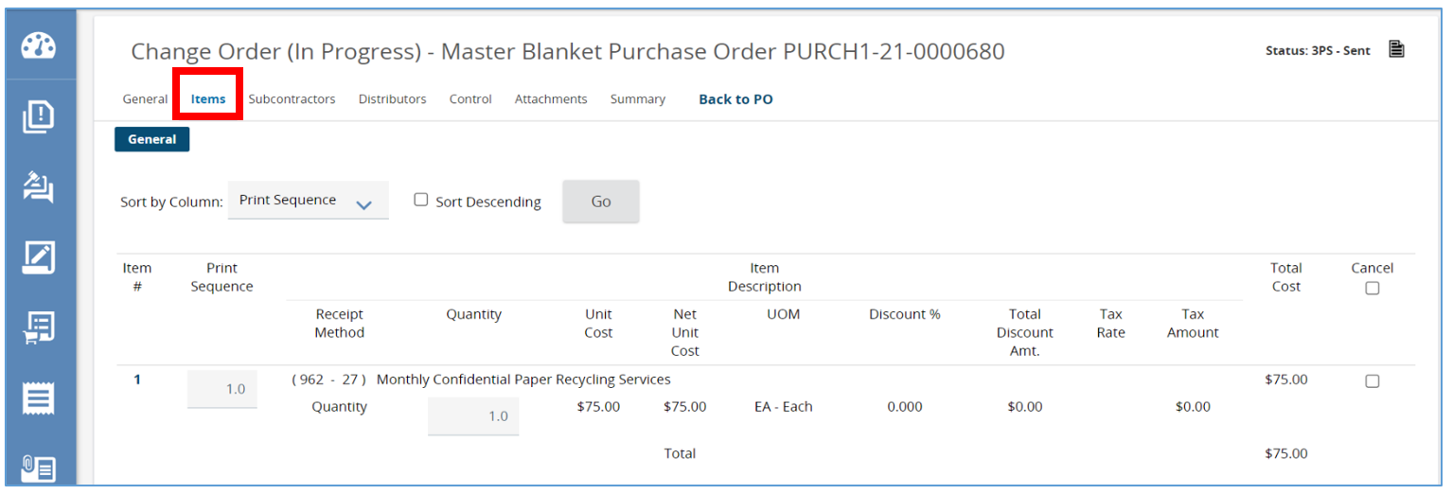
- To modify an existing item, click the Item number.
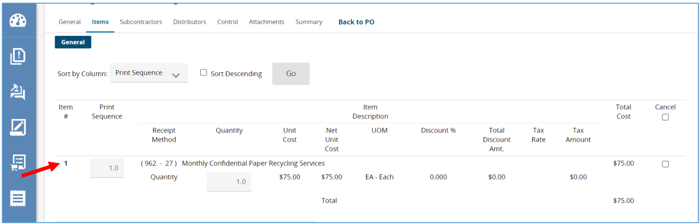

- The page will refresh allowing any changes to be made. For example, the Unit Cost can be updated here.
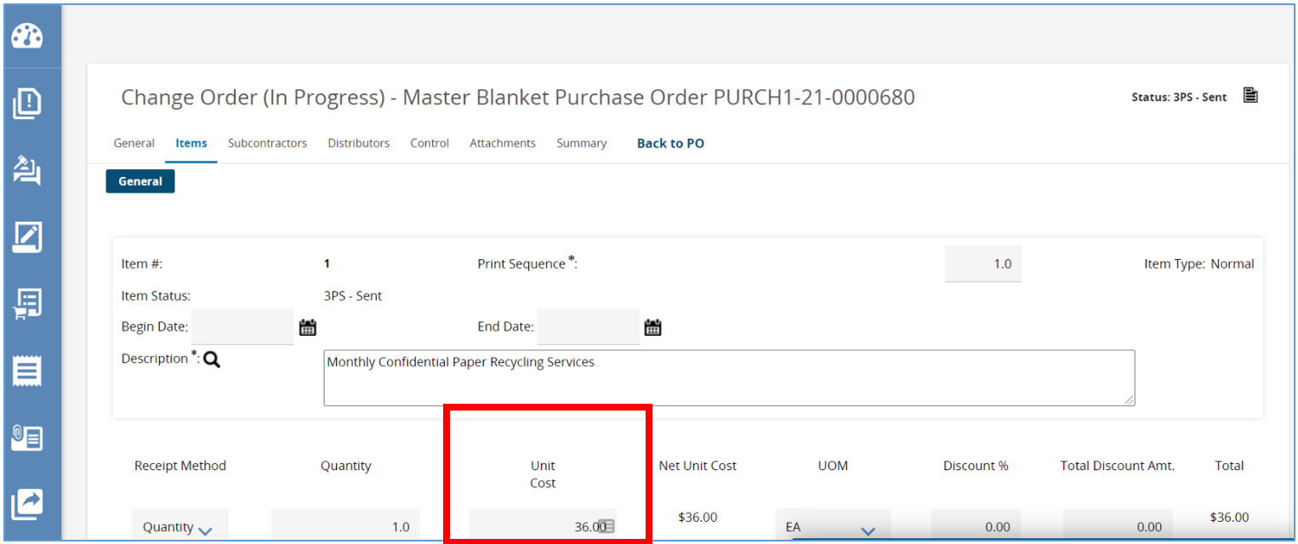

- Once all changes are complete, scroll down and click Save & Exit
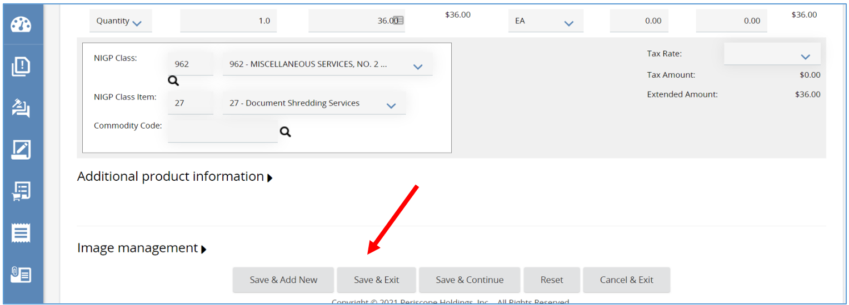

- The page will redirect to the Items tab where changes can be seen.
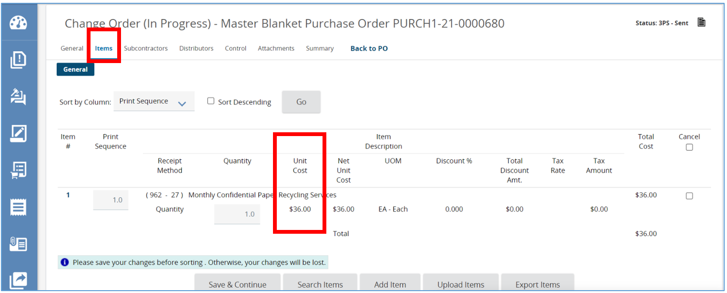

General Tab
This section covers the General Tab of the Master Blanket Purchase Order Change Order. This tab includes the Purchaser assigned to the Master Blanket Purchase Order and the Release Type.
- Next, click on the General tab.
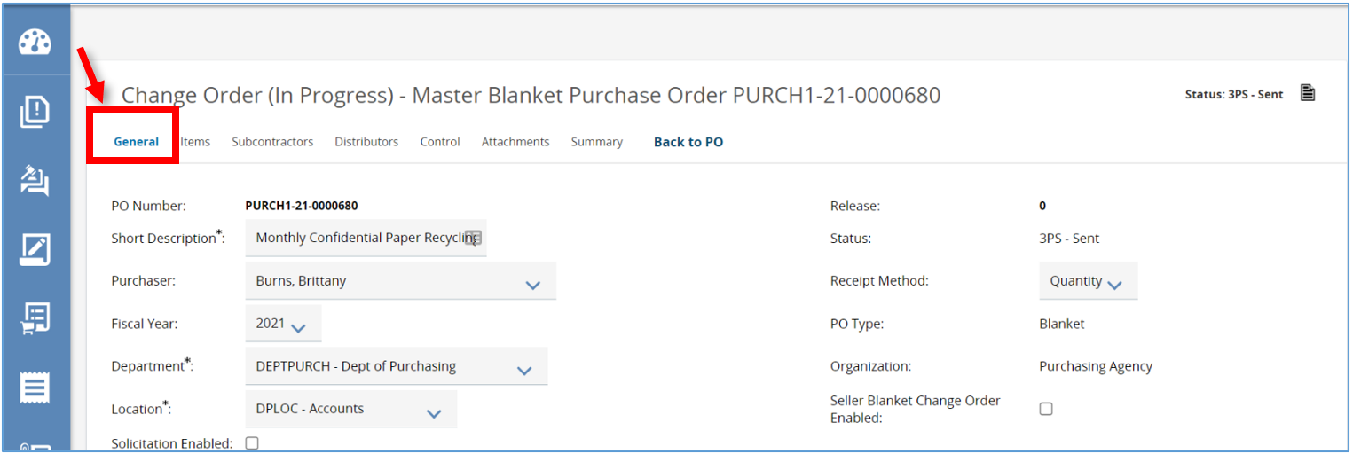
- If there is a new Basic Purchasing user managing this Master Blanket Purchase Order, select them from the drop-down menu in the Purchaser field.
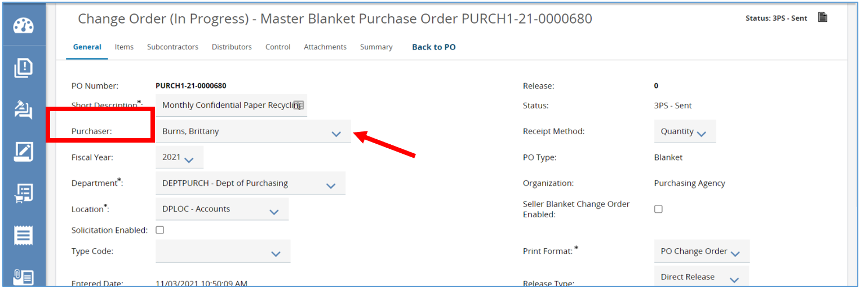
- If there needs to be a change to how someone can purchase against the Master Blanket Purchase Order, modify the Release Type by clicking the drop-down menu.
  - A Release Type:
    - Direct Release
    - Standard Release
    - RPA Only Release
Note: To learn about Release Types, refer to Requisitions II.
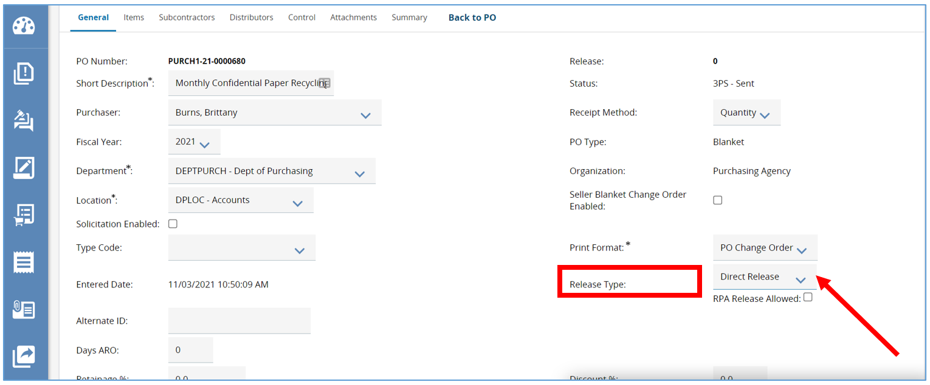
- Click Save & Continue after changes have been made.
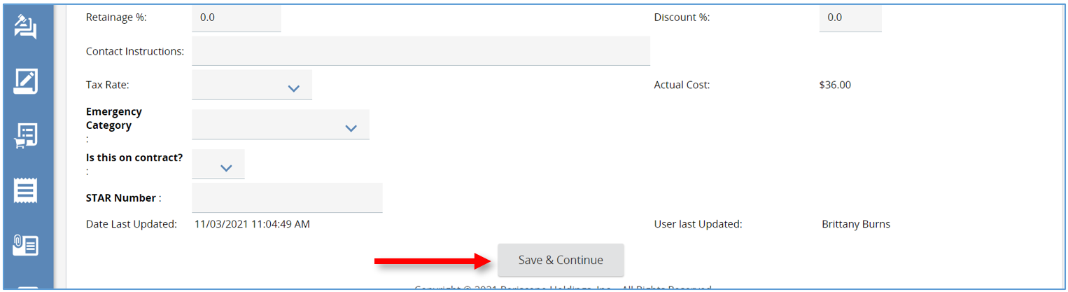

Control Tab
This section covers the Control Tab of the Master Blanket Purchase Order Change Order. This tab is where the contract’s Begin and End dates can be changed, as well as managing access from other agencies or departments.
- The Control tab is where the Master Blanket Purchase Order contract’s Begin and End dates can be managed.
  - Modifications to which organizations and departments are eligible to request orders on this Master Blanket can be made in the Control tab.
  - Changes to the do-not exceed limit, which is the Dollar Limit field, or the Minimum Order Amount field can be made in the Control tab also.
- Click Save & Continue after all changes.
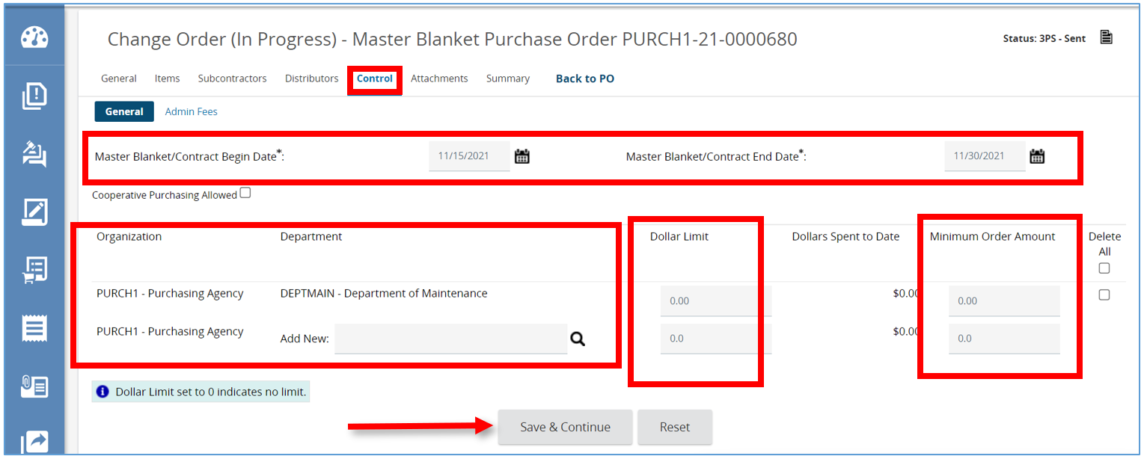

Attachments Tab
This section covers the Attachments Tab on the Master Blanket Purchase Order Change Order. This tab allows for existing attachments to be managed or deleted or adding new attachments.
This tab is where additional documents related to the Change Order can be attached, such as an updated Buyer’s Guide.
- To add a file, click Add File.
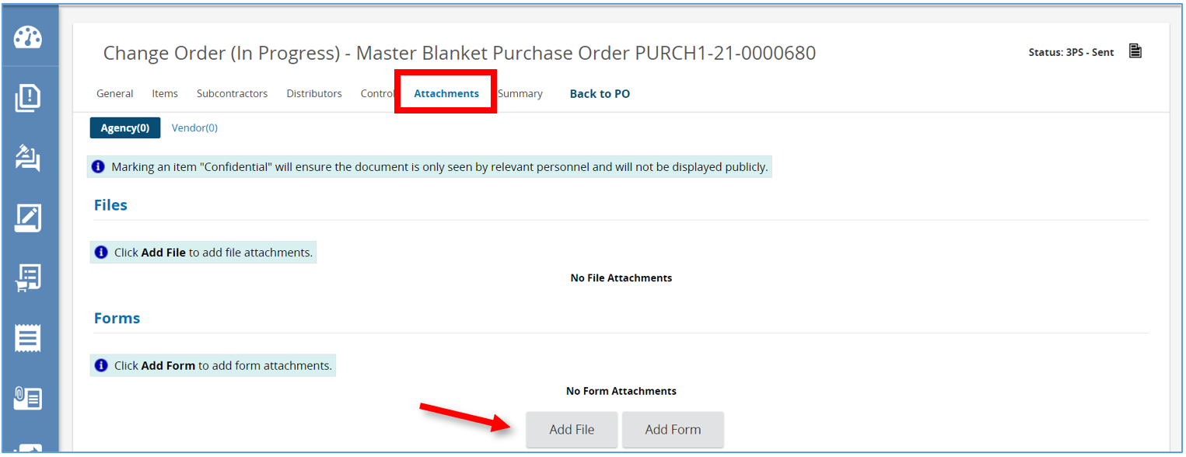
- Optionally, enter the name of the file and a description. then click Choose File and locate and select the document from computer.
- Next click Save & Exit. The Page will redirect back to the Attachment tab and the document will show as a hyperlink.
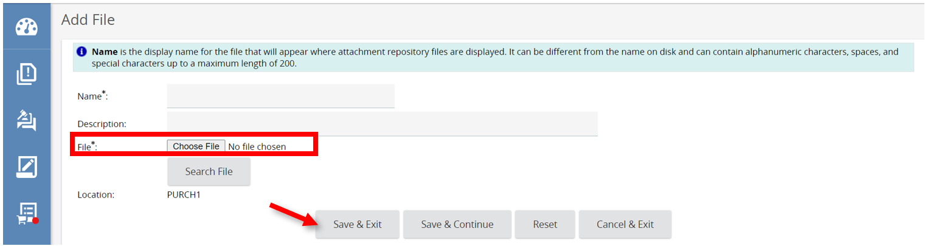

Summary Tab
This tab summarizes all the changes made on the Change Order and is also where it is submitted.
- To enter general comments about the changes that were made, use the Comment for the whole change order field. This guarantees that the vendors will be notified about the Change Order and see the comment added.
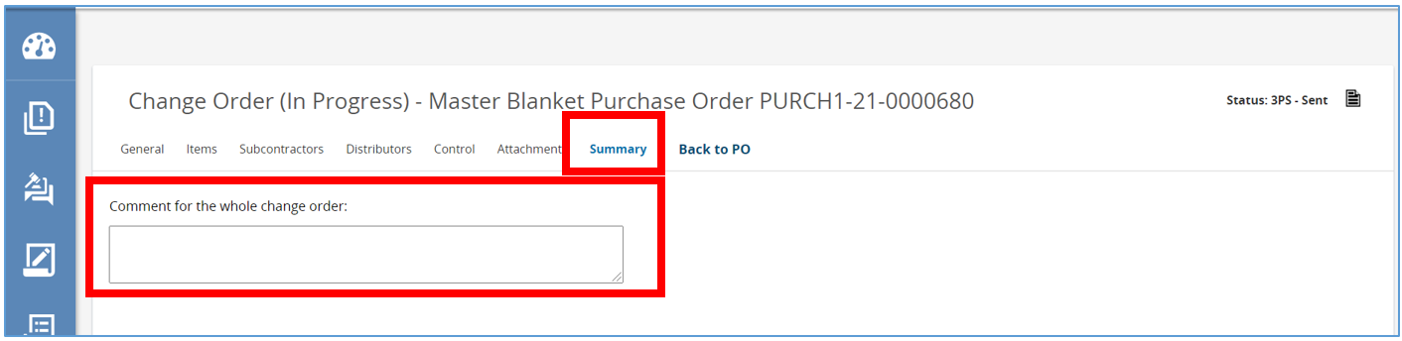

- Specific comments to each individual change made can be added under the Modified field and in the Comment field.
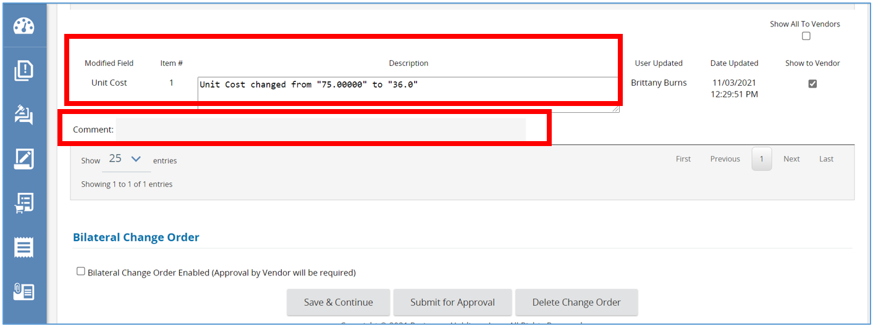

- By default, the vendors will be notified of the changes and individual comments. There is also an option to hide one of the changes from a vendor, just deselect Show to Vendor box.
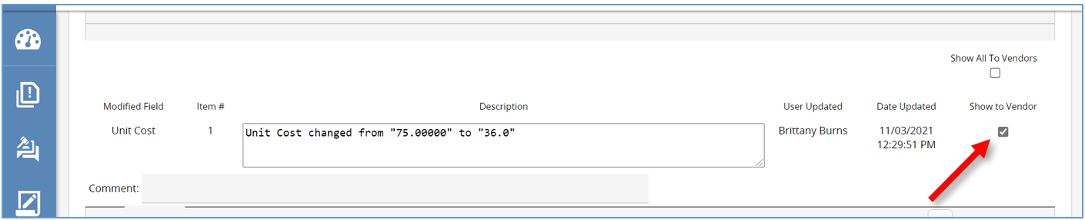

- Scroll down to the bottom of the page to see the Bilateral Change Order field. If selected, the vendor will be added as the final approver before the Change Order can be applied.
- Click Save & Continue to save all changes.
- After reviewing changes click Submit for Approval.
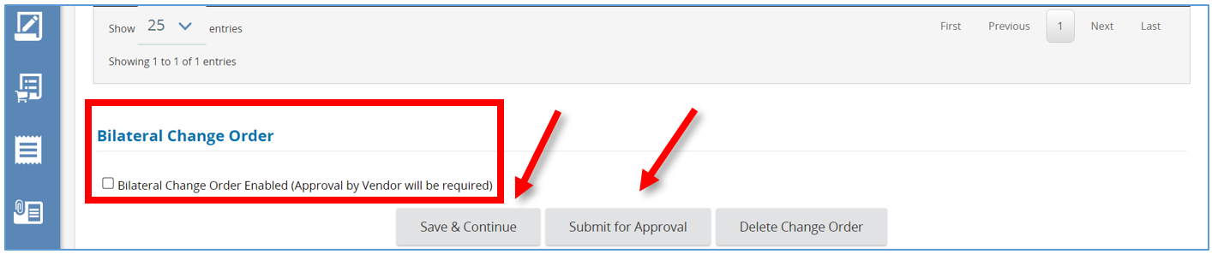

Set up Approval for the Change Order
Once all of the changes have been made to the Master Blanket Purchase Order, it can be submitted for approval.
- After clicking Submit for Approval, the page will redirect bringing up another screen.
  - If an approval path exists for the document, you will be prompted to submit the document after viewing the approval path.
  - If no approval path meets the document criteria , there will be two options to approve the Change Order.
    - Manually add approvers allows you to add one or more approvers. Select the approver from the drop-down and select Add Approver.
    - Automatic approval automatically approves the document.
- After making selection, click Save & Continue.
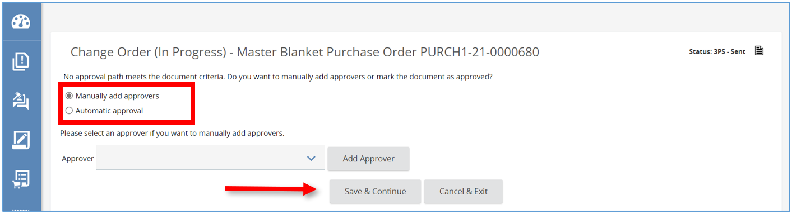
- The page will redirect back to the Change Order Summary tab where the status will change to Ready for Approval.
Notice that the Change Order status is on the left in parenthesis, and the Master Blanket Purchase Order Status is still in Sent status as displayed at the top right.

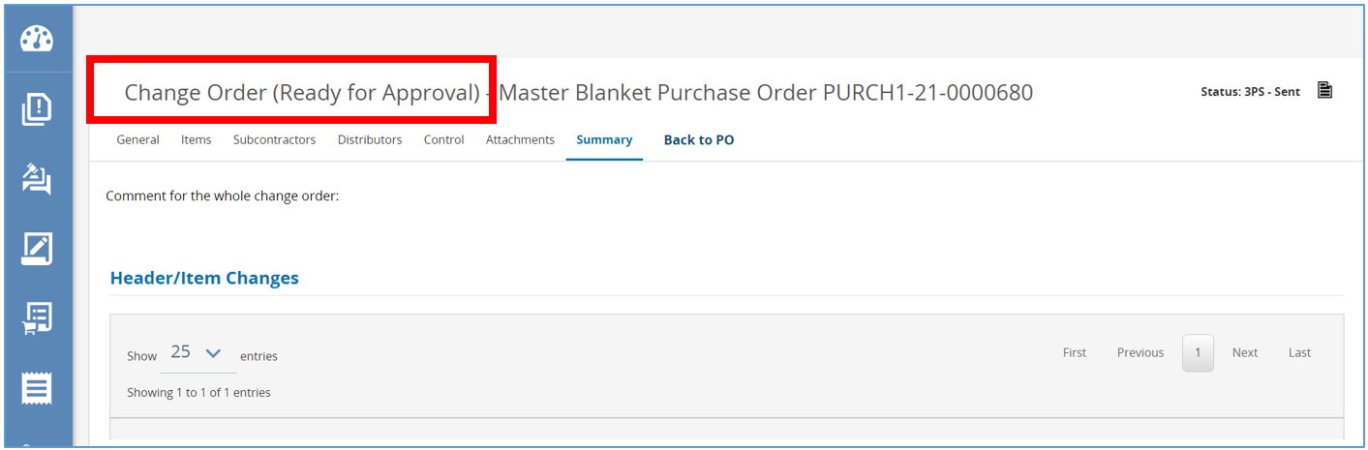

Apply Change Order
The Basic Purchasing user created a change order and had the change order approved. This next step is required in order to apply the change order to the Master Blanket Purchase Order.

Prerequisites
- An approved Change Order
- Once the Change Order is approved, the status will change to Ready to Send.
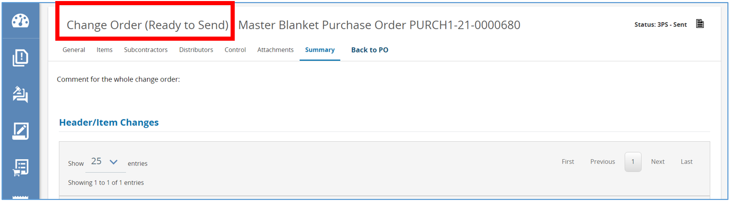2. Scroll down and click Apply Change Order.
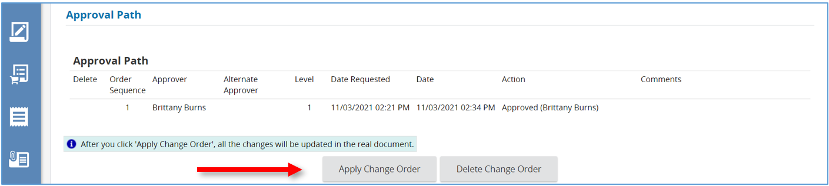
3. The Page will redirect back to the Summary tab and the Change Order has now been applied.
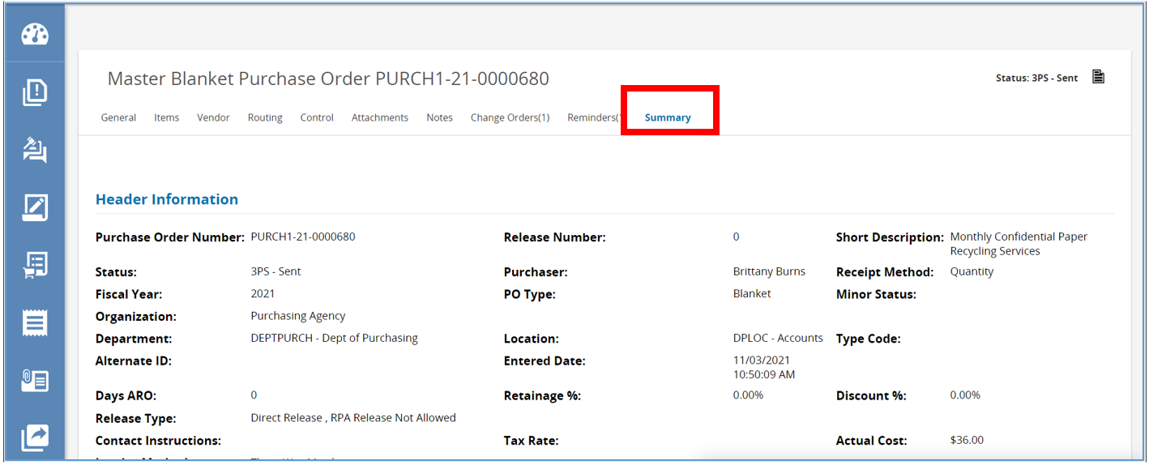

Next Steps
After the Change Order is applied, the Vendor is notified via email of the Change Order and can view it in OregonBuys. The Basic Purchasing user should next communicate the change to stakeholders.

