Purchase Order II: OregonBuys Master Blanket

Table of Contents
Introduction 2
Scenario: 2
1. General 2
2. Item 2
3. Vendor 3
4. Routing 3
5. Control 3
6. Attachments 3
7. Notes/Change Orders/Reminders 3
8. Submission 3
Creating a Master Blanket 3
General Tab 5
Items Tab 6
Vendor Tab 10
Routing Tab 12
Control Tab 13
Attachments Tab 17
Notes Tab 18
Change Orders Tab 18
Reminders Tab 19
Summary Tab 20
Submit the Open Market Purchase Order for approval. 22
Approving Master Blanket 23

Introduction
This guidance document will help Basic Purchasers (BP) create a Master Blanket Purchase Order. A Master Blanket is a formal agreement with a vendor or multiple vendors for goods and/or services. A Master Blanket allows you to set the duration of the agreement including multi-year agreements.
Figure 1: High Level Process Flow
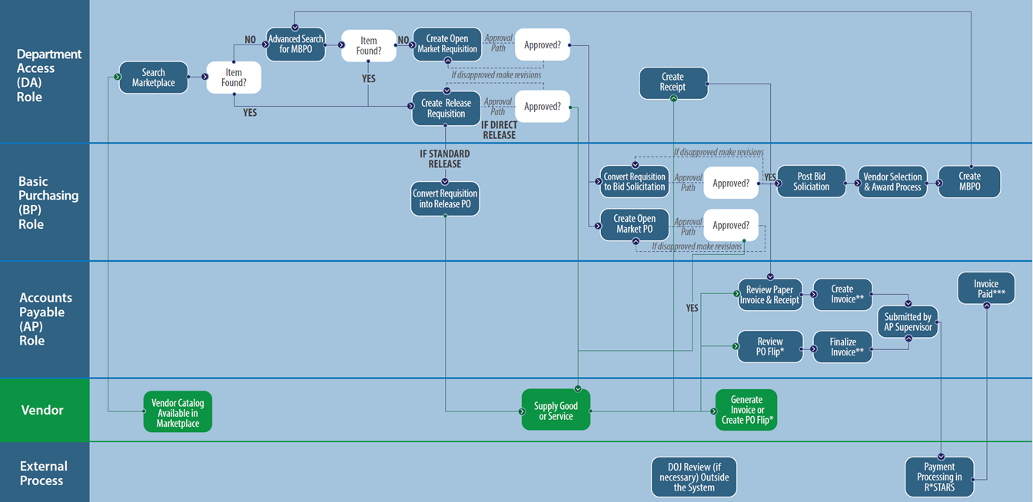

Scenario:

General
In this guidance document the Basic Purchaser in the agency is creating a Master Blanket Purchase Order (formerly known as Price Agreement) to procure Monthly Confidential Paper Recycling. This MBPO is for Department of Maintenance at the Main Office Building location. In the future, any Requisitions issued for this MBPO will be “Direct Release” which means that once they are approved, they are automatically, electronically, sent to the vendor.

Item
The line item associated with this MBPO is a ESS Model 100 Optical Ballot Scanner. Through research, the Basic Purchaser discovered that this service is NIGP Class 578 and NIGP Class Item 34. The Basic Purchaser also indicate in additional product information that this Scanner is Model 100.
In addition, the MPBO is set up to purchase 50 of the Scanners at a unit cost of $280 with no discount.

Vendor
To add the vendor associated with NGIP Class 578 and NIGP Class Item 34, use the “Look Up & Change Vendor” at the bottom of the screen. In the new window that pops up, use the NIGP options to search.
There are no Subcontractors, Distributors, or Vendor Performance associated with this vendor.

Routing
The Routing for the Approvals for this document may be set manually or selected at the point that the document is Submitted for Approval.

Control
The Basic Purchase will establish “Control” information for this MBPO. For this MBPO, the Contract Begin Date is 11/15/2021, the Contract End Date is 11/30/2021. This MBPO allow Cooperative Purchasing, which means that if you are not doing Cooperative Purchasing, then just select your own department – no other entities will have access to this MBPO.
This MBPO is configured for Department Only. Optionally, dollar limits and minimum order amounts can also be set on the Control Tab.

Attachments
The Basic Purchaser should add attachments to document background information for this MBPO. In addition, the Agency may have set up standard documents (for example Terms and Conditions) to be attached to all MBPOs for the Agency.

Notes/Change Orders/Reminders
It is suggested that notes related to deadlines, approval information, contact information, or another information that the Basic Purchaser deems important for tracking or approving this MBPO be added on the Reminders and Notes tab. It would be good practice for the Agency Procurement Team to establish standard procedures for using these tabs.

Submission
The PO should be submitted for any applicable approvals and the user will see the status change to ‘Ready for Approval’

Creating a Master Blanket
This section includes a step-by-step overview of how to create a Master Blanket.
- Beginning on the Home Page as a Basic Purchaser, click the plus button and select Purchase Order.
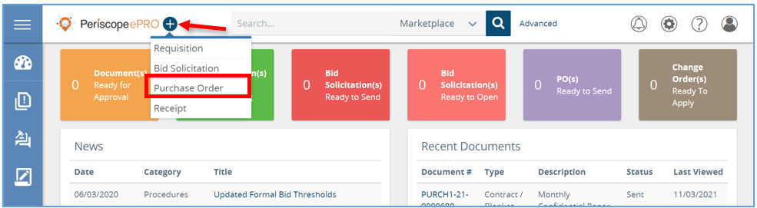
- From here change the PO Type of the New Purchase Order field to Blanket and click Continue.
- You would create the Purchase Order from scratch if you weren’t cloning an existing Purchase Oder and you weren’t converting from a Requisition document.
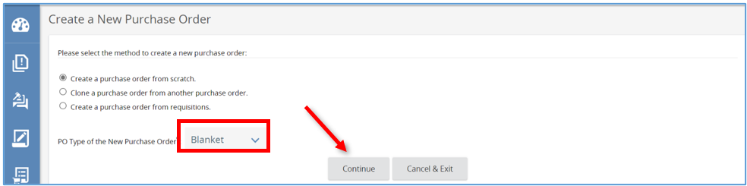

General Tab
- Next, on the New PO page you will fill out any field with an asterisk, starting with the Short Description field.
  - Enter the description. The Department and Location fields will prepopulate if starting from a new Master Blanket based on your default settings
  - If the user needs to change these two fields, they can click on the drop-down menu and select a different Department and Location.
    - Locations are a subset of Departments similar to an agency’s divisions, bureaus, or programs.
- The user can leave the Print Format as is.
- Next, look at the Receipt Method.
  - This field is not required but drives additional functionality. The Receipt Method determines how receiving is entered into the system.
  - Receiving is entered in the system by Quantity or Dollars.
- Next, look at the Release Type.
  - This field determines the flow of Requisitions on the Blanket once approved.
    - The default option is Direct Release.
    - If you choose this option, the Release Requisition will auto-convert to a Release Purchase Order. If configured, the system will also auto-send to the vendor once the Requisition is approved.
    - If selected, Standard Release will create an In-Progress Purchase Order.
    - The last option is RPA Only Release, this is selected when orders outside of the system are allowed and need to be documented.
    - If selected, make sure the RPA Release Allowed box is checked.
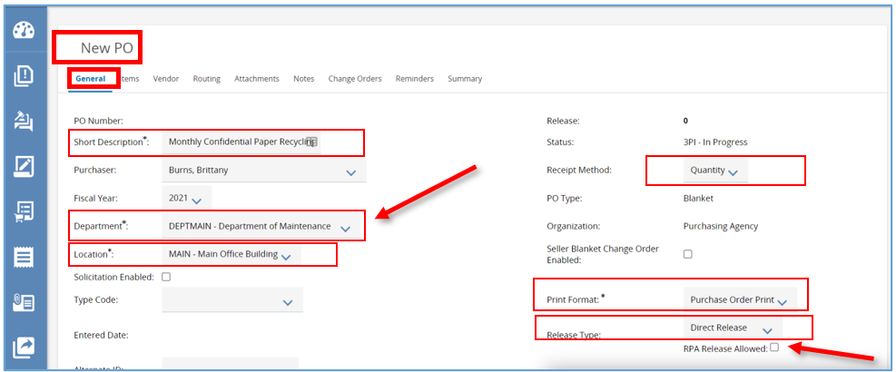
- Once you’ve completed all the required fields marked with an asterisk and any other fields of choice, scroll down, and click Save & Continue.
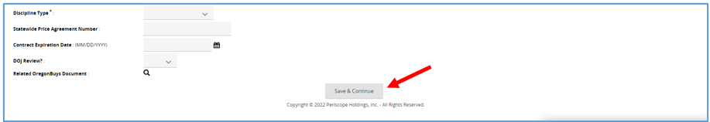

- Once saved, the system will generate a unique document number for the Master Blanket Purchase Order just created.
  - The order will now have a status of In Progress. This means the document is now saved and editable
- Next is the Items Tab.
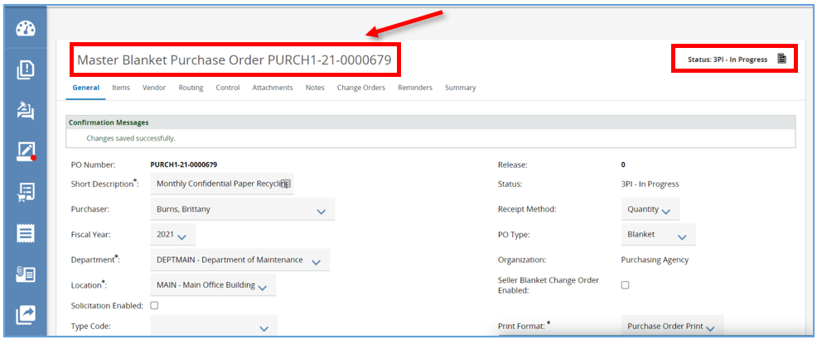

Items Tab
- To create an item from scratch, click Add Item.
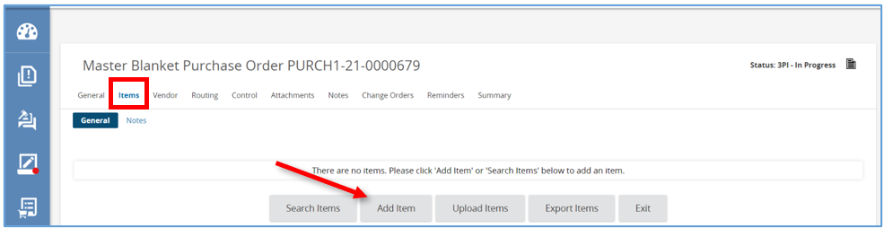
- This will take you to the Item Detail screen. First add the Item Description. It is best practice to be as specific as possible.
- Next, fill in the Quantity field.
- There is also a Unit Cost field, this will default to zero dollars. If the amount is known enter it in this field.
- The Unit of Measure field will default to each.
  - The Unit of Measure field can be changed by clicking the drop-down menu, from there select the option that best fits.
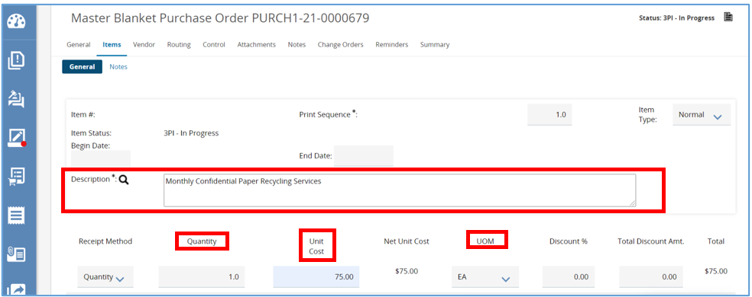
- Next are the NIGP Class and NIGP Class Item fields.
  - When adding an item to a Master Blanket Purchase Order, that item needs to be assigned a Commodity Code.
    - The Commodity Code can be entered manually.
    - Or by clicking the drop-down arrow in either field.
    - The most common way is by clicking the magnifying glass to complete a search.
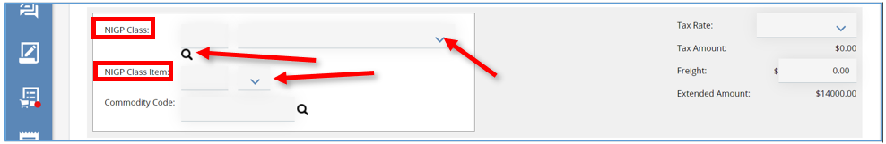
- Once the magnifying glass is selected, a pop-up window will open. From here search for the code using the NGIP Keyword field, then click Search.
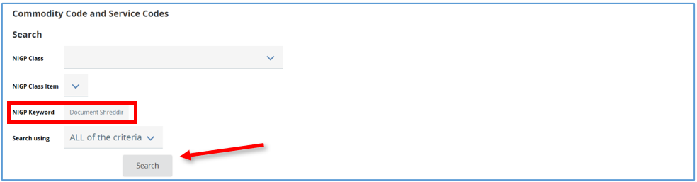
- The screen will refresh and display all the codes associated with the search completed.
  - Click the appropriate code, then click Save and Exit.
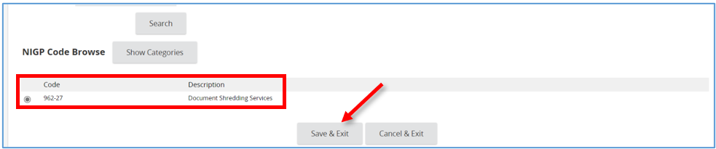
- The page will redirect back to the Item Detail screen.
  - The Commodity Code will be populated.
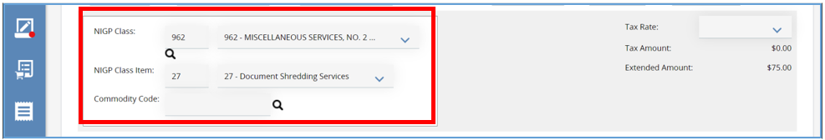
- Additional information about the item can be added by expanding the Additional product Information section.
- When finished click one of these options:
  - Click Save & Add New to save this Item Detail and to start a new item.
  - Click Save & Continue to save data entered and continue working on this Item Detail.
  - Click Save & Exit to save this Item Detail and return to the Items tab. Here the General subtab will show the item entered.
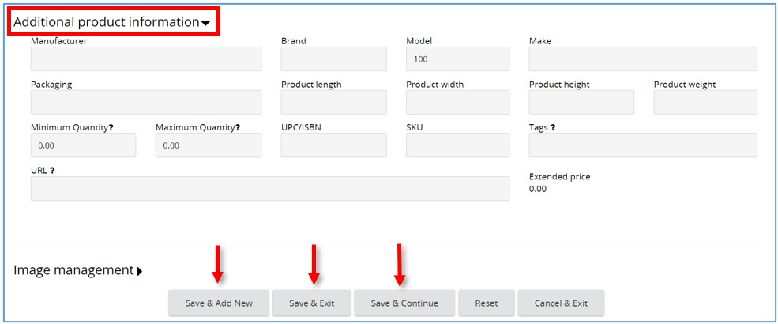
- An item can also be added from a previously approved order by clicking Search Items.
- Items can also be loaded from a system-generated spreadsheet using Upload Items. The spreadsheet to upload the items can be generated using the Export Items button.
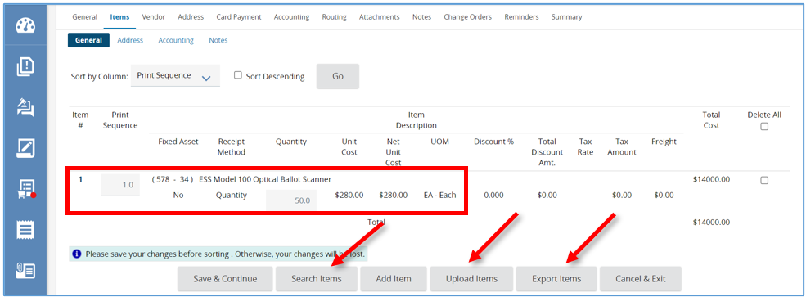

Vendor Tab
The Vendor tab is where the vendor who will fulfill the Master Blanket Purchase Order is added.
- To select a vendor, click Look Up & Add Vendor.
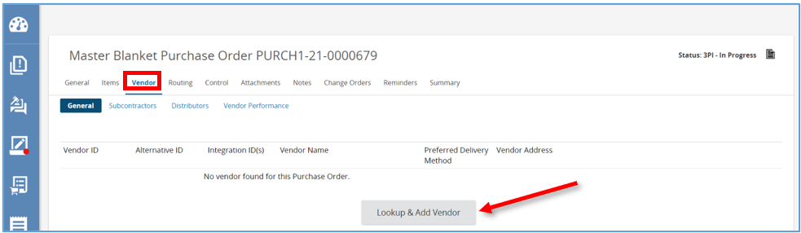
- A pop-up window will appear allowing for a vendor search.
3. Type the vendor’s name in the Vendor Name field
4. Scroll down and click Find It.
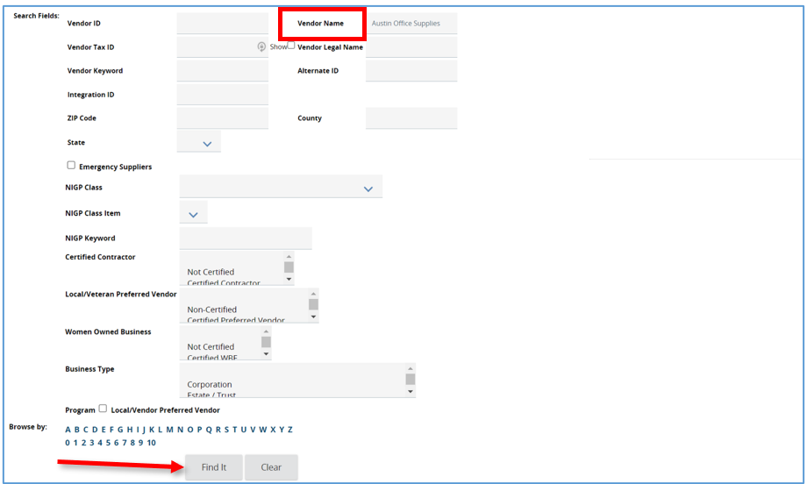
- Select the vendor, then click Add Vendor.
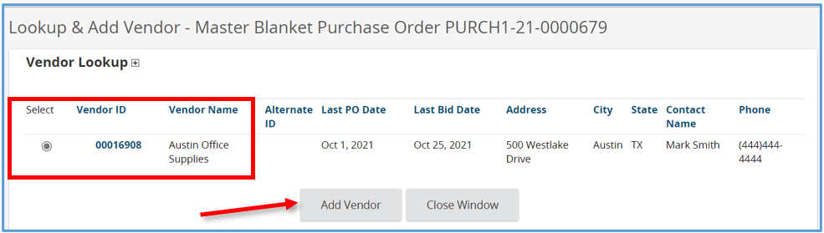
- The page will refresh back to the Vendor tab, General subtab where the vendor is added.
  - The Subcontractors tab allows you to list any subcontractors the primary vendor will work with for the duration of the contract.
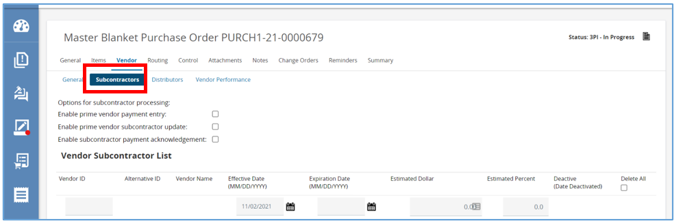
  - The Distributors tab allows you to list all eligible providers of the line items under this Master Blanket.
    - Always remember to check the box Include Primary Vendor in the Vendor Distributor List, whether any additional vendors are added.
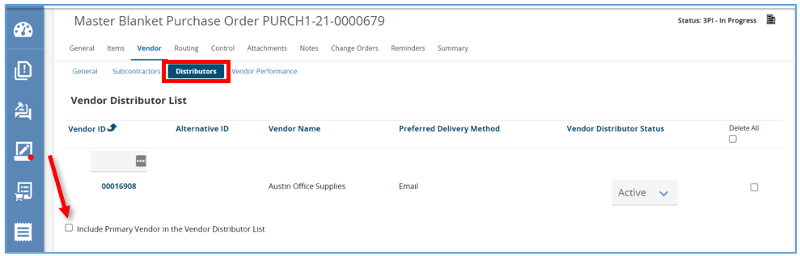

Routing Tab
This tab displays the approval paths the Master Blanket triggered.
This tab is initially blank. When this document is submitted for approval, an approval path can be selected. So, this tab will remain blank until the approval path is determined.
The Routing Tab provides the ability to track who is in the process of reviewing and approving the document. It also allows the ability to refer back to who reviewed and approved the document for historical purposes.
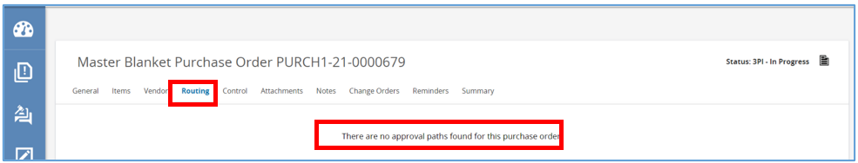

Control Tab
This tab is where the duration of the contract, the organizations eligible to use it, the order thresholds, and the minimum order amount is determined.
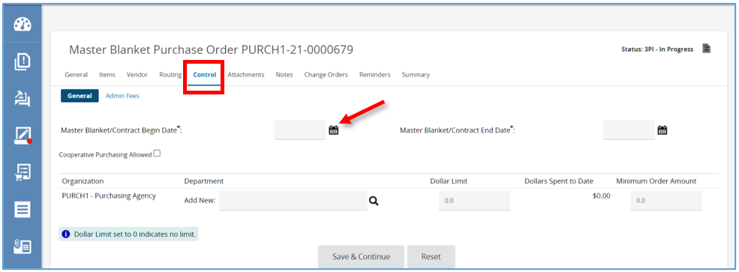
- First, select the Master Blanket/Contract Begin Date by clicking the calendar and choose the date the organization will begin using the contract. Then click Done on the calendar once date is selected. This is the first day shoppers can create a Release Requisition on this blanket.
- Next, select the Contract End Date. This is the expiration date of the contract and the last day a Release Order can be sent. Click Done on the calendar once date is selected.
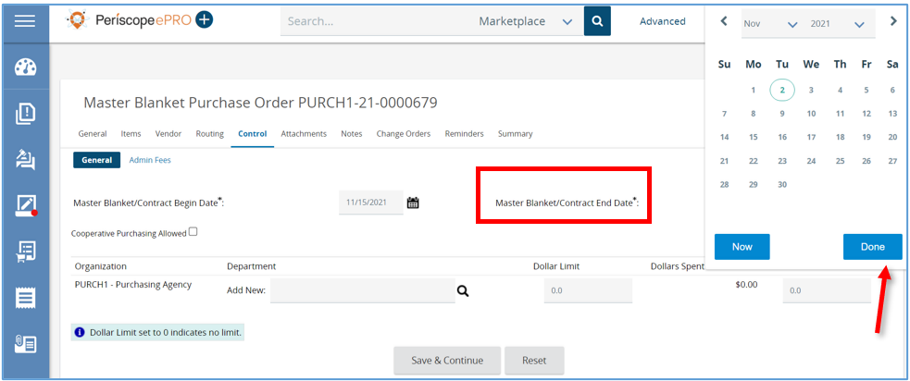
- Next, if a contract is system-wide, like a state-wide or a county-wide contract, all organizations in the system will have to have access. First, click the Cooperative Purchasing Allowed checkbox, this grants the Basic Purchaser the option to add any or all organizations.

- Next, under Organization click the magnifying glass. A pop-up window will appear.
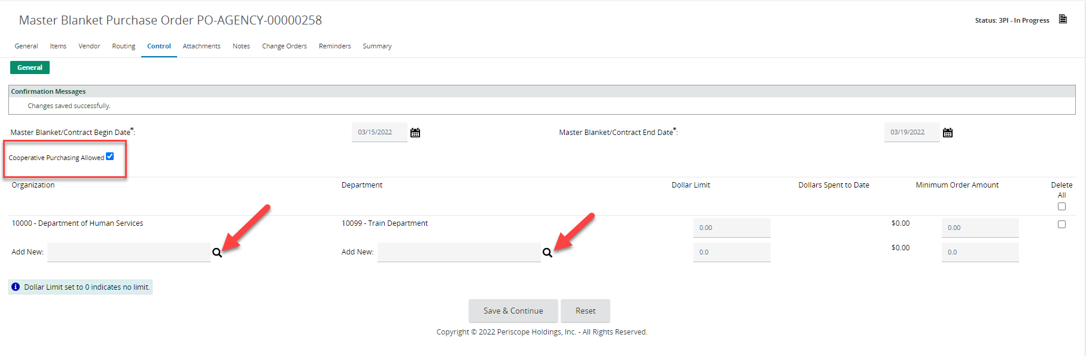
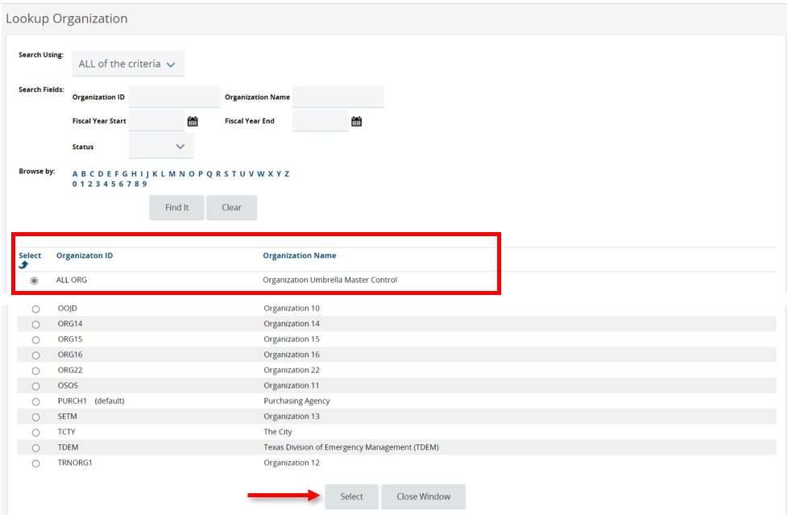
- In the pop-up window, select ALL ORG-Organization Umbrella Master Control, then scroll down and click Select.
  - The page will refresh back to the Control tab, then click Save and Continue.
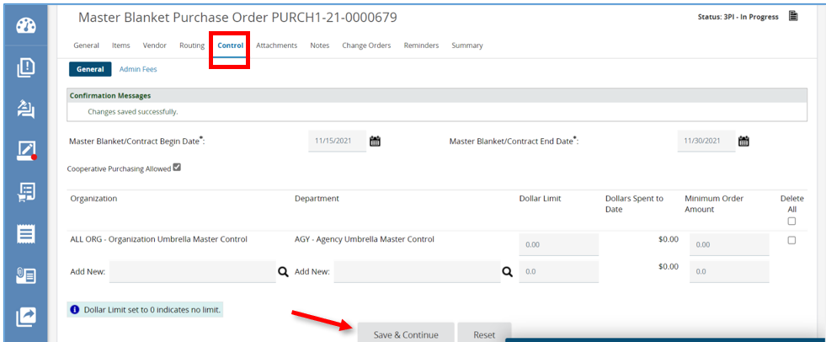
- If access is determined to only be needed at the department level Cooperative Purchasing Allowed box should not be checked.
  - To identify the department, click the magnifying glass under the Department column.
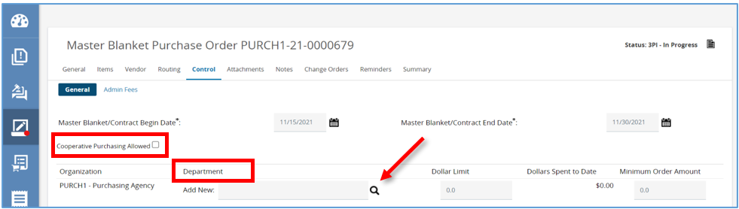
- A pop-up window will appear and select the department of your choice.
- Once the department is selected, click Select at the bottom of the page.
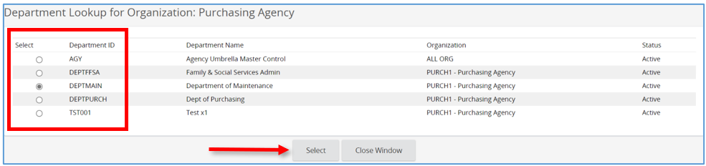
- There are a few additional fields available on this screen.
  - Dollar Limit places a cap on the total spend by Organization or Department.
  - Dollars Spent to Date displays the total order to date.
  - Minimum Order Amount allows you to set the minimum dollar amount for each order within the system.
  - Click Save & Continue to save all changes.
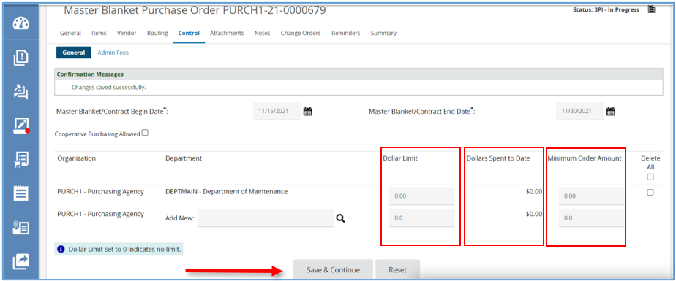

Attachments Tab
This tab is where additional documents related to the Master Blanket can be attached.
- To add a file, click Add File.
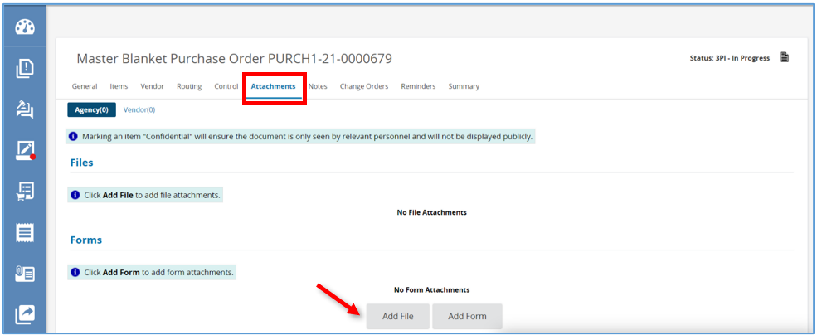
- Then click Choose File and locate and select the document from computer.
- Next click Save & Exit.
- The page will refresh back to the Attachment tab and the document will show as a hyperlink.
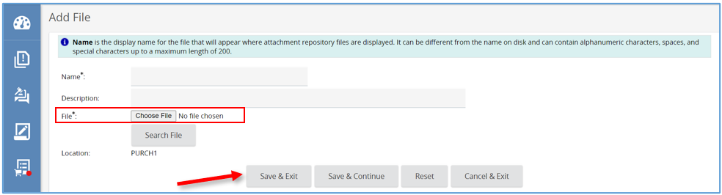

Notes Tab
This tab is similar to a digital post-it viewable by the user and others in the organization.
- Type the note in the text field and click Save & Continue.
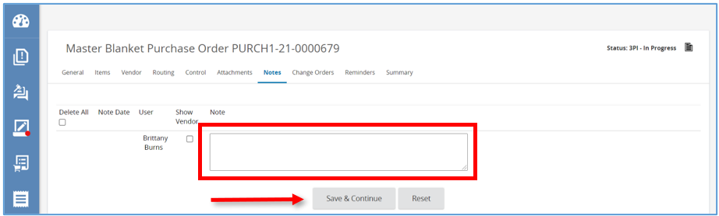

Change Orders Tab
This tab is where the Master Blanket can be modified after it’s been approved and sent.
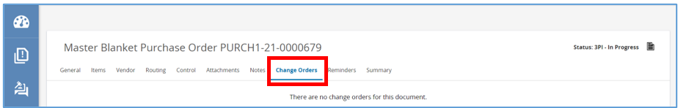

Reminders Tab
This is where a reminder can be sent to the user or another user within the organization about taking an action on this specific Master Blanket.
- To create a reminder, click the calendar icon to select the due date, which is the date the action needs to be completed. Then click Done.
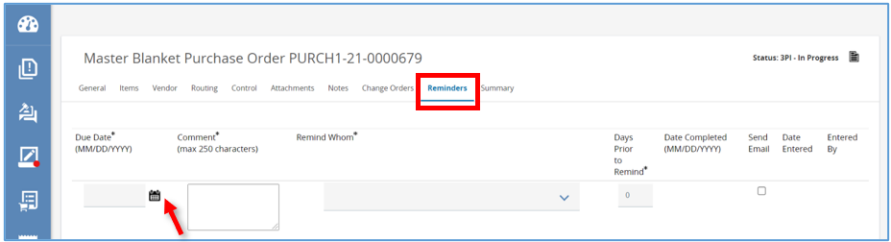
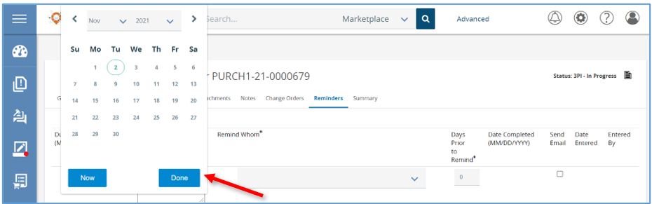
- Type the reminder in the Comment section.
- Select the person that needs to be reminded.
- Set the Days Prior to Remind field to the day the person needs to be notified.
- Check the Send Email box to have the system email the reminder and click Save & Continue.
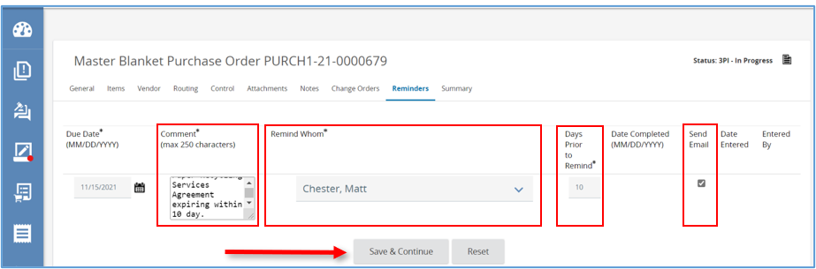

- After clicking Save & Continue there will now be a Date Completed field. When the task is completed this field for can be updated.
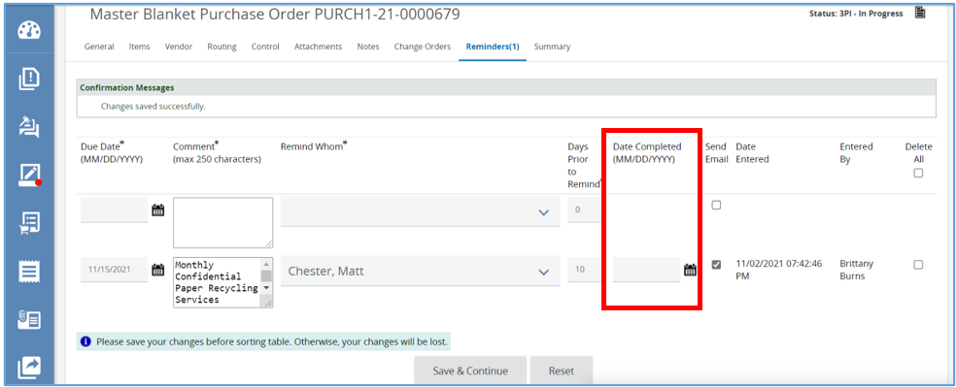

Summary Tab
This tab summarizes all the information on the previous tabs on one screen and is where this document is submitted for approval.
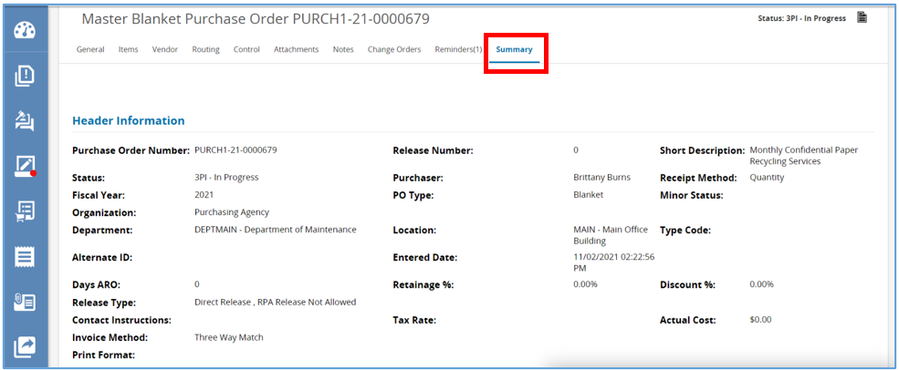
- Towards the bottom of the screen there are five buttons.
  - Click Submit for Approval to submit Master Blanket to the predetermined approval paths.
  - Click Cancel PO to cancel the Master Blanket which will change the status to canceled.
  - Click Clone PO to clone this Master Blanket which will create a second In-Progress Master Blanket, copying the date from this one to the new one.
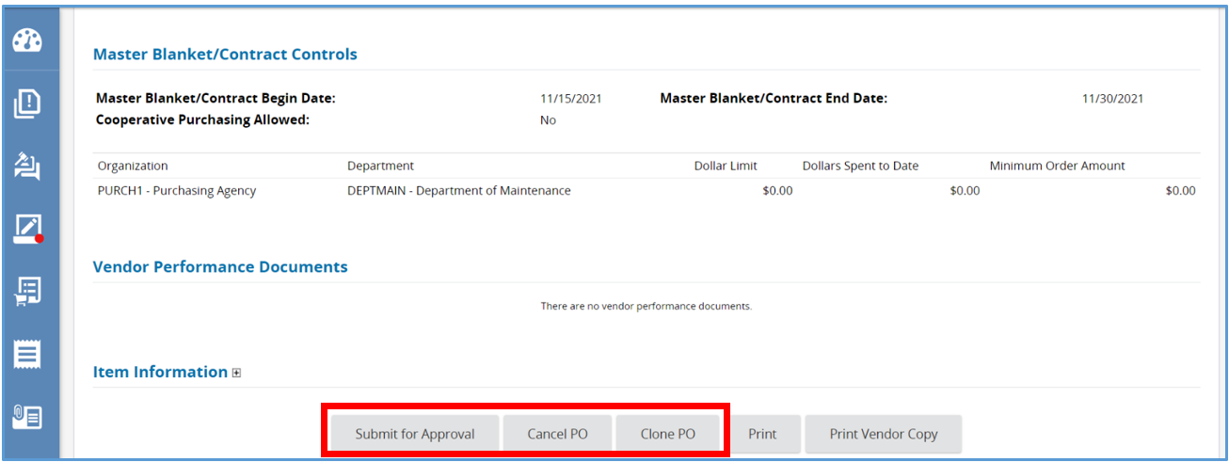

Submit the Open Market Purchase Order for approval.
The following instructions begin on the Summary tab of the Master Blanket. This is where the Purchase Order needs to be submitted for approval and converted to a “Sent” status.
- After clicking Submit for Approval, the page will refresh and on the next page, you will see the list of approval paths triggered. This is the last chance to review those paths prior to entering the approval queue.
  - If there is no Approval Path configured, there will be two options to approve the Master Blanket.
    - Automatic-approval
    - Manually add approvers
- After making selection, click Save & Continue.
- The page will refresh back to the Summary tab and a message will appear confirming the changes have been saved. The status of the Master Blanket will now change to Ready for Approval.
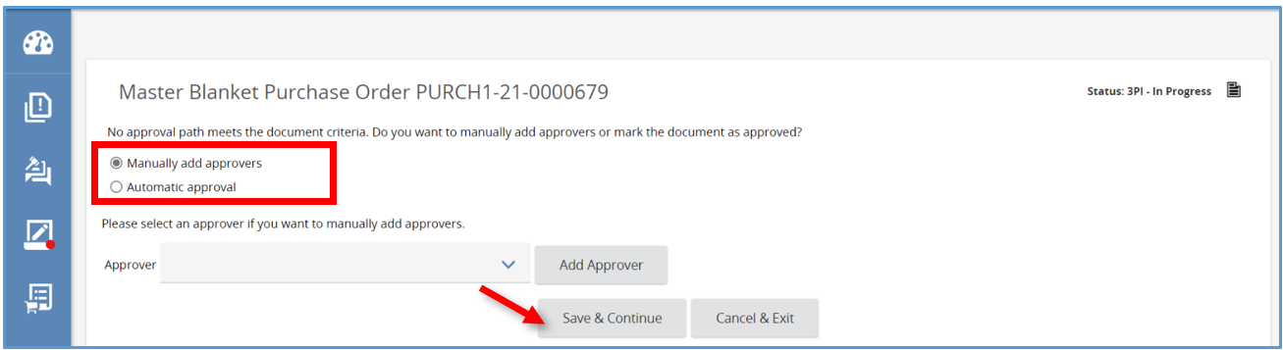
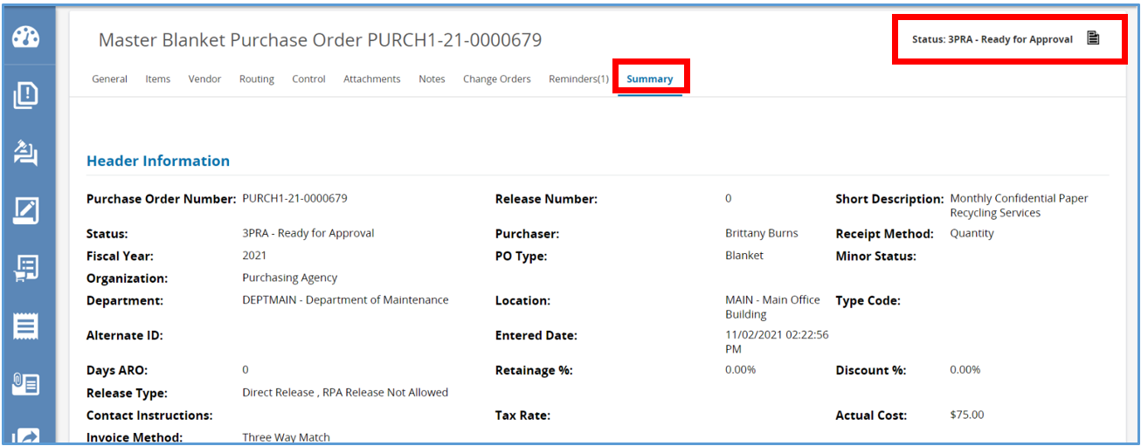

Approving Master Blanket
- Once the Master Blanket is approved, the status will change Ready to Send.
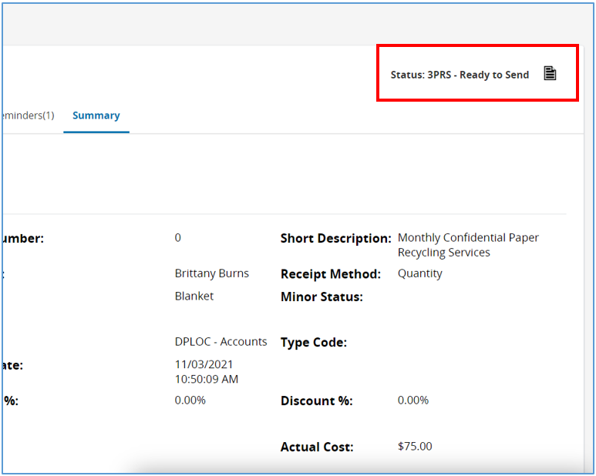
- Scroll to down to the bottom of the screen and click Save & Continue.
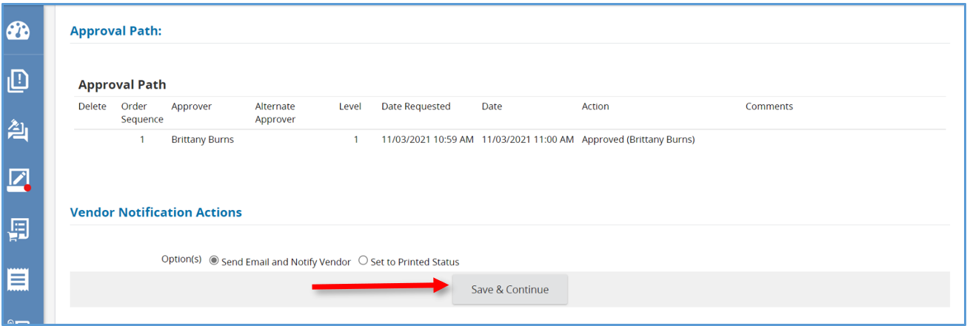
- The page will refresh back to the summary tab and the status has now been changed to Sent.
- The vendor will receive an email about their Master Blanket and DA users with contract shopper privileges can begin using the contract on the Begin Date.
