OregonBuys Receipt Guidance

Table of Contents

Table of Figures 2

Introduction 3

High Level Process Flow 3

Prerequisites 3

Scenario 3

Creating a Receipt 4

Returning Items 11

Scenario 11

Canceling Items 17

Scenario 17

Special Case: Paying Invoice in Biennium following Purchase Order 23

Scenario 23

# Table of Figures

Figure 1: High Level Process Flow 3

Figure 2: Login ID & Password Prompt Screen 4

Figure 3: Basic Purchaser or Department Access Home Screen 4

Figure 4: Green “+” icon and “Receipt” drop-down Screen 5

Figure 5: Purchase Order Receipts Screen after Selecting Receipt from the Green "+" Icon Dropdown 5

Figure 6: Search for Purchase Order Using NIGP Class 6

Figure 7: Select Purchase Order From the Results Screen 6

Figure 8: Select Department and Location on the Receipt Screen 7

Figure 9: Select Attachments from the Attachments Section 7

Figure 10: Add File Screen and Update Name & Description Fields 8

Figure 11: Enter Goods and Services Received 8

Figure 12: Receipt Ready to Submit for Approval 9

Figure 13: Specify Approvers or Approval Path for Receipt 9

Figure 14: Receipt Complete 10

Figure 15: Login to Home Page to Begin to Return Items 11

Figure 16: Basic Purchaser or Department Access Home Screen 12

Figure 17: Green “+” icon and “Receipt” drop-down Screen 12

Figure 18: Purchase Order Receipts Screen after Selecting Receipt from the Green "+" Icon Dropdown 12

Figure 19: Search for Purchase Order Using NIGP Class 13

Figure 20: Select Purchase Order From the Results Screen 13

Figure 21: Select Department and Location on the Receipt Screen 14

Figure 22: Select Attachments from the Attachments Section 14

Figure 23: Add File Screen and Update Name & Description Fields 15

Figure 24: Enter Goods and Services to be Returned 15

Figure 25: Return Receipt Ready to Submit for Approval 16

Figure 26: Specify Approvers or Approval Path for Return Receipt 16

Figure 27: Return Receipt Complete 16

Figure 28: Login to Home Page to Begin Canceling Items 17

Figure 29: Basic Purchaser or Department Access Home Screen 17

Figure 30: Green “+” icon and “Receipt” drop-down Screen 18

Figure 31: Purchase Order Receipts Screen after Selecting Receipt from the Green "+" Icon Dropdown 18

Figure 32: Search for Purchase Order Using NIGP Class 19

Figure 33: Select Purchase Order From the Results Screen 19

Figure 34: Select Department and Location that will Cancel Items on the Receipt Screen 19

Figure 35: Select Attachments from the Attachments Section 20

Figure 36: Add File Screen and Update Name & Description Fields 20

Figure 37: Enter Goods and Services Being Cancelled 21

Figure 38: Cancel Receipt is Complete 21

Figure 39: Specify Approvers or Approval Path for Cancelled Receipt 22

Figure 40: Approved for Invoice Status Screen 22

Figure 41: Login to Home Page to Begin Paying Invoice in Biennium following Purchase Order 23

Figure 42: Basic Purchaser or Department Access Home Screen 24

Figure 43: Green “+” icon and “Receipt” drop-down Screen 24

Figure 44: Purchase Order Receipts Screen after Selecting Receipt from the Green "+" Icon Dropdown 24

Figure 45: Search for Purchase Order Using NIGP Class 25

Figure 46: Select Purchase Order From the Results Screen 25

Figure 47: Select Department and Location on the Receipt Screen 26

Figure 48: Cancel All Receipt Items 26

Figure 49: Canceled Purchase Order Screen 27

# Introduction

This guidance document will help Basic Purchasing (BP) and Department Access (DA) users as they create Receipts in OregonBuys. To facilitate enhanced learning and ease of use among users, this document describes three receipt scenarios.

Each section reviews each tab with detailed descriptions of required fields for completion.

The Receipt is used to document the receipt of goods or services on the PO. The receipt is part of the 3-way match criteria that uses the Purchase Order, the Receipt, and the Invoice to confirm the correct items are ordered, received, and paid.

## High Level Process Flow

The following is a high-level process overview for OregonBuys. This guidance document is focused on the Create Receipt process used by the Department Access and Basic Purchasing users.

Figure 1: High Level Process Flow

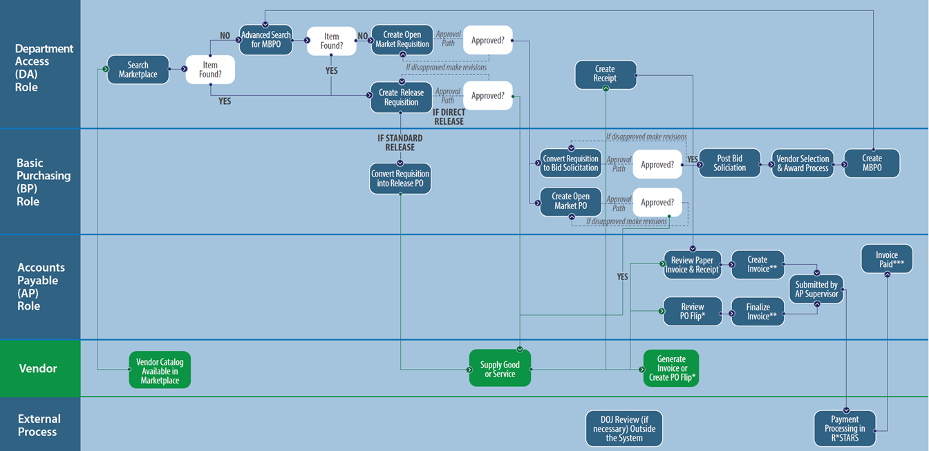

# Prerequisites

1. The Purchase Order is in ***sent*** status
2. The goods or services have been received or rendered

# Scenario

1. Goods or services have been ordered and have been delivered to the State.
2. The Basic Purchase or Department Access user has been notified of the delivery and verified that the goods or services have been delivered.
3. The delivery should be recorded in OregonBuys with a Receipt document associated with the purchase.

# Creating a Receipt

**Notes:**

1. A Full Receipt will record that receipt of all items from the Order
2. A Partial Receipt will record receipt of some of the items from the Order.
3. By specifying the Receipt Quantity Received the BP or DA users can indicate whether this is a Full or Partial receipt.

This section includes a step-by-step process of how to create a Full Receipt (in contrast to a Partial Receipt) in OregonBuys.

1. Login using your login credentials at oregonbuys.gov. To create a Receipt, you must have a Basic Purchasing or Department Access role.

Figure 2: Login ID & Password Prompt Screen

Figure 3: Basic Purchaser or Department Access Home Screen

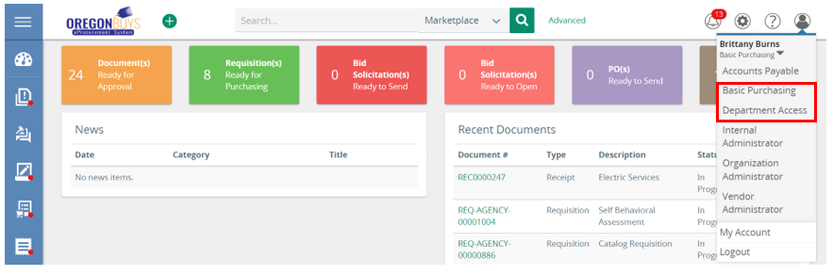

1. Navigate to the left side of the Homepage and click the **green “+” icon**
   1. Select “**Receipt”** on the drop down reen “+” icon and “Receipt” drop-down Screen

Figure 4: Green “+” icon and “Receipt” drop-down Screen

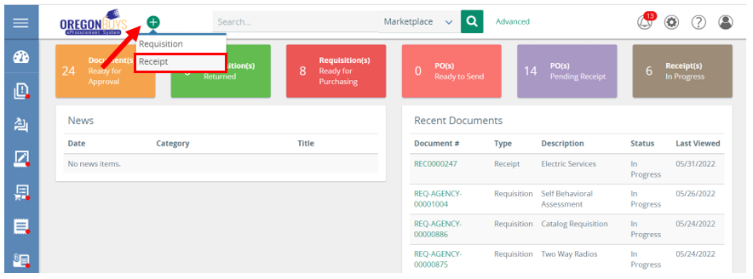

Figure 5: Purchase Order Receipts Screen after Selecting Receipt from the Green "+" Icon Dropdown

1. Search for the **Purchase Order**
   1. Use the fields to search for the Purchase Order based on a number of criteria (e.g. NIGP Class and Class Item codes)
   2. Select ***Find it***

Figure 6: Search for Purchase Order Using NIGP Class

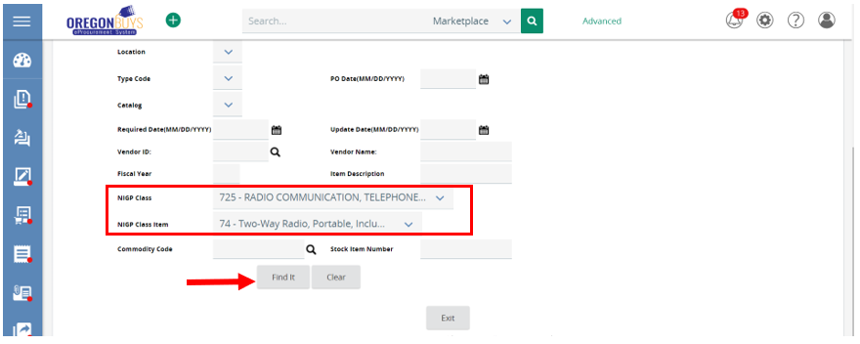

* 1. Select the correct **Purchase Order**
  2. Click ***Select***

Figure 7: Select Purchase Order from Results Screen

**

1. The page will refresh, and this immediately creates a new In Progress Receipt. Fill out the required fields indicated with an asterisk.
   1. ***Department***
   2. ***Location***
   3. ***Receipt Description***
   4. ***Receipt Owner***
   5. The ***Received Date*** can also be input, if different from the current date and time

Figure 8: Select Department and Location on the Receipt Screen

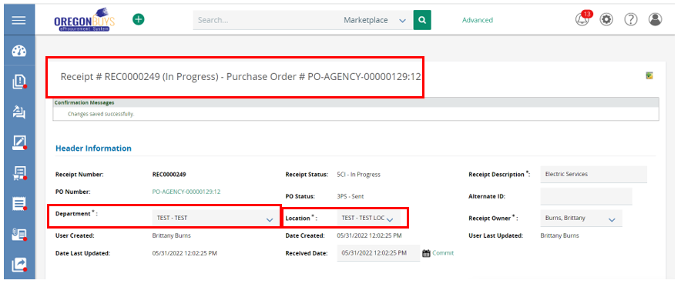

1. Next is the **Attachments** section where you can add any supporting documentation regarding the Receipt that may be helpful to others.
2. Next to ***Files* or *Forms*,** click the ***Add New Attachments*** icon.

Figure 9: Select Attachments from the Attachments section

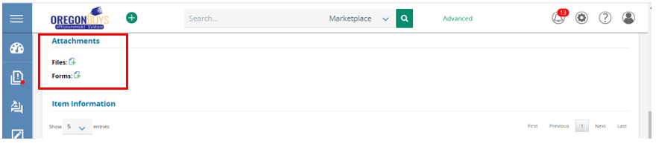

* 1. The page will refresh to the **Add File** screen.
  2. Select ***Choose File*** to select the file from your computer
  3. Update ***Name*** and add a ***Description*** if necessary
  4. Select ***Save & Exit*** to attach file

Figure 10: Add File screen and Update Name & Description Fields

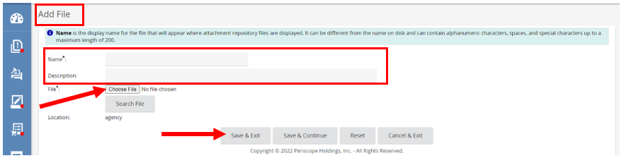

1. Next is the **Items** section. Here you will see the items ordered on the Purchase Order you’re entering a Receipt against. This section allows you to enter the **Quantity** or **Dollar Amount** of the item that was either **received**, **returned**, or **canceled**.
   1. **Select the item** by clicking the box under the Select column.
   2. Next select ***Receive*** from the *Receipt Type* field.
   3. Then in the ***Quantity/Dollars*** field enter in the goods or services received.
   4. Add a comment in the ***Comments*** section to describe what has been received.
   5. Select ***Save & Continue*** for Partial Receipt or select ***Receive All*** for full Receipt

Figure 11: Enter Goods and Services Received

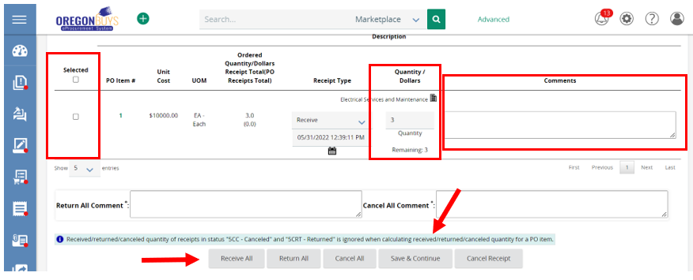

1. The page will refresh, and the remaining quantity will now show as zero.
2. Select ***Submit for Approval*** when complete.

Figure 12: Receipt Ready to Submit for Approval

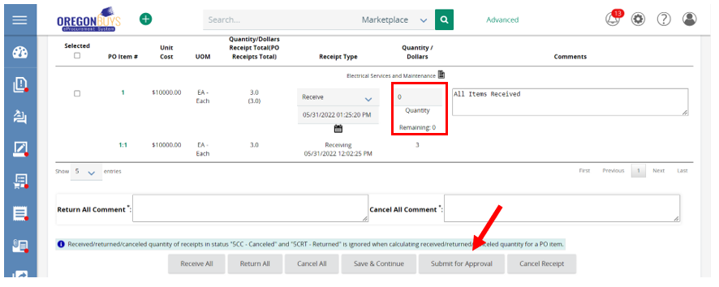

1. **NOTE:** On the next screen, if there is an Approval Path that meets the document criteria it will show accordingly. Otherwise, the system will prompt for a selection to be manually made as shown in the next step below.
2. If there is no Approval Path triggered two options will show appear:
   1. **Manually add approvers:** if you would like to add approvers not included in an agency defined approval path
   2. **Automatic approval:** if an approval path is not set by the agency
   3. Click ***Save and Continue***

Figure 13: Specify Approvers or Approval Path for Receipt

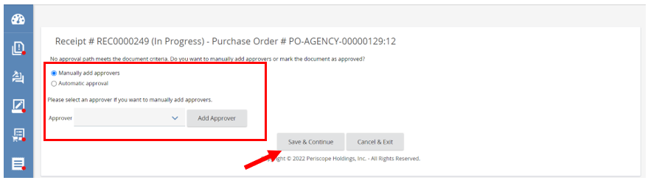

1. Receipt now moves to an ***Approved for Invoice*** Status.

*Figure 14: Receipt Complete*

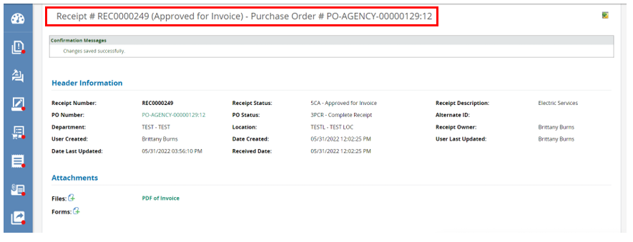

# Returning Items

## Scenario

1. Goods or services have been ordered and have been delivered to the State.
2. The Basic Purchaser (BP) or Department Access (DA) user has been notified of the delivery.
3. A portion of the delivery cannot be accepted by the state and needs to be returned to the vendor.
4. The Receipt is created to record the number of items to be returned to the vendor.

**Note:**

1. This scenario may go with the Partial Receipt scenario. A shipment of goods is received from the vendor, but some are found to not function and must be returned. In this scenario, a Receipt will be created for the goods received, and an additional action on that Receipt will be taken to return those broken items.

This section includes a step-by-step process of how to Return items in OregonBuys.

1. Login using your login credentials at oregonbuys.gov. To create a Receipt, you must have a Basic Purchasing or Department Access role.

Figure 15: Login to Home Page to Begin to Return Items

Figure 16: Basic Purchaser or Department Access Home Screen

2. Navigate to the left side of the Homepage and click the **green “+” icon**.

1. Select **“Receipt”** on the drop down

Figure 17: Green “+” icon and “Receipt” drop-down Screen

*Figure 18: Purchase Order Receipts Screen after Selecting Receipt from the Green "+" Icon Dropdown*

1. Search for the **Purchase Order**
   1. Use the fields to search for the Purchase Order based on a number of criteria (e.g. NIGP Class and Class Item codes)
   2. Select ***Find it***

Figure 19: Search for Purchase Order Using NIGP Class

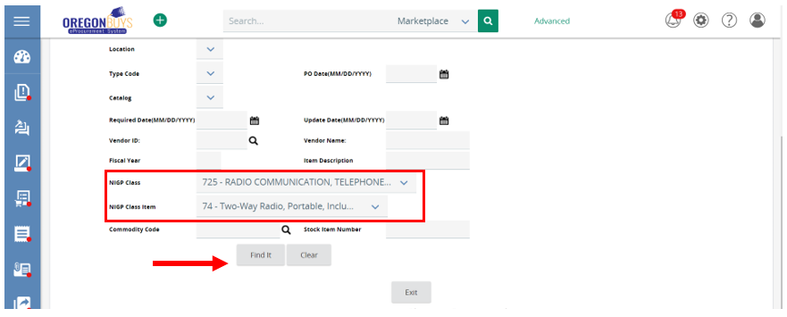

* 1. Select the correct **Purchase Order**
  2. Click***Select***

Figure 20: Select Purchase Order from the Results Screen

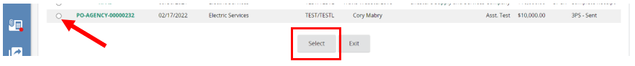

1. The page will refresh, and this immediately creates a new ***In Progress*** Receipt. Fill out the required fields indicated with an asterisk.
   1. ***Department***
   2. ***Location***
   3. ***Receipt Description***
   4. ***Receipt Owner***

Figure 21: Select Department and Location on the Receipt Screen

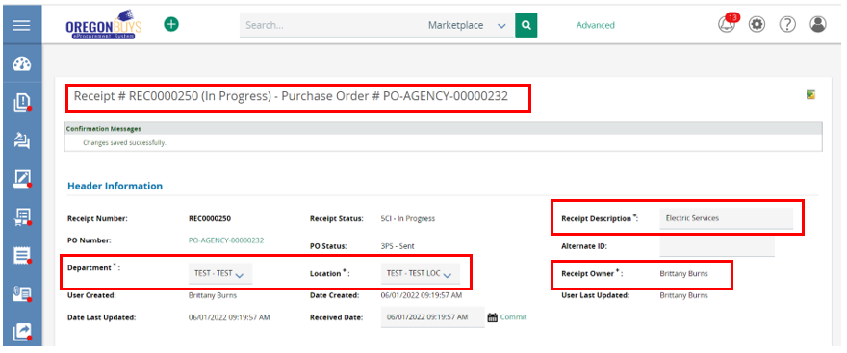

1. Next is the **Attachments** section where you can add any supporting documentation regarding the Receipt that may be helpful to others.
2. Next to ***Files* or *Forms***, click the ***Add New Attachments*** icon.

Figure 22: Select Attachments from the Attachments section

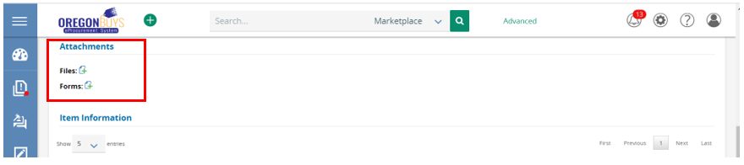

* 1. The page will refresh to the **Add File** screen.
  2. Select ***Choose File*** to select the file from your computer
  3. Update ***Name*** and add a ***Description*** if necessary
  4. Select ***Save & Exit*** to attach file

Figure 23: Add File screen and Update Name & Description Fields

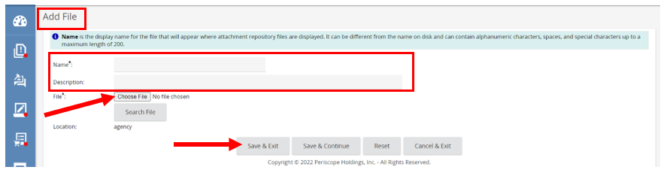

1. Next is the ***Items*** section. Here you see the items ordered on the Purchase Order you’re entering a Receipt against. This section allows you to enter the **Quantity** or **Dollar Amount** of the item that was either **receive**d, **returned**, or **canceled**.
   1. Select the item by **clicking the box** under the **Select** **column.**
   2. Next select ***Return*** from the ***Receipt Type*** field.
   3. Then in the ***Quantity/Dollars*** field enter in the goods or services received.
   4. Add a comment in the ***Comments*** section to describe what is being returned.
      1. Add a comment in the ***Return All Comment*** section if returning all items
   5. Select ***Save & Continue*** for a partial return or select ***Return All*** to return all items on Receipt.

Figure 24: Enter Goods and Services to be Returned

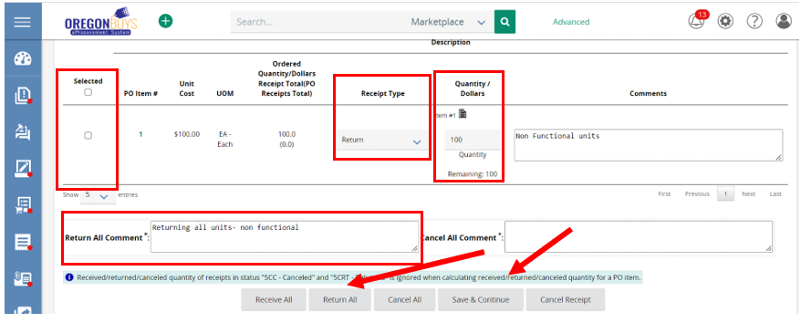

1. The page will refresh, and the remaining quantity will update to show all items returned
2. Select ***Submit for Approval*** when complete.

Figure 25: Return Receipt Ready to Submit for Approval

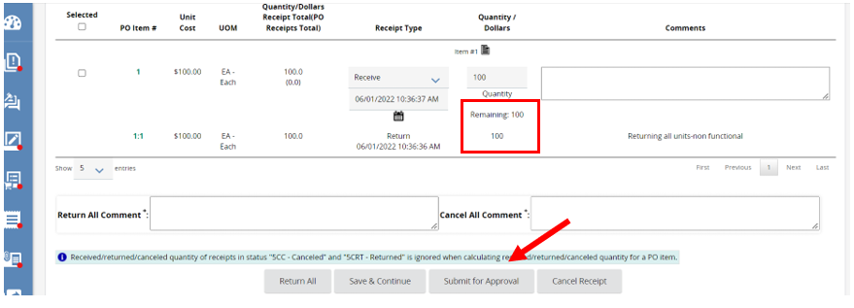

1. **NOTE:** If there is an Approval Path that meets the document criteria, it will show on the next screen after clicking the “Submit for Approval” button.
2. If there is no Approval Path triggered two options will appear:
   1. **Manually add approvers:** if you would like to add approvers not included in an agency defined approval path
   2. **Automatic approval:** if an approval path is not set by the agency
   3. Click ***Save and Continue***

*Figure 26: Specify Approvers or Approval Path for Return Receipt*

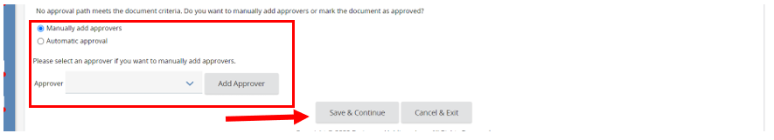

1. Receipt now moves to an ***Approved for Invoice*** Status.

Figure 27: Return Receipt Complete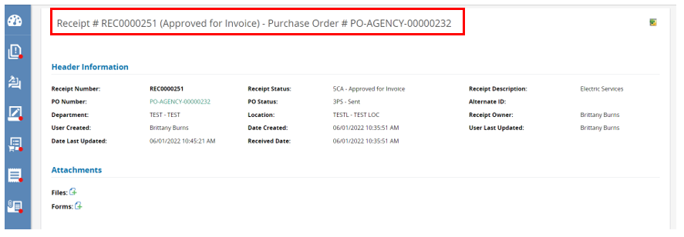

# Canceling Items

## Scenario

1. Goods or services have been ordered, and have not been delivered to the State.
2. The Basic Purchase or Department Access user has been notified that the items are not needed

This section includes a step-by-step process of how to Cancel items in OregonBuys.

* Login using your login credentials at oregonbuys.gov. To create a Receipt, you must have a Basic Purchasing or Department Access role.

Figure 28: Login to Home Page to Begin Canceling Items

*Figure 29: Basic Purchaser or Department Access Home Screen*

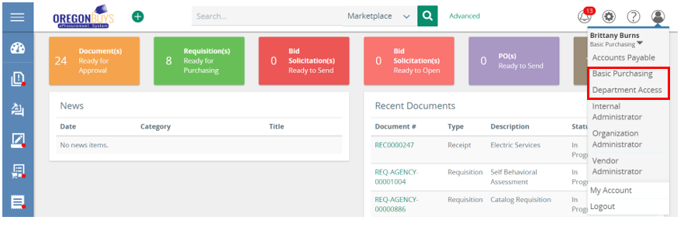

2. Navigate to the left side of the Homepage and click the **green “+” icon.**

1. Select **“Receipt”** on the drop down Green “+” icon and “Receipt” drop-down Screen

*Figure 30: Green “+” icon and “Receipt” drop-down Screen*

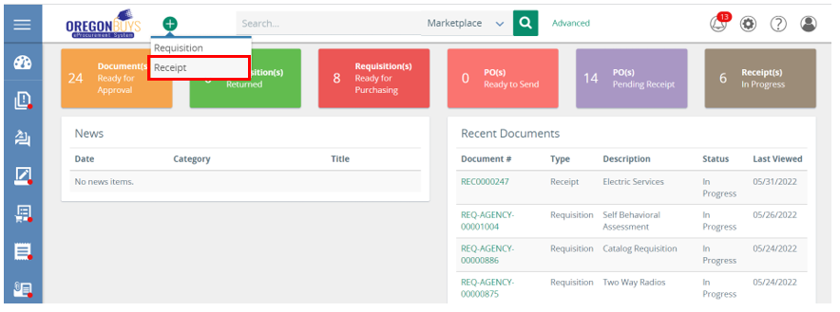

*Figure 31: Purchase Order Receipts Screen after Selecting Receipt from the Green "+" Icon Dropdown*

* Search for the **Purchase Order**
  1. Use the fields to search for the Purchase Order based on a number of criteria (e.g. NIGP Class and Class Item codes)
  2. Select ***Find it***

Figure 32: Search for Purchase Order Using NIGP Class

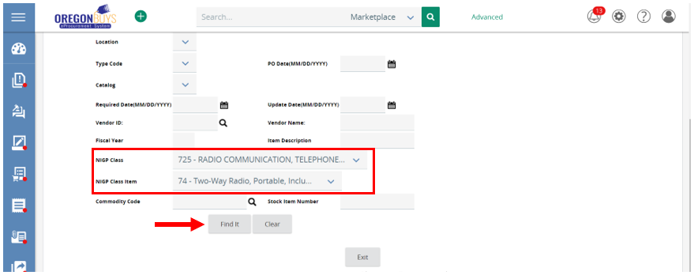

* 1. Select the correct **Purchase Order** Select Purchase Order from the Results Screen
  2. Click***Select***

*Figure 33: Select Purchase Order from the Results Screen*

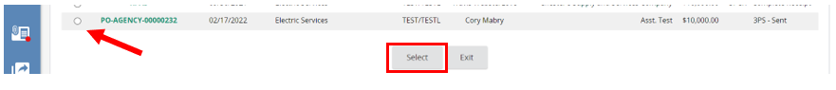

* The page will refresh, and this immediately creates a new ***In Progress*** Receipt. Fill out the required fields indicated with an asterisk.
  1. ***Department***
  2. ***Location***
  3. ***Receipt Description***
  4. ***Receipt Owner***

Figure 34: Select Department and Location that will Cancel Items on the Receipt Screen

* Next is the **Attachments** section where you can add any supporting documentation regarding the Receipt that may be helpful to others.
* Next to ***Files*** or ***Forms*,** click the ***Add New Attachments*** icon.

Figure 35: Select Attachments from the Attachments section

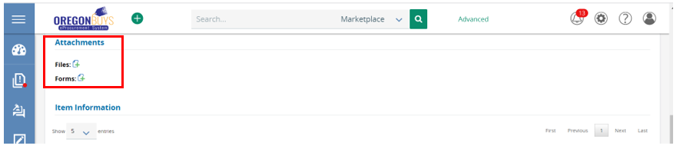

* 1. The page will refresh to the ***Add File*** screen.
  2. Select ***Choose File*** to select the file from your computer
  3. Update ***Name*** and add a ***Description*** if necessary
  4. Select ***Save & Exit*** to attach file

Figure 36: Add File screen and Update Name & Description Fields

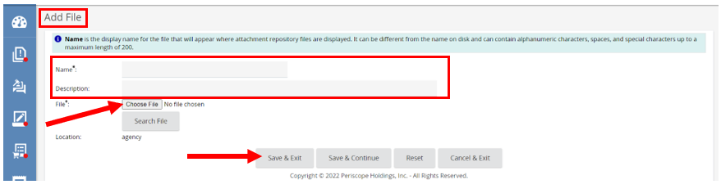

* Next is the ***Items*** section. Here you will see the items ordered on the Purchase Order you’re entering a Receipt against. This section allows you to enter in the ***Quantity*** or ***Dollar***amount of the item that was either received, returned, or canceled.
  1. Select the item by clicking the box under the ***Select*** column.
  2. Next select ***Cancel***from the ***Receipt Type*** field.
  3. Then in the ***Quantity/Dollars*** field enter in the amount of goods or services being returned.
  4. Add a comment in the ***Comments*** section to describe what is being returned.
     1. Add a comment to the ***Cancel All Comment*** section if canceling all items.
  5. Select ***Save & Continue*** to cancel a partial amount or select ***Cancel All*** to return all items on Receipt.

Figure 37: Enter Goods and Services to be Cancelled

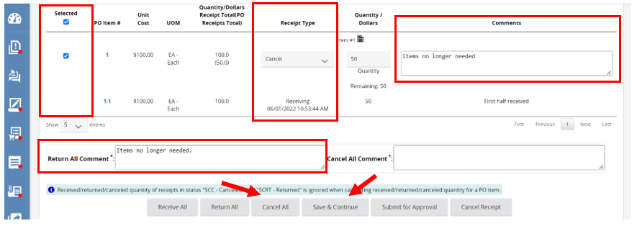

1. The page will refresh, and the remaining quantity will update to show all items returned
2. Select ***Submit for Approval*** when complete.

Figure 38: Cancel Receipt is Complete

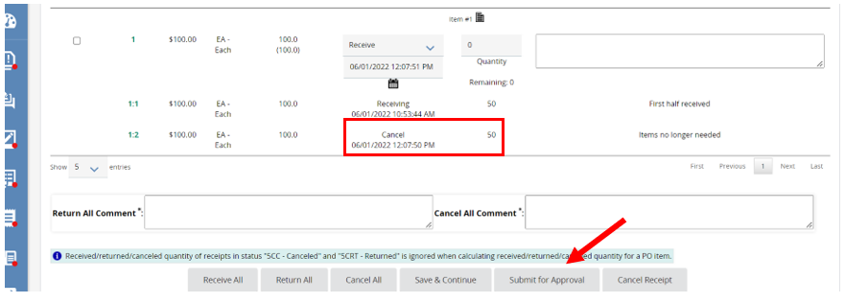

1. **NOTE:** If there is an Approval Path that meets the document criteria, it will show on the next screen after the “Submit for Approval” button has been clicked.
2. If there is no Approval Path triggered two options will show appear:
   1. **Manually add approvers:** if you would like to add approvers not included in an agency defined approval path
   2. **Automatic approval:** if an approval path is not set by the agency
   3. Click ***Save and Continue***

*Figure 39: Specify Approvers or Approval Path for Cancelled Receipt*

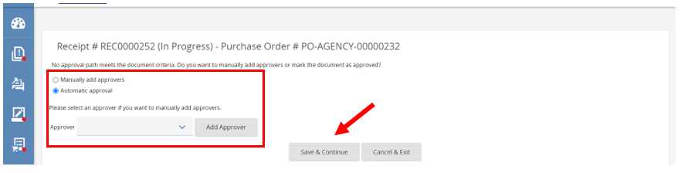

1. Receipt now moves to an ***Approved for Invoice*** Status.

*Figure 40: Approved for Invoice Status Screen*

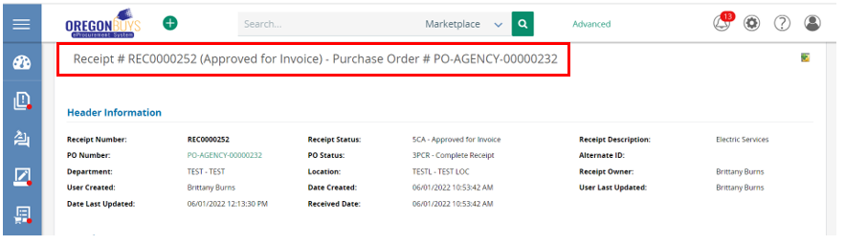

# Special Case: Paying Invoice in Biennium following Purchase Order

## Scenario

1. Goods or services have been ordered in a prior biennium and have been delivered to the state.
2. The Basic Purchase or Department Access user has been notified of the delivery.
3. A payment needs to be made for the item in the biennium after the items were originally ordered because Invoices cannot pay for items from a previous biennium after the roll period ends.

**Notes:**

1. Items cancelled on the original PO will be marked as received on the cloned PO for the new biennium.
2. The Basic Purchaser will clone the PO from the previous biennium into the current biennium.

Users will need to use this process when a good/service is received in the biennium after the Purchase Order is created. The Invoice guidance document will cover the parts of the process relating to Invoices.

To start this process user should navigate to their existing PO.

This section includes a step-by-step process of how to Cancel items in OregonBuys.

1. Login using your login credentials at oregonbuys.gov. To create a Receipt, you must have a Basic Purchasing or Department Access role.

Figure 41: Login to Home Page to Begin Paying Invoice in Biennium following Purchase Order

*Figure 42: Basic Purchaser or Department Access Home Screen*

1. Navigate to the left side of the Homepage and click the **green “+” icon.**
2. Select ***“Receipt”*** on the drop down

*Figure 43: Green “+” icon and “Receipt” drop-down Screen*



Figure 44: Purchase Order Receipts Screen after Selecting Receipt from the Green "+" Icon DropdownGraphical user interface, application

Description automatically generated

1. Search for the **Purchase Order.**
   1. Use the fields to search for the Purchase Order based on a number of criteria (e.g. NIGP Class and Class Item codes)
   2. Select ***Find it***

Figure 45: Search for Purchase Order Using NIGP Class

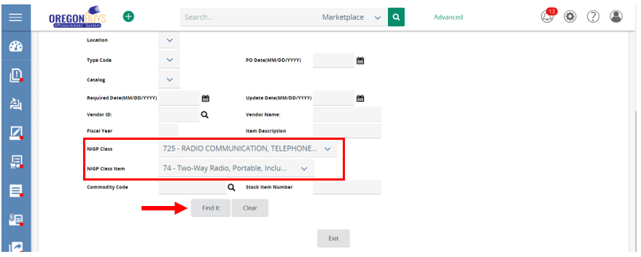

* 1. Select the correct **Purchase Order.**
  2. Click***Select***

*Figure 46: Select Purchase Order from the Results Screen*

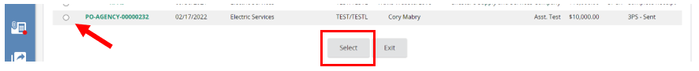

1. The page will refresh, and this immediately creates a new ***In Progress*** Receipt. Fill out the required fields indicated with an asterisk.
   1. ***Department***
   2. ***Location***
   3. ***Receipt Description***
   4. ***Receipt Owner***

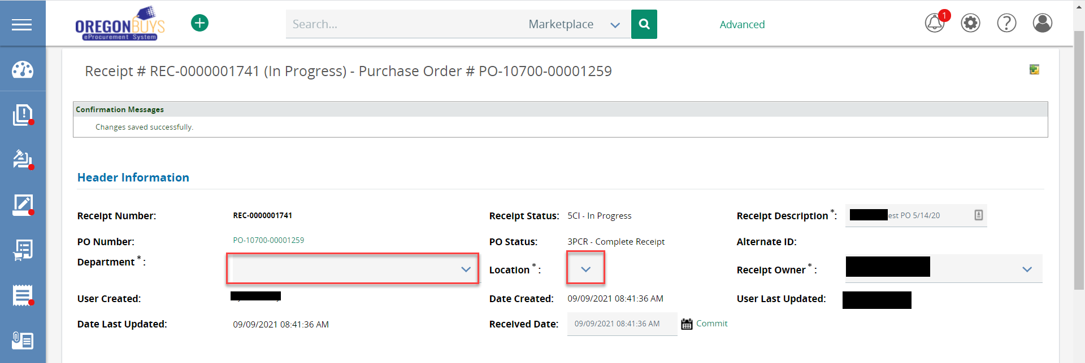Figure 47: Select Department and Location on the Receipt Screen

1. **Cancel all items** on the Receipt.
   1. Make sure the **“Receipt Type”** is set to **“*Cancel”.***
   2. Fill out the ***quantity to cancel***
   3. **Specify** the **end of the Biennium** in the **“Comment”** box
   4. **Specify** the **end of the Biennium** in the **“Cancel All Comment”** box
   5. Click ***“Cancel All”***

Figure 48: Cancel All Receipt Items

The page will refresh and now show that the Receipt has been canceled. Next the Basic Purchaser will clone the Purchase Order (PO) this Receipt is tied to and then a new Receipt will be created to receive the necessary items.

*Figure 49: Canceled Purchase Order Screen*