OregonBuys Release Purchase Order Guidance

Table of Contents
Introduction 2
High Level Process Flow 2
Scenario 2
1. General 2
2. Item 2
3. Accounting 2
4. Vendor 2
5. Routing 3
6. Attachments 3
7. Notes 3
8. Summary 3
Prerequisites 3
Locating the In-Progress Release Purchase Order 3
Method 1 – Using the Purchase Order Viewer 3
Method 2 – Using Search 5
General Tab 6
Items Tab 7
Vendor Tab 8
Address Tab 9
Card Payment Tab 9
Accounting Tab 10
Routing Tab 10
Attachments Tab 11
Notes Tab 11
Change Orders Tab 11
Reminders Tab 12
Summary Tab 13
Purchase Order Approval 14

Introduction
This guidance document will cover how to locate and review an “In Progress” status Release Purchase Order, how to submit it for approval, and how to send it to the Vendor to be fulfilled. Only a Standard Release can become an In Progress Release Purchase Order, a Direct Release will convert from a Release Requisition into a Release Purchase Order in Sent status.
A Basic Purchaser will use a Release Purchase Order when purchasing off an existing contract or Master Blanket Purchase Order (MBPO). This is in contrast to an Open Market Purchase Order, which is used when there is no existing contract.

High Level Process Flow
The following is a high-level process overview for OregonBuys.
Figure 1: High Level Process Flow
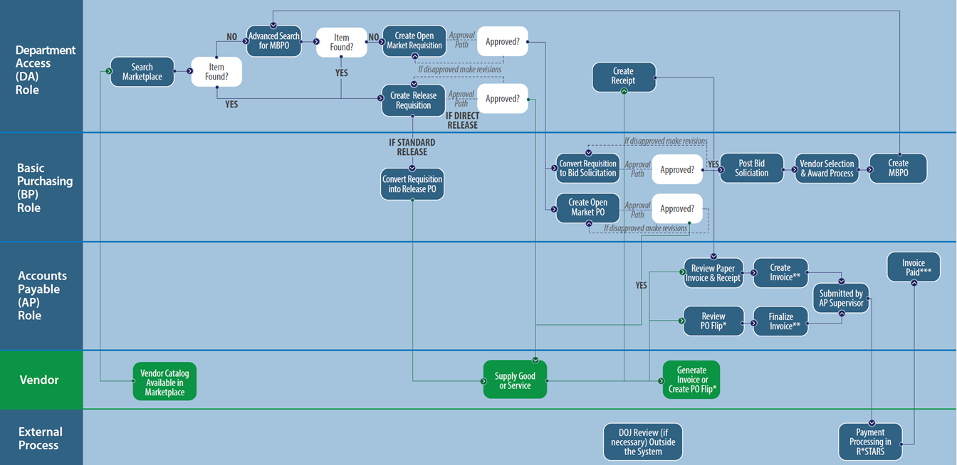

Scenario

General
In this guidance document the Basic Purchaser (BP) in the agency is finding and sending a Release Purchase Order to purchase laptops from an existing Master Blanket Purchase Order (MBPO). This Release is for the Department of Purchasing’s Accounts division.

Item
The line item associated with this Release is an Optical Ballot Scanner. The item comes from the Release Requisition.

Accounting
The account code segments are input on this tab.

Vendor
The line item that came from an established MBPO and Release Requisition also includes the vendor information on this tab.
There are no Subcontractors, Distributors, or Vendor Performance associated with this vendor.

Routing
The Routing for approvals for this document may be set manually or selected at the point that the document is Submitted for Approval.

Attachments
The Basic Purchaser should add attachments to document background information for this Release. In addition, the Agency may have set up standard documents (for example Terms and Conditions) to be attached to all Purchase Orders for the Agency.

Notes
It is suggested that notes related to deadlines, approval information, contact information, or other information that the Basic Purchaser deems important for tracking or approving this Release Purchase Order be added on the Reminders and Notes tabs. It would be good practice for the Agency Procurement Team to establish standard procedures for these tabs.

Summary
The Release Requisition should be submitted for any applicable approvals and the user will see the status change to “Ready for Approval”.

Prerequisites
- A Release Requisition from a “Standard Release” MBPO has been created and approved
- Information specific to the services or supplies be purchased is known (e.g., quantity, price, shipping and billing addresses, etc.

Locating the In-Progress Release Purchase Order

Method 1 – Using the Purchase Order Viewer
- A Department Access (DA) user from an organization will submit a Release Requisition from a Standard Release Master Blanket Purchase Order. The Requisition is approved, and the status is now Gone to PO.
- The Basic Purchasing (BP) user will locate the In Progress Purchase Order as follows.
  - If the In-Progress Purchase Order is assigned to you, it can be located by expanding the left navigation bar and clicking on Purchase Orders.
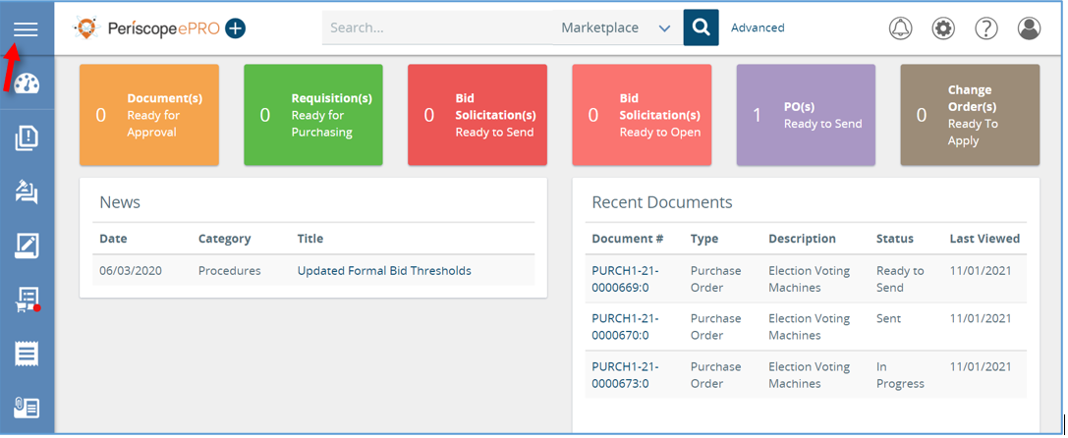
The following image shows the menu options when the icon on the top of the left navigation bar is clicked.
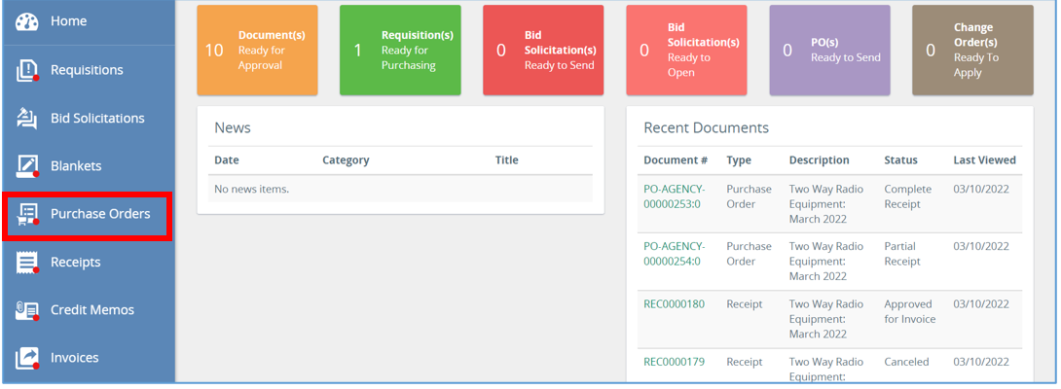
- Next, there will be a list of In-Progress Purchase Orders that are assigned to you, click the document number of the Purchase Order being worked on. This will then bring up the Summary Tab of that Purchase Order.
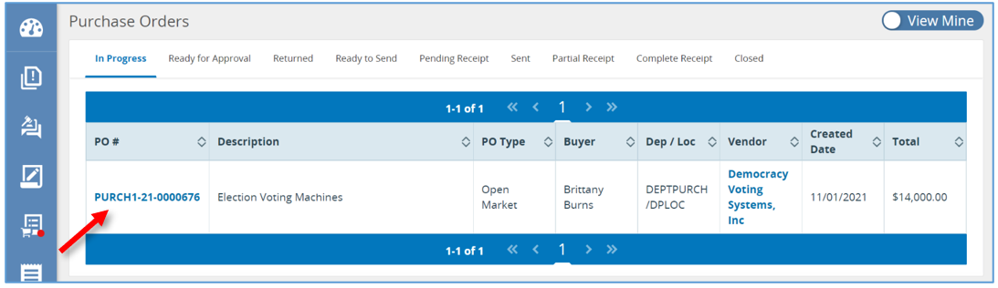
- Once Purchase Order is selected, the page will redirect to the Summary tab of that Purchase Order.
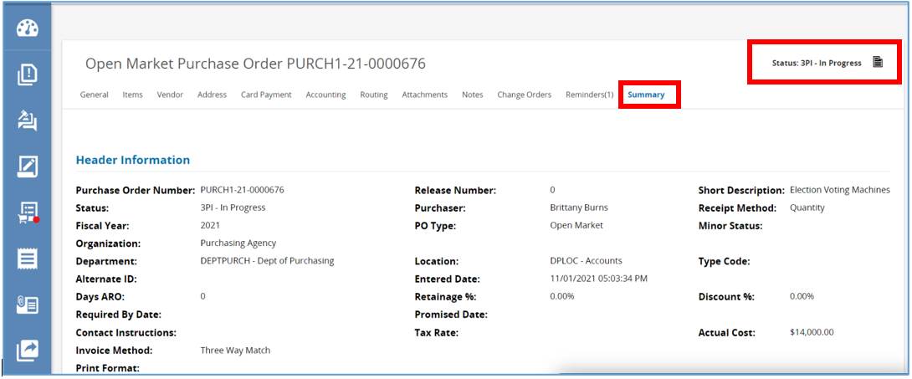

Method 2 – Using Search
Another way to access the Purchase Order is by going back to the Home Page and entering in the Purchase Order number if known.
- Enter in the Purchase Order number in the Navigation search bar located at the top of the page.
- Let the system know what is being searched in the Navigation search bar by selecting Purchase Order from the drop-down menu.
- Then click the magnifying glass to complete the search.
- The screen will refresh twice landing back on the Summary Tab of that Purchase Order.
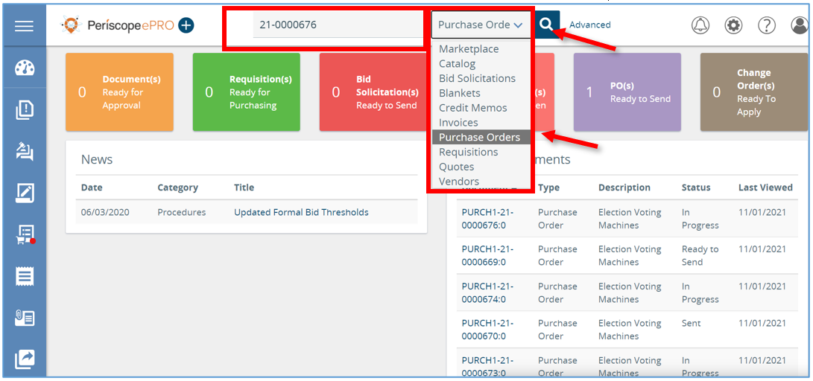

General Tab
Starting in the General Tab review the document and make any changes necessary
- The Short Description, Department and Location fields have been carried over from the Requisition document.
  - If those fields or any other fields need to be modified, make the changes and then scroll down and click Save & Continue.
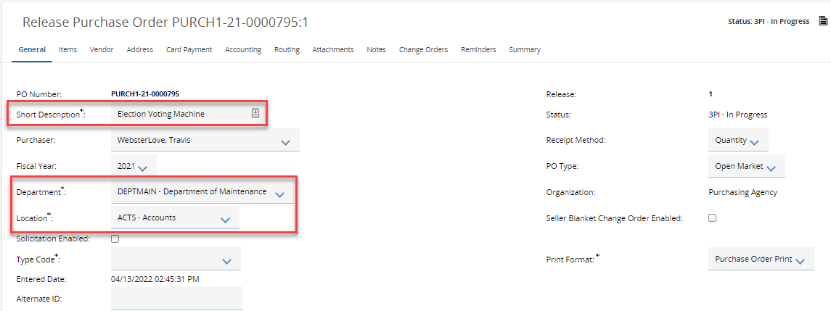
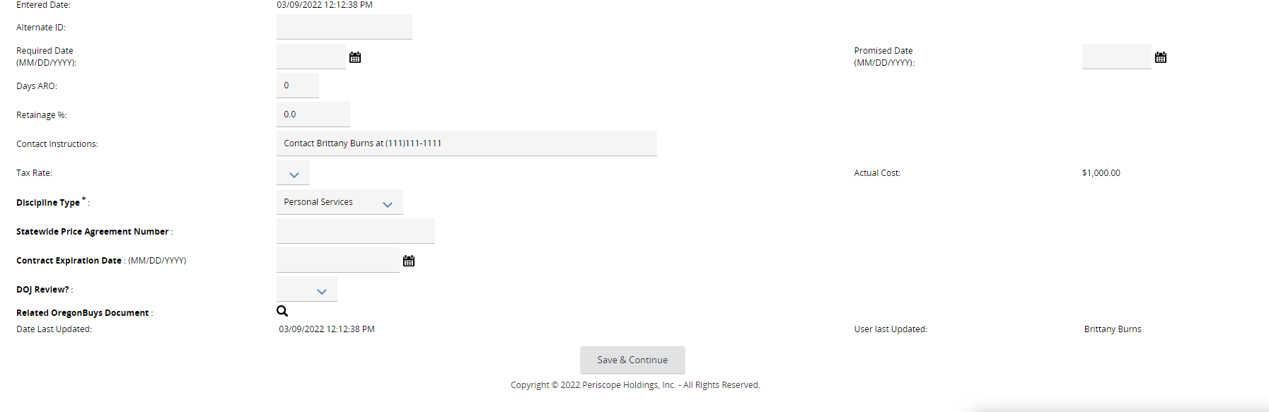

Items Tab
- Next, click on the Items tab. The items selected on the Requisition have been copied to the Purchase Order.
  - Each item will have a Master Blanket number and a Requisition number.
  - The Master Blanket and Requisition numbers will show as links that can be selected if the user has access to the Master Blanket or Requisition that this Purchase Order came from.
- To edited one of the listed items, click the item number and make any necessary changes on this screen.
- Scroll down and click Save & Exit.
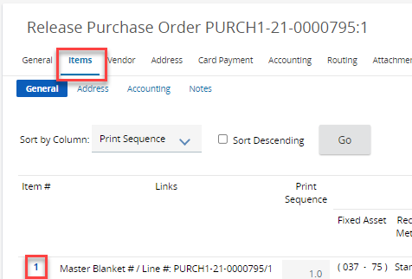
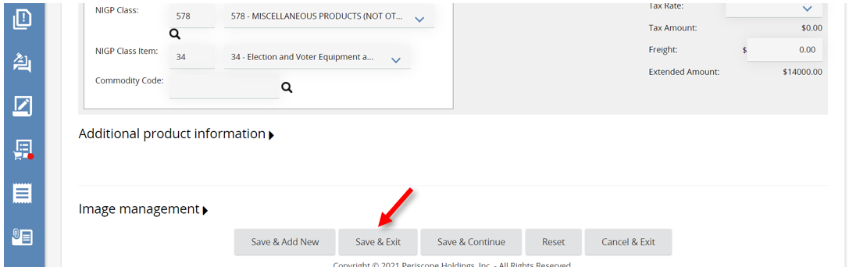

Vendor Tab
Next, review the Vendor Tab. Here the vendor will already be selected.
- The Remit-to Address or PO Mailing Address can be updated if necessary.
  - Payment, Freight, Shipping Terms, or the Shipping Method can also be selected on this page.
  - Vendor Terms to the PO can also be applied if needed. This saves vendor terms to the document.
  - Once all changes are made, click Save & Continue.
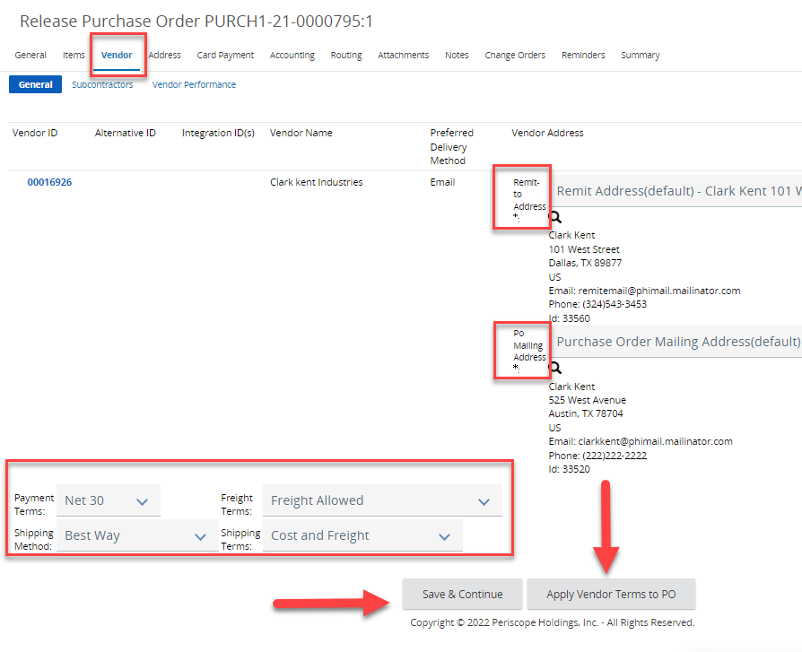

Address Tab
- Next, review the Address Tab for any changes that need to be made.
- Click Save & Continue after all changes have been completed.
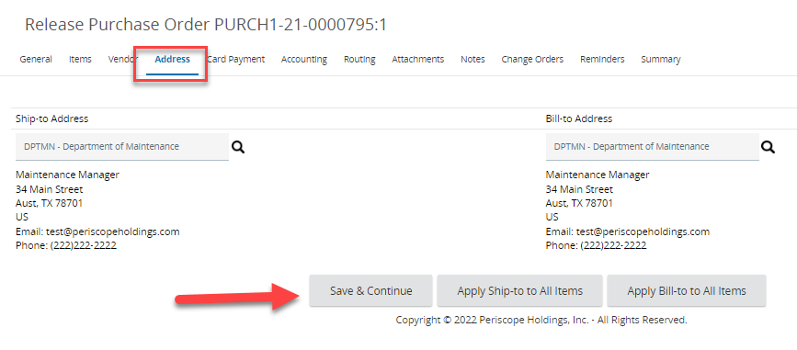

Card Payment Tab
- Next, review the Card Payment Tab for any changes that need to be made.
- Click Save & Continue after all changes have been completed.
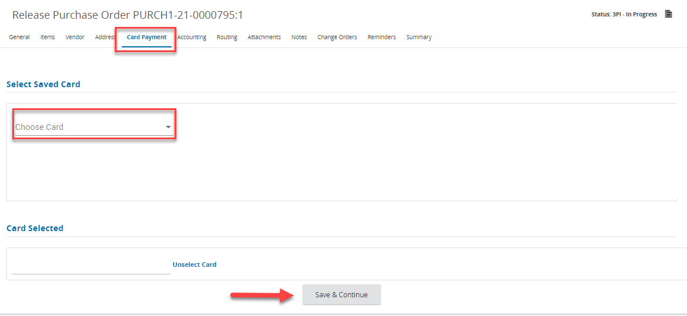

Accounting Tab
- Next, review the Account Tab for any changes that need to be made.
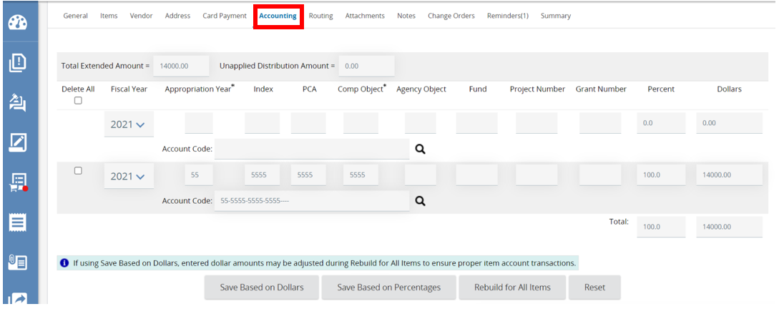

Routing Tab
- Next, review the Routing Tab for any changes that need to be made.
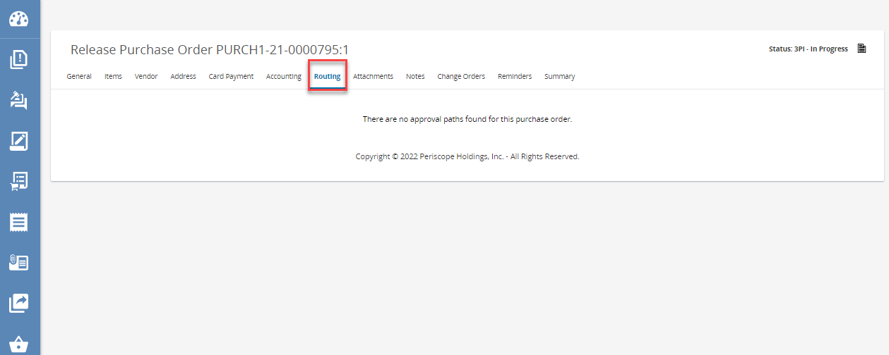

Attachments Tab
- Next, review the Attachment Tab for any changes that need to be made.
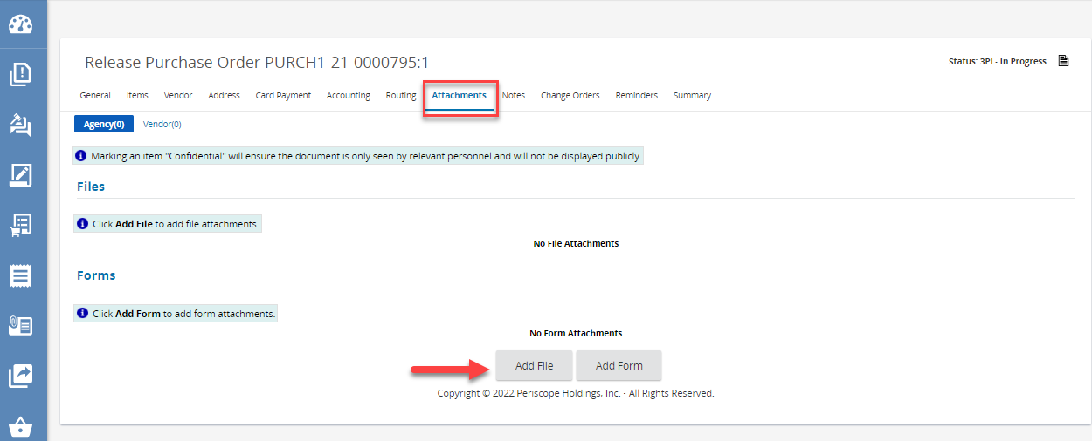

Notes Tab
- Next, review the Notes Tab for any changes that need to be made.
- Click Save & Continue after all changes have been completed.
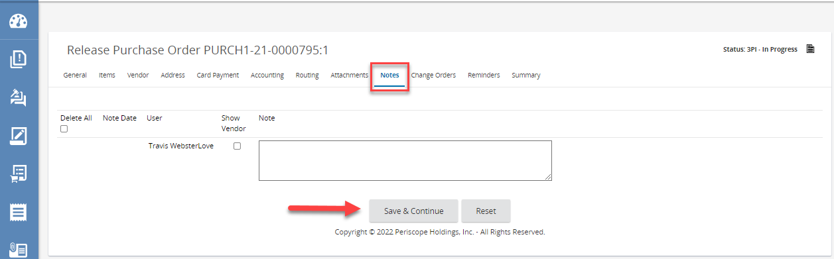

Change Orders Tab
- Next, review the Change Orders Tab for any changes that need to be made.
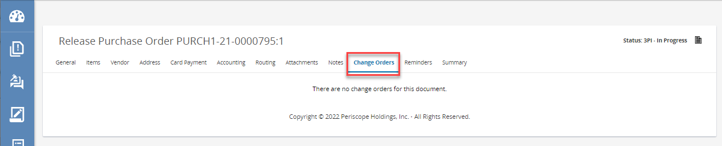

Reminders Tab
- Next, review the Reminders Tab for any changes that need to be made.
- Click Save & Continue after all changes have been completed.
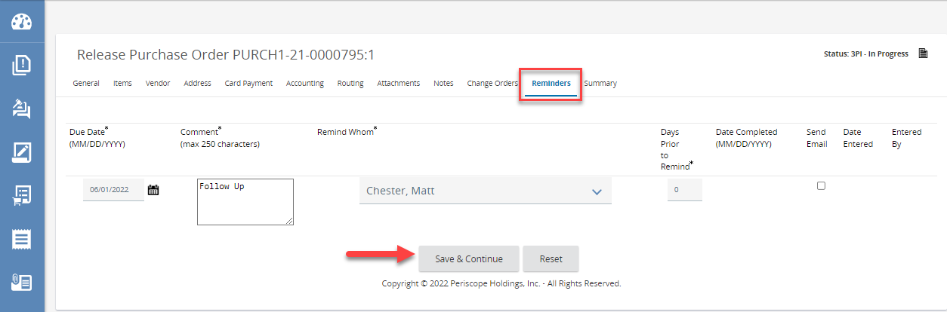

Summary Tab
- Lastly, there is the Summary Tab where the Purchase Order is ready to be submitted for approval.
- Scroll down to the bottom of the page and click Submit for Approval.
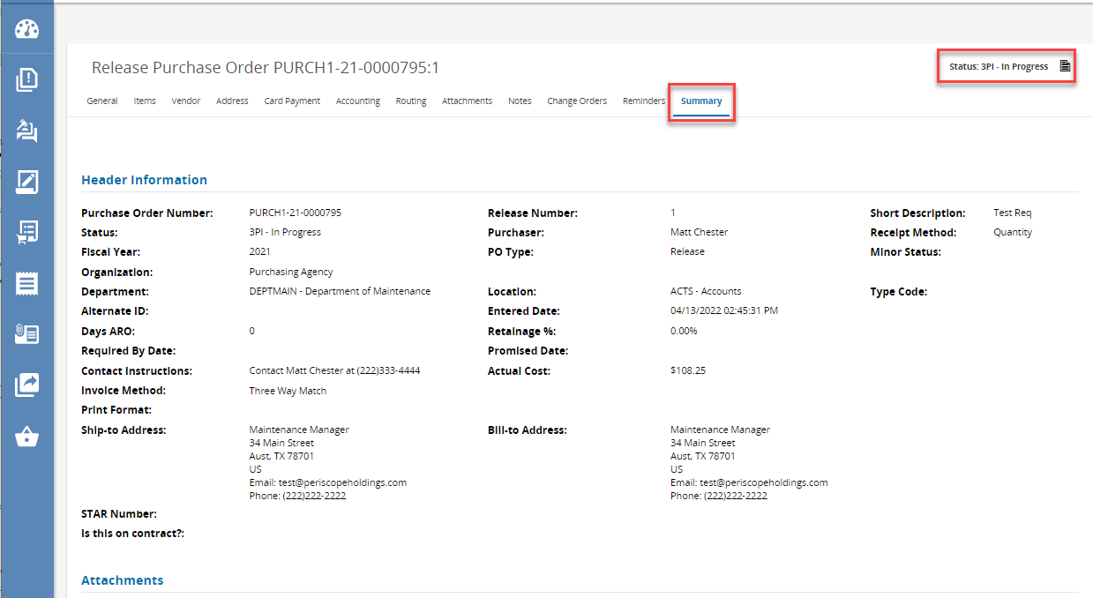
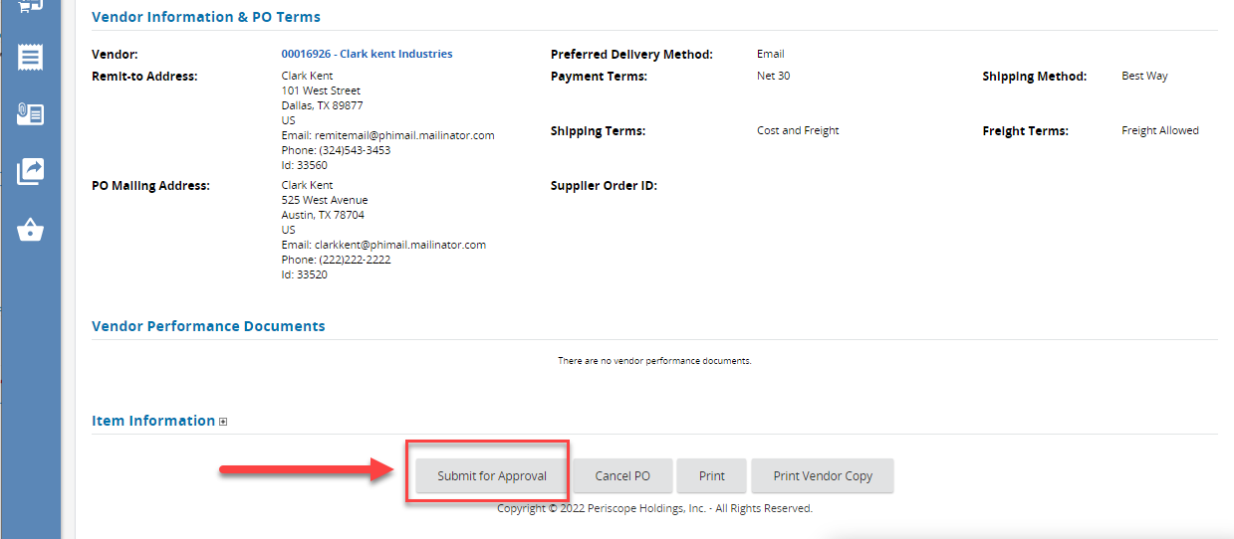
- The Summary Tab will refresh and the status of the Purchase Order will change to Ready for Approval.
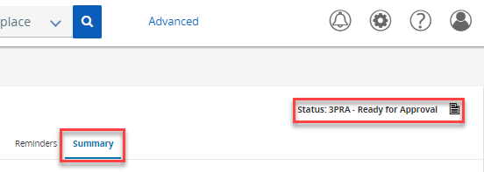

Purchase Order Approval
On the Home Page the POs Ready to Send status box will have a “1” in it, indicating that there is a Purchase Order ready to send.
- Click on the box to see the list of Purchase Orders.
- Click on the document number to open it.
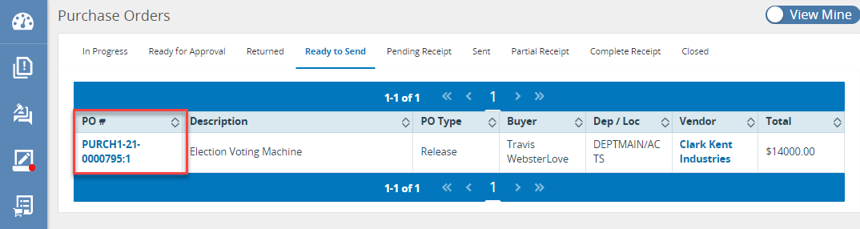
- Once the Purchase Order is opened, the page will redirect to the Summary Tab.
  - The status will show as Ready to Send.
  - This allows the Purchase Order to be reviewed one more time before sending it to the Vendor.
- Once reviewed and ready to send, scroll down to the bottom of the page and click Save & Continue.
- The page will refresh and the status in the top right corner will change to “Sent”.
  - The vendor is then emailed about the Purchase Order, and they can log in to review the order and fulfill it as well.
