OregonBuys Requisitions IV: Request for Payment Authorization (RPA)

Table of Contents
Introduction 2
High Level Process Flow 2
Prerequisites 2
Scenario 3
How to Access an Open Market Requisition 4
Creating a New Requisition 5
General Tab 5
Items Tab 9
Vendors Tab 18
Summary Tab 21

Introduction
This guidance document will demonstrate how to enter an RPA in the system. This document will also show how the system will create a Purchase Order, a Receipt, and an In-Progress Invoice ready for an Accounts payable user to process once the RPA is approved. An RPA stands for Request for Payment Authorization. This is a type of Requisition document used to request payment for off-contract commodities or services outside the system. Typically, RPA’s initiate payments for commodities and services where no Purchase Order exist prior to the actual purchase, such as emergency purchases. The system user should be prepared in advance with the prerequisite information listed below

High Level Process Flow
The following is a high-level process overview for OregonBuys. This guidance document is focused on the Requisitions Request for Payment (RPA) process used by the Department Access user.
The RPA process is outside of the normal procurement process shown in the graphic below. The RPA is created when a commodity or service is obtained outside the system and an Invoice needs to be paid.
Figure 1: High Level Process Flow
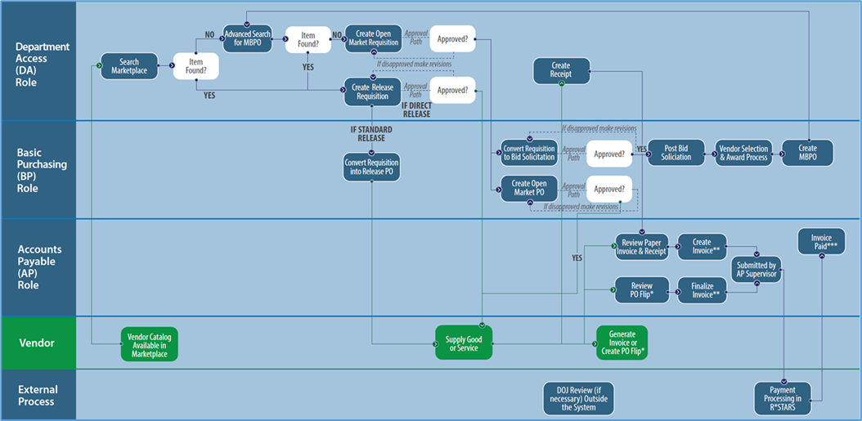

Prerequisites
- Department Access User with set Department and Location
- Have a need to purchase an item that isn’t currently on a contract such as an emergency purchase
- Need a vendor invoice showing vendor information and purchase information such as item, service, costs, etc.
- Need to know detailed item details and NIGP code or how to look up
- Need accounting/PCA Information to load into the system
- Identify approvers

Scenario
General Overview:
In this guidance document the Department Access user in the agency is creating and sending an RPA Requisition. The DA user has already purchased a commodity or service outside the system and now has an Invoice from the vendor that needs to get paid.
Item Info:
The line item associated with this RPA is a Staffing Assessment. The NIGP code for this item is NIGP Class Code 918 and NIGP Class Item Code 38.
Accounting:
The account code segments are input on this tab.
Vendor:
There are no Subcontractors, Distributors, or Vendor Performance associated with this vendor.
Routing:
The Routing for approvals for this document may be set manually or selected at the point that the document is Submitted for Approval.
Attachments:
The Department Access user should add attachments to document background information for this Requisition. In addition, the Agency may have set up standard documents (for example Terms and Conditions) to be attached to all Requisitions for the Agency.
Notes:
It is suggested that notes related to deadlines, approval information, contact information, or other information that the Department Access user deems important for tracking or approving this RPA Requisition be added on the Reminders and Notes tabs. It would be good practice for the Agency Procurement Team to establish standard procedures for these tabs.
Summary:
The RPA Requisition should be submitted for any applicable approvals and the user will see the status change to “Ready for Approval”.

How to Access an Open Market Requisition
- Starting from the Home page, click the Person Icon in the top right corner, and select Department Access as the user from the drop-down menu.
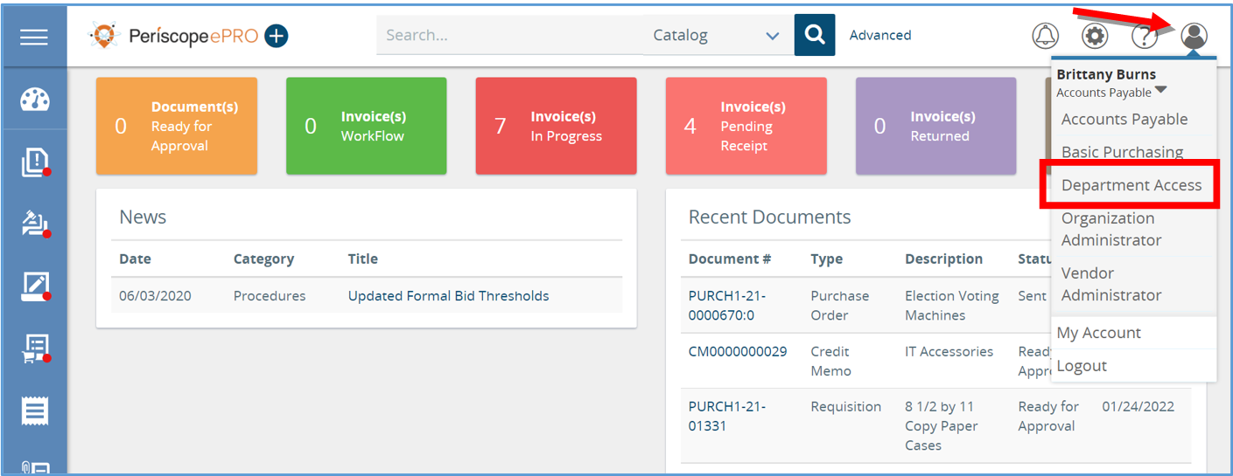
- Next, click the plus button and then select Requisition. This will create an RPA Requisition from scratch where you can document the completed service, the total cost, and the vendor who provided it.
  - This will create a New Requisition.
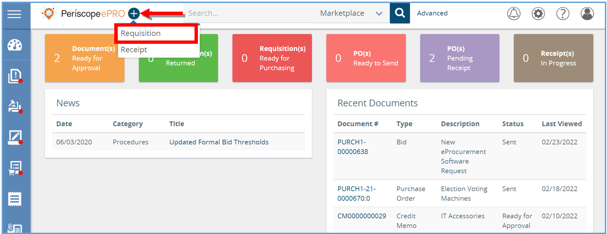

Creating a New Requisition
The New Requisition document will now show a series of tabs at the top. Starting with the General tab and ending with the Summary tab, you will work your way through the tabs from left to right to create a New Requisition. Fields that have an asterisk next to them are required fields to be completed.
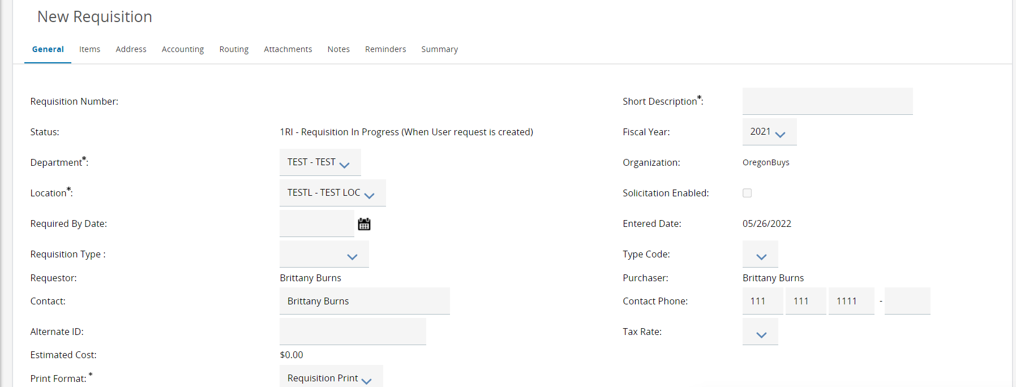

General Tab
- Starting from the General tab, enter the Short Description of the service that has already been completed.
- Next, navigate to the Department and Location fields.
  - Both fields will be populated based on your default settings.
  - If you need to change the Department and Location fields, use the drop-down arrow, and select the appropriate options needed.
    - Locations are subsets of departments which are similar to an agency’s divisions, bureaus, or programs.

- Next, navigate to the Print Format. This field can stay as is.
- The next required field to complete on the General tab is the Requisition Type field.
  - This determines the type of Requisition you want to create and drives additional functionality on the Item tab. For the RPA Requisition, it will require Invoice information for the item.
- Select RPA
  - This will drive additional functionality related to the line Items entered on this Requisition and the resulting Purchase Order.
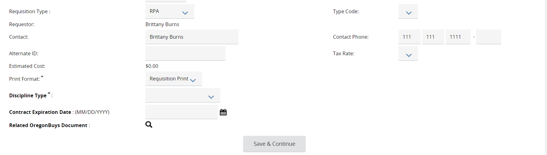

6. The last required field to complete on the General tab is the Discipline Type field.

- Once the required fields are completed, click Save & Continue. This will save all the data entered if you need to finish at a later time.
- The system will now generate a unique document number in the left-hand corner of the screen.
  - In the right hand-corner the status will now show In Progress. This means the document is saved and is editable.
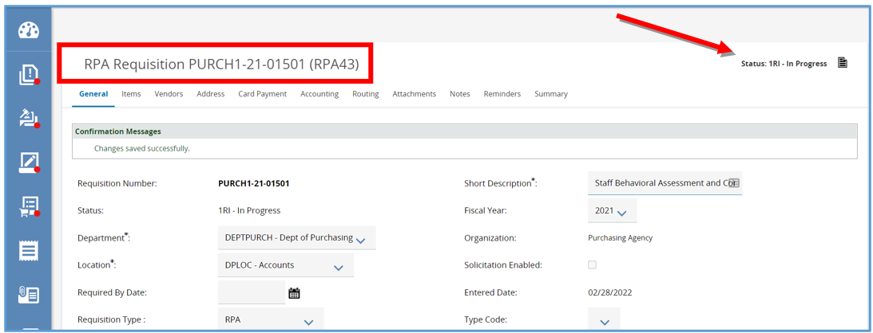

Items Tab
The Items tab is where you will enter the RPA Item detailing the commodity or service already ordered and received outside the system.
You can search for Items from previously entered RPAs or Open Market Purchase Orders by clicking Search Items and then clicking the Add to Req & Exit button to add the Items onto the Requisition.
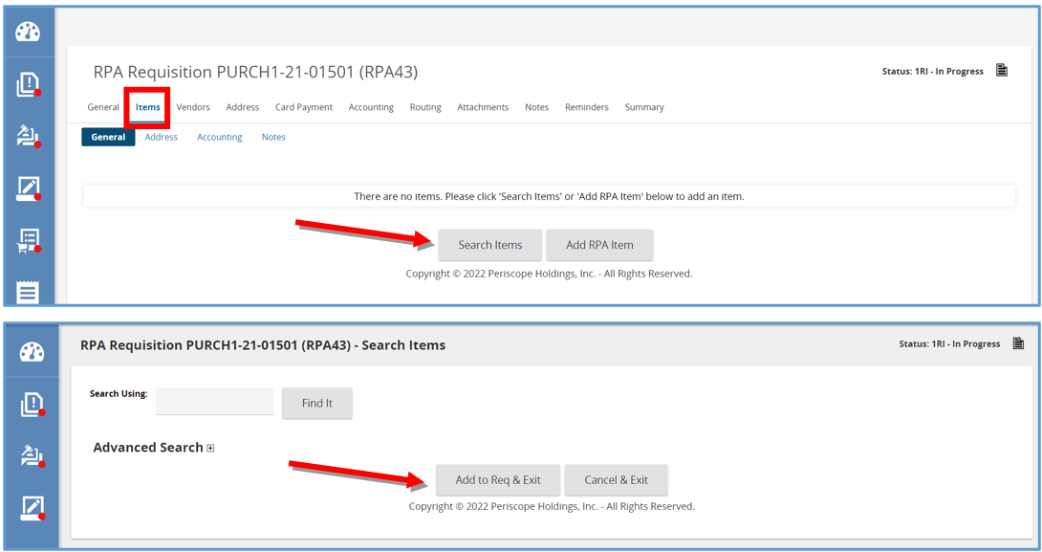
- To enter an RPA Item from scratch click Add RPA Item, which brings you to the RPA Item template. This document will cover how to create an RPA from scratch.
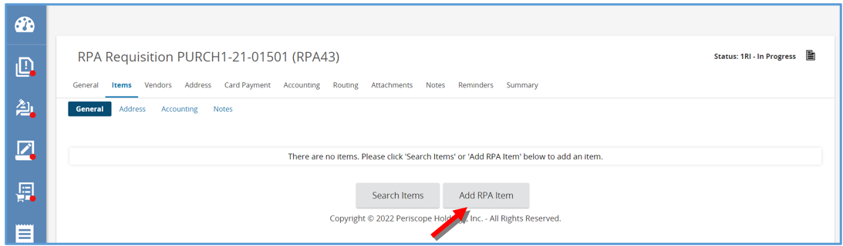

2. The page will refresh to the to the Items General subtab.
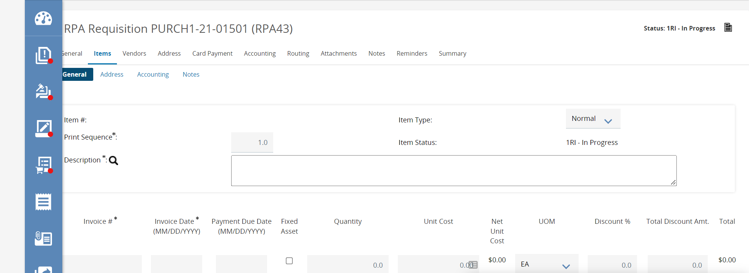
- From there, enter the Commodity or Service in the Description field.
  - It is recommended to be as detailed as possible when creating the RPA Item.
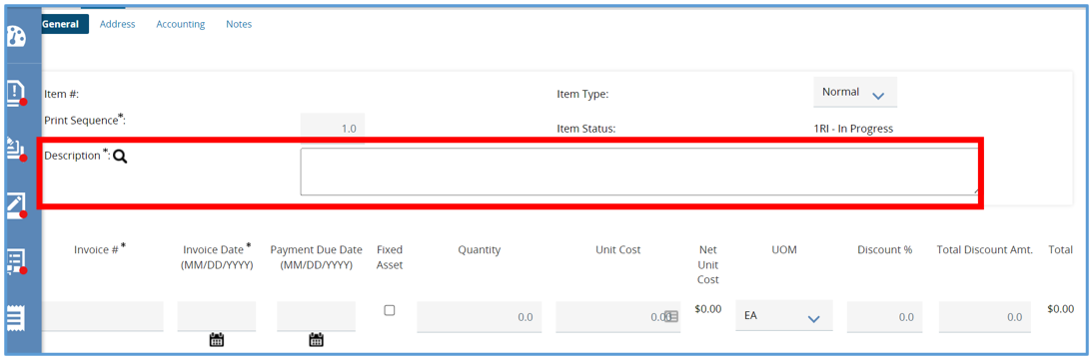
- Next, complete the three fields that are unique to the RPA Item and only appear because we chose RPA in the Requisition Type field back on the General tab.
- First the Invoice # field, which is where you enter the Invoice number provided by the vendor. This is also a field that is required.
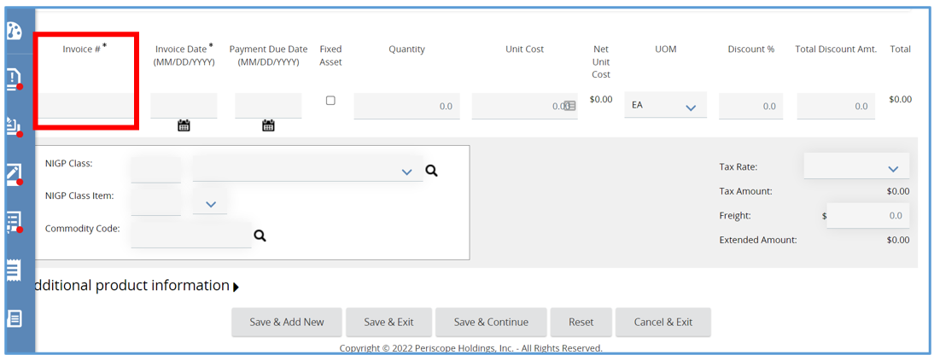
- Next, is the Invoice Date field, this field is also a required field, and this field is where you enter the date the invoice was received or the date the invoice was sent by the vendor.
- Click the calendar icon to select the date and click Done once the date is selected.
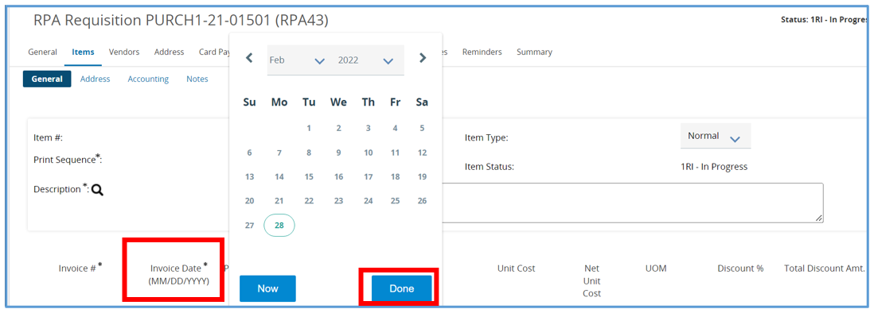
- Then, complete the Payment Due Date field, which is the date the payment is due to the vendor.
- Click the calendar icon to select the date and click Done once the date is selected.
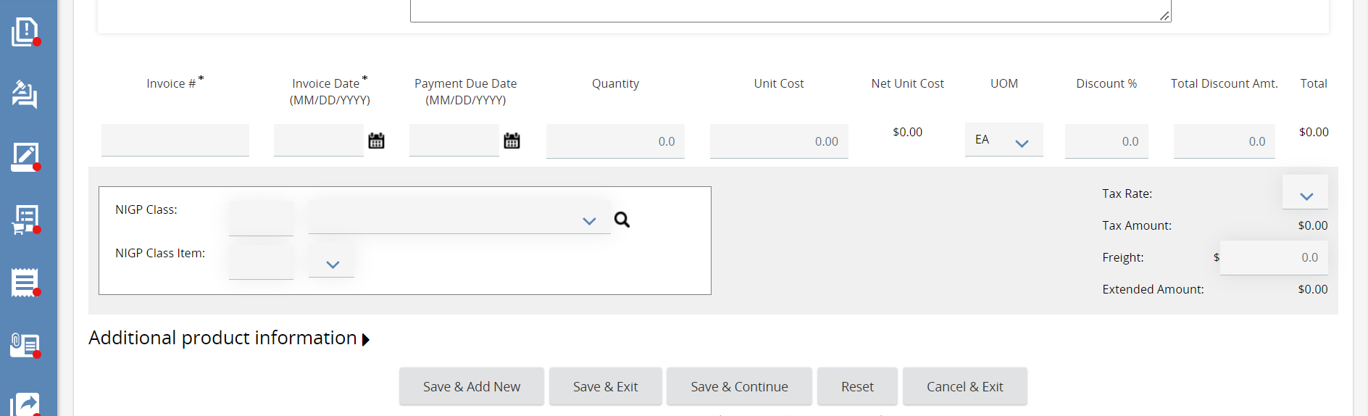
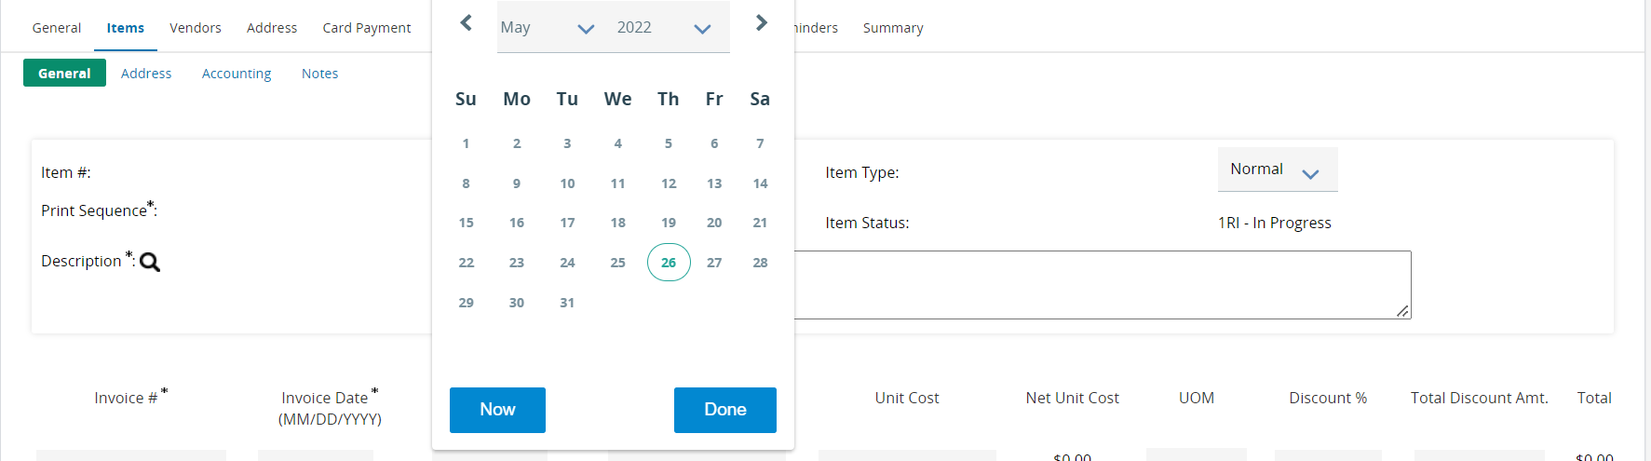
- Next, complete the Quantity field.
  - If the RPA Item is for a service, just enter 1.
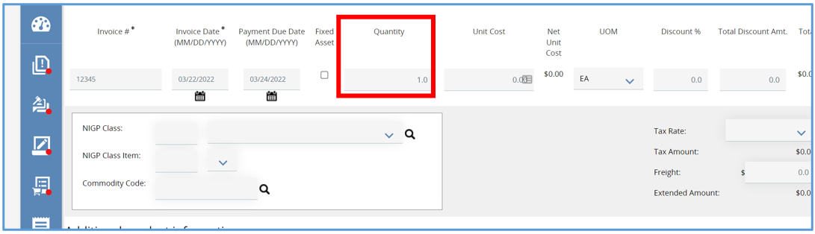
- Then, complete the Unit Cost field. This is where you will enter the total cost of the service.
  - The total amount will then update.
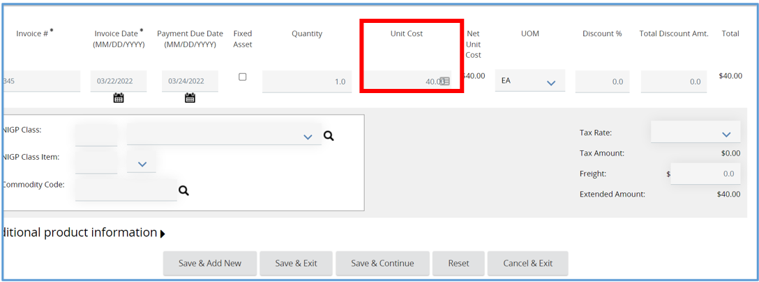

- Then, complete the Unit of Measure field.
  - This field will default to Each and can be left as is.
  - If the RPA Item needs a different Unit of Measure, click the drop-down, and choose the appropriate option.
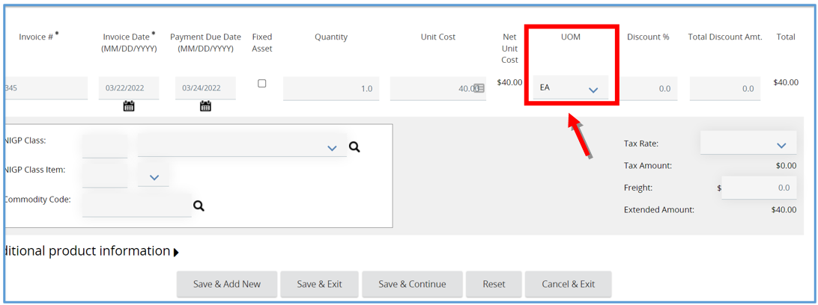
- Next assign the Item a Commodity Code by completing the NIGP Class and NIGP Class Item fields.
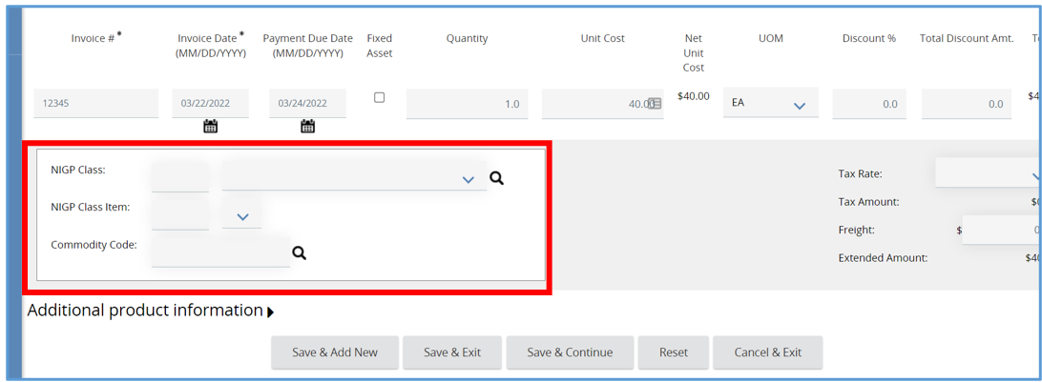
- There are three ways to add a Commodity Code.
  - If you know the commodity code, manually enter it into the fields.
  - You can use the drop-down menu in each of the fields.
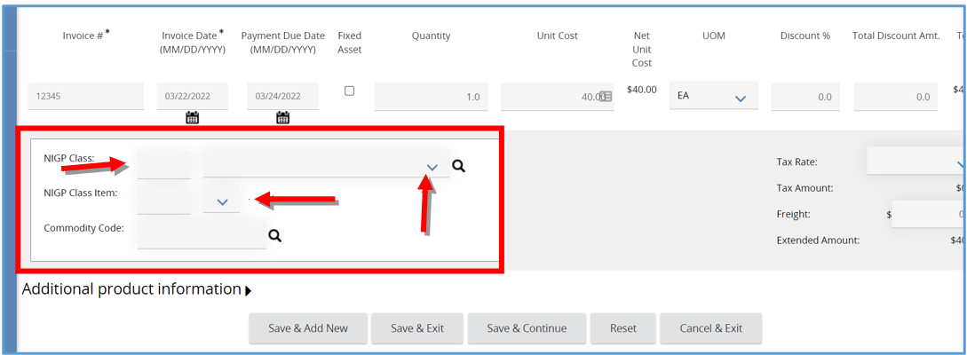
  - Lastly, click the magnifying glass, this will open a pop-up window allowing a search for the code.
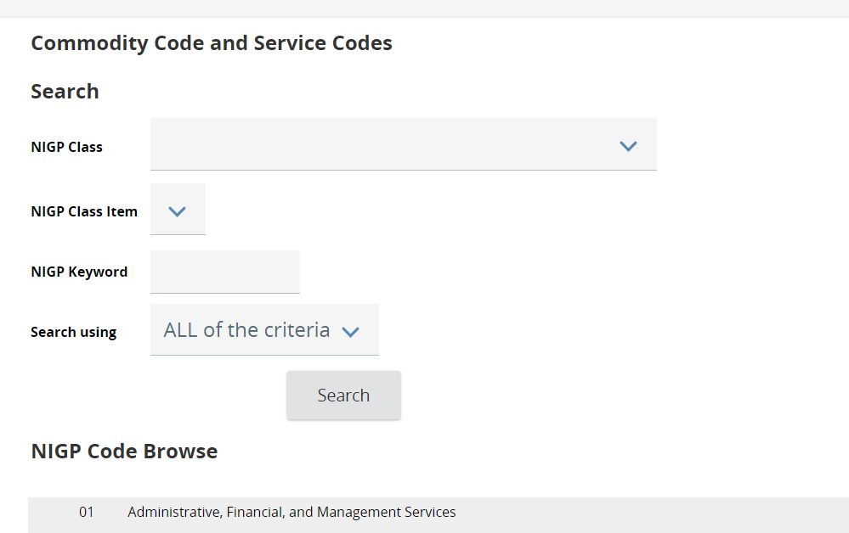
        - In the Commodity Code and Service Codes pop-up box, type in a keyword in the NIGP Keyword field and click Search. The screen will refresh showing the codes associated with the search just completed.
        - Select the code you want, then click Save & Exit.
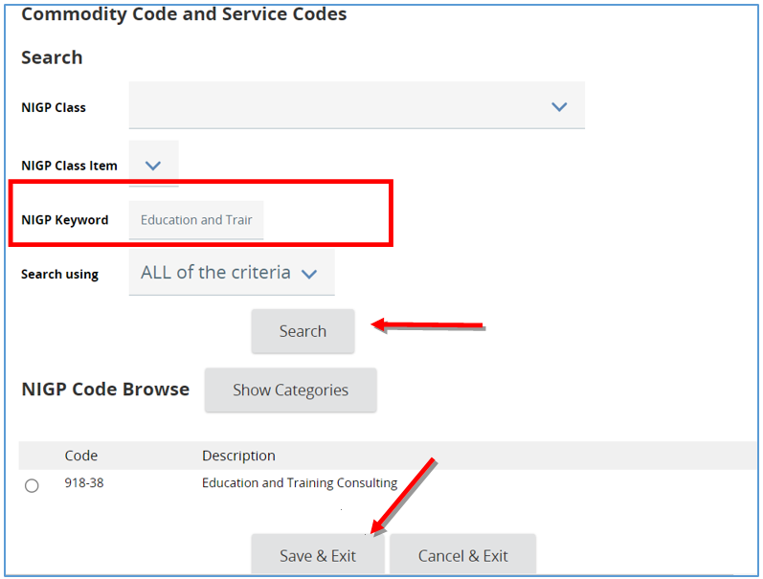
  - The page will refresh back to the Item Details screen where the Commodity Code renders.
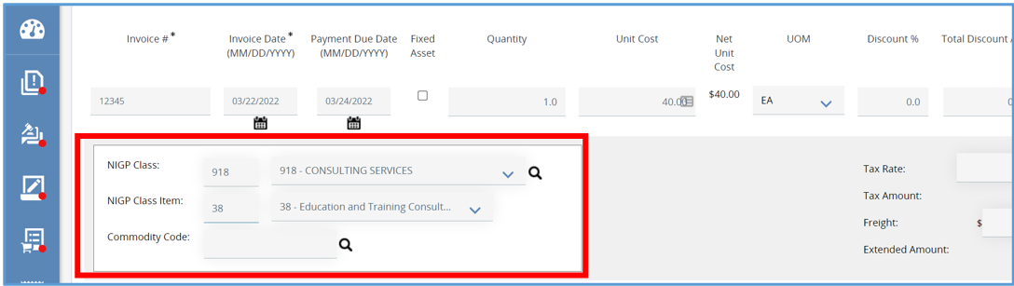
- Next, expand the Additional Product Information field if you have any additional information you would like to provide to the Vendors.
  - Enter information in any of the fields provided.
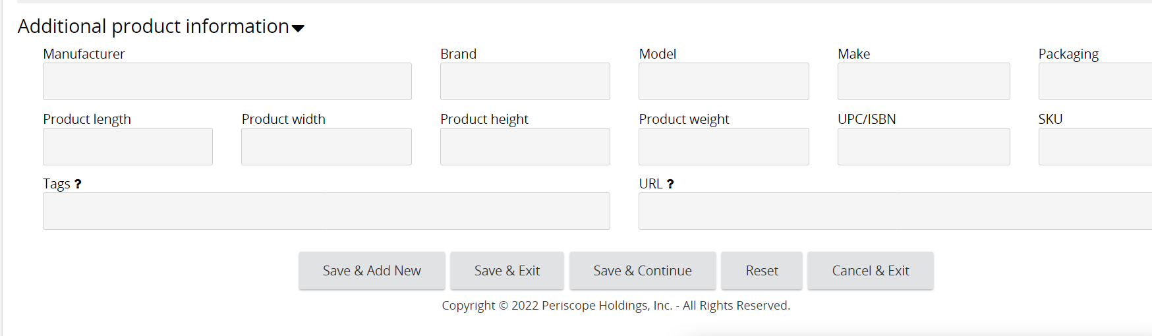
- Once completed, click Save & Exit to save this Item Detail and to return to the Items General subtab.
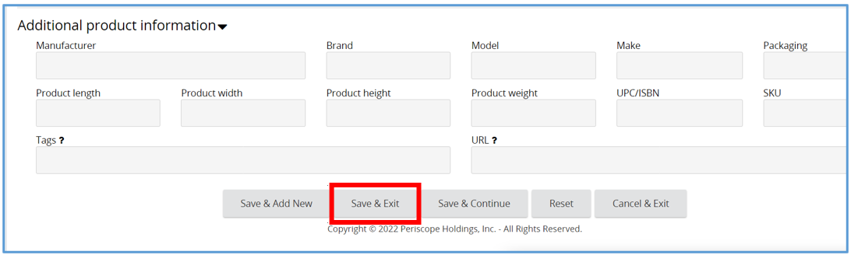
- You will now see a confirmation message confirming the Item was saved.
    - If a Payment Due Date was not entered on the item, you will also see a soft warning message stating there wasn’t a Payment Due Date entered., this message can be bypassed, and the document can still be submitted for approval.
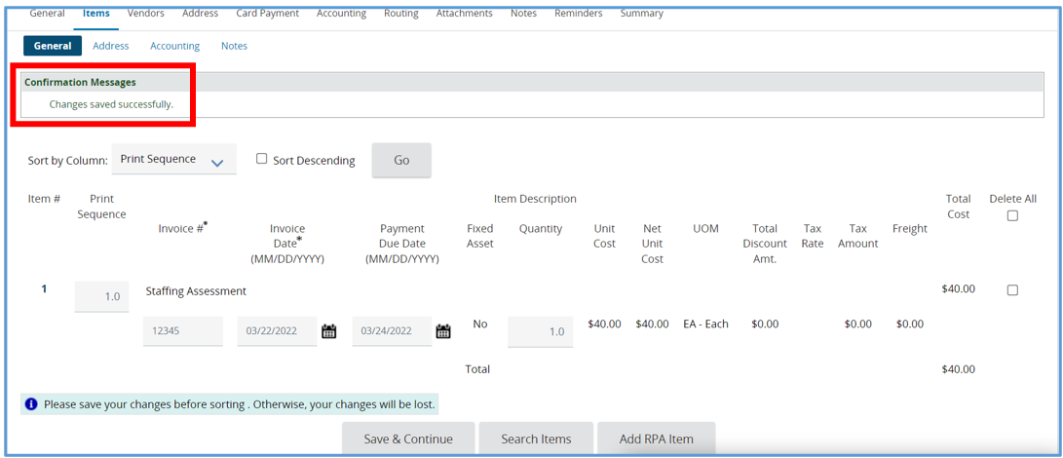

Vendors Tab
This tab is where you add the Vendor that provided the services to the RPA Requisition. Once the vendor is added the red Vendor Validation Error message will disappear.
- Start by clicking Lookup and Add Vendor.
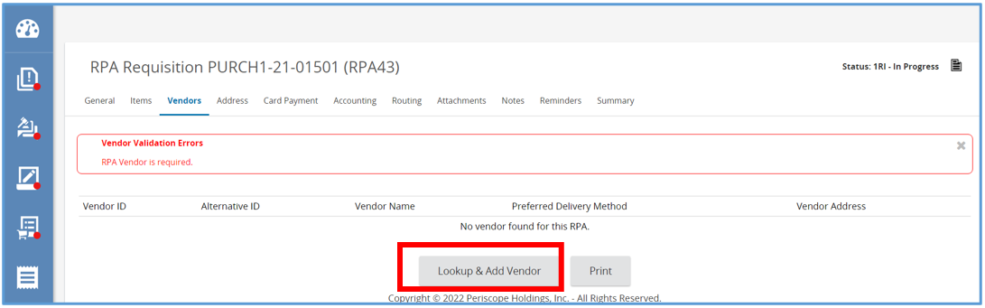
- A pop-up window will appear where you will search for the Vendor using the Vendor Name field.
- Then click Find It.
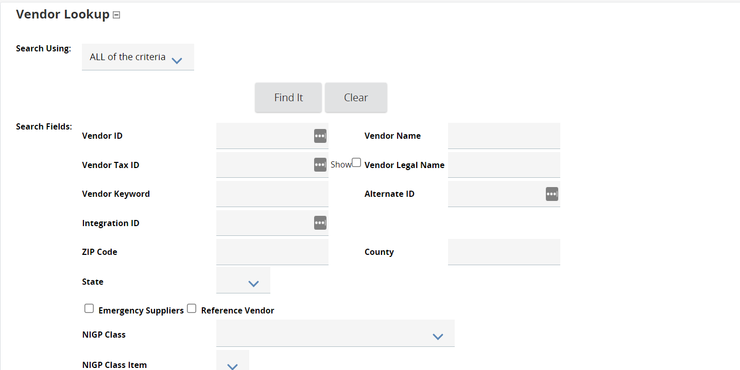
- The page will refresh, and the vendor will appear. Click the Select button and then click the Add Vendor button.
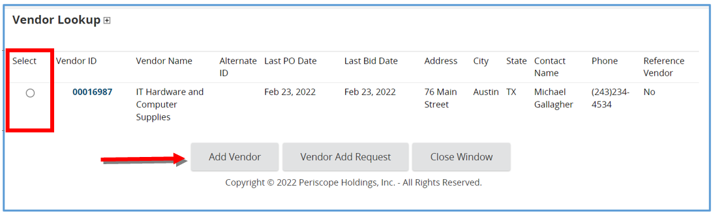
- The page will redirect back to the Vendors Tab, displaying the vendor selected.
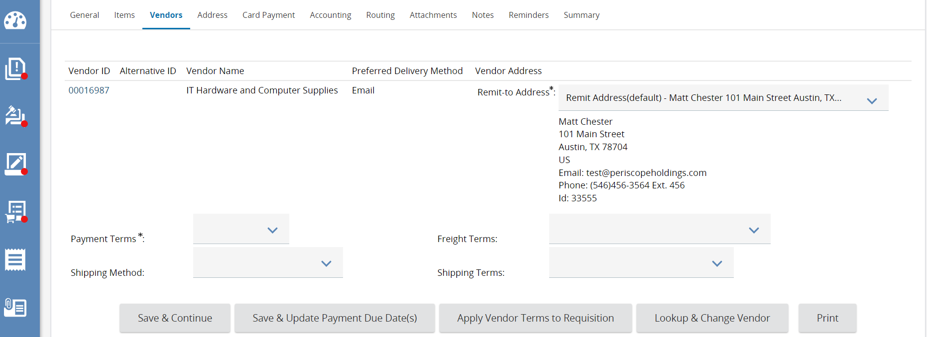
- Now complete the required fields. The Payment Terms and Shipping Method fields.
  - The required fields will be marked with an asterisk.
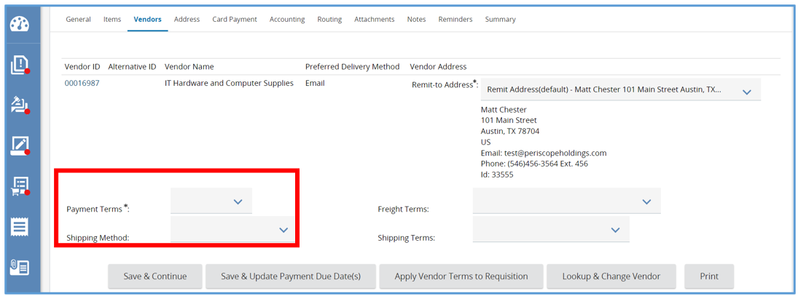
- To complete the remaining tabs and submit the RPA Requisition for approval, refer back to the guidance document Requisition I for those steps.

Summary Tab
Once approved, navigate to the Summary Tab of the RPA Requisition. At the bottom of the page, select Submit for Approval. If no approval path is triggered, use Automatic Approval to move the document forward.
The page will refresh and return the user to the Summary Tab of the RPA Requisition. The status will now read Gone to PO and an RPA Purchase Order has been created as a result.
- Click the RPA Purchase Order link, which will bring you to the Summary Tab of the Purchase Order.
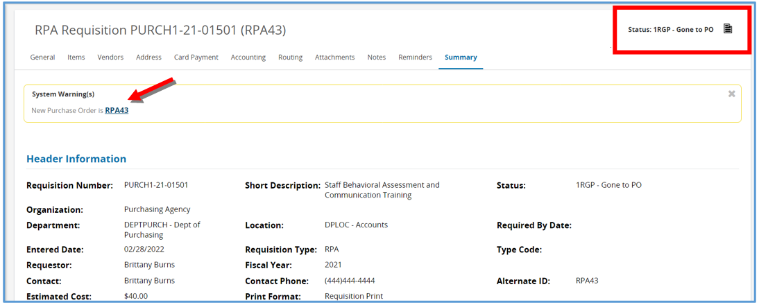
- The top right corner of the Purchase Order screen will now show the status as Complete Receipt.
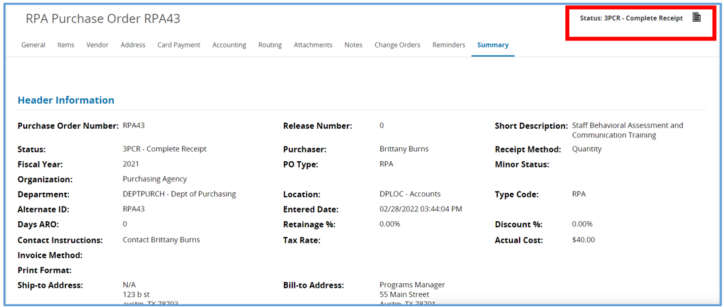
- The system has auto-created a Receipt against the RPA Purchase Order, indicating all the RPA Items on this Purchase Order has been received.
- The receipt will now show under the Receipt Information section of the page.
- The In-Progress Invoice has now been created and shows under the Invoice Information section.
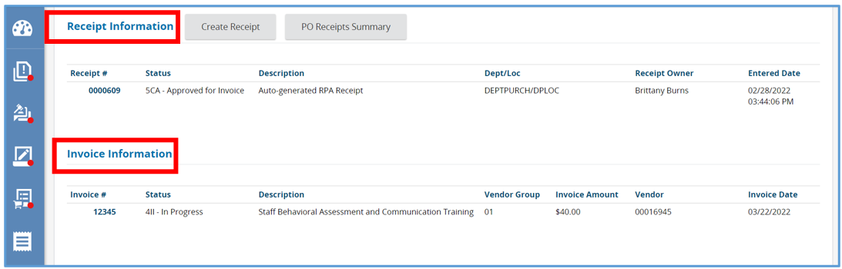
- An Accounts Payable user can now locate the Invoice and complete it.
  - If you are not entering in invoices to the system, you can leave the document as is.

