OregonBuys Requisitions II: Release Requisition
Table of Contents
Introduction 2
OregonBuys Process Flow 2
Scenario 2
1. General 2
2. Item 2
3. Accounting 2
4. Vendor 2
5. Routing 3
6. Attachments 3
7. Notes 3
8. Summary 3
How to Access a Release Requisition 3
Creating a New Release Requisition 4
General Tab 4
Prerequisites 4
Items Tab 8
Prerequisites 8
Vendors Tab 12
Address 12
Card Payment 13
Accounting 13
Splitting Account Strings 14
Apply Account Strings by Dollars 15
Routing Tab 15
Attachments Tab 16
Notes Tab 17
Reminders 18
Summary Tab 20
Create a Release Requisition Catalog Search 20
Prerequisites 21
Next Steps 24

Introduction
This guidance document will show you how to create a Release Requisition from start to finish and how to initiate a Release Requisition when choosing an item from the Catalog Search. A Release Requisition is a document used to request orders for commodities or services on an existing contract or a Master Blanket Purchase Order in the system. Release Requisitions are created by Department Access or Basic Purchaser users.

OregonBuys Process Flow
Below you can see where Requisitions are located in the overall process of OregonBuys when creating a Release Requisition.
Figure 1: High Level Process Flow
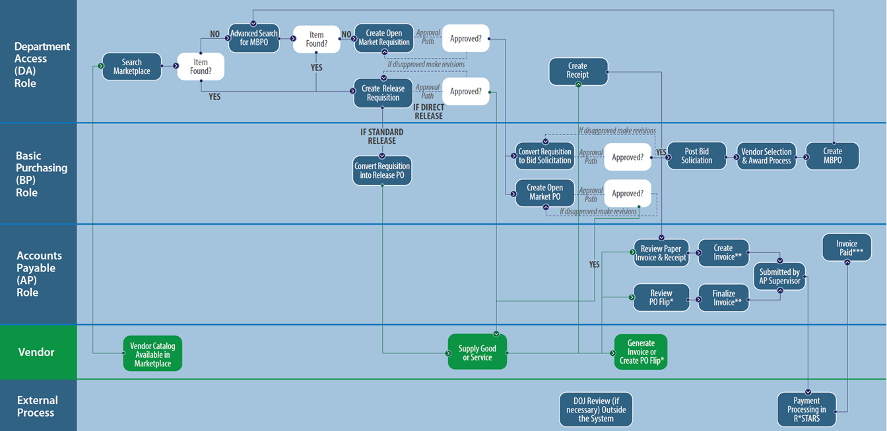

Scenario

General
In this guidance document the Department Access user in the agency is creating a Release Requisition to purchase laptops from an existing Master Blanket Purchase Order. This Release is for the Department of Purchasing’s Accounts division.

Item
The line items associated with this Release is a Dell touchscreen laptop. Through research, the Department Access user finds the MBPO established for their agency for this item with NIGP Class 204 and NIGP Class Item 54.

Accounting
The account code segments are input on this tab.

Vendor
The line item that came from an established MBPO also includes the vendor information on this tab.
There are no Subcontractors, Distributors, or Vendor Performance associated with this vendor.

Routing
The Routing for approvals for this document may be set manually or selected at the point that the document is Submitted for Approval.

Attachments
The Department Access user should add attachments to document background information for this Release. In addition, the Agency may have set up standard documents (for example Terms and Conditions) to be attached to all Requisitions for the Agency.

Notes
It is suggested that notes related to deadlines, approval information, contact information, or other information that the Department Access user deems important for tracking or approving this Release Requisition be added on the Reminders and Notes tabs. It would be good practice for the Agency Procurement Team to establish standard procedures for these tabs.

Summary
The Release Requisition should be submitted for any applicable approvals and the user will see the status change to “Ready for Approval”.

How to Access a Release Requisition
- Starting from the Home page, click the person icon in the top right corner, and select Department Access as the user from the drop-down menu.
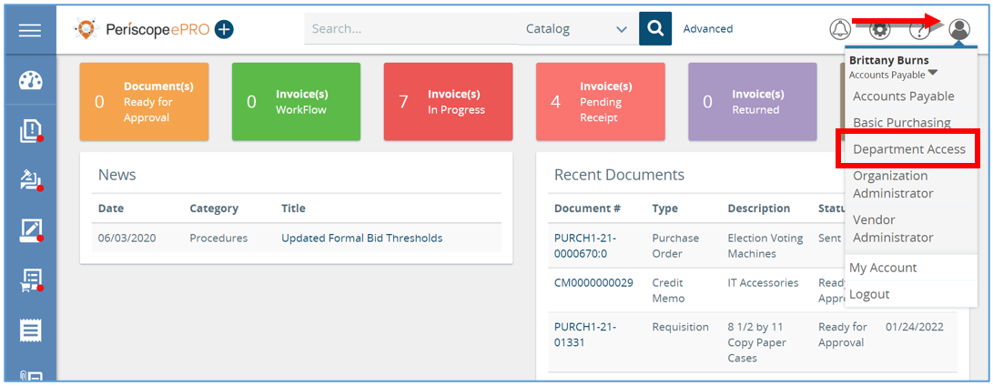
- Next, click the plus button and then select Requisition.
  - This will create a new Requisition
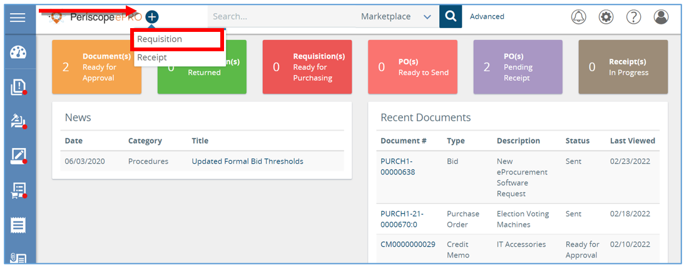

Creating a New Release Requisition
The new Requisition document will now show a series of tabs at the top. Starting with the General tab and ending with the Summary tab, you will work your way through the tabs from left to right to create a new Requisition. Fields that have an asterisk next to them are required fields to be completed.
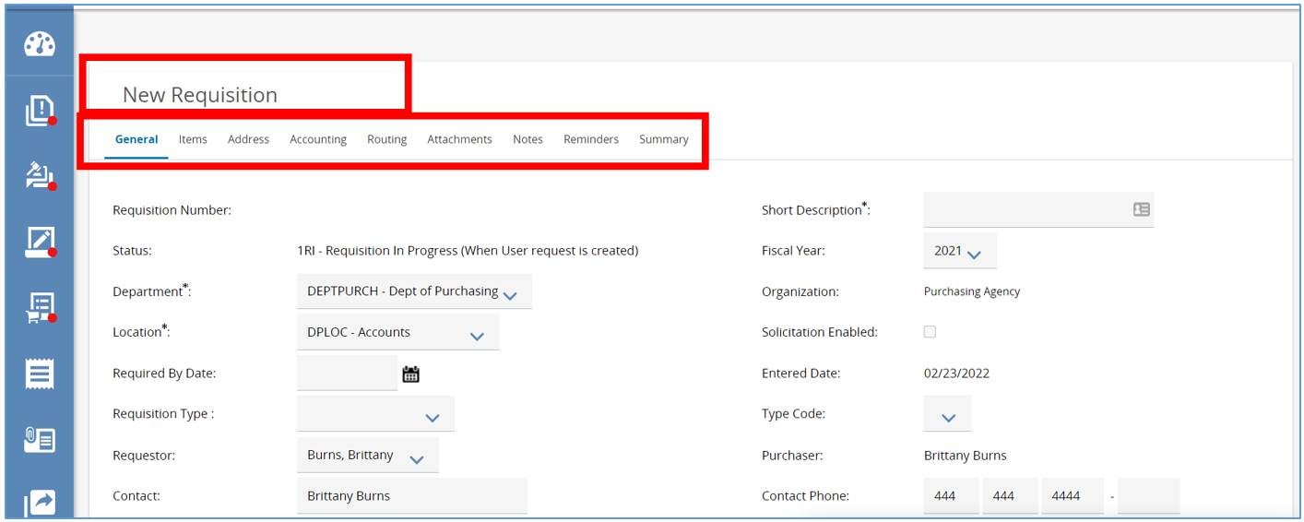

General Tab
The General Tab of the Release Requisition holds detailed general information about your document. The required fields will be indicated with an asterisk and must be completed before moving onto the next tab.

Prerequisites
- Information about the purchase.
- Who the purchase is for (what Department and Location this document belongs in).
- What Discipline Type this purchase is.

- Starting from the General tab, enter the Description of the commodities or services the organization needs.
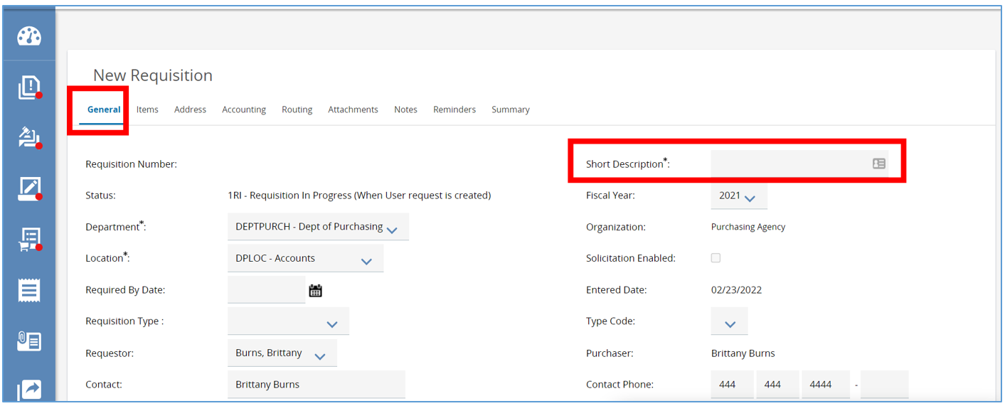

- Next, navigate to the Department and Location fields.
  - Both fields will be populated based on your default settings.
  - If you need to change the Department and Location fields, use the drop-down arrow, and select the appropriate options needed.
    - Locations are subsets of departments which are similar to an agency’s divisions, bureaus, or programs.
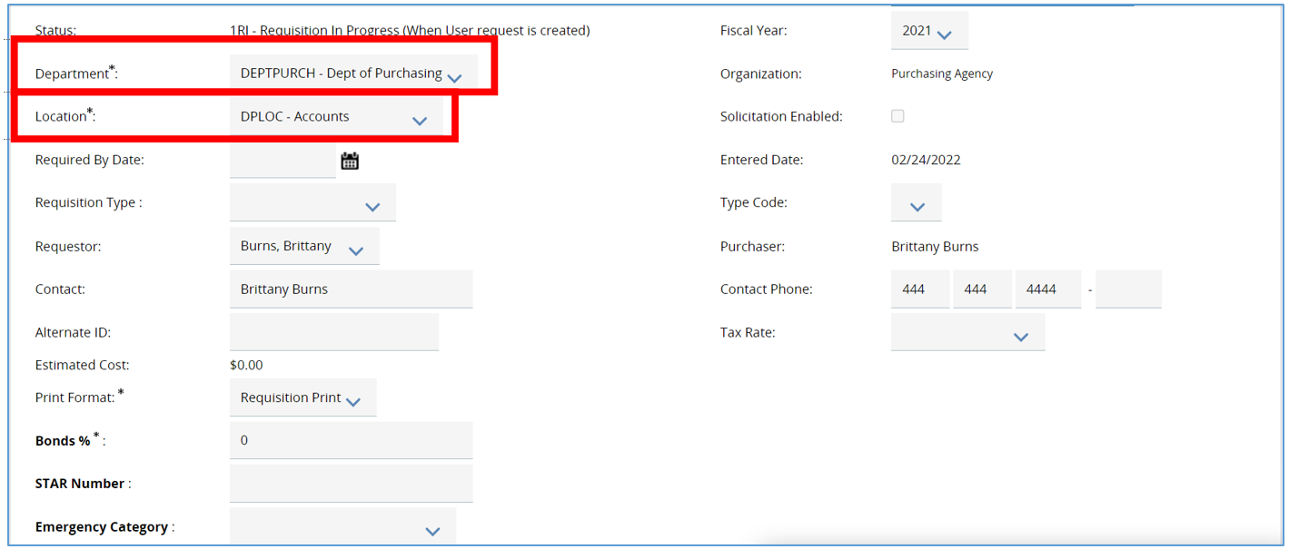
- Next, navigate to the Print Format. This field can stay as is.
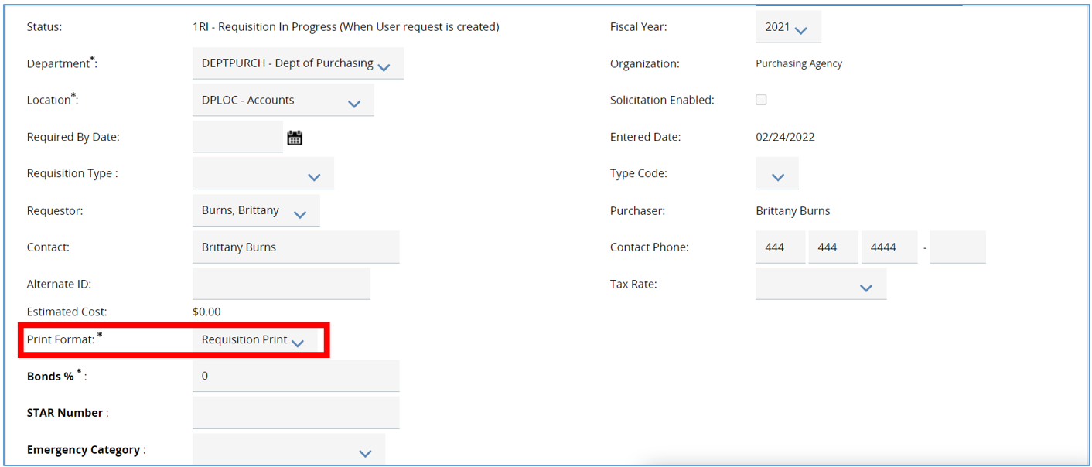
- The last field to complete on the General tab is the Requisition Type field.
  - This determines the type of Requisition you want to create and drives additional functionality on the Item tab.
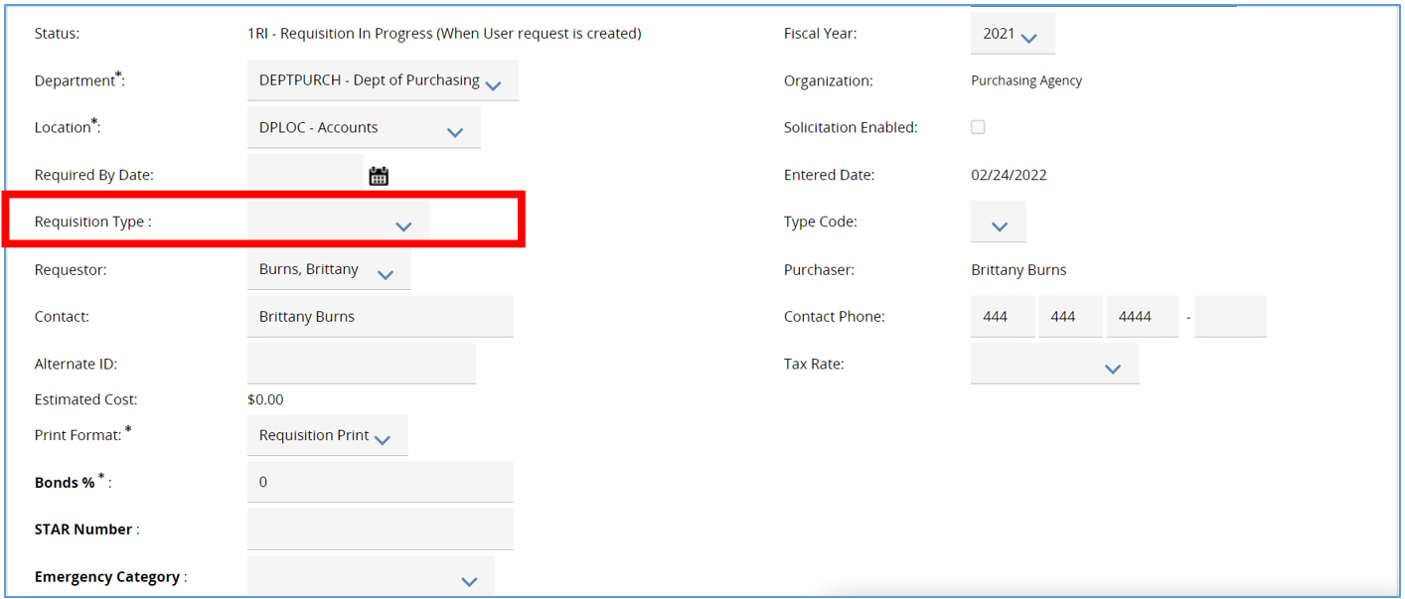
- Select Release
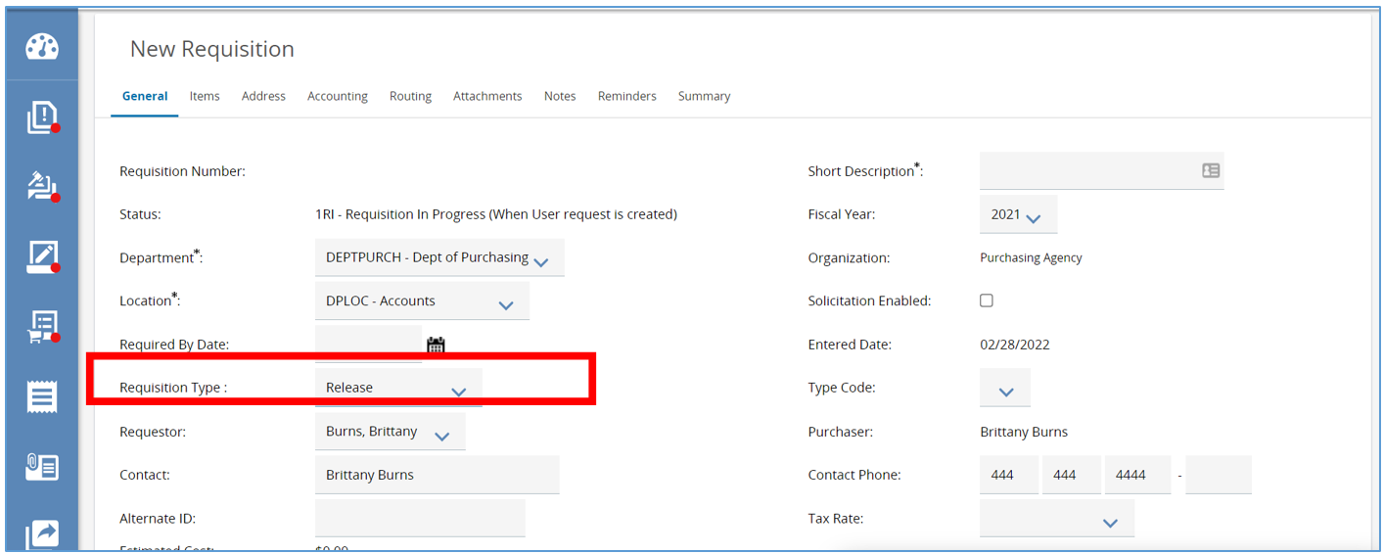

- The next required field on the General tab is the Discipline type field. Once the required fields are completed, click Save & Continue. This will save all the data entered if you need to finish at a later time.
  - Required fields are identified with an asterisk.

- The system will now generate a unique document number in the left-hand corner of the screen.
  - In the right hand-corner the status will now show In Progress.
    - This means the document is saved and is editable.
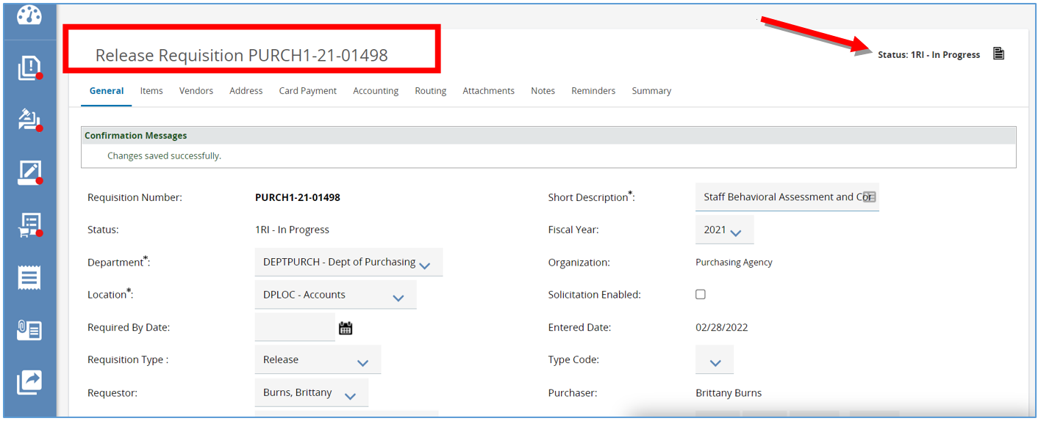

Items Tab
The Items tab is where you can search for and add line items detailing the commodities or services on an existing contract.

Prerequisites
- Knowledge about the commodity or service being purchased.
- Knowledge about the quantity of the item being purchased.

- Start by clicking Search Items.
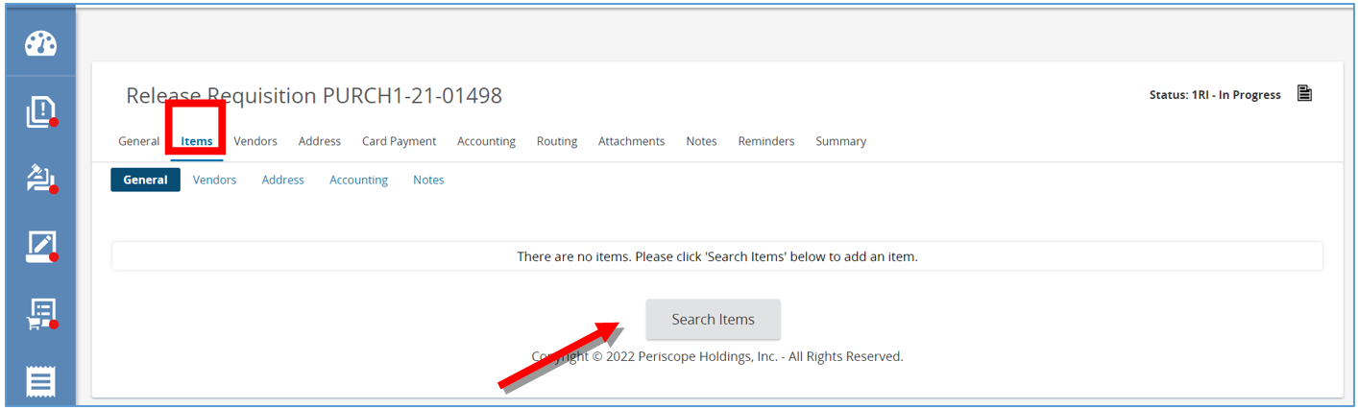
- Then expand the Advanced Search options by clicking the plus button.
  - You can search by the Master Blanket Purchase Order number, the Master Blanket Purchase Order, Description, Items Description, the Vendor Name, Favorites and any the additional fields.
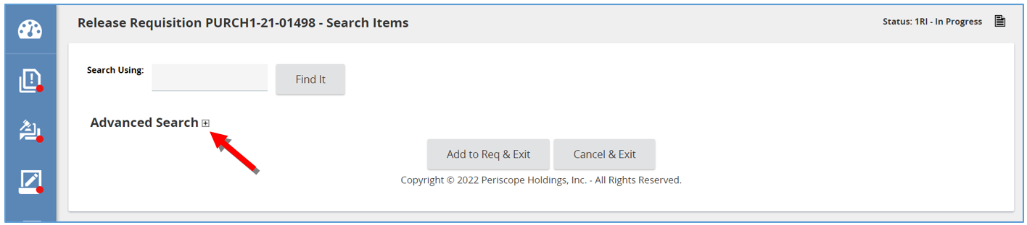
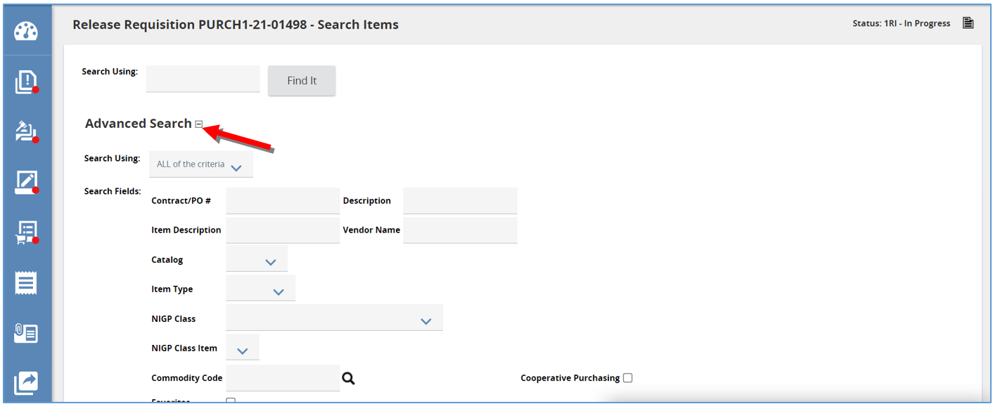
- Then, click Find it.
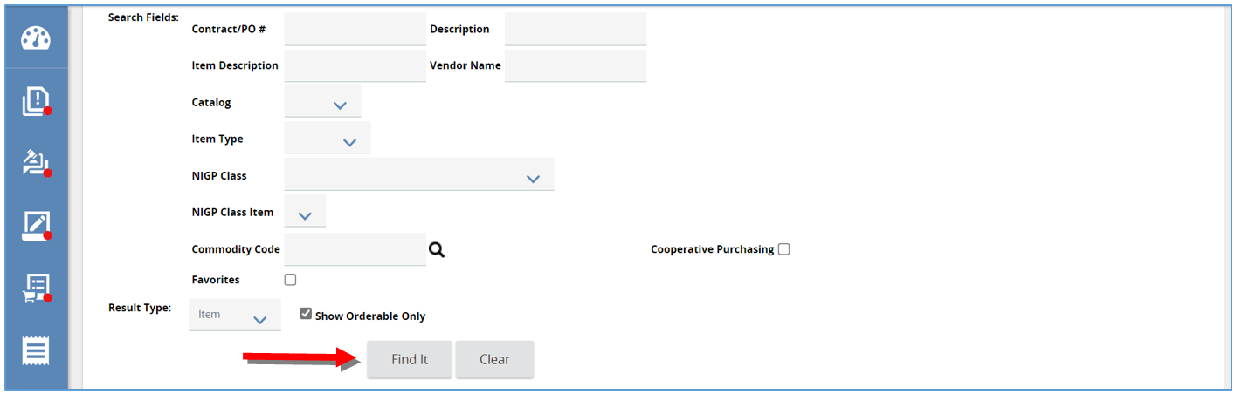
- The page will refresh and display the search results.
  - Some of the fields are:
    - Minimum Order Quantity
    - Item Description
    - Unit Cost
    - Unit of Measure
    - Vendor Name
    - Commodity Code (Class Item)
    - Discount %
    - Master Blanket Purchase Order number
    - Direct Release Allowed.
  - You have the option to star an item as a favorite by clicking the star icon.
    - To access the list of Favorites, check the Favorites box under the Advanced Search option.
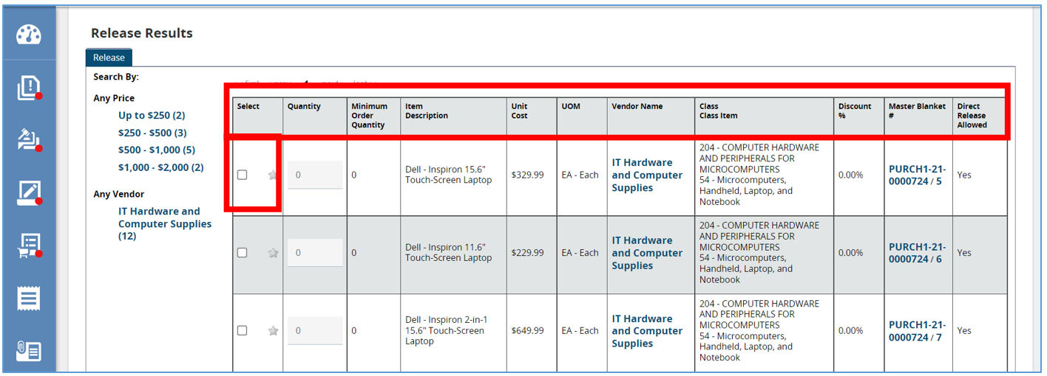
- To select the Item, check the box in the Select column of the Item of your choice.
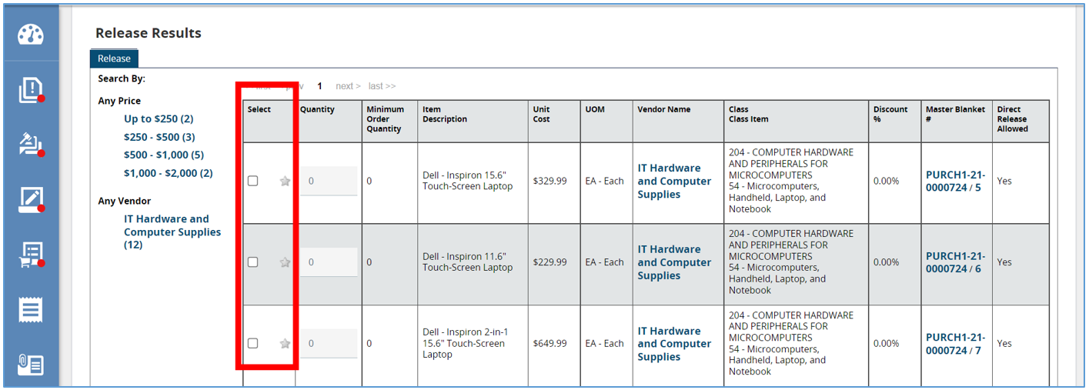
- Then, enter in the quantity in the Quantity field.
- Scroll down and click Add to Req & Exit.
- 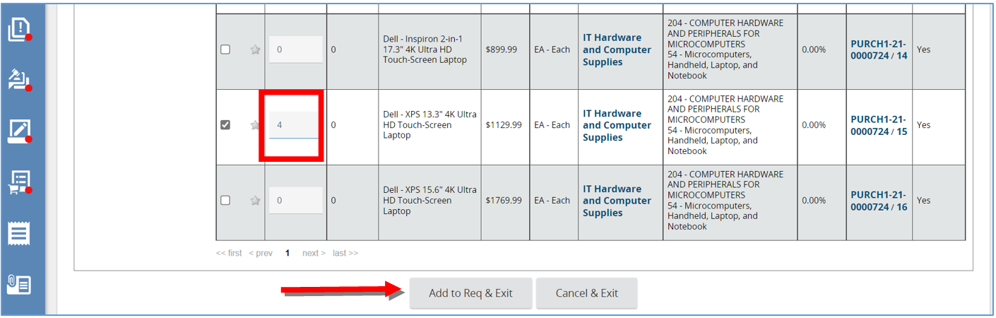This will bring you back to the Items tab, with the chosen Item displaying and the Master Blanket Purchase Order it is associated with.
- To continue to add Items, click Search Items and repeat the previous steps.
- When finished click Save & Continue.
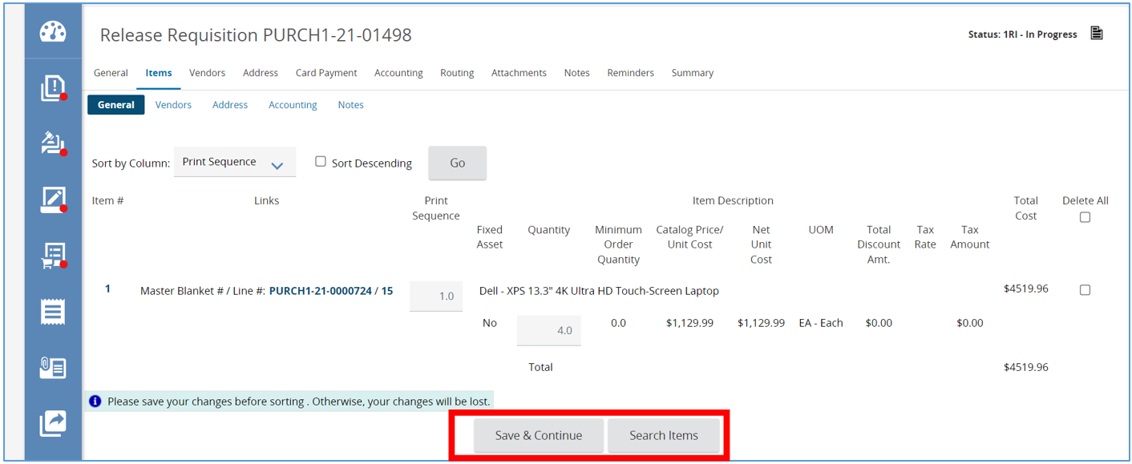

Vendors Tab
On this tab you will see the Vendor that is offering the Item you chose back on the Items tab. If the Release Requisition contains multiple Items from different Vendors, all Vendors are listed on this tab.
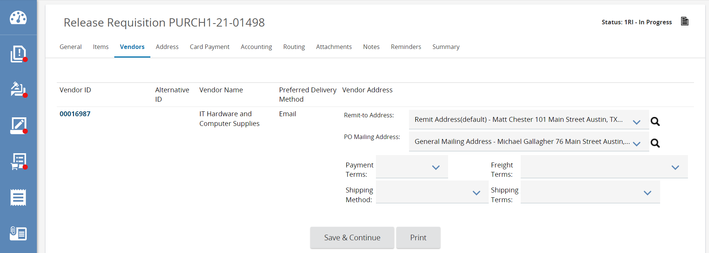
- First, complete the required fields and any other fields you want on the remaining tabs.
  - Required fields are identified with an asterisk.
- Once finished, you can submit the Release Requisition for approval. Refer back to the Requisition I course for those steps.

Address
This tab displays the Ship-to and Bill-to Address for your Items on the Requisition. The options that appear on this tab are based on your default settings.
- To change the Ship-to Address, click the drop-down and select the appropriate Department.
- Then click Save & Continue.
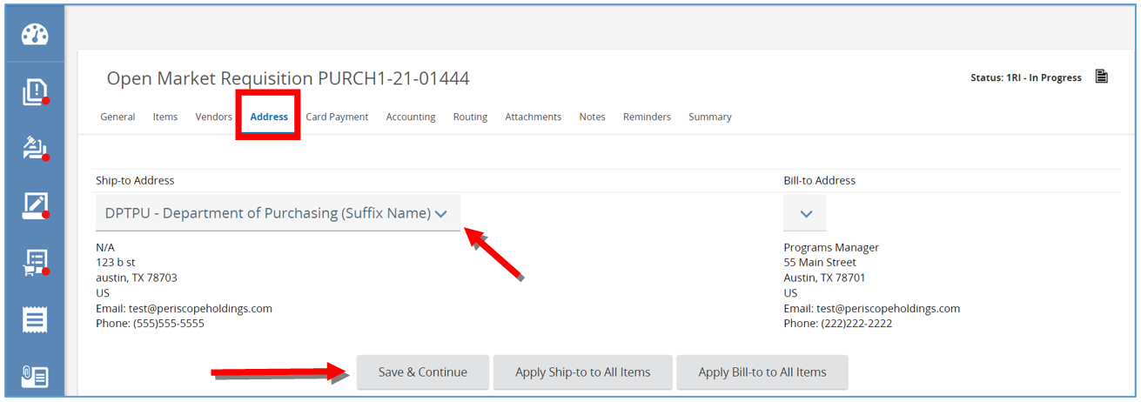

- Next, the page will refresh and then click Apply Ship-to To all Items.
  - This will apply the new address to all the Items.
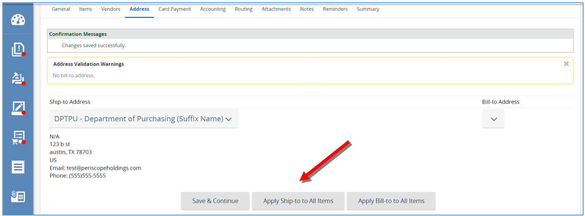

Card Payment
This tab is only available if you’ve enabled the Card Payment functionality for your system.
- If applicable, select a P-Card assigned to your account by clicking on the drop-down arrow.
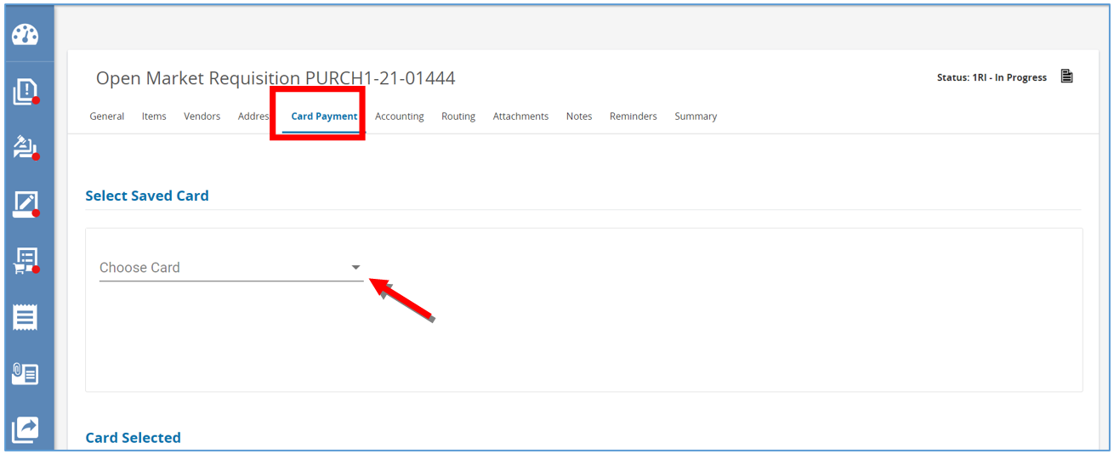

Accounting
This tab is where you define all account strings and the dollar or percentage split, so it can be applied to all Items. If you have one account string to pay 100% of you Items, use these three steps:
- First enter in the account string.
  - You can search for an entire string.
  - You can also search by segment.
  - Lastly you can search manually by entering each segment or select segments.
    - The first row will default to 100% which means this account string is meant to pay 100% of the
order.
- Click Save Based on Percentages.
  - This will save the account string including the percent.
- Click Rebuild for All Items.
  - This will apply the account string with the percent to all Items entered in the Requisition.
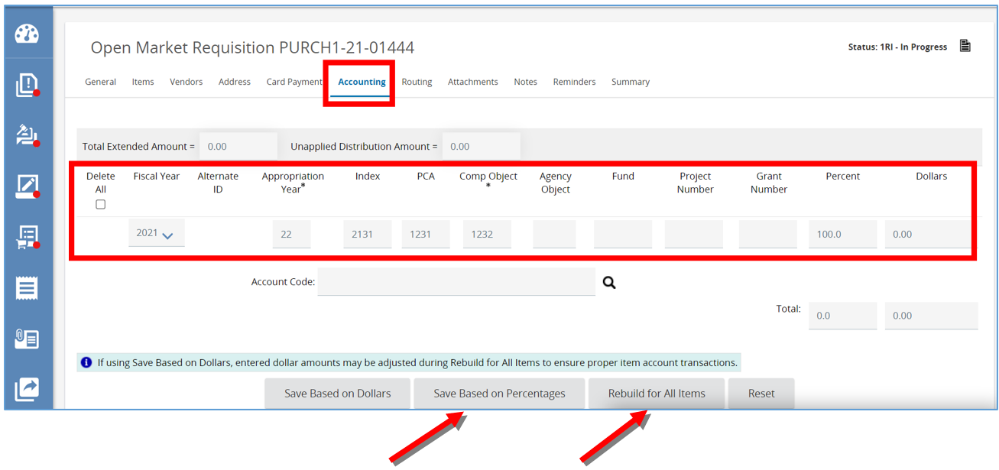

Splitting Account Strings
You wanted to split two account strings 60/40. You will need to enter each account string separately and assign the percentage split.
- Change the first account string to 60%.
- Then enter in the second account string and then enter 40 in the percentage field.
- Click Save Based on Percentages, the page will refresh.
- Then click Rebuild for All Items to apply the account strings and percentages to all the Items.
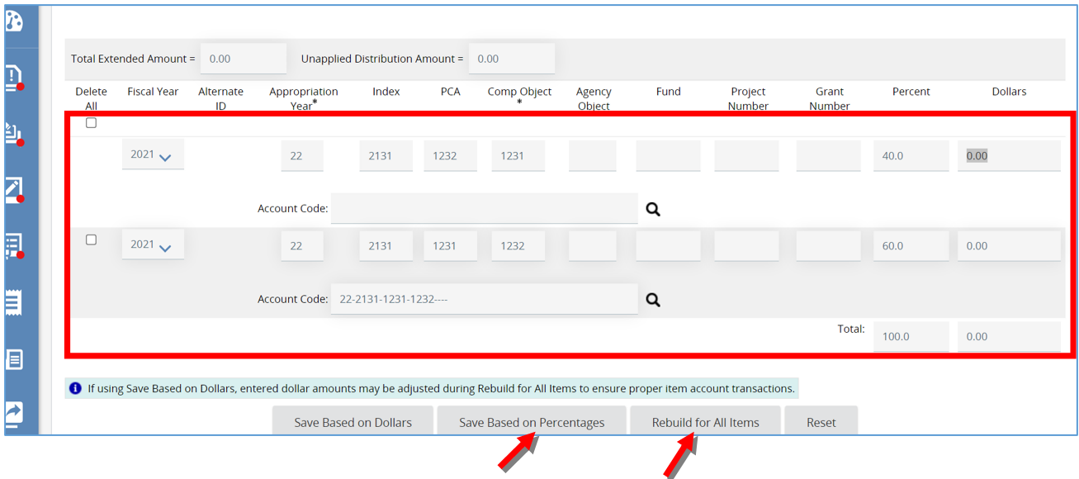

Apply Account Strings by Dollars
You can also apply account strings by dollars.
- To do this enter in the dollar amount for each account string under the Dollars field.
- Then click Save based on Dollars.
- Then click Rebuild for All Items.
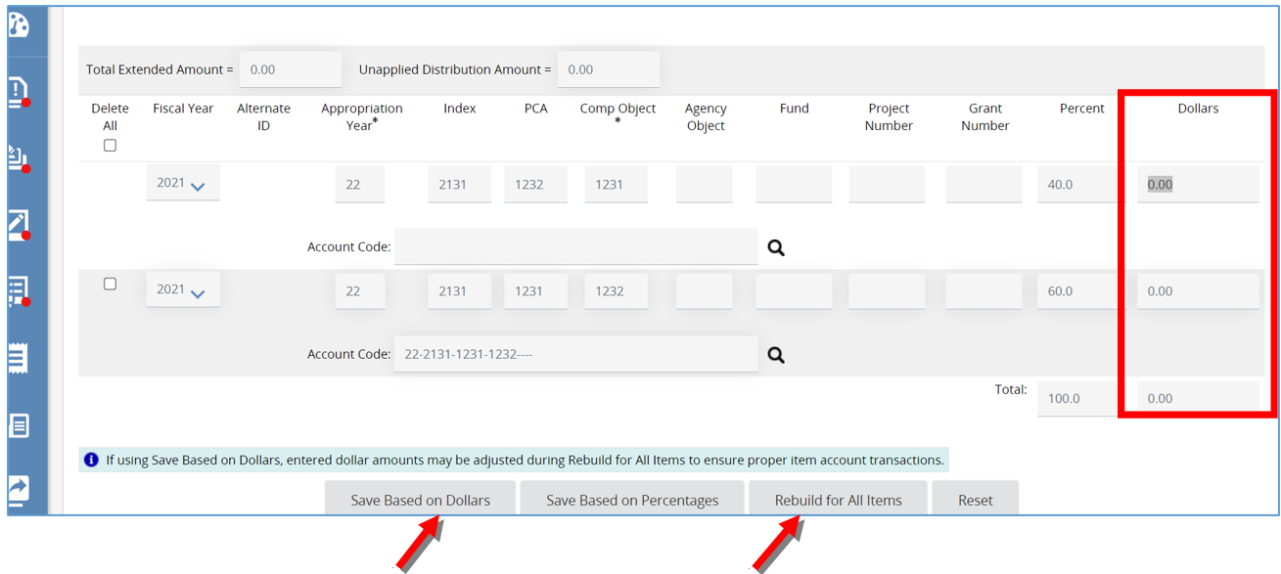

Routing Tab
This tab displays the approval paths the Requisition triggered which allows you to track who is in the process of reviewing and approving the document. This tab also allows you to refer back to who reviewed and approved the document for historical purposes.
This tab will remain blank until an approval path is determined when the Requisition is submitted for approval.
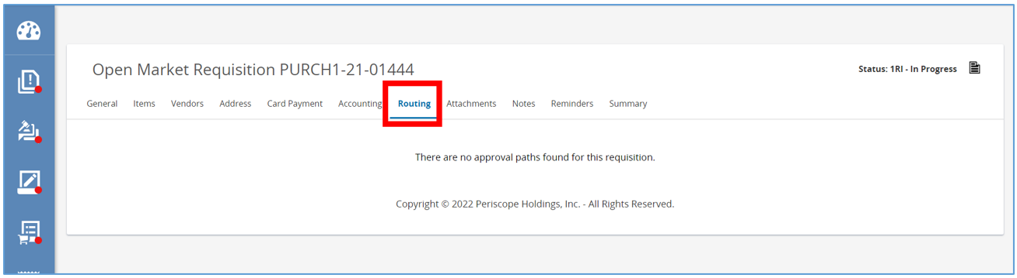

Attachments Tab
This tab is where you can attach additional documents related to your request.
- To add a file, click Add File.
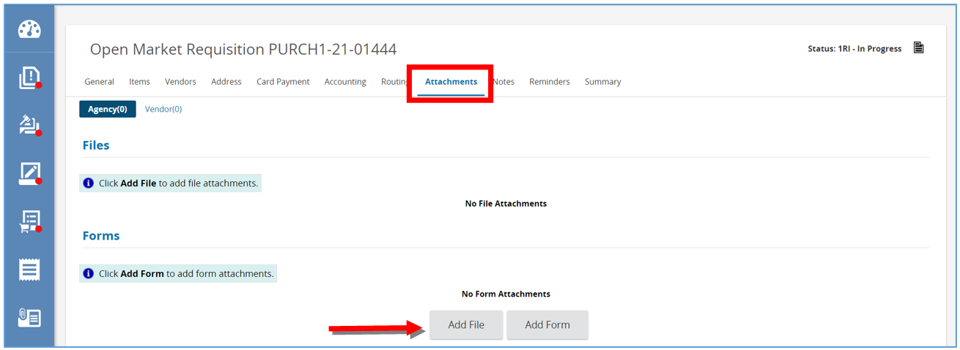
- Then click Choose File and locate and select the document from computer.
- Next click Save & Exit.
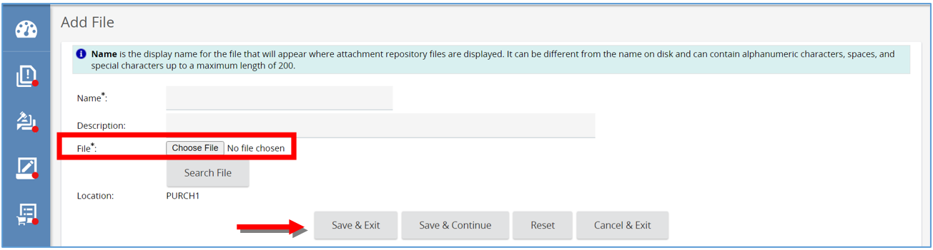
- Page will refresh back to the Attachment tab and document will show as a hyperlink.

Notes Tab
This tab is like a digital post-it only viewable by you and others in your organization.
- If you want an approver to review the information on the account tab, type your note in the text field.
- Then click Save & Continue.
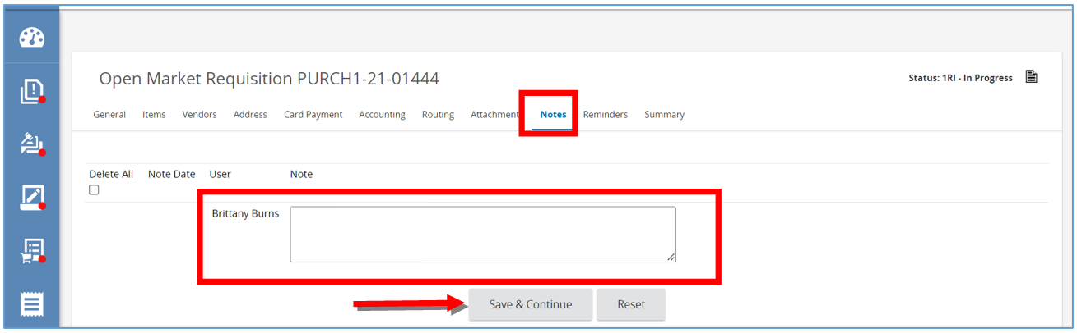

Reminders
This tab is where you can send a notification to ourselves or another user in our organization about acting on this specific Requisition.
- First, to create a reminder select the calendar in Due Date field. This is the date the action needs to be completed.
  - Once the date is select, click Done on the calendar.
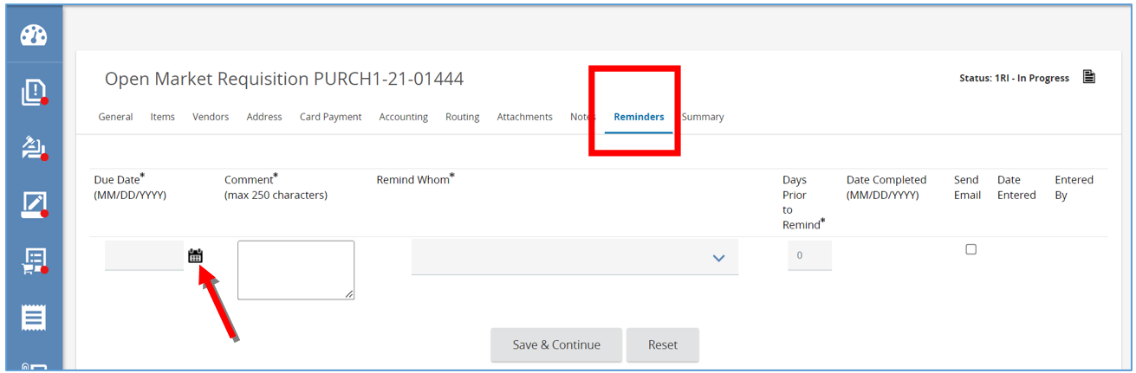
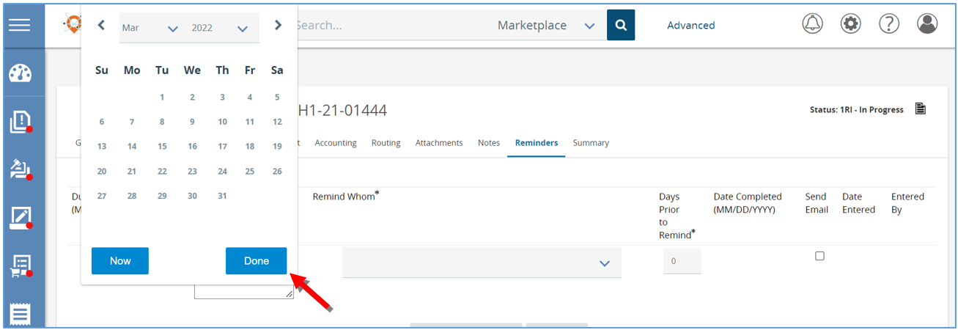
- Next, type the reminder into the Comment section.
- Then select the person that need to be reminded.
- Next, set the Days Prior to Remind field to the day you want the person to be notified.
- Check the Send Email box to have the system send an email reminder
- Lastly, click Save & Continue.
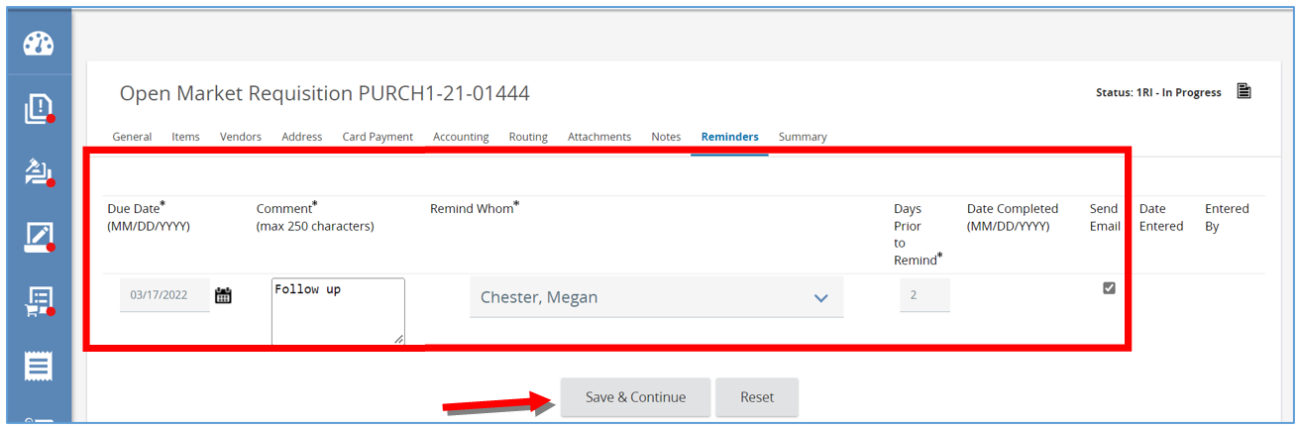
- You will now see a Date Completed field, which the person you selected to be reminded can update when they’ve completed the task.
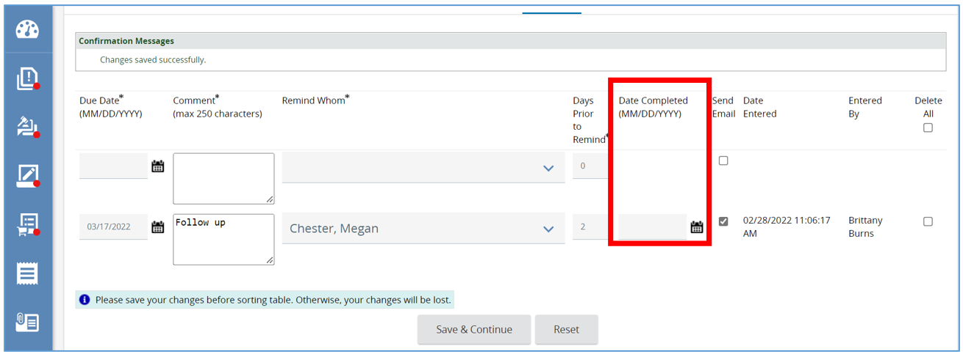

Summary Tab
This tab summarizes all the information from the previous tabs on one page. At the bottom of the page, you have four options for this Requisition
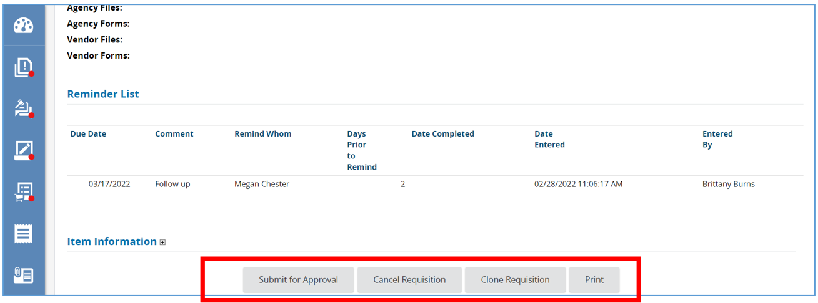
- Click Submit for Approval to submit the Requisition to the approval paths.
- The page will refresh and on the next page, you will see the list of approval paths triggered. This is the last chance to review those paths prior to entering the approval queue.
- To submit, click Continue or to go back to make changes by clicking Cancel & Exit.
- After submitting for approval, the page will refresh back to the Summary tab.
- This is also where you can see the status has updated to Gone to PO. This means the Requisition is approved and a Release Purchase Order has been created as a result.
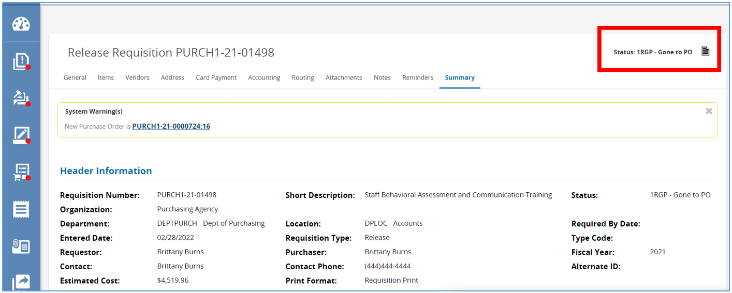
Here you can configure the Release Purchase Order to auto-send to the Vendor or manually send by a Basic Purchasing user after further review. Whichever you chose, the Release Purchase Order will be sent to the Vendor with all the information on the Release Requisition, so they know who ordered what and where to ship the items.

Create a Release Requisition Catalog Search
In addition to the method provided above, a Release Requisition can be created from a Catalog Search.

Prerequisites
- Information about the purchase
- Who the purchase is for (what Department and Location this document belongs in)
- What Discipline Type this purchase is
- Starting from the Home page, click the person icon in the top right corner, and select Department Access as the user from the drop-down menu.
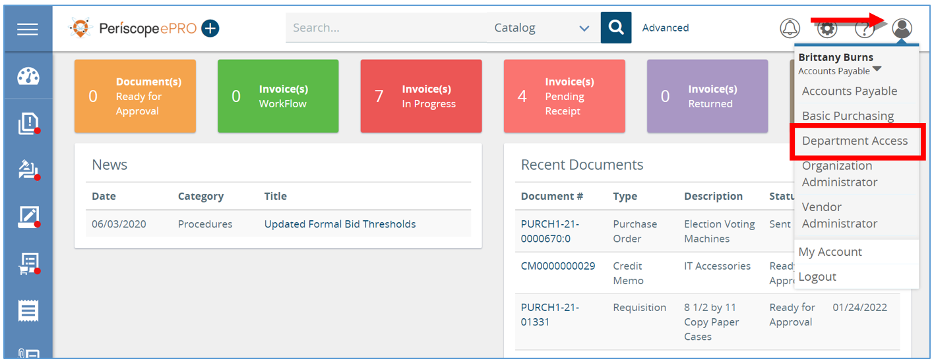
- Enter the search criteria in the top Navigation Search Bar.
You can search by vendor, PO#, item name or category <<anything else?>>
- Choose Catalog from the drop-down menu.
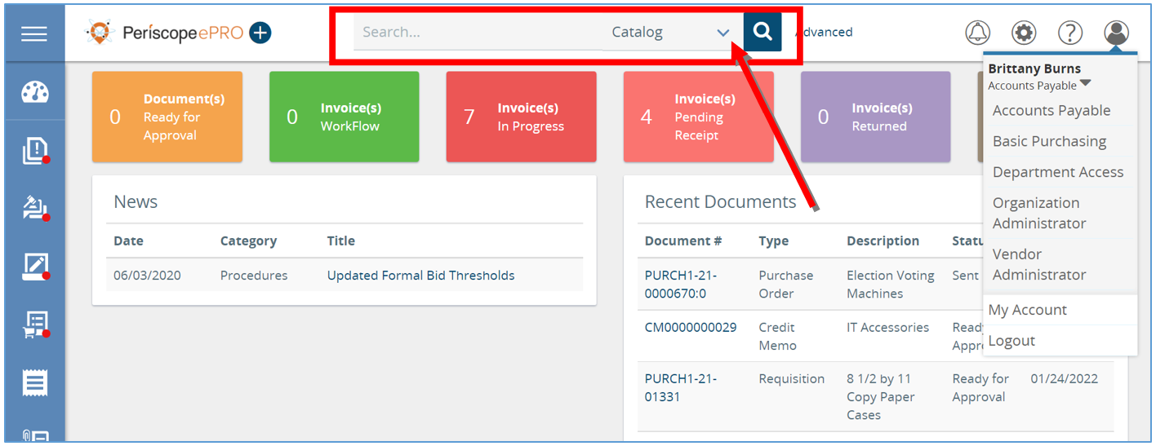
- Then click the magnifying glass to perform the search. This will bring up the Catalog Search Results.
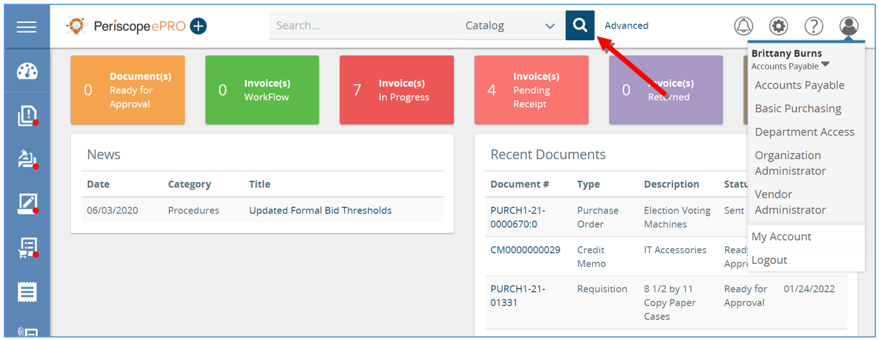
- Note: Changing the Type from “On-Contract” will change the Requisition the user is creating from a Release Requisition to an Open Market Requisition.
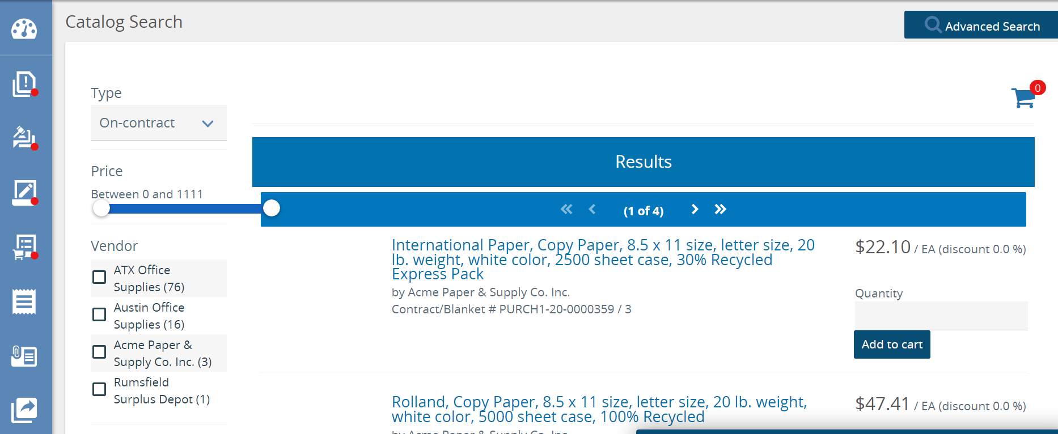
- Enter the quantity and click Add to Cart.
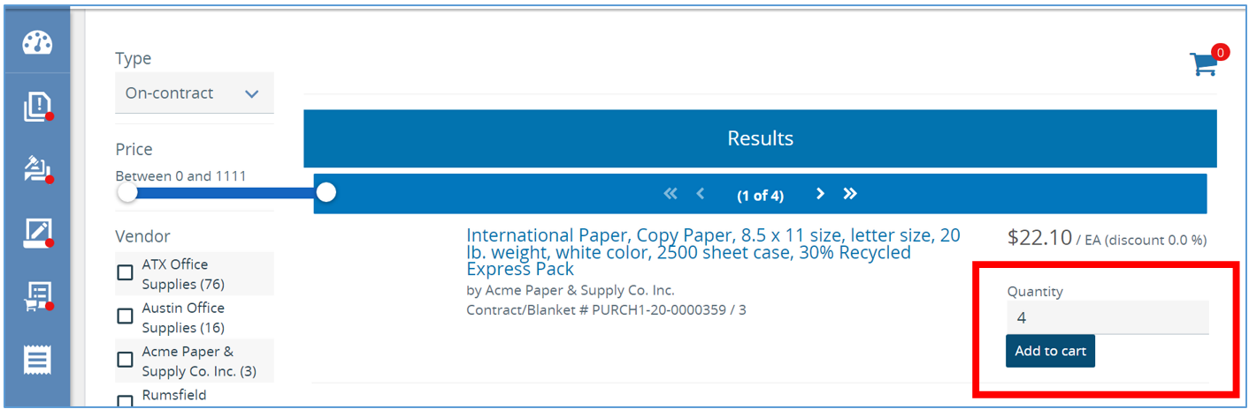
- Next, click the blue shopping cart.
- Then click Add to New req.
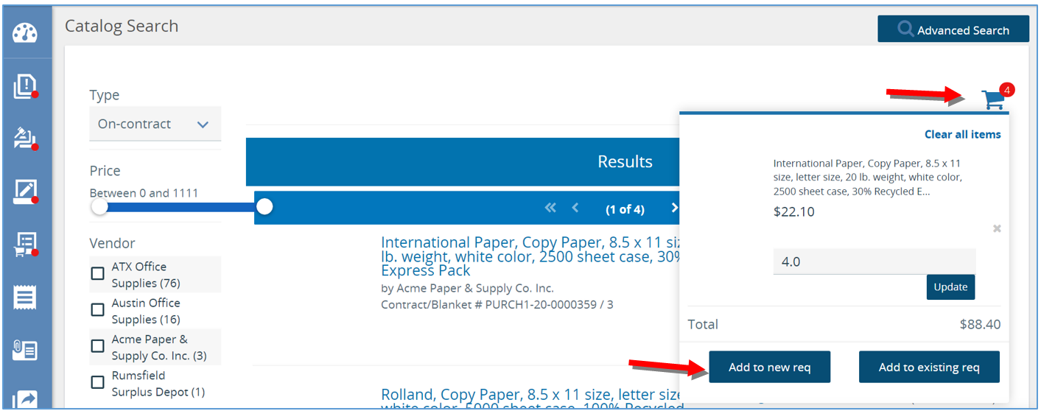
- The page will refresh to the Items tab, displaying the items selected.
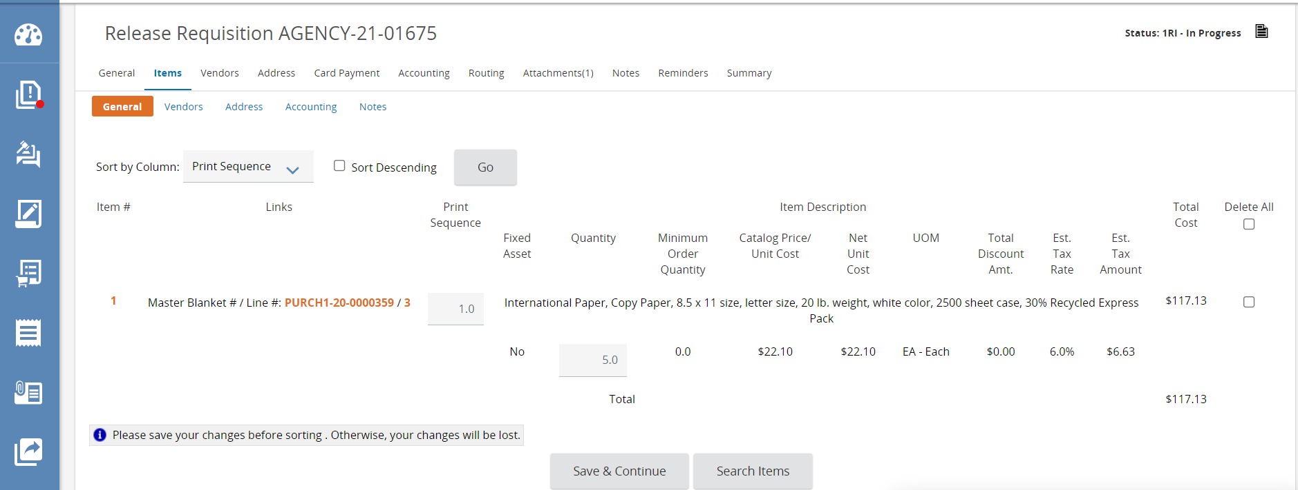
- Next, go to the General tab, and working your way from left to right, review the document and make any modifications necessary. See the first example in this document to review the tabs and required fields.
  - Required fields will always be identified with an asterisk.
- Lastly, submit it for approval on the Summary tab.

Next Steps
Please refer to the previous example for what happens in the system after submitting for approval.

