OregonBuys Requisitions III: Informal Quotes.

Table of Contents
Introduction 2
Prerequisites: 2
Scenario 2
General notes 3
How to Access an Open Market Requisition 3
Creating a New Requisition 3
General Tab 4
Items Tab 8
Vendors Tab 16
Notifying the Vendors about the Opportunity 20
How to View Vendors Submitted Informal Quotes. 23
How to Document a Vendor’s Quote on Their Behalf 24
How to Recommend a Vendor for Award 26
Conclusion 30

Introduction
This guidance document will show you how to use the Vendors tab of an Open Market Requisition to request informal quotes from Vendors for a commodity not available on an existing contract and how to view the vendor’s submitted quotes, how to document any quotes submitted outside the system and how to recommend a vendor for award. You need to a refresher on how to create an Open Market Requisition from scratch refer back to the guidance document Requisition I. An Open Market Requisition is a document used to request goods or services that are not available on an existing contract that falls within an organization’s small procurement dollar threshold. An Open Market Requisition can be created to request and receive informal quotes from vendors for small purchases, or to provide documentation and request approval of special purchasing arrangements.
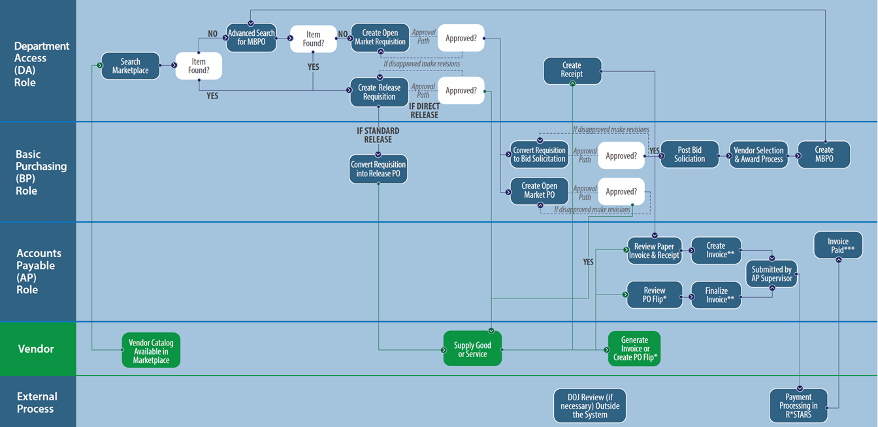
- Figure 1: High Level Process Flow

Prerequisites:
- Search existing contracts for commodities
- Creating open market requisitions from scratch (Requisition Guidance I)
- Vendor List and whether or not to send notifications
- Item details and NIGP code, or how to look up

Scenario
In this guidance document the Department Access (DA) user is requesting quotes from vendors on a requisition. The vendors are able to respond, and the DA user can select a recommended vendor prior to approval of the Open Market Requisition. The DA user will submit the requisition with the recommended vendor for approval before the Basic Purchasing (BP) user will take action on the request.

General notes
Prior to creating an Open Market Requisition with Informal Quotes, it is important to confirm your agencies policy related to this functionality.

How to Access an Open Market Requisition
- Starting from the Home page, click the person icon in the top right corner, and select Department Access as the user from the drop-down menu.
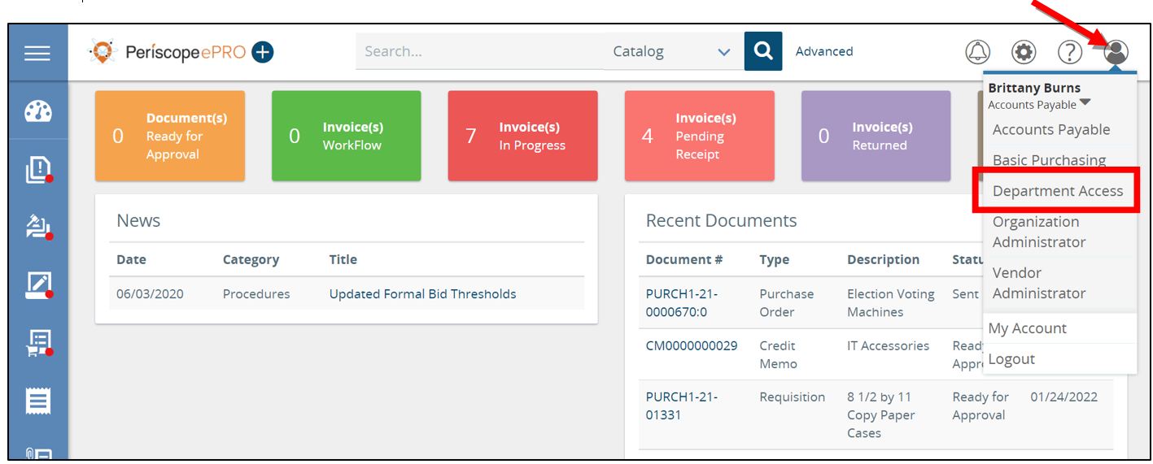
- Next, click the plus button and then select Requisition.
  - This will create a new Requisition
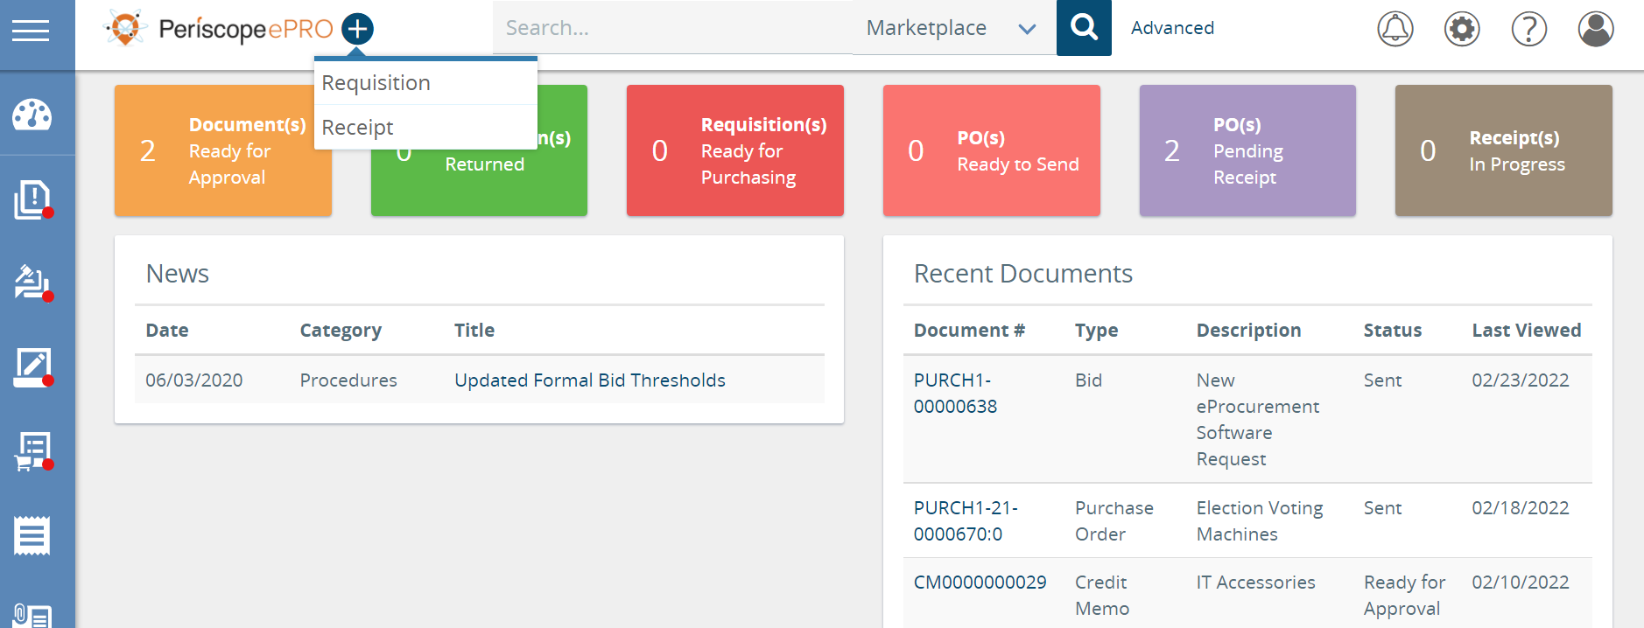

Creating a New Requisition
The new Requisition document will now show a series of tabs at the top. Starting with the General tab and ending with the Summary tab, you will work your way through the tabs from left to right to create a new Requisition. Fields that have an asterisk next to them are required fields to be completed.
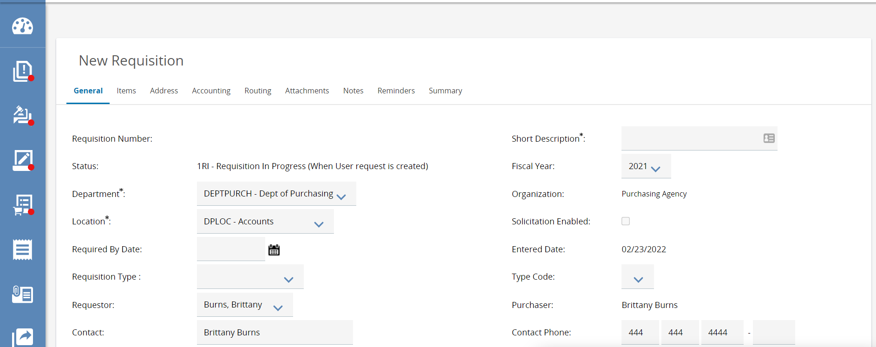

General Tab
- Starting from the General tab, enter the description of the commodities or services the organization needs into the Short Description field.
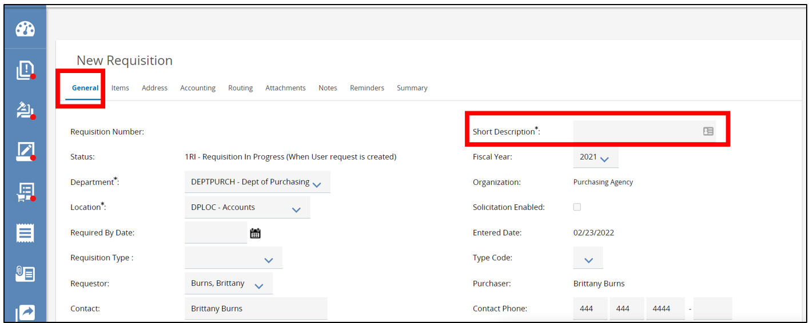
- Next, navigate to the Department and Location fields.
  - Both fields will be populated based on your default settings.
  - If you need to change the Department and Location fields, use the drop-down arrow, and select the appropriate options needed.
    - Locations are subsets of departments which are similar to an agency’s divisions, bureaus, or programs.
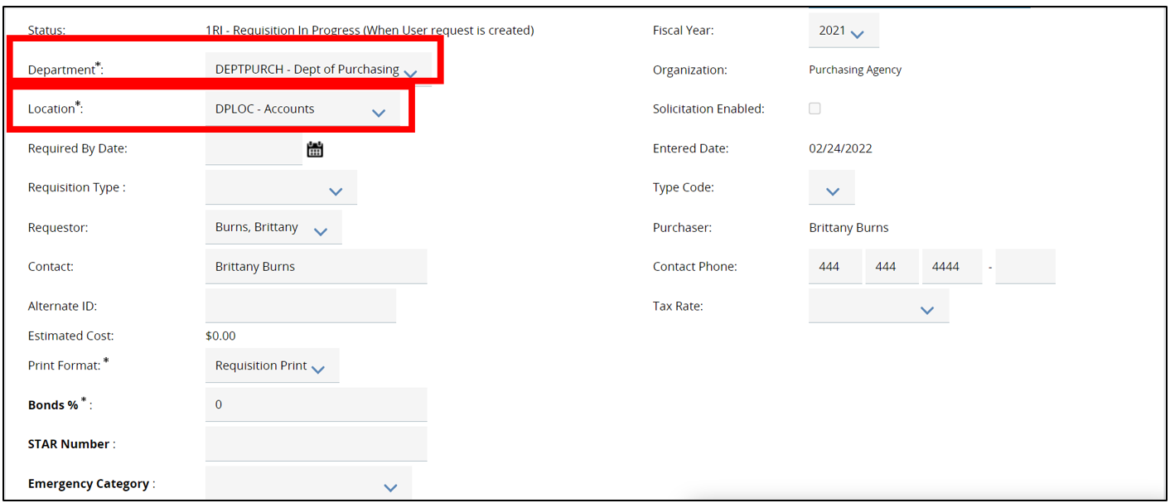
- Next, navigate to the Print Format. This field can stay as is.
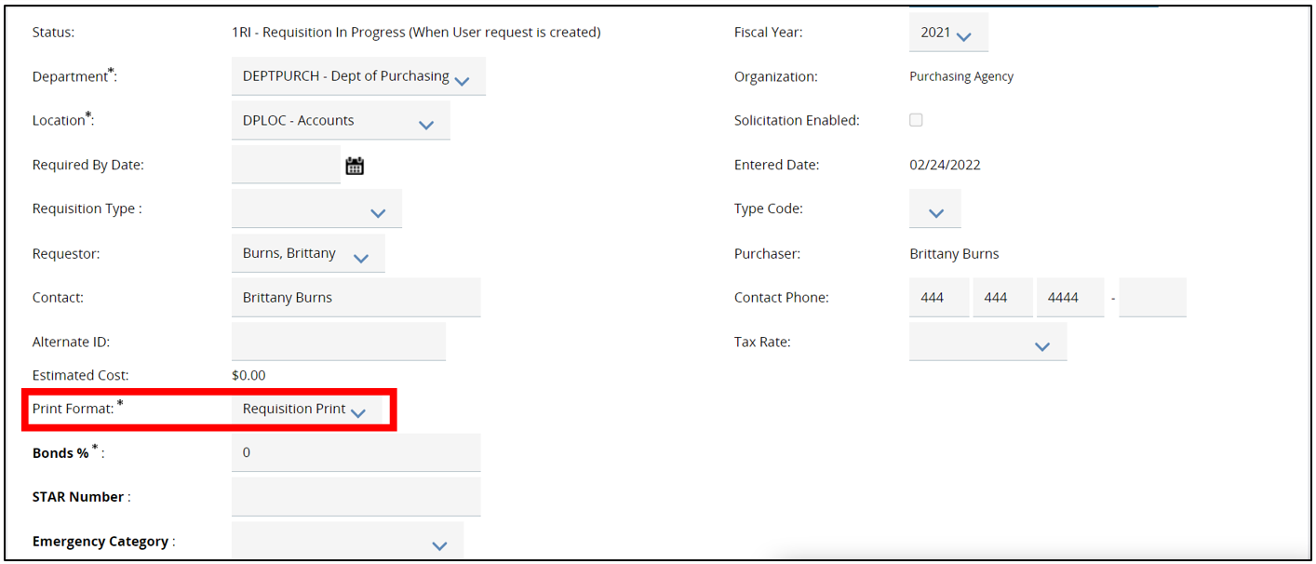
- Next required field to complete is the Discipline Type field.
  - The options provided are set at the Enterprise level and come across from the ORPIN System
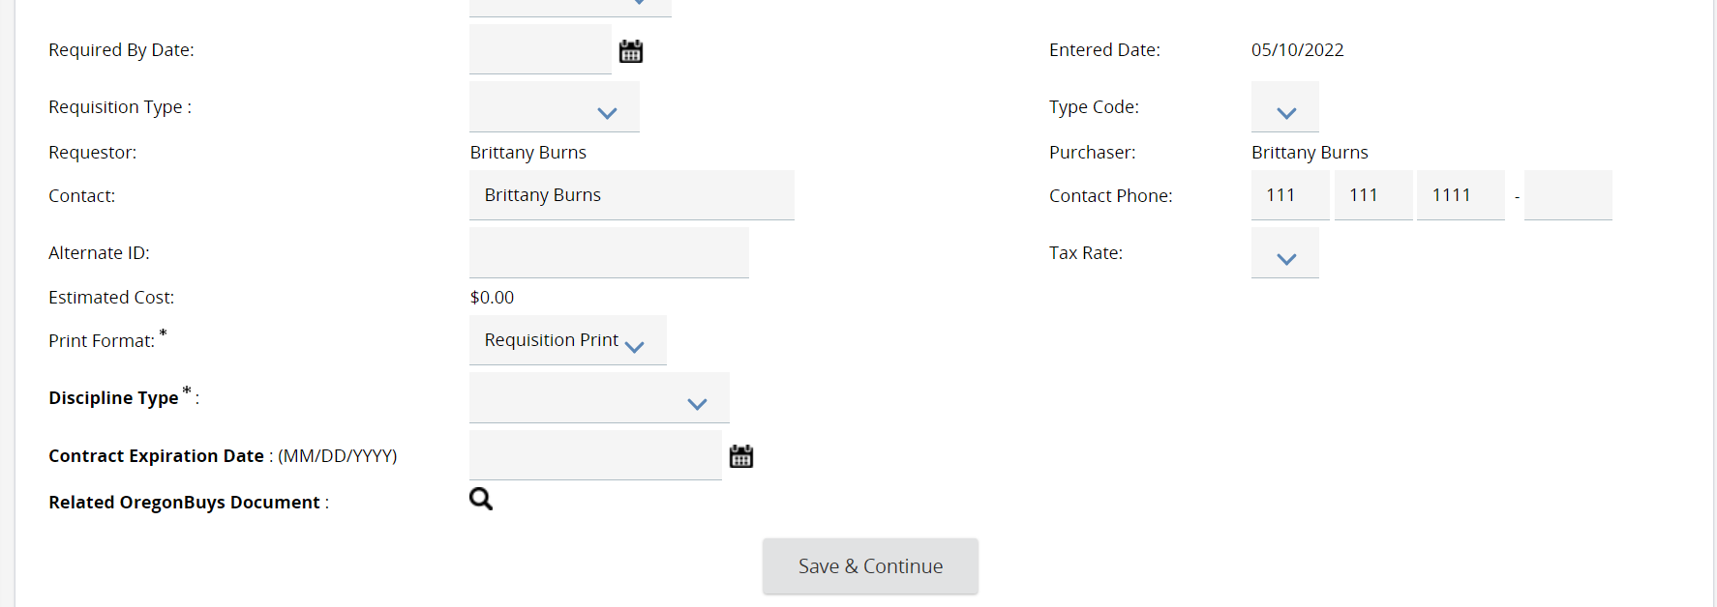
- The next field to complete on the General tab is the Requisition field.
  - This determines the type of Requisition you want to create and drives additional functionality on the Item tab. This guidance takes you through Open Market Requisitions. For other types, see alternative guidance.
    - To learn more about Release Requisitions refer to OregonBuys Requisition II: Release Requisition guidance document.
    - To learn more about RPA’s refer to OregonBuys Requisition IV: Request for Payment Authorization guidance document
      - An RPA Release is an RPA against Master Blankets that allow RPA Releases.
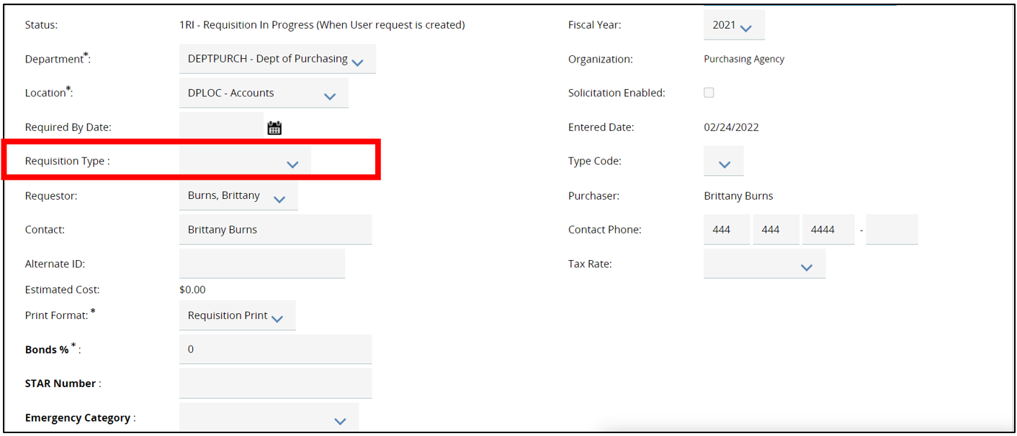
Select Open Market.
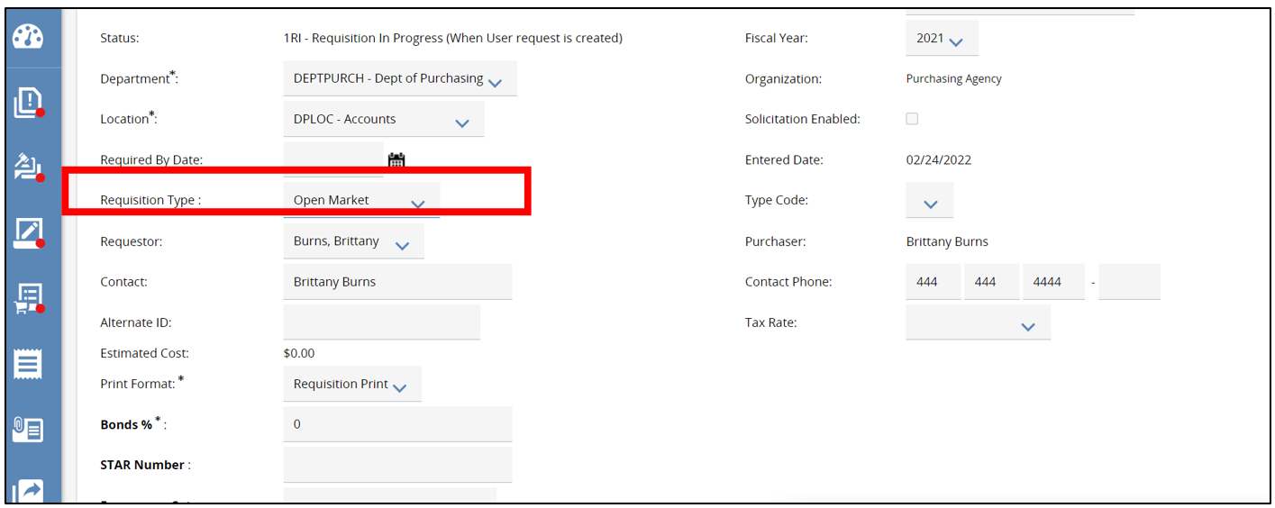
- Once the required fields are completed, click Save & Continue. This will save all the data entered if you need to finish at a later time.
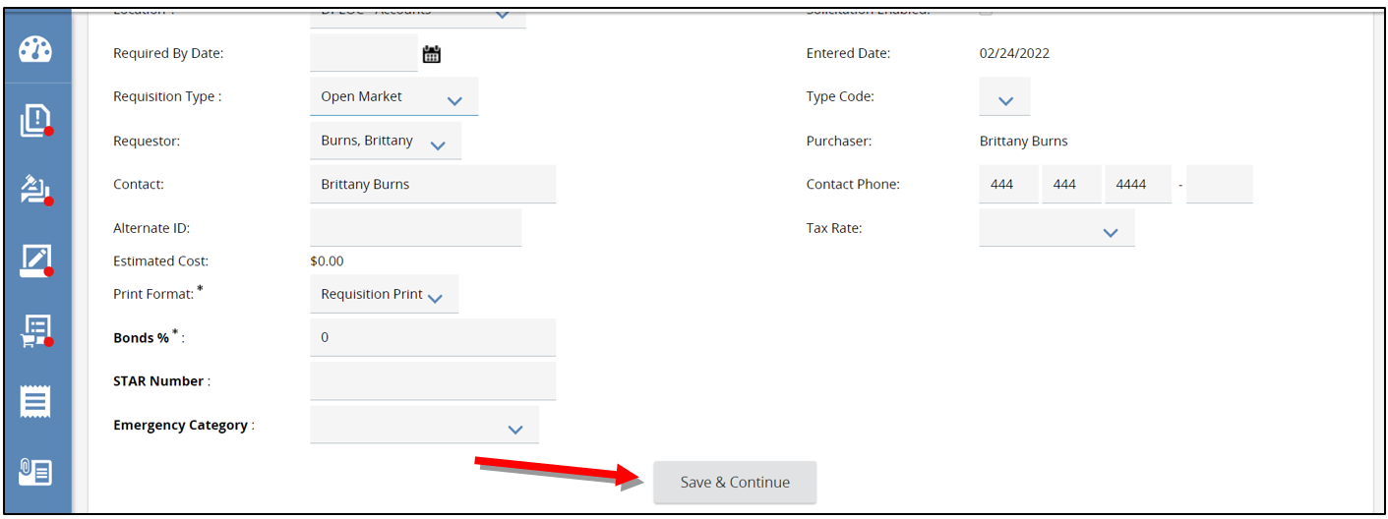
- The system will now generate a unique document number in the left-hand corner of the screen.
  - In the right hand-corner the status will now show In Progress.
    - This means the document is saved and is editable.
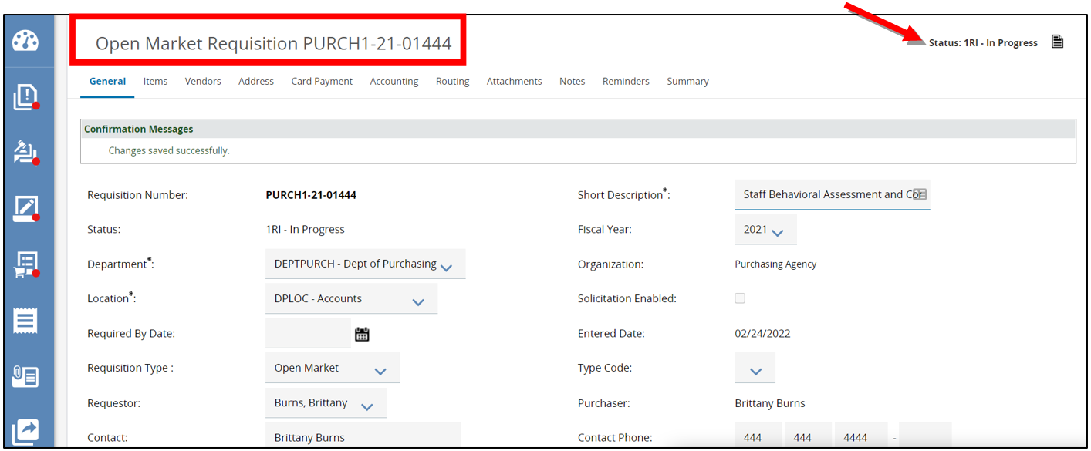

Items Tab
The Items tab is where you create line items detailing the commodities or services that the Requisition is for.
- To create a new line item, click Add Open Market Item.
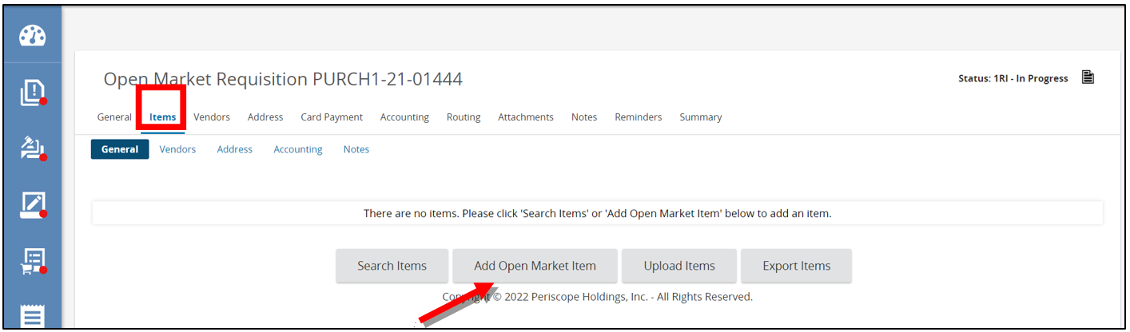
  - The page will refresh to the Item Detail screen.
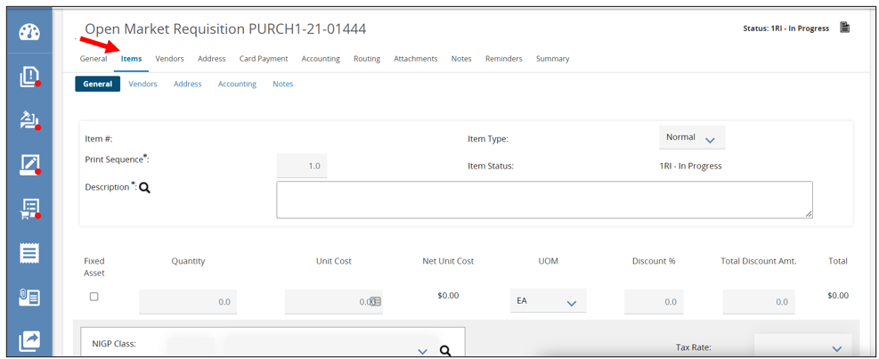
- Next, add the Item Description
  - It is recommended to be as specific as possible.
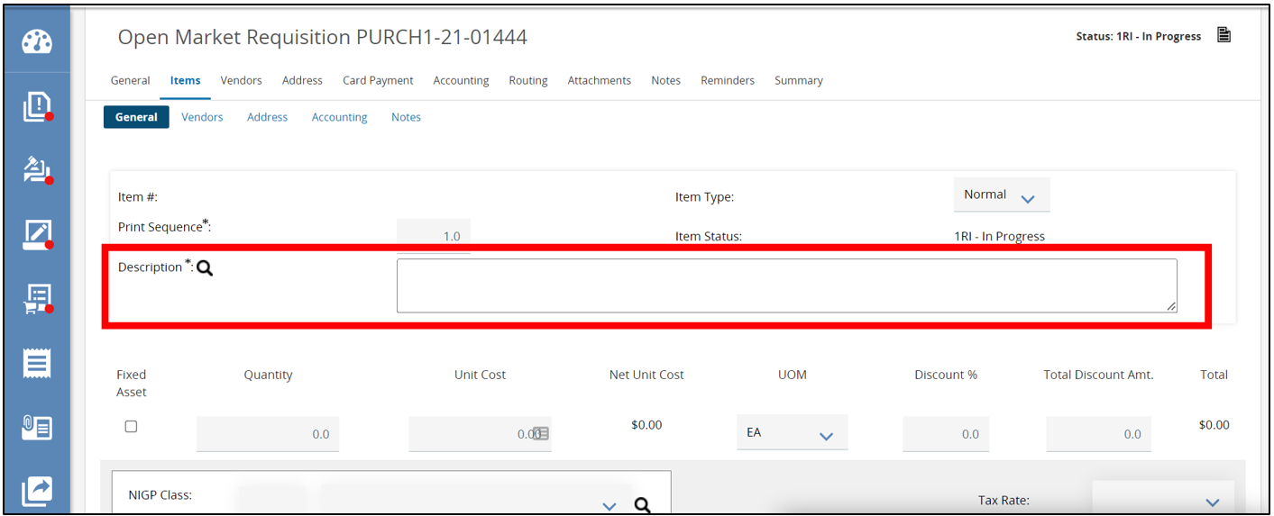
- Then, fill in the Quantity field.
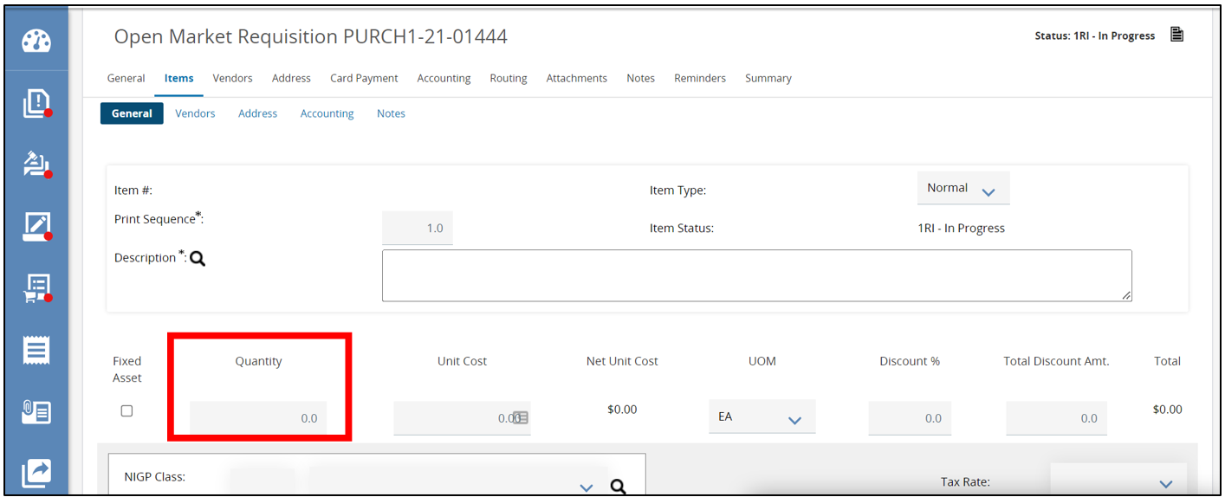
- Next, complete the Unit Cost field.
  - This field defaults to $0.
  - To trigger certain approval thresholds or based on information you’ve requested from subject matter experts, enter in the estimated Unit Cost in this field.
    - The total amount will than update.
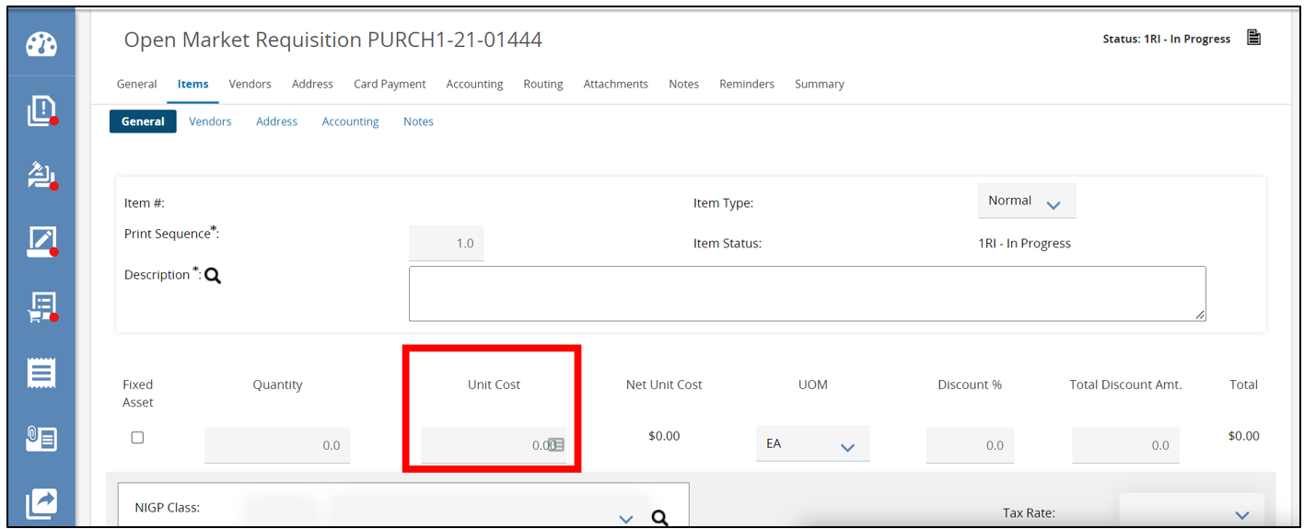
- Then, complete the Unit of Measure (UOM) field.
  - This field will default to Each and can be left as is.
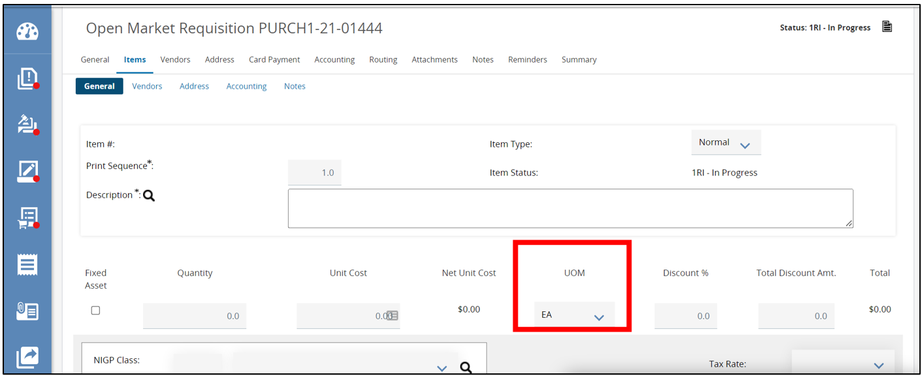
  - To change the Unit of Measure, click on the drop-down menu and select the appropriate choice.
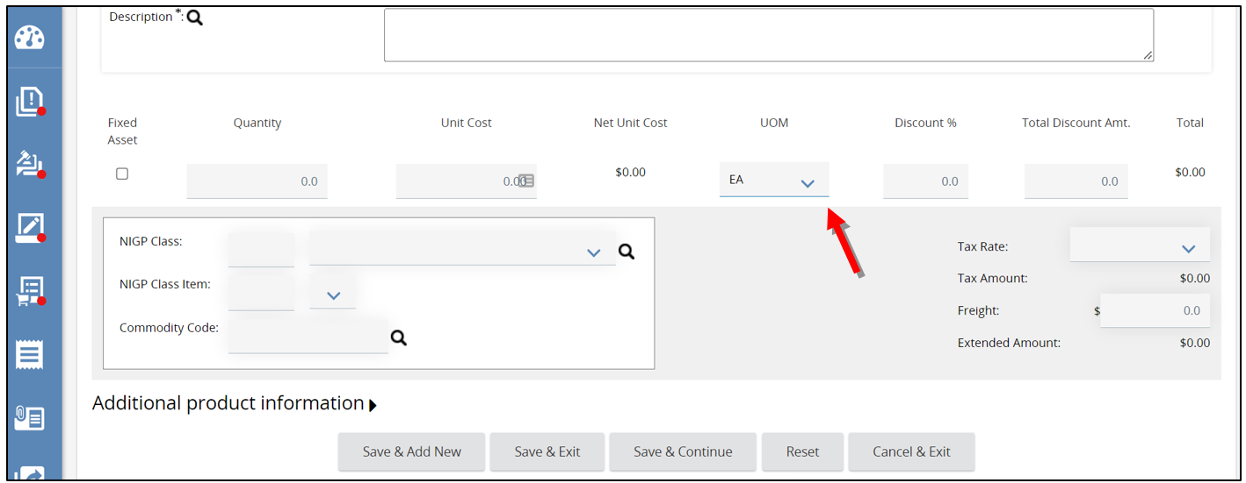
- Next, complete the NIGP Class and NIGP Class item fields.
  - Anytime an Item is being added to a Requisition, a Commodity Code needs to be assigned.
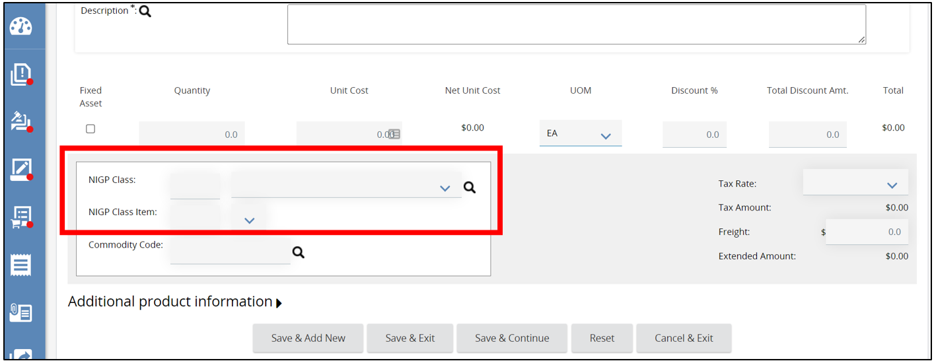
    - There are three ways to add a Commodity Code.
      - If you know the Commodity Code, manually enter it into the fields.
      - You can use the drop-down menu in each of the fields.
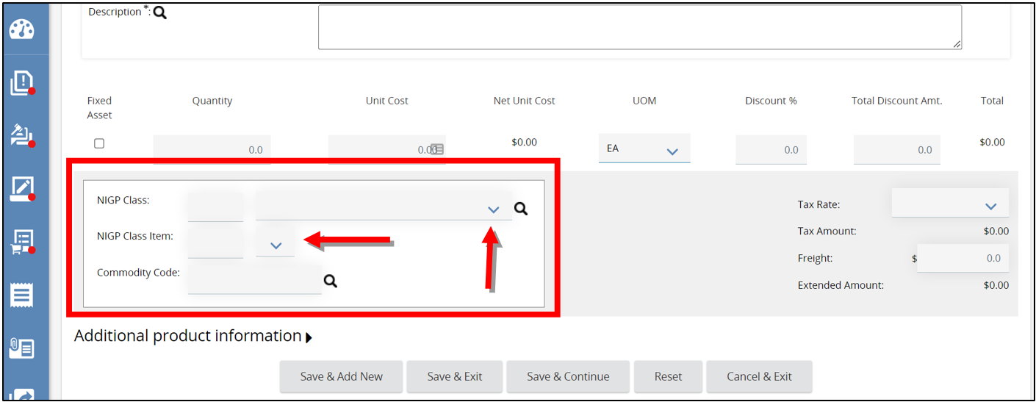
      - Lastly, click the magnifying glass, this will open a pop-up window allowing a search for the Commodity Code.
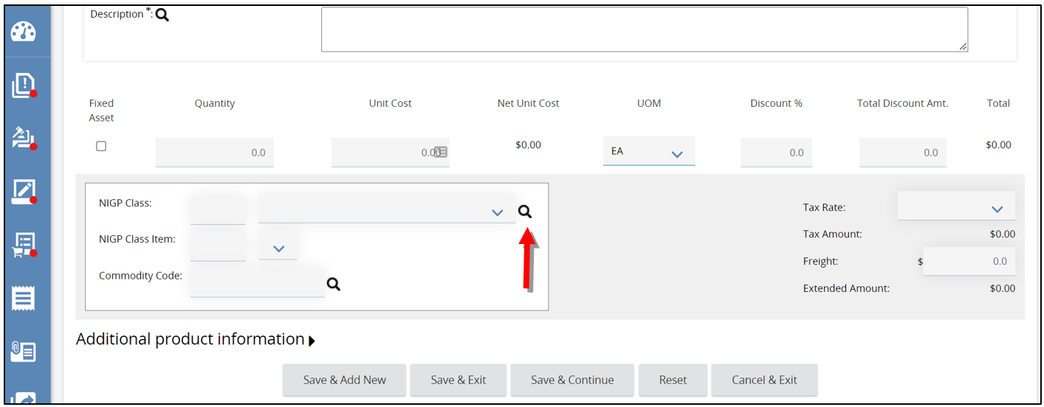
        - Example Pop-Up Window
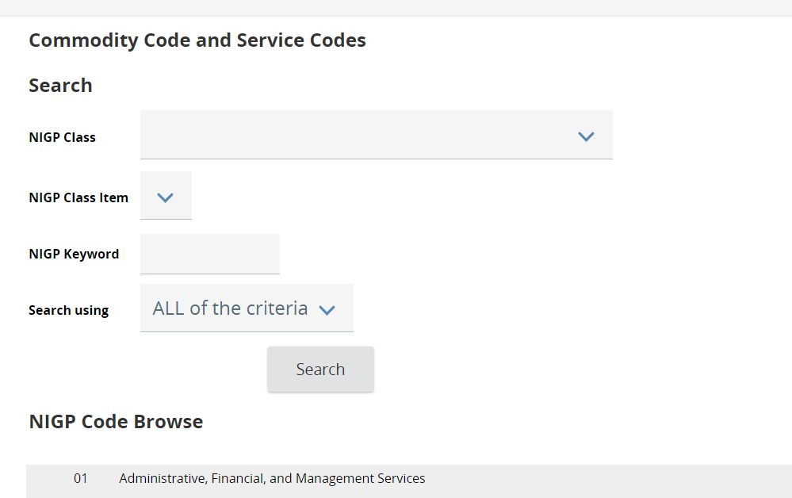
        - Type in a keyword in the NIGP Keyword field and click Search. The screen will refresh showing the codes associated with the search just completed.
        - Select the Commodity Code you want, then click Save & Exit.
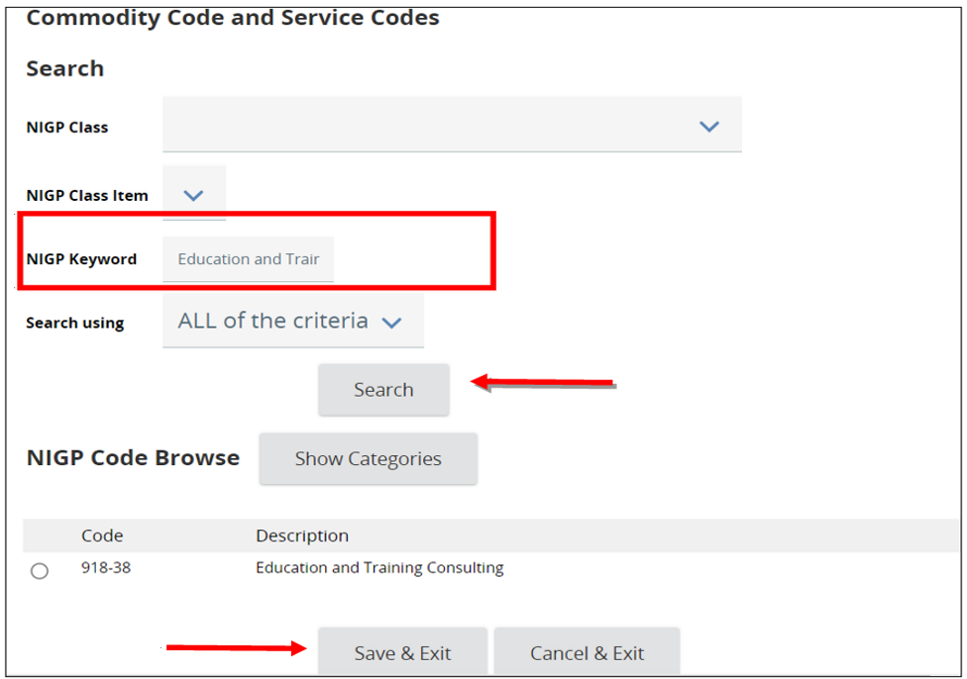
  - The page will refresh back to the Item Details screen where the Commodity Code renders.
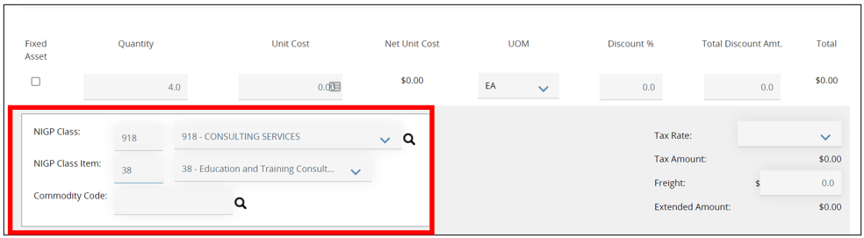
- Next, expand the Additional Product Information field if you have any additional information you would like to provide to the Vendors.
  - Enter information in any of the fields provided.
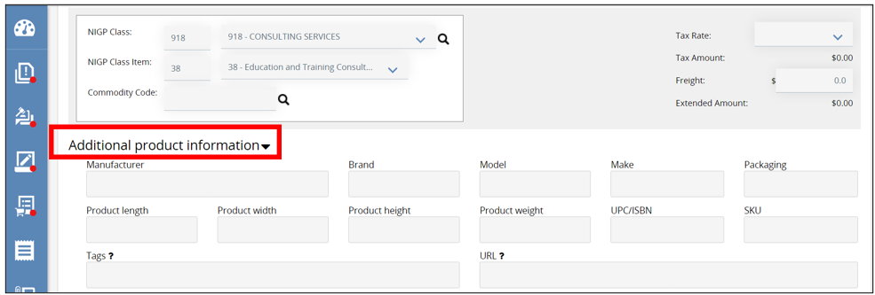
- When finished click Save & Exit to save this Item Detail and to return to the Items General subtab. You will now see a confirmation message confirming the Item was saved.
  - Or click Save & Continue to save the data entered and continue working on this Item Detail
  - Or click Save & Exit to save this Item Detail and to return to the Items General subtab.
  - click Save & Add New to save the Item Detail just completed and start a new Item.
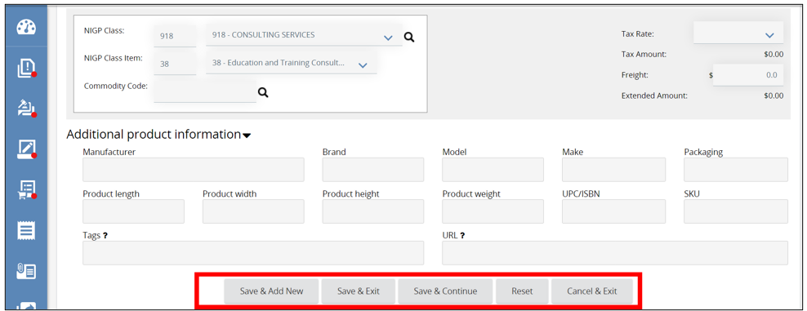
- Lastly, if you had more than one Item on a Requisition, the other subtabs allow you to assign specific information to each item if necessary.

Vendors Tab
This tab is used to notify specific vendors about the opportunity to submit quotes.
- First, check Publish Informal Bid on Web. This allows vendors to view the Requisition listing the line items and submit an Informal Quote.
  - To give vendors a sense of expected pricing for each line item, check Show Unit Prices to Vendors
  - To allow vendors to change the Quantity, check Allow Vendor to Change Quantity.
  - To allow vendors to change the UOM, check Allow Vendor to Change UOM.
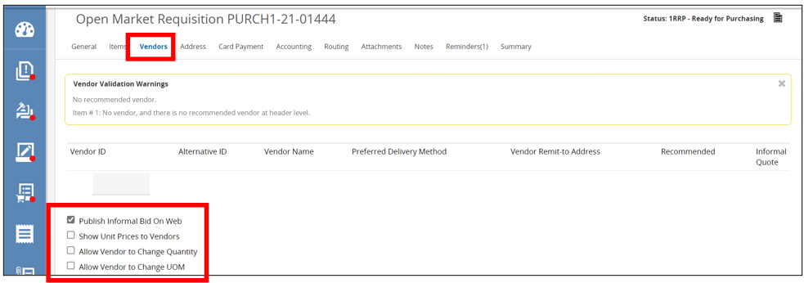
- Next for vendor participation, select Unrestricted informal bid, all vendors can view and resend. This allows all vendors in the system to view and respond. This helps increase competition throughout your vendor community.
  - If you select Restricted informal bid, only selected vendors can view and respond. This is used when you are purchasing goods or services that are deemed sensitive, or when limited competition is acceptable and pragmatic.
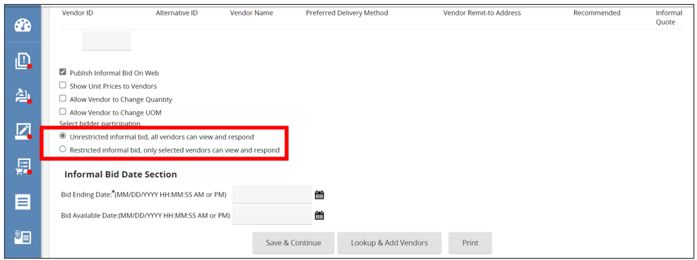
- Next, complete the Bid Ending Date, this field is required. This is the deadline for vendors to submit their quotes.
  - Click the Calendar icon
  - Then choose the Date and Time.
  - Next, click Done
    - The Date and Time will now show.
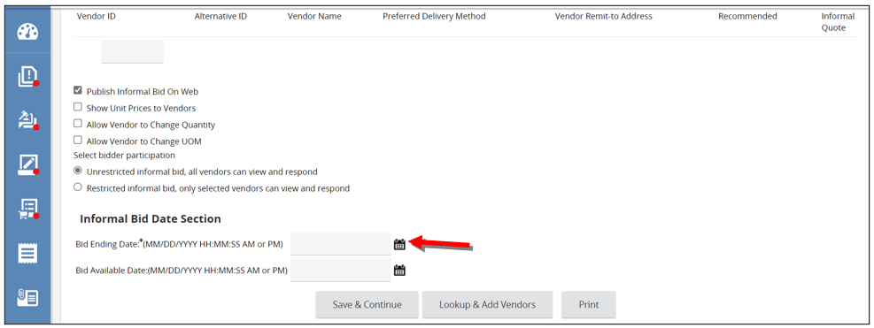
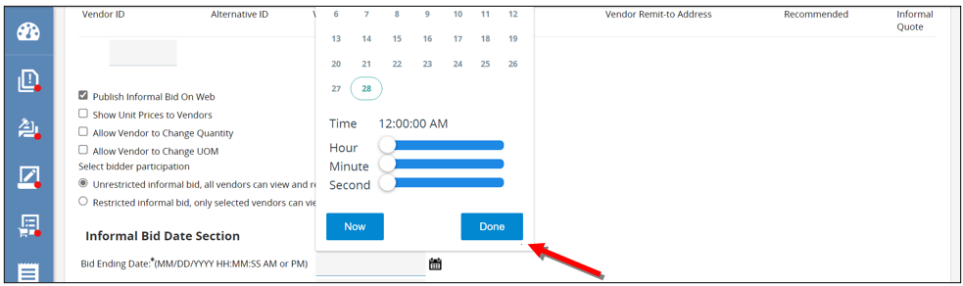
- Once you are finished, click Save and Continue.
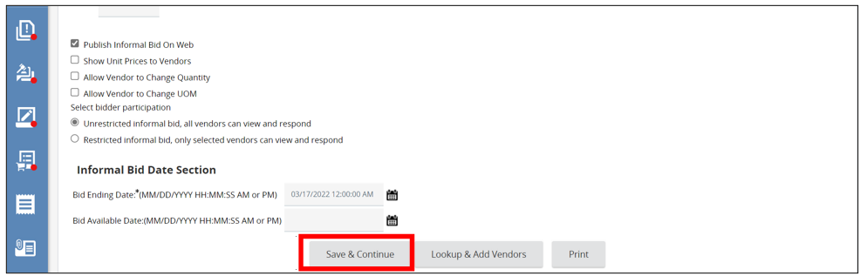

- Next, add the vendors you want to notify about the opportunity to participate by scrolling to the bottom of the page and click Lookup & Add Vendors.
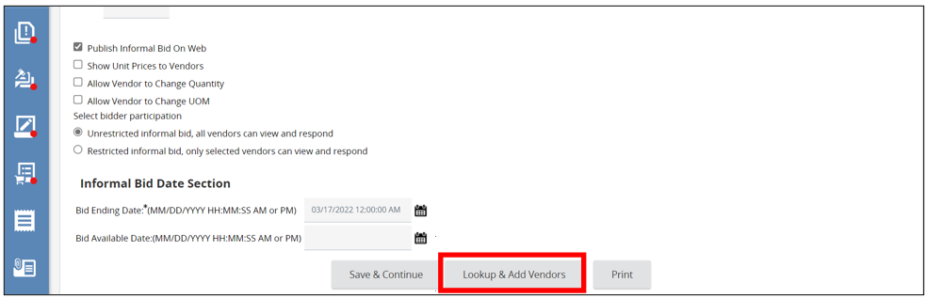
- A pop-up window will appear where you will search for vendors using any of the fields available.
  - It is recommended to search for vendors that use the commodity code of your line item by scrolling down and clicking Find Vendors for all Commodity Code on the Req.
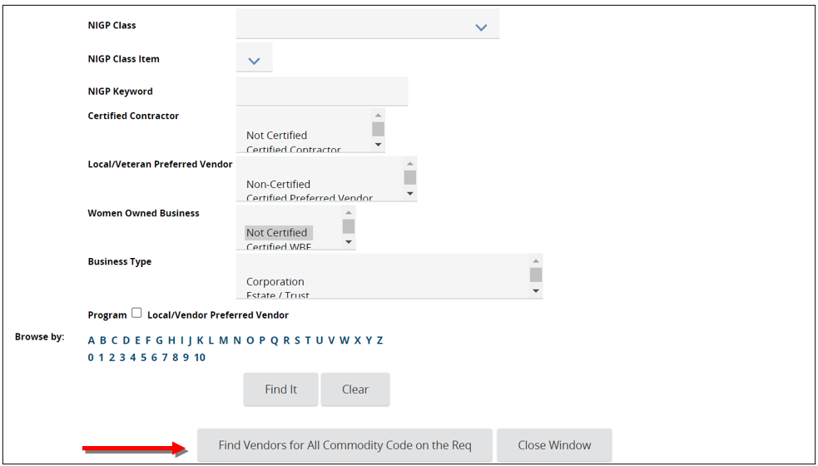
- The screen will refresh and a list of all the vendors whose accounts have the same commodity code will appear.
  - To choose all vendors click the Select header box.
  - Or select each individual vendor by checking the box next to the Vendor ID.
- Then click Save & Exit.
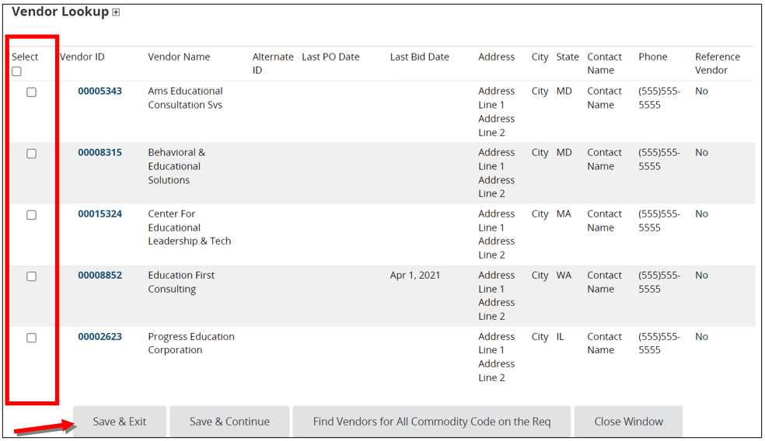
- The page will refresh back to the Vendors tab showing all the vendors that have been selected.
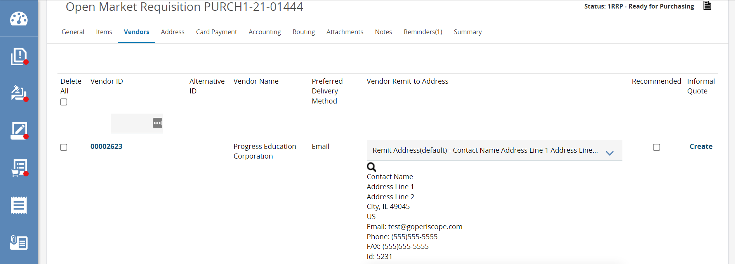

Notifying the Vendors about the Opportunity
- Scroll down and click Notify Vendors.
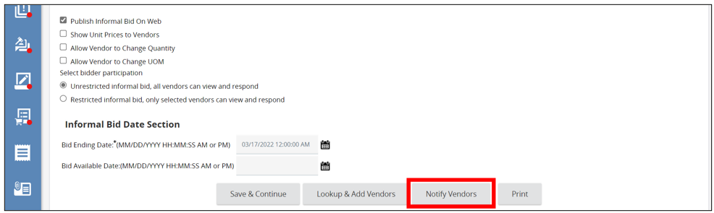
- The page will refresh displaying all the vendors added to the Vendors Tab.
- Next, identify the vendors you want to be notified about the opportunity
- Select the vendors individually by selecting the Send Notification box next to the Vendor ID
  - Or select all of the vendors by checking the Send Notification header box.
- Then click Send Notification to Selected Vendors.
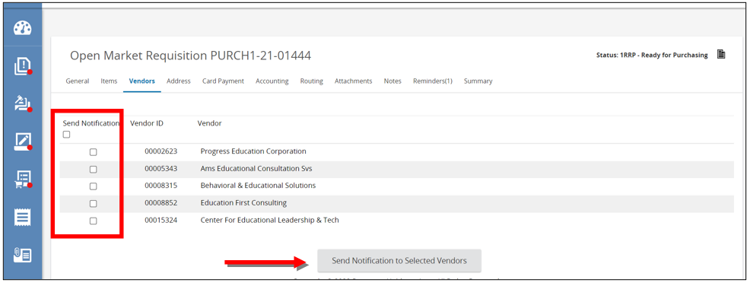
- The page will refresh bringing you to the Send Informal Quote Email screen. This is where you can see the vendors that will be emailed about the opportunity.
  - The Subject and Text fields will already be populated with the information that the system will email the vendors.
  - Either field can be edited if necessary.
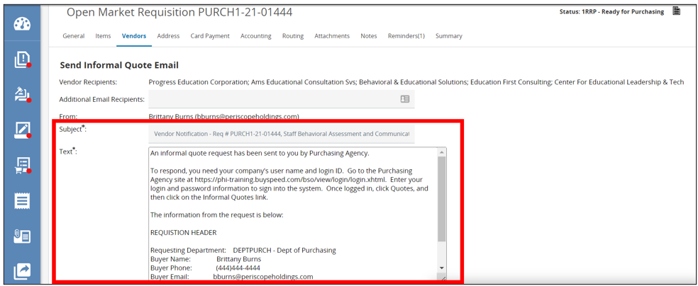
- To add a product or service specifications that vendors need to review and complete to send back as a part of their informal quote, attach the document by clicking Upload Attachment.
  - These specification documents can also be added on the Attachments Tab.
    - The Attachment Tab is covered in the Requisition I guidance document.
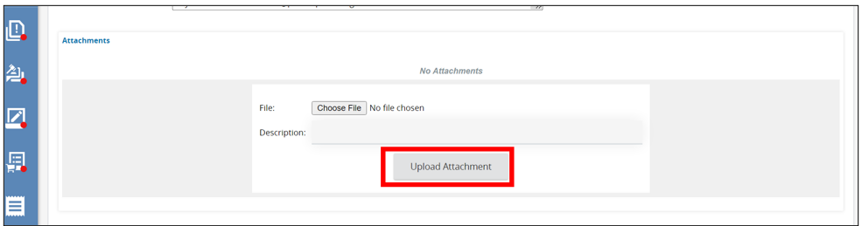
- Click Send Notification, to notify the vendors.
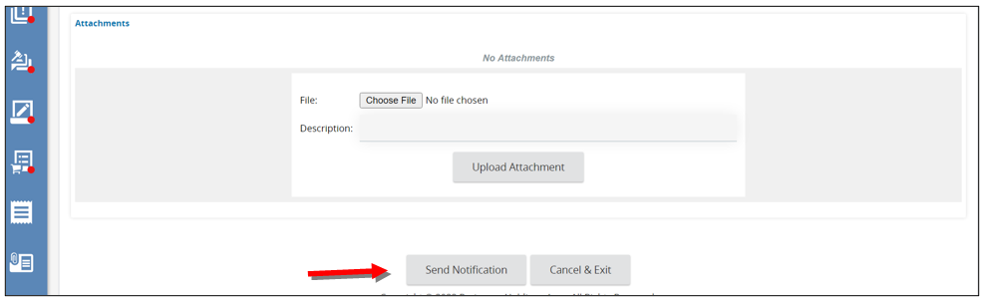
- A pop-up window will appear, click OK.
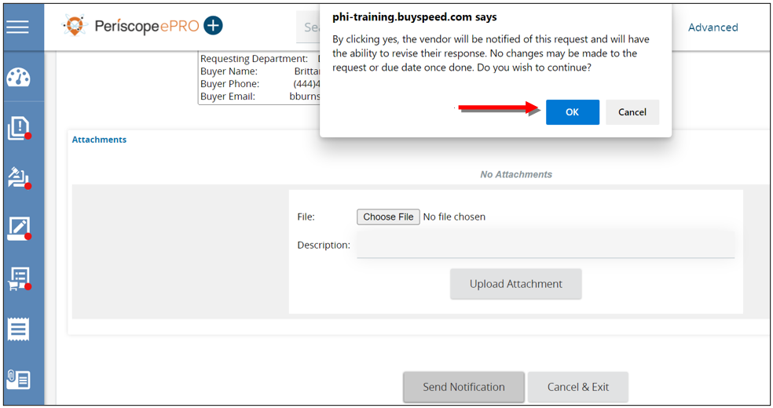
- The page will redirect to the Vendor Notification Result screen, displaying all the vendors that have been notified.
- Click OK to redirect back to the Vendors tab.
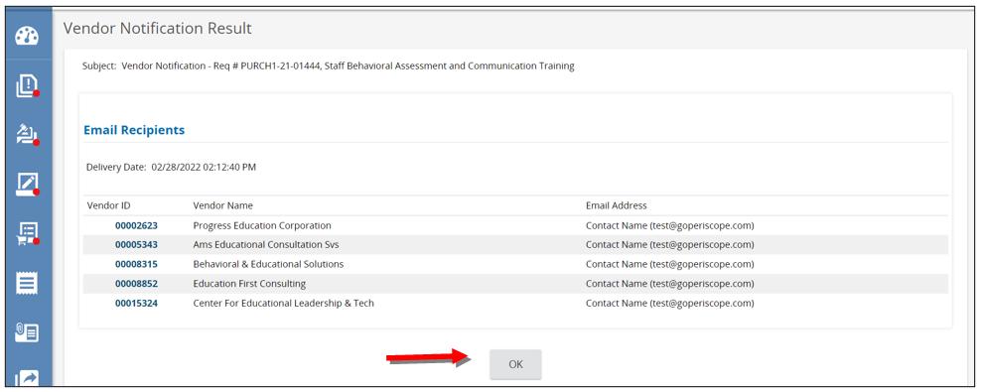

How to View Vendors Submitted Informal Quotes.
If enough time has passed for the vendors to submit their informal quotes and you are ready to review. Follow these steps:
- On the Vendors Tab, look under the Informal Quote column.
  - If a vendor submitted their quote in the system, you’ll see a View/Edit link for the vendor.
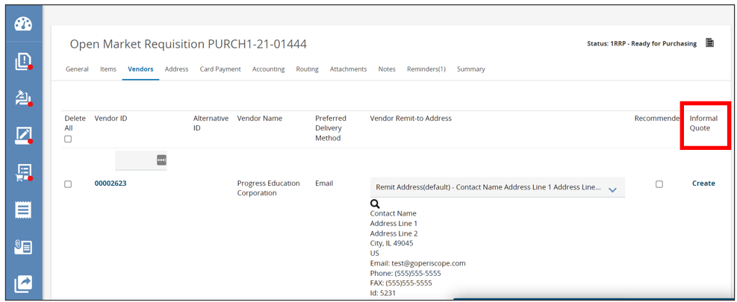
- To view that vendor’s informal quote, click the View/Edit link.
- Scroll down to view and download any of the vendor’s attachments.
  - The vendor’s price for each item appears under the Unit Cost field.
- Click close Window to close out of their quote.

How to Document a Vendor’s Quote on Their Behalf
If you see a link that says Create under the Informal Quote column, that means the vendor hasn’t responded or the vendor responded but outside of the system. You can enter their pricing on their behalf.
- First, click Create. This will redirect you to the Informal Quote screen for the vendor.
  - The bottom of the screen contains the line-item information on the Requisition.
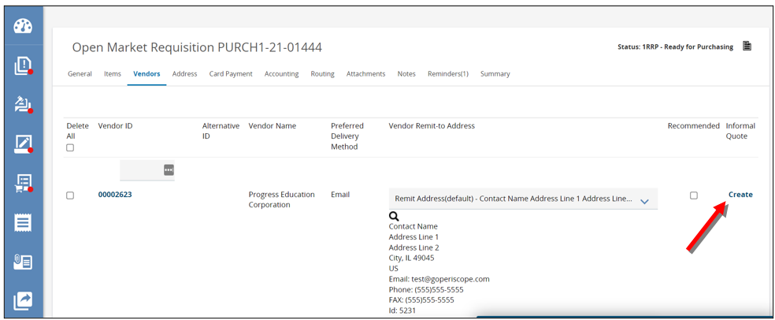
- Next, enter the vendor’s price in the Unit Cost field.
- Click Save & Exit to save their pricing and redirect back to the Vendors Tab.
  - Or click Save & Continue to save their pricing and provide additional action buttons.
    - The Manage Attachments button allows you to add any quote attachments the vendor may have sent along with their quote.
  - Click Save & Exit when you are done.
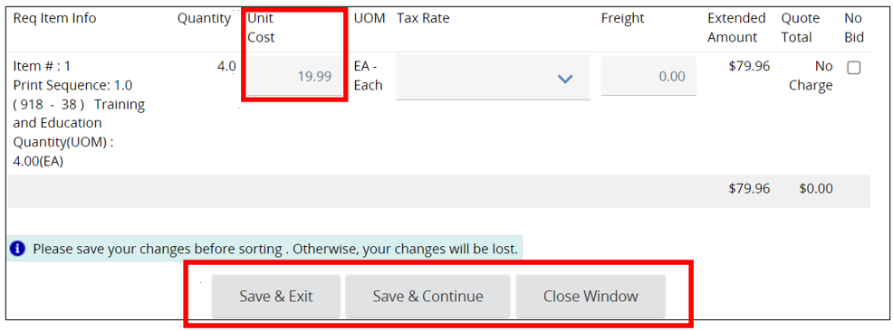
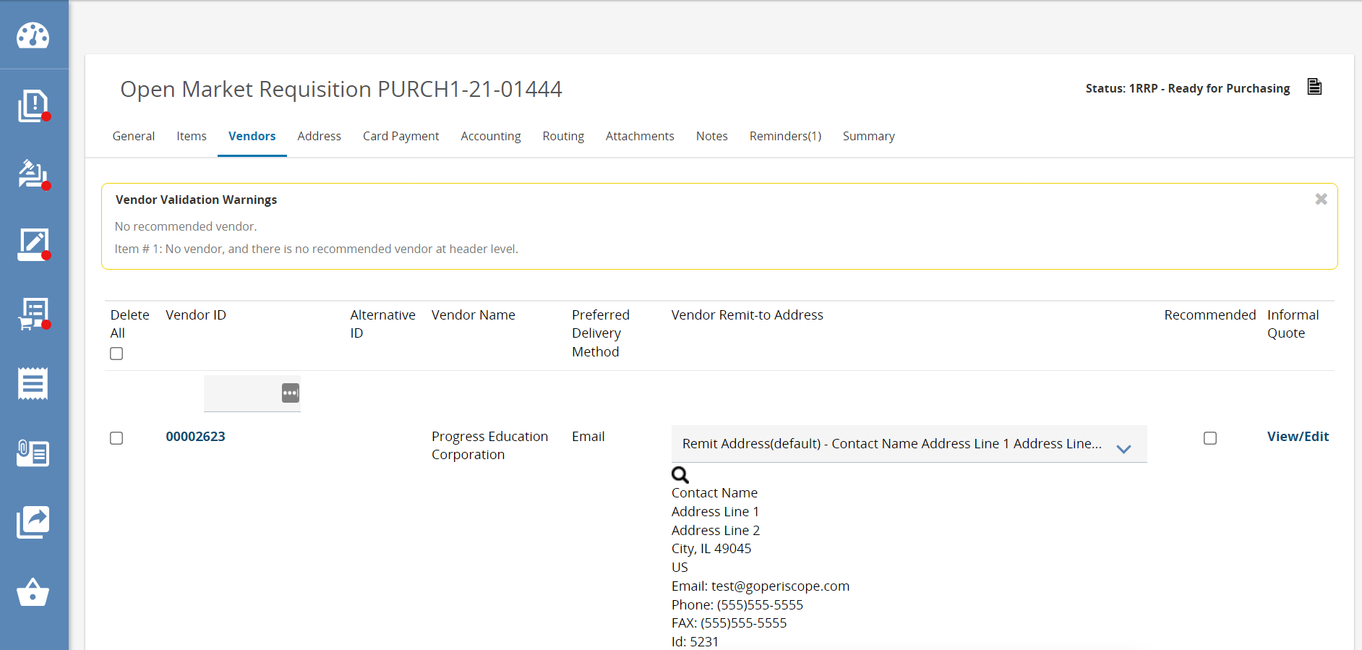

How to Recommend a Vendor for Award
- To view each vendor’s submitted price side-by-side, scroll down and click Informal Quote Tabulation button.
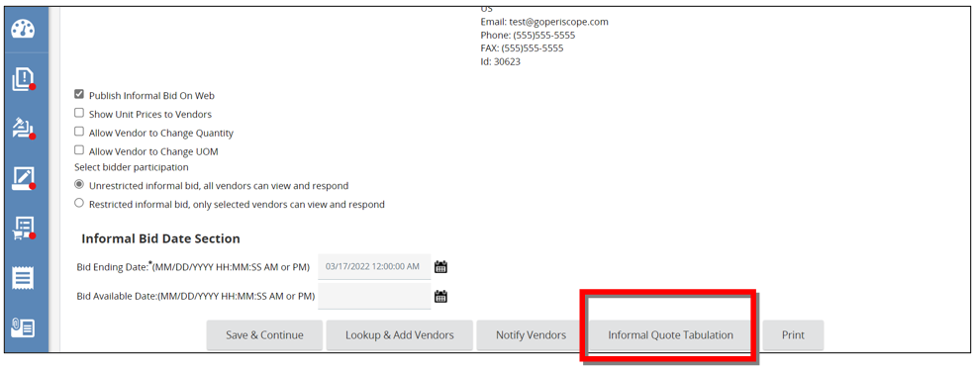
- A pop-up window will appear, and you will see each vendor listed with their pricing for each item.
  - The system uses a double asterisk and the color green to indicate the lowest Unit Cost.
- You can apply their pricing to the line item we entered on the Items tab by clicking Apply Pricing under their name. 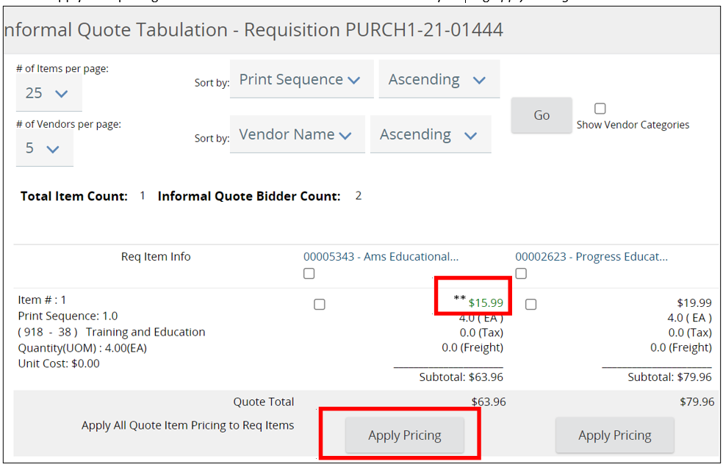

- A pop-up window will appear, click OK.
  - This will fill in the Unit Cost field for the Item.
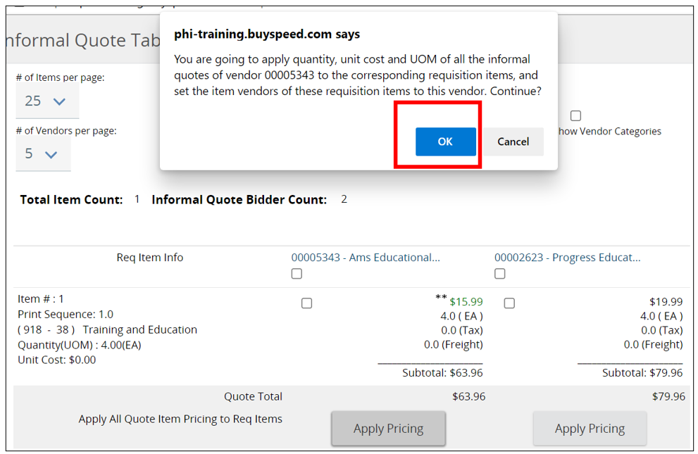

- Next, add the vendor’s quote attachment to the Requisition document by clicking Select and Apply Attachments.
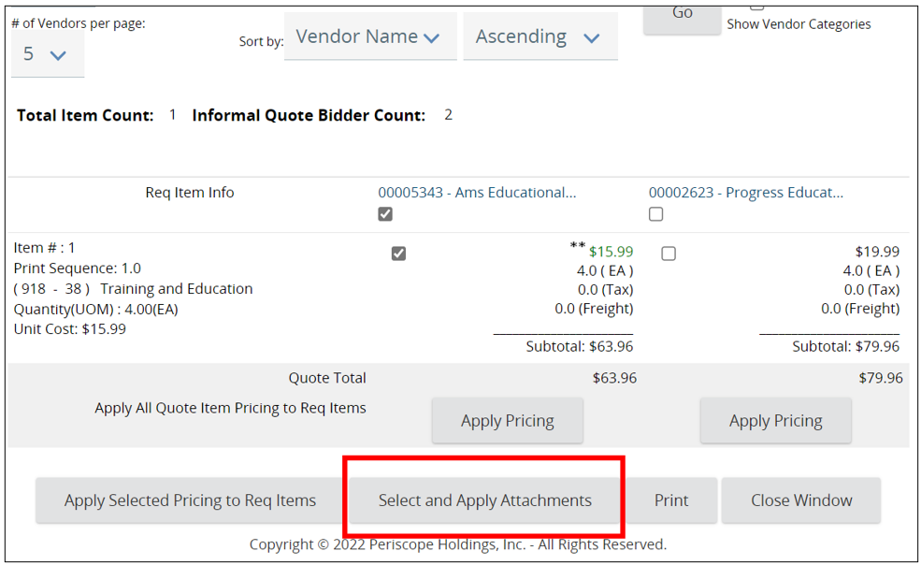
- Click the appropriate box to choose the vendor’s attachments. 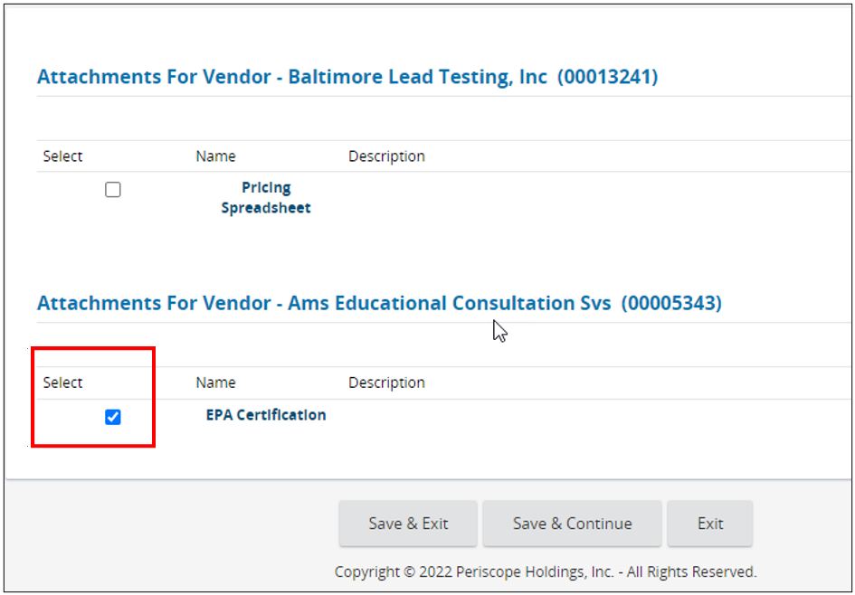
- Then click Save & Exit.
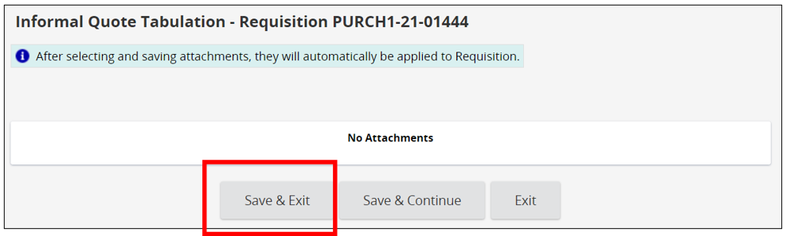
- Once the vendor’s price and any attachments have been applied, click Close Window to redirect back to the Vendors tab.
  - If there is only one line item, the system will automatically identify the vendor you recommended for award.
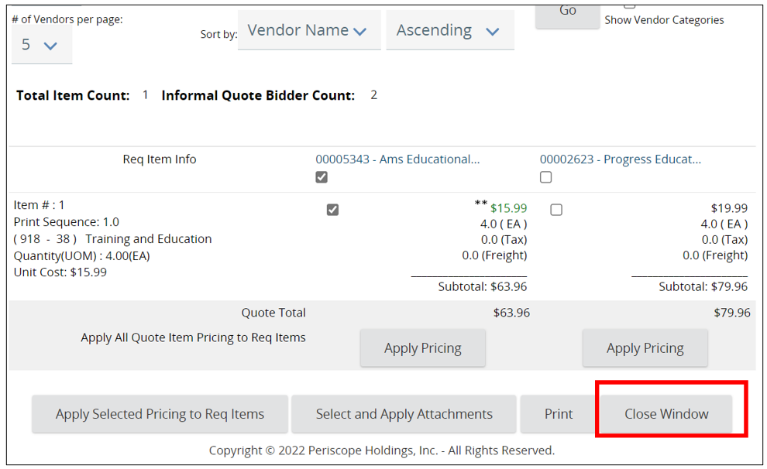

Conclusion
From here complete the remaining tabs and submit the document for approval. Refer back to the Requisition I guidance documents for those steps.

