OregonBuys Standard Reports Guide

Introduction
This guide will help individual Agency users navigate to standardized reports available to all organizations.

Important Highlights
Published reports include OregonBuys Standard Reports and any custom reports that have been published by the Internal Administrator or Organization Administrator. The list below provides detail on each of the OregonBuys Standard Reports. The user will only see the reports that have been published to the user role for their organization.
Note: Phase 1 of implementing OregonBuys is limited to solicitations and Master Blanket Purchase Orders. Some reports may not have data until an Agency completes Phase II – End to End Rollout.

How to Access Standard Reports
To access Standard Reports, follow the below steps.
- Login using your login credentials.
- Navigate to the right of the Homepage and click on the “Settings” icon.
- Click on the “Reports” icon and select Reports from the dropdown menu.
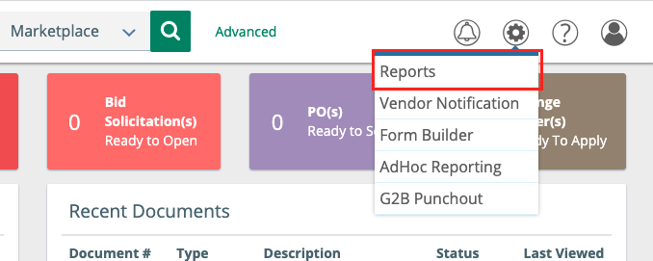

- Once you are on the Administrative Reports page, click the report you wish to see. Click the title of the report you wish to see.
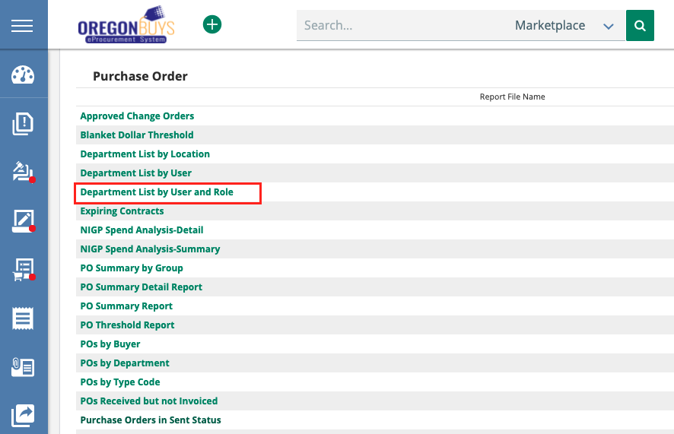

- Once you have selected the report, a new tab will open in your browser and you will be directed to the Business Intelligence tool.
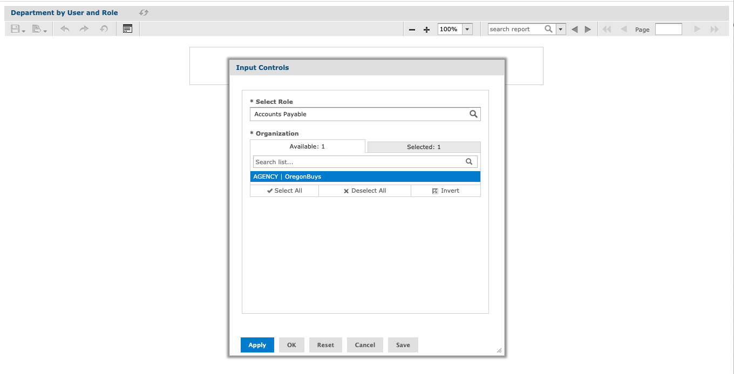

- In the “Input Controls” dialog box, complete each available field. Click OK at the bottom of the dialog box. Note: In this example, the system Role and Organization will be selected.
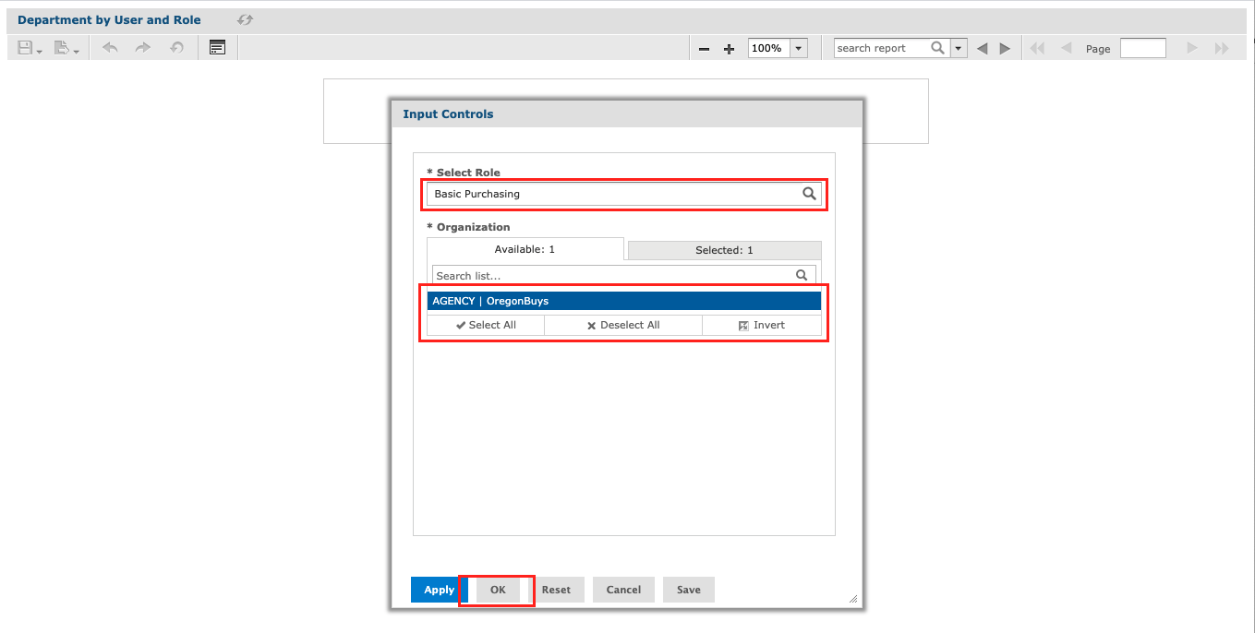

- After a few seconds, the Business Intelligence tool will create the report. To export the report for use, click the Export icon in the top left, and select the format you wish to use.
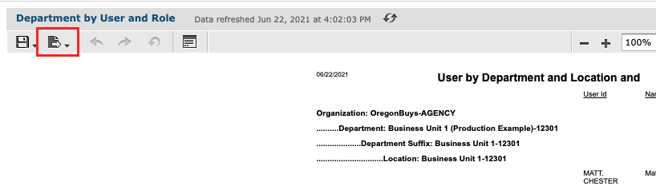

Standard Report Options

Analytical Reports: Operations
Analytical reports are pre-built reports provided to address a wide range of reporting needs. The selectable parameters within the report allow the user to customize the data set and functionality. Many analytical reports are available under the Administrative Reports section of the system.
- Cycle Time Reports
  - Bid Processing Cycle Time - The Bid Processing Cycle Time report captures the amount of time a particular Bid has stayed at each Document Status in days. The report displays the current Status and the number of days for all Status changes. The report allows the user to search on a specific Bid Number as input. The parameters are Organization and Bid Number (optional - can be left as wild card "%"). The data sources are Bids of all Statuses.
  - Requisition Approval Cycle Detail - The Requisition Approval Cycle Detail report calculates the number of days a Requisition moves from Ready for Approval to Ready for Purchasing Status. The detailed report shows the individual Requisitions, approval paths and the number of days. The parameters are Organization, Date, and Requisition Type.
  - Requisition Approval Cycle Summary - The Requisition Approval Cycle Summary report calculates the number of days Requisitions move from Ready for Approval to Ready for Purchasing Status. The summary report shows by Department the average number of days by Requisition type. The parameters are Organization, Date, and Requisition Type.
- Contract Usage Reports
  - Vendor Contract Usage - The purpose of the Vendor Contract Usage Report is to show users the Purchase Order Releases and the spend amount for Master Blanket Purchase Orders. The report will also include the Purchase Order Release number, Department and Location, Status, Start and End Date, and the total dollar spent on each Release Purchase Order among many other relevant fields. The parameters are Organization, Purchase Order number, and Contract/Blanket End Date- greater than and equal to or less than and equal to the date specified. The data sources include Release Purchase Orders that are in the Statuses of: Sent, Partial Receipt, Complete Receipt, and Closed.
- Financial Management Reports
  - Open PO Balance - The Open PO Balance report is designed to tally the remaining encumbered amounts for Purchase Orders by Account Code. The parameters are Organization and Purchase Order number (optional - can be left as wild card "%"). The data sources are Purchase Orders in Ready to Send, Sent, Partial Receipt, and Complete Receipt Statuses.
  - POs Received but not Invoiced - The PO Received But Not Invoiced report is designed to tally the Purchase Order Receipts and to display the dollar amount that has not been invoiced. The parameters are Organization, Fiscal Year, and the outstanding balance threshold. The data sources are Purchase Orders where receiving has been made, but Invoices have not reached Paid or Approval Status.
  - Unpaid Receipts - The Unpaid Receipts report is designed to tally Purchase Order Receipts amounts that have not been paid. The calculation sums the Receipt and Invoice totals and shows the difference. The single parameter is Organization. The data sources are Purchase Orders with receiving that have not been invoiced.
- Spend Analysis Reports
  - NIGP Spend Analysis Detail - The NIGP Spend Analysis Detail report is designed to show the detailed spend by NIGP Code. The detailed report includes a listing of Release Purchase Orders by Buyer for each Department. The parameters are Organization, Purchaser, Start and End Date, Department, and Class and Class Item. The data sources are the on and off Contract spending based on NIGP Code.
  - NIGP Spend Analysis Summary - The NIGP Spend Analysis Summary report is designed to show the total amount of spend by NIGP Code. The summary report summarizes spend by NIGP for each Department by On/Off Contract; it does not show individual Purchase Order documents. The parameters are Organization, Purchaser, Start and End Date, Department, and Class and Class Item. The data sources are on and off Contract spending based on NIGP Code.
  - Purchasing Statistics - The Purchasing Statistics report is designed to show the number of Requisitions and Purchase Orders by Organization and Department. It captures the number of documents, number of line Items, average number of line Items, and the total dollar amounts. The parameters are Organization, Department, and Start and End Date.

  - Spend by Vendor Category Detail - The Spend by Vendor Category Detail report is designed to show the total amount of spend by the Agency defined Vendor Categories. It then displays spend by Category for each Category type and individual Vendors including the Purchase Order document numbers. The parameters are Organization, Start and End Date, Category, and Category Type (optional - can be left as wild card "%").
  - Spend by Vendor Category Summary - This report is designed to show the total amount of spend by the Agency defined Vendor Categories. The report summarizes by the Category and Category types. The parameters are Organization, Start and End Date, Category, and Category Type (optional - can be left as wild card "%").
  - Vendor Spend Analysis Detail - The Vendor Spend Analysis Detail report lists the total amount of spend by Vendor according to the Purchase Method on the Purchase Order. The detailed report includes the Purchase Order document numbers. The parameters are Organization, Start and End Date, and Vendor, which is optional.
  - Vendor Spend Analysis Summary - The Vendor Spend Analysis by Summary report lists the total amount of spend by Vendor according to the Purchase Method on the Purchase Order. The parameters are Organization, Start and End Date, and Vendor, which is optional.
- Vendor Reports
  - Vendor Award by Category - The Vendor Award by Category report lists the awarded vendors on bids and their categories and category types. The parameters are Organization, Category and Category Type (optional - can be left as wild card "%") and Start and End Date.
  - Vendor Bid Notification by Category - The report is designed to list the Vendors that were selected to be notified of a formal Bid by Vendor Category and Category type. The parameters are Organization, Bid Number (optional), and Category (optional - can be left as wild card "%").
  - Vendor Bid Notification by Category Type - This report is designed to list the Vendors that were selected to be notified of a formal Bid by Vendor Category and Category type. The selection criteria include the user entering beginning and ending input parameters. The parameters are Organization, Category and Category Type (optional - can be left as wild card "%") and Start and End Date.
  - Vendor Participation by Bid and Category - The Vendor Participation by Bid and Category report lists the Vendor Category and Category types for each Vendor who responded with a Quote on the Bids selected. The parameters are Organization, bid number, which is optional, and Category (optional - can be left as wild card "%").
  - Vendor Participation by Category Type - The Vendor Participation by Category and Category Type report summarizes the number of Vendors of each Category and Category types that responded with a Quote for the Bid selected. The parameters are Organization, Category and Category Type (optional - can be left as wild card "%") and Start and End Date.
  - Vendor PO by Category - The Vendor PO by Category report lists the Category and category type of the awarded Vendors on Purchase Orders and the summary of the number of Purchase Orders to each Category type. The parameters are Organization, Category and Category Type (optional - can be left as wild card "%") and Start and End Date.
- Workload Management Reports
  - Blanket Dollar Threshold - Blanket Dollar Threshold report shows the Control tab information for Blankets/Contracts including dollar amounts remaining in Contract limit and each Department's spend to date. The parameters are Organization, Purchase Order, and Dollar Balance Remaining.
  - Expiring Contracts - The Expiring Contracts report is designed to display Contracts whose expiration dates are within the range selected by the user. This will include the dollars spent to date. The user may select from range of days to expiration. The parameters are Organization and Expiring Within (drop-down with 30, 60, 90, 120 and days and over).
  - Purchaser Workload - The Purchaser Workload report displays the total number of days a particular Requisition or Purchase Order is in process up until the Purchase Order is ready to send to the Vendor. The parameters are Organization and Purchaser.

Analytical Reports: Purchasing
The purpose of the Purchasing reports is to provide Basic Purchasers, Internal Administrators, Inquiry, Accounts Payable, and Department Access users with reporting data that can aid them in their daily duties.
The reports include:
- Approval Paths - Provides data on all approval paths in the system
- POs by Buyer
- POs by Department
- Total POs
- POs by Type Code
- Requisitions by Department
- Total Requisitions
- Department List by User
- Department List by User and Role
- DepartmentList by Location
- Purchase Orders in Sent Status
- PO Summary Detail Report
- PO Summary Report
- PO Summary by Group
- PO Threshold Report
- Req. Accounting Report
- Req. Accounting Summary by Acct Code
- Req. Accounting Summary
- Req. Approval Report (by Approver)
- Req. Approval Report
- Req. Status Detail
- Req. Summary
- Req. Detailed Summary
- Subcontractor Payment by Vendor - Payments to Subcontractors listed by Vendor
- Purchase Orders with Subcontractors - Purchase Orders with Subcontractors
- Subcontractor Unacknowledged-Buyer - Buyers that have no acknowledged Subcontractor payments
- Approved Change Orders
- Vendor Purchase History
- Vendor Spend by NIGP Class Items
- Vendor Contract Usage - Provides information about spend against Contracts

