After months of planning and preparation, we’re just days away from August 1 when OregonBuys procure-to-pay functionality goes live at our agency. Here’s everything you need to know to be ready:

Activate your account now
If you haven’t already done so, activate your account (in the Production environment) using the steps below. Note: You’ll have to wait until August 1 to process procure-to-pay activities in OregonBuys.

- Navigate to the OregonBuys site https://oregonbuys.gov (bookmark the URL for future access).
2. Click on the orange Sign In button in the top right corner. | 
3. From the pop-up window, click the dropdown for Login Assistance and choose Forgot Password. | 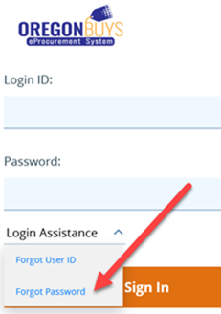
4. In the next window, enter your OR number as your Login ID (OR included), then enter your state email address in the Email Address field and click the Continue button.  Moving forward, your Login ID will remain your OR number. Be sure to save your newly reset password for future use. | 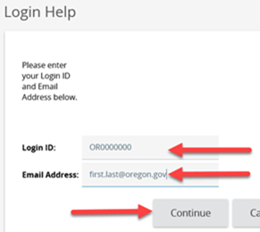
Go-live is August 1
Begin using OregonBuys to process procurement-related activities and spend on August 1. Review the updated transition guidance for processing tips.

Training and resources
Visit the OregonBuys training & resources webpage for courses, instruction guides, and terminology crosswalk.

Help and system support
If you need help activating your account or need system support, contact the OregonBuys helpdesk at 1-888-472-9102 or epro-support@periscopeholdings.com. You can also bring questions to a support session:
Virtual Drop-in Support Sessions (via Zoom)
August 1 through October 3, 2022  - Mondays, Wednesdays, and Fridays from 8 – 10 a.m.  - Tuesdays & Thursdays  from 1 – 3 p.m. |  | URL: https://us06web.zoom.us/j/3685374434  Dial in (choose one phone number):  1 253 215 8782  1 669 900 6833  Meeting ID: 368 537 4434
With all the excitement, we want you to know we’re committed to making this a smooth transition for our agency. Please reach out if you have additional questions or concerns ‒ we’re here to help if you need us.

Sincerely,
Project Coordinator Name & Contact Info

