Revising a Quote After a Bid has Closed in OregonBuys

Overview
- This document is for vendors who have received a revision request from a buyer after a bid has closed. Buyers may submit revision requests for various reasons:
- Clarification or additional information is needed
- A Best and Final Offer (BAFO) is requested
- An error in your quote needs correcting (e.g. “No Bid” must be changed to “No Charge” for a specific line item for awarding purposes)

- If a buyer requests a revision to your quote, you will be notified through an OregonBuys generated email. If the buyer attached any files to the revision request, it will be found within the Revisions tab in OregonBuys, not the OregonBuys-generated email. You must save changes by clicking Save & Continue on the tab where the edit was made.
- Quotes in OregonBuys may not be revised after the Bid Opening Date except at the buyer’s request.
- Only users with Seller privileges can revise a quote in OregonBuys. These instructions assume the logged in user has Seller credentials.

Process to Revise a Quote

Step 1: Launch OregonBuys
- Enter the web site address for OregonBuys (https://oregonbuys.gov) in your browser.
- Once the OregonBuys landing page displays click Sign In.
- Enter your Login ID and Password
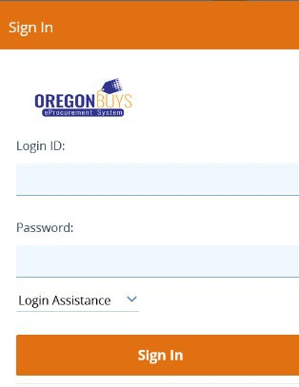
- Click Sign In
- Additional authentication may be required.

Step 2: Locate Requests for Quote Revisions
- From the Homepage click on the Vendor Communications tab to view quote revision requests that have been sent to your company.
- 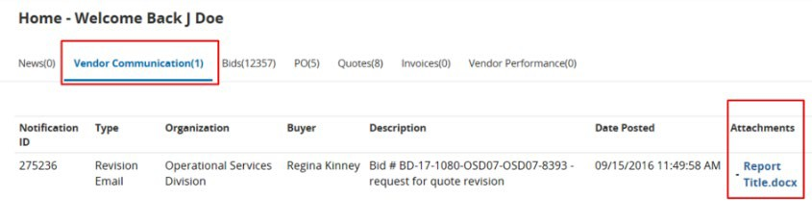
- Any files uploaded with the Revision Request will appear under the Attachments column within the Vendor Communications tab. Click on the blue hyperlinked file name to access the attachment.

Step 3: Locate Quotes that Require Revision
Click on the Quotes tab, and then click on the Revision sub-tab to view quotes that need revising.
- Note: Each quote that has a revision request will have an identifying marker located at the end of the quote number. The first revision request will be identified with an R1, with subsequent revision requests marked as R2, R3, etc.
- 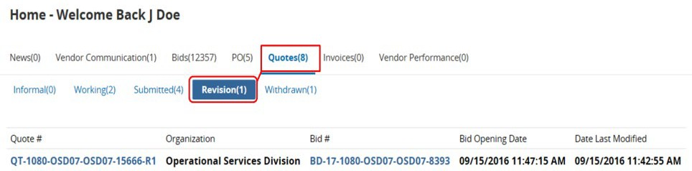

Step 4: Reopen Quotes that Require Revision
- Click on the hyperlinked Quote # to reopen the quote and start the revision process.
- 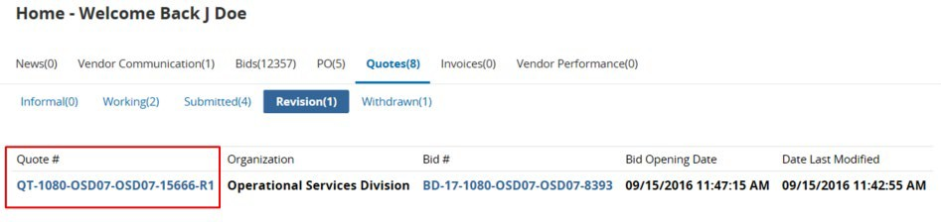

Step 5: Acknowledge Quote Revision

Click Yes to confirm that your revised quote has not been submitted and to begin editing your quote.

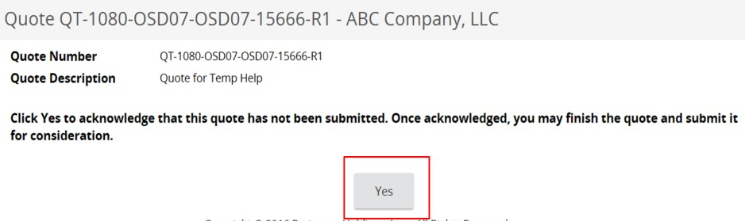

Step 6: Revise the Quote
The system will display the General tab.
- Revise your quote as prescribed by the buyer using any of the following tabs:
- General Tab – modify general quote information such as Description
- Items Tab – add, remove, or edit item information such as Unit Cost
- Questions Tab – answer any questions posed by the buyer (if necessary)
- Attachments Tab – upload or remove files and documents
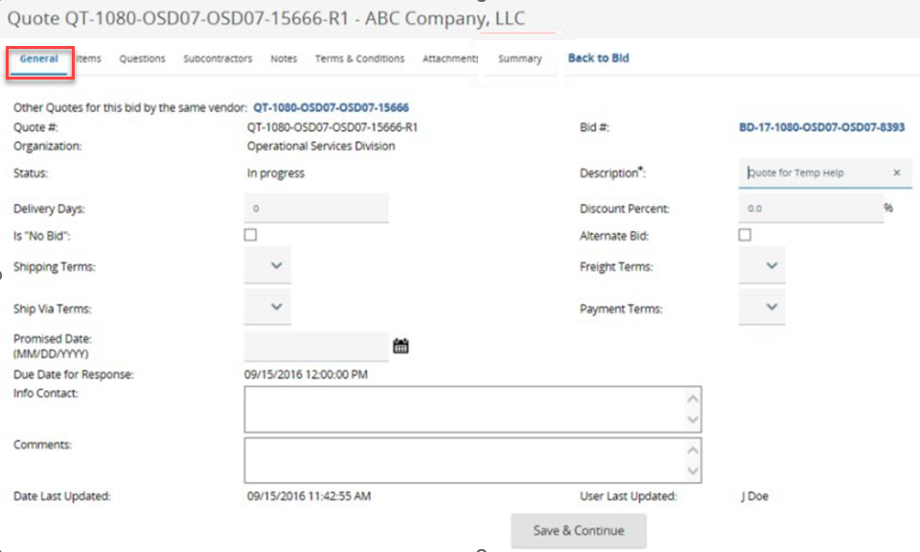
- Click Save & Continue on each tab where the changes were made.
- Review for completeness and compliance with the buyer’s requirements.
- Click on the Summary tab.

Step 7: Resubmit the Quote
- Review the information on the Summary tab for completeness and accuracy.
- Scroll to the bottom of the page and click Submit Quote.
- Click OK in the dialog box to confirm your action
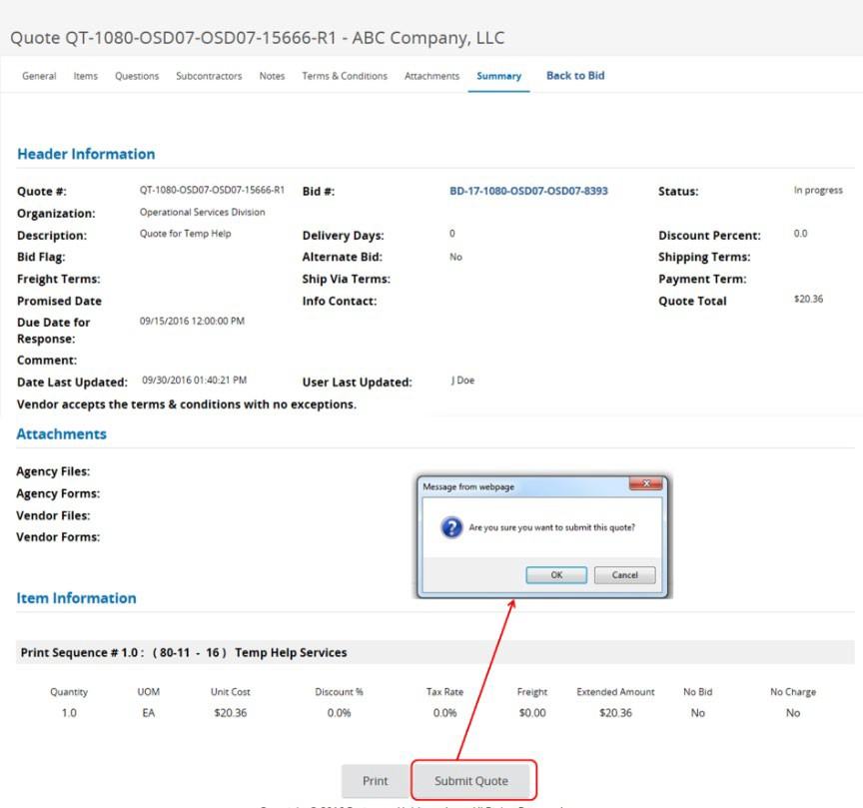

Step 8: Confirm Submission
From the Homepage click on the Quotes tab then the Submitted sub-tab to confirm your revised quote was submitted.
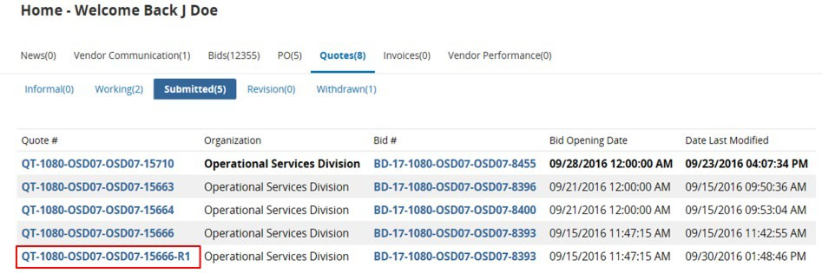
- Note: You will also receive an OregonBuys-generated email confirming your revised quote has been submitted.

