How to Search in Marketplace

Question(s) Answered: | What is Marketplace?  How do I search for on-contract items in Marketplace?  How can I use filters to narrow search results in Marketplace? How can I compare items in Marketplace?  How do I find vendors in Marketplace?
Audience: | All OregonBuys Users
Linked Training | Video: DAS - PS - OregonBuys Search in Marketplace
Disclaimer: The following guidance is provided by DAS State Procurement Services as an overview of this process. Some Agencies may have internal policies procedures or guidelines further detailing these processes. Please check with the agency or organization procurement office for further details.

Vendor Help Desk support.oregonbuys@oregon.gov or 1-855-800-5046
State Agency / OrCPP User Help Desk epro-support@periscopeholdings.com or 1-888-472-9102

Contents
What is Marketplace? 3
Background: What you need to know about Vendors and Marketplace 3
Sample Scenario 4
How do I search for on-contract items in Marketplace? 4
How can I use filters to narrow search results in Marketplace? 6
How do I compare items in Marketplace? 7
How do I find vendors in Marketplace? 8
Next Steps 8

What is Marketplace?
Marketplace is a feature in OregonBuys that is intended to streamline the process of procuring products and services from Oregon’s Statewide Price Agreements. Products and contracts in Marketplace originate from Statewide Price Agreements and Agreements from Oregon Corrections Enterprises or Oregon Forward Contracts.
Marketplace offers simplified searching, the ability to filter, conduct product comparisons, as well as access product images and detailed product specifications.

Key things to know are:
- Marketplace is accessible only while logged into OregonBuys as a Basic Purchasing or Department Access User.
- Vendors in Marketplace have a negotiated and awarded Price Agreement through Oregon’s Department of Administrative Services – State Procurement Services (DAS SPS)
- Not all Price Agreements are represented in Marketplace
- State Agency authorized personnel may initiate requisitions directly from Marketplace.
- OrCPP agencies can use Marketplace to view products and services, however ordering is accomplished through other means that are detailed in the Price Agreement.
- Though items are available for procurement in Marketplace, it is the responsibility of the buyer to know procurement statute and rules and organization policies and procedures around socioeconomic considerations, including, but not limited to the Buy Decision.

Background: What you need to know about Vendors and Marketplace
Vendors with established Price Agreement Contracts that are utilized by state agencies and local government entities can have a presence in OregonBuys through Marketplace. Vendors partner with OregonBuys Supplier Enablement to build a catalog, but the type of information available and the number of items will vary by vendor.
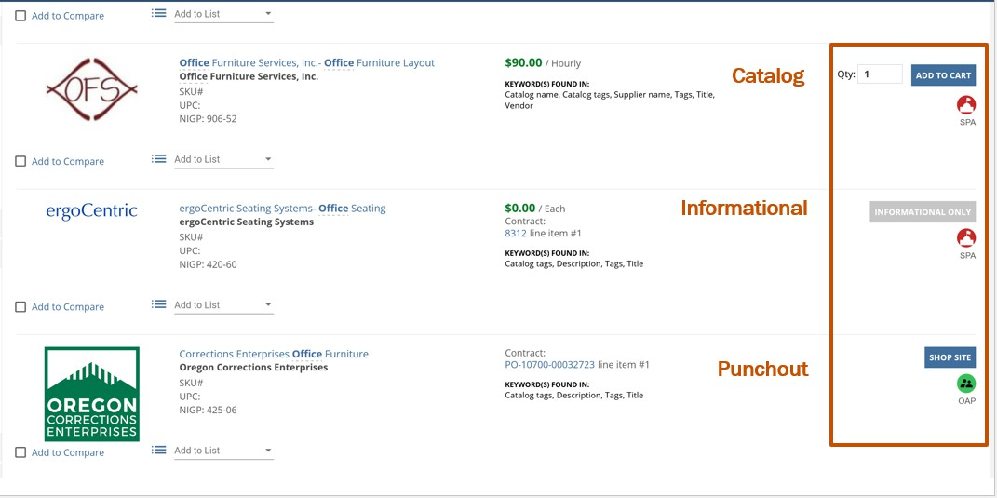
Price agreements may be represented in Marketplace by one of these three presences:
Itemized Catalog: Shows individual items with details (photos, pricing, etc.). Buyers can add these items to a cart and export that cart.
Punchout catalogs: Marketplace displays a connection to the supplier’s ecommerce side. Only the agreed upon contract items are displayed in the punchout.
Informational: Displays general contract information, how to purchase from the contract, and who to contact for purchases.
These are generally one page with no pricing

Sample Scenario
You are a procurement specialist and need carpet tiles and installation for a project. You have accessed the Active Statewide Price agreement list and see that flooring is available. You would like to determine if the contract is available in Marketplace and available for catalog ordering.

How do I search for on-contract items in Marketplace?
- Ensure you are logged into OregonBuys in either a Basic Purchasing or Department Access Role.

- There is more than one way to initiate your search (the Top bar search explained in a. below is the preferred method.) Select one of the Search options below:
  - Option 1: Top Bar Search Option

    - Check to ensure the word “Marketplace” appears in the top search bar.
    - Enter an item name, vendor, contract number, NIGP Code into the Search bar.
    - Click the magnifying glass to initiate the search.


  - Option 2:
    - Select the Marketplace icon from the left menu bar:

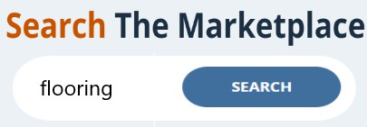
    - Enter a search parameter in the field indicated in the picture below. (Example: “flooring”)

    - Click the blue “Search” icon.

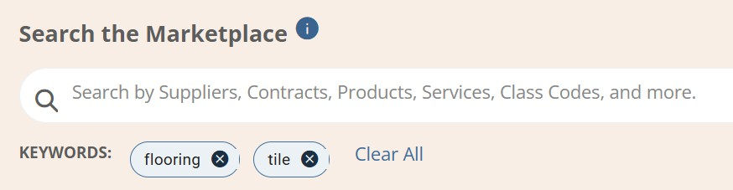
  - Option 3:
After an initial search using one of the methods above, a page displays that allows narrowing of search features by additional key words.

    - Type one or more keywords and press “enter” to initiate the search
    - If you want to limit your results to exact matches, enclose your keywords in quotes (“ “).
    - Please not that all entered keywords will augment your current search and impact the search results accordingly.
    - To begin a fresh search, click the “Clear All” button.
- Whatever search option is used, the two tabs of “Products and Services” and “Contracts” will display below the search results. The products and services tab is the default tab that will be displayed. Each catalog is coded with key words to aid in the search process.

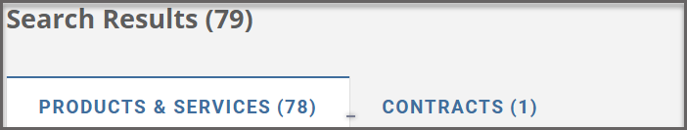
Clicking on the Products and Services Tab displays 78 products and services in Marketplace  This option is most useful when you would like to browse individual items available and would like to compare items from different vendors. | Clicking on contracts displays 1 vendor and the details of their associated contract for flooring.  This option is most useful when you wish to discover available vendors, or you know exactly the vendor you need. The catalog tab will display the contracts that match the entered search terms.
Scroll through images and item details to identify the desired item. The search results displayed originate from the keyword displayed adjacent to the product image.  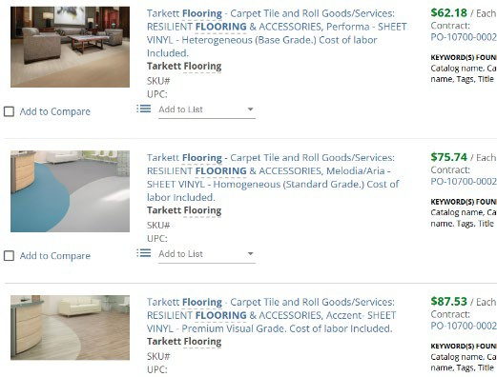  Further item details, including the contract to which it is linked, can be accessed by clicking the item’s name or image.  Similar items and other top 10 related items are indicated as well. | Summary information on each supplier can be viewed. Example: Clicking the link for the one vendor displays information including:  A link to the PO in OregonBuys Contract Heading information Contract Details:  - Addresses and Contact information  - Contract Administrator Information  - Contract Terms  - Contract Detail  Contract Attachments:  - Buyers Guide  - Other contract documentation

- Search tips:

  - Place search terms inside quotes. (“flooring”)
  - Use higher level search terms instead of individual items. (Office supplies instead of pencils)
  - Try using different search terms if you receive no results.

How can I use filters to narrow search results in Marketplace?
In some instances, utilizing filters in Marketplace can help narrow the number of items, or it may assist Buyers in identifying vendors meeting certain criteria. The filters differ depending upon whether the user has selected the Contracts Tab or the Items Tab.
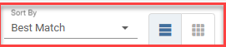
- A sort feature allows viewing results by price and product name.
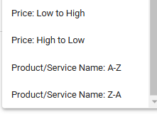


- The two icons next to Best Match allow the user to view products vertically or horizontally.

- The products and services tab allows for filtering by price, NIGP codes, PO numbers, Procurement Priority/Preferences, Vendors, Catalog Categories, and more. The categories additionally have expandable dropdown menus to allow more refined filtering. For example. The filter for “Manufacturer” displays a list of specific businesses from which you can filter products.

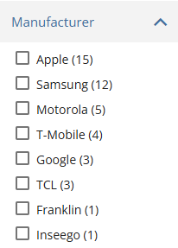
- The contract tab allows filtering by Contract Status, Contract Categories, NIGP Codes, Vendors, and more.

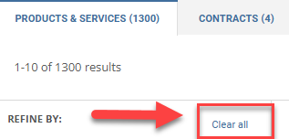
- Use CLEAR ALL to clear filters from previous searches.

How do I compare items in Marketplace?
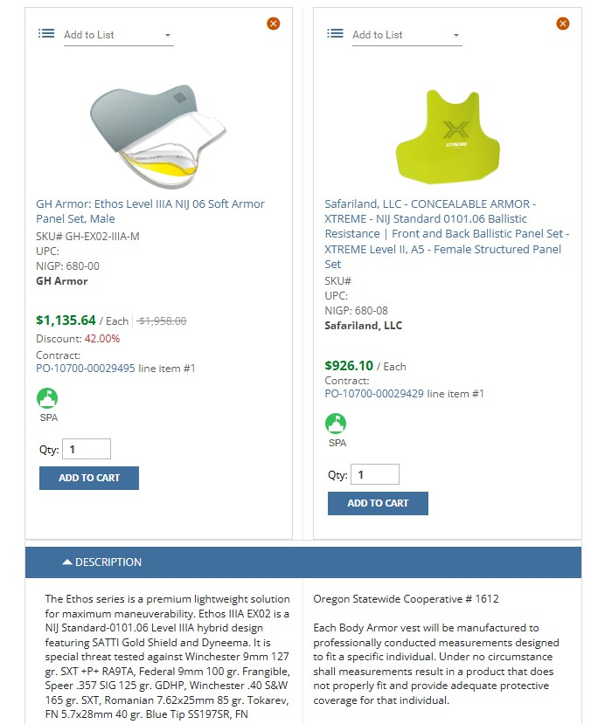
- Ensure you are on the products and services tab
- Locate the image of the item(s)
- Select “Add to Compare” for up to three items you would like to compare. Below is an example of the comparison steps for two body armor panels.

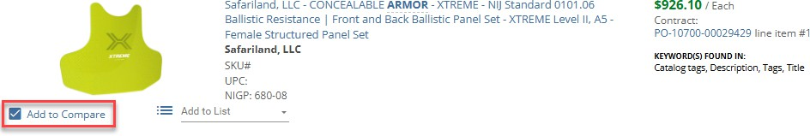
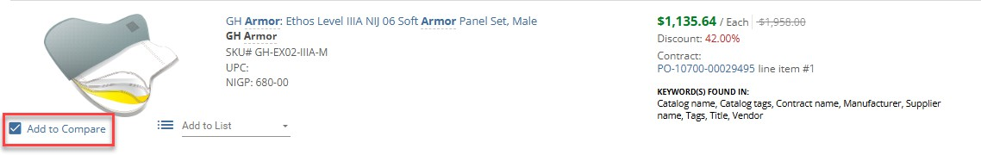

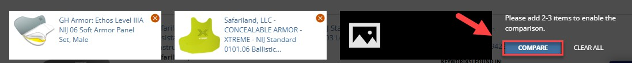
- Compare the items now listed as the bottom of the screen.

Click the Compare icon. A side-by-side view is enabled. State agency viewers at this point could select the desired item and add it to the Shopping cart. Details on requisitions (state agency users only) are covered in a different guidance document.

How do I find vendors in Marketplace?
Several features are available through browsing in Marketplace to assist users in quickly locating contracts, items and vendors.
The example below shows a search for a list of suppliers with contracts in Marketplace.

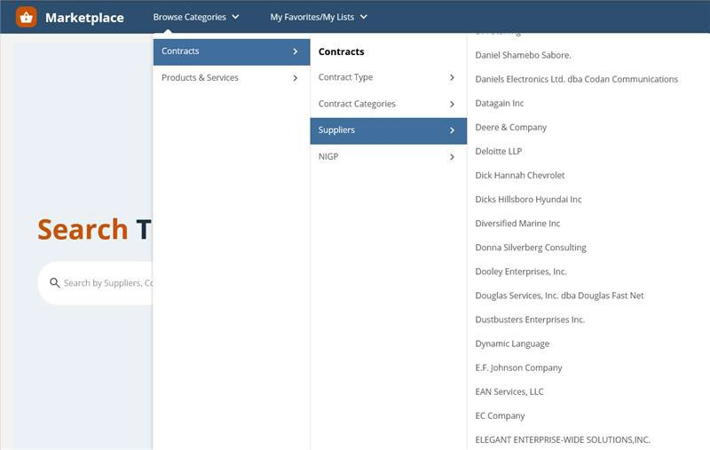

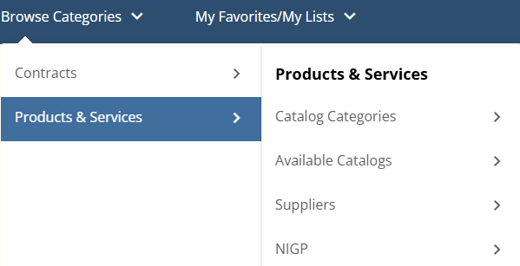
Additional search options under Products and Services allow searching by supplier or other parameters.

Next Steps
Once you have located the product(s) or services needed through Search, Browsing, and Filtering features in Marketplace, you may be ready to order. This is known as the Requisition process. State Agency users in OregonBuys may continue the requisition process utilizing OregonBuys.
As noted earlier in this guidance document, OrCPP (local government) members will need to access the vendor information and continue the ordering process outside of OregonBuys.

