After months of planning and preparation, we’re just days away from May 2 when OregonBuys procure-to-pay functionality goes live at our agency. Here’s everything you need to know to be ready:

Activate your account now
If you haven’t already done so, activate your account (in the live Production environment) using the steps below. Note: You’ll have to wait until May 2 to process procure-to-pay activities in OregonBuys.

- Navigate to the OregonBuys site https://oregonbuys.gov (bookmark the URL for future access).
2. Click on the orange Sign In button in the top right corner. | 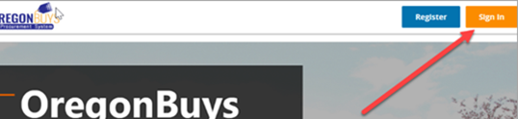
3. From the pop-up window, click the dropdown for Login Assistance and choose Forgot Password. | 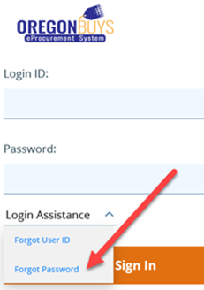
4. In the next window, do one of the following:  - If your account was setup prior to January 2023, enter your OR number in the Login ID field (OR included), then enter your state email address in the Email Address field, and click the Continue button.  - If this is a new account, enter your state email address in the Login ID, and again in the Email Address field, then click the Continue button.  - If you’re not sure which of the above options to use, click on the orange “sign in” button (as shown in step 2 above), and click login assistance, then “forgot user ID”.  Moving forward, your Login ID will remain your OR number or your email address. Be sure to save your newly reset password for future use. | 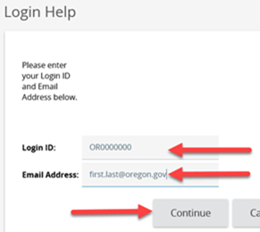
Go-live is May 2
On May 2, begin using OregonBuys to process procurement-related activities and spend. Review this updated transition guidance for processing tips.

Training and resources
Visit the OregonBuys training & resources webpage for courses, instruction guides, and terminology crosswalk.

Help and system support
If you need help activating your account or need system support, contact the OregonBuys helpdesk at 1-888-472-9102 or epro-support@periscopeholdings.com. You can also bring questions to a support session:
Virtual Drop-in Support Sessions (via MS Teams)
- May 2 – 23, 2023  - Monday – Friday  - From 8 – 9 a.m. |  | Click here to join the meeting  Or call in for audio only:  +1 647-793-7613,,334527853#  Meeting ID: 334 527 853#
Lastly, we want you to know we’re committed to making this a smooth transition for our agency. Please reach out if you have additional questions or concerns ‒ we’re here to help if you need us.

Sincerely,
Project Coordinator Name & Contact Info

