After months of planning and preparation, we’re just days away from September 19 when OregonBuys procure-to-pay functionality goes live at our agency. Here’s everything you need to know to be ready:

Activate Your Account Now
If you haven’t already done so, activate your account (in the live Production environment) using the steps below. Note: You’ll have to wait until September 19 to process any procure-to-pay activities in OregonBuys.

- Navigate to the OregonBuys site https://oregonbuys.gov (bookmark the URL for future access).
2. Click on the orange Sign In button in the top right corner. | 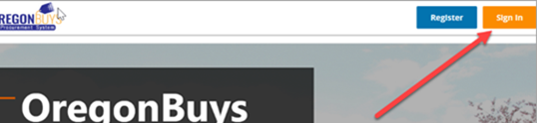
3. From the pop-up window, click the dropdown for Login Assistance and choose Forgot Password. | 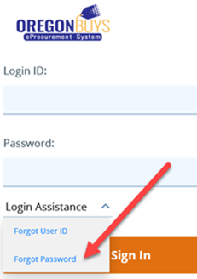
4. In the next window, enter your state email address in the Login ID, and again in the Email Address field, then click the Continue button.  Moving forward, your Login ID will remain your email address. Be sure to save your newly reset password for future use. | 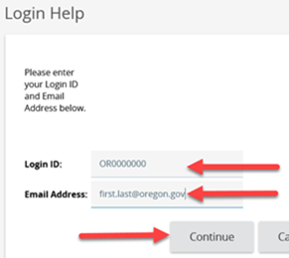
Go-live is September 19
On September 19, begin using OregonBuys to process procurement-related activities and spend. Review this updated transition guidance for processing tips.

Training and Resources
There is one more facilitated training offered for the roles of Accounts Payable (AP), Basic Purchasing (BP), or Department Access (DA) users during the week of September 11 – so don’t miss out. Visit the OregonBuys training & resources webpage for links to these and other self-guided courses, instruction guides, and a terminology crosswalk.

Help and System Support
If you need help activating your account or need system support, contact the OregonBuys helpdesk at 1-888-472-9102 or epro-support@periscopeholdings.com. You can also bring questions to a support session:
Virtual Drop-in Support Sessions (via MS Teams)
Sep. 19 – Oct. 30, 2023  Monday – Friday  From 1 – 2 p.m. |  | Click here to join the meeting  Or call in for audio only:  +1 647-793-7613,,198425462#  Conference ID: 198 425 462#
Lastly, we want you to know we’re committed to making this a smooth transition for our agency. Please reach out if you have additional questions or concerns ‒ we’re here to help if you need us.

Sincerely,
Project Coordinator Name & Contact Info

