

How to Withdraw, Reopen, and Resubmit a Quote

in OregonBuys

Overview
Quotes can be withdrawn, modified, and resubmitted any time before the Bid Opening Date. The Bid Opening Date is the deadline to submit a quote response to a bid.
The submitter may need to withdraw and resubmit a quote because:
- The wrong file was uploaded to the quote
- A file was mistakenly excluded from the original quote submission
- Additional information may need to be included in the quote
Only users with Seller privileges can modify a quote in OregonBuys. These instructions assume the logged in user has Seller credentials.

Steps

Step 1: Launch OregonBuys

- Enter the web site address for OregonBuys (https://oregonbuys.gov) in a web browser.

- Once the OregonBuys landing page displays click on the Sign In button.
- Enter user’s Login ID and Password and sign in to OregonBuys.
- Click Sign In
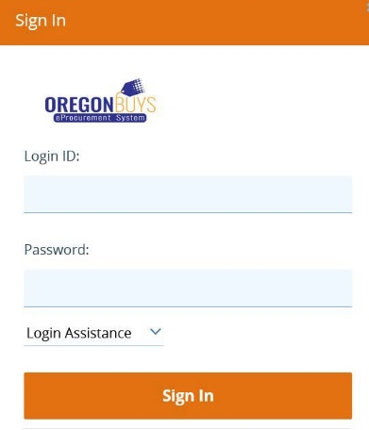

Step 2: Locate Quotes
- From the Homepage click on the Quotes tab, then click the Submitted subtab to view quotes that have been submitted.
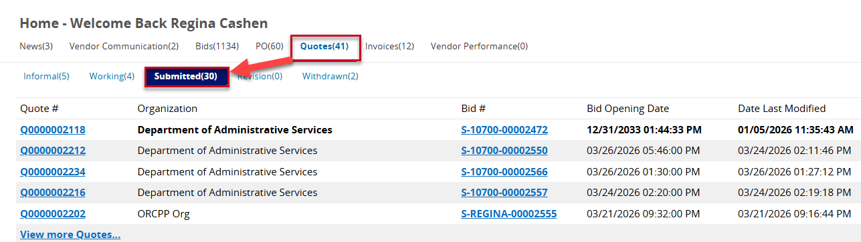
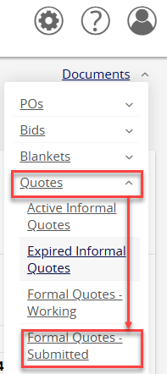
- Quotes can also be accessed by using the Documents navigation link. Click on the down-facing arrow next to Documents. Then click on the down-facing arrow next Quotes. Click on Formal Quotes – Submitted to view quotes that have been submitted by the company.

Step 3: Access Quotes
Click on the blue hyperlinked Quote # to access the quote the user wishes to withdraw.

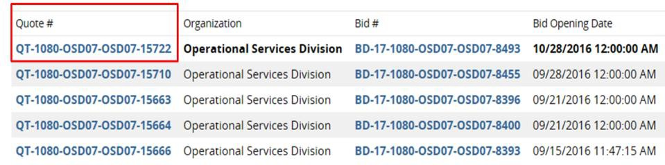

Step 4: Withdraw the Quote
- Click on the blue hyperlinked Quote # to which takes the user to the General tab of the quote.
- Click on the Summary tab then scroll to the bottom of the page. 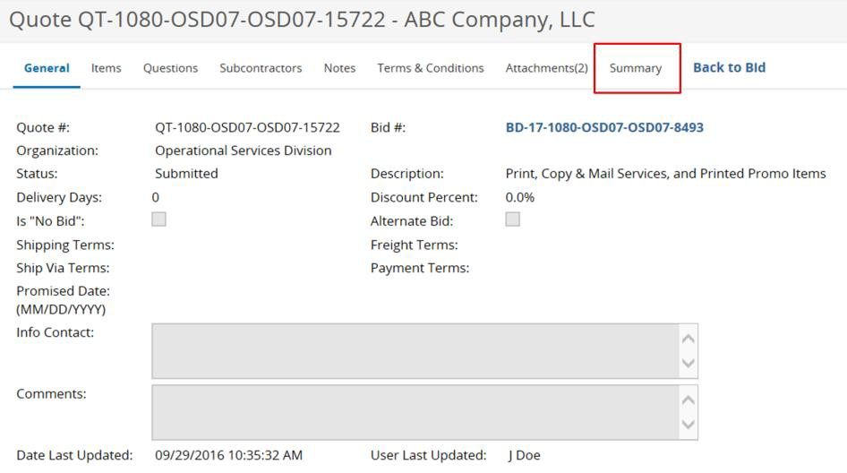
- Click the Withdraw Quote button.
- Click OK in the dialog box to confirm the action.
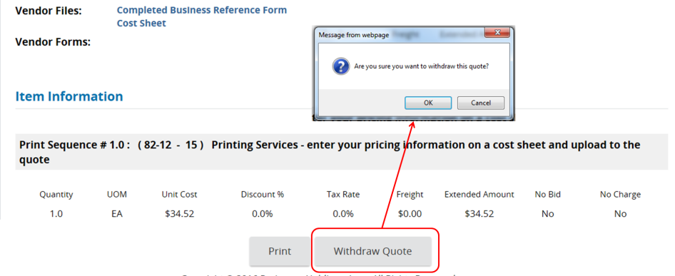

Step 5: Reopening the Quote
- A yellow confirmation message will appear at the top of the page stating, “Your quote has been withdrawn.”
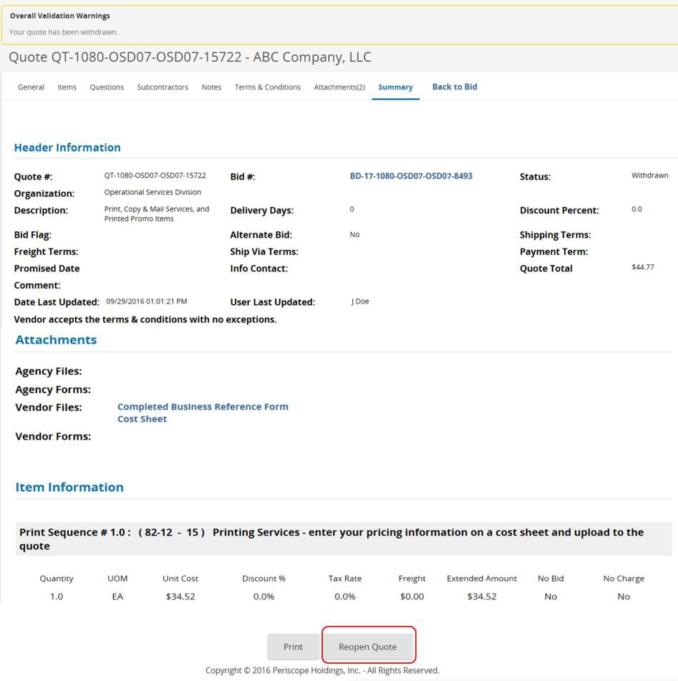
- Scroll to the bottom of the page and click Reopen Quote.

Step 6: Modify the Quote
Modify the quote using any of the following tabs:
  - General tab – modify general quote information such as Description
  - Items tab – add, remove, or edit item information such as Unit Cost
  - Questions tab – answer any questions posed by the buyer
  - Attachments tab – upload or remove files and documents

Step 7: Review the Summary Tab and Resubmit
- Review all sections for completeness and compliance with bid requirements. When any changes have been made and saved, and the quote is ready to submit, click on the Summary tab.
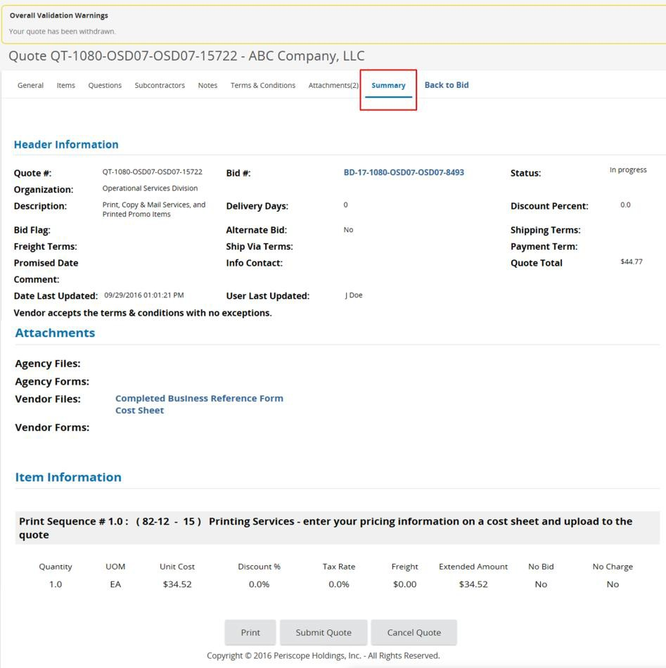

Resubmit the quote:

Scroll to the bottom of the page and click Submit Quote.

Click OK in the dialog box to confirm.

