Emergency Commodity Report

***REMINDER***
Your report will not run until 6PM
What is the Emergency Commodity Report?

This is a report in ORPIN that can be generated based on a listing of commodities that may be needed during an emergency. It will return a list of suppliers registered in the ORPIN system that have marked they can supply those items or services.

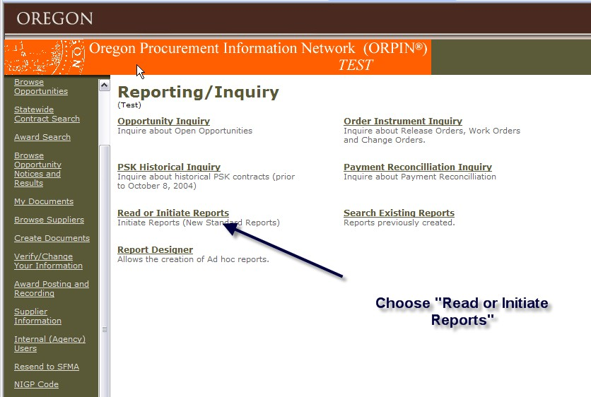

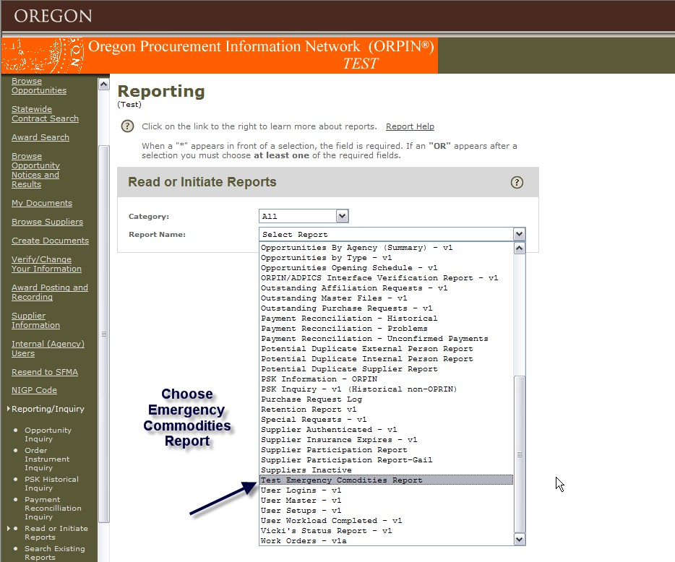

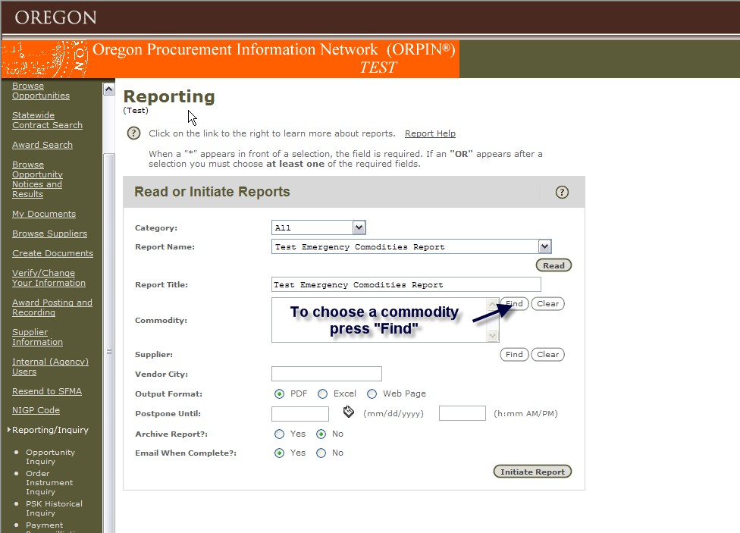

The list below shows the current commodities you can search for this report.

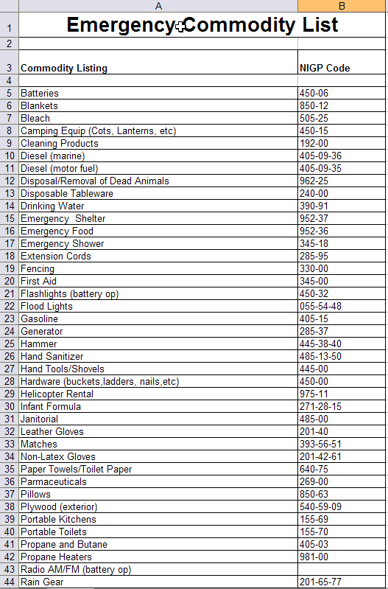

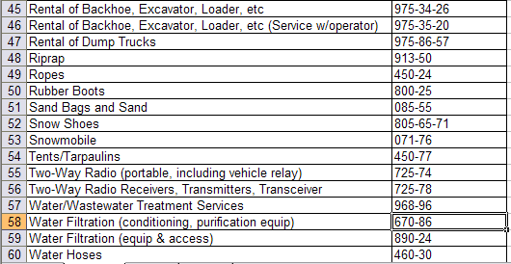

For my example I will be choosing the commodity of “water”

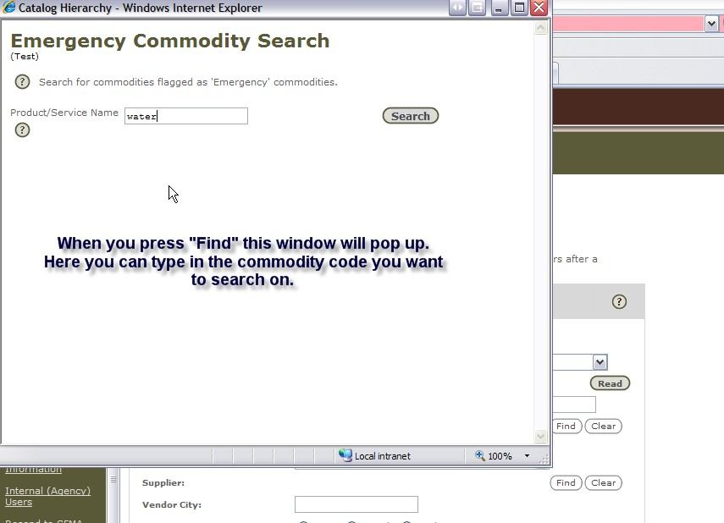

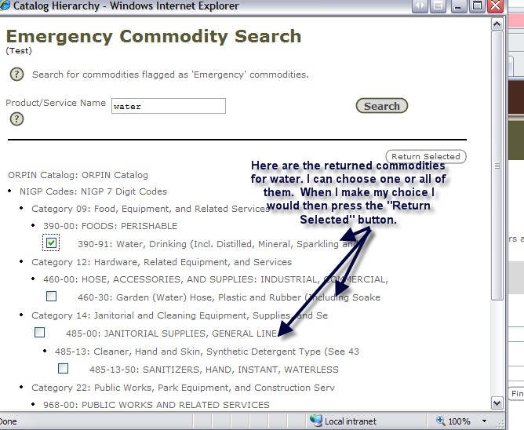

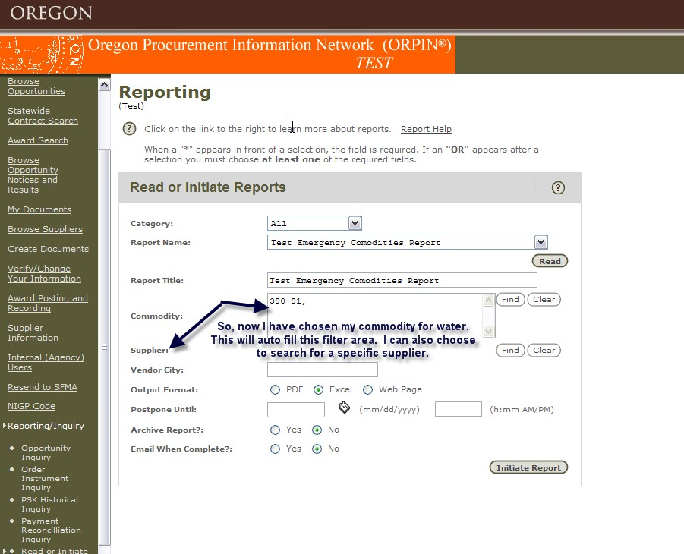

You also have the option to narrow your search on this screen by choosing the city the vendor is located.

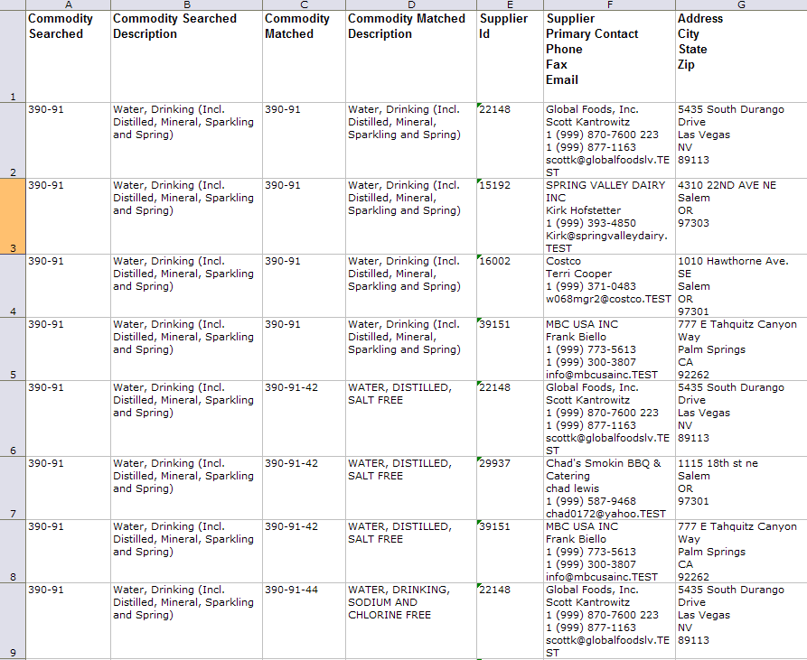

Now I will search for a commodity that is NOT already on the emergency commodities list

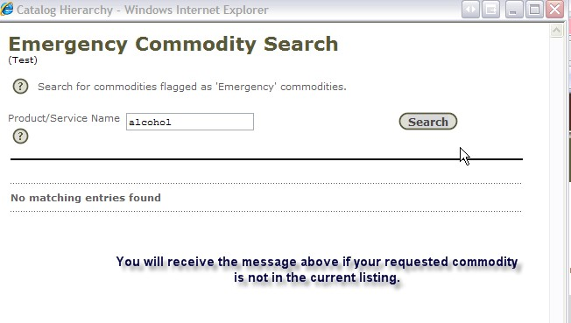
If you strongly believe that a commodity has been left off of the emergency commodity list, please contact the ORPIN team at (503) 378-4642.

