Searching Existing Awards in ORPIN

- Log into the ORPIN website at https://orpin.oregon.gov
- Click on Award Search in the menu bar.
  - Use the General Award Search to view award documents that you have authorization for. (This would consist of awards for your Agency or statewide contracts
  - Use the Contract Browse option to research award documents for other agencies.
- Search for award documents by your preferred criteria.
  - Before performing a Keyword search, it is recommended to check the In Title box so that the program will search award titles as well.
  - If you want to look specifically at Interagency Agreements, set the Contract Type dropdown to “Intergovernmental Agreement (ORS 190)” to reduce your search results.
  - To limit results to a specific Agency’s contracts, click the Find button next to Organization to search for the Agency’s name. Be sure to choose the highest level of that Agency’s hierarchy. (For example, choose the Agency level of Department of Parks and Recreation, not a specific state park.)
  - If you are searching by Organization, BE SURE to check the box to include organizational sub-units!!! If you do not check this box, ORPIN will not include awards issued for any of the lower levels of this agency.
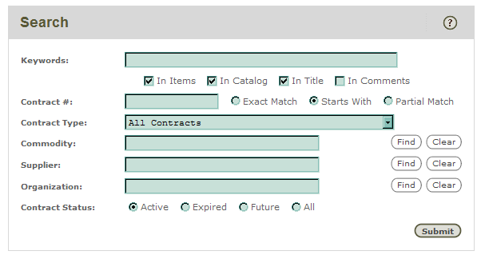
4. Once you find an award that you want to look into, click on the underlined award number. This will take you to the face of the ORPIN award document. Read the information displayed in the white screen, and look for any attachments uploaded in the “Attachments Exist” folder under the state seal image.
Disaster Procurement Guidebook
Page 18

