Form DP200 - Procurement Process Flow Chart

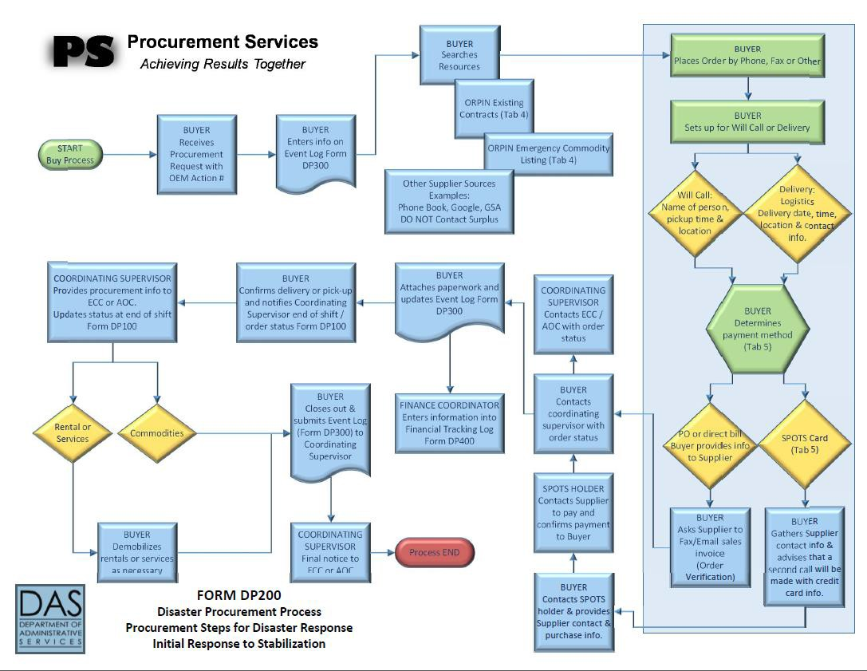
OregonBuys
OregonBuys

