Private Lots – Salem Capitol Mall Area
Location # (see map on following page) |  | Rates may vary during Legislative Session
1 | Oregon Business & Industry – 12th & Court NE | $80/mo. (assigned) | 503-580-1964
2 | Bellinger Tire – 14th and State | $60/mo. (assigned) | 503-399-1198
3 | Howard Street Charter School – 625 Marion NE | $70/mo. (assigned) | ctracy@howardstreet.org
4 | Deems, Inc. – 315 12th NE | $70/mo. (assigned) | 503-585-1645
5 | Deems, Inc. – 266 Capitol & 1170 Center NE | $70/mo. (assigned) | 503-585-1645
6 | Pike’s NW Property Mgmt. – 1350 Ferry SE | $65/mo. (assigned/lease) | 503-588-3586
7 | Lee Apartments – 585 Winter NE | $35-$50/mo. (assigned) | 503-364-1641
8 | Willamette Heritage Center (Mission Mill) – 1313 Mill NE (North alley parking strip) | $59/mo. (assigned) | 503-585-7012
9 | St. John Lutheran Church – 1350 Court NE | $50/mo. (assigned) | 503-588-0171
10 | John or Betty Lippold – 540 Union St NE | $45/mo. (assigned) | 503-585-9514
11 | 6 Nineteen Apartments – 1245 Chemeketa NE | $50/mo. (assigned) | 6nineteenapartments@gmail.com

Private Lots - Portland Lloyd District
City Center Parking – Office: 65 SW Yamhill St | 503-221-1666
Star Park – 7th & Irving | 503-223-4128

Other Information
Parking
State of Oregon Parking Office (provider of this list) | 503-378-5090
City of Salem – Parking Permits | 503-589-2075 x 7
Transit
Salem-Keizer Transit Bus Information – Cherriots www.cherriots.org | 503-588-2877
SMART Bus – Wilsonville/Salem www.ridesmart.com | 503-682-7790
Tri-Met Bus Information – Portland trimet.org | 503-238-7433
Vanpool/Carpool
Cherriots Trip Choice – vanpool and carpool matching via Drive Less Connect www.cherriots.org/en/tripchoice | 503-588-2877
Valley Vanpool www.cwride.org | 541-812-2004



Private Parking Locations - Salem Capitol Mall Area

State buildings or parking lots are noted in black

Private parking lots are noted in blue

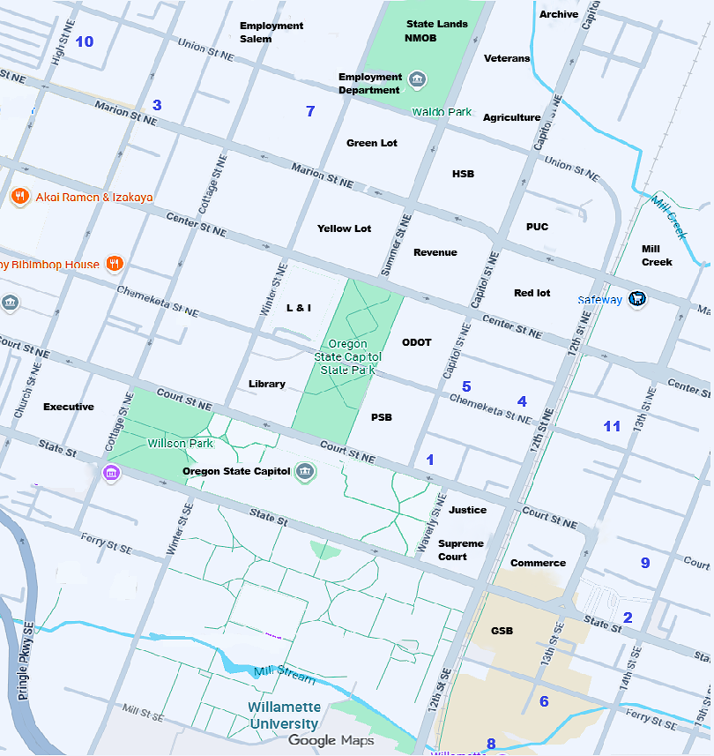

12221

