Sampling and Analysis Plan
Volunteer Water Quality Monitoring
Descriptive Project Title Here

Submitted to: If needed
Month 20xx
This template is to be used when creating a sampling and analysis plan (SAP) in partnership with the Oregon DEQ Volunteer Monitoring Program. This particular template is designed to be used with the DEQ Volunteer Monitoring Quality Assurance Project Plan (QAPP) acting as an umbrella document. All projects requesting SAP approval through the Volunteer Monitoring Program agree to follow the quality assurance requirements defined in the Program QAPP, unless specifically stated and justified within this SAP. For unique projects, this template can be adapted to be a stand-alone quality assurance document, with approval by the DEQ Volunteer Monitoring Program Coordinator.
Template guidance: blue
Example content: red
Final text: black

REMOVE BEFORE PUBLISHING

This document was prepared by
Oregon Department of Environmental Quality
Laboratory and Environmental Assessment Division
7202 NE Evergreen Parkway
Hillsboro, OR 97124
Contact: Contact
Phone: 503-693-5700
www.oregon.gov/deq

DEQXX-LAB-XXXX-SOP
Version X.X
Last updated:

Printed copies of this document are considered uncontrolled.

Translation or other formats

Español | 한국어 | 繁體中文 | Pусский | Tiếng Việt | العربية
800-452-4011 | TTY: 711 | deqinfo@deq.oregon.gov

Non-discrimination statement
DEQ does not discriminate on the basis of race, color, national origin, disability, age or sex in administration of its programs or activities. Visit DEQ’s Civil Rights and Environmental Justice page.

Project approvals

Prepared by: |  | Date:
 | Name, Position/Title
Reviewed by: |  | Date:
 | Name, Watershed Council Coordinator/Monitoring Partner
Reviewed by: |  | Date:
 | Name, DEQ Quality Assurance Officer (QAO)
Approved by: |  | Date:
 | Name, Volunteer Monitoring Coordinator/DEQ Project Manager
Approved by: |  | Date:
 | Add as needed

Table of contents
1. Project Management 1
1.1. Distribution List 1
1.2. Project/task organization 1
1.3. Problem definition/background 1
1.4. Project/task description 2
1.5. Quality objectives and criteria 3
1.6. Training Requirements and Certification 3
1.7. Documentation and Records 3
2. Data Generation and Acquisition 4
2.1. Sampling Process Design 4
2.2. Sampling methods 5
2.3. Sample handling and custody 5
2.4. Analytical methods 6
2.5. Quality control 6
2.6. Instrument/equipment testing, inspection, and maintenance requirements 6
2.7. Instrument calibration and frequency 6
2.8. Non-direct measurements 7
2.9. Data management 7
3. Assessment and Oversight 7
3.1. Assessment and response actions 7
3.2. Reports to management 7
4. Data validation and usability 8
4.1. Data review, validation, and verification 8
4.2. Validation and verification methods 8
4.3. Reconciliation with data quality objectives 8
5. Revision History 9

List of tables
Table 1 Distribution List 1
Table 2 [Example Project Gantt Chart] 2
Table 3 Controlled Documents 3
Table 4 Summary of the sampling locations 4
Table 5 Summary of sampling parameters 5
Table 6 Summary of analytical parameters and methods 6
Table 7 Revision History 9

Project Management

Distribution List
The following personnel will be emailed regarding all aspects of this sampling and analysis plan (SAP). Deviations from this SAP must be communicated in writing (email is acceptable) to all individuals identified in Table 1. Final reports from the DEQ Laboratory will be emailed and mailed to the project manager, regional monitoring coordinator and laboratory monitoring coordinator/data manager.
Table 1 Distribution List
Name | Phone | Email
Name, Organization Project Manager | Phone | Email address
Nick Haxton-Evans, DEQ Volunteer Monitoring Program Coordinator | 503-693-5731 | nick.haxton-evans@deq.oregon.gov
Ben Hamilton, DEQ Field QAO | 503-839-6551 | benjamin.t.hamilton@deq.oregon.gov
(fill in Distribution List as appropriate)

Project/task organization
Sampling Organization(s): Include all relevant groups
Analytical Organization: Include third party laboratory details including contact information
Example:
DEQ Laboratory and Environmental Assessment Program
7202 NE Evergreen Parkway,
Suite 150
Hillsboro, Oregon 97124
Ph: 503-693-5700
Contact: Jane Quality, Laboratory Representative
Add additional organizations as needed

Problem definition/background
Clearly state the purpose of your monitoring.
For example: The purpose of this monitoring is to characterize summer baseline water quality conditions for dissolved oxygen and temperature in the Our River watershed.
Include a brief discussion of the specific problem to be solved, decision to be made, or outcome to be achieved. Provide sufficient background information to communicate a historical, scientific, and/or regulatory perspective for this particular project.
Identify how your data will be used and by whom.
For Example: The data will be used by the Our River Watershed Council to prioritize basins where restoration activities should occur. The Oregon DEQ will use the data to assess whether the Our River is meeting water quality criteria to protect beneficial uses.
Give a brief description of your watershed and any important background information that is relevant to this plan.

Project/task description
Provide a summary of all work to be performed, products to be produced, and the schedule for implementation: what sampled, where sampled, kind of samples taken, conditions to be sampled, how data will be analyzed.
For Example: The Our River Watershed Council will collect continuous temperature and dissolved oxygen data in the Our R. Samples will be collected at major landscape changes and at the mouths of major tributaries at a total of six sites. Dissolved oxygen sampling will alternate between morning and afternoon sampling. Summary statistics for the continuous temperature (seven-day maximum moving average and daily differences in min and max temps) and dissolved oxygen will be compared between locations and against designated water quality criteria. Summary statistics of interest for temperature will be the maximum seven day moving average and differences between daily minimum and maximum temperatures. Dissolved oxygen summary statistics will be: number of samples outside of water quality criteria and average morning or afternoon concentrations.
Include any constraints that might limit your ability to complete the project as defined. Consider financial limitations, volunteer time, land owner site access, etc.
Provide a timetable for the project. For Example: Table 2
Table 2 [Example Project Gantt Chart]
Tasks to be completed | Months for year 2005 - 2007
 | 1 | 2 | 3 | 4 | 5 | 6 | 7 | 8 | 9 | 10 | 11 | 12
Sampling planning and revision | x | x | x
Temperature logger quality control testing |  |  |  | x |  |  |  |  |  | x
Continuous temperature data collection |  |  |  | x | x | x | x | x | x | x
Weekly dissolved oxygen and temperature testing |  |  |  |  |  | x | x | x | x | x
Data entry |  |  |  | x | x | x | x | x | x | x | x
Data analysis and reporting | x | x |  |  |  |  |  |  |  |  | x
Etc.

Quality objectives and criteria
This section should discuss the quality objectives for the project and the performance criteria to achieve those objectives.
Data quality levels are defined within the most current DEQ Volunteer Monitoring QAPP. When referencing the QAPP for the first time in this SAP document, please identify which version of the QAPP is being referenced. Select what data quality level will be your target for your parameters and state that here. If you have parameters which are not listed within the Program QAPP then you will need to develop your own criteria. Contact the DEQ Volunteer Monitoring Coordinator with questions.
If there are any elements of the DEQ VOLUNTEER MONITORING QAPP measurement quality objectives that you do not wish to commit to, then you should define your exceptions here.
If analytical laboratories are involved, they should be ORELAP accredited for the analysis conducted. If non-ORELAP approved analysis is included, information on Limits of Quantitation (LOQs), Quality Controls (QC) and control limits must be provided within this SAP or within referenced documentation.
For representativeness, define what conditions your sampling will be characterizing: ambient, storm event, morning, summer, etc.
For Example: The monitoring is intended to capture storm event conditions. For the purposes of this project, a storm event flows are defined as …

Training Requirements and Certification
Groups participating in the program should be trained by DEQ staff or go through other appropriate training. Explain here how all participating individuals will receive training prior to data collection. Alternatively, describe levels of education, certification and/or field experience that show sufficient competence in the proposed monitoring methods for all participating individuals.

Documentation and Records
This section should describe how project documents will be controlled or revised. In order to assure data quality over time, groups will follow the Document Retention Policy outlined in the DEQ Volunteer Monitoring QAPP for all documents relevant to their study. Key documents of that policy are listed in Table 3. If there are elements of the policy that you do not wish to commit to, then you should define your exceptions here.
Table 3 Controlled Documents
Document or Record Name and Description | Storage Location | Storage Time
DEQ Quality Assurance Project Plan (QAPP) (v.X)- DEQ04-LAB-0047-QAPP project description and assurance procedures. | DEQ Internet Page | 5 years
Our Sampling Analysis Plan- specific sampling information for each groups activities. | DEQ Laboratory and Our R. WC office | 5 years
DEQ Laboratory Mode of Operations Manual- Methods manual | Our R. WC office | 5 years
Equipment Notebooks - records of quality control checks, calibrations and maintenance. | DEQ equipment case, Our R. WC office, etc. | 5 years
Field Data or Chain of Custody Sheets/Electronic Files – Field forms containing sampling meta data and raw field data. | Our R. WC office | 5 years
Additional entries as needed

Data Generation and Acquisition

Sampling Process Design
Sampling design, collection, methods and handling will be managed by the sampling organization identified in section 1.2. The sampling organization will ensure that all samples will be collected in the appropriate sample containers, preserved as identified in the appropriate reference methods, and transported to the analytical organization within the appropriate sample holding times, with the appropriate documentation, and under the appropriate sample transport conditions. Analytical laboratories assume no responsibility for the quality of data resulting from samples that were collected, shipped, or stored under inappropriate conditions.
From this section a reader should be able to quickly identify the different parameter tests that will be needed for your project.
- Define the logic for your sampling plan including how you are selecting the intended sampling sites; what parameters are to be collected at each site; when samples are to be collected.
Examples include:
Locations- mouth of major tributaries, land use boundaries, randomized, etc.
Parameters- why certain test(s) were selected
Time of sample- consider daily fluctuations of some parameters, storm events, time of beneficial use like fecal bacteria during swimming season, or salmon spawning and temperature.
- How will you identify new sites over the life of the project if you plan to add new stations?
- If not covered in first bullet, identify any environmental conditions that will determine when you sample—rain events, stream flows, seasons, etc.
- How your access to sites may be limited—private property, weather conditions, etc.
- If the exact locations are known for your sites, include a table similar to Table 4 with the following information: DEQ Station ID, Station Description, parameters tested, latitude and longitude. Please note you will need to send in a latitude and longitude as well as an image showing where on a map each station is located. Accuracy of the site location is essential to properly associating data to its source.
The locations to be sampled are summarized in Table 4.
Table 4 Summary of the sampling locations
DEQ Station ID * | Organizational Site ID | Latitude/Longitude | Station Description | Parameters
*If a Station ID number is not available during QAPP/SAP development, the DEQ Laboratory will generate the unique identifier prior to data processing.

Sampling methods
Describe the procedures for collecting samples and identify the sampling methods and equipment.
- How will you collect samples? (sample container from bridges, wading, from boat, etc.)
- Review section 2.3 “Sample Handling and Custody Procedures” of the Volunteer Monitoring Program QAPP. If there are any differences in sample collection containers, holding times or preservation for your project specify the changes.
- Indicate how field instruments should be deployed and operated to avoid contamination and ensure maintenance of proper data.
- Where applicable, describe the process for the preparation and decontamination of sampling equipment, including the disposal of decontamination by-products.
- For continuous monitoring equipment, what results recording interval will you use? (1 hour, 30 minutes, etc.)

Sample handling and custody
If applicable to our monitoring, identify how samples should be labeled, physically handled, transported, and then received and held in the laboratory. Examples: Sample labels will include location, date, time, type of sample, and sampler’s name. Samples will be shipped overnight to laboratory.
Table 5 Summary of sampling parameters
Sample Type | Container | Preservation | Holding Time
- Provide a summary of sampling containers, preservation requirements, and holding times. Example: Table 5
- If you will be compositing samples that aren’t defined in the Volunteer Monitoring Program QAPP, define how you will composite samples.
- Describe procedures for keeping track of what samples came from what site. If you have a chain of custody form for sending samples to a lab, refer to it here. Please append the form to the end of the sheet.
- For continuous monitors, identify the maximum time before the units will be retrieved and the data downloaded.

Analytical methods
- Review the Volunteer Monitoring Program QAPP for analytical requirements. If you are conforming to the standard methods defined in the QAPP, please list where the sample will be analyzed (field or lab) and reference the QAPP. Complete Table 6.
- If you will be performing different methods than defined in the QAPP, you will need to give a complete description or reference for the alternative methods. Provide the following information:
  - List analytical methods for each parameter in Table 6.
  - What equipment will be used to make the measurement?
  - Will the analysis happen in the field or lab?
  - When using documented standards refer to them and give a reference where the information can be found. If the methods are not easily found by the reference attach a copy of the methods.
  - How will you dispose of processed samples?

Table 6 Summary of analytical parameters and methods
Sample Type | Parameter | Reference Method (required)
Surface water sample | E.coli | NEMI Method SM 9223B

Quality control
Identify QC activities and criteria which should be used for each type of sampling, analysis, or measurement technique.
- Review the Volunteer Monitoring Program QAPP for quality control requirements. If you are following these protocols, list the quality control tests you will use (duplicates, accuracy checks, splits, etc.) and reference the QAPP.
- If you will be conducting different quality control procedures than defined in the QAPP, provide a complete description or reference for the alternative procedures. Define your quality control tests and the frequency of each type of quality control test.
- If you are using an outside laboratory, state whether or not it is ORELAP accredited for the analysis you are requesting. For non-ORELAP accredited analyses, please include or reference their quality control procedure documentation. See Appendix C from the Volunteer Monitoring Program QAPP for appropriate quality control considerations.
- Regardless of your methods, describe what you will do if quality control results show a sampling problem.

Instrument/equipment testing, inspection, and maintenance requirements
Review the “Maintenance and Inspection” table in Section 2.6 of the Volunteer Monitoring Program QAPP and reference it here if you agree to follow these procedures. If you wish to make any additions or changes to these procedures, clearly define these in this section.

Instrument calibration and frequency
Review the “Instrument Calibration and Frequency” table in Section 2.7 of the Volunteer Monitoring Program QAPP and reference it here if you agree to follow these procedures. If you wish to make any additions or changes to these procedures, clearly define these in this section.

Non-direct measurements
Review “Data Acquisition and Requirements”, section 2.9 of the Volunteer Monitoring Program QAPP, and reference it here if you agree to follow these procedures. If you wish to make any additions or changes to these procedures, clearly define these in this section.

Data management
Review “Data Management”, section 2.10 of the Volunteer Monitoring Program QAPP. Summarize your internal data management and include the following information:
- Trace the path of your data from recording the information in the field to its analysis and presentation.
- How will your data be stored? (Field sheets, electronically)
- Identify who is responsible for the data for each step going from field to data storage.
- Include a description, example or reference of the electronic format of your data including metadata (data about site location and date).
- Include a list or reference a list of the data fields that will be stored in your data.
- How will data be checked for completeness, reasonableness, transcription errors and calculation errors?
- Where will electronic data be stored and backed up?
- What type of computer hardware and software will be used to store and manage data?
- Clearly define or reference how data submitted to the DEQ will be formatted, what will be included and when it will be submitted. Be sure to include an image of a map accurately showing where stations are if you do not have an existing DEQ Station ID number assigned.
- What software will be used to analyze the data?

Assessment and Oversight
Project assessment and oversight, including field activities, will be the responsibility of the project manager.

Assessment and response actions
- Review “Assessment and Response Actions”, section 3.1 of the Volunteer Monitoring Program QAPP, and reference it here if you agree to follow these procedures. Describe how (actions or processes) you will correct problems identified during the assessments. If you have other assessment and response action needs please describe the additions or changes in this section by answering the following:
  - Discuss how you will evaluate field, lab and data management performance (how will you determine accuracy, precision, representativeness, completeness and comparability).
  - Identify any other audits of volunteer performance, equipment or data quality that will be done.

Reports to management
- Identify how the results of quality control tests and other project assessments will be reported including to whom the information will be reported and when. Review the Reports to Management section 3.2 of the Volunteer Monitoring Program QAPP.

Data validation and usability
Data quality levels (DQL) will be assigned in accordance to DEQ guidance document Data Validation and Qualification (DEQ09-LAB-0006-QAG). Generally, only targeted DQLs of “A”, or “B” will be acceptable unless the basis for the data acceptability is approved and documented by the project manager and DEQ Volunteer Monitoring Coordinator. All data verification, validation, and assessment activities for project purposes are the responsibility of the project manager.

Data review, validation, and verification
Review “Data Review, Validation and Verification”, section 4.1 of the Volunteer Monitoring Program QAPP, and reference it here if you agree to follow these procedures for accepting, rejecting or qualifying data. If you have other assessment needs please describe your additions or changes.

Validation and verification methods
Review “Validation and Verification”, section 4.2 of the Volunteer Monitoring Program QAPP, and reference it here if you agree to follow these procedures. If you have other assessment needs please describe your additions or changes to these procedures by answering the following questions:
- Who will review field data sheets and how and when will they do it?
- Who will review data entered into the database and how and when will they do it?
- Where applicable, who will review laboratory results and how and when will they do it?
- Who will determine the data quality levels for data? How and when will they do it?

Reconciliation with data quality objectives
Review “Reconciliation with Data Quality Objectives”, section 4.3 of the Volunteer Monitoring Program QAPP, and reference it here if you agree to follow these procedures. If you have other needs please describe your additions or changes to the QAPP section 4.3 by addressing the following:
- Define what you will do with data that falls outside of the target precision and accuracy from your data quality objectives in the context of answering your monitoring question (may include the process/who will decide what to do).
- How will you compare the completeness, representativeness and comparability of your actual data to those outlined in your data quality objectives?
- Who will decide what type of actions can be taken with the data once it is compared to the data quality objectives?
- How will data quality be communicated to data users?

Revision History
Revision History will track revisions that occur after the first approved version of the SAP. There is no need to include any information in this table for the initial version.
Table 7 Revision History
Revision | Date | Changes | Editor

Figure 1 Sample Stream Survey Field Form
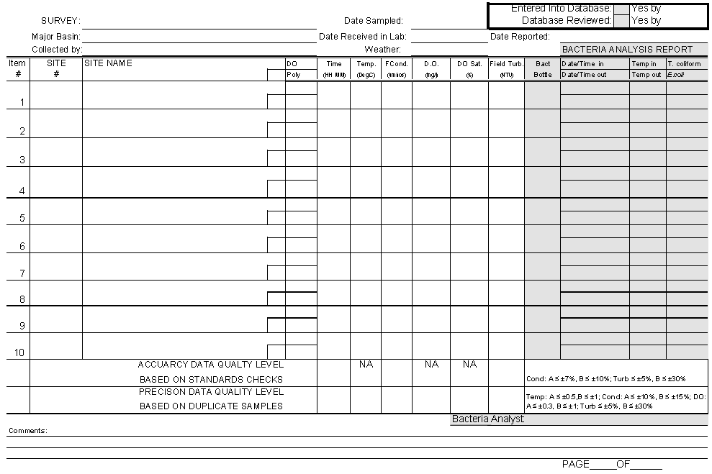
Figure 2 Sample Continuous Monitoring Log Sheet (example parameters are temperature and dissolved oxygen)
