Dust Sampling and Analysis Plan
Cascade Steel Rolling Mills, Inc.
3200 North Highway 99W
McMinnville, Oregon

Prepared For:
Cascade Steel Rolling Mills

Submitted To:
Oregon Department of Environmental Quality
Northwest Region
700 NE Multnomah Street, Suite 600
Portland, OR 97232

Prepared By:
7100 SW Hampton St. Suite 235
Tigard, OR 97223

Contents
Contents ii
FIGURES ii
SECTION 1 Introduction and Purpose 1
SECTION 2 BACKGROUND 2
Section 2.1 DEQ Request 2
SECTION 3 SCRAP HANDLING DUST SAMPLING AND ANALYSIS 3
3.1 Scrap Handling Activity 3
3.2 Scrap Handling Dust Sample Collection 3
3.3 Proposed Sample Preparation and Analysis 3
3.5 Data Evaluation for Scrap Handling Emissions 4
SECTION 4 UNPAVED ROAD DUST TAC EMISSIONS 5
4.1 Unpaved Road Dust Emissions & Composition 5
4.2 Data Evaluation for Unpaved Road Dust Emissions 5

FIGURES
Figures (Following the Text)
Figure 1 Scrap Handling Areas & Truck Sweep-Off Building
Figure 2 Truck Sweep-Off Area and Representative Sample

SECTION 1 Introduction and Purpose
Cascade Steel Rolling Mills, Inc (Cascade) operates a steel mill located at 3200 North Highway 99W McMinnville, Oregon. Cascade is currently working with the Oregon Department of Environmental Quality (DEQ) to prepare an air toxics emissions inventory (ATEI) as part of the Cleaner Air Oregon regulatory program. Certain activities at the site generate fugitive air emissions of particulate matter and portions of that particulate matter may contain toxic air contaminants (TACs) regulated under the Cleaner Air Oregon (CAO) program. The purpose of this Sampling and Analysis Plan (SAP) is to describe the means and methods that will be used to collect representative samples of the source material that can generate fugitive emissions of particulate matter and analyze that material for potentially present TACs such that that information can be used in the CAO ATEI.

SECTION 2 BACKGROUND

Section 2.1 DEQ Request
DEQ requested additional information regarding potential TAC emissions from two sources at the site, 1) fugitive road dust from unpaved roads and 2) fugitive dust from scrap handling. More specifically DEQ requested the following:
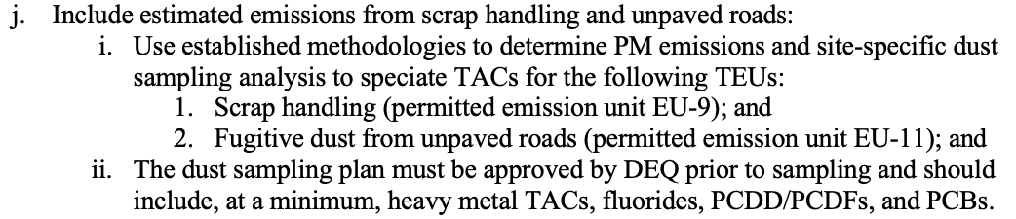
Section 3 details Cascade’s proposed procedures for sampling and analyzing dust from scrap handling. Section 4 explains Cascade’s approach to estimating fugitive dust TAC emissions from unpaved roads.

SECTION 3 SCRAP HANDLING DUST SAMPLING AND ANALYSIS
This section summarizes the sampling and analytical procedures for scrap handling dust at the Cascade facility.

3.1 Scrap Handling Activity
Cascade processes ferrous scrap metal to produce various steel products, primarily reinforcing bar. The scrap ferrous metal is transported to the scrap storage yards by rail or by truck. At the Main Scrap Storage Area scrap is transported to the EAF using scrap buckets, which are filled by electromagnets and grapples that pick up the scrap. At the Secondary Scrap Storage Area scrap is also received by rail or truck and temporarily stored until it is transferred to the Main Scrap Storage Area. These areas are shown in Figure 1.
During the scrap handling movements surficial material, primarily rust, can be dislodged from the scrap and become airborne.

3.2 Scrap Handling Dust Sample Collection
The EPA describes a method for collecting “representative” sample from storage piles. The procedure calls for taking samples consisting of increments from all exposed areas of the pile (i.e., top, middle, and bottom) and collecting the material with a shovel or garden spade. This method cannot be applied to a pile of metal scrap. The scrap itself is not representative of the surficial dust material that is needed to be characterized and there is no “pile” of this dust material at the scrap handling areas. An alternate method needs to be developed.
As previously described, representative portions of scrap are delivered to the site via truck. During transport and delivery scrap movements occur within the enclosed truck bed generating a representative dust sample. After delivery, the trucks go to a sweep-off area where residual materials, including fines, are swept out of the truck bed prior to leaving the site. This plan proposes to obtain a representative sample from the truck sweep off area because such a sample is representative of the dust that could be generated at the actual scrap handling areas.
The location of the truck sweep-off building is shown in Figure 1. Photos of the truck sweep-off area and the material proposed to be sampled is provided in Figure 2. This plan calls for a linear sweep of fines collected along the truck sweep off area concrete border wall and generating a single representative pile in which to take a single grab sample for analysis.

3.3 Proposed Sample Preparation and Analysis
This plan proposes to sieve the field collected sample to a less than 10 micron fraction for analysis. Compositionally, this finer fraction will be representative of the airborne fugitive dust generated from the scrap handling activity. Sample analysis will be for total metals by EPA 6020B (ISPMS) for the following analytes.
Analyte | CAS No.
Antimony (Sb) | 7440-36-0
Arsenic (As) | 7440-38-2
Barium (Ba) | 7440-39-3
Beryllium (Be) | 7440-41-7
Cadmium (Cd) | 7440-43-9
Chromium (Cr) | 7440-47-3
Cobalt (Co) | 7440-48-4
Copper (Cu) | 7440-50-8
Lead (Pb) | 7439-92-1
Manganese (Mn) | 7439-96-5
Mercury (Hg) | 7439-97-6
Nickel (Ni) | 7440-02-0
Phosphorus (P) | 7723-14-0
Selenium (Se) | 7782-49-2
Silver (Ag) | 7440-22-4
Thallium (Tl) | 7440-28-0
Zinc (Zn) | 7440-66-6
Vanadium (V) | 7440-62-2
Aluminum (Al) | 7429-90-5

Fluorides, PCDD/PCDFs and PCBs are not primary components of, nor anticipated contaminants in, ferrous metal scrap and are not proposed as analytes in this SAP.

3.5 Data Evaluation for Scrap Handling Emissions
The results of the analysis will provide metal concentrations of scrap handling dust and can be used with estimated PM10 emission rates to speciate TAC emissions for scrap handling as requested by DEQ.

SECTION 4 UNPAVED ROAD DUST TAC EMISSIONS

4.1 Unpaved Road Dust Emissions & Composition
When a vehicle travels on unpaved roads the force of the wheels on the roads surface can cause dust emissions. The unpaved roads at the facility are constructed of Electric Arc Furnace (EAF) slag, a byproduct of the steel making process. Analytical data describing the heavy metal TAC composition of slag has already been provided to DEQ. DEQ has provided the facility compositional data of PCDD/PCDFs and PCBs in slag. While fluoride containing materials are added to the Ladle Metallurgical Furnace (LMF) they are not added to the EAF and it is not expected that fluorides would be present in EAF slag. Given that compositional data is already available for slag used to construct unpaved roads at the facility no sampling and analysis of unpaved roads is currently proposed in this SAP.

4.2 Data Evaluation for Unpaved Road Dust Emissions
The existing compositional information described in the previous section will be applied to the estimated PM10 emission rates to speciate TAC emissions from vehicle travel on unpaved roads as requested by DEQ.

Figures

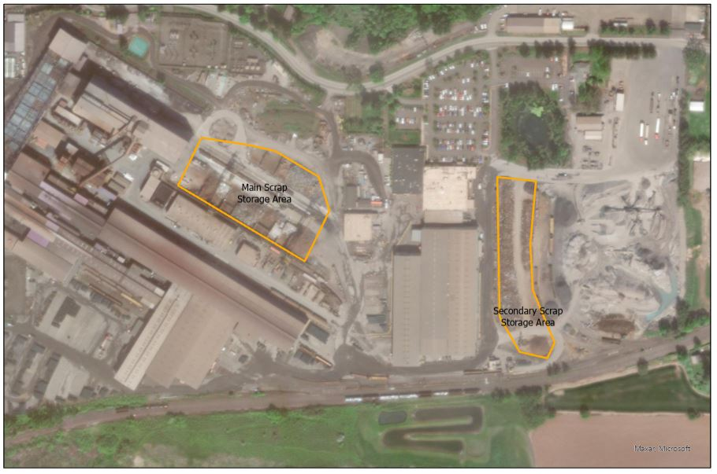
Figure 1
Scrap Handling Areas
& Truck Sweep-Off Building
Truck Sweep-Off Building
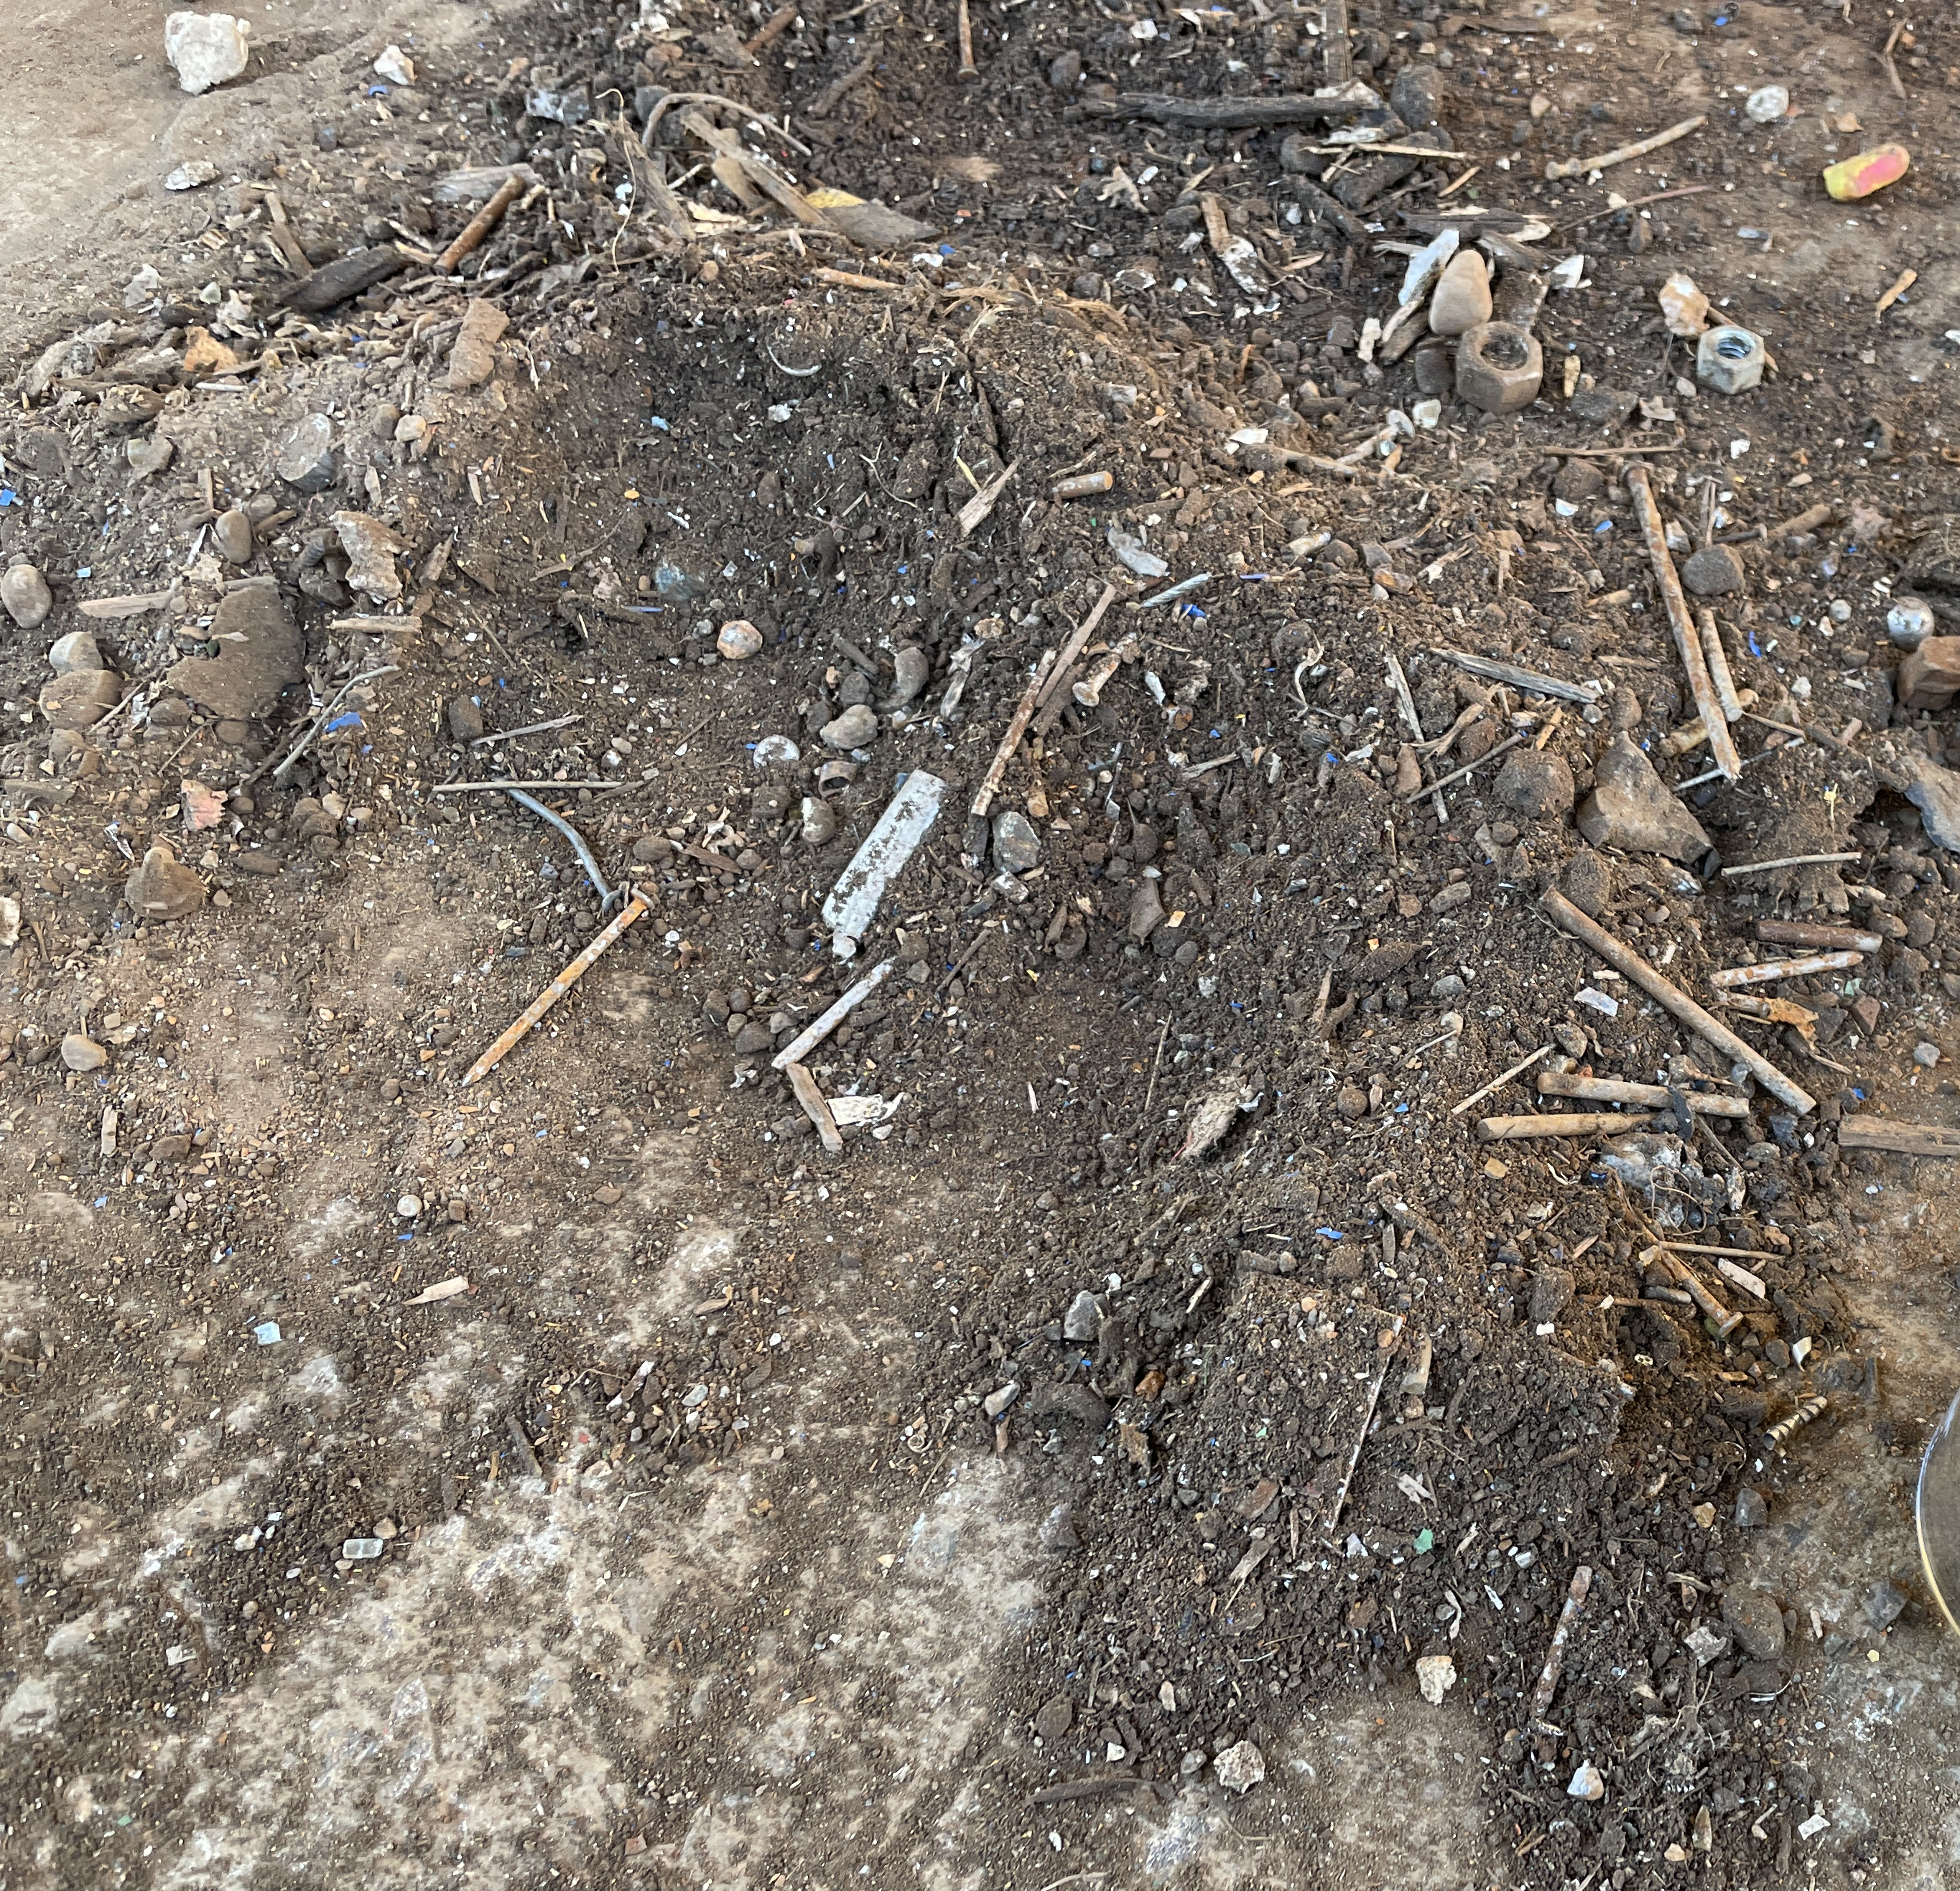
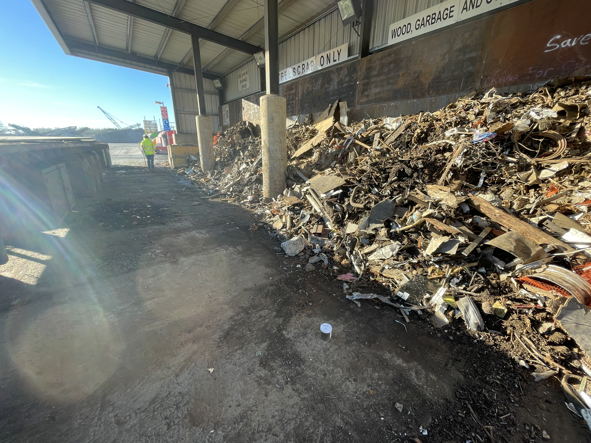
Figure 2
Truck Sweep-Off Area & Representative Sample

Procedures for Sampling Surface/Bulk Dust Loading. https://www.epa.gov/sites/default/files/2020-11/documents/app-c1.pdf

