

Table 6: Soil Textural Classification Chart
The following chart shows…
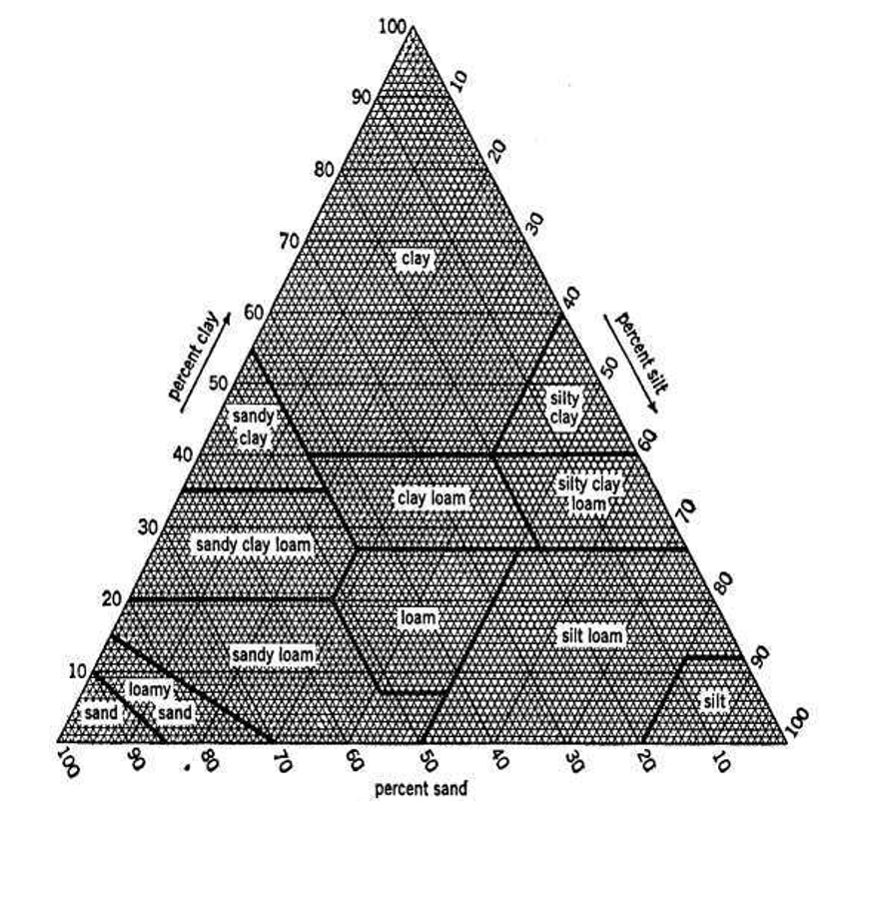
Non-discrimination statement
DEQ does not discriminate on the basis of race, color, national origin, disability, age, sex, religion, sexual orientation, gender identity, or marital status in the administration of its programs and activities. Visit DEQ’s Civil Rights and Environmental Justice page.

