Department of Public Safety  Standards and Training  Fire Standards and Certification  4190 Aumsville Hwy SE  Salem, OR 97317  Phone: 503-378-2100  Fax: 503-378-4600 | 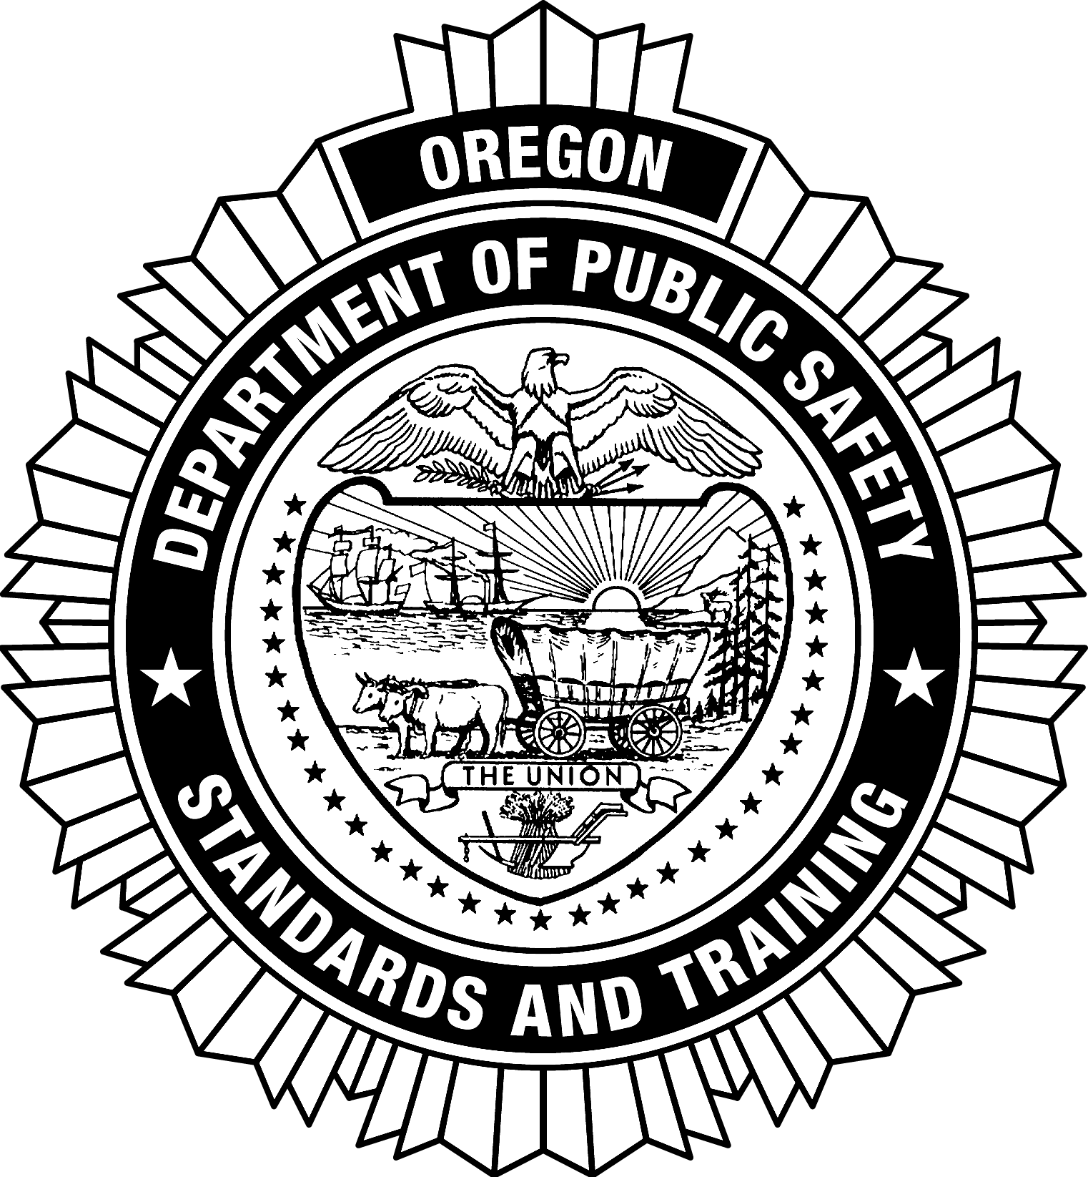  OREGON SPECIFIC  URBAN SEARCH AND RESCUE  APPLICATION FOR CERTIFICATION  (Revised 07/2017) | DPSST Office Use Only  LEDS Check: OK  OECI Check: OK  Levels:  Date:  Reviewer Initials:

Name: |  |  |  |  |  | DPSST Fire #:
Last |  | First |  | MI |  | Date of Birth:
Applicant’s Fire Agency: |  |  |  |  | Social Security #*:
 |  |  |  |  | (Required)

*You are required to provide your Social Security Number (SSN) to DPSST. The authority for this requirement is ORS 25.785 and ORS 305.385, 42 USC 405(c)(2)(C)(i), 42 USC 666(a)(13). Your SSN will only be used for child support enforcement and tax purposes. Failure to provide your SSN will be basis to refuse issuance of a certificate.

In the "Training Completed" column record all applicable DPSST certified course number(s), college/university course number(s), or the fire agency where training was completed. PROVIDE COPIES OF ALL DOCUMENTATION AS PROOF OF COURSE COMPLETION IF IT IS NOT REFLECTED IN SNAPSHOT. For all out-of-state college/university courses, provide course descriptions for evaluation. In the "Date" column record the date the training was completed. Failure to complete this application in its entirety will result in the application being returned.

RESCUE TECHNICIAN | TRAINING COMPLETED | DATE
I-200 Basic ICS
- Is applicant certified as a NFPA Structural Collapse Rescue? Yes No
- Is applicant certified as a NFPA Confined Space Rescue? Yes No
- Is applicant certified as a NFPA Vehicle Rescue? Yes No
- Is applicant certified as a NFPA Trench Rescue? Yes No
- Is applicant certified as a NFPA Rope Rescue? Yes No
- Is applicant certified as a NFPA Machinery Rescue? Yes No

MEDICAL TECHNICIAN | TRAINING COMPLETED
FEMA Medical Specialist Course
- Is applicant certified as a US&R Rescue Technician? Yes No
- Is applicant a licensed active Oregon Health Authority Paramedic or equivalent? Yes No

RIGGING TECHNICIAN | TRAINING COMPLETED | DATE
FEMA Rigging Specialist Course
- Is applicant certified as a US&R Rescue Technician? Yes No
- Is Applicant qualified on specific pieces of heavy equipment, showing safety and use competency? Yes No

SEARCH TECHNICIAN | TRAINING COMPLETED | DATE
FEMA Technical Search Specialist Course
- Is applicant certified as a US&R Rescue Technician? Yes No

ATTEST: As an authorized signer I have reviewed this form for completeness and accuracy. I understand that falsification of this document makes my certifications subject to denial or revocation under ORS 181A.640 and OAR 259-009-0070.

AS THE APPLICANT: I am aware that a criminal history check will be conducted with submission of this application for certification. I understand that if I have been convicted of a crime(s) I may be subject to denial or revocation of my application or certification(s): Yes No
Signature of Applicant |  |  | Date
Signature of Agency Head or Designee |  |  | Printed name of Agency Head or Designee |  |  | Date

