
Date Received

Communication Site Application Form

AGENCY WILL ASSIGN NUMBER
Oregon Department of State Lands Application No.
SEND COMPLETE AND SIGNED APPLICATION TO:
DEPARTMENT OF STATE LANDS
Real Property Program
951 SW Simpson Ave., Suite 104
Bend, OR 97702
541-388-6112
www.oregon.gov/dsl
New | Renewal | Assignment |  |  | Modification |  | Co-Locator(s) Change
1 - APPLICANT INFORMATION
Applicant’s Name and Address: |  |  |  | Business Phone: Home Phone: Fax:  Email Address:
Co-Applicant’s Name and Address: |  |  |  | Business Phone: Home Phone: Fax:  Email Address:
Authorized Agent Name and Address: |  |  |  | Business Phone: Home Phone: Fax:  Email Address:
2 - PROJECT LOCATION
Street, Road or other descriptive location |  |  | Legal Description
 |  |  | Township |  | Range | Section |  | Quarter
In or Near (City or Town) | County |  | Tax Map # |  |  | Tax Lot #
Other |  |  | Other

3 - PROJECT INFORMATION
Activity Type (Check all that apply):

Communications facilities Personal/scientific/research
Local/county government & emergency services State, federal, or tribal government or emergency services Non-profit/non-commercial Commercial
Wireless cellular - macro Wireless cellular – small wireless facility Other, please describe use:
Are you aware of any Endangered Species on the project site? Yes No
Are you aware of any Cultural Resources on the project site? Yes No
Is the project site near a State Scenic Waterway? Yes No
If yes, please explain in the project description (Section 4). How will activity impact area and proposed mitigation?
4 - PROJECT PURPOSE & DESCRIPTION
Existing | Proposed
Project Purpose and Need:
Project Description:
Estimated Start Date: | Estimated Completion Date:
5 - ADDITIONAL INFORMATION
Names, address and phone number for adjacent property owners.

Has the applicant received any prior authorizations from the Department of State Lands? Yes No
If yes, what identification number(s) were assigned:
State of Oregon #

6 - CITY/COUNTY PLANNING AFFIDAVIT
(to be completed by local planning official)
- This project is not regulated by the local comprehensive plan and zoning ordinance.
- This project has been reviewed and is consistent with the local comprehensive plan and zoning ordinance.
- This project has been reviewed and is not consistent with the local comprehensive plan and zone ordinance.
- Consistency of this project with the local planning ordinance cannot be determined until the following local approval(s) are obtained:
- Conditional Use Approval |  |  | - Development Permit
- Plan Amendment |  |  | - Zone Change
- Other:
An application  has  has not been made for local approvals checked above.
Signature of local planning official |  | Title | City / County |  |  |  | Date
7 - BUSINESS INFORMATION
LIMITED LIABILITY COMPANY: Complete the following
- Do you have authority from the Oregon Secretary of State to do business in the State of Oregon?  - Is the LLC presently in good standing with the Oregon Secretary of State?  - In what state is the LLC primarily domiciled?  - Is the LLC name and the Oregon business address the same as stated in this application? If no, state the legal Name:  Address: |  |  |  |  |  | Yes Yes  Yes |  | No No  No
Street or Box Number City State |  |  |  |  |  | Zip Code
Additionally, a LIMITED LIABILITY COMPANY must submit the following with the application:
- A certified copy of the company’s Articles of Organization
- A copy of the company’s operating agreement
CORPORATION: Complete the following:
- Do you have authority from the Oregon Secretary of State to do business in the State of Oregon?  - Is the corporation presently in good standing with the Oregon Secretary of State?  - In what state are you incorporated?  - Are the legal corporation name and Oregon business address the same as stated in this application? If no, state the legal Corporate Name: |  |  |  |  |  | Yes Yes  Yes |  | No No  No
Address:
Street or Box Number City State |  |  |  |  |  | Zip Code
PARTNERSHIP OR JOINT VENTURE: Complete the following
NAME | BUSINESS ADDRESS |  |  | %SHARE | DIVISION
TRUST: Complete the following for each beneficiary of the Trust:
NAME |  |  | BUSINESS ADDRESS

OR identify the Trust document by title, document number, and county where document is recorded:
TITLE |  | DOCUMENT NUMBER | COUNTY
A resolution that the individual designated to sign the lease is authorized to act on behalf of the company in this matter.
8 - ATTACH ALL THE FOLLOWING FOR APPROVAL:
INCOMPLETE APPLICATIONS WILL BE RETURNED
- A street or highway location map with road directions to the site from the nearest main highway or road.
- A legal description of the lease area with an accurate delineation of the area relative to the tax lot boundaries of the upland parcel. (The department may require a survey for this purpose).
- A separate diagram of all existing and proposed structures for the lease area showing the dimensions of each structure by length and width.
- A list of proposed structures and equipment for the lease area.
- Supplemental frequency information.
- Non-refundable application fee of $ . *See fee schedule attached on page 13. Note: A and B are only required for new sites.
9 - APPLICANT SIGNATURE
I hereby request a state authorization for (number) years.
Application is hereby made for the activities described herein. I certify that I am familiar with the information contained in the application, and, to the best of my knowledge and belief, this information is true, complete, and accurate. I further certify that I possess the authority to undertake the proposed activities. I understand that the granting of other permits by local, county, state or federal agencies does not release me from the requirement of obtaining the authorization requested before commencing the project. I understand that payment of the required state application fee does not guarantee authorization.
Applicant Signature |  | Title
Date
I appoint the person named below to act as my duly authorized agent.
Print /Type Name |  | Title
Authorized Agent Signature | Date

Exhibit A

Communication Site Map (required only for new sites)

Exhibit B

Leased Premises Map (required only for new sites)

Exhibit C

Diagram of Equipment and Structures

Exhibit C EXAMPLE
Diagram of Equipment and Structures

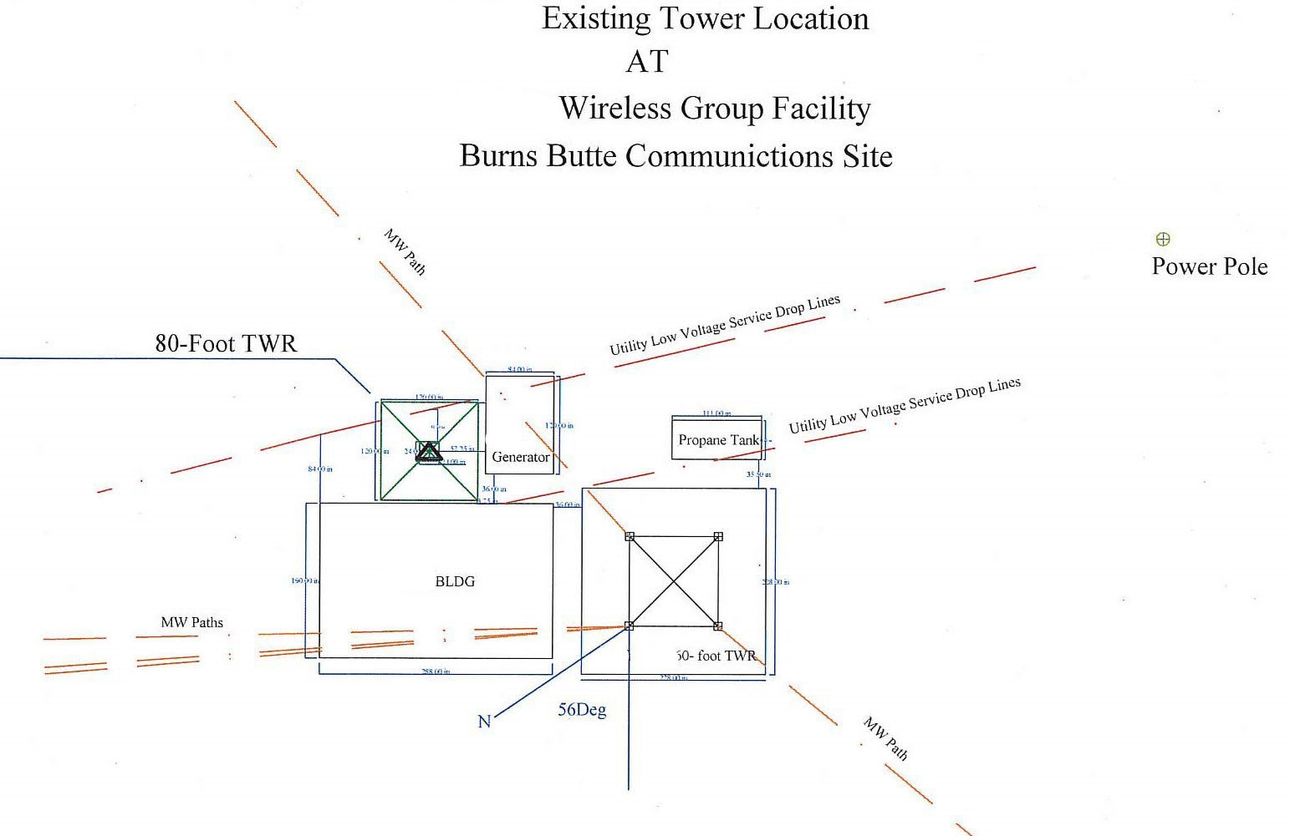

Exhibit D

Structures and Equipment List
Include major elements of facility such as buildings, towers, propane tanks, solar panels, number of antennae, generators, fence, etc.

1.

2.

3.

4.

5.

6.

7.

8.

9.

10.

Exhibit E Supplemental Frequency Information

The following additional information is needed in conjunction with the Joint Permit Application Form when requesting permission to occupy state-owned submerged and/or submersible lands, or uplands administered by the Department of State Lands.

- Transmitting frequency:
- Receiving frequency:
3. Standby frequency:
4. Output Power:
5. Transmitter make and model:
6. Receiver make and model:
7. Alternate power source and output:
- Antenna direction (If any):

- Antenna gain:
10. Has an FCC License been granted? | Yes: License Number: No

Exhibit F

Co-Locators

CO-LOCATOR | CO-LOCATOR CONTACT INFO | SUBLEASE TERM | SUBLEASE ANNUAL RENT

Division 126, Communication Site Facilities, Proposed Rule Lease Rates and Fee Schedule
The following tables present the lease rates and fee schedules for communication site facility leases under the proposed rules for OAR 141-126. The Division 126 rules would establish distinct administrative rules for communication site facilities located on school lands – lands owned by the people of Oregon that generate revenue for the state’s Common School Fund.

Lease Rates
Use Type | Specific Use | Minimum Compensation Rate | Co-Location* Minimum Compensation Rate
Non-commercial | Personal/research/scientifi c | $750/year or a one-time negotiated payment | $500 one-time payment or 25% of fee charged to co-locator per year, whichever is greater
Non-commercial | Local or county government and  emergency services | $3,000/year | $750 one-time payment or 25% of fee charged to co-locator per year,  whichever is greater
Non-commercial | State, Federal, or Tribal government or emergency services | $4,500/year | $1,125 one-time payment or 25% of fee charged to co-locator per year, whichever is greater
Non-commercial | Non-profit/non-commercial | $3,000/year | $750 or 25% of fee  charged to co-locator per year,
Commercial | Small commercial | $4,000/year | $1,000/year or 25% of fee charged to co-locator per year, whichever is  greater
Commercial | Medium commercial | $6,000/year | $1,500/year or 25% of fee charged to co-locator per year, whichever is  greater
Commercial | Large commercial | $8,000/year | $2,000/year or 25% of fee charged to co-locator per year, whichever is  greater
Wireless Cellular Communication s | Macro | $10,000/year | 25% of fee charged to co-locator per year
Wireless Cellular Communication s | Small wireless facility | $270/year | $100/year
Note: The Department reserves the right to establish a base compensation rate greater than the minimum annual base compensation. Minimum compensation rate and minimum co-locator compensation rate will increase annually by three percent (3%) for every year.
whichever is greater
*Co-location: When more than one entity shares the same communication site facility.

Fee Schedule
Fees for lease applications and assignments
Use Type and Specific Use |  | Application fees |  |  |  | Assignment fee
 |  | New or renewed lease with changes | Lease renewal with no changes | Co-location lease (new and renewal) | Lease modification | Assignment fee
Non-commercial | Personal/research/ scientific | $375 | $375 | $375 | $250 | $250
Non-commercial | Local or county government and emergency  services | $750 | $375 | $375 | $250 | $250
Non-commercial | State, Federal, or Tribal government or emergency  services | $750 | $375 | $375 | $250 | $250
Non-commercial | Non-profit/non-Commercial | $750 | $375 | $375 | $250 | $250
Commercial | Small commercial | $1,000 | $500 | $500 | $500 | $500
Commercial | Medium commercial | $1,000 | $500 | $500 | $500 | $500
Commercial | Large commercial | $1,000 | $500 | $500 | $500 | $500
Wireless Cellular Communications | Macro | $1,500 | $750 | $750 | $500-$750¹ | $750
Wireless Cellular Communications | Small wireless facility | $500 for up to 5 SWF, $100 per additional SWF |  | $100 | $250-$500² | $250
¹ When modification results in change of frequency only: $500. When modification results in enlargement of lease area or change in buildings or towers: $750.
² When modification results in change of frequency only: $250. When modification results in enlargement of lease area or change in structures or poles: $500.

