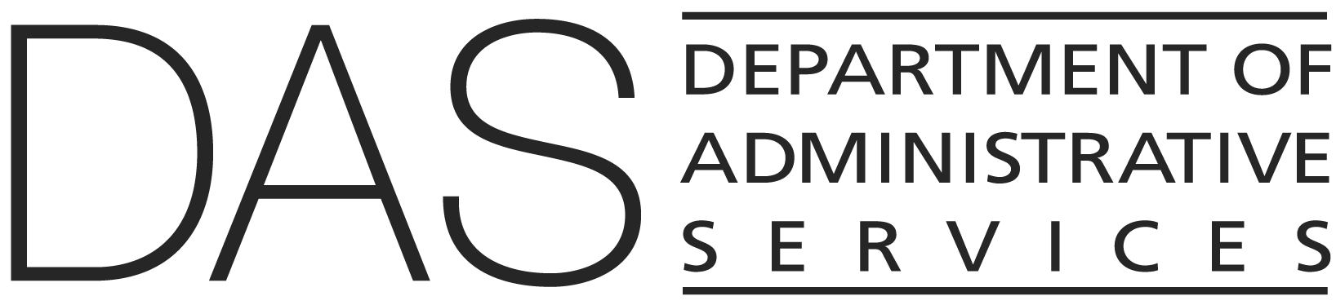  Statewide Procedure | NUMBER  107-004-030_PR | SUPERSEDES  Policy #107-004-030_PR (2015)
 | EFFECTIVE DATE | PAGE NUMBER  Pages 1 of 5
 | REVIEWED DATE | PAGE NUMBER  Pages 1 of 5
Division  Enterprise Information Services (State CIO) | REFERENCE  ORS: 276A.223, 174.112, 276A.200, 276A.206, 276A.203, 279A.010, 279B.040, 279B.110, 352.002  Policy: 107-004-030
Policy Owner

Shared Services
SUBJECT  Independent Quality Management Services for Information Technology Initiatives | APPROVED SIGNATURE
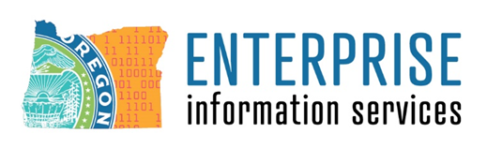

PURPOSE
This procedure describes Enterprise Information Services (EIS) and agency responsibilities and actions that must be followed to comply with Statewide Policy 107-004-030 (Independent Quality Management Services for Information Technology Initiatives).

APPLICABILITY

This procedure applies to all agencies within the Executive Department as defined in ORS 174.112.

FORMS/EXHIBITS/INSTRUCTIONS

- FAQ: IT Initiatives That Require IQMS
- IQMS Statement of Work Templates
- IQMS Contract Administration (Guidance 4)
- Independent Contractor Deliverables Distribution Report
- Project Assessment Report
- Project Variance Report
- Project Status Update Report

DEFINITIONS
See Statewide IT Policy 107-004-030 (Independent Quality Management Services for Information Technology).

PROCEDURE

IQMS Determinations

When Statewide Quality Assurance (SWQA) determines an agency IT initiative requires independent quality management services (IQMS), the agency will work with the assigned SWQA point of contact to determine the appropriate scope and timing for such services. SWQA will receive notifications of a new IT initiative in the enterprise portfolio via the Enterprise PPM Tool (PPM Tool). Requirements may vary for individual IT initiatives based on unique or project-specific circumstances. As an IT initiative progresses through its lifecycle, changes may occur that require modification of the IQMS determination or the designated scope and timing for IQMS. SWQA will communicate any change in IQMS requirements for an IT initiative to the agency.

The IT initiative’s required level of IQMS will, in part, be based on the agency’s submission of the foundational documents identified within the IT Investment Oversight Policy (107-004-130) and its companion IT Investment Oversight Procedure (107-004-130_PR), along with any additional documents SWQA deems necessary based on the unique conditions of the IT initiative. The criteria SWQA uses to determine if IQMS is required are published on the SWQA website (FAQ: IT Initiatives That Require Independent Quality Management Services).

RESPONSIBILITY | STEP | ACTION
Agency | 1 | Submit project initiation documents as required by the IT Investment Oversight Policy (107-004-130) and companion IT Investment Oversight Procedure (107-004-130_PR).  Agency will identify, with the support of their Statewide IT Portfolio Manager (SIPM) and Assistant State Chief Information Officer (ASCIO), whether the agency has upcoming projects which may qualify the agency to structure the IQMS engagement as an IQMS portfolio opportunity. Agency shall inform SWQA that they have identified a portfolio opportunity.
SWQA | 2 | Analyze the IT initiative to determine if IQMS is required, and the appropriate scope of and timing for IQMS.  Notify the agency and Project Portfolio Performance (P3) of IQMS determination.  Add the IQMS determination memo to the PPM tool, using the folder where the project’s other EIS endorsements and decisions are kept.

IQMS Procurement and Contract Administration

When SWQA requires IQMS for an IT initiative, the agency must procure IQMS services using the master price and services agreement for the IQMS service category of IT professional services.

RESPONSIBILITY | STEP | ACTION
Agency | 1 | Initiate a procurement request and develop the IQMS statement of work (SOW) in consultation with SWQA.  (SWQA provides three statement of work (SOW) templates for different types of IQMS projects and programs. Tailoring of these SOWs must include the input and approval of SWQA.)
SWQA | 2 | Approve the request for quote (RFQ) packet prior to RFQ release.  (The RFQ packet is also subject to oversight per the IT Investment Oversight Policy #107-004-130.)
Agency | 3 | Complete RFQ and vendor selection. Agency must include SWQA participation as an advisor to the RFQ evaluation team.
Agency and SWQA | 4 | The agency and SWQA ensure that the Work Order Contract (WOC) requires IQMS contractor to:  - Document independence in accordance with the policy.  - Utilize an independent and objective approach to review the project’s purpose, documentation, governance, plans, estimates, resources, methodologies, change processes, deliverables and risks during the life of the IT initiative; and compare this information to the quality standards defined for the project and industry best practices.  - Report omissions and gaps in the project’s planning, execution, control methodologies, reporting and closing to the required parties as identified in the policy.  - Review identified risks and risk mitigation plans developed by the contracting agency. Document and quantify any major risks not identified by the contracting agency and identify any major concerns related to the agency’s risk mitigation plans.  - Perform their work in alignment with the IQMS SOW and oversight process, and any applicable SWQA guidance, report formats, templates and reporting schedules.  All IQMS contracts for an IT initiative shall include provisions requiring the prior consent of SWQA for an agency’s authorization and acceptance of IQMS deliverables, unless SWQA delegates authorization and acceptance of these deliverables to the agency’s management.
Agency | 5 | Complete contract negotiation processes.
Agency | 6 | Administer the IQMS WOC as the Authorized Representative, ensuring that the IQMS contractor performs their work in alignment with contract requirements.  (The WOC is also subject to oversight per the IT Investment Oversight Policy #107-004-130.)  Note: At SWQA discretion, the SWQA Program Manager may take on the role of Authorized Representative.
Agency | 7 | Coordinate with IQMS contractor to schedule an IQMS kickoff meeting that includes SWQA and P3. Agency may choose to include additional participants, e.g., the assigned Legislative IT Analyst.
Agency | 8 | During the life of the initiative, agency is responsible to:  - Give IQMS contractor sufficient access to project artifacts, work products, meetings, work sessions and team members to allow them to perform their work as set forth in the IQMS contract.  - Take appropriate steps to address risks and issues associated with omissions, gaps, defects and other quality concerns identified by the IQMS contractor; or document business reasons for not doing so.  - Report steps taken and progress made in addressing these risks and issues to parties identified for report distribution within this policy and within the applicable IQMS contract, and the appropriate legislative committees if so instructed.

Distribution Requirements for IQMS Deliverables

RESPONSIBILITY | STEP | ACTION
Agency | 1 | To ensure that IQMS reports are being distributed as required by ORS 276A.233 and the IQMS contract, the agency must do the following:  - Ensure that all contractual requirements are met by the IQMS contractor, including the distribution of all preliminary (draft) and final versions of all IQMS deliverables (i.e., reports) to:  - the state CIO (EIS_DL_QualityManagementOR@oregon.gov)  - the DAS director (EIS_DL_QualityManagementOR@oregon.gov)  - the legislative fiscal officer (LFO) (LFO.ITQAReports@oregonlegislature.gov);  - the director of the agency or its appropriate governing body; and  - other persons required by the IQMS contract.  - Maintain records documenting that IQMS contractor has distributed all reports to the required recipients.  Note: SWQA and the agency may designate additional entities to whom copies of relevant reports should be provided for the specific IT Initiative.

Major IT Project Reporting

RESPONSIBILITY | STEP | ACTION
Agency | 1 | Submit quarterly reports for all IT initiatives required to utilize IQMS that are currently in execution (Stage 4). On dates specified on the SWQA Reporting Services website, agencies must submit the following reports:  - Independent Contractor Deliverables Distribution Report  - Project Assessment Report  - Project Variance Report  - Project Status Update Report
SWQA | 2 | Prepare quarterly reports on the status and health of agency IT initiatives requiring IQMS. Reports shall be distributed to the LFO and other parties deemed necessary by SWQA.

