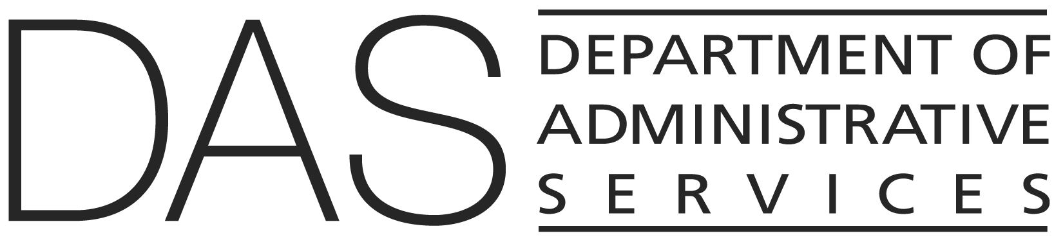  Statewide Policy | NUMBER  107-004-030 | SUPERSEDES  Policy # 107-004-030 (2015)
 | EFFECTIVE DATE | PAGE NUMBER  Pages 1 of 3
 | REVIEWED DATE | PAGE NUMBER  Pages 1 of 3
Division  Enterprise Information Services (State CIO) | REFERENCE  - ORS: 276A.223, 276A.230, 174.112, 276A.200, 276A.206, 276A.203, 279A.010, 279B.040, 279B.110, 352.002  - Procedure: 107-004-030 PR and 107-004-130_PR  - Policy 107-004-130
Policy Owner

Shared Services
SUBJECT  Independent Quality Management Services for Information Technology Initiatives | APPROVED SIGNATURE

PURPOSE

An agency planning to implement an information technology (IT) initiative shall obtain all appropriate quality management services (QMS) from a qualified, independent contractor if:
- QMS are required by specific legislative action or executive mandate; or
- The IT initiative is estimated to exceed $5 million; or
- Statewide Quality Assurance (SWQA) determines QMS is required for the IT initiative under review based on estimated costs and risk factors to the agency or the state.

APPLICABILITY

This policy applies to all agencies within the Executive Department as defined in ORS 174.112.
In accordance with state procurement law and regulation, agencies may not artificially divide or fragment an investment to avoid application of this policy.

DEFINITIONS

Independence or independent means delivery of services by a third party free from real or perceived conflict with the interests of the agency and its contractors involved in project design, development, implementation, deployment, and operational activity.

Independent Quality Management Services (IQMS) means quality management services performed by an entity not under the managerial or technical control of the agency or any of its other contractors, where managerial independence means departmental and hierarchical separation from the design, development, implementation, deployment, operational and program, and project management organizations; and technical independence means no past, present, or future involvement in any project efforts around design, development, implementation, deployment, operations and program, and project management.

Information Technology Initiative or IT Initiative involves an IT investment that is a project or program (as defined by Statewide IT Procedure #107-004-130_PR) and is subject to Department of Administrative Services (DAS) and Enterprise Information Services (EIS) review and oversight responsibilities as prescribed in statewide IT policies.

Preliminary Quality Assurance Services means the delivery of IQMS during the initiation, planning, and procurement phase of an IT initiative.

Quality Management means the practices and processes used to ensure that a project or program will satisfy identified requirements. It includes all activities that determine the quality strategy, objectives, responsibilities, and their implementation in accordance with the Project Management Body of Knowledge (PMBOK), International Organization for Standardization (ISO) 12207, and applicable IT industry best practices. These practices and processes comprise general project verification and validation, and at a minimum include:

- Quality planning, which refers to identifying which quality standards are relevant to a project and determining how they will be satisfied by project activities.
- Quality assurance, which refers to evaluating overall project performance on a regular basis to provide confidence that the project continues to satisfy relevant quality standards.
- Quality control and testing, which refers to monitoring specific project results to determine if they comply with relevant quality standards and identifying ways to eliminate causes of unsatisfactory performance.
- Risk management, which includes risk identification (determining which risks might affect the project and documenting their characteristics), risk assessment (the thorough assessment of the probability and impact for the occurrence of risks), risk avoidance, mitigation or transfer (seeking ways to remove or reduce the probability and impact of an identified risk below an acceptable threshold in compliance with statewide IT policies and SWQA), and other related activities as defined by the PMBOK for the effective management of project risk.

Within an IT initiative, responsibilities for verification and validation are typically shared among all participating staff of the agency and its contractors. However, only QMS provided by an independent contractor participating in SWQA or with written consent of EIS may be regarded as independent QMS.

Quality Management Services or QMS means the services delivered by SWQA IQMS contractors and may encompass preliminary quality assurance services and quality & risk management services during all phases of IT initiatives (e.g., initiation, planning, execution, monitoring and controlling, and closing).

Statewide Quality Assurance (SWQA) means the team that establishes and oversees access to the group of pre-qualified QMS providers under statewide contracts. Each SWQA QMS contractor has executed with the state a master agreement that includes negotiated provisions, such as standard contract terms and conditions, established hourly rate cards, and the SWQA enterprise statement of work (SOW) that identifies, defines and describes the task areas that comprise the State’s required QMS scope.

EXCLUSIONS AND SPECIAL SITUATIONS
Non-project IT investments (as defined by Statewide Procedure #107-004-130_PR) are not considered IT initiatives, and thus are not typically covered by this policy.

GENERAL INFORMATION

- Agencies planning an IT initiative must first review and ensure their compliance with Statewide Policy: #107-004-130, Information Technology Investment Oversight. The planned IT Initiative must be engaged in the oversight process SWQA determines the required level of QMS for the Project(s).

- SWQA will determine the required level of IQMS for the IT initiative based on estimated costs as well as the project profile for risk and complexity. Agencies may opt to use IQMS when not required by SWQA. Agencies that choose to procure IQMS when not required by SWQA should consult with SWQA as a courtesy during the procurement process.

- IQMS must be delivered by SWQA IQMS contractors that satisfy the policy’s declared and defined measure of independence.

- During the entire duration of each IQMS engagement, the contracting agency must not authorize or accept other (non-IQMS) products and services from the engaged IQMS contractors and their subcontractors without prior SWQA consent.

- All amendments and change orders to an IQMS SOW require approval from SWQA.

