Small AND Mighty

2024 Nomination
oregon - State cio award

State: Oregon
agency: Enterprise Information Services
Award category: Cybersecurity and risk management
Enterprise Mobile SECURITY (EMS) Project
Medium, oversight level 2
October 2021 – may 2025
Bruno Gautier | Cybersecurity manager | bruno.gautier@das.oregon.gov

EXECUTIVE SUMMARY
An October 2020 survey of Executive Branch agencies, boards, and commissions showed 39 of them had no Mobile Device Management (MDM) solution or other compensating control to manage their mobile devices. Agencies that did have an MDM were using multiple third-party solutions with varying levels of security.

Unmanaged and improperly managed mobile devices expose significant risk to the State. Mobile devices needed to comply with cybersecurity standards to protect and securely provide access to the State’s information systems as we do with workstations.

Security is of the utmost importance. If a device is lost, stolen, or otherwise compromised without proper security configurations, regulated data could be exposed. Mobile Device Management solutions can control remote access to data, provide user authentication, and remote data wiping of devices if they become lost or stolen.


Microsoft Endpoint Manager (MEM/Intune) enables the centralized management of mobile devices for Executive Branch agencies, boards, and commissions. All mobile devices are configured with the same security settings ensuring the device and synced data are always secure. Above all else it was very important for the success of this project that we were able to maintain a balance between security requirements and usability.

IDEA
The project tackled a critical security gap in mobile devices used by state agencies. Systems lacked a unified approach to ensure compliance with cybersecurity standards. Mobile devices need to be secured, as they play an essential role in accessing the State’s information systems. Without proper management, agencies with no Mobile Device Management (MDM) solutions faced inconsistent security levels, manual processes, and higher costs for third-party solutions. Addressing these gaps aligns with Enterprise Information Services (EIS) strategic priorities.
MDM solutions, such as Microsoft Endpoint Manager, offer a scalable and centralized way to manage mobile devices for the Executive Branch's agencies, boards, and commissions. The initiative ensured enterprise-wide security, consistent protection, and significant cost savings while improving business processes.
Why Does It Matter?
Mobile devices are integral to modern business operations, and the State of Oregon is no exception. Employees rely on smartphones and tablets to handle tasks ranging from critical to routine. Consequences of inaction include heightened security risks, inefficiencies in managing devices, increased costs, and non-compliance with cybersecurity standards.
This project accomplished:
- Improved security by standardizing technical controls across all mobile devices
- Treated each agency as an equal partner, fostering collaboration and clear communication
- Saved costs by replacing disparate third-party MDM solutions with a unified Microsoft solution
What Makes It Different?
This innovative project stands out because:
- It encompassed all Executive Branch agencies, boards, and commissions across the state, impacting all mobile device users
- It was achieved through collaboration among Cyber Security Services (CSS), and all Executive Branch agencies, boards, and commissions along with NTT Partners and Vendors
- Despite resource limitations, the team successfully implemented a complex multi-faceted solution with creative problem-solving

What Makes It Universal?
The project’s principles are applicable statewide as they address universal challenges of cybersecurity and mobile device management. They align with federal and state guidelines and embody key State CIO priorities.

The diverse and collaborative team followed EIS’ guiding principles:
- Collaboration and Visibility
- Holistic Approach
- Simplicity and Practicality
- Customer-Focused Solutions

By unifying security measures, this project ensured a consistent, secure, and cost-effective approach that benefited all stakeholders.

Implementation
This project aimed to fill a critical security gap in mobile device management across the enterprise. The roadmap below focused on centralizing device management while addressing each agency's unique needs. Using an agile project management approach, agencies were treated as individual “mini projects,” fostering strong collaboration. Pre-planning was meticulous, accounting for blackout dates and organizational priorities, ensuring readiness and efficiency.

Successful implementation is defined by:
- Enterprise-wide adoption of a unified MDM solution
- Improved security and compliance for all mobile devices
- Positive customer experiences and enhanced workflows
- Serves as a replicable model for future enterprise level endeavors

Progress and success were measured through feedback from agencies, operational performance metrics, and compliance audits.

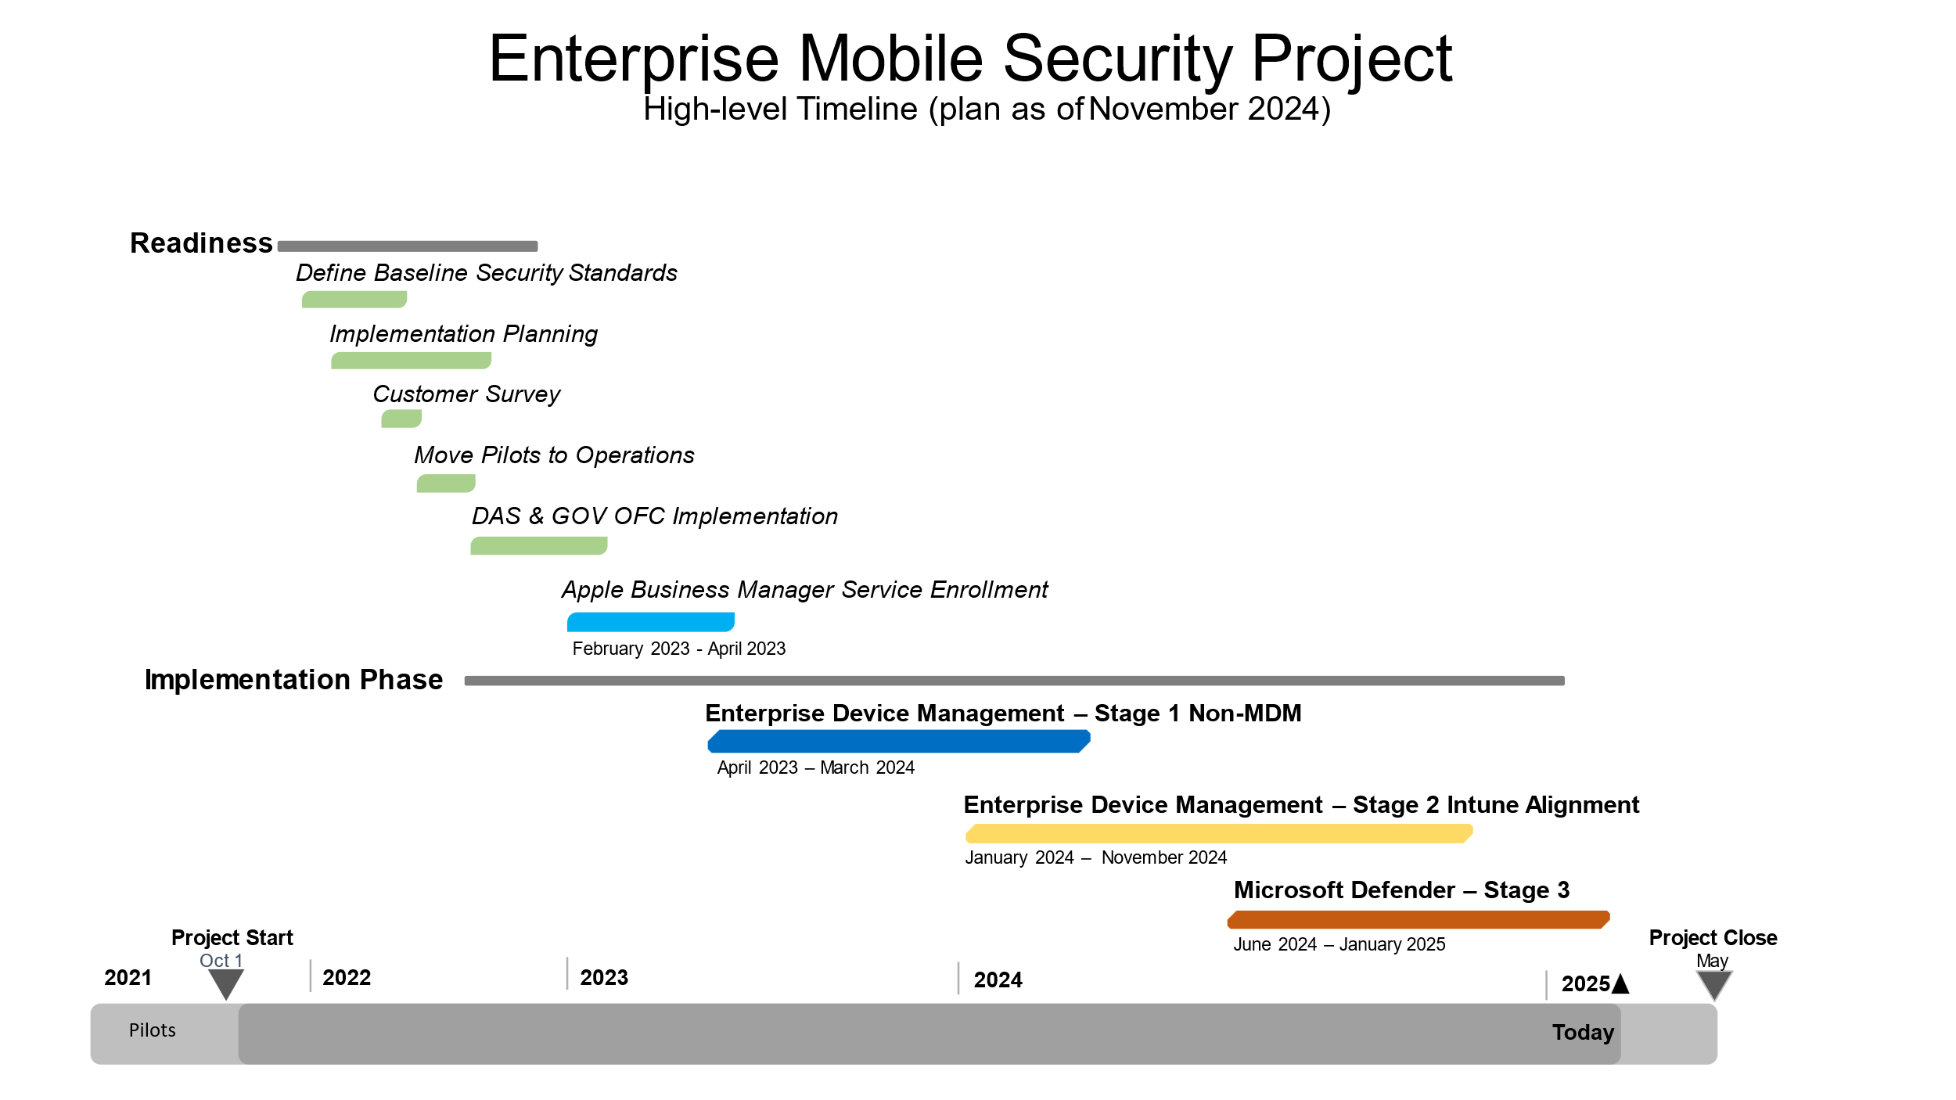
Key Stakeholders:
The project relied on coordinated efforts among diverse groups:
- EIS and Project Team: Core implementation and leadership, ensuring consistent customer focus
- Agencies: Advocates, beneficiaries, and key collaborators who helped tailor solutions to organizational needs
- NTT Partners and Vendors: Provided critical technical expertise and support
- Agency Representatives: Actively engaged in defining requirements, ensuring communication alignment, and adopting the solution
Stakeholder buy-in was achieved through leadership meetings, regular communications, customized templates, training sessions, and secure chat channels, ensuring transparency and collaborative engagement.

Resources and Technical Approach:
Despite resource constraints, the project succeeded through careful allocation of financial, human, and time resources:
- Human Resources: Teams invested in creating a personalized, consistent "customer" experience
- Financial: Leveraged existing tools, such as Microsoft Endpoint Manager (Intune), to minimize cost
- Time: Worked extensively with each agency, dedicating at least 5 weeks to onboarding and support as needed
The technical architecture emphasized enterprise-wide visibility and scalability. By implementing delegated roles technology, each agency managed its devices while adhering to enterprise security standards. This approach ensured a balance between centralized governance and localized flexibility. Leading practices such as accessibility, privacy frameworks, and emerging technologies drove the project. Training videos and templates further supported agencies, simplifying adoption and improving end-user experience.


Impact
The project significantly transformed the state's enterprise environment by enhancing security, transparency, and operational efficiency. Prior to the project, there was no unified approach to mobile device management, resulting in limited visibility, varied security postures, and increased vulnerabilities. Post-implementation, we achieved a secure, standardized state for mobile device management, ensuring safety and ease of management across all Executive Branch agencies, boards, and commissions.

For the enterprise:
- Addressed the security gap, creating a safer and more manageable environment
- Established baseline standards for device security and management
- Centralized approach ensures transparency by streamlining audit reviews and enabling effective alerting

For the customer:
- Delivered consistently configured secure state-managed devices to save time and improve efficiency
- Realized cost savings by leveraging the enterprise MEM instead of third-party solutions
- Improved security across the state, placing Executive Branch agencies, boards, and commissions in a much stronger position than 3 years ago
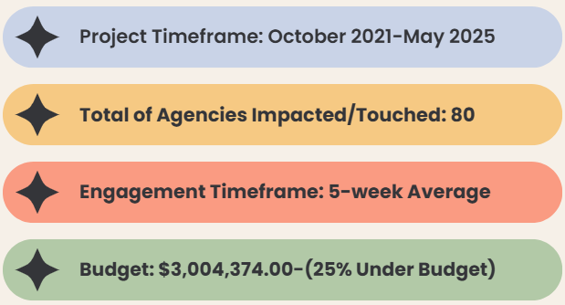

How Do We Know?
Quantitative data demonstrates cost savings and ROI through reduced third-party solution expenditures. Transaction times have improved, and qualitative feedback highlights enhanced constituent experiences. For instance, one business area (PERS) noted a marked improvement aligned with success criteria, emphasizing the project’s transformative impact.

By optimizing Microsoft 365 entitlements already owned by the state which includes Microsoft Intune, agencies no longer need to procure or maintain separate solutions.

What Now?
Intune will be maintained by M365 Program Operations, with an ongoing commitment and partnership with CSS Solutions to follow the established Intune Mobile roadmap and continually improving security standards, baseline configurations with service & security refinements. This foundational work ensures that the state is well-prepared for future challenges, making this effort a worthy and sustainable investment.

Project Benefits:
Benefit | Value | Measurement Method | Note
Provide a common security baseline for mobile devices across executive branch agencies, boards, and commissions. | Increase MDM security by 95% among Executive Branch agencies, boards, and commissions.  Reduce the number of agencies without an MDM solution.  Reduce the number of third-party MDM solutions used in the Executive Branch agencies, boards, and commissions by 95%. | Surveys and analysis of project information gathered during implementation. | An agency survey in October 2020 identified 39 as having no mobile device management (MDM) solution.  Security is of utmost importance. If a device is lost, stolen or otherwise compromised without proper security configurations, regulated data could be exposed. All mobile devices will be configured with the same security settings ensuring the device and synced data are always secure.
Improve the security posture of the state by gaining visibility to the security status of the mobile devices connected to the State network. | Reduce the varying levels of security for third-party MDM solutions. | Analysis of Microsoft Intune information. | Microsoft Intune stores information about enrolled devices usage and inventory, apps and software inventory, device configuration and compliance policies.

Successes
Customer success is at the heart of any successful business strategy and understanding the impact it has on both the customers and the organization is crucial. A key aspect of fostering customer success is capturing the insights and feedback that reflect its value. The quotes below highlight the importance of proactive engagement, collaboration, and continuous support to our customers to demonstrate the true power of building strong and trustworthy relationships.

Customer Quotes
