[Framework Data Element]

Data Standard

Version [x.x]

[Month] [Year]

Endorsed by the Oregon Geographic Information Council [Month] [Year]

Revision History:

Original Draft Written by [Author Name and Agency Name]

[Version x.x] revised based on [FIT work group name]

[Version x.x] revised based on [GIS community comment]

[Version x.x] revised based on [Advisory Group comment]

For questions about this data standard, contact:

[Steward Agency Name]
[Email of Agency]

Table of Contents

1.0 INTRODUCTION 4
1.1 MISSION AND GOALS OF THE STANDARD 4
1.2 RELATIONSHIP TO EXISTING STANDARDS 4
1.3 DESCRIPTION OF THE STANDARD 5
1.4 Applicability and Intended Use of Standard 5
1.5 STANDARD DEVELOPMENT PROCEDURES 5
1.5.1 Participants: 5
1.5.2 Comment Opportunities and Reviews: 6
1.6 MAINTENANCE OF THE STANDARD 6
2.0 BODY OF THE STANDARD 6
2.1 SCOPE AND CONTENT OF THE STANDARD 6
2.2 NEED FOR THE STANDARD 6
2.3 PARTICIPATION IN STANDARD DEVELOPMENT 7
2.4 INTEGRATION WITH OTHER STANDARDS 7
2.5 TECHNICAL AND OPERATIONAL CONTEXT 7
2.5.1 Data Environment 7
2.5.2 Reference System 8
2.5.3 Integration of Themes 8
2.5.4 Encoding 8
2.5.5 Resolution 9
2.5.6 Accuracy 9
2.5.7 Edge Matching 10
2.5.8 Feature Identifier 10
2.5.9 Attributes 10
2.5.10 Transactional Updating 11
2.5.11 Records Management 11
2.5.12 Metadata 11
3.0 DATA CHARACTERISTICS 12
3.1 mINIMUM GRAPHIC DATA ELEMENTS 12
3.2 Minimum ATTRIBUTE or Non-Graphic Data Elements 12
3.2.1 Point 12
3.2.2 Line 12
3.2.3 Polygon 13
3.3 Optional Graphic data elements 13
3.3.1 Point 13
3.3.2 Line 13
3.3.3 Polygon 13
3.4 optional attribute or non-graphic data elements 13
3.4.1 Point 13
3.4.2 Line 14
3.4.3 Polygon 14
References
Appendices

INTRODUCTION
Overview of the data element and data standard procedures.
Examples from other data standards:
“Under the direction of the Oregon Geographic Information Council (OGIC), the Oregon Framework Program provides the structure through which the development of new, statewide GIS data are created, documented, and stewarded. In 2015, the Framework Implementation Team leaders reviewed and prioritized the data elements in the Framework program. This prioritization ranked the statewide land use data layer as a high priority dataset. While this dataset is not a foundational element, it will be valuable to many state agencies and is a key data element for the Land Use Land Cover Framework theme. A statewide land use dataset was created to represent the many ways land is currently used. There are several related datasets that are often used as surrogates for land use: zoning data represents how land is allowed to be used as dictated by local jurisdictions; and comprehensive plan data are used to represent a community’s long-term vision of how and where land will be developed over the next 20 years to accommodate expected population and job growth. The statewide land use data…”
“The Oregon Geographic Information Council (OGIC) oversees preparation of geospatial data standards for the state. The development of these standards facilitates the sharing of geospatial data and assists with cooperative data development efforts. OGIC assigned a framework implementation team (FIT) to guide the development of standards for the various data themes, and separate framework work groups are developing standards for each theme. The Hazards Framework is a collection of spatially referenced digital representations of potential natural hazards. Data elements in the Hazards Framework include channel migration, coastal erosion, earthquakes, debris flows, drought areas, dust storm occurrences, flooding, landslides, volcanic hazards, wildfire, and tsunami inundation. Under the direction of the Oregon Geospatial Enterprise Office (GEO), the Oregon Department of Geology and Mineral Industries (DOGAMI) was tasked with developing a Tsunami Hazard Data Standard (THDS) to accompany the dataset. The focus of the THDS is to develop a consistent framework to allow for the systematic processing, storage, display and public access of a wide variety of tsunami parameters including the earthquake deformation models used…”

MISSION AND GOALS OF THE STANDARD
Statement regarding the mission/purpose of the data standard and what will be achieved via use of the standard.
Examples from other data standards:
“The Oregon THDS provides a consistent and maintainable structure for data producers and users to ensure the compatibility of datasets within the same framework feature set. The following goals influenced development of this standard:
• Foster the orderly development, sharing and maintenance of tsunami modeling data and associated derivative products that are being generated by DOGAMI and potentially others;…”

“The SLUDS provides a structure for aggregating county tax lot data into a single, statewide land use classification hierarchy. It leverages work currently performed by local governments while also encouraging consistent application of the Oregon Cadastral Data Standard across the state. The goal of the SLUDS is to provide information about…”

RELATIONSHIP TO EXISTING STANDARDS
Summarize how the data standard enhances or leverages other existing standards and regulations or note if there are no other related state or federal standards for these data.
Examples from other data standards:
“At its core, the SLUDS is designed to derive a set of attributes from property class codes found within county assessor data. The assessor data is provided in a standard format to the Oregon Department of Revenue (DOR) following the Oregon Cadastral Data Exchange standard. It is this standard that provides the foundational data from which the SLUDS is derived….”

“Guidelines for tsunami modeling and mapping have been developed through a collaborative approach between scientists and emergency managers representing federal, state and territory members of the National Tsunami Hazard Mitigation Program (NTHMP), which is part of the National Weather Service (NWS) of the National Oceanic and Atmospheric Administration (NOAA). The NTHMP is a unique and effective partnership between NOAA, the Federal Emergency Management Agency (FEMA), the U.S. Geological Survey (USGS), and 28 U.S. coastal states and territories with the collective goal of protecting lives and reducing economic losses at the community level from tsunamis1. Since its inception in 1995, DOGAMI and Oregon Emergency Management (OEM) have been core members of the NTHMP, pioneering tsunami modeling and mapping activities in ….”

DESCRIPTION OF THE STANDARD
Summary statement/paragraph outlining the different elements and structures for the data standard. These may include highlighting the data attributes, geospatial elements, naming conventions, or other pertinent details.
Example from another data standard:
“The THDS outlines the different elements and data structures for tsunami data in Oregon. It describes all vector and tabular attributes and raster values. It also establishes naming convention rules which enforce layer name consistency between different categories of tsunami data and within individual projects which often contain 100+ individual data layers. Tsunami data types include point, polygon, line, table, raster and raster mosaic datasets. These datasets include tsunami modeling source data and derivatives, maritime specific tsunami products, evacuation modeling products and statewide compilations of tsunami inundation zones. The THDS is adaptive and adheres to the data and interpretations the author used to developed the original tsunami products. Section 3 describes all the data layers and the Appendices lay out the layer naming convention rules.”

Applicability and Intended Use of Standard
Detail the intended purpose for the data standard, such as what other data it supports, expected usage and by whom.
Example from another data standard:
“This data standard has a singular focus and is applicable to the compilation of county tax assessor data into a consistent, set of statewide land use classifications. It is intended to help data users understand 1) why the data is collected by local jurisdictions and the Department of Revenue, 2) how the locally produced data can be assembled into a statewide data set, and 3) how a set of attributes can be combined to provide additional details that characterize how a parcel of land is currently used, regardless of its zoning or comprehensive plan designation.”

STANDARD DEVELOPMENT PROCEDURES

Participants:
Describe who is working on the creation of the data standard, providing edits, input, and content.
Example from another data standard:
“The Shoreline Access Work Group (SAWG) is centered in the Department of Land Conservation and Development’s Oregon Coastal Management Program, and has coordinated with other public access data collectors and users. This community is composed of the Parks and Recreation Department, Oregon State Marine Board, Department of Environmental Quality, Oregon Coast Visitors Association, Oregon Shores Conservation Coalition, Oregon Coast Trail Association, and local jurisdictions. SAWG has contributed to all aspects of the SADES, including structure, definitions, and language. All of these participants have considered their unique requirements and perspectives to assist in creating this document. For more information on participants in the construction of this document, contact the Coastal & Marine FIT lead.”

Comment Opportunities and Reviews:
Document the stages of the data standard review process; groups or forums where the standard was presented; public comment periods; and when the data standard will be put forth to OGIC for final approval.
Example from another data standard:
“The SADES was circulated throughout the community for review and comment. Initial review began with informal comments from the FIT leads group followed by other framework discussion channels such as the GIS Program Leaders group (GPL), FIT listservs, and the spring 2021 Framework Forum. The first formal review period occurred from March 17, 2021 to April 28, 2021. SAWG reviewed and integrated comments, and initiated final review on May xx, 2021. Following the adoption of this standard, additional reviews and comments shall be incorporated on a timely basis contingent on community approval.”

MAINTENANCE OF THE STANDARD
Detail the frequency at which the Data Standard will be updated and who is responsible for its maintenance.
Example from another data standard:
“Maintenance of the standard will occur on an as-needed basis. A variety of possibilities exist for a future data standard update. The primary driver for an update will be the need to accommodate new local property class codes that do not fit cleanly within the statewide set of codes. Other potential maintenance requests could be to modify/add attributes that provide…”

BODY OF THE STANDARD

SCOPE AND CONTENT OF THE STANDARD
Similar to the ‘Description of the Standard’ section above; provide greater detail on what the standard encompasses and primary components.
Example from another data standard:
“The scope of this standard encompasses the public domain geospatial elements (point, polygon, line, table, raster and raster mosaic datasets), attributes of the geospatial data, and metadata compiled for a broad suite of tsunami modeling data. The various datasets that comprise the complete suite of tsunami input and modeling data are summarized in Figure 1 and include: earthquake deformation models used in performing tsunami modeling, resultant model outputs that include tsunami flow depths, current velocities, momentum flux, inundation zones, and runup elevations as well as various derivative geospatial products that have been produced from the original tsunami model data, including…”

NEED FOR THE STANDARD
State the reasoning and necessity for the data standard; include other state or regional government agencies that have a business need for the data; note how and where this data standard is to be applied or used.
Examples from other data standards:
“Multiple state and regional government agencies have a business need for land use data that can be analyzed across administrative boundaries. Land use data for individual counties is not currently available for any Oregon county. However, county tax assessor data are available on a county-by-county basis and most counties use a standard set of property classification codes. Nevertheless, the counties may apply the property codes to individual parcels differently or may create custom codes for their use. The SLUDS aggregates all of the…”

“Tsunami data are used to guide tsunami wayfinding signage along major highways (e.g. Highway 101) and in coastal communities to facilitate evacuation, the establishment of new critical facilities, for evacuation modeling, and for maritime preparation and guidance. Specific users of this data include local and county emergency managers, emergency responders, resource managers, technical consultants and the public at large. There are two main objectives of the THDS. First, to ensure consistency between many different types of tsunami data products that can be produced in Oregon. Second, given the lack of…”

PARTICIPATION IN STANDARD DEVELOPMENT
Detail other agencies, organizations, or departments that are acting players or ongoing participants in the data standard creation and maintenance.
Examples from other data standards:
“The SADES was developed by the agencies participating in SAWG. The SAWG fosters collaboration from different public access programs and stakeholders throughout Oregon. The entities involved in SAWG and this standard’s development process include the Oregon Coastal Management Program, Parks and Recreation Department, Oregon State Marine Board, Department of Environmental Quality, Oregon Coast Visitors Association, Oregon Shores Conservation Coalition, Oregon Coast Trail Association, and local jurisdictions. For more information, please visit https://www.coastalmarinedata.net/workgroups/shoreline-access/.”

“The Land Use Workgroup is comprised of local, state, and regional government representatives. Participation in the Workgroup was open to all entities interested in the production, use and exchange of land use information. Member affiliations that were involved in this specific data layer include:
• Oregon Department of Land Conservation and Development
• Oregon Department of Agriculture
• Oregon Department of Transportation
• Oregon Department of Environmental Quality”

INTEGRATION WITH OTHER STANDARDS
Describe if this data standard follows or is integrated with another data standard, ex. Federal standard or other Oregon data standard.
Examples from other data standards:
“The Oregon Historical Railroad Data Standard is integrated with the FGDC Geospatial Information Framework Data Content Standard, Part 7b: Transportation – Rail. (FGDC-STD-014.7b-2008). It is anticipated that any rail standard adopted by OGIC will be aligned with the FGDC standard.”

“The SLUDS is highly dependent on the Oregon Cadastral Data Exchange Standard which provides the standard for local county assessor data provided to the Oregon Department of Revenue on an annual basis. The Cadastral standard provides the foundation for both the vector polygons and attribute data used in the SLUDS.”

TECHNICAL AND OPERATIONAL CONTEXT

Data Environment
Describe how the data elements are comprised (e.g., vector, raster, tabular) and in what format (e.g., geodatabase, shapefiles, etc.).
Examples from other data standards:
“Tsunami elements may be comprised of points, polygons, lines, tables, rasters and raster mosaic datasets. The exchange formats for geographical data is the Esri file geodatabase, a format supported by GIS software most commonly used by local, state, and federal agencies. Information about file geodatabase formats may be found at the Esri website (http://www.esri.com).”

“The data environment for the SLUDS is a vector model comprised of polygons and supplemental tables stored in an esri file geodatabase. The tables provide the individual county assessor property codes and descriptions used to create the set of statewide codes, along with a table of the statewide detailed property class codes and descriptions. These tables provide reference data that can be used in conjunction with the polygon feature class, if desired.”

Reference System
Provide the coordinate system these data are published in. Provide additional information regarding decisions, transformations, or other details about the data reference system, including any post-processing.
Examples from other data standards:
“Exchange data should utilize a well-known coordinate reference system, either geographic or projected, that is recognized by the European Petroleum Survey Group (EPSG) Registry. The most commonly used projected coordinate reference systems in Oregon are currently based on the North American Datum 1983 (NAD83) or World Geodetic System 1984 (WGS84). These systems include the OGIC endorsed Oregon Lambert, the State Plane Coordinate System, the Oregon Coordinate Reference System (OCRS) zones, Universal Transverse Mercator (UTM), USFS Region 6 Albers, and Web Mercator. When data is exchanged between state agencies, Oregon Lambert is required.”

“Local county assessor data may be maintained in a variety of formats and coordinate systems. These data are provided to the Oregon Department of Revenue (DOR) as part of the ORMAP program following the Oregon Cadastral Exchange Standard. Upon collection, DOR will ensure that data are stored and exchanged in the Oregon Lambert projection. This is the standard projection adopted by the Oregon Geographic Information Council. Specific parameters of this projection can be found at: https://www.oregon.gov/geo/Pages/projections.aspx”

Integration of Themes
Which Framework Theme is this data standard categorized with and does it have a connection to data standards within other themes?
Example from another data standard:
“The SADES is currently categorized with the Coastal Marine theme for ease of stewardship, but shoreline access can also be considered relevant to the Preparedness theme (due to emergency response or evacuation needs), as well as the Transportation theme (as connection nodes between networks).”

Encoding
Describe how these data elements are encoded; vector, raster, or tabular data, in a file geodatabase, etc.
Examples from other data standards:
“Encoding translates user formats into standard formats, like the file geodatabase specified here for exchange. This is not an issue for the SLUDS as all data are exchanged and created in a GIS-compatible, standard format.”

“N/A”

Resolution
Describe how the resolution of the data was determined. Is it scale dependent, vary on geographic location, or other factors which determine the resolution?
Examples from other data standards:
“The resolution of the data is determined by the local county assessors.”

“The resolution of tsunami elements varies depending on location. Generally, urban areas have the highest resolution; other areas on land also tend to have relatively high resolution though it varies depending on population density. Data layers continue to experience high resolution to water depths of about 10 m (33 ft), especially around bathymetric features such as in estuary channels. With further progress seaward, the resolution decreases as the influence of the seabed on the tsunami wave and physics decreases with depth. Thirteen computational grids were developed as part of the coastwide tsunami modeling undertaken between 2010 and 2013. These grids were constructed by first compiling digital elevation models (DEMs) covering five different model regions of the Oregon coast and then retrieving from the DEM elevations at a series of points defining a triangular irregular network (TIN). The DEM for the regional simulations was compiled from ETOPO1 1-arc-minute (~1.9 km (1.2 mi)) database (http://www.ngdc.noaa.gov/mgg/global/global.html) and 1/3-arc-second (~10 m (33 ft)) tsunami grids obtained for each region (Astoria, Garibaldi, Central and Port Orford) and obtained from the National Center for Environment Information (NCEI, formerly National Geophysical Data Center), supplemented in areas…”

Accuracy
Accuracy refers to the location of the geospatial data compared to its true location. This section can be formatted in several ways by either paragraph or subsections. Address the data accuracies that apply; horizontal, vertical, positional, attribute, etc. Create subsections if fitting.
Examples from other data standards:
“The SLUDS addresses both positional accuracy and attribute accuracy.
2.5.6.1 Positional Accuracy As stated in the Cadastral Standard, accuracy refers to the location of the tax lot boundaries in relation to control points identified by licensed surveyors. Cadastral tax lot line accuracy is not intended to represent positional accuracy. A licensed surveyor must be consulted if statements about positional accuracy need to be made.
2.5.6.2 Attribute Accuracy – Summary Property class codes are assigned by the data originators (county assessors) and may be assigned to parcels using different methodologies. This can create county-to-county discrepancies in the statewide…”

“Horizontal Accuracy: This standard supports varying levels of horizontal accuracy, as implied by the range of bathymetric and topographic datasets that are used to generate the computational model grids. Tsunami simulations performed for the State of Oregon using SELFE/SCHISM have been undertaken using unstructured computational grids constructed from detailed bathymetric and topographic data, including lidar collected via the Oregon lidar consortium. Spacing between computational grid points, a measure of the precision of these data, varies from ~3 to 5 km (1.9 to 3.1 mi) at the CSZ source, ~140 m (459 ft) at 70 m (230 ft) depth, ~50 m (164 ft) at 20 m (66 ft) depth, to ~7 m (23 ft) at the coast…”

Edge Matching
Detail if there were any edge matching issues with these data. Describe what these were and how they were addressed. Were there topology errors with overlaps or is the data seamless?
Examples from other data standards:
“Many of the derivative data layers are seamless for the Oregon coast. The individual source layers contain overlaps. Site specific data layers are not always seamless for the entire coast. The degree of completeness of each data layer is described in the metadata. Overlapping geometry within any single data layer is not necessary and is not allowed.”

“The SLUDS facilitates the compilation of a statewide dataset for land use. Edge matching between jurisdictional submissions is not performed by DOR or the data steward. Additionally, neither the DOR nor the data steward has the authority to perform edge matching on parcel data that is created and managed by local jurisdictions in Oregon. Therefore, topology errors due to edge matching issues are not reconciled in the statewide land use dataset.”

Feature Identifier
Detail what is used as the unique identifier in these data.
Example from another data standard:
“The source points derived from the tsunami modeling are linked directly back to their original modeling nodes with the “Grid_ID” column. Applicable tsunami data layers contain the “DataSourceID” column, which links the citation back to a data sources citation table which is included in the same geodatabase. The latter is a source citation convention follows the GeMS (Geologic Map Schema) convention. For many derivative tsunami data layers, a feature identifier coding serves no purpose and is not included. The feature identifiers will be created and maintained by the Horizontal Steward for tsunami elements.”

Attributes
When a feature is captured in digital form, it may be further described by a set of attributes and relationships. Attributes define the feature's characteristics; examples include name and function. Relationships may be defined to express interactions that occur between features, such as flow in a river system or connectivity in a transportation network.
Examples from other data standards:
“Administrative boundaries and other geographic areas are commonly used to show the location of authority or responsibility for some activity. Attributes for each boundary type vary widely and do not lend themselves to complete standardization. Where appropriate, a minimum set of attributes typically expected to be associated with specific boundary types will be defined in type-specific extensions promulgated under this umbrella standard. The attributes set forth in paragraph 3.0 of this standard will be included at a minimum.”

“Attributes are categorized in two principal ways: points, and associated characteristics.
In this context, points are geospatial objects that represent spot elevations of randomly intersected features. Attributes are X, Y and Z coordinates at a minimum, but may also include pulse number, return number, intensity, flight line number, scan angle, GPS time and feature class.
Associated characteristics are any of the additional information that is collected and shared in relation to point cloud data. See Section 3 for the specification of minimal characteristics.”

“A full description of the data attributes can be found in section 3.1. The feature data types are lines, points, and polygons.”

Transactional Updating
Detail the plan for these data to be updated and responsible parties for these updates.
Examples from other data standards:
“Transactional updating for applicable data layers will be possible. The applicable data layers will have periodic updates and will be hosted at the Department of Geology and Mineral Industries.”

“The update process for the data produced following this standard is the responsibility of the local jurisdictions, the Oregon Department of Revenue for collection, and the data steward for statewide compilation. While the data at the local level is updated regularly, annual updates are sent to DOR and other state agencies. Once the crosswalks are built for each county, future updates of the dataset should be less intensive. At this time, data produced using this standard are not expected to be updated on a regular or annual basis due to a lack of stewardship resources.”

Records Management
Describe where the data standards will be hosted or stored. Provide detailed information if these will be available to the public, versioned releases, or other relevant information related to management.
Examples from other data standards:
“The SLUDS will be stored with other Oregon Framework standards. The geospatial data created using this standard will be made available to the public through standard means such as online data services or data downloads provided by state, federal or university organizations. Past published versions of the statewide land use data will be maintained by the data steward and available for retrieval through a public records request.”

“Past versions of Tsunami data will be maintained and available for retrieval through versioned releases hosted by the Horizontal Steward.”

Metadata
State what metadata standard these data follow. Federal Geographic Data Committee (FGDC), or the Oregon Metadata Standard? Provide website link if necessary or other important reference information.
Examples from other data standards:
“The standard follows the Oregon Framework Metadata Standard for geospatial data which is integrated with the Federal Geographic Data Committee, Content Standard for Digital Geospatial Metadata.”

“The Tsunami Standard follows the Federal Geographic Data Committee (FGDC), Content Standard for Digital Geospatial Metadata. Metadata detailing the characteristics and quality of submitted tsunami data must be provided. Metadata must provide sufficient information to allow the user to determine if that dataset will meet the intended purpose, as well as telling the user how to access the data.”

DATA CHARACTERISTICS

mINIMUM GRAPHIC DATA ELEMENTS
Describe the minimum graphic/spatial attributes associated with the data.
Example from another data standard:
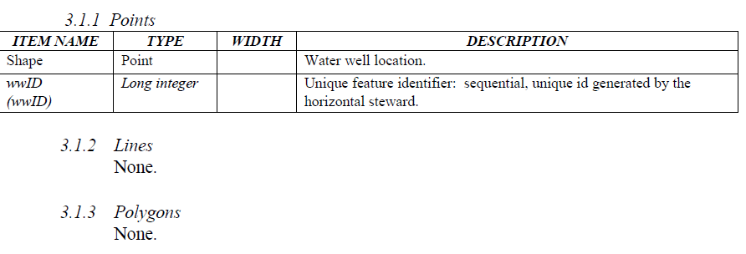

Minimum ATTRIBUTE or Non-Graphic Data Elements
Describe the minimum data attributes that are required for all feature types; include information about relationships (joins and relates); can also include complex database models and relationship information in an Appendix. See the Geologic Data Standard as an example.

Point
Describe the minimum data attributes that are required for a point feature.
Example from another data standard:
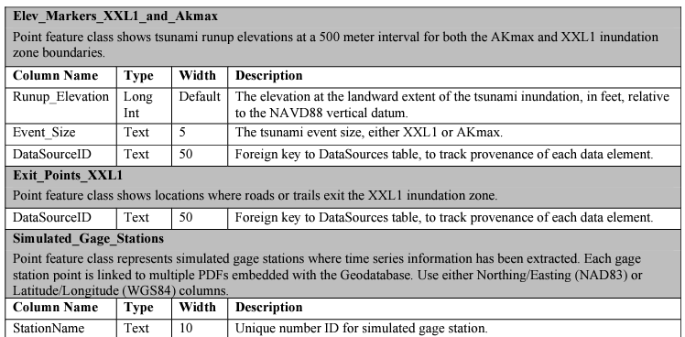

Line
Describe the minimum data attributes that are required for a line feature.
Example from another data standard:
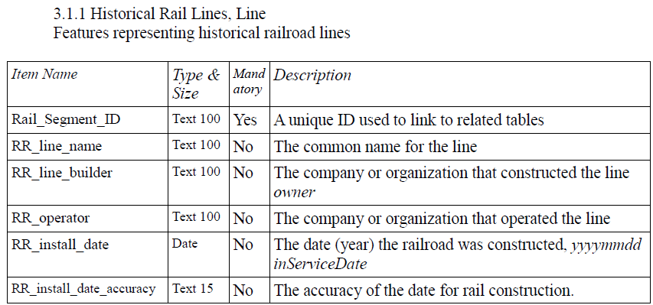

Polygon
Describe the minimum data attributes that are required for a polygon feature.
Example from another data standard:
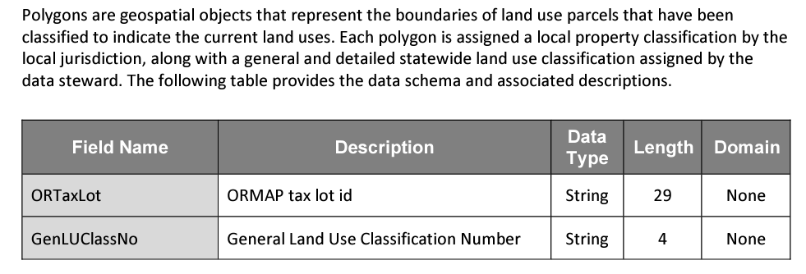

Optional Graphic data elements

Point
Describe optional data that is included and represented by a point feature

Line
Describe optional data that is included and represented by a line feature

Polygon
Describe optional data that is included and represented by a polygon feature

optional attribute or non-graphic data elements

Point
Describe optional data that is included and represented by a point feature

Line
Describe optional data that is included and represented by a line feature

Polygon
Describe optional data, tables, or non-graphic elements that are included and represented by a polygon feature
Example from another data standard:
“There are a set of supplemental tables included with the file geodatabase alongside the geospatial data. These tables include the set of statewide land use classifications and county assessor property class codes and descriptions used to assist in the assignment of tax lot polygons to the set of statewide land use codes, along with other supplemental data to aid in the detailed attribution of parcels. The schemas for these reference tables are below.”

Example from another data standard:
“The wwLogCounty, wwLogNbr, and/or the wwStartCardNbr items are optional unless the well label (a.k.a., the well tag) is unknown. These attributes are presented in order of preference. The remaining attributes on this list are helpful if the well log (wwLogCounty & wwLogNbr) is unknown since they provide clues about a water well that can be used to tie it to the correct well log. Suggested field names of 10 characters or less are shown in parentheses.”
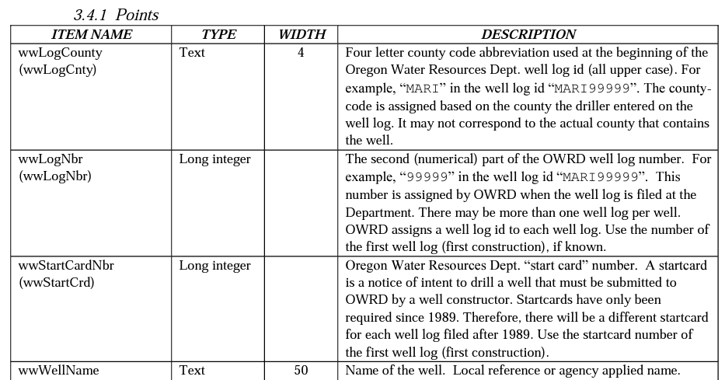

References

