Unemployment Insurance Trust Fund Forecast Summary
2026Q3

Executive summary
This report summarizes the 2026Q3 forecast of Oregon’s Unemployment Insurance (UI) Trust Fund through 2030. This report is based on data from the Oregon Employment Department, U.S. Department of Labor, and Oregon Office of Economic Analysis. This report is released four times per year – March, June, September, and December. Historical data in each report is through the previous quarter, except for employment data which lags an additional quarter. This report includes actual UI data through the second quarter of 2026 and actual employment data through the first quarter of 2026.

State benefit payments are largely forecast to be higher (albeit with some year-to-year variance) than in our 2026Q2 forecast. Employer contributions are forecast to be lower. The trust fund balance is lower over the forecast horizon than in our 2026Q2 forecast. The UI Trust Fund balance was $7.2 billion on June 30, 2026.

UI tax schedule II is in effect in 2027. We are now forecasting that schedule II will also be in effect in 2028 before returning to schedule III in 2029 and 2030.

Contents
The remainder of this report covers the following:
- State benefit payments and employer contributions forecast through 2030
- Comparison of the last two UI Trust Fund balance forecasts
- UI Tax schedule forecast through 2030 and long-term average UI tax rates
- Appendix 1: Economic data for the last two forecasts
- Appendix 2: Definitions of economic data
- Appendix 3: Data for figures 1-4 from the last two forecasts

State benefit payments from the UI Trust Fund
Overall, projected state benefits payments are higher in the 2026Q3 forecast than they were in the 2026Q2 forecast. The following table summarizes these payments over the last two forecasts:

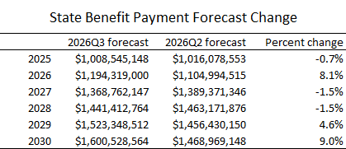

Benefit payment changes in our 2026Q3 forecast compared to our 2026Q2 forecast are influenced by changes in forecast methodology designed to more accurately model quarterly seasonality in claims activity. Post-COVID, the amplitude in seasonal claim activity has been more muted than prior to COVID. We will continue refining this portion of our forecast.

Figure 1 shows actual and forecast state benefit payments from the UI Trust Fund from 2004 to 2030. The UI workload forecast is based on projected economic conditions, historic claims data, and workload forecasts.

Figure 1. State benefit payments from the UI Trust Fund, Oregon, 2004-30

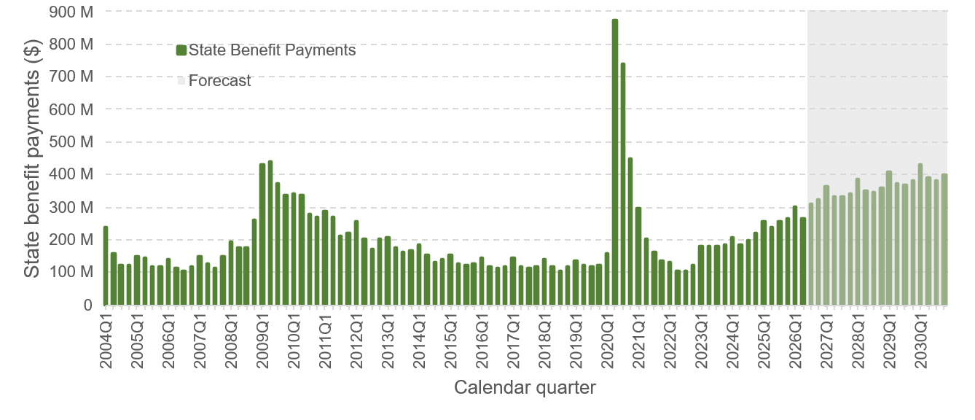
Source: Oregon Employment Department / ETA 5159 / OED Workload Report / Office of Economic Analysis

Employer contributions to the UI Trust Fund
The decreases in our 2026Q3 forecast in 2028 and 2029 are driven by a reduction to tax schedule II in 2028. Note that, because of timing, employer contributions in 2029Q1 are based on the 2028 tax schedule. Other changes are driven by changes in forecast employment and wages. The following table shows projected employer contributions through 2029 for our two most recent forecasts:

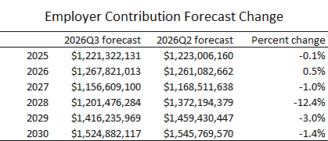

Figure 2 shows actual and forecast employer contributions to the UI Trust Fund between 2004 and 2030. Contributions to the UI Trust Fund are based on the UI tax schedule and they exclude contributions for the Supplemental Employment Department Administrative Fund. Please note that lower revenue in 2027 and 2028 (compared to 2026) is driven by the adoption of tax schedule II for 2027 which is projected to continue into 2028.

Figure 2. Employer contributions to the UI Trust Fund, Oregon, 2004-30

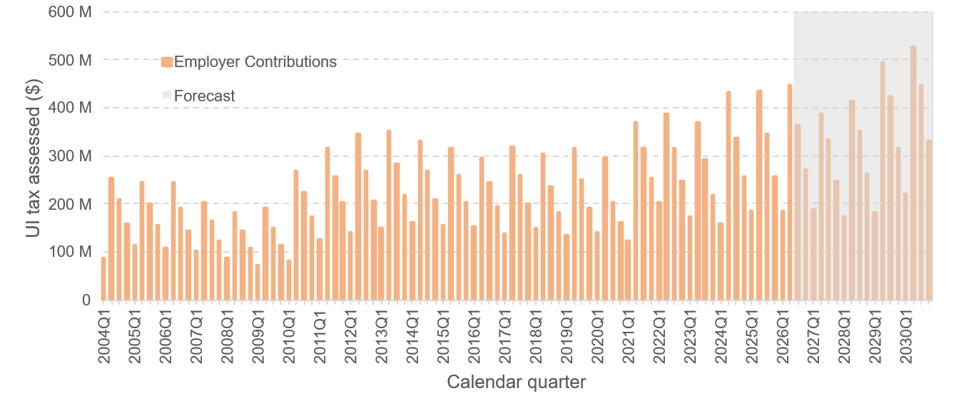
Source: Oregon Employment Department / ETA 2112 / Office of Economic Analysis

UI Trust Fund balance
Figure 3 shows the actual and forecast UI Trust Fund balance between 2004 and 2030 for the last two forecasts. The 2026Q3 balance forecast is slightly lower than our 2026Q2 forecast in the out years of the forecast. The balance was $7.2 billion on June 30, 2026.

Figure 3. UI Trust Fund balance, Oregon, 2004-30

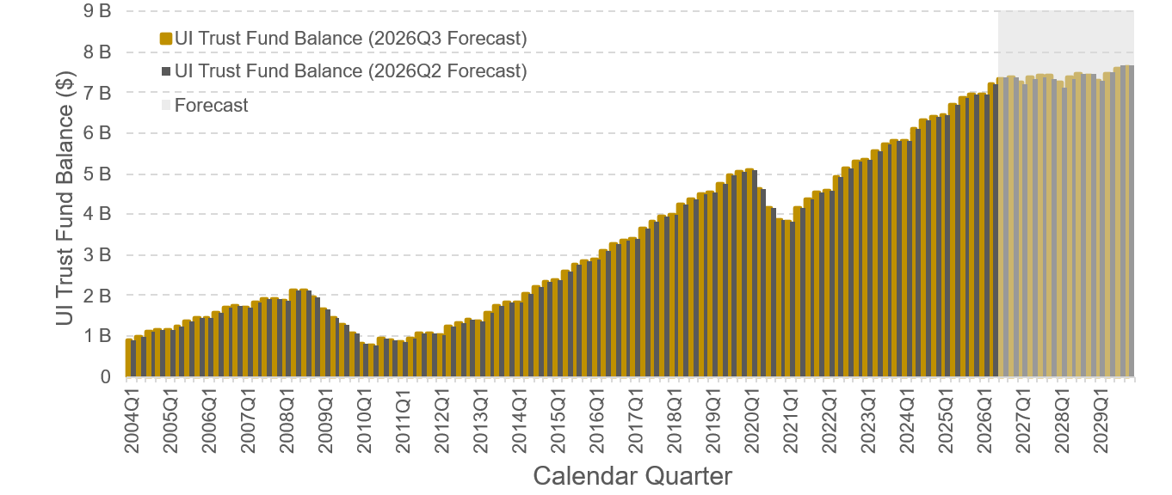
Source: Oregon Employment Department / ETA 2112

The UI Trust fund earns quarterly interest on the balance invested at the U.S. Treasury. This additional fund stream increases the likelihood of a lower statewide UI tax schedule and individual employer tax rates. Since the Trust Fund balance low point of $767 million in the second quarter of 2010, the UI Trust Fund has earned more than $1.5 billion in interest, including $57.8 million in 2026Q2.

Statewide tax schedule and individual employer tax rates
Figure 4 shows the actual and forecast statewide UI tax schedule between 2004 and 2030. UI tax schedule II is in effect in 2027. We currently project that tax schedule II will be in effect in 2028 before returning to tax schedule III.

Figure 4. Statewide UI tax schedule, Oregon, 2004-29
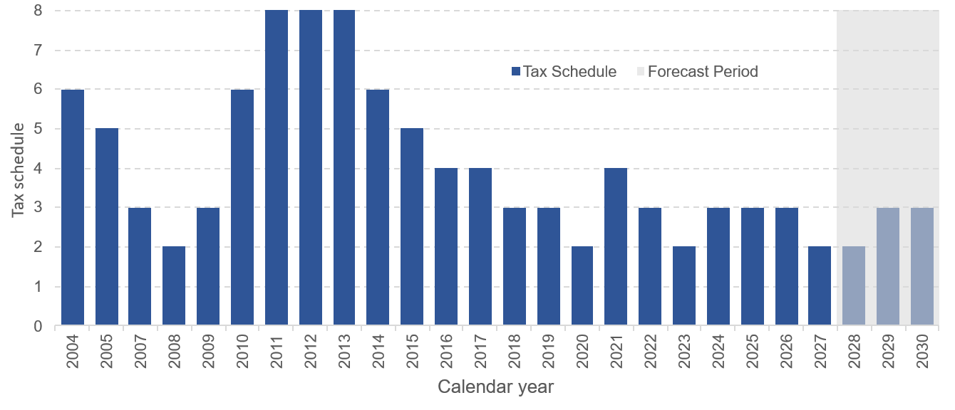
Source: Oregon Employment Department / ETA 5159

Contact information
For more information, contact OED’s Communication team at OED_communications@oregon.gov.

The Oregon Employment Department (OED) is an equal opportunity agency. OED provides free help so you can use our services. Some examples are sign language and spoken-language interpreters, written materials in other languages, large print, audio, and other formats. To get help, please go to unemployment.oregon.gov and click on Contact Us or call us at 877-345-3484. TTY users call 711.

El Departamento de Empleo de Oregon (OED) es una agencia de igualdad de oportunidades. El OED proporciona ayuda gratuita para que usted pueda utilizar nuestros servicios. Algunos ejemplos son intérpretes de lengua de señas e idiomas hablados, materiales escritos en otros idiomas, letra grande, audio y otros formatos. Para obtener ayuda, vaya a https://unemployment.oregon.gov/es/ y haga clic en Contact o llámenos al 877-345-3484. Usuarios de TTY pueden llamar al 711.
Appendix 1: Economic data
Appendix table A1 reports the major economic variables from the Office of Economic Analysis forecast, including a comparison of the data from the last two forecasts.

Appendix table A1. Employment, income, and other indicators forecasts, Oregon, 2022-2030
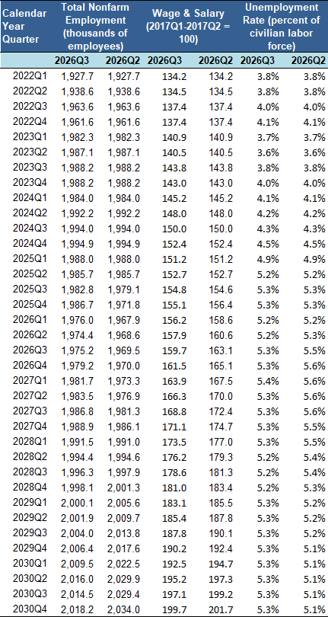
Source: Office of Economic Analysis

Appendix 2: Definitions of economic data
The following are definitions for the economic data reported in table A1:
- Total nonfarm employment: A measure of the number of workers in the economy that excludes proprietors, private household employees, unpaid volunteers, farm employees, and the unincorporated self-employed. Nonfarm employment is used in the UI Trust Fund model to forecast covered employment and taxable employment.
- Wage and salary: This component of personal income consists of the monetary remuneration of employees. It reflects disbursed wages and salaries, but not necessarily earned, during the quarter. This component is measured before deductions, such as Social Security contributions and union dues. The percentage growth for wage and salary is used in the UI Trust Fund model to forecast state benefit payments, taxable payroll, and the fund adequacy percentage ratio (ORS 657.459).
- Unemployment rate: The rate computed by dividing total unemployed by the civilian labor force. The rate is seasonally adjusted, which smooths out the impact of cyclical patterns that occur every year, such as the increase in unemployment due to winter weather and reduced schooling in summer.

Appendix 3: Data for figures 1-4

Appendix table A2. State benefit payments, employer contributions, UI Trust Fund balance and UI tax schedule forecasts, Oregon, 2022-2030.
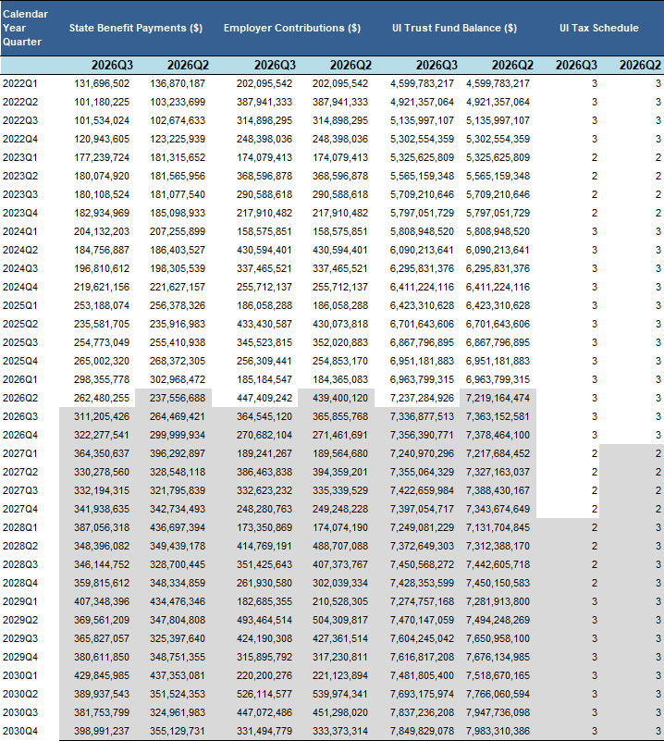
Source: Oregon Employment Department
Note: Forecast shaded in gray. Small differences in historical actuals represent delays in availability of information.

