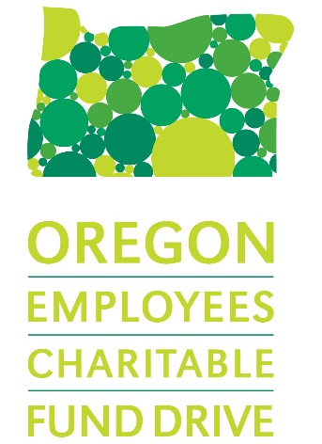
Sample Communication for Coordinators
- Sample graphic for your email signature during the campaign
- Email for Recruiting Campaign Volunteers
Recruit campaign helpers to assist you with the Fund Drive.
- Sample letters to a business to request a donation
A draft letter that can be customized to ask a business to help with incentives, auction items, or other opportunities to support you in your campaign efforts. If you do solicit gifts from businesses, please contact the CMO Team (oregoncfd@unitedwaymwv.org) for thank you letters for those companies who donate.
- Sample Letter / Email for Leadership Endorsement of Fund Drive
Provide this text to your Agency Head or Site Managers who are endorsing the Fund Drive.
- Publicizing your Campaign Kickoff
Sample text to promote your kickoff event.
- Email to Co-workers - Highlighting Online Giving Site
Sample text explaining how to log on to the online pledge site, and how to search for charities using the system.
- Sample End-of-Campaign Thank-You Email to Campaign Volunteers
A short thank you easily customized to thank those that helped you make the 2019 Charitable Fund Drive a success.
- End of Campaign email to all staff
A thank you to everyone in your department or agency informing them of the results of the campaign and thanking them for their participation.

Sample Graphic for your email signature during the campaign
Paste this graphic into your standard email signature while your office’s campaign is approaching and until the campaign wraps up:
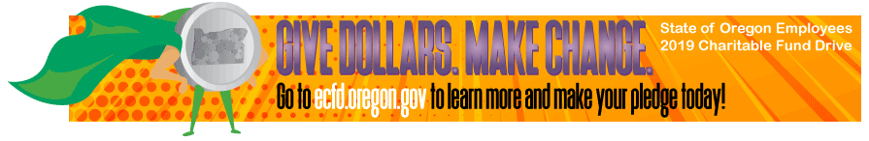
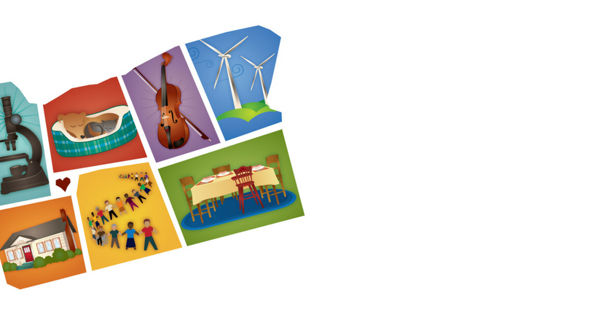

Email for Recruiting Campaign Volunteers
Dear [NAME]:
It’s almost time for this year’s Oregon Employees’ Charitable Fund Drive! Last year, [AGENCY / WORKPLACE] raised [$XXXX] for more than over 600 nonprofit organizations . Our main message is “Give dollars. Make change.” which recognizes the power each of us has to make our communities better through Charitable Fund Drive donations.
I hope the Charitable Fund Drive spurs each of us to think about our own passions for improving our communities – and to realize that every State employee deserves to know how they can use the Fund Drive to support their communities.
If making this happen interests you, I would love to have your assistance with the Charitable Fund Drive. We need volunteers to talk about the CFD in their staff meetings and spread the word. If you want to get a little more involved, we are hoping to plan [INSERT INFORMATION ABOUT FUNDRAISER, LUNCHTIME ACTIVITY, ICE CREAM SOCIAL, ETC.]. Helping to plan this event might be a fun way for you to help us bring awareness to the campaign and the 600+ nonprofit organizations that will benefit from it this year.
Please let me know if you are interested in being part of the team planning Charitable Fund Drive activities – I would love to work with you on this!
Many thanks,
[YOUR NAME]
[YOUR TITLE, AGENCY]

Sample letter to a business to request a donation
Dear Business Owner:
Each year, The State of Oregon holds a campaign to raise hundreds of thousands of dollars for nonprofits statewide.
The Charitable Fund Drive (CFD) generates support for nonprofit organizations that make a difference in:
- Changing lives through the caring power of community
- Inspiring and supporting people working for justice
- Providing resources to people with low incomes
- Preventing child abuse and domestic violence
- Working to find cures for major diseases
- Protecting the environment
- Helping animals
- Providing simple, decent, affordable housing
- Supporting arts and culture
Many State of Oregon offices sponsor fundraising events, like prize drawings and silent auctions, which incorporate items donated by local businesses. Any items donated by your business for the 2019 Charitable Fund Drive will be used to raise donations for the nonprofits.
If you decide to make a donation, the Fund Drive can then provide you with a letter that acknowledges your donation and provides a charity federal tax ID number for tax purposes. The CFD is managed as a project of the United Way of the Mid-Willamette Valley, a tax-exempt 501(c)(3) nonprofit (Tax ID# 93- 0395586.)
On behalf of all 600+ nonprofit organizations, we offer our sincere thanks for supporting the State of Oregon Charitable Fund Drive, and your willingness to partner with us to improve our community.
Sincerely,
(NAME)
(AGENCY)

Sample Letter / Email for Leadership to send, with endorsement of CFD
Dear Colleague,
Give dollars. Make change.
- You’re probably seeing this slogan on posters and materials around the office these days, as part of the Charitable Fund Drive. This important, once-a-year campaign is a great way for State employees to support the charities they’re most passionate about. But what do our dollars, donated through this campaign, really do? They make a real and meaningful difference every day for thousands of Oregonians who are helped by our donations. [choose 3-4 of the stories below that you think will speak to your co-workers]
- $5.00 per paycheck provides emergency food boxes to feed a family for a month.
- $5.00 per paycheck provides clothes, shoes, and winter coats for 40 children.
- $5.00 per paycheck supports two at-risk parents enrolled in parenting classes.
- $10.00 per paycheck helps families in crisis with emergency assistance for things like electricity and water.
- $10.00 per paycheck repairs four musical instruments that are given to a student, free-of-charge, to use for an entire school year.
- $15.00 per paycheck provides a night of shelter for a homeless teen.
We here at [AGENCY], both through the Charitable Fund Drive and other avenues of personal giving, have always done great things for our communities. I personally participate in the Charitable Fund Drive because… [TELL YOUR OWN STORY ABOUT WHY YOU GIVE.]
…
I encourage all of us to think about what we value most, and think about giving through the Charitable Fund Drive to the charities we believe in. Giving online is easy at (http://ecfd.oregon.gov and click “PLEDGE NOW”).
[date] begins our agency’s Charitable Fund Drive. Let’s continue our commitment to our community through employee payroll contributions. If every State of Oregon employee gave just $5.00 a month to the Fund Drive, we could raise more than $3.2 million for our nonprofit community. It’s amazing what a lasting impact State employees have when we give together!
Thank you for your generous support.
[Name]
[Title]

Publicizing your Campaign Kickoff
In just a few weeks, starting on [DATE], [AGENCY] will launch our Charitable Fund Drive for 2019. Our slogan is “Give Dollars. Make Change.”
To kick off the Fund Drive with a big splash, we are hosting a special [LUNCHTIME ACTIVITY, COFFEE BREAK, ICE CREAM SOCIAL, ETC.]. If you attend, you’ll not only get a chance to find out about your giving options in this year’s Charitable Fund Drive (more than 600 organizations ), but have a little fun, too! The goal for this year's campaign is to [INSERT SITE GOAL or; raise participation by 5 percent]. We know we can reach this goal, but only with your help. Please join us!
Sincerely,
[your name here]
[your title here]

Email to Co-workers Highlighting Online Giving Site
We here at [AGENCY], both through the Charitable Fund Drive and other avenues of personal giving, have always done great things for our communities. I personally participate in the Charitable Fund Drive because… [TELL YOUR OWN STORY ABOUT WHY YOU GIVE.]
…
The annual State of Oregon Employees’ Charitable Fund drive kicks off in our office on [DATE]. This is your annual opportunity to support the charities you care about most, joining forces with your fellow State employees to give, to make a lasting impact on Oregon.
If you haven’t tried it yet, it’s easy and fast to make a gift through the Charitable Fund Drive using the online pledging system. Just go to http://ecfd.oregon.gov and click “Pledge Now – State Employees”. Log in using your employee ID number (with “OR” and all the preceding zeroes), and your name. That’s all it takes to sign in!
Through the Charitable Fund Drive, your gift of any size has a lasting, positive impact on your community. A gift of $5 per month can do things like:
- Provide two teens with one month of mentoring and activities in an alcohol- and drug-free environment.
- enroll a person with dementia in Medic Alert® + Safe Return® that responds to medical emergencies and wandering.
- purchase 15 meals per month, 180 meals per year
- buy a sturdy front door for a new home for a family in need.
You’d be surprised what wonderful things your gift can do, and how far your donation can go. Please contact me if you have any questions about the Charitable Fund Drive, or if you just want to email me your story of why YOU give through the Charitable Fund Drive. This year, let’s all do something great for those nonprofits that we are most passionate about.

End of Campaign Thank-You Email to Donors / Helpers
Dear [NAME]:
Thank you for all your hard work to make the 2019 Charitable Fund Drive a success. Through your gift of time and effort to the campaign, [AGENCY / WORKSITE] employees donated [$AMOUNT] to help over 600 nonprofit organizations across the state. Together, we are showing that State employees care about the future of Oregon’s families, housing, health, environment, human rights, equality, arts and culture, and pets and animals.
Again, my sincere thanks for the work you put into the Charitable Fund Drive. We couldn’t have done it without you!
Sincerely,
[YOUR NAME HERE]
[YOUR TITLE HERE]

End of Campaign email to all staff
Thank you for your support of the Charitable Fund Drive. Through your participation and support, [AGENCY/WORKSITE] raised [$total raised] which [met or exceeded our goal] of [$goal amount]. This was the result of [XXX] of our co-workers, each of whom donated towards the charities they’re most passionate about. Together, we are having a great positive impact on our communities and our state.
If you want to keep up-to-date on what our donations do throughout the year, sign up for the Fund Drive’s “Your Gifts At Work” email newsletter. And, if you forgot to pledge, there’s still time; just go to ecfd.oregon.gov and click “Pledge Now”.
Thanks again, everyone!
[your name]

