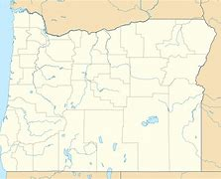
Expected Implementation Date
December 31, 2027
Expected Indicator Selection Completion Date December 2025.
Key Dates
1
Implementation guidance is expected to be available by December 31, 2027
2
Learn more about the current progress on the Oregon Environmental Justice Council website.
Resources
State Agencies
Public
Oregon Environmental Justice Council
Targeted individuals

This fact sheet is for new Environmental Justice Council members, other Oregon boards, commissions, and councils who are interested in an environmental justice mapping tool, the Oregon Legislature, state staff, and the public.
1
Key recommendations for environmental justice mapping tool development are considered through ten decision points.
Decision Points
2
Six in person listening sessions to inform environmental justice mapping tool development.
Listening Sessions
3
Statewide survey to gather feedback from all Oregon communities statewide supplement in person listening sessions.
Community Survey
Key Processes
Project Fact Sheet
Oregon Environmental Justice Mapping Tool
The Oregon Environmental Justice Mapping Tool is tool being developed for state agencies to help them identify communities traditionally unrepresented in government processes and harmed by environmental and health hazards as required by House Bill 4077.

This tool can potentially influence how agencies target community engagement, develop new programs, and consider how to allocate resources to communities.

Oregon Environmental Justice Council
Effective from – April 4, 2025

