Oregon ABS – Title II
Standards-based PLCs

Assessment Data & Learning Standards PLC Sample Activities
Submitted by State ABS Team

- Form a PLC that includes program director(s)/administrator(s), data professionals, and instructors
- Review available TOPSPro reports that break out data by learning standards (ex: TOPSPro Individual Skills Profile Summary by CCRS)
- Work together to interpret the reports
- Utilize the appropriate OACCRS Language Arts/Mathematics Handbook to examine the standards
- Determine priority OACCRS standards to address in classroom practice
- Create a plan for how priority OACCRS standards will be addressed
- Monitor student learning on identified priority standards using formative (classroom) and summative (CASAS) assessments
- Extend the PLC by:
    - Sharing, reflecting on, and refining instruction based on learning standards
    - Identifying additional priority standards to address
    - Analyzing and interpreting additional student learning data from TOPSPro

Resources:
Learning Standards Handbooks
TOPSPro Sample Reports
Interpreting the CASAS ISPS Report by CCRS (Reading) (below)

Interpreting the CASAS Individual Skills Profile Summary – CCRS to Support Student Learning For Reading
This document provides a step-by-step guide to interpret the above report so that instructors can use student data to focus instruction and help meet students’ learning goals and so that programs can make data-driven decisions when implementing the Oregon Adult College and Career Readiness Standards (OACCRS). When reviewing the report, it is helpful to remember that OACCRS utilizes the College and Career Readiness Standards (CCRS) designations. If you have additional questions about implementing learning standards in Title II-funded ABS programs, contact ashley.garrigan@hecc.oregon.gov.
- Download the sample report provided by CASAS
Navigate to Sample Reports and download the Individual Skills Profile Summary by CCR Standards.
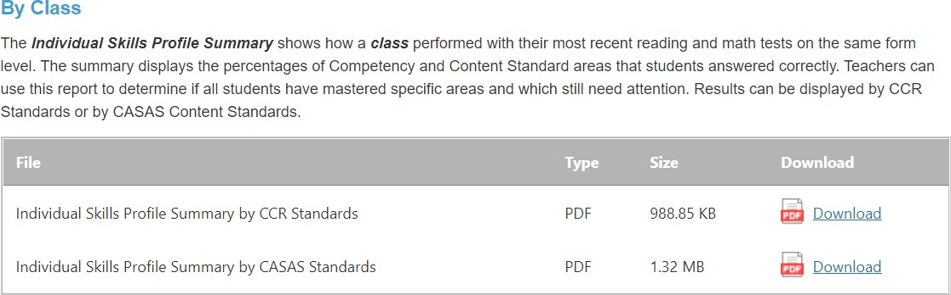

NOTE: When you download the PDF, you will notice that there are multiple pages to the report. This is because the report provides the most recent reading and math test scores for everyone in your class. You will want to review all the appropriate subject area results to determine learning opportunities across the class, identify priority standards to focus instruction, and identify the appropriate level(s) for instruction before planning instruction.

Review the sample CASAS report
While you will want to review all the appropriate subject area results in the report before making instructional decisions, only one reading result will be reviewed in this instructional document.
Skim page 2 of the PDF. Note the following:

➔ Assessment Forms – the CASAS Assessment Form Number
➔ Form Level – the CASAS Assessment Level
➔ Total Students – the number of students in the class who took this assessment
➔ Mean Score – the mean CASAS Scale Score for all tests
➔ CCRS Chart – the CCRS Content Areas, CCRS Anchor Standards, number of test questions, and percentage of questions answered correctly
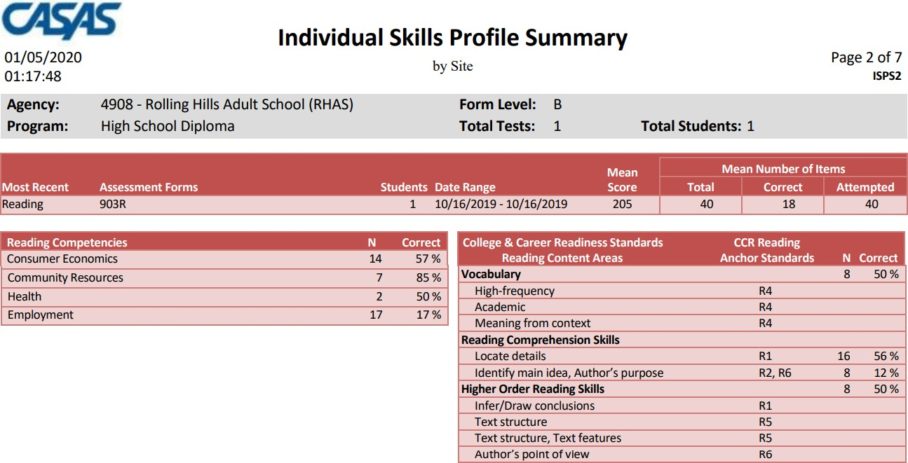
These are noted in the highlighted areas below:

Utilize the CCRS Chart to determine student learning opportunities
Analyze and interpret the chart.
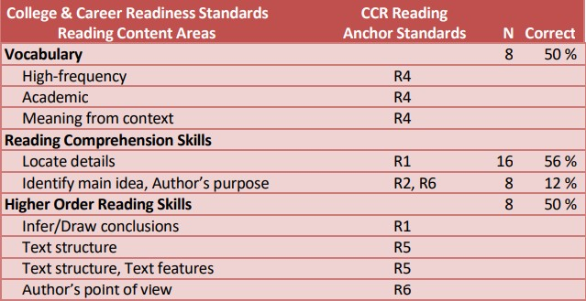

In other words:
➔ 50% of questions related to vocabulary (CCRS Anchor R4) were answered correctly
➔ 56% of questions related to locating details (CCRS Anchor R1) were answered correctly
➔ 12% of questions related to identifying main idea and author’s purpose (CCRS Anchors R2 and R6) were answered correctly
➔ 50% of questions related to higher order thinking skills (CCRS Anchors R1, R5, R6) were answered correctly

Identify priority standards to focus instruction
Base selection on student needs, as well as on program goals.1 For example, based upon student learning need in the selected result, the greatest area for opportunity is:
➔ 12% of questions related to identifying main idea and author’s purpose (CCRS Anchors R2 and R6) were answered correctly
Additionally, being able to identify the main idea and author’s purpose are critical skills across a wide variety of personal, employment, and educational settings. Therefore, focusing instruction on these skills fulfills both student needs and program goals.
Similarly, CCR Anchor Standard R4 would also be a productive area to focus on given the importance of vocabulary for reading success.

Identify the appropriate level for instruction

CASAS Level | CASAS Scale Score | CCRS Level
A | 203 and below | A
Low B | 204-216 | B
High B | 217-227 | C
C | 228-238 | D
D | 239-248 | E
E | 249 and above | E
Note: Per CASAS, the CASAS/CCRS correlation is not absolute (see CASAS Reading Standards, p. 8). For a more detailed chart, including how this aligns to NRS Levels, see the LA Handbook, p. 51.
The Mean Scale Score highlighted on the sample above is 205. This correlates with CASAS Level Low B and CCRS Level B.

View the CCRS Anchor and Level Descriptor in the OACCRS LA Handbook
View identified priority CCRS Anchor(s) and Level Descriptor(s) in the Handbook for instructional guidance. After reviewing R4 Level B below, consult the Handbook for guidance and applications for the other priority standards identified in the sample above (R2 Level B, R6 Level B).
There are two options for viewing:
  - Cross-Level View

1 Programs also may want to consult the Reading Goals Test Blueprint referenced in Step 7. The blueprint breaks down the coverage of CCR Anchor Standards at each Reading Goals Test Level by percentage.

Notice that, with the Cross-Level View, instructors can see what students should have mastered at the previous level and will be expected to master at the next level.
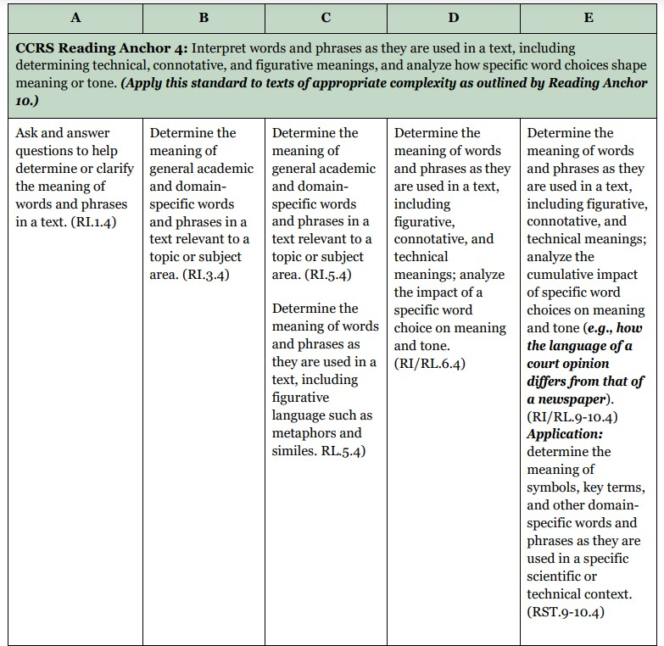
See Language Arts Handbook, p. 19

  - Single-Level View

Notice that, with the Single-Level View, instructors can see applications for use at the specific level.
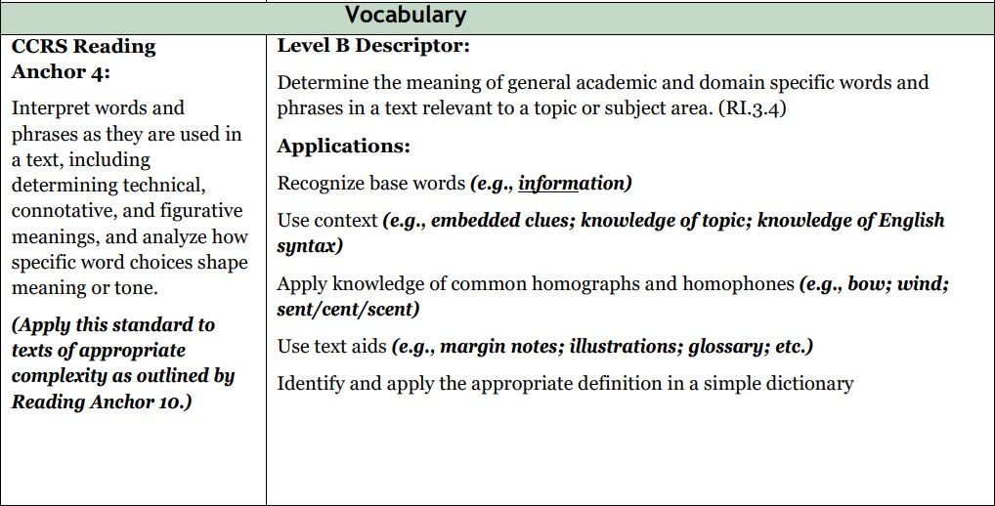

See Language Arts Handbook, p. 85

Utilize resources to guide standards implementation

The OACCRS Language Arts Handbook
➔ The Teacher Toolbox addresses the three Key Advances of CCRS. Included are practical strategies for selecting appropriately-leveled texts, identifying questions worth answering, and creating high-quality writing prompts.
➔ The Four Dimensions of Performance helps instructors judge proficiency and assess learning. The handbook contains standards-based examples of how to use the four dimensions to plan instruction, as well strategies for using them to teach multi-level classes.
➔ The Glossary defines standards-related terms and describes how the terms are used in context.

The Common Core State Standards (CCSS)
After each CCR Reading Standard Level Descriptor is a citation that references a specific Common Core State Standard. These citations are present in both the Cross-Level and Single-Level Views. For example, the citation for CCRS Reading Anchor 4 Level B (from Step 6 above) is RI.3.4. See p. 16 of the OACCRS Language Arts Handbook for information about interpreting CCSS citations.
Enter the code into a search engine for additional resources, such as lesson planning and teaching ideas. Take care that chosen activities are appropriate for adults rather than young children.

CASAS.org
The Reading GOALS Test Blueprint shows the percentage of CCRS Reading Anchors and Descriptors in each CASAS Reading GOALS Test level. Programs can use the blueprint to inform teaching and assessment strategies.

