Study Name

Public Involvement Plan

<Date>
HOW TO USE THIS TEMPLATE
This template is designed to help you prepare a successful public involvement plan. However, public involvement programs are not “one-size-fits-all”. It is important to select specific outreach tools and strategies that are suited to your intended purpose. Refer to DLCD’s “Putting the People in Planning” Guidebook for more information.
Notes and suggestions in the template are provided in blue text boxes and should be deleted from your final document. Sample narrative is provided in normal font and should be edited to suit your specific study.

Inside the front cover is a good place to provide information on how people with disabilities can get help to access study information. For example:
Americans with Disabilities Act (ADA) Information: Accommodation requests for people with disabilities can be made by contacting <insert your agency’s ADA contact person here>.
All governmental agencies are required to comply with Title VI of the Civil Rights Act. Information about your agency’s Title VI policy and complaint process should be provided. For example:
Title VI Statement to Public: It is <your agency’s> policy to assure that no person shall, on the grounds of race, color, national origin or sex, as provided by Title VI of the Civil Rights Act of 1964, be excluded from participation in, be denied the benefits of, or be otherwise discriminated against under any of its federally funded programs and activities. Any person who believes his or her Title VI protection has been violated, may file a complaint with <insert your agency contact person here>.

Study Name
Public and Stakeholder Engagement Plan
Contents
1 Introduction 3
1.1 Study Overview and Purpose 3
1.2 Study Area 3
1.3 Public Involvement Objectives 4
1.4 Study Decision-Making Process 5
2 The Audience for this Study 6
2.1 Interested Parties 6
2.2 Title VI and Environmental Justice Populations 7
3 Public Communication Protocol 8
3.1 Public Inquiries 8
3.2 Media Relations 9
3.3 Stakeholder Agency Interactions 9
3.4 Documentation 10
4 Public Outreach Activities 10
4.1 Study Info Sheet 10
4.2 Study Email List 10
4.3 Direct Mailing Campaign 10
4.4 Study Advisory Group 10
4.5 Online Information and Tools 10
4.6 Public Meetings 10
4.7 Outreach Strategies for Specific Groups 10
4.7.1 Reaching Young People 10
4.7.2 Reaching Older People 10
4.7.3 Reaching Low Income People 10
4.7.4 Accommodating Disabled People 11
4.7.5 Accommodating People with Limited English Proficiency 11
4.7.6 Outreach to Neighborhood Groups 11
4.7.7 Outreach to Business Interests 11
4.7.8 Outreach to Elected Officials 11
5 Schedule of Outreach Activities 11
6 How Community Input Will Be Used 11
7 Monitoring the Effectiveness of the Public Engagement Program 12
8 Outreach Responsibilities (Optional Section) 12
Appendix A: Title VI and Environmental Justice Populations 14
Appendix B: Public Comment Log 15

Introduction

Study Overview and Purpose
This document describes anticipated methods for engaging the public, including key audiences, strategies for disseminating information, conduits for receiving public and stakeholder input, and incorporating input into the study.
Provide some background for the planning study, including a brief history on how the study came to be. Include a statement on the purpose and desired outcomes for the overall study. What existing problem(s) or issues will the plan address?
State the purpose for this public involvement plan as well. For example:

Study Area
Figure 1. Study Location
Describe the planning area. You may wish to include easily identifiable landmarks and a map. If decisions made during your planning process may impact areas outside of your study area, you may also wish to expand the study to include those areas, or simply identify them as extended “areas of influence”.

<Insert a map showing the area likely to be affected by your study or plan.>

Public Involvement Objectives
Public involvement will be key to the study’s successful implementation. We know that the study will affect a wide variety of people with many different interests. Because of this, it is unlikely that everyone will agree 100 percent with every aspect of the study recommendations. Two-way communication between the planning team and people who may be affected by the study’s outcome is important. This will help the team to identify and understand different interests and concerns and provide the best chance of shaping the study to fit the public’s overall needs.
Explain why public involvement is important for the study. Perhaps include a paragraph like the suggestion below. (Edit or replace to suit your study.)
The objectives of the study’s public and stakeholder engagement program are to:
Explain what you intend to accomplish with your outreach activities. Perhaps some of the bullets below may be relevant to your effort – add, remove or edit them as you see fit.

- Communicate accurate, understandable and timely information throughout the study.
- Give all potentially affected interests an opportunity for input.
- Actively seek community input throughout the study, engaging a broad, diverse audience.
- Actively seek participation of potentially affected and/or interested agencies, individuals, neighborhoods, businesses and organizations.
- Provide meaningful public involvement opportunities and demonstrate how input has influenced the process.
- Clearly articulate the process for decision-making and opportunities for input or influence.
- Time interactions with the public and stakeholders to coincide with key technical phases of the study.
- Clarify key issues and address potential conflicts early. Obtain a thorough understanding of the reasons behind potential concerns to give the team the best chance of identifying an appropriate solution or response.
- Convene a study advisory group to collaboratively develop solutions and vet potential decisions. Clearly explain the roles, responsibilities and authorities of advisory group members in the decision-making process.
- Explore partnerships between <your agency> and other agencies and organizations, for overcoming potential barriers to plan implementation. (Partner actions may be in the form of policy support, coordination of operational activities, and/or assistance with arterial integration elements.)
- Comply with Title VI of the Civil Rights Act and Environmental Justice rules. The outreach process will promote the fair and meaningful involvement of all people regardless of race, color, national origin or income. No person shall be excluded from participation or subjected to discrimination on the basis of these factors.
- Ensure that the public involvement process is consistent with applicable state and federal laws and requirements, and is sensitive to local policies, goals and objectives.
Funding and resources for the study’s public involvement activities are not unlimited. We also understand that people have many competing demands on their time, and it will be important to be sensitive to this. For these reasons, a final objective is to provide a budget-conscious public involvement program that provides meaningful opportunities for input and feedback that are both inexpensive and convenient for participants.
If your budget for the outreach effort is tight, you might include a brief statement about that here. (If your study needs to include more time-intensive outreach activities such as in-person meetings, interviews or workshops, the sample paragraph below may not apply and could be deleted.)

Study Decision-Making Process
People need to know who is involved in study decisions and understand how their input and feedback will be communicated to those decision makers. Clearly explain how much influence the public can expect to have. Will they have an opportunity to provide feedback on recommendations developed by the planning team? Or will they have an active role in formulating recommended solutions?
A diagram can explain at a glance who is in position to make recommendations, and who is the ultimate decisionmaker. Replace the sample information below with your own version.

Figure 2. Decision Making Process
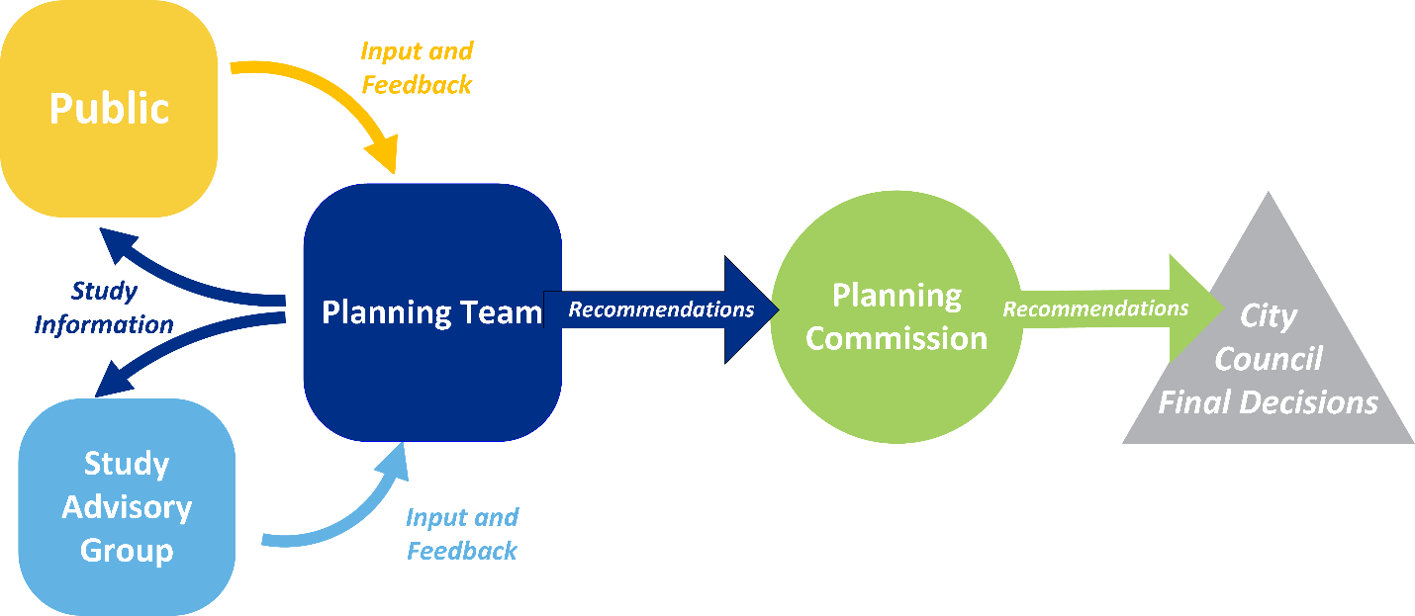
Figure 2 shows the general decision-making process for the study. The planning team will share study information with stakeholders and the public for input and feedback. The planning team is then responsible for balancing community needs and desires expressed through the public engagement process. An advisory committee will serve as a sounding board for the project team, providing additional input on public concerns and feedback on possible solutions. Ultimately, study recommendations will be developed based on the judgment of the planning team.
Final study approval rests with <your decision-making body>.

The Audience for this Study

Interested Parties
Describe the people and groups who are likely to be interested in the planning study. Revise the suggested language below to fit your study.

The outreach process will provide opportunities for input and feedback from many interested people and organizations in the study area, including, but not limited to:

- Elected officials
- Local agency partners
- Business organizations, associations and chambers of commerce
- Bike and pedestrian interests
- Transit providers and transit users
- Local airports interests
- Freight interests
- Environmental interests
- Senior services
- Low-income, racial and ethnic minority groups
- Health equity interests
- Tourism agencies and interests
- Schools and universities
- Housing and community development interests
- Emergency services providers
- Natural disaster risk management agencies
- Neighborhood councils
- Downtown associations
- Large employers
- Employer-based commuting programs
- Recreation interests
- General public
- Local media
- Internal stakeholders at <your agency>

Title VI and Environmental Justice Populations
Title VI of the Civil Rights Act of 1964 requires that no person shall be excluded from participation in, be denied the benefits of, or be subjected to discrimination under any program or activity receiving federal financial assistance on the grounds of race, color, or national origin; including the denial of access for Limited English Proficient persons.
You will need to do some analysis to determine where Title VI and Environmental Justice populations might exist in and around your study area. The US Census and American Community Survey are typical data sources for this, and the US EPA has an online tool, EJSCREEN, that can help with simple Environmental Justice population maps. The Oregon Department of Transportation’s TransGIS site also allows users to query Environmental Justice populations above a defined threshold by zip code. Urban areas with populations greater than 50,000 typically have a regional metropolitan planning organization (MPO) that may also be a good resource for this information. For larger, more complex studies, you may need the assistance of a GIS analyst.
Sample narrative for this section is provided below.

In addition, the fair treatment and meaningful involvement of all people regardless of race, color, national origin, or income (also known as “Environmental Justice”) was the subject of an Executive Order signed by President William J. Clinton in 1994. Executive Order 12898 focused federal attention on the environmental and human health effects of governmental actions on minority and low-income populations.
Maps provided in Appendix A show concentrations of populations that meet the criteria for Title VI and/or Environmental Justice consideration. These maps, based on <describe the data source you used>, were generated to screen for potential densities of:
- Ethnic minority populations (African-American, Hispanic, Asian, Native American, and Pacific Islander populations)
- Elderly populations
- Low-income populations (median household income at or below the poverty line)
- Disabled populations (both mental and physical disabilities)
- Limited English Proficiency populations.
This high-level scan is intended to help the planning team anticipate potential vulnerable and disadvantaged populations which may be interested in, or affected by, the study. However, a more detailed analysis may be needed later to understand the specific impacts resulting from the study.

Public Communication Protocol
Use this section to explain how you will manage and document public communications while the study is underway.

Public Inquiries
Describe how you will handle public inquiries for the study. Be sure to cover these points:
- To whom should public inquiries about the study be directed?
- What will happen with those inquiries after they are received?
- Who will make response and follow-up assignments?
- How long may people need to wait for a response?
Are all planning team members authorized to communicate directly with members of the public, or will you have a designated person do so?

Media Relations
Describe how you will handle media relations for the study. These points are important to consider:
- Who will prepare and distribute press releases? When/how often? Where will they be sent?
- Who will be the primary contact person for media inquiries?
- Are any other team members authorized to speak to the media?
- Will you arrange to meet with specific reporters or editors to discuss the study?
- Where will you store information available to the media?
- Who is responsible for collecting and storing published stories about the study?
If your study is large, complex or controversial, you may wish to prepare a media packet to help promote factual information and keep messaging on point. The packet may include, for example, a generalized map of the study area, study description, frequently asked questions, team contact information and other information developed and approved by your agency for external publication.

Stakeholder Agency Interactions
include this section if there are other public agencies and organizations that will need to be engaged during the study. This could include federal, state, regional, local or tribal governments. It may also include other quasi-public agencies such as utility companies or certain non-profit agencies that provide social services to the public.
- Which agencies will you need to engage and why?
- How will you engage them? (Interviews? Surveys? Include them on an advisory group?)
Who will reach out to them?

Documentation
A general public comment log (Appendix B) will be created and maintained by the planning team. Written comments received online, at outreach events and through other means will be tabulated by <responsible person> and provided to the study manager for review and follow-up assignments if needed. <Be sure to describe how often the comment log will be reviewed, by whom, and how public comments will be communicated to the rest of the team during the study. Will your comment log include information on how each comment was addressed?>
How will you document the public involvement process? Starter wording for this section is provided below. Edit as needed to suit your study.

A complete summary of the community engagement process will be compiled at the end of the study and published in a final public involvement report.

Public Outreach Activities
Use this chapter to describe the specific outreach activities you will use as the study is underway. We’ve listed a few typical activities – add, remove, or revise these subheadings to suit your study and audience. Describe the purpose of each activity and how you will perform it.

Study Info Sheet

Study Email List

Direct Mailing Campaign

Study Advisory Group

Online Information and Tools

Public Meetings

Outreach Strategies for Specific Groups

Reaching Young People

Reaching Older People

Reaching Low Income People

Accommodating Disabled People

Accommodating People with Limited English Proficiency

Outreach to Neighborhood Groups

Outreach to Business Interests

Outreach to Elected Officials

Schedule of Outreach Activities
Include a timeline information to show how outreach activities will align with the rest of the study work. This could be a simple list of dates and milestones that includes public involvement tasks, or a timeline graphic like the sample below

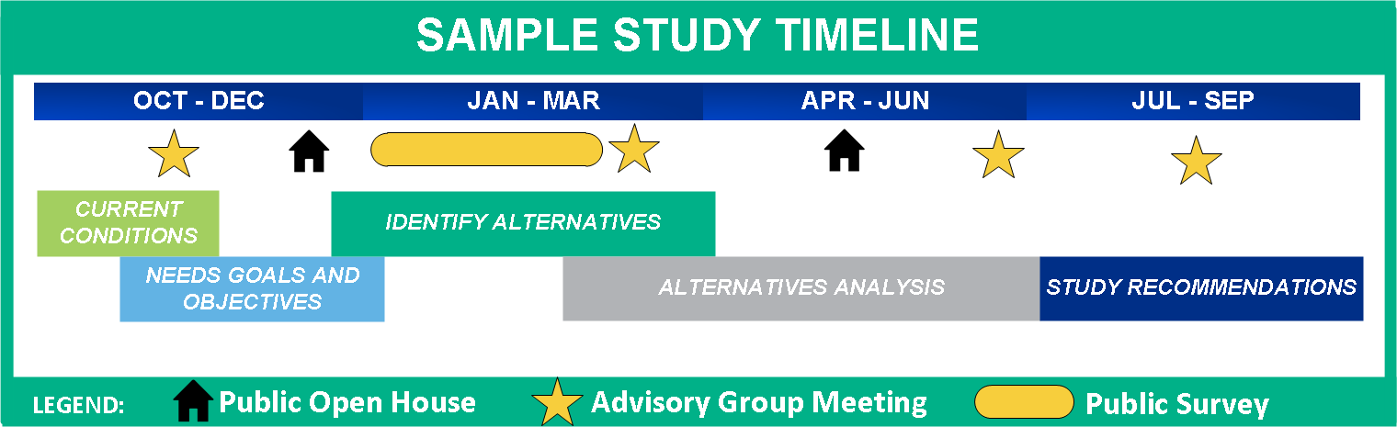

How Community Input Will Be Used
The planning team will have a standing agenda item to review and consider public comments received as the study moves forward. A comment summary will also be created by the planning team following each public meeting event and shared with technical staff and decisionmakers. Comments meriting further action will be identified by the study manager and assigned to planning team members for follow up as appropriate.
Describe how you will use input and feedback received from the public during the study. For example:

Monitoring the Effectiveness of the Public Engagement Program
Monitoring your outreach activities is a good idea, to make sure information is making its way to your audience, and that you are accomplishing your stated public engagement objectives. As the study is underway, consider asking participants to complete interim feedback forms to rate how well they are able to understand process and technical information provided.
Describe how you will track public participation, and what you will do if people are not engaging as hoped.

Outreach Responsibilities (Optional Section)
To keep your planning team accountable and make sure you have all bases covered, it can be helpful to identify a lead person for each outreach activity.
If external organizations will have roles in the outreach effort, or if a consultant team is involved in the study, clearly identify who is responsible for each outreach task.
Edit the sample table below as you see fit. This information can be included here in your public involvement plan or kept separate as part of your project management process.

Sample Outreach Item or Activity | Responsible Parties
 | Our Agency | Partner Organization | Consultant | Lead Person
Maintain public inquiry/comment log |  |  | x | Le
Press releases | x |  |  | Hernandez
Media packet | x |  |  | Hernandez
Study area map |  |  | x | Johnson
Study information sheet |  |  | x | Patel
FAQ flyer |  |  | x | Patel
Key message bullets | x |  |  | Ramirez
Advisory group roster | x |  |  | Kahn
Reserve venues, schedule advisory group meetings and invite stakeholders | x |  |  | Kahn
PowerPoint slides for advisory group meetings and public open houses |  |  | x | Ash
Facilitate advisory group meetings |  |  | x | Ash
Advisory group meeting summaries |  |  | x | Le
Reserve venues for open houses (ensure ADA compliant) |  |  | x | Le
Public notices for open houses | x |  |  | Hernandez
Open house posters and handouts |  |  | x | Patel
Attend two open houses | x | x | x | Ash, Hernandez, Patel, Daniels
Open house comment tabulation |  |  | x | Le
Presentations to other groups | x | x |  | Hernandez, Daniels
Set up study website |  |  | x | Le
Information and graphics for website |  |  | x | Johnson
Etc.

Appendix A: Title VI and Environmental Justice Populations
Include study area maps or statistical tables showing densities of
- Minorities:
  - American Indian and Alaska Native
  - Asian
  - Black or African American
  - Hispanic or Latino
  - Native Hawaiian or Other Pacific Islander
- Older people (e.g. 65 and over)
- Children (e.g. under 18)
- Disabled people
- Low-income populations (e.g. household income is at or below the US Department of Health and Human Services poverty guidelines)
- People with limited English proficiency

Appendix B: Public Comment Log

Ref. No. | Date Received | Name | Comment | Planning Team Response

