Large Cities Middle Housing Model Code
User’s Guide:
Oregon House Bill 2001 (2019) (HB 2001) requires that “Large Cities” (defined as cities with a population of 25,000 or more and each county or city within a metropolitan service district) must allow: (1) all middle housing types in areas zoned for residential use that allow for the development of detached single-family dwellings; and (2) a duplex on each lot or parcel zoned for residential use that allows for the development of detached single-family dwellings. Middle housing, which HB 2001 defines as duplexes, triplexes, quadplexes, cottage clusters, and townhouses, provides an opportunity to increase housing supply in developed neighborhoods and can blend in well with detached single-family dwellings.
The bill allows local governments to regulate siting and design of middle housing, provided that the regulations do not, individually or cumulatively, discourage middle housing development through unreasonable costs or delay. When regulating siting and design of middle housing, Large Cities should balance concerns about neighborhood compatibility and other factors against the need to address Oregon’s housing shortage by removing barriers to development and should ensure that any siting and design regulations do not, individually or cumulatively, discourage the development of middle housing through unreasonable costs or delay.
Large Cities may develop their own standards in compliance with the requirements of HB 2001. This model code may provide guidance toward that end. However, if Large Cities do not wish to prepare their own standards or if Large Cities do not adopt the required code amendments by June 30, 2022, they must directly apply this model code prepared by the Department of Land and Conservation Development (DCLD) to development in their jurisdictions. The model code is intended to be straightforward and implementable by Large Cities throughout the state, and is consistent with the requirements and intent of HB 2001. The model code will be adopted by reference into Oregon Administrative Rules.
To the extent they are applicable, the Administrative Rules contained in Chapter 660, Division 46 apply to and may be used to interpret this model code.

Chapter 1. Combined Standards for All Middle Housing
Sections:
- Purpose
- Definitions
- Applicability
- Relationship to Other Regulations
- Duplex, Triplex, and Quadplex Examples

A. Purpose
The purpose of this middle housing model code (“code”) is to implement HB 2001, codified in ORS 197.758 et seq, by providing siting and design standards for middle housing developed in areas zoned for residential use that allow for the development of detached single family dwellings.

B. Definitions
The following definitions shall apply for the purposes of this code, notwithstanding other definitions in the development code:
- “Building footprint” means the horizontal area as seen in plan, measured from outside of all exterior walls and supporting columns. It includes dwellings and any area of attached garage that exceeds 200 square feet. It does not include detached garages or carports; accessory structures; trellises; patios; areas of porch, deck, and balcony less than 30 inches from finished grade; cantilevered covers, porches or projections; or ramps and stairways required for access.
- “Common courtyard” means a common area for use by residents of a cottage cluster. A common courtyard may function as a community yard. Hard and soft landscape features may be included in a common courtyard, such as pedestrian paths, lawn, groundcover, trees, shrubs, patios, benches, or gazebos.
- “Common wall” means a wall or set of walls in a single structure shared by two or more dwelling units. The common wall must be shared for at least 25 percent of the length of the side of the building of the dwelling units. The common wall may be any wall of the building, including the walls of attached garages.
- “Cottage” means an individual dwelling unit that is part of a cottage cluster.
- “Cottage cluster” means a grouping of no fewer than four detached dwelling units per acre, each with a footprint of less than 900 square feet, located on a single lot or parcel that includes a common courtyard. Cottage cluster may also be known as “cluster housing,” “cottage housing,” “bungalow court,” “cottage court,” or “pocket neighborhood.”
- “Cottage cluster project” means a development site with one or more cottage clusters. Each cottage cluster as part of a cottage cluster project must have its own common courtyard.
- “Detached single family dwelling” means a detached structure on a lot or parcel that is comprised of a single dwelling unit. Detached single family dwellings may be constructed off-site, e.g., manufactured dwellings or modular homes.
- “Door area” is the area of the portion of a door other than a garage door that moves and does not include the frame.
- “Driveway approach” means the edge of a driveway where it abuts a public right-of-way.
- “Duplex” means two dwelling units on a lot or parcel in any configuration. In instances where a development can meet the definition of a duplex and also meets the definition of a primary dwelling unit with an accessory dwelling unit (ADU), the applicant shall specify at the time of application review whether the development is considered a duplex or a primary dwelling unit with an ADU. See Figure 3 through Figure 8 in Section E for examples of possible duplex configurations.
- “Floor area” means the total area of all floors of a building. Floor area is measured for each floor from the exterior faces of a building or structure. Floor area includes stairwells, ramps, shafts, chases, and the area devoted to garages and structured parking. Floor area does not include the following (see Figure 1):
- Areas where the elevation of the floor is 4 feet or more below the adjacent right-of way;
- Roof area, including roof top parking;
- Roof top mechanical equipment; and
- Roofed porches, exterior balconies, or other similar areas, unless they are enclosed by walls that are more than 42 inches in height for 75 percent or more of their perimeter.
Figure 1. Areas Excluded from Floor Area Calculation
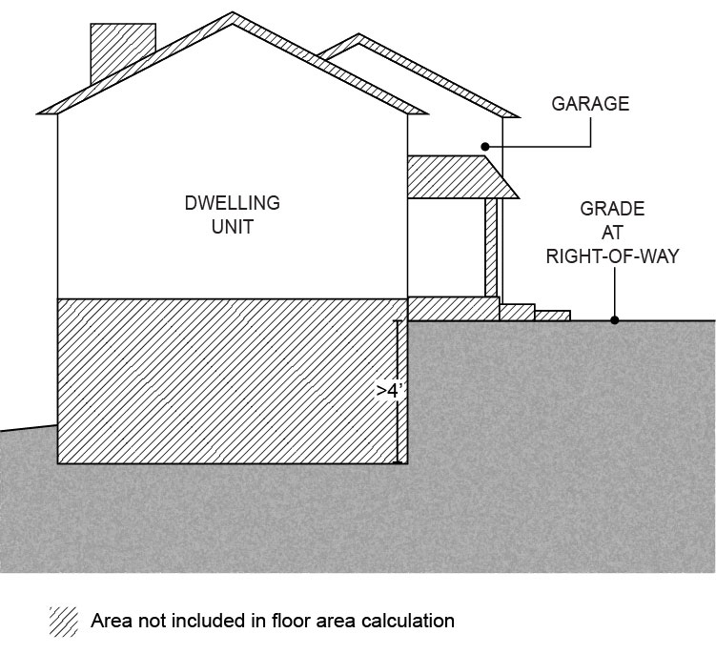
- “Floor area ratio (FAR)” means the amount of floor area of a building or structure in relation to the amount of site area, expressed in square feet. For example, a floor area ratio of 0.7 to 1 means 0.7 square feet of floor area for every one square foot of site area. FAR is calculated by dividing the total floor area of all buildings on a site by the total site area (See Figure 2).
Figure 2. Floor Area Ratio (FAR) Calculation
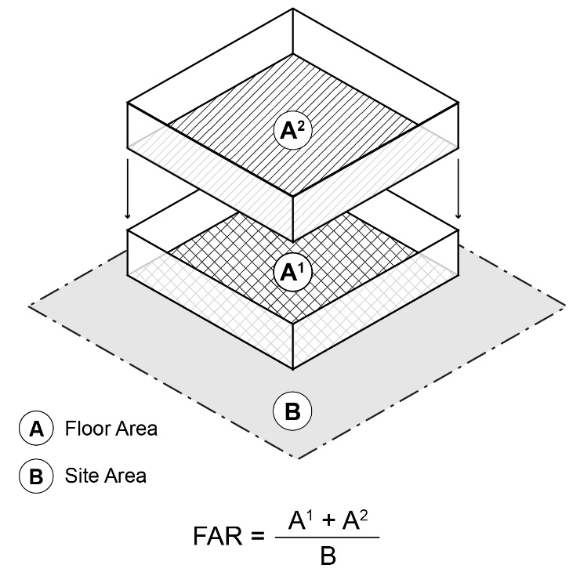
- “Frontage” means the portion of a lot or parcel that abuts a street.
- “Goal Protected Lands” means lands protected or designated pursuant to any one of the following statewide planning goals:
- Goal 5 Natural Resources, Scenic and Historic Areas, and Open Spaces;
- Goal 6 Air, Water, and Land Resource Quality
- Goal 7 Areas Subject to Natural Hazards;
- Goal 9 Economic Development;
- Goal 15 Willamette River Greenway;
- Goal 16 Estuarine Resources;
- Goal 17 Coastal Shorelands; or
- Goal 18 Beaches and Dunes.
- “Lot or parcel” means any legally created unit of land.
- “Middle housing” means duplexes, triplexes, quadplexes, cottage clusters, and townhouses.
- “Quadplex” means four dwelling units on a lot or parcel in any configuration. See Figure 11 and Figure 12 in Section E for examples of possible quadplex configurations.
- “Site area” means the total area of a development site calculated after subtracting any required or planned dedication of public rights-of-way and/or designation of private rights-of-way.
- “Story” means a portion of a building between the surface of any floor and the surface of the floor next above it, or, if there is no floor above it, the space between such floor and the ceiling next above it, provided that the following shall not be deemed a story:
- A basement or cellar if the height from finished grade at the exterior perimeter of the building to the finish floor elevation above is six (6) feet or less for at least 50 percent of the perimeter and does not exceed twelve (12) feet above grade at any point;
- An attic or similar space under a gable, hip, or gambrel roof, the wall plates of which on at least two opposite exterior walls are not more than two (2) feet above the floor of such space.
- “Sufficient Infrastructure” means the following level of public services to serve new Triplexes, Quadplexes, Townhouses, or Cottage Cluster development:
- Connection to a public sewer system capable of meeting established service levels.
- Connection to a public water system capable of meeting established service levels.
- Access via public or private streets meeting adopted emergency vehicle access standards to a city’s public street system.
- Storm drainage facilities capable of meeting established service levels for storm drainage.
- “Townhouse” means a dwelling unit constructed in a row of two or more attached units, where each dwelling unit is located on an individual lot or parcel and shares at least one common wall with an adjacent unit. A townhouse is also commonly called a “rowhouse,” “attached house,” or “common-wall house.”
- “Townhouse project” means one or more townhouse structures constructed, or proposed to be constructed, together with the development site where the land has been divided, or is proposed to be divided, to reflect the townhouse property lines and any commonly owned property.
- “Triplex” means three dwelling units on a lot or parcel in any configuration. See Figure 9 and Figure 10 in Section E for examples of possible triplex configurations.
- “Window area” means the aggregate area of the glass within each window, including any interior grids, mullions, or transoms.
- “Zoned for residential use” means a zoning district in which residential dwellings are the primary use and which implements a residential Comprehensive Plan map designation. This excludes lands zoned primarily for commercial, industrial, agricultural, public, or mixed uses, even if those zones allow for the development of detached single family dwellings.

C. Applicability
1. Applicability of Code Sections.
a. Code sections applicable to all middle housing types are: Chapter 1, Sections A (Purpose), B (Definitions), C (Applicability), and D (Relationship to Other Regulations).
b. Code standards applicable to specific housing types are listed below:
- Duplexes: Chapter 2.
- Triplexes: Chapter 3.
- Quadplexes: Chapter 3.
- Townhouses: Chapter 4.
- Cottage clusters: Chapter 5.
2. Applicability by Development Type and Location.
a. Except as specified in subsection (b) of this section (C)(2), the standards in this code allow for the following development on lots or parcels zoned for residential use that allow for the development of detached single family dwellings:
- New duplexes and those created through conversion of existing detached single family dwellings.
- New triplexes, quadplexes, cottage clusters, and townhouses, and those created through conversion of existing detached single family dwellings or duplexes, on lots or parcels with Sufficient Infrastructure.
b. Exceptions. The standards in this code do not allow the following, unless otherwise permitted by the development code through clear and objective standards, criteria, and procedures:
• On Goal Protected Lands, the creation of triplexes, quadplexes, cottage clusters, or townhouses, or the creation of more than two dwelling units on a single lot or parcel, including accessory dwelling units.
• On lands that are not zoned for residential use, the creation of middle housing.

D. Relationship to Other Regulations
1. Conflicts. In the event of a conflict between this code and other local jurisdictional standards applicable to a middle housing development, the standards of this code control.
2. Public Works Standards. Clear and objective exceptions to public works standards granted to single family dwellings shall also be granted to duplexes.
3. Protective Measures. Middle housing shall comply with protective measures (plans, policies, or regulations) adopted pursuant to statewide land use planning goals (e.g., environmental and natural hazard protections).

E. Duplex, Triplex, and Quadplex Examples
The following figures illustrate examples of possible configurations for duplexes, triplexes, and quadplexes. Other configurations may also be acceptable, provided the development meets the definition of duplex, triplex, or quadplex, pursuant to Section B.

Figure 3. Stacked Duplex  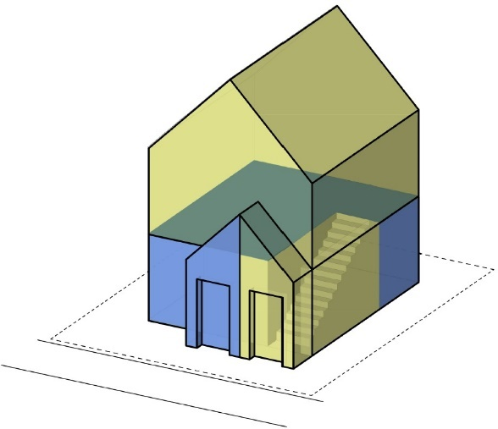 | Figure 4. Side-by-Side Duplex  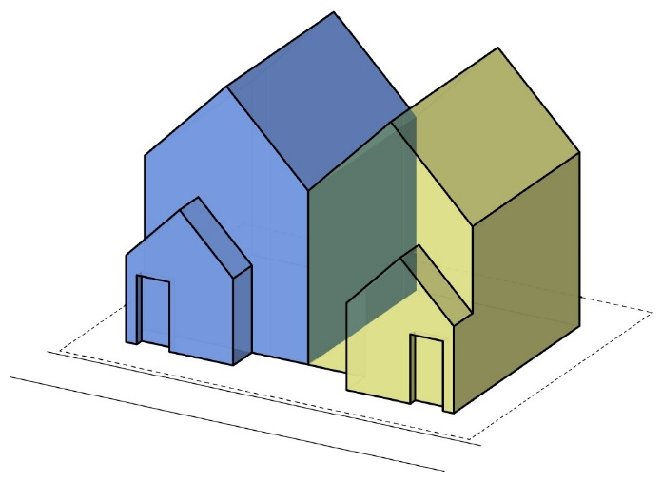

Figure 5. Duplex Attached by Breezeway  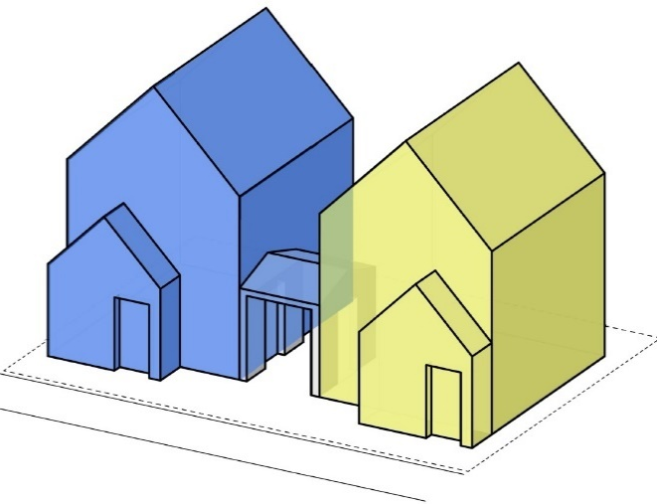 | Figure 6. Duplex Attached by Garage Wall  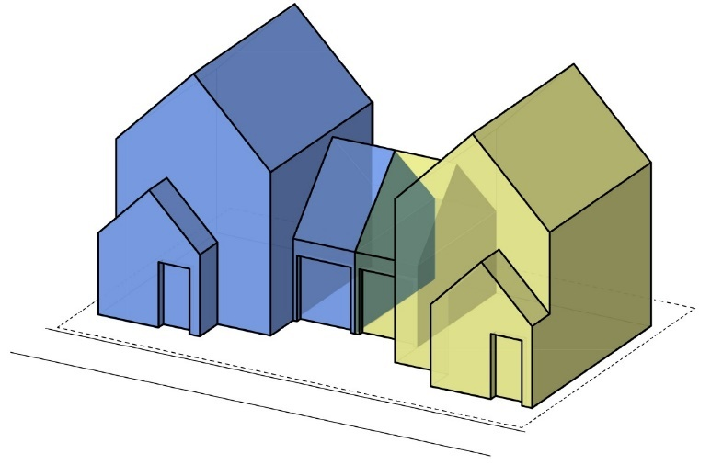

Figure 7. Detached Duplex Units Side-by-Side  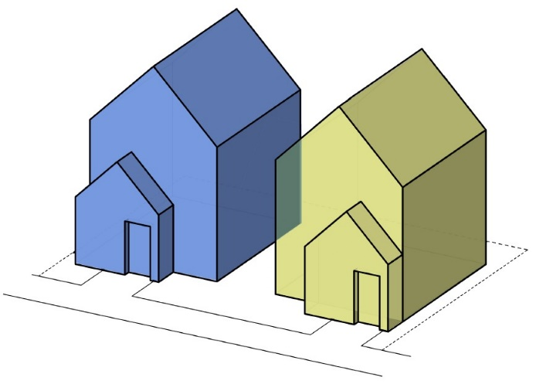 | Figure 8. Detached Duplex Units Front and Back  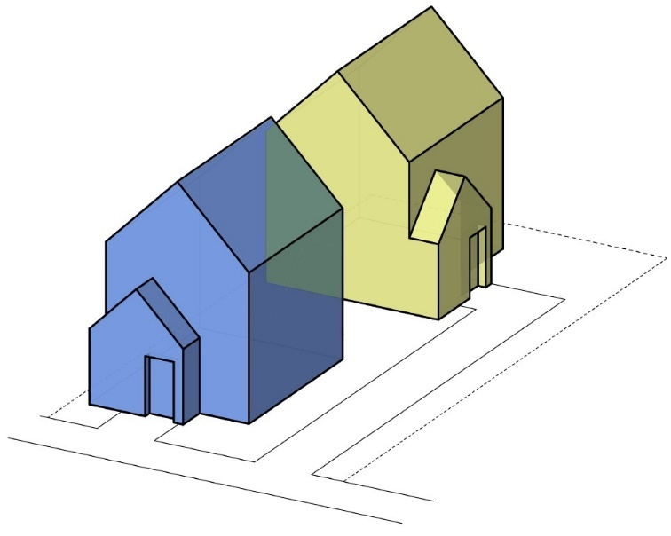
Figure 9. Attached Triplex Front and Back  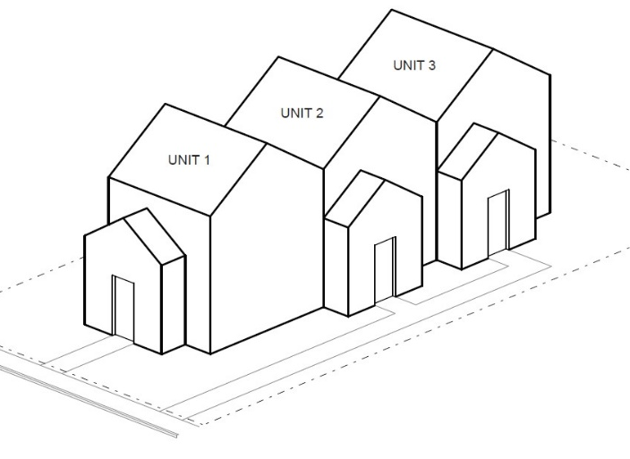 | Figure 10. Attached Triplex Side-by-Side  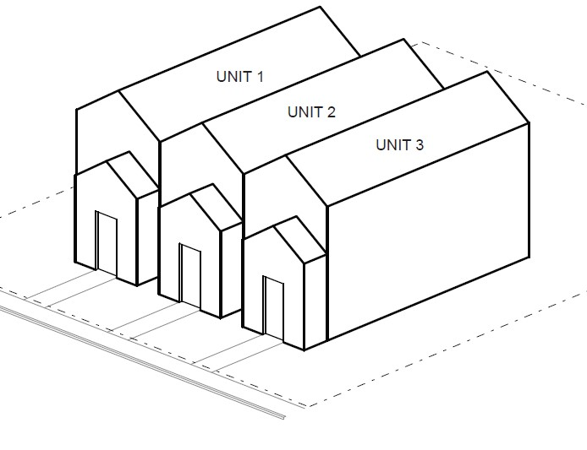
Figure 11. Stacked Quadplex  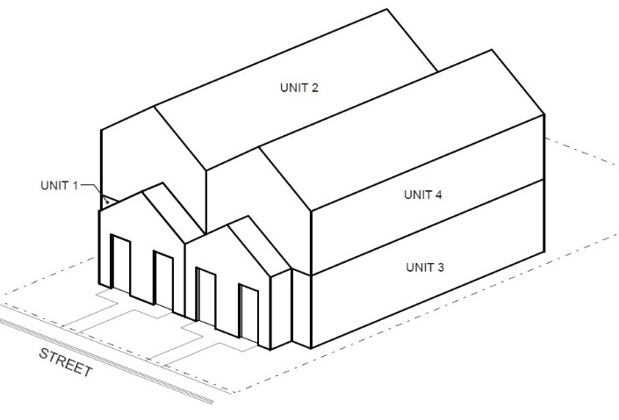 | Figure 12. Detached Quadplex  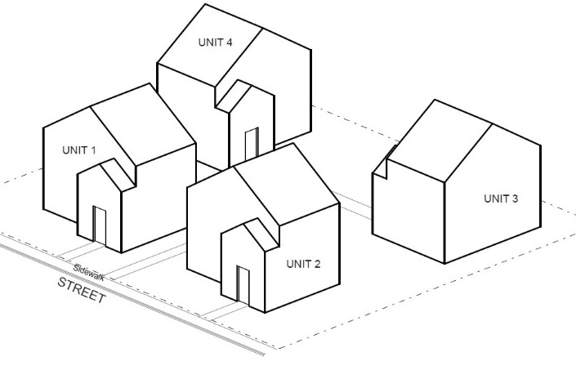

Chapter 2. Duplexes
Sections:
- Permitted Uses and Approval Process
- Development Standards
- Design Standards
- Duplex Conversions

A. Permitted Uses and Approval Process
Duplexes are permitted outright on lots or parcels zoned for residential use that allow for the development of detached single family dwellings. Duplexes are subject to the same approval process as that for detached single family dwellings in the same zone and are subject only to clear and objective standards, approval criteria, conditions, and procedures, unless discretionary standards and criteria have been adopted in accordance with ORS 197.307(5). Alternatively, an applicant may choose to submit an application for a duplex subject to discretionary standards and criteria adopted in accordance with ORS 197.307(6), if such a process is available.

B. Development Standards
Except as specified below, duplexes shall meet all clear and objective development standards that apply to detached single family dwellings in the same zone (including, but not limited to, minimum and maximum lot size, minimum and maximum setbacks, and building height), unless those standards conflict with this code.
The following development standards are invalid and do not apply to duplexes being developed on lots or parcels zoned for residential use that allow the development of a detached single family dwelling:
1. Maximum Density. The jurisdiction’s pre-existing density maximums and minimum lot sizes for duplexes do not apply.
2. Setbacks. A minimum front setback of greater than 20 feet or a minimum rear setback of greater than 15 feet except for those minimum setbacks applicable to garages and carports.
3. Off-Street Parking. Any off-street parking requirement.

C. Design Standards
New duplexes shall meet all clear and objective design standards (e.g., entry orientation, window coverage, articulation, etc.) that apply to detached single family dwellings in the same zone, unless those standards conflict with this code. Facades of dwellings that are separated from the street property line by another dwelling are exempt from meeting building design standards.
Any design standards that apply only to duplexes are invalid.

D. Duplex Conversions
Conversion of an existing detached single family structure to a duplex is allowed, pursuant to Chapter 1, Section C (Applicability), provided that the conversion does not increase nonconformance with applicable clear and objective standards.

Chapter 3. Triplexes and Quadplexes
Sections:
- Permitted Uses and Approval Process
- Development Standards
- Design Standards
- Triplex and Quadplex Conversions

A. Permitted Uses and Approval Process
1. Permitted Use. Triplexes and quadplexes are permitted outright wherever they are allowed as provided in Chapter 1, Section C (Applicability).
2. Approval Process. Triplexes and quadplexes are subject to the same approval process as that for detached single family dwellings in the same zone and are subject only to clear and objective standards, approval criteria, conditions, and procedures, unless discretionary standards and criteria have been adopted in accordance with ORS 197.307(5). Alternatively, an applicant may choose to submit an application for a triplex or quadplex subject to discretionary standards and criteria adopted in accordance with ORS 197.307(6), if such a process is available.
3. Sufficient Infrastructure. Applicants must demonstrate that Sufficient Infrastructure is provided, or will be provided, upon submittal of a triplex or quadplex development application.

B. Development Standards
1. Applicability.
a. Triplexes and quadplexes shall meet:
- The standards in subsections (2) through (7) of this section (B).
- All other clear and objective development standards that apply to detached single family dwellings in the same zone (including, but not limited to, lot size and dimensions, minimum and maximum setbacks, and building height), unless those standards conflict with this code and except as specified in subsections (1)(b) and (2) through (7) of this section (B).
b. The following standards are invalid and do not apply to triplexes or quadplexes allowed by this code:
- Maximum lot coverage, minimum landscape area, or minimum open space standards.
- The jurisdiction’s development standards other than those in subsections (2) through (7) of this section (B) that apply only to triplexes, quadplexes, or multifamily development.
2. Number of Units. This code does not allow for the creation of more than four (4) dwelling units on a lot, including accessory dwelling units.
3. Maximum Density. The jurisdiction’s pre-existing density maximums do not apply.
4. Setbacks. Minimum front and street side setbacks greater than 10 feet and minimum rear setbacks greater than 10 feet are invalid, except for those minimum setbacks applicable to garages and carports.
5. Building Height. A maximum height of less than 35 feet or three (3) stories is invalid. Building height is measured in accordance with the development code.
6. Maximum Floor Area Ratio (FAR). The maximum floor area ratio for all buildings onsite, cumulatively, is based on the minimum lot size for a detached single family dwelling in the same zone, as provided below:
Minimum Lot Size for Detached Single Family Dwellings | Maximum FAR
3,000 sf or less | 1.4 to 1
More than 3,000 sf, up to and including 5,000 sf | 1.1 to 1
More than 5,000 sf, up to and including 10,000 sf | 0.7 to 1
More than 10,000 sf but less than 20,000 sf | 0.6 to 1
20,000 sf or more | 0.4 to 1
7. Off-Street Parking.
a. Required Off-Street Parking. The minimum number of required off-street parking spaces is:
i. In zones with a minimum lot size of less than 5,000 square feet, one (1) off-street parking space per development.
ii. In zones with a minimum lot size of 5,000 square feet or more, two (2) off-street parking spaces per development.
A credit for on-street parking shall be granted for some or all the required off-street parking as provided in subsection (b). No additional parking spaces shall be required for conversion of a detached single family dwelling to a triplex or quadplex, including those created through the addition of detached units.
b. On-Street Credit. If on-street parking spaces meet all the standards in subsections (i)-(iv) below, they shall be counted toward the minimum off-street parking requirement.
i. The space must be abutting the subject site;
ii. The space must be in a location where on-street parking is allowed by the jurisdiction;
iii. The space must be a minimum of 22 feet long; and
iv. The space must not obstruct a required sight distance area.

C. Design Standards
1. Applicability.
a. New triplexes and quadplexes, including those created by adding building square footage on a site occupied by an existing dwelling, shall meet:
- The design standards in subsections (2) through (5) of this section (C); and
- All other clear and objective design standards that apply to detached single family dwellings in the same zone, unless those standards conflict with this code and except as specified in subsection (1)(b) of this section (C).
b. The following standards are invalid and do not apply to triplexes or quadplexes allowed by this code:
- Mandates for construction of a garage or carport.
- The jurisdiction’s design standards other than those in subsections (2) through (5) of this section (C) that apply only to triplexes, quadplexes, or multifamily development.
2. Entry Orientation. At least one main entrance for each triplex or quadplex structure must meet the standards in subsections (a) and (b) below. Any detached structure for which more than 50 percent of its street-facing facade is separated from the street property line by a dwelling is exempt from meeting these standards.
a. The entrance must be within 8 feet of the longest street-facing wall of the dwelling unit; and
b. The entrance must either:
i. Face the street (see Figure 13);
ii. Be at an angle of up to 45 degrees from the street (see Figure 14);
iii. Face a common open space that is adjacent to the street and is abutted by dwellings on at least two sides (see Figure 15); or
iv. Open onto a porch (see Figure 16). The porch must:
(A) Be at least 25 square feet in area; and
(B) Have at least one entrance facing the street or have a roof.
Figure 13. Main Entrance Facing the Street
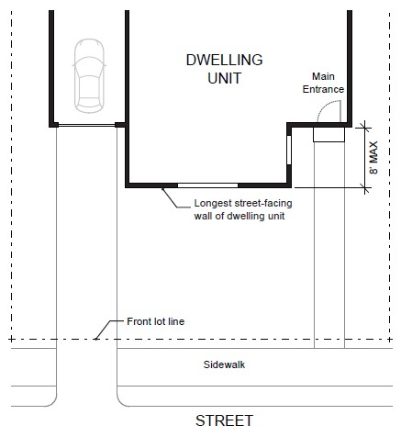
Figure 14. Main Entrance at 45° Angle from the Street
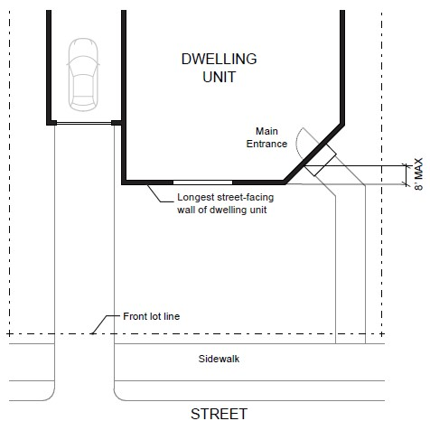

Figure 15. Main Entrance Facing Common Open Space
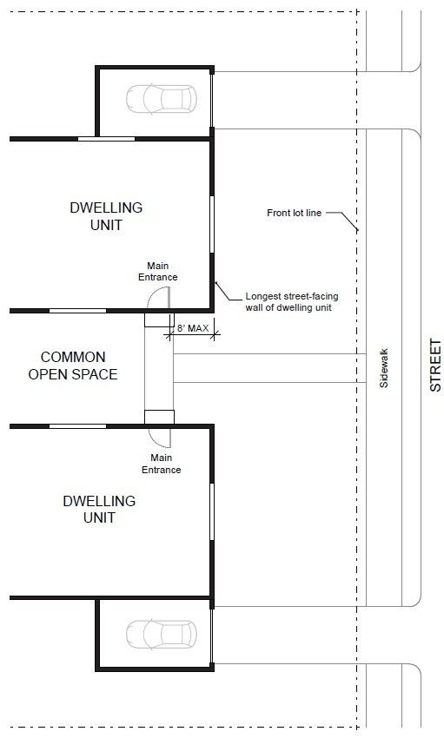
Figure 16. Main Entrance Opening onto a Porch
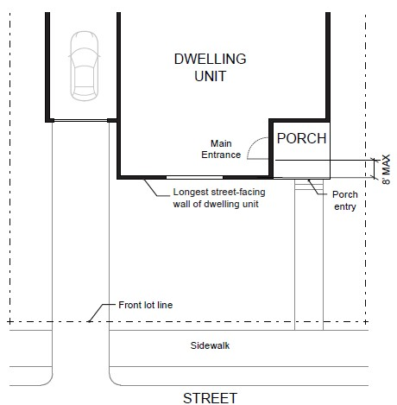

3. Windows. A minimum of 15 percent of the area of all street-facing facades must include windows or entrance doors. Facades separated from the street property line by a dwelling are exempt from meeting this standard. See Figure 17.
Figure 17. Window Coverage
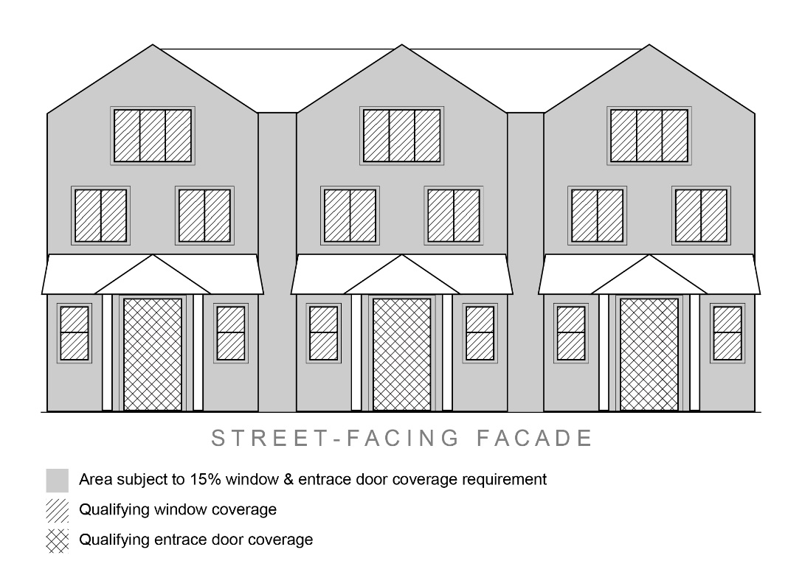
4. Garages and Off-Street Parking Areas. Garages and off-street parking areas shall not be located between a building and a public street (other than an alley), except in compliance with the standards in subsections (a) and (b) of this subsection (C)(4).
a. The garage or off-street parking area is separated from the street property line by a dwelling; or
b. The combined width of all garages and outdoor on-site parking and maneuvering areas does not exceed a total of 50 percent of the street frontage (see Figure 18).
Figure 18. Width of Garages and Parking Areas
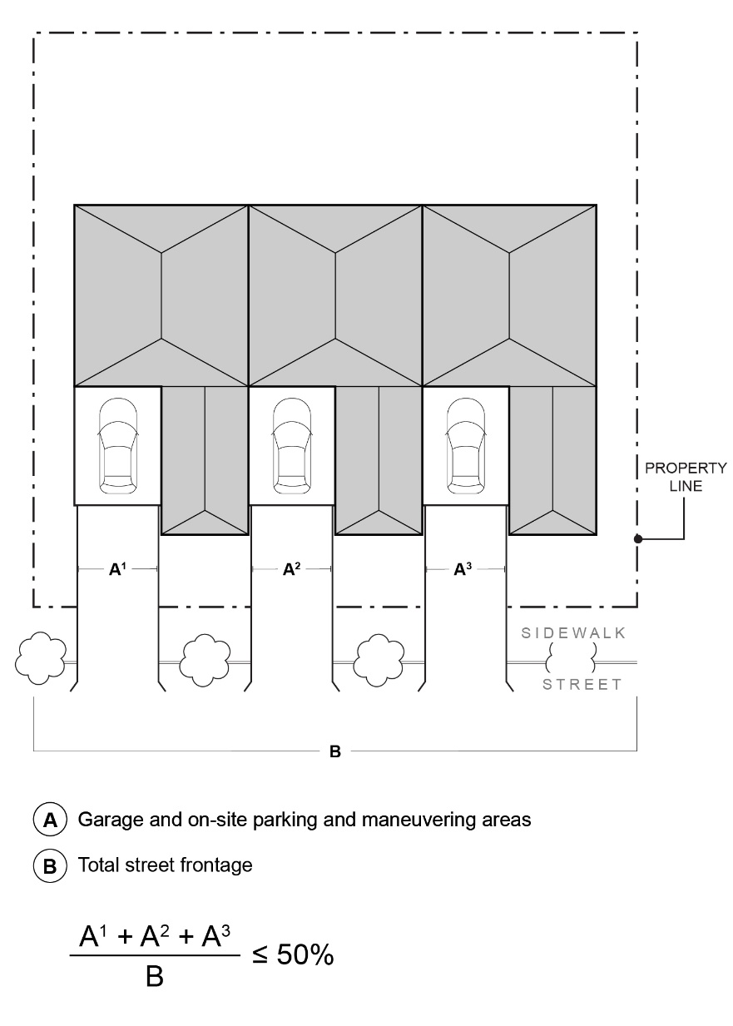
5. Driveway Approach. Driveway approaches must comply with the following:
a. The total width of all driveway approaches must not exceed 32 feet per frontage, as measured at the property line (see Figure 19). For lots or parcels with more than one frontage, see subsection (5)(c) of this subsection (C).
b. Driveway approaches may be separated when located on a local street (see Figure 19). If approaches are separated, they must meet the jurisdiction’s driveway spacing standards applicable to local streets.
c. In addition, lots or parcels with more than one frontage must comply with the following:
i. Lots or parcels must access the street with the lowest transportation classification for vehicle traffic. For lots or parcels abutting an improved alley (defined as an alley that meets the jurisdiction’s standards for width and pavement), access must be taken from the alley (see Figure 20).
ii. Lots or parcels with frontages only on collectors and/or arterial streets must meet the jurisdiction’s access standards applicable to collectors and/or arterials.
iii. Triplexes and quadplexes on lots or parcels with frontages only on local streets may have either:
- Two driveway approaches not exceeding 32 feet in total width on one frontage; or
- One maximum 16-foot-wide driveway approach per frontage (see Figure 21).
Figure 19. Driveway Approach Width and Separation on Local Street
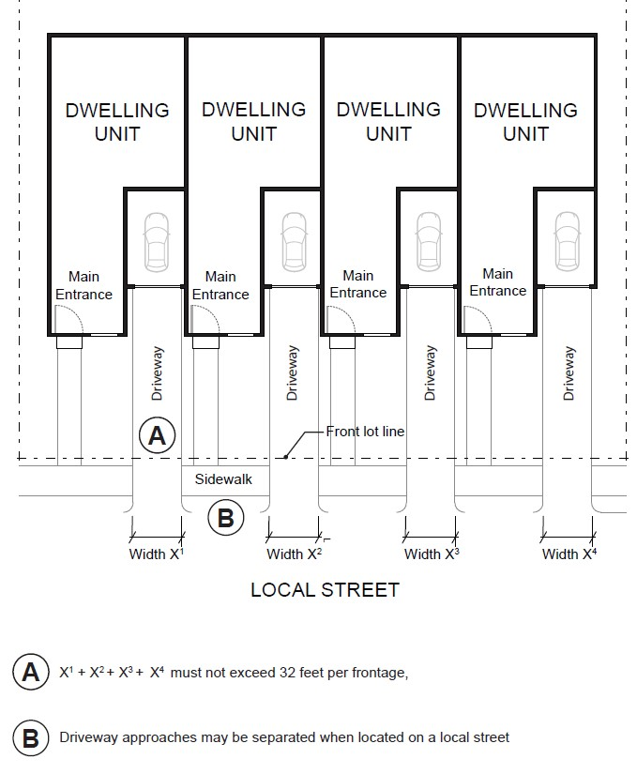
Figure 20. Alley Access
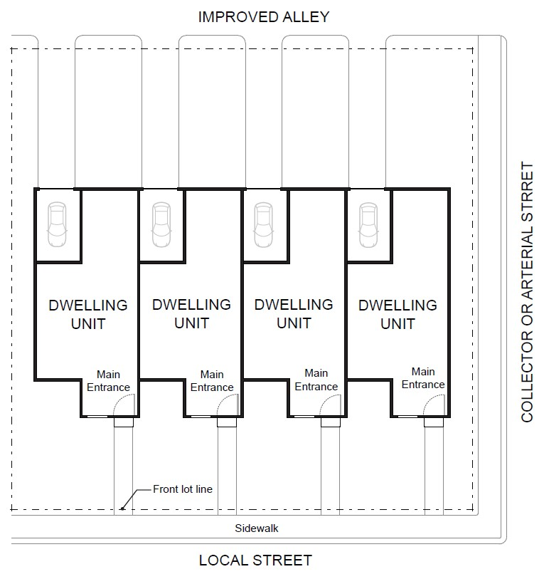
Figure 21. Driveway Approach Options for Multiple Local Street Frontages
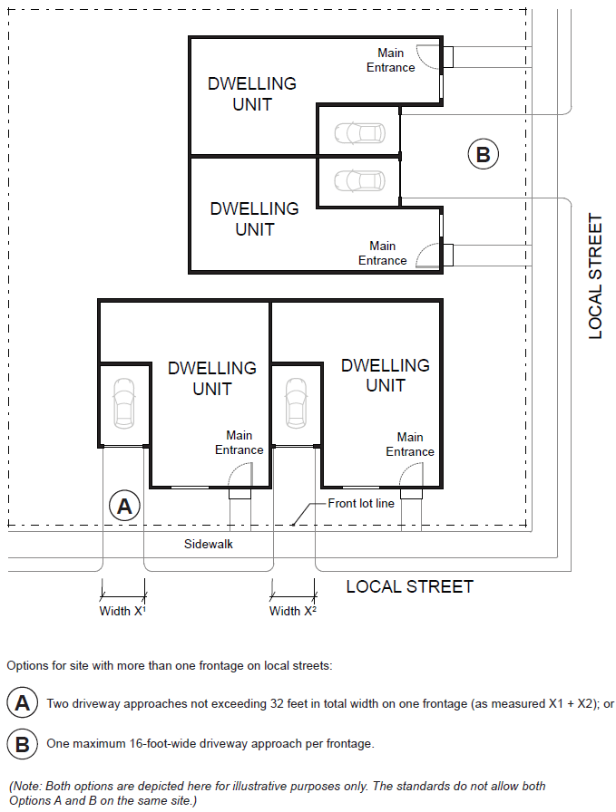

D. Conversions to Triplex and Quadplex
Internal conversion of an existing detached single family structure or duplex to a triplex or quadplex is allowed, pursuant to Chapter 1, Section C (Applicability), provided that the conversion does not increase nonconformance with applicable clear and objective standards, unless increasing nonconformance is otherwise permitted by the development code.

Chapter 4. Townhouses
Sections
- Permitted Uses and Approval Process
- Development Standards
- Design Standards

A. Permitted Uses and Approval Process
1. Permitted Use. Townhouses are permitted outright wherever they are allowed as provided in Chapter 1, Section C (Applicability).
2. Approval Process. Townhouse structures are subject to the same approval process as that for detached single family dwellings in the same zone. Townhouse projects are subject only to clear and objective standards, approval criteria, conditions, and procedures, unless discretionary standards and criteria have been adopted in accordance with ORS 197.307(5). Alternatively, an applicant may choose to submit an application for a townhouse project subject to discretionary standards and criteria adopted in accordance with ORS 197.307(6), if such a process is available.
3. New Lots or Parcels. Creation of new lots or parcels as part of a townhouse project is subject to the applicable land division approval process.
4. Sufficient Infrastructure. Applicants must demonstrate that Sufficient Infrastructure is provided, or will be provided, upon submittal of a townhouse development application.

B. Development Standards
1. Applicability.
a. Townhouses shall meet the standards in subsections (3), (4), and (5) of this section (B).
b. Townhouse projects shall meet:
- The standards in subsections (2), (5), and (6) of this section (B).
- Any applicable clear and objective platting standards, unless those standards conflict with this code.
c. The following standards are invalid and do not apply to townhouses or townhouse projects allowed by this code, except as specified in this section (B):
- Additional development standards of the applicable base zone related to the standards addressed under subsections (2) through (6) of this section (B).
- Development standards of the applicable base zone related to lot dimensions, lot coverage, landscape or open space area, or the siting or design of dwellings.
- The jurisdiction’s other development standards that apply only to townhouses and that conflict with provisions of this code.
2. Maximum Density. The maximum density for a townhouse project is as follows:
- In zones in which the minimum lot size for detached single family dwellings is 2,500 square feet or less, townhouse projects are allowed two (2) times the allowed density for detached single family dwellings.
- In zones in which the minimum lot size for detached single family dwellings is more than 2,500 square feet but less than 5,000 square feet, townhouse projects are allowed three (3) times the allowed density for detached single family dwellings.
- In zones in which the minimum lot size for detached single family dwellings is 5,000 square feet or more, townhouse projects are allowed four (4) times the allowed density for detached single family dwellings.
3. Setbacks. Townhouses shall meet the minimum and maximum setback standards that apply to detached single family dwellings in the same zone, except as noted below:
- Front and Street Side: Minimum front and street side yard setbacks greater than 10 feet are invalid, except those applicable to garages or carports.
- Rear: Minimum rear setbacks greater than 10 feet and minimum rear setbacks greater than zero (0) feet for lots with rear alley access are invalid.
- Non-street Side:
  - The minimum setback for a common wall lot line where units are attached is zero (0) feet.
  - The minimum side setback for an exterior wall at the end of a townhouse structure is five (5) feet.
4. Building Height. Townhouses shall meet the maximum building height standards that apply to detached single family dwellings in the same zone, except a maximum height of less than 35 feet or three (3) stories is invalid. Building height is measured in accordance with the development code.
5. Off-Street Parking.
a. Required Off-Street Parking. The minimum number of required off-street parking spaces for a townhouse project is one (1) space per unit. Spaces may be provided on individual lots or in a shared parking area on a common tract. A credit for on-street parking shall be granted for some or all of the required off-street parking as provided in subsection (b).
b. On-Street Credit. If on-street parking spaces meet all the standards in subsections (i)-(iv) below, they shall be counted toward the minimum off-street parking requirement.
i. The space must be abutting the subject site;
ii. The space must be in a location where on-street parking is allowed by the jurisdiction;
iii. The space must be a minimum of 22 feet long; and
iv. The space must not obstruct a required sight distance area.
6. Areas Owned in Common. Common areas must be maintained by a homeowners association or other legal entity. A homeowners association may also be responsible for exterior building maintenance. A copy of any applicable covenants, restrictions and conditions must be recorded and provided to the jurisdiction prior to issuance of a building permit.

C. Design Standards
New townhouses shall meet the design standards in subsections (1) through (4) of this section (C). Mandates for construction of a garage or carport and any other design standards are invalid.
1. Entry Orientation. The main entrance of each townhouse must:
a. Be within 8 feet of the longest street-facing wall of the dwelling unit, if the lot has public street frontage; and
b. Either:
i. Face the street (see Figure 13);
ii. Be at an angle of up to 45 degrees from the street (see Figure 14);
iii. Face a common open space or private access or driveway that is abutted by dwellings on at least two sides; or
iv. Open onto a porch (see Figure 16). The porch must:
(A) Be at least 25 square feet in area; and
(B) Have at least one entrance facing the street or have a roof.
2. Unit definition. Each townhouse must include at least one of the following on at least one street-facing façade (see Figure 22):
a. A roof dormer a minimum of 4 feet in width, or
b. A balcony a minimum of 2 feet in depth and 4 feet in width and accessible from an interior room, or
c. A bay window that extends from the facade a minimum of 2 feet, or
d. An offset of the facade of a minimum of 2 feet in depth, either from the neighboring townhouse or within the façade of a single townhouse, or
e. An entryway that is recessed a minimum of 3 feet, or
f. A covered entryway with a minimum depth of 4 feet, or
g. A porch meeting the standards of subsection (1)(b)(iv) of this section (C).
Balconies and bay windows may encroach into a required setback area.
Figure 22. Townhouse Unit Definition
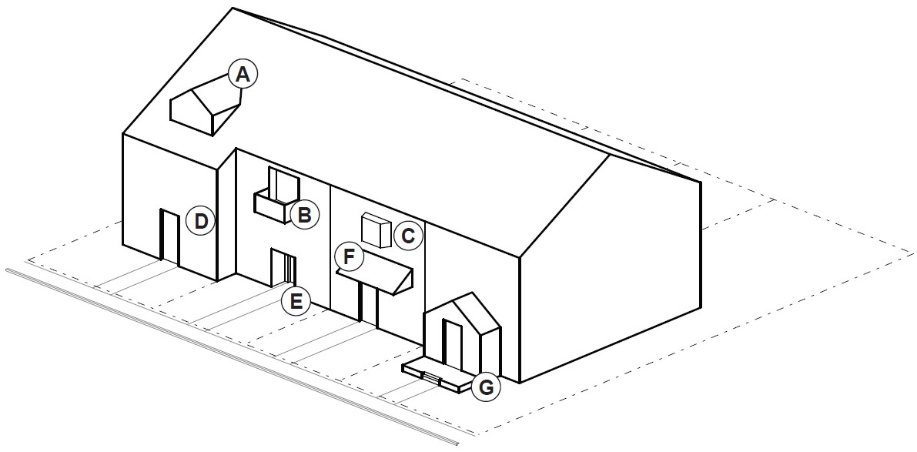
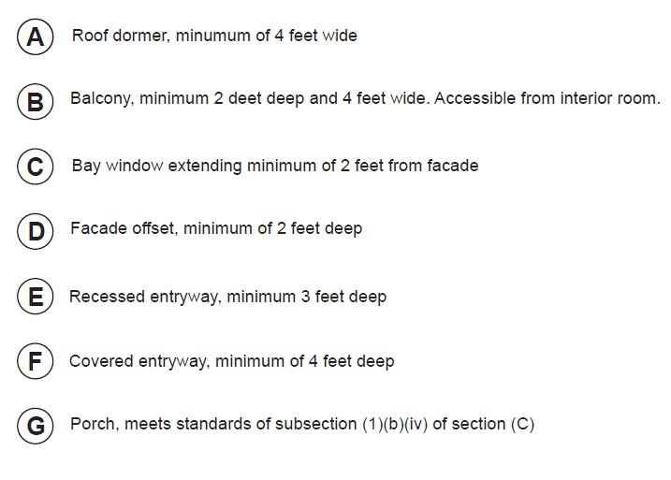
3. Windows. A minimum of 15 percent of the area of all street-facing facades on each individual unit must include windows or entrance doors. Half of the window area in the door of an attached garage may count toward meeting this standard. See Figure 17.
4. Driveway Access and Parking. Townhouses with frontage on a public street shall meet the following standards:
a. Garages on the front façade of a townhouse, off-street parking areas in the front yard, and driveways in front of a townhouse are allowed if they meet the following standards (see Figure 23).
i. Each townhouse lot has a street frontage of at least 15 feet on a local street.
ii. A maximum of one (1) driveway approach is allowed for every townhouse. Driveway approaches and/or driveways may be shared.
iii. Outdoor on-site parking and maneuvering areas do not exceed 12 feet wide on any lot.
iv. The garage width does not exceed 12 feet, as measured from the inside of the garage door frame.
Figure 23. Townhouses with Parking in Front Yard
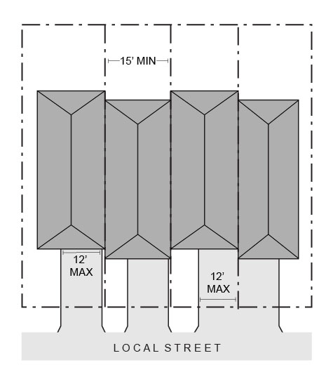
b. The following standards apply to driveways and parking areas for townhouse projects that do not meet all of the standards in subsection (a).
i. Off-street parking areas shall be accessed on the back façade or located in the rear yard. No off-street parking shall be allowed in the front yard or side yard of a townhouse.
ii. A townhouse project that includes a corner lot shall take access from a single driveway approach on the side of the corner lot. See Figure 24.
Figure 24. Townhouses on Corner Lot with Shared Access
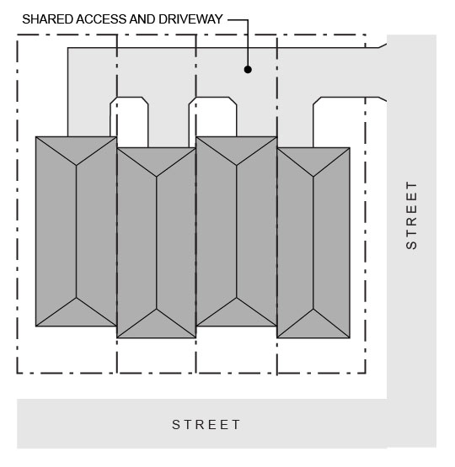
iii. Townhouse projects that do not include a corner lot shall consolidate access for all lots into a single driveway. The driveway and approach are not allowed in the area directly between the front façade and front lot line of any of the townhouses. See Figure 25.
Figure 25. Townhouses with Consolidated Access
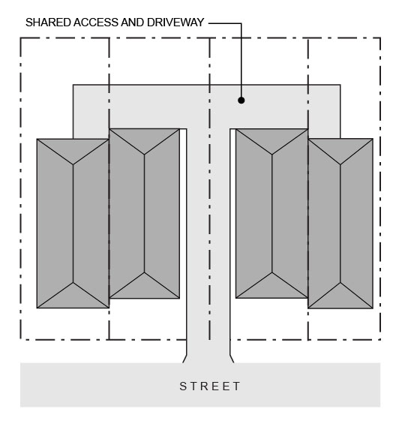
iv. A townhouse project that includes consolidated access or shared driveways shall grant access easements to allow normal vehicular access and emergency access.
c. Townhouse projects in which all units take exclusive access from a rear alley are exempt from compliance with subsection (b).

Chapter 5. Cottage Clusters
Sections:
- Permitted Uses and Approval Process
- Development Standards
- Design Standards

A. Permitted Uses and Approval Process
1. Permitted Use. Cottage cluster projects are permitted outright wherever they are allowed as provided in Chapter 1, Section C (Applicability).
2. Approval Process. Cottage cluster projects are subject to the same approval process as that for detached single family dwellings in the same zone and are subject only to clear and objective standards, approval criteria, conditions, and procedures, unless discretionary standards and criteria have been adopted in accordance with ORS 197.307(5). Alternatively, an applicant may choose to submit an application for a cottage cluster project subject to discretionary standards and criteria adopted in accordance with ORS 197.307(6), if such a process is available.
3. Sufficient Infrastructure. Applicants must demonstrate that Sufficient Infrastructure is provided, or will be provided, upon submittal of a cottage cluster development application.

B. Development Standards
1. Applicability.
a. Cottage clusters shall meet the standards in subsections (2) through (7) of this section (B).
b. The following standards are invalid and do not apply to cottage clusters allowed by this code, except as specified in this section (B):
- Additional development standards of the applicable base zone related to the standards addressed under subsections (2) through (7) of this section (B).
- Development standards of the applicable base zone related to lot dimensions, lot coverage, floor area ratio, landscape or open space area, or the siting or design of dwellings.
- The jurisdiction’s other development standards that apply only to cottage clusters and that conflict with provisions of this code.
2. Minimum Lot Size and Dimensions. Cottage clusters shall meet the minimum lot size, width, and depth standards that apply to detached single family dwellings in the same zone.
3. Maximum Density. The jurisdiction’s pre-existing density maximums do not apply.
4. Setbacks and Building Separation.
a. Setbacks. Cottage clusters shall meet the minimum and maximum setback standards that apply to detached single family dwellings in the same zone, except that minimum setbacks for dwellings in excess of the following are invalid:
- Front setbacks: 10 feet
- Side setbacks: 5 feet
- Rear setbacks: 10 feet
b. Building Separation. Cottages shall be separated by a minimum distance of six (6) feet. The minimum distance between all other structures, including accessory structures, shall be in accordance with building code requirements.
5. Average Unit Size. The maximum average floor area for a cottage cluster is 1,400 square feet per dwelling unit. Community buildings shall be included in the average floor area calculation for a cottage cluster.
6. Building Height. The maximum building height for all structures is 25 feet or two (2) stories, whichever is greater.
7. Off-Street Parking.
a. Required Off-Street Parking. The minimum number of required off-street parking spaces for a cottage cluster project is zero (0) spaces per unit with a floor area less than 1,000 square feet and one (1) space per unit with a floor area of 1,000 square feet or more. Spaces may be provided for individual cottages or in shared parking clusters. A credit for on-street parking shall be granted for some or all of the required off-street parking as provided in subsection (b).
b. On-Street Credit. If on-street parking spaces meet all the standards in subsections (i)-(iv) below, they shall be counted toward the minimum off-street parking requirement.
i. The space must be abutting the subject site;
ii. The space must be in a location where on-street parking is allowed by the jurisdiction;
iii. The space must be a minimum of 22 feet long; and
iv. The space must not obstruct a required sight distance area.

C. Design Standards
Cottage clusters shall meet the design standards in subsections (1) through (8) of this section (C). No other design standards shall apply to cottage clusters unless noted in this section. Mandates for construction of a garage or carport and any other design standards are invalid, except as specified in this Section (C).
1. Cottage Orientation. Cottages must be clustered around a common courtyard, meaning they abut the associated common courtyard or are directly connected to it by a pedestrian path, and must meet the following standards (see Figure 26):
a. Each cottage within a cluster must either abut the common courtyard or must be directly connected to it by a pedestrian path.
b. A minimum of 50 percent of cottages within a cluster must be oriented to the common courtyard and must:
i. Have a main entrance facing the common courtyard;
ii. Be within 10 feet from the common courtyard, measured from the façade of the cottage to the nearest edge of the common courtyard; and
iii. Be connected to the common courtyard by a pedestrian path.
c. Cottages within 20 feet of a street property line may have their entrances facing the street.
d. Cottages not facing the common courtyard or the street must have their main entrances facing a pedestrian path that is directly connected to the common courtyard.
2. Common Courtyard Design Standards. Each cottage cluster must share a common courtyard in order to provide a sense of openness and community of residents. Common courtyards must meet the following standards (see Figure 26):
a. The common courtyard must be a single, contiguous piece.
b. Cottages must abut the common courtyard on at least two sides of the courtyard.
c. The common courtyard must contain a minimum of 150 square feet per cottage within the associated cluster (as defined in subsection (1) of this section (C)).
d. The common courtyard must be a minimum of 15 feet wide at its narrowest dimension.
e. The common courtyard shall be developed with a mix of landscaping, lawn area, pedestrian paths, and/or paved courtyard area, and may also include recreational amenities. Impervious elements of the common courtyard shall not exceed 75 percent of the total common courtyard area.
f. Pedestrian paths must be included in a common courtyard. Paths that are contiguous to a courtyard shall count toward the courtyard’s minimum dimension and area. Parking areas, required setbacks, and driveways do not qualify as part of a common courtyard.
Figure 26. Cottage Cluster Orientation and Common Courtyard Standards
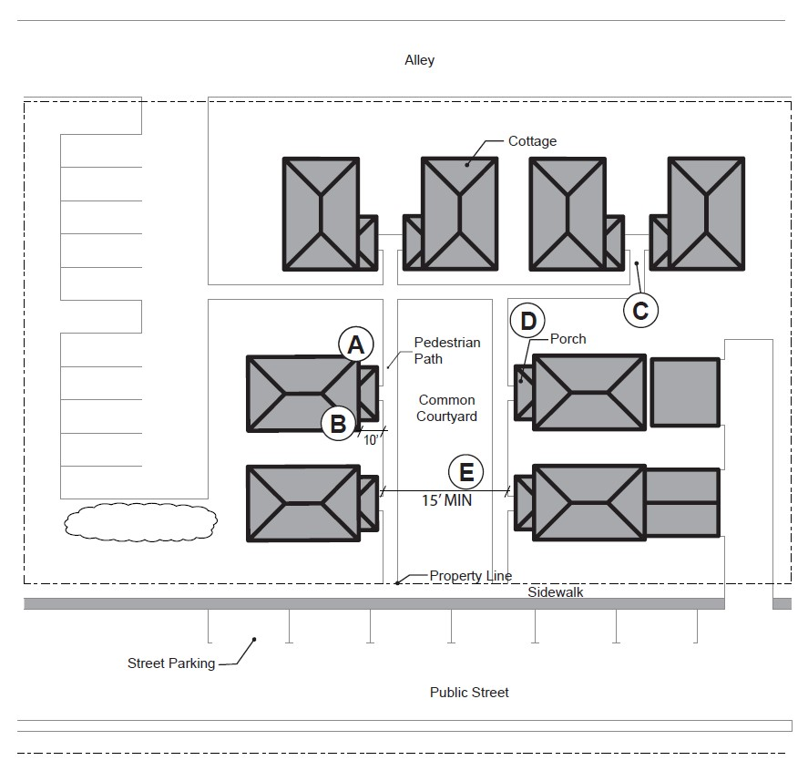
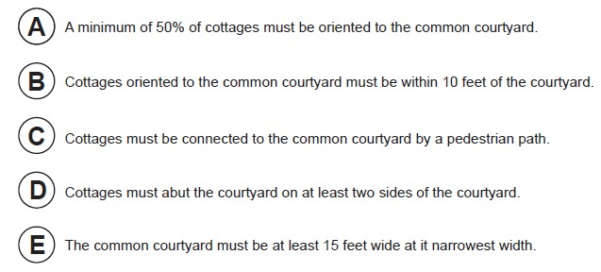
3. Community Buildings. Cottage cluster projects may include community buildings for the shared use of residents that provide space for accessory uses such as community meeting rooms, guest housing, exercise rooms, day care, or community eating areas. Community buildings must meet the following standards:
a. Each cottage cluster is permitted one community building, which shall count towards the maximum average floor area, pursuant to subsection (B)(5).
b. A community building that meets the development code’s definition of a dwelling unit must meet the maximum 900 square foot footprint limitation that applies to cottages, unless a covenant is recorded against the property stating that the structure is not a legal dwelling unit and will not be used as a primary dwelling.
4. Pedestrian Access.
a. An accessible pedestrian path must be provided that connects the main entrance of each cottage to the following:
i. The common courtyard;
ii. Shared parking areas;
iii. Community buildings; and
iv. Sidewalks in public rights-of-way abutting the site or rights-of-way if there are no sidewalks.
b. The pedestrian path must be hard-surfaced and a minimum of four (4) feet wide.
5. Windows. Cottages within 20 feet of a street property line must meet any window coverage requirement that applies to detached single family dwellings in the same zone.
6. Parking Design (see Figure 27).
a. Clustered parking. Off-street parking may be arranged in clusters, subject to the following standards:
i. Cottage cluster projects with fewer than 16 cottages are permitted parking clusters of not more than five (5) contiguous spaces.
ii. Cottage cluster projects with 16 cottages or more are permitted parking clusters of not more than eight (8) contiguous spaces.
iii. Parking clusters must be separated from other spaces by at least four (4) feet of landscaping.
iv. Clustered parking areas may be covered.
b. Parking location and access.
i. Off-street parking spaces and vehicle maneuvering areas shall not be located:
- Within of 20 feet from any street property line, except alley property lines;
- Between a street property line and the front façade of cottages located closest to the street property line. This standard does not apply to alleys.
ii. Off-street parking spaces shall not be located within 10 feet of any other property line, except alley property lines. Driveways and drive aisles are permitted within 10 feet of other property lines.
c. Screening. Landscaping, fencing, or walls at least three feet tall shall separate clustered parking areas and parking structures from common courtyards and public streets.
d. Garages and carports.
i. Garages and carports (whether shared or individual) must not abut common courtyards.
ii. Individual attached garages up to 200 square feet shall be exempted from the calculation of maximum building footprint for cottages.
iii. Individual detached garages must not exceed 400 square feet in floor area.
iii. Garage doors for attached and detached individual garages must not exceed 20 feet in width.
7. Accessory Structures. Accessory structures must not exceed 400 square feet in floor area.
8. Existing Structures. On a lot or parcel to be used for a cottage cluster project, an existing detached single family dwelling on the same lot at the time of proposed development of the cottage cluster may remain within the cottage cluster project area under the following conditions:
a. The existing dwelling may be nonconforming with respect to the requirements of this code.
b. The existing dwelling may be expanded up to the maximum height in subsection (B)(4) or the maximum building footprint in Chapter 1, subsection (B)(1); however, existing dwellings that exceed the maximum height and/or footprint of this code may not be expanded.
c. The floor area of the existing dwelling shall not count towards the maximum average floor area of a cottage cluster.
d. The existing dwelling shall be excluded from the calculation of orientation toward the common courtyard, per subsection (1)(a) of this section (C).
Figure 27. Cottage Cluster Parking Design Standards
