Medium Cities Middle Housing Model Code
User’s Guide:
Oregon House Bill 2001 (2019) (HB 2001) requires that “Medium Cities” (defined as cities with a population of more than 10,000 and less than 25,000 that are not within Metro’s jurisdiction) allow a duplex on each lot or parcel zoned for residential use that allows for the development of detached single family dwellings. Duplexes provide an opportunity to increase housing supply in developed neighborhoods and can blend in well with detached single-family dwellings.
The bill allows local governments to regulate siting and design of duplexes, provided that the regulations do not, individually or cumulatively, discourage duplex development through unreasonable costs or delay. When regulating siting and design of duplexes, Medium Cities should balance concerns about neighborhood compatibility and other factors against the need to address Oregon’s housing shortage by removing barriers to development and should ensure that any siting and design regulations do not, individually or cumulatively, discourage the development of duplexes through unreasonable costs or delay.
Medium Cities may develop their own standards in compliance with the requirements of HB 2001. This model code may provide guidance toward that end. However, if Medium Cities do not wish to prepare their own standards or if Medium Cities do not adopt the required code amendments by June 30, 2021, they must directly apply this model code prepared by the Department of Land and Conservation Development (DCLD) to development in their jurisdictions. The model code is intended to be straightforward and implementable by Medium Cities throughout the state. The model rules are consistent with the requirements and intent of HB 2001 and are intended to ensure that a duplex is no more difficult to develop than a detached single family home. The model code will be adopted by reference into Oregon Administrative Rules.
To the extent they are applicable, the Administrative Rules contained in Chapter 660, Division 46 apply to and may be used to interpret this model code.

Sections:
- Purpose
- Definitions
- Applicability
- Relationship to Other Regulations
- Permitted Uses and Approval Process
- Development Standards
- Design Standards
- Duplex Conversions
- Figures

A. Purpose
The purpose of this model middle housing code (“code”) is to implement HB 2001, codified in ORS 197.758 et seq, by providing siting and design standards for duplexes developed on lots or parcels that allow for the development of detached single family dwellings.

B. Definitions
The following definitions shall apply for the purposes of this code, notwithstanding other definitions in the development code:
1. “Detached single family dwelling” means a detached structure on a lot or parcel that is comprised of a single dwelling unit. Detached single family dwellings may be constructed off-site, e.g., manufactured dwellings or modular homes.
2. “Duplex” means two dwelling units on a lot or parcel in any configuration. Figures 1–6 in Section I illustrate examples of possible duplex configurations. In instances where a development can meet the definition of a duplex and also meets the definition of a primary dwelling unit with an accessory dwelling unit (ADU), the applicant shall specify at the time of application review whether the development is considered a duplex or a primary dwelling unit with an ADU.
3. “Lot or Parcel” means any legally created unit of land.
4. “Zoned for residential use” means a zoning district in which residential dwellings are the primary use and which implements a residential Comprehensive Plan map designation.

C. Applicability
1. Except as specified in subsection (2) of this section (C), the standards in this code allow for the development of duplexes, including those created through conversion of existing detached single family dwellings, on lots or parcels zoned for residential use that allow for the development of detached single family dwellings.
2. The standards in this code do not allow the following, unless otherwise permitted by the development code:
- Creation of duplexes on lots or parcels on lands that are not zoned for residential use. This includes lands zoned primarily for commercial, industrial, agricultural, public, or mixed uses, even if those zones allow for the development of detached single family dwellings.
- Creation of more than two dwelling units on a single lot or parcel.

D. Relationship to Other Regulations
1. Conflicts. In the event of a conflict between this code and other standards applicable to a duplex, the standards of this code control.
2. Public Works Standards. Clear and objective exceptions to public works standards granted to single family dwellings shall also be granted to duplexes.
3. Protective Measures. Duplexes shall comply with protective measures (plans, policies, or regulations) adopted pursuant to statewide land use planning goals (e.g., environmental and natural hazard protections).

E. Permitted Uses and Approval Process
Duplexes are permitted outright on lots or parcels zoned for residential use that allow for the development of detached single family dwellings. Duplexes are subject to the same approval process as that for detached single family dwellings in the same zone and are subject only to clear and objective standards, approval criteria, conditions, and procedures. Alternatively, an applicant may choose to submit an application for a duplex subject to discretionary standards and criteria adopted in accordance with ORS 197.307, if such a process is available.

F. Development Standards
Except as specified below, duplexes shall meet all clear and objective development standards that apply to detached single family dwellings in the same zone (including, but not limited to, minimum and maximum lot size, minimum and maximum setbacks, and building height), unless those standards conflict with this code.
The following development standards are invalid and do not apply to duplexes being developed on lots or parcels zoned for residential use that allow the development of a detached single family dwelling:
1. Maximum Density. The jurisdiction’s pre-existing density maximums and minimum lot sizes for duplexes do not apply.
2. Setbacks. A minimum front setback of greater than 20 feet or a minimum rear setback of greater than 15 feet except for those minimum setbacks applicable to garages and carports.
3. Off-Street Parking. Any off-street parking requirement.

G. Design Standards
New duplexes shall meet all clear and objective design standards (e.g., entry orientation, window coverage, articulation, etc.) that apply to detached single family dwellings in the same zone, unless those standards conflict with this code. Facades of dwellings that are separated from the street property line by another dwelling are exempt from meeting building design standards.
Any design standards that apply only to duplexes are invalid.

H. Duplex Conversions
Conversion of an existing detached single family dwelling to a duplex is allowed, pursuant to Section C, provided that the conversion does not increase nonconformance with applicable clear and objective standards.

I. Figures
The following figures illustrate examples of possible duplex configurations. Other configurations may also be acceptable, provided the development meets the definition of duplex, pursuant to Section B.
Figure 1. Stacked Duplex
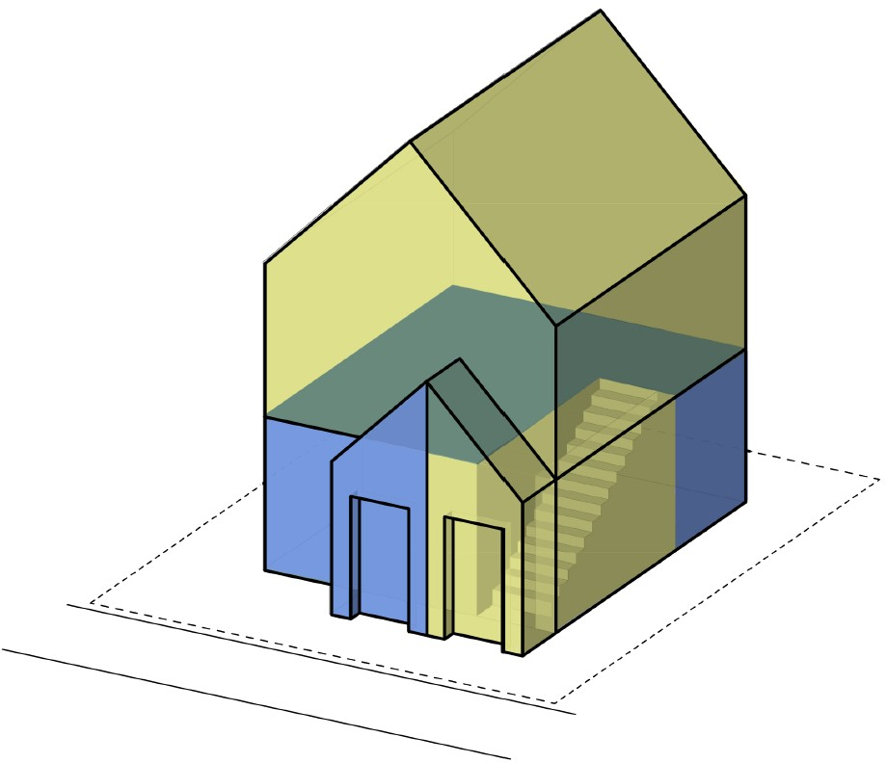
Figure 2. Side-by-Side Duplex
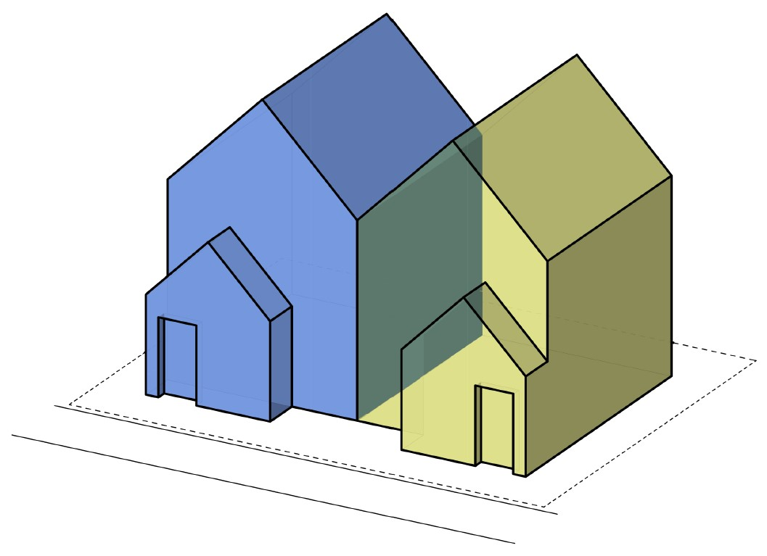
Figure 3. Duplex Attached by Garage Wall
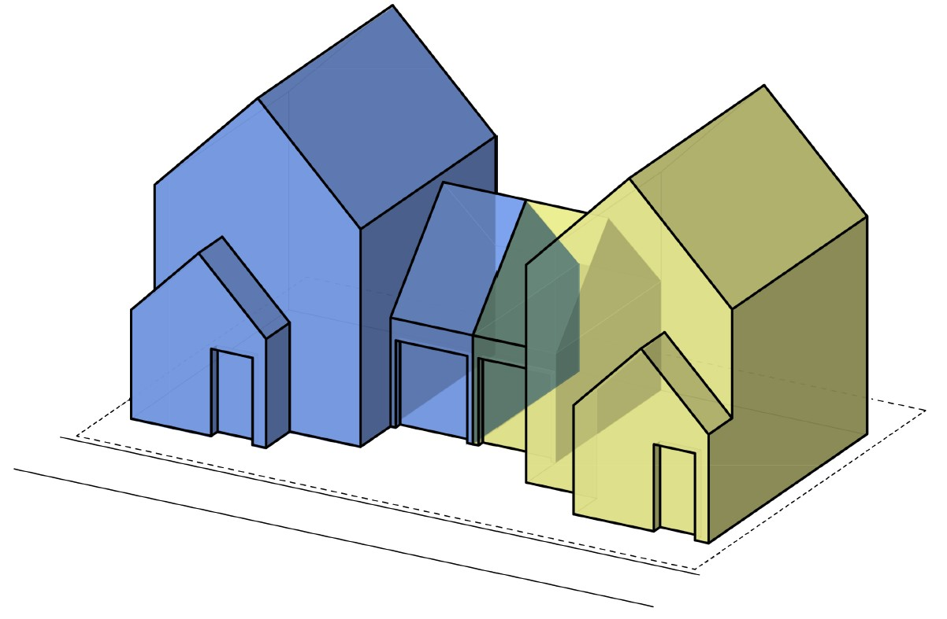
Figure 4. Duplex Attached by Breezeway
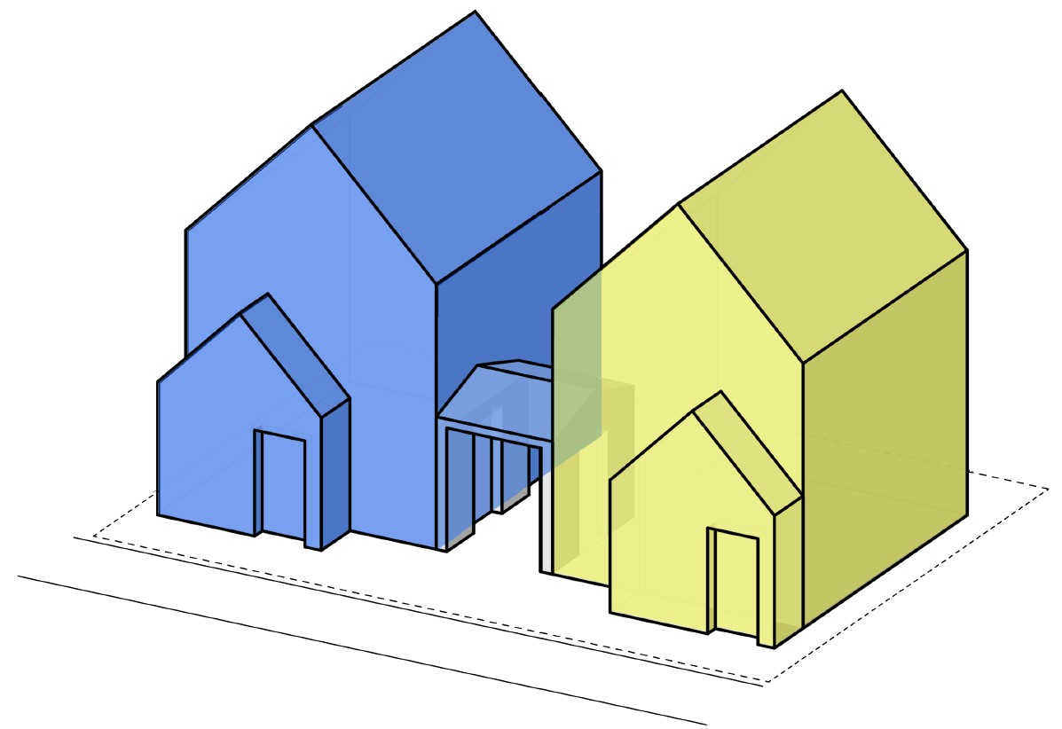
Figure 5. Detached Duplex Units Side-by-Side
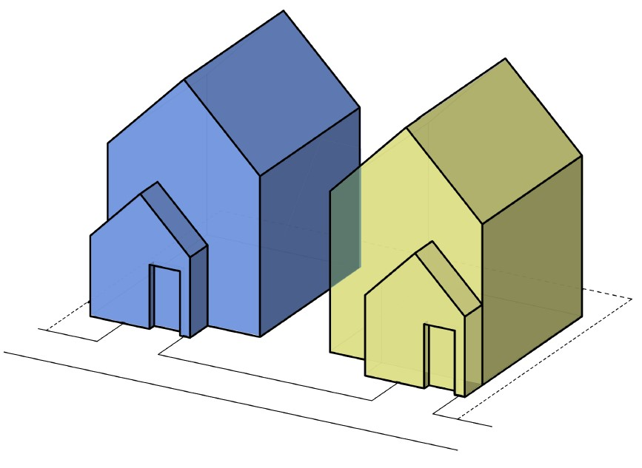
Figure 6. Detached Duplex Units Front and Back
