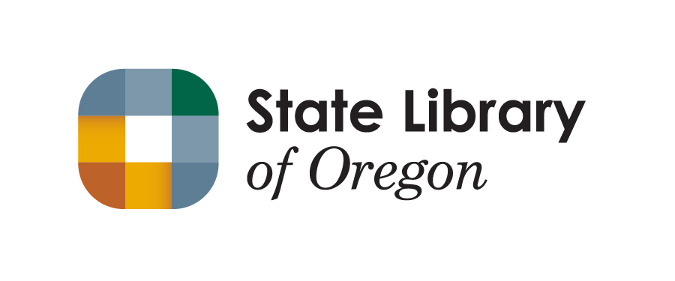

Government-to-Government Report
2021

Nancy Hoover
Acting State Librarian
State Library of Oregon

  - Government-to-Government Annual Report
  - State Library Collaboration with Oregon Tribes in 2021

2021 Activities
The State Library implemented initiatives and participated in activities over the course of this year to strengthen relations with Oregon tribes, and to provide resources and support to tribal libraries and the communities they serve.

Grants Awarded to Tribes
The State Library engaged Oregon tribes in two grant opportunities during 2021.
CARES Act grants
This year, three tribes completed projects funded through State Library grants made possible by the Coronavirus Aid, Relief, and Economic Security (CARES) Act of 2020. The Institute of Museum and Library Services (IMLS) received $50 million from the CARES Act, of which $381,000 was allocated to the State Library of Oregon. The funds were intended to help libraries, museums, and tribes address digital inclusion and respond to the COVID-19 pandemic. All nine federally recognized tribes were offered grants, of which three applied for and received funds. These projects were also mentioned in last year’s report, but they were completed in 2021.
Tribe: Confederated Tribes of the Grand Ronde Community of Oregon
Project: Grand Ronde Tribal Library Digital Access Project
Amount: $4,256.05
Description: The tribal library facilitated virtual learning by purchasing five tablet computers that students could check out to do homework and read children’s books. To allow students to use the library’s WiFi after hours, the library also purchased a picnic table and related furniture to put on its covered patio. An estimated 40 students were served during the course of this project.
Tribe: Confederated Tribes of the Umatilla Indian Reservation
Project: Tamástslikt Library Connectivity Project
Amount: $2,663.72
Description: The Tamástslikt Cultural Institute purchased equipment to extend WiFi throughout the museum and library, much of which lacked coverage before. The additional WiFi range allows the public and staff to use the Internet throughout the facility, as well as share files and the collection database wirelessly. Tamástslikt also used some of the funds to replace old, difficult-to-clean public furniture.
Tribe: Cow Creek Band of the Umpqua Tribe of Indians
Project: Digital Technology to Enhance Career Center Capabilities for Tribal Members
Amount: $2,722.00
Description: The Cow Creek Career Center created informational videos and other content to help Tribal members search for jobs, create resumes, engage in interviews, and be successful on the job. The videos were produced with the assistance of the Tribe’s professional video producers and are available to tribal members throughout the country.
ARPA grants
IMLS received an additional $200 million from the American Rescue Plan Act (ARPA) or 2021. Most of these funds were distributed directly to state library agencies, of which Oregon received $2.9 million. The Funds were awarded to support libraries, museums, and tribes to increase digital equity and connectivity, reach out to their communities, promote workforce development, and address ongoing needs arising from the pandemic.
About $200,000 of the ARPA funds are set aside specifically for tribal library projects. State Library staff are reaching out individually to tribes to see if there are any projects for which these funds could be used. So far, one project has been identified.
Tribe: Confederated Tribes of the Warm Springs Reservation of Oregon
Project: Museum at Warm Springs Education and Digitization Program
Amount: $40,000.00
Description: The Museum at Warm Springs, an independent but tribally affiliated organization, will use the funds to hire a contractor to coordinate educational outreach programs and help create curriculum on tribal history. They’ll also use a portion of the funds to purchase equipment to digitize portions of their collection.
State Library staff currently are reaching out to the other eight tribes to explore possibilities for projects on which they could spend ARPA funds.

Statewide Database Licensing Program Participation
Four tribal libraries are enrolled in the Statewide Database Licensing program. This program provides 23 library information databases (general reference, business, health, etc.) and the LearningExpress Library test preparation database at no cost to tribal libraries. A tribal member is serving as a member of the Statewide Database Licensing Advisory Committee.

Consultation and Information Sharing with Tribal Libraries
The State Library shared information with tribes through the tribal library directors email list hosted and managed by the State Library. This is a communication tool for the State Library to share relevant information and announcements such as grant program opportunities. Information shared included timely updates and resources for libraries related to COVID-19 response.

Other Related Activities
Using ARPA funds, the State Library also created a competitive grant process open to all libraries and museums. Through that process, we awarded a grant to an organization affiliated with a tribe that is not currently recognized in Oregon.
Organization: Nez Perce Wallowa Homeland
Project: History of Tamkaliks Short Film
Amount: $20,000.00
Description: The organization will create a short film about the history of the powwow, to keep the spirit of Tamkaliks alive and highlight the connection of the Wallowa Band of Nez Perce to the Wallowa Valley. As a part of the project, they will also digitize and archive hundreds of slides and photographs from powwows and make them publicly available online.

Goals and Plans for 2022

Needs Assessment
As part of the 2019 – 2021 Affirmative Action Plan, the State Library will conduct a needs assessment with the nine federally recognized tribes and develop a plan based on the assessment to provide resources, training, and consultation in support of tribal library services.

Promotion of Grants and Services
The State Library will continue to share information and promote grant opportunities and services through various communication channels including the tribal library directors email list and will update contact lists to ensure regular communication with Oregon Tribes. In early 2022 we will focus on promoting the availability of ARPA funds for tribal projects.

Accessible Library Services
The State Library will offer promotional materials and presentations for accessible library services. The Talking Book and Braille Library division of the State Library has a large collection of audio and Braille library books available to any person living in Oregon who has a print disability. The materials are offered for all ages with various methods for delivery available. Providing in-person or virtual training for tribal library staff will increase awareness of this free library service for community members and help support tribal library services by offsetting budget needs for audio library materials.

Training Opportunities
The State Library will continue to invite tribal library staff to trainings sponsored by the State Library in 2022 and work directly with tribal libraries to promote the use of statewide database products in their libraries.
Key Contact:
Buzzy Nielsen, Program Manager – Library Support and Development Services
State Library of Oregon
971-375-3486
buzzy.nielsen@slo.oregon.gov

Education Cluster and Culture Cluster Meetings
The State Librarian will attend relevant meetings of the Government-to-Government Education Cluster and Culture Cluster in 2022.
Key Contact:
Nancy Hoover, Acting State Librarian
State Library of Oregon
503-378-4367
nancy.hoover@slo.oregon.gov

